Supplementary material
Table S1 Alpha diversity of the bacterial community in different treatments
Alpha diversity indices
Treatments | Chao1 index (mean ± SD) | Observed species (mean ± SD) | Pielou_J index (mean ± SD) | Shannon (mean ± SD)
CRM | 4787.3016 ± 944.61739 ab | 3458.3333 ± 475.18137 ab | .8217 ± .02069 ab | 6.6919 ± .27894 ab
CRF | 4956.1690 ± 432.90079 ab | 3377.0000 ± 74.50503 ab | .7434 ± .05181 c | 6.0402 ± .43386 c
T1RM | 5304.6773 ± 34.71557 ab | 3583.0000 ± 92.86011 ab | .8099 ± .01749 ab | 6.6282 ± .16419 ab
T1RF | 5007.8619 ± 377.12055 ab | 3527.3333 ± 161.49407 ab | .7931 ± .00745 ab | 6.4781 ± .09660 ab
T2RM | 5279.2777 ± 500.62904 ab | 3611.3333 ± 183.64731 ab | .8234 ± .01001 ab | 6.7447 ± .12028 ab
T2RF | 4345.1018 ± 805.00853 ab | 3300.6667 ± 316.68649 ab | .8153 ± .01206 ab | 6.6025 ± .03638 ab
T3RM | 4806.0314 ± 248.49714 ab | 3246.3333 ± 157.17930 ab | .7821 ± .03527 bc | 6.3238 ± .30755 b
T3RF | 4599.1251 ± 534.52306 ab | 3353.6667 ± 266.67271 ab | .8040 ± .02982 ab | 6.5265 ± .30311 ab
CBM | 5324.8761 ± 180.37109 ab | 3809.3333 ± 112.01042 a | .8295 ± .01299 a | 6.8394 ± .13079 a
CBF | 4030.6845 ± 1690.04520 b | 3120.6667 ± 737.35835 b | .8052 ± .02176 ab | 6.4648 ± .25234 abc
T1BM | 5440.6193 ± 603.20349 a | 3777.0000 ± 303.71203 a | .8343 ± .02147 a | 6.8711 ± .22857 a
T1BF | 5072.7610 ± 486.15039 ab | 3500.3333 ± 314.12153 ab | .7924 ± .02304 ab | 6.4659 ± .24880 abc
T2BM | 5235.0310 ± 627.69257 ab | 3618.3333 ± 249.90065 ab | .8053 ± .02038 ab | 6.5984 ± .22068 ab
T2BF | 4643.8323 ± 470.30564 ab | 3433.6667 ± 298.62072 ab | .8066 ± .02246 ab | 6.5660 ± .24901 ab
T3BM | 4251.1463 ± 761.54694 ab | 3209.3333 ± 366.48920 ab | .7959 ± .00624 ab | 6.4228 ± .12731 abc
T3BF | 5036.6235 ± 489.76927 ab | 3617.6667 ± 231.73548 ab | .8156 ± .01673 ab | 6.6826 ± .18605 ab

Footnote: Mean ± SD values at ANOVA and Duncan’s test, significant P-value < 0.05
Abbreviations: B = bulk soil, R = rhizosphere soil, M = middle point, F = final point, C = control, T1 = PS 106 µm, T2 = PS 50 µm, T3 = PS 13 µm

Table S2 Correlation table between soil parameters and alpha diversity indices (Chao1 index, observed species, pielou_J index and Shannon index)

Alpha diversity indices
Soil Parameters | Chao1 index | Observed species | Pielou_J index | Shannon index
TP | -0.10742 | 0.192142 | 0.414851 | 0.415724
OM | -0.10849 | 0.18898 | 0.387584 | 0.390209
TC | -0.06463 | 0.151093 | 0.286466 | 0.301313
EC | -0.02283 | 0.206331 | 0.196673 | 0.250231
pH | -0.04767 | 0.239215 | 0.381332 | 0.410461
TN | -0.22686 | -0.38221 | -0.29836 | -0.38839
NH₄⁺ | 0.08341 | -0.2397 | -0.41003 | -0.439
NO₃⁻ | 0.210085 | -0.02736 | -0.38751 | -0.31601
NO₂⁻ | 0.16595 | -0.04855 | -0.3116 | -0.27099
Cd | -0.07287 | 0.192283 | 0.336276 | 0.351202
Cu | -0.08326 | 0.160391 | 0.430338 | 0.409303
Pb | -0.22686 | 0.056494 | 0.425467 | 0.359264
Zn | 0.018405 | 0.290982 | 0.417191 | 0.44962
As | -0.08852 | 0.23226 | 0.513601 | 0.497824

Footnote：R>0：positive correlation，R<0 ：negative correlation，R=0：uncorrelated，|R|<0.4indicates low linear correlation，0.4≤|R|<0.7indicates significant correlation，0.7≤|R|<1 indicates a highly linear correlation
Abbreviations: TP (total phosphorus), OM (organic matter), TC (total carbon), EC (electric conductivity), pH, TN (total nitrogen), NH₄⁺ (ammonia), NO₃⁻ (nitrate), NO₂⁻ (nitrite), Cd (cadmium), Cu (copper), Pb (iron), Zn (zinc), As (arsenic)

Table S3 Correlation table between soil physiochemical parameters and bacterial phylums
Soil Indicators | Proteo  bacteria | Acido  bacteriota | Actino  bacteriota | Chloroflexi | Gemmati  monadota | Bacteroidota | Myxococcota | Planctomycetota
TP | -0.18777 | 0.15284 | -0.27773 | 0.331008 | 0.057642 | -0.03406 | 0.487341 | 0.213102
OM | -0.25897 | 0.241474 | -0.1916 | 0.396333 | 0.162733 | -0.07962 | 0.488198 | 0.216977
TC | -0.15197 | 0.097818 | -0.01572 | 0.204369 | 0.006987 | -0.03231 | 0.217469 | 0.186901
EC | -0.15804 | 0.217745 | -0.11238 | 0.224769 | 0.116775 | -0.14838 | 0.056192 | 0.062338
pH | -0.18449 | 0.236567 | -0.27276 | 0.373387 | 0.093567 | -0.12535 | 0.351319 | 0.200376
TN | 0.305418 | -0.32307 | 0.05208 | -0.28247 | -0.22597 | 0.048549 | -0.18184 | -0.35044
NH₄⁺ | 0.181747 | -0.2555 | 0.309057 | -0.39335 | -0.10975 | 0.173845 | -0.36349 | -0.19404
NO₃⁻ | 0.049432 | -0.03001 | 0.255986 | -0.29041 | 0.003531 | 0.037957 | -0.44136 | -0.17478
NO₂⁻ | -0.07327 | 0.052963 | 0.259517 | -0.24186 | 0.122697 | 0.080327 | -0.28865 | -0.07415
Cd | -0.1677 | 0.183503 | -0.15277 | 0.309057 | 0.037754 | -0.10536 | 0.261645 | 0.153651
Cu | -0.02717 | 0.099915 | -0.40229 | 0.324287 | -0.04645 | -0.11043 | 0.390897 | 0.209472
Pb | -0.09445 | 0.109456 | -0.3266 | 0.350437 | 0.052963 | -0.09622 | 0.5208 | 0.199493
Zn | -0.19895 | 0.212101 | -0.21736 | 0.374245 | 0.057846 | -0.08502 | 0.34532 | 0.219113
As | -0.34795 | 0.377751 | -0.20071 | 0.482925 | 0.236642 | -0.1376 | 0.454878 | 0.289229

Footnote: R>0：positive correlation，R<0 ：negative correlation，R=0：uncorrelated，|R|<0.4indicates low linear correlation，0.4≤|R|<0.7indicates significant correlation，0.7≤|R|<1 indicates a highly linear correlation
Abbreviations: TP (total phosphorus), OM (organic matter), TC (total carbon), EC (electric conductivity), pH, TN (total nitrogen), NH₄⁺ (ammonia), NO₃⁻ (nitrate), NO₂⁻ (nitrite), Cd (cadmium), Cu (copper), Pb (iron), Zn (zinc), As (arsenic)

Table S4 Correlation table between soil parameters and bacterial classes
Soil Indicators | Gamma  proteobacteria | Alpha  proteobacteria | Actino  bacteria | Vicinmi  bacteria | Gemmati  monadetes | Bacteroidia | Anaerolineae | KD4-96
TP | -0.21398 | 0.223583 | -0.27686 | 0.15022 | 0.140613 | -0.0524 | 0.240177 | 0.275985
OM | -0.22485 | 0.119862 | -0.2021 | 0.250223 | 0.23885 | -0.09886 | 0.223101 | 0.373585
TC | -0.20786 | 0.172927 | 0.00961 | 0.129259 | 0.083844 | -0.04804 | 0.117905 | 0.248037
EC | -0.17999 | 0.078142 | -0.10273 | 0.161553 | 0.201063 | -0.18175 | 0.111507 | 0.37842
pH | -0.17478 | 0.063555 | -0.2807 | 0.172129 | 0.209203 | -0.15889 | 0.22774 | 0.435177
TN | 0.365443 | -0.17301 | 0.066203 | -0.28423 | -0.31866 | 0.080327 | -0.26834 | -0.22597
NH₄⁺ | 0.155407 | -0.0878 | 0.295887 | -0.20809 | -0.23531 | 0.208087 | -0.26252 | -0.42495
NO₃⁻ | -0.00794 | -0.03619 | 0.29306 | -0.0662 | -0.03884 | 0.045018 | -0.10946 | -0.27805
NO₂⁻ | -0.12005 | 0.079444 | 0.274523 | 0.064438 | 0.046784 | 0.097981 | -0.05031 | -0.35397
Cd | -0.16243 | 0.047412 | -0.16243 | 0.146627 | 0.135213 | -0.13433 | 0.160675 | 0.40915
Cu | 0.029799 | -0.02279 | -0.41544 | 0.04207 | 0.061352 | -0.13673 | 0.231383 | 0.299746
Pb | 0.015889 | -0.00177 | -0.35044 | 0.129759 | 0.109456 | -0.10857 | 0.171246 | 0.295708
Zn | -0.21385 | 0.106927 | -0.227 | 0.174414 | 0.170032 | -0.11657 | 0.25943 | 0.393527
As | -0.2866 | 0.148997 | -0.23138 | 0.404044 | 0.319028 | -0.15951 | 0.33831 | 0.39265

Footnote: R>0：positive correlation，R<0 ：negative correlation，R=0：uncorrelated，|R|<0.4indicates low linear correlation，0.4≤|R|<0.7indicates significant correlation，0.7≤|R|<1 indicates a highly linear correlation
Abbreviations: TP (total phosphorus), OM (organic matter), TC (total carbon), EC (electric conductivity), pH, TN (total nitrogen), NH₄⁺ (ammonia), NO₃⁻ (nitrate), NO₂⁻ (nitrite), Cd (cadmium), Cu (copper), Pb (iron), Zn (zinc), As (arsenic)

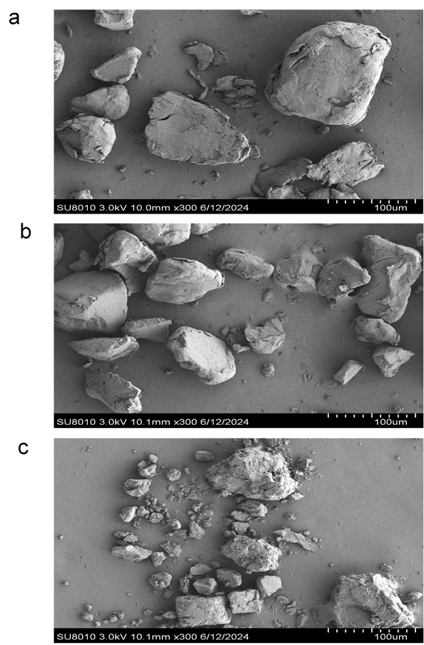

Figure S1 SEM images of PS-MPs indicate that PS-MPs are in nonuniform size and shape, and PS-MPs have blunt edges and rough surface. 10 mg of PS-MPs were taken by a spatula and poured onto a double-sided carbon tape, blown by a nitrogen gun to remove unstuck particles, then coated with sputtered ions for 40s at 25 mA (Emitech K575 Au-Pd sputter coater, Emitech Ltd., UK) for SEM observation, using a Hitachi SU8010 (Hitachi High-Tech America Inc., USA). Images were obtained in high vacuum mode with secondary electron detection at an accelerating voltage of 3 kV. While Figure a = PS 106 µm (T1), Figure b = PS 50 µm (T2) and Figure c = PS 13 µm (T3)
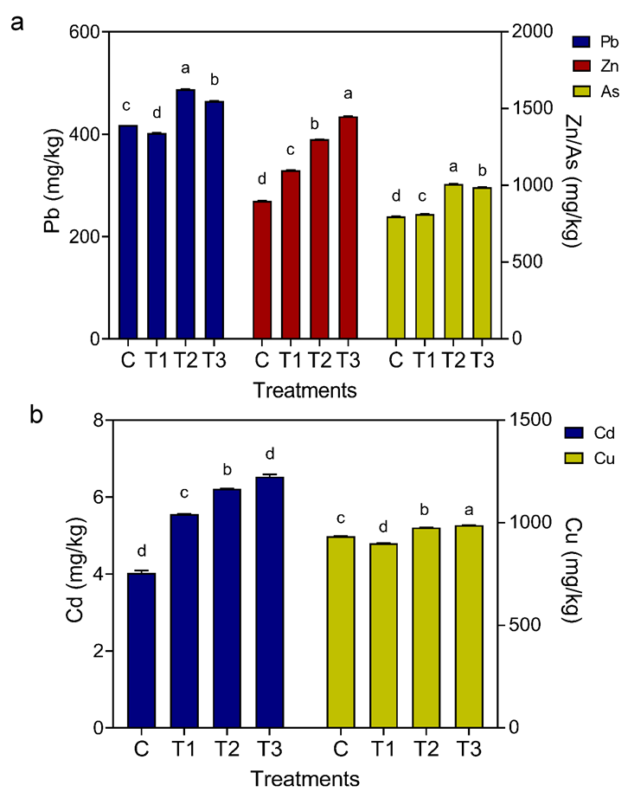

Figure S2 Soil heavy metals. Figure a represents the Pb (iron), Zn (zinc), and As (arsenic) while Figure b represents the Cd (cadmium) and Cu (copper). Small letters indicate significant differences at ANOVA and Duncan’s test, P-value < 0.05 while C = control, T1 = PS 106 µm, T2 = PS 50 µm, T3 = PS 13 µm

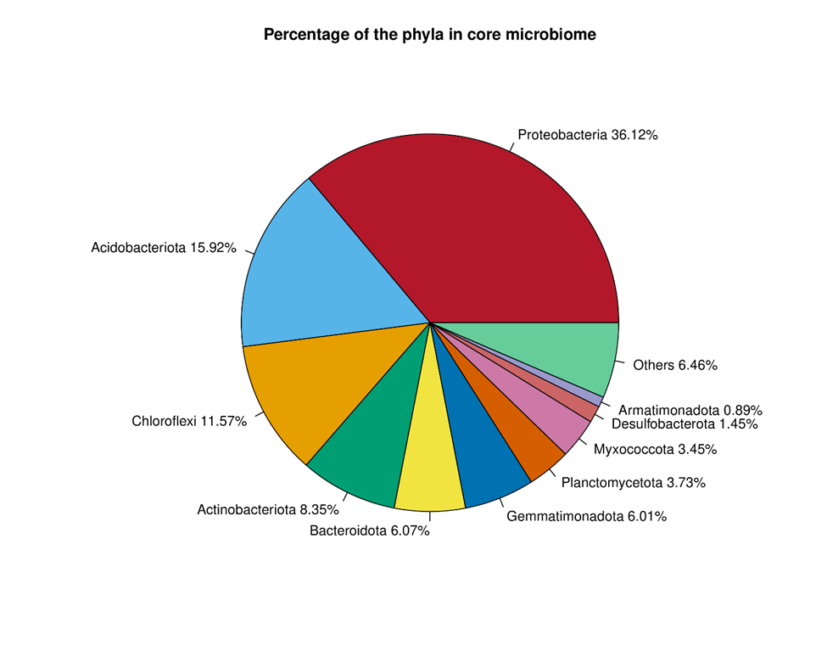
Figure S3 Percentage of the total core microbiome at the phylum level. Pie chart showing the percentage of total core microbiome at the phylum level

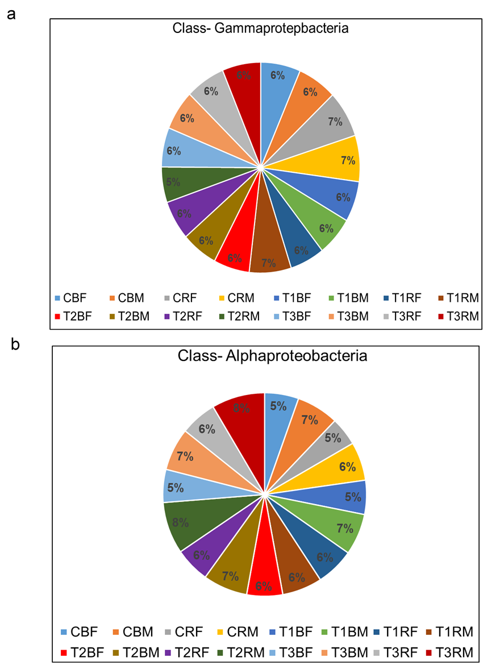
Figure S4 Pie chart showing the percentage of dominant classes. Figure a represents the dominant class Gammaproteobacteria and Figure b represents the class Alphaproteobacteria while M= middle point, F= final point, B=bulk soil, R= rhizosphere soil, C= control, T1= PS 106 µm, T2= 50 µm, T3= 13 µm
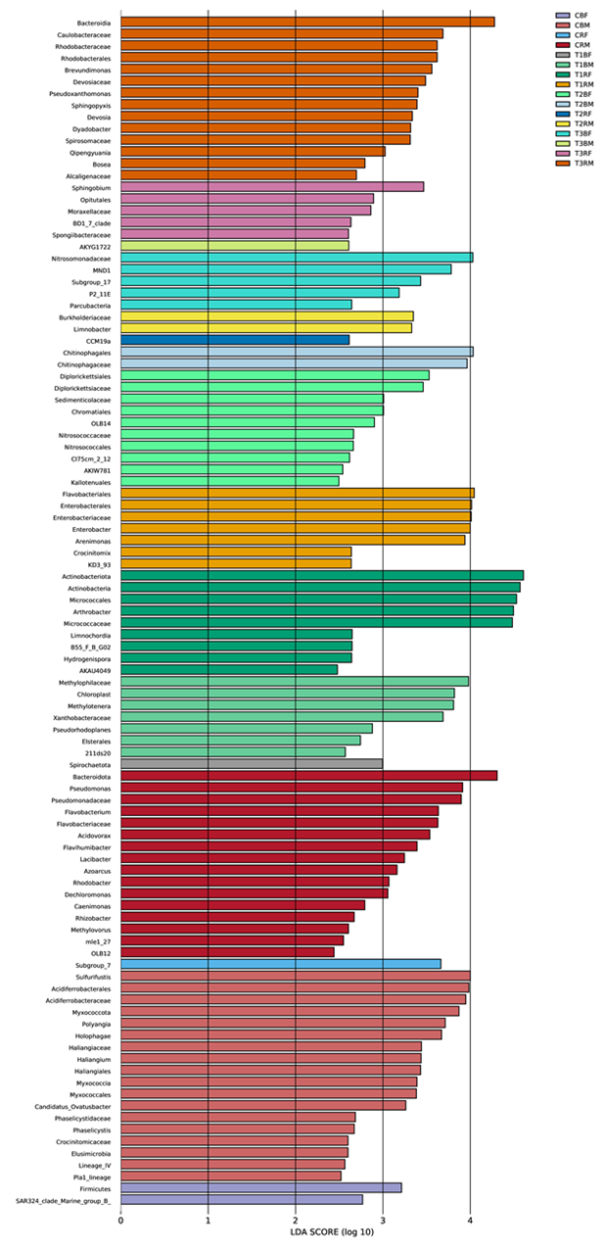

Figure S5 Linear discriminant analysis effect size (LEfSe) analysis of bacterial abundance differences among treatments. The LDA threshold score of 2.0 obtained the differences among classes. The bar plots represent the significantly differential taxa between treatments and plants, based on effect size (LDA score). While M= middle point, F= final point, B=bulk soil, R= rhizosphere soil, C= control, T1= PS 106 µm, T2= PS 50 µm, T3= PS 13 µm

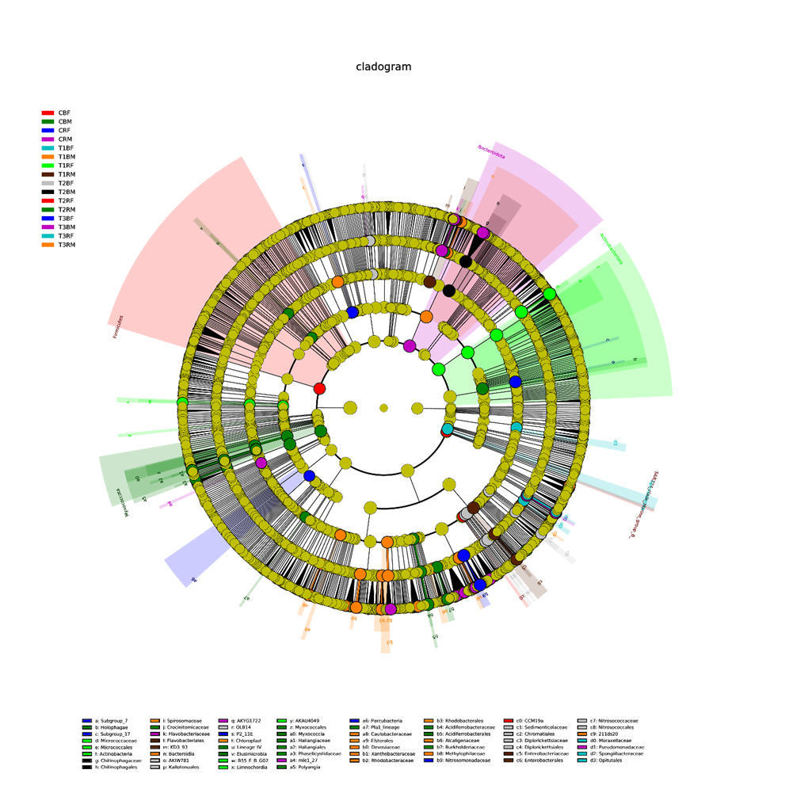
Figure S6 Linear discriminant analysis effect size (LEfSe) analysis of bacterial abundance differences among treatments and plants. The cladogram shows the taxonomic hierarchy of biomarkers identified between different treatments from phylum to family level. between treatments and plants. While M= middle point, F= final point, B=bulk soil, R= rhizosphere soil, C= control, T1= PS 106 PS µm, T2= PS 50 µm, T3= PS 13 µm

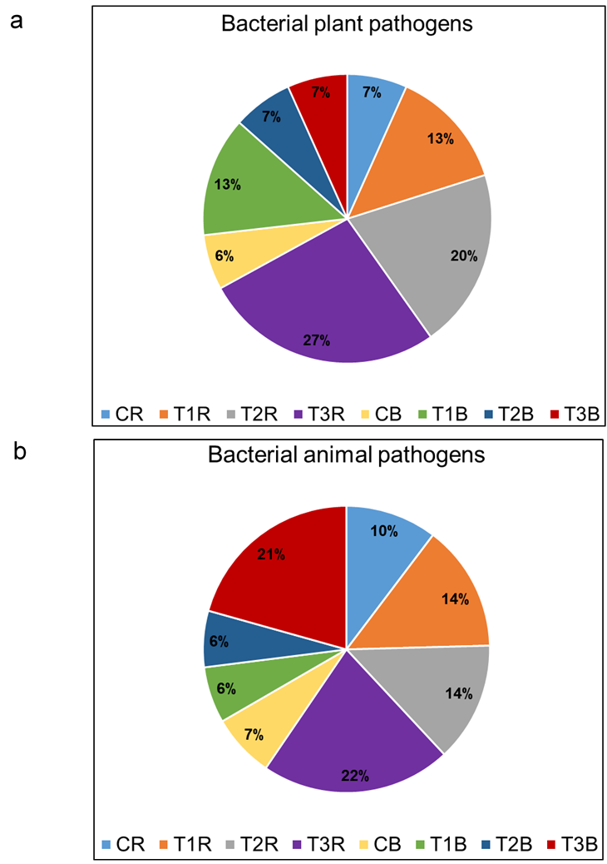

Figure S7 Bacterial plant and animal pathogens. Figure a represents a pie chart for the total average of bacterial plant pathogens and the figure b represents the pie chart for the total average of bacterial animal pathogens. While R= rhizosphere soil, B= bulk soil, C= control, T1= PS 106 µm, T2= PS 50 µm, T3= PS 13 µm

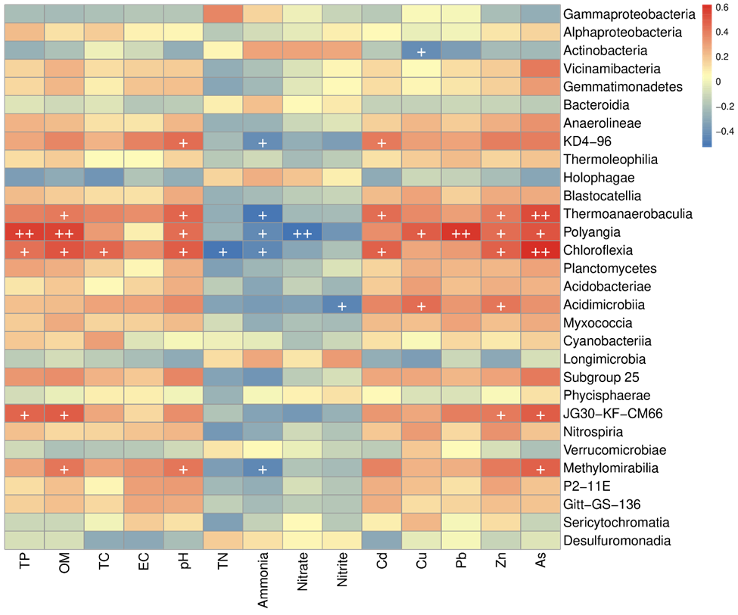
Figure S8 Heatmap between soil parameters including TP (total phosphorus), OM (organic matter), TC (total carbon), EC (electric conductivity), pH, TN (total nitrogen), NH₄⁺ (ammonia), NO₃⁻ (nitrate), NO₂⁻ (nitrite), Cd (cadmium), Cu (copper), Pb (iron), Zn (zinc), As (arsenic) and bacterial classes. Note：R>0：positive correlation，R<0 ：negative correlation，R=0：uncorrelated，|R|<0.4indicates low linear correlation，0.4≤|R|<0.7indicates significant correlation，0.7≤|R|<1 indicates a highly linear correlation

