Supplementary materials
Table S1.Details of sites and observation periods.
Site | Lat. | Lon. | Depth | Short-period observation |  |  | Long-period observation
ID |  |  | [m] | Sampling rate | Started time | Finished time | Sampling rate | Started time | Finished time
KK11 | 33°22.9′ N | 136°22.1′ E | 2063 | 8 Hz | JST 2009/07/19  17:40:14.000 | JST 2009/07/27  07:30:14.000 | – | – | –
KK12 | 33°17.9′ N | 136°26.0′ E | 2002 | 8 Hz | JST 2009/07/21  00:00:00.000 | JST 2009/07/27  23:59:59.000 | – | – | –
KK13 | 33°14.1′ N | 136°28.2′ E | 2044 | 8 Hz | JST 2009/07/23  00:00:25.000 | JST 2009/09/08  06:50:59.000 | – | – | –
KK14 | 32°55.7′ N | 136°40.4′ E | 4446 | 8 Hz | JST 2009/08/06  00:00:31.000 | JST 2009/08/29  10:51:59.000 | – | – | –
EMK1 | 33°29.2′ N | 136°34.6′ E | 2085 | 8 Hz | JST 2019/10/18  00:00:26.000 | JST 2019/11/07  23:58:59.875 | 60 s | JST 2019/11/08  00:01:00.000 | JST 2020/09/28  13:59:00.000
EMK2 | 33°35.9′ N | 136°49.6′ E | 2064 | 8 Hz | JST 2019/10/18  00:00:26.000 | JST 2019/11/07  23:58:59.875 | 60 s | JST 2019/11/08  00:01:00.000 | JST 2020/11/15  18:59:00.000
EMK3 | 33°07.3′ N | 136°43.6′ E | 3316 | 8 Hz | UTC 2019/10/18  00:00:13.000 | UTC 2019/11/07  23:58:59.875 | 60 s | UTC 2019/11/08  00:00:00.000 | UTC 2020/12/04  05:00:59.000
EMK4 | 33°46.5'N | 136°43.5'E | 1978 | 8 Hz | UTC 2020/12/02  03:00:16.000 | UTC 2020/12/23  02:58:59.000 | 10 s | UTC 2020/12/23  03:00:10.000 | UTC 2021/01/08  01:51:10.000
EMK5 | 33°24.2'N | 136°55.2'E | 1839 | 20 Hz | UTC 2020/12/04  00:00:23.200 | UTC 2020/12/25  23:58:59.200 | 10 s | UTC 2020/12/26  00:00:30.000 | UTC 2021/01/08  05:44:00.000
EMK6 | 33°12.9'N | 137°00.0'E | 3542 | 20 Hz | UTC 2020/12/04  00:00:20.200 | UTC 2020/12/25  23:58:59.200 | 10 s | UTC 2020/12/26  00:00:30.000 | UTC 2021/01/08  09:45:10.000
EMK7 | 33°00.1'N | 137°06.2'E | 4252 | 8 Hz | UTC 2020/12/04  03:00:26.000 | UTC 2020/12/23  02:58:59.000 | 10 s | UTC 2020/12/23  03:00:30.000 | UTC 2021/01/08  23:35:40.000

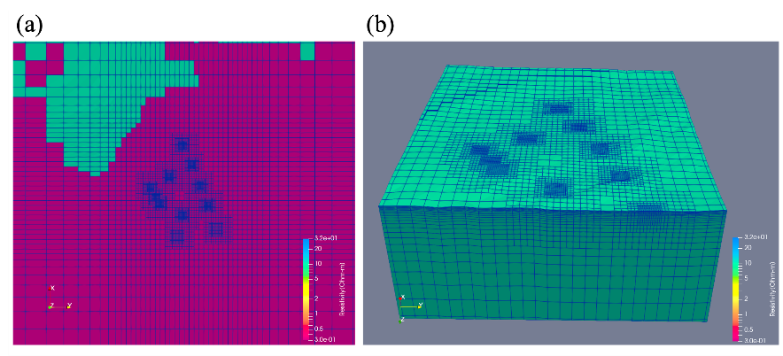
Fig. S1 Overview of the deformed non-conforming hexahedral elements used for the inversion with the FEMTIC code. (a) Mesh division of the surface of land (green) and sea (purple). The mesh is finer around the seafloor electromagnetic field observation sites. (b) Bird’s-eye view showing only the seafloor and land surface elements in the main analysis area.

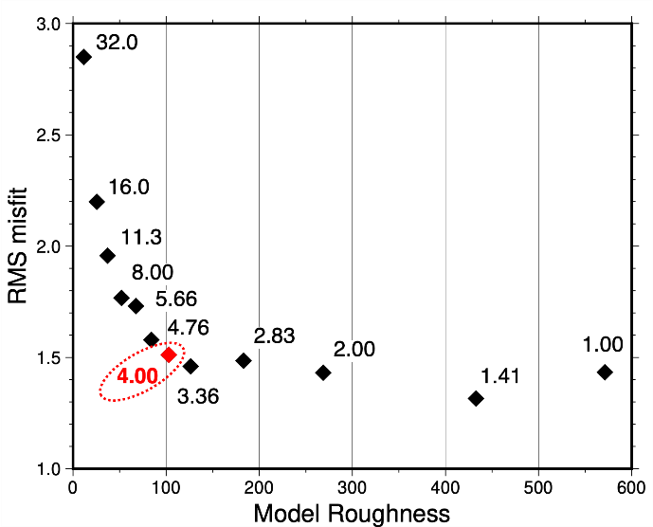
Fig. S2 The relationship between model roughness and RMS misfit from the results of three-dimensional inversion with different trade-off parameters α. The values of the trade-off parameter α are indicated by the numbers adjacent to the diamonds. The red diamond represents model roughness and RMS misfit from the optimal resistivity structure selected for this study (α = 4.00), determined by the L-curve method (Hansen and O’Leary 1993).
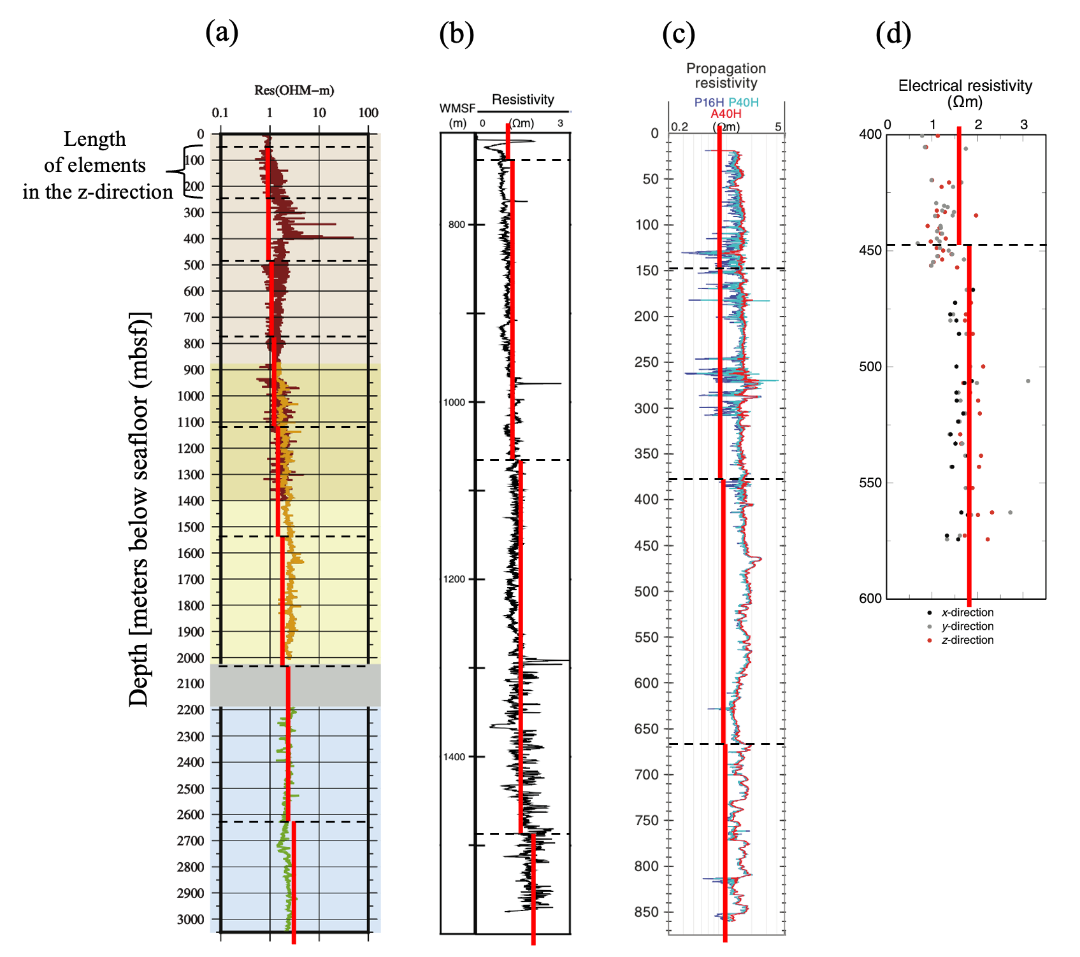
Fig. S3 Resistivity values from three-dimensional resistivity structure overwritten borehole measurements. The resistivity values from are overwritten on values by borehole measurements at C0002 (Wu et al. 2019) (a), C0009 (Saffer et al. 2009) (b), C0024 (Tobin et al. 2019) (c) and C0025 (Kimura et al. 2020) (d). The red lines show the resistivity of each element from the three-dimensional resistivity structure, the black dashed lines show the z-directional boundaries of each element. The vertical axis is the depth [mbsf (meters below seafloor)].

Supplementary Document. Sensitivity tests of resistivity variations along the plate boundary
Sensitivity tests were conducted to check the importance of resistivity variations along the plate boundary. Along the plate boundary, the optimal resistivity structure can be summarized as follows (Fig. 4): 0.7–2 Ωm at <5 km depth; 3–20 Ωm at 5–10 km depth; and 40–200 Ωm at 10–20 km depth. We conducted sensitivity tests to check for resistivity differences corresponding to these three zones identified by Obara and Kato (2016), by replacing the resistivity values of the elements and performing forward calculations. The replaced element was centered on Line 2 and trough-parallel length was 120 km; the replacements were performed in the shallow, moderate, and deep parts of the optimal resistivity structure.
The resistivity along the plate boundary at <5 km depth (<1.4 Ωm in our model) was replaced by 1.4 Ωm (Fig. 5b) and the forward analysis was performed. For EMK6, the forward calculated MT responses were higher than the observed MT responses, particularly at periods of 30–1000 s in the apparent resistivity (Fig. 2). This finding means that the observed MT responses cannot be explained by the replaced resistivity (1.4 Ωm) in the vicinity of the plate boundary at <5 km depth. Therefore, the resistivity near the plate boundary at those depths is best explained as being <1.4 Ωm.
Because the resistivity at the plate boundary below observation site EMK6 (Line 3, 15 km along section, 4.7 km depth) was 1.3–2.2 Ωm, the element near the plate boundary at 5–10 km (>2 Ωm in our model) was replaced by 2 Ωm (Fig. 5b) and the forward calculation was performed. At KK13, the forward calculated MT responses were lower than the lower limit of error on the observed MT responses, particularly for apparent resistivities at periods >200 s (Fig. S4). Similarly, at EMK5, the forward calculated MT responses were lower than the observed MT responses for apparent resistivities at periods >100 s (Fig. S4). In other words, the replaced value of 2 Ωm at 5–10 km depth along the plate boundary cannot explain the observed MT responses. Therefore, the resistivity along the plate boundary at those depths is best explained as being >2 Ωm.
To verify the upper limit of resistivity values near the plate boundary at 5–10 km depth, forward calculations were conducted by replacing resistivities of elements in this area with values of 64, 128, and 181 Ωm. However, compared to the inversion results, the forward calculated MT responses and GVTFs show no significant changes. Therefore, the upper limit of the resistivity values at 5–10 km depth could not be determined.
Conversely, the lower limit of resistivities at 10–20 km depth along the plate boundary is constrained. Referring to the resistivity value of 8.5 Ωm near the plate boundary directly below EMK5 (Line 3, 37 km along section, 7 km depth), the MT responses and GVTFs were compared by replacing model values (>8.5 Ωm) with 8.5 Ωm at 10–20 km depth along the plate boundary (Fig. 5b). At EMK1, the apparent resistivity from the forward calculation was estimated to be lower than the error limit of the observed MT response at periods of 100–2000 s (Fig. S5). Similarly, for EMK4, the apparent resistivity was lower than the lower limit of the observed MT response error at periods of 60–2000 s, and the GVTFs deviated from the observed data errors at periods of 300–2000 s (Fig. S5). Therefore, the resistivity along the plate boundary at 10–20 km depth must be greater than 8.5 Ωm, indicating that this zone is not conductive.
These sensitivity tests indicate that the resistivities along the plate boundary are indeed <1.4 Ωm at <5 km depth, >2 Ωm at 5–10 km depth, and >8.5 Ωm at 10–20 km depth, confirming the depth-dependent resistivity variation estimated along the plate boundary in our three-dimensional resistivity model.

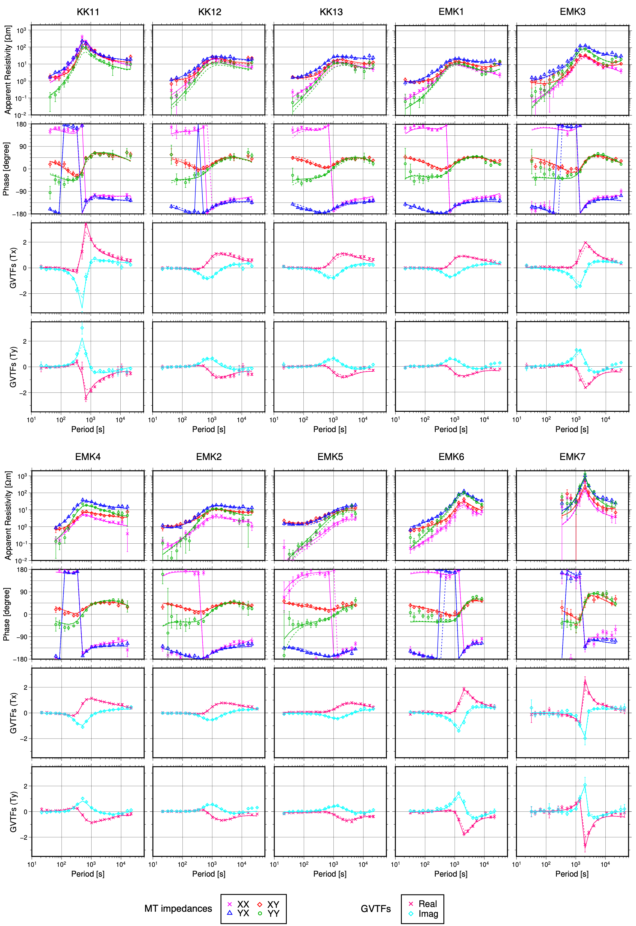
Fig. S4 Sounding curves of the apparent resistivity and phase of the MT impedance tensors and the GVTFs. The solid line shows model-predicted values of the optimal resistivity structure obtained by inversion. The dashed line shows the result of the forward calculation when the mesh near the plate boundary at depths of 5–10 km is replaced with 2 Ωm.

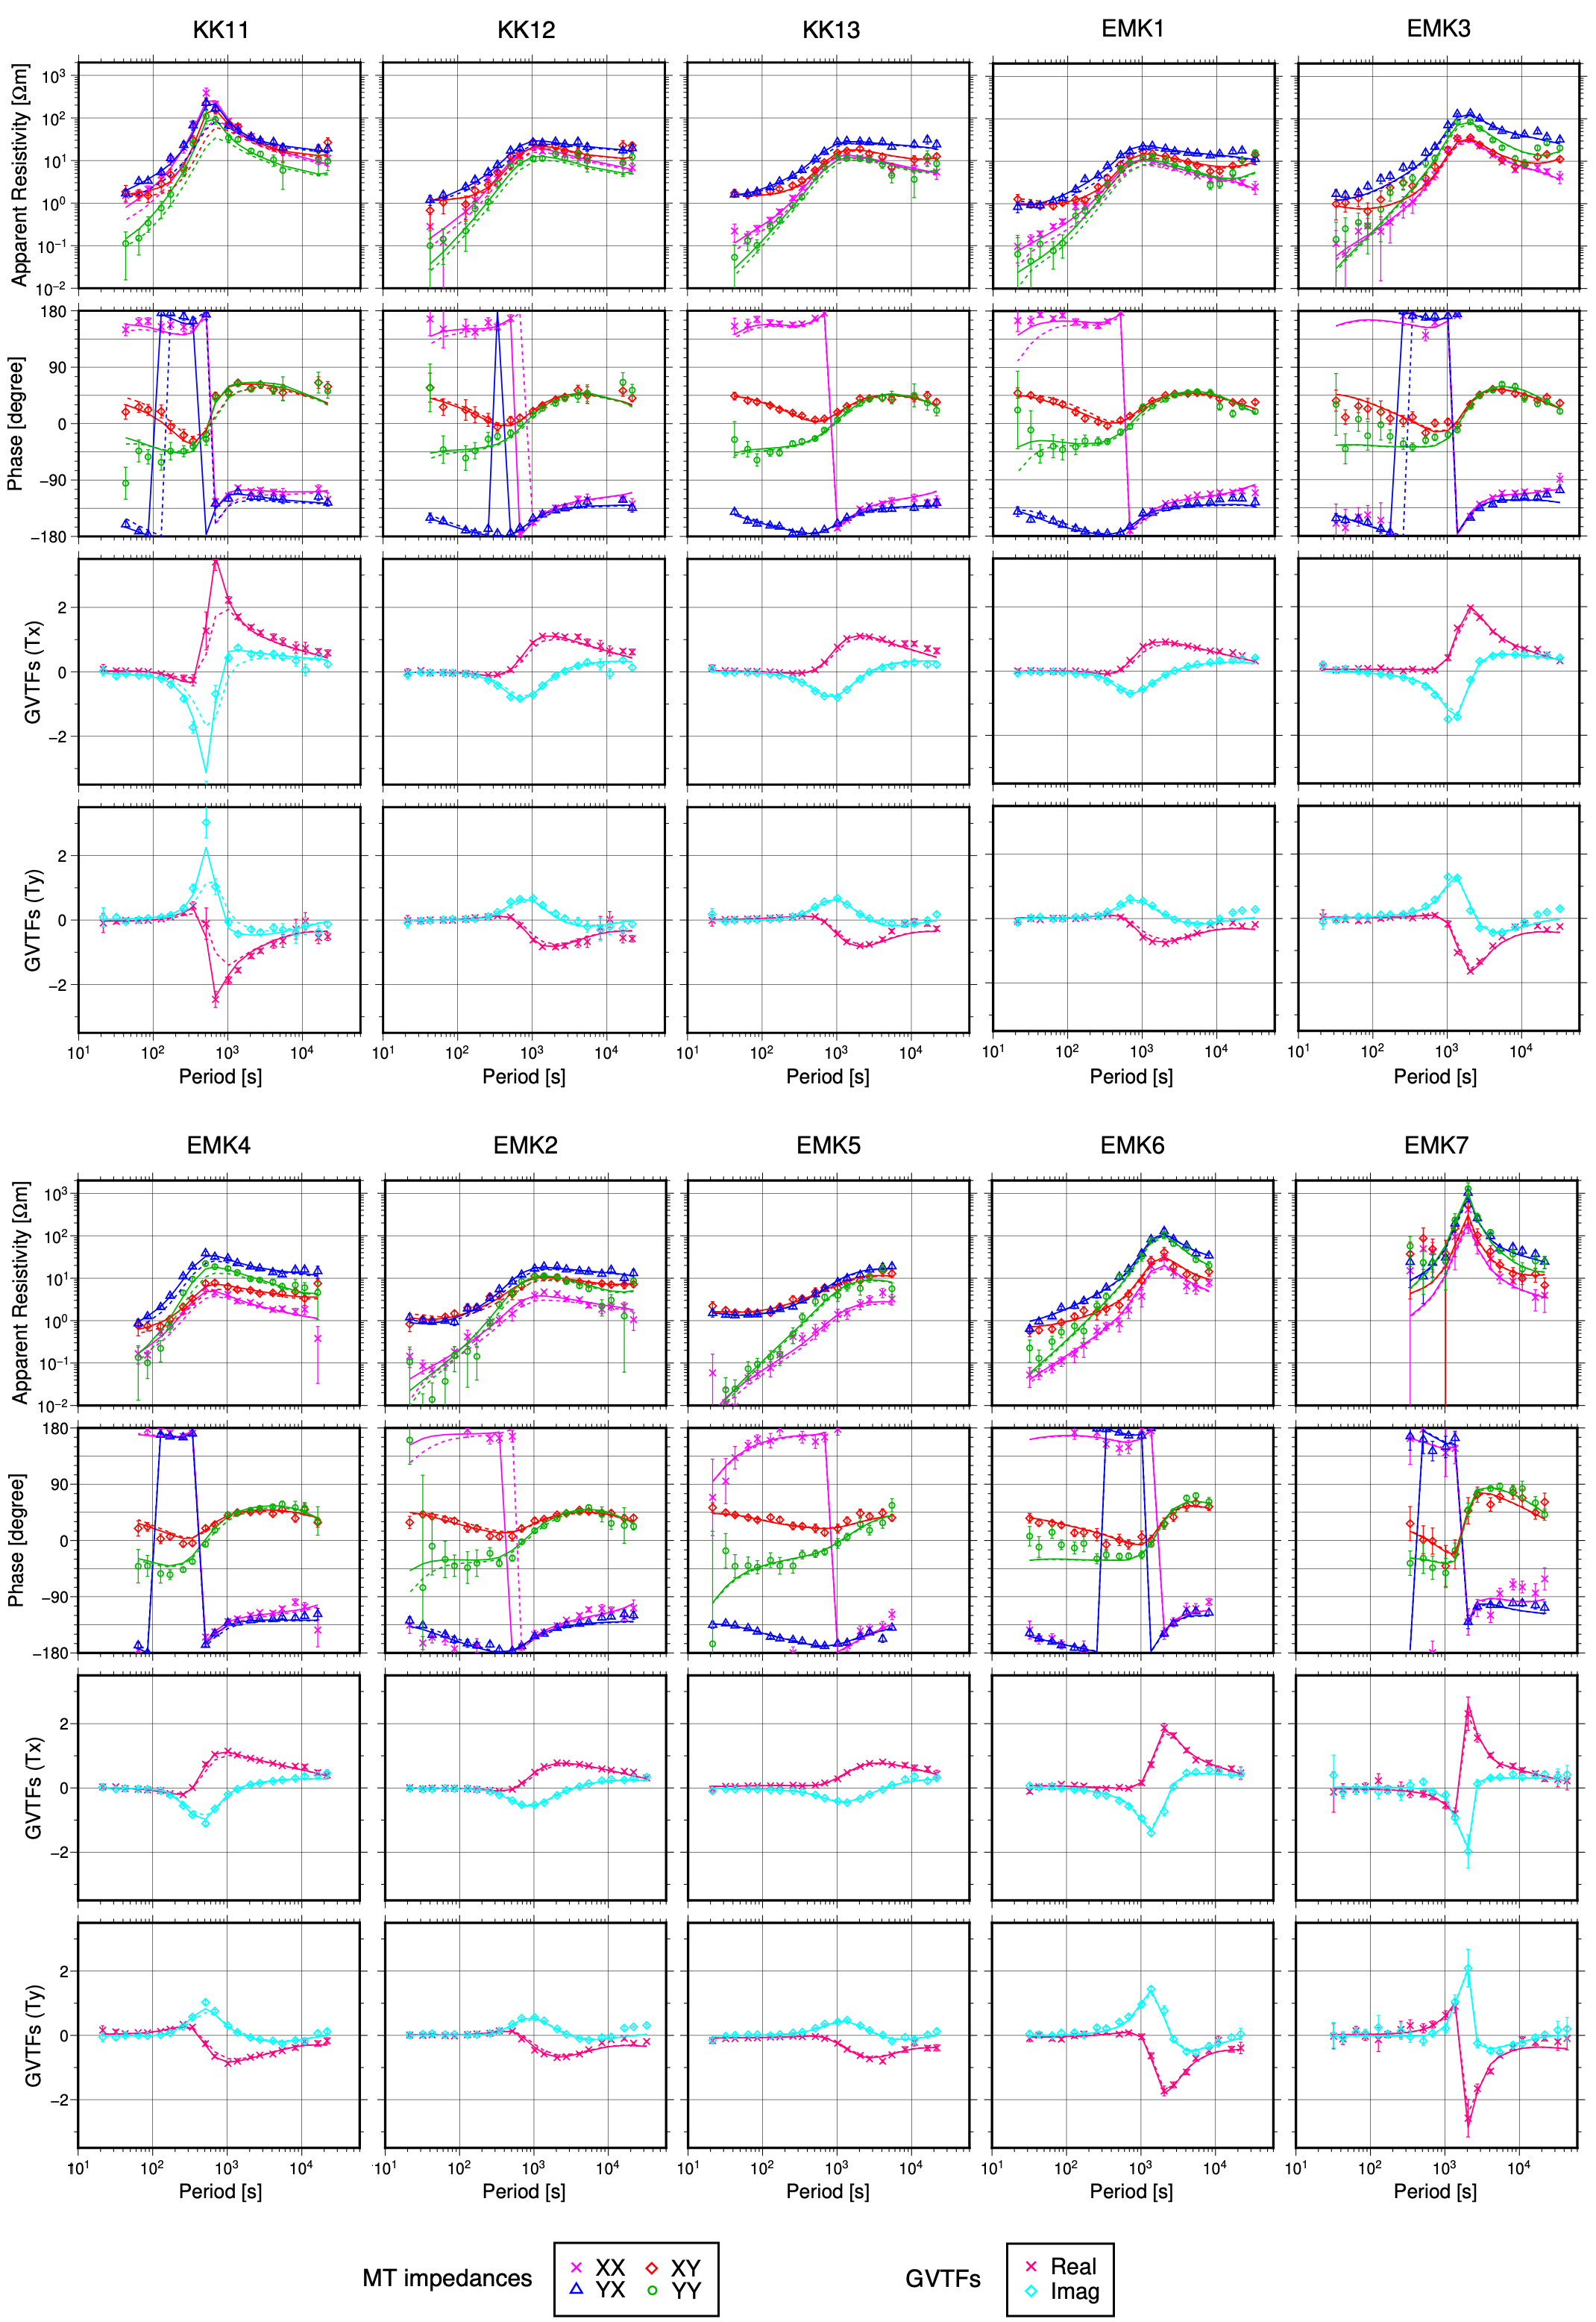
Fig. S5 Sounding curves of the apparent resistivity and phase of the MT impedance tensors and the GVTFs. The solid line shows model-predicted values of the optimal resistivity structure obtained by inversion, and the dashed line shows the result of the forward calculation when the mesh near the plate boundary at depths of 10–20 km is replaced with 8.5 Ωm.

