Ultra-Conformal Skin Electrodes with Synergistically Enhanced Conductivity for Low-Motion Artifact Epidermal Electrophysiology
Yan Zhao¹, Song Zhang², Tianhao Yu³, Yan Zhang¹, Guo Ye¹, Wenchao Jiang³, Yifei Lu³, Weifeng Zhang¹, Xiaojia Du¹, Jiakang Qiu¹, Xiaodan Gu² and Nan Liu^{1,3*}
¹ Beijing Key Laboratory of Energy Conversion and Storage Materials, College of Chemistry, Beijing Normal University, Beijing 100875, P. R. China
² School of Polymer Science and Engineering, The University of Southern Mississippi, Center for Optoelectronic Materials and Device, Hattiesburg, Mississippi 39406, United States
³ Beijing Graphene Institute, Beijing 100094, China
* Corresponding author: E-mail: nanliu@bnu.edu.cn
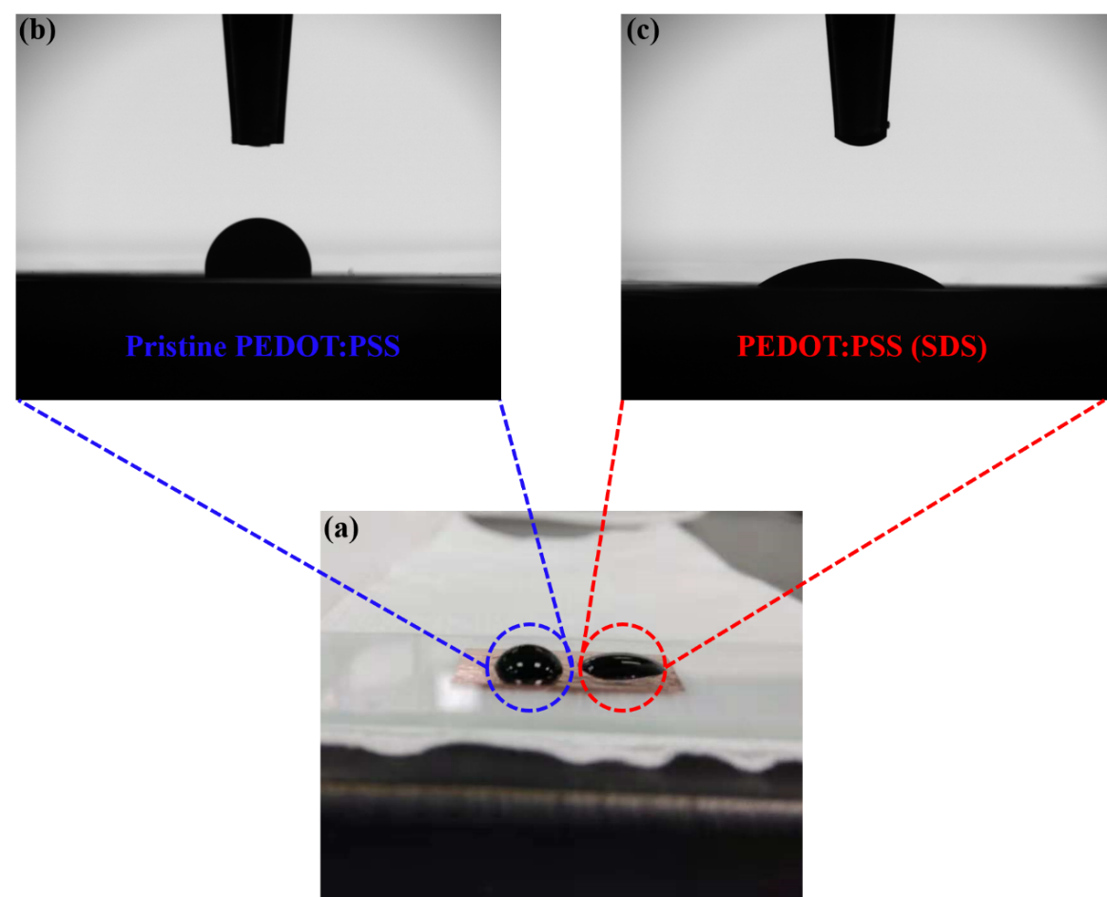
Figure S1. Contact angle between PEDOT:PSS and graphene, where (b) was pristine PEDOT:PSS and (c) was PEDOT:PSS with SDS.
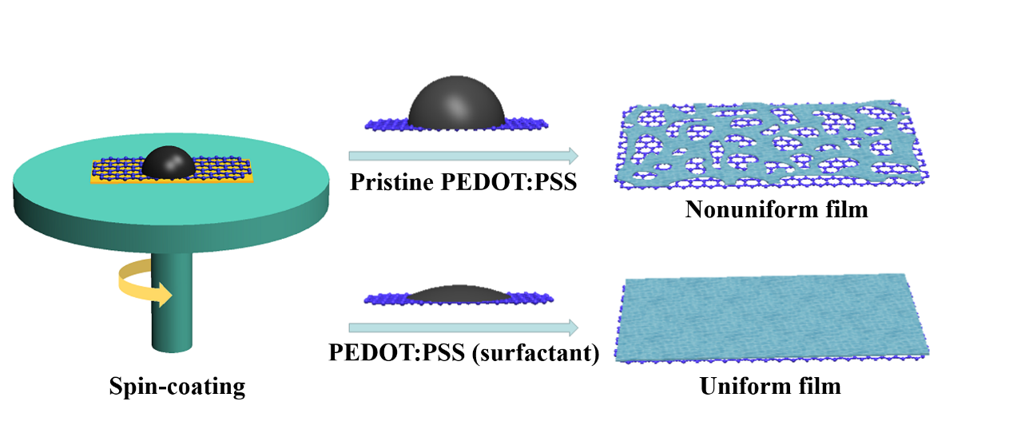
Figure S2. Schematic illustration of the fabrication process of continuous and in-continuous PEDOT:PSS on graphene, showing the function of surfactants.
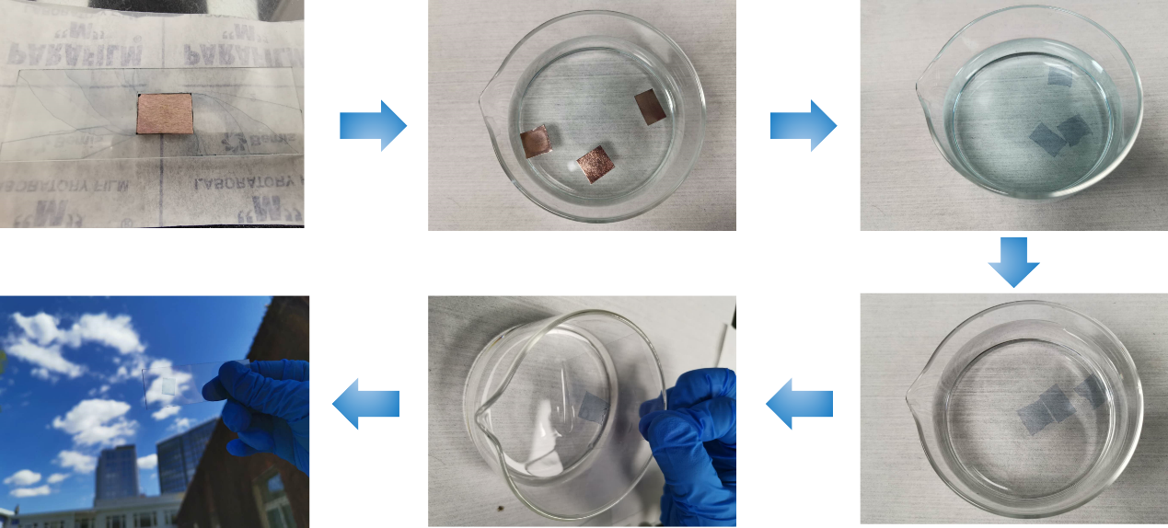
Figure S3. Pictures shows the procedures of Cu etching and transfer to obtain PTG on glass.
After spin-coating and annealing, the sample was floated in (NH₄)₂S₂O₈ solution to etch the underlying Cu foil, followed by rinsing in deionized water to remove residues. The resultant PTG thin film can be scooped onto an arbitrary substrate. The PTG on glass was quite transparent.
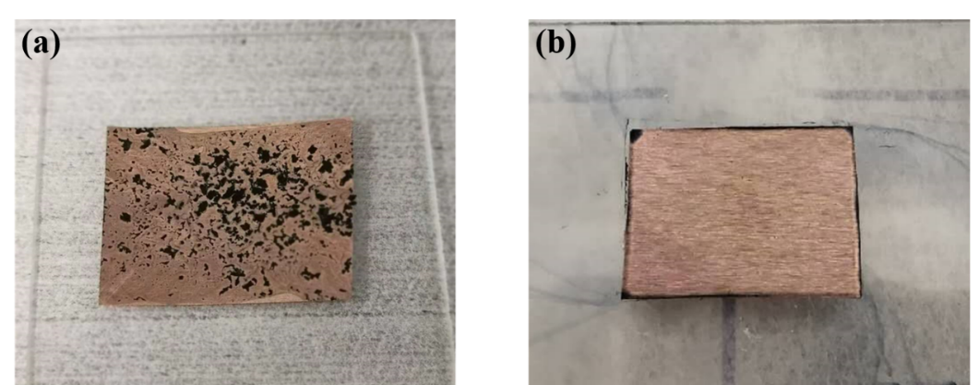
Figure S4. The pictures of (a) precipitated PEDOT:PSS on graphene film and (b) uniform PTG.
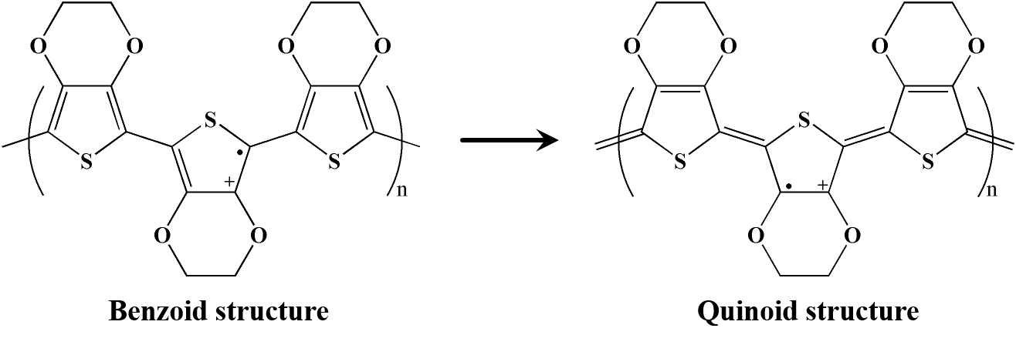
Figure S5. The structure transition of PEDOT chain from benzoid to quinoid structure.
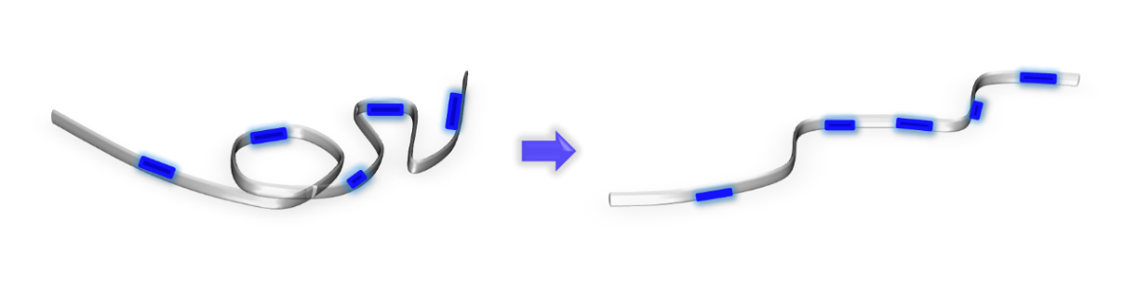
Figure S6. The structure transition of PEDOT:PSS from coil to linear. The thiophene ring on PEDOT chains transits from a coil-like benzoid structure in pristine to a linear-like quinoid structure. With the addition of SDS and BSL, the coiled PEDOT chain in the pristine PEDOT:PSS aqueous solution became linear.

Table S1. The sheet resistance of various samples.
Sample | Sheet Resistance (Ω/sq)
Graphene | ~ 600
PEDOT:PSS (SDS+BSL) | ~ 1560
Parallel resistance | ~ 433
PTG | ~ 50

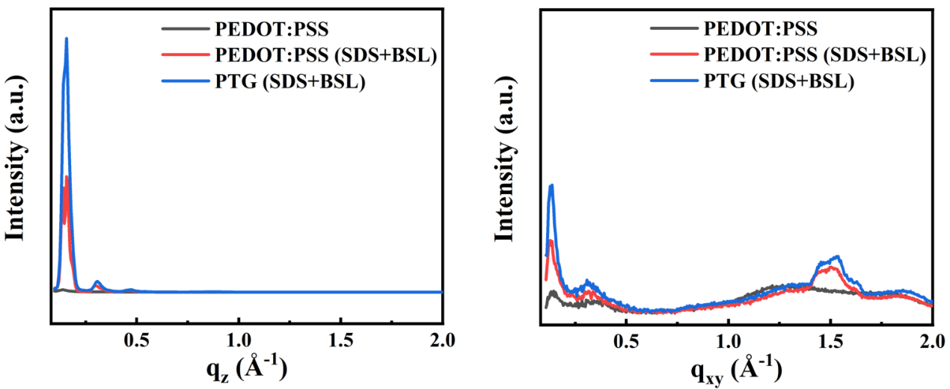
Figure S7. The 1D scattering q_{z} and q_{xy} profiles obtained from the 2D GIWAXS patterns.
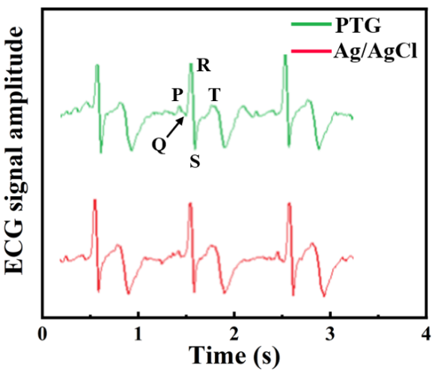
Figure S8. The SNR of sEMG measured by PTG and Ag/AgCl electrodes
Figure S9. ECG measured by PTG and Ag/AgCl electrodes.
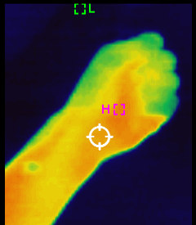
Figure S10. Infrared image of PTG on the forearm, showing that a minimal level of heat was accumulated upon mounting the PTG electrodes on a volunteer’s forearm.

