Supplementary Data
This Supplementary Data entry contains:
- Detailed analytical methods
- Materials
- Scanning Electron Microscopy
- Electron Microprobe
- NanoSIMS analysis
- Raman Spectroscopic Measurements
- Mineral liberation analyser
- Thermodynamic modelling: GEMs Selektor Calculations
- Supplementary Tables
- Table S1 - EMPA results of feldspars [found in external excel file]
- Table S2 - Conditions of each experiments
- Table S3 - Starting composition of each system used in GEMs modelling
- Supplementary figures
- Figure S1 - BSE images of Biotite, fluorite and ilmenite
- Figure S2 - Chemical compositions of three different feldspar phases
- Figure S3 – MLA results of different feldspar fractions
- Figure S4 - ¹⁸O and ¹⁶O counts in feldspars
- Figure S5 - Main Raman spectrum peaks of each phase
- Figure S6 – Raman Mappings of the position of Raman-active bending mode at 515 cm-1 in feldspars
- Supplementary reference

Detailed analytical methods

Materials
The starting material for the experiments was a homogenous natural sanidine sample from Dellen Quarries, Niedermending, Mendig, Eifel, Rhineland-Palatinate, Germany.

Scanning Electron Microscopy (SEM)
A high-resolution FEI Quanta 3D field emission gun (FEG) scanning electron microscope was used to study the microstructure of the reaction products. The working distance was 10 mm for analysis of the polished epoxy block. The accelerating voltage and beam current used were 15-20 kV and 16 nA. Elemental compositions were determined by energy-dispersive X-ray spectroscopy (EDS). The calculated chemical formula of sanidine from EDS is K_{0.6}Na_{0.3}Al_{1.1}Si₃O₈.

Electron Microprobe Analysis (EMPA)
A JEOL JXA-8530F electron microprobe incorporating wavelength dispersive spectrometers (WDS) detector at the commonwealth scientific and industrial research organization (CSIRO), Clayton, Australia, was used to measure the chemical composition of all feldspar phases. Point Measurements were performed with an accelerating voltage of 15 kV, a probe current of 15 nA and a 5-10 nm-defocused probe size. Counting times were 40 s on peak and background. The elements were acquired using analyzing crystals PETH Ka for K, Ca, Ti, Cl, and TAP Ka for Na, Al, Si, and LDE1 for F Ka. The detection limits of Na, K, Al and Si in feldspar under such condition are below 185 ppm. Analytical errors for elemental concentrations are a function of the X-ray line intensities, background count rates, background positions, probe currents, counting times and the correction procedure applied. Repeated analyses of reference samples point to relative errors of 1 – 2 % for the major elements.

NanoSIMS analysis
NanoSIMS analysis was performed on polished epoxy mounts at the Centre for Microscopy,
Characterisation and Analysis (CMCA) at the University of Western Australia (UWA), using CAMECA NanoSIMS 50L optimized as described by Wu et al. (2019). A Cs+ ion source with spot size of approximately 50 nm was employed. Multiple electron multipliers record ion counts from the same sputtered sample volume at five masses simultaneously. Each region of interest was pre-sputtered using a beam current of 250 pA, to remove surface contaminants and implant Cs+ ions into the sample matrix to achieve a steady state of secondary ion emission.
The electron gun was used for charge compensation because the samples were predominantly composed of insulating materials. Analysis areas ranged in size from 20×20 to 40×40 μm², the image sizes were 256×256 pixels. NanoSIMS images were processed using ImageJ. The ion intensity of each trace element provides a simple, semi-quantitative expression of localized trace element enrichment.

Raman Spectroscopic Measurements
Raman mapping was conducted using a confocal WITec alpha 300 microspectrometer (WITec GmbH, Germany). Measurements were performed using 532 nm laser and 10 mW power with a 50× objective. The scattered light was dispersed by a grating of 1800 grooves/mm on a CCD detector cooled to −60 °C. The WITec system was controlled using WITec Project 2.10 software. Several single points from mappings were chosen to show different phase spectrum characteristics. Frequency modes located between ~430-550 cm⁻¹ correspond to O-Si-O and O-Al-O bending and stretching modes within the four-membered (Si₃AlO₁₂) tetrahedral rings.

Mineral liberation analyser (MLA)
Automatic whole sample mapping is performed by FEI QUANTA 650 FEG. Typical operating conditions use an accelerating voltage of 25 kV and spot size of 6-7. The typical magnification is around 250 times with the diameter of mapping area ranging from 30000 mm to 8000 mm, resulting the whole mapping time is around 3-5 hours. The analysis provides volume% of each phase; because of the similar density of sanidine, albite and K-feldspar, these volume% values were taken to also represent the weight percentage of these minerals.

Thermodynamic modelling: GEMs Selektor Calculations
The chemical composition of the bulk fluid in equilibrium with sanidine at the respective experimental conditions was calculated using the GEMs Selektor software (Wagner et al., 2012). The MINES16 thermodynamic database (http://tdb.mines.edu/) (Gysi, 2017), which contains standard thermodynamic properties for aqueous, gas and mineral species was chosen for our simulations. For aqueous electrolyte solutions, we use the extended Debye-Hückel (Helgeson) model to calculate activity coefficients of charged aqueous species (Helgeson et al., 1981). For gas/fluid phase, the standard properties of pure real gaseous species are computed from the modified Peng-Robinson-Stryjek-Vera (PRSV) (Stryjek and Vera, 1986). Details of all the models can be found in Wagner et al., (2012). Due to the asymmetric solvus system of alkali-feldspar, the multi-component Van Laar model (Holland and Powel, 2003) was used for the solid solution in calculations. Because at low temperatures there exists a miscibility gap between sodium and potassium feldspar end-members (Wagner et al., 2012), two solid solution phases need to be used in the chemical system. For simplicity, two feldspar solid solution phases available in MINES16 were adopted but assuming that anorthite amount is negligible.
The staring composition of fluid and minerals used in Fig. 4 from main article can be found in table DR2. A titration model is used to model the reaction path of sanidine in contact with pure water or Na-rich halide solution and calculate the evolution of the fluid and the minerals formed as a function of increase rock-fluid interaction by increasing the fraction of sanidine gradually to 1.
A conventional way to visualize Aq–SS equilibria and saturation states is based on plotting the Lippmann total solubility product (Glynn and Reardon, 1990). In our case, 1 molar alkali feldspar solid solution with changing orthoclase to albite ratio to react with 40 g pure water, and the total solubility product can be written as:
$$∑∏=a({{SiO}_{2})}^{3}*a(Al\left(OH)_{4}^{-}\right)*(a\left(K^{+}\right)+a({Na}^{+}))$$
And the Lippmann diagram usually consists of two plots with a common ordinate log₁₀∑∏ against two superimposed abscissas y1 and y2, where y1 is the aqueous ion activity fraction (X(Na⁺); solutus) and y2 is the mole fraction in the solid (X(Ab); solidus). In the case of a miscibility gap, a segment of the solidus curve is metastable (Kulik et al. 2010). The boundary points between stable and metastable segments show the compositions of two SS phases in equilibrium with the peritectic composition of the aqueous phase (Kulik et al. 2010).

Supplementary Tables
Table S1. EMPA results of feldspars [found in external excel file]
Table S2: Conditions of each experiments
Sample No. | S4-1 | S4-3 | S2-1 | S3-4 | S5-1 | S2-2 | S3-2
Reactants
Sanidine (mmol) | 0.11 ± 0.01
Water (mmol) | 2 ± 0.25
Total halide (mmol) | 0.15 ± 0.003
Cl:(Cl+F) ratio | 1 | 1 | 1 | 0 | 0 | 0 | 0.5
Solution | ¹⁸O-enriched | ¹⁸O-enriched | ¹⁶O-enriched | ¹⁸O-enriched | ¹⁶O-enriched | ¹⁶O-enriched | ¹⁸O-enriched
Reaction day(s) | 1 | 3 | 5 | 1 | 3 | 5 | 5
Main Products (vol%)
Sanidine | 71.52% | 70.64% | 52.78% | 72.14% | 54.00%% | 19.00% | 33.00%
Albite | 27.57% | 29.21% | 46.41% | 7.40% | 16.52%% | 29.79% | 34.57%
K-feldspar |  | 0.08% | 0.41% | 20.05% | 26.88%% | 51.01% | 31.15%

Table S3: Starting composition of each system used in modelling
 | H2O | NaCl solution | NaF solution
Name | Quantity | Quantity | Quantity | units
Al₂O₃ | 5.64 | 5.64 | 5.64 | g
CaO | 1.00E-09 | 1.00E-09 | 1.00E-09 | mol
K₂O | 3.18 | 3.18 | 3.18 | g
NaO | 0.99 | 0.99 | 0.99 | g
SiO₂ | 19.89 | 19.89 | 19.89 | g
H₂O | 40 | 40 | 40 | g
NaCl | 0 | 0.15 | 0 | mol
NaF | 0 | 0 | 0.15 | mol
Cl | 1.00E-09 | 0 | 1.00E-09 | mol
F | 1.00E-09 | 1.00E-09 | 0 | mol
Thermodynamic modelling data source from: 1) Tagirov and Schott, 2001; 2) Miron al., 2016; 3) Schock et al., 1997; 4) Sverjensky et al., 1997; 5) Tagirov et al., 1997; 6) Slop98.dat file

Supplementary Figures
Figure S1. Biotite only exist with albite in NaCl solution (S2-1) and fluorite and ilmenite coexist with albite in NaF solution (S2-2). Note the different accessory products formed in NaCl solution compared to NaF solution.
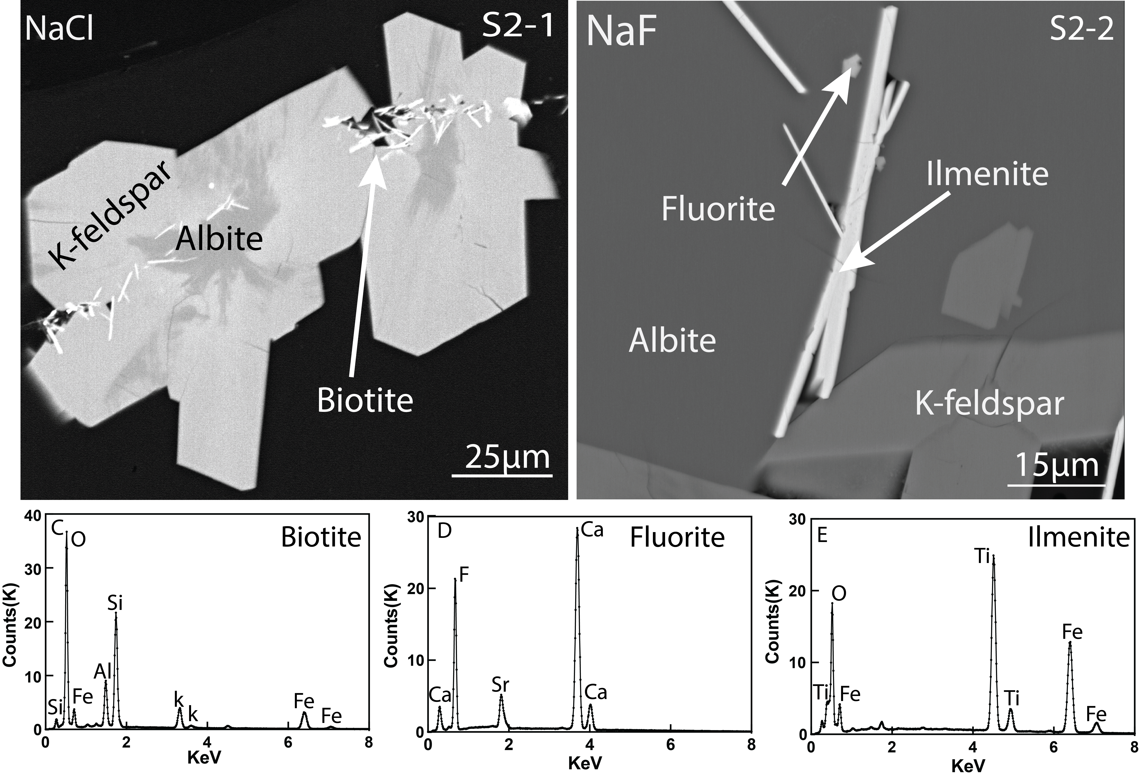
Figure S2. Chemical compositions of three different feldspar phases, sanidine, albite and K-feldspar.
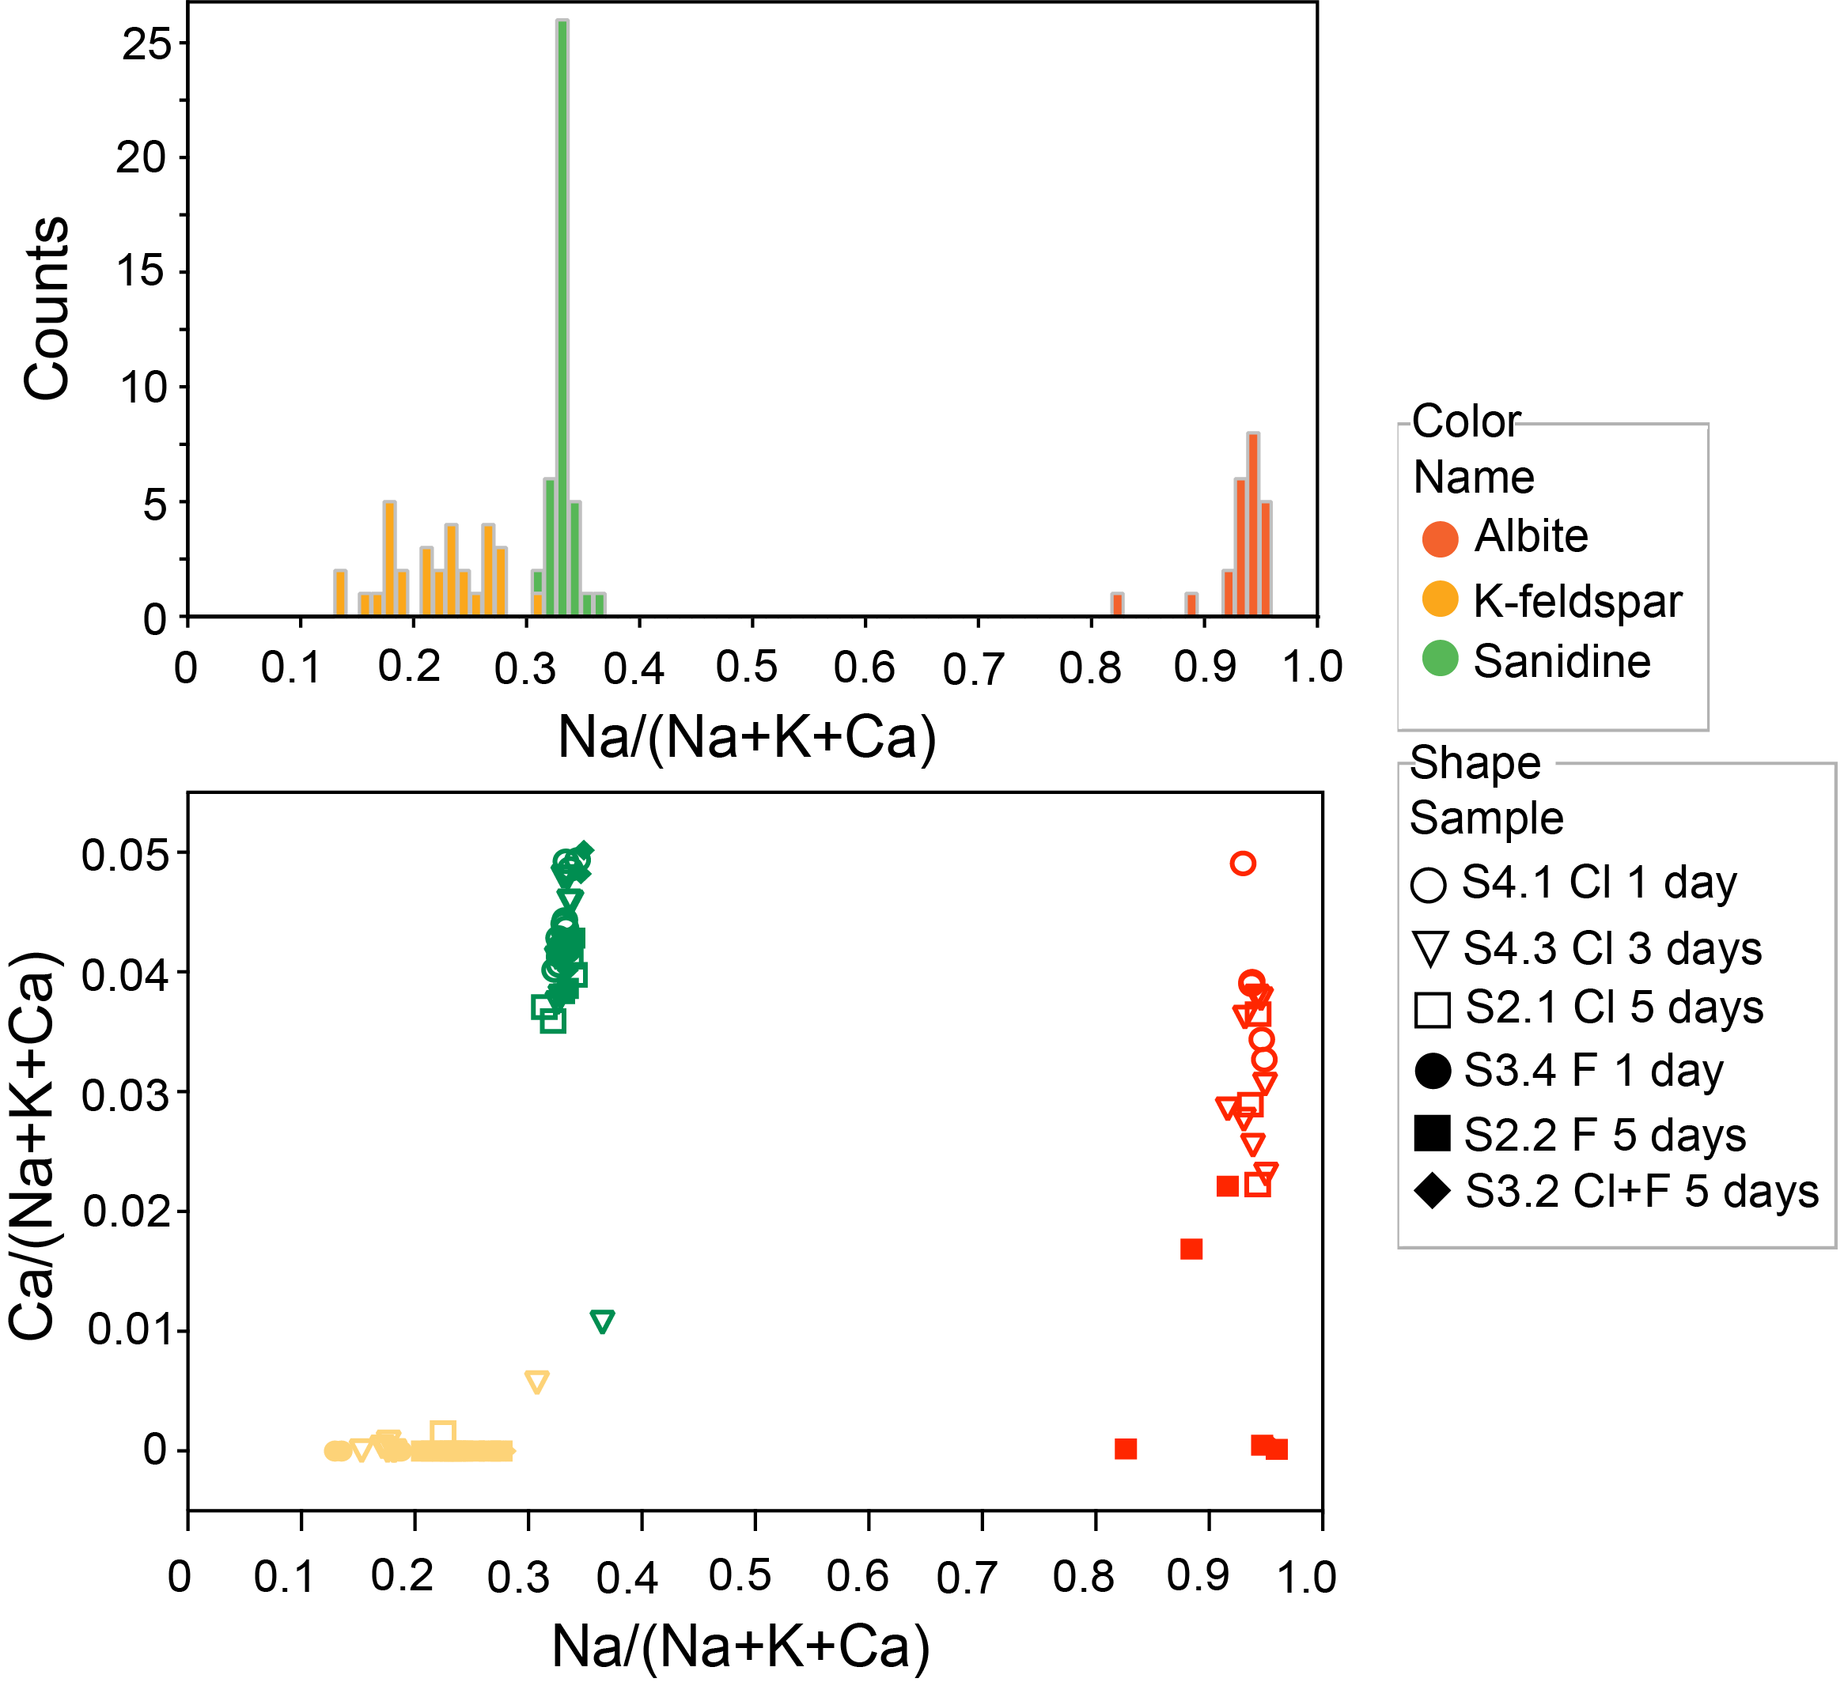

Figure S3. Characteristic MLA mapping results show different feldspar fractions formed in NaCl solution (S2-1; Figs, a-b) and NaF solution (S2-2; Figs. c-d). A and C are the representative BSE images of reaction products. B and D are corresponding MLA analysis. Blue, green and yellow represent sanidine, albite and K-feldspar, respectively. Small red part in B and orange part in D represent small biotite and fluoride grains.
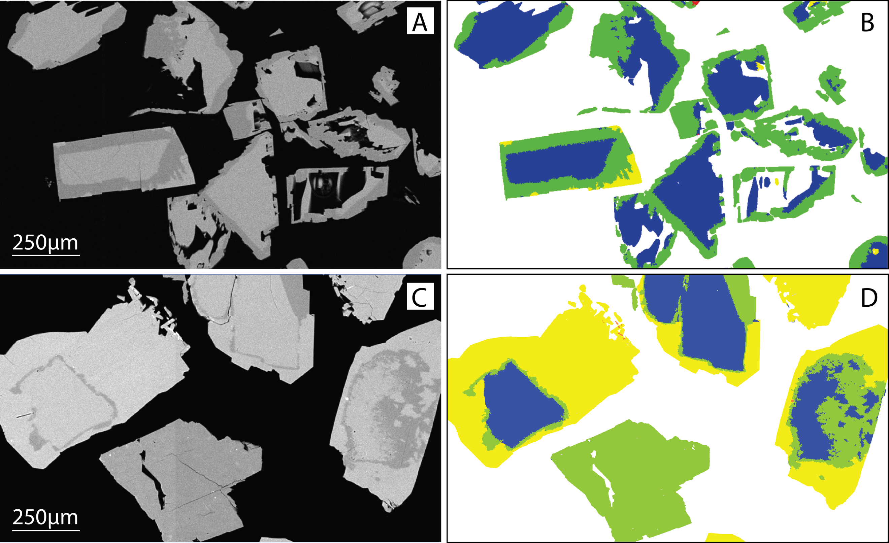

Figure S4. Nano-sims analysis of line scan in reactions products formed in ¹⁸O-enriched solutions with different reaction times. Note that the increasing trends of both ¹⁸O and ¹⁶O isotopes may be caused by charging or presents a diffusion effect.
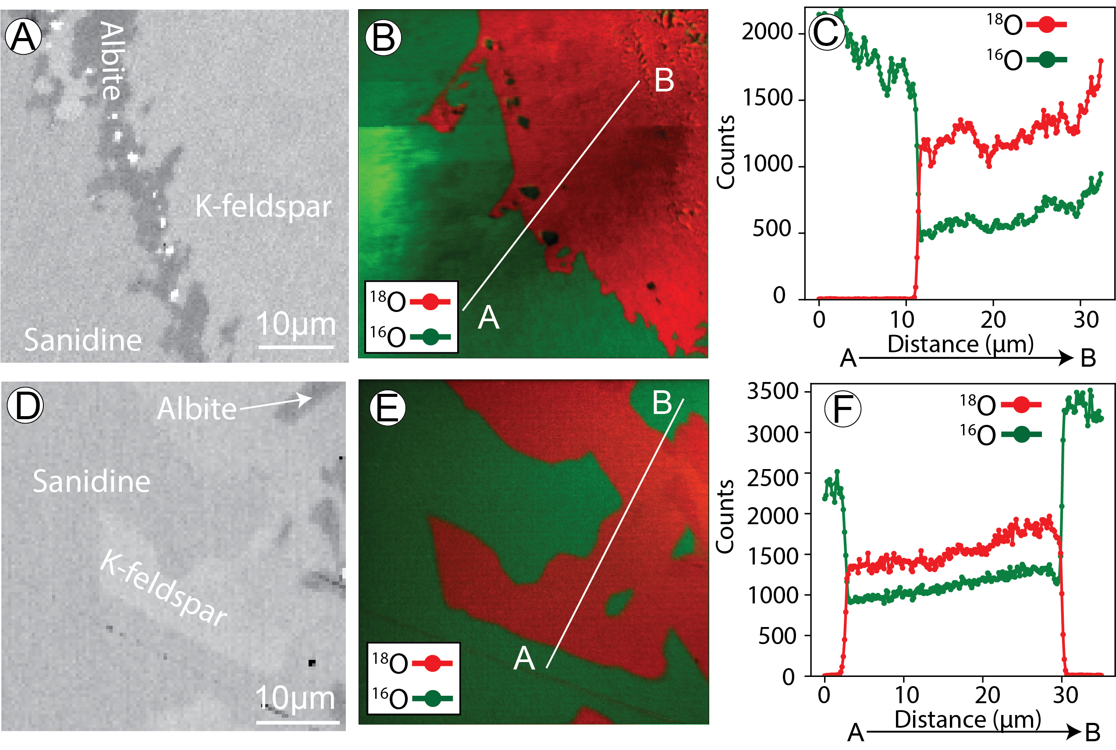

Figure S5. Single point analysis of main Raman spectrum peaks of each phase. Solid lines represent albite and K-feldspar formed in ¹⁶O-enriched solution, and dash lines represent albite and K-feldspar formed in¹⁸O-enriched solution. Vertical lines represent the main peak near 515 cm⁻¹ (compression of four-membered tetrahedral rings along c) and 473 cm⁻¹ (tetrahedral ring compression in ab-plane) in each phase (McKeown et al., 2005).
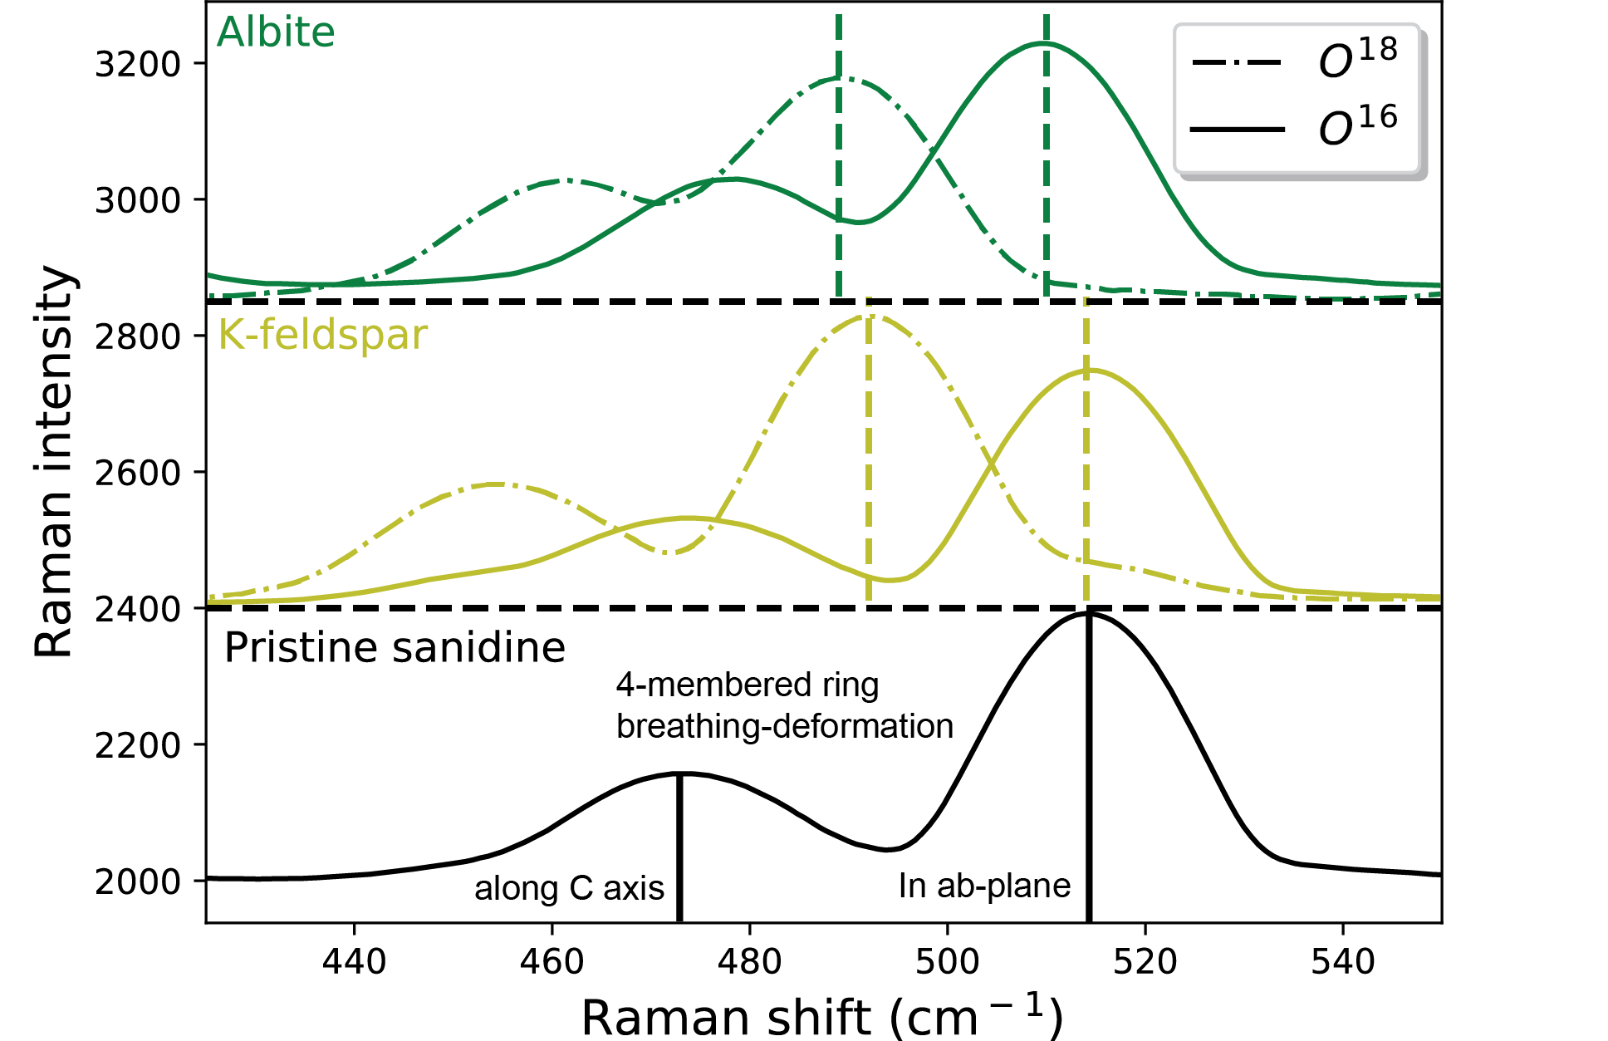

Figure S6. Mappings of the position of the main Raman-active bending mode at 515 cm⁻¹ in reaction products formed in in normal (Figs. A, B) and ¹⁸O-enriched solution (Figs. C-F) with different reaction times. Blue and green colours of K-feldspar in D and F suggest the breakdown of the sanidine tetrahedral structural framework and incorporation of ¹⁸O from water into albite and K-feldspar (Niedermeier et al., 2009).
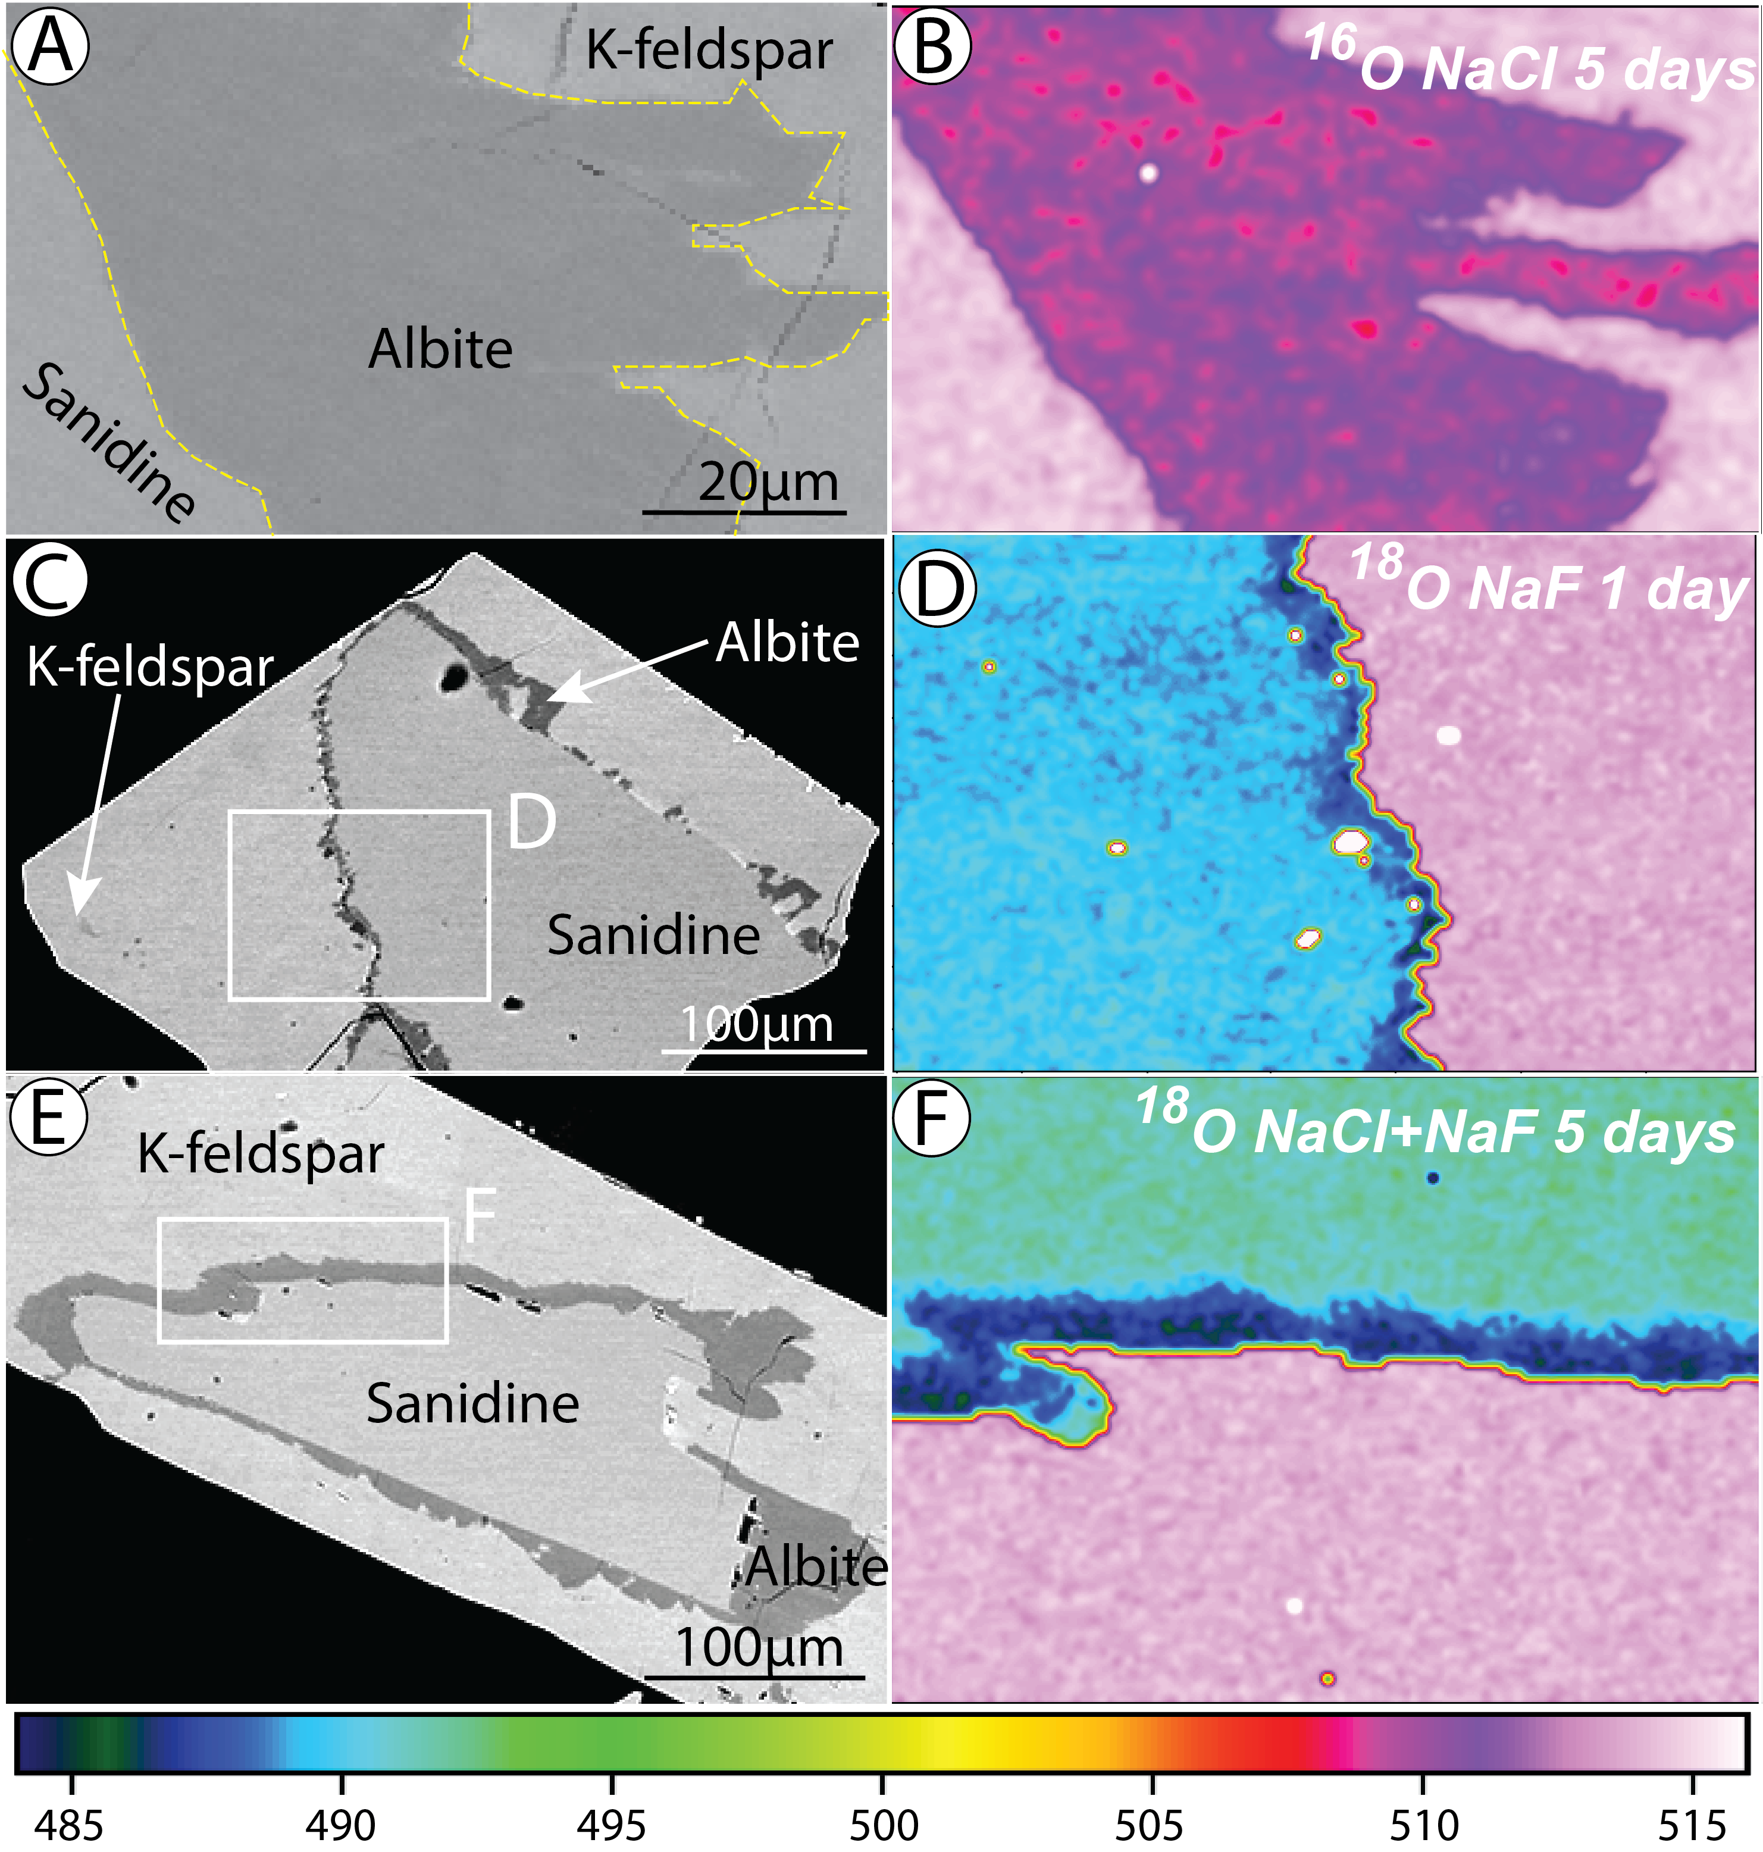

Supplementary Reference
Glynn, P.D. and Reardon, E.J., 1990, Solid-solution aqueous-solution equilibria; thermodynamic theory and representation. American Journal of Science, v. 290, no. 2, p. 164-201.
Gysi, A. P., 2017, Numerical simulations of CO2 sequestration in basaltic rock formations: challenges for optimizing mineral-fluid reactions: Pure and Applied Chemistry, v. 89, no. 5, p. 581-596.
Helgeson, H. C., Kirkham, D. H., and Flowers, G. C., 1981, Theoretical prediction of the thermodynamic behavior of aqueous electrolytes by high pressures and temperatures; IV, Calculation of activity coefficients, osmotic coefficients, and apparent molal and standard and relative partial molal properties to 600 degrees C and 5kb: American journal of science, v. 281, no. 10, p. 1249-1516.
Holland, T. and Powell, R., 2003, Activity–composition relations for phases in petrological calculations: an asymmetric multicomponent formulation: Contributions to Mineralogy and Petrology, v. 145, no. 4, p. 492-501.
McKeown, D.A., 2005, Raman spectroscopy and vibrational analyses of albite: From 25 °C through the melting temperature: American Mineralogist, v. 90, no. 10, p.1506-1517.
Miron, G.D., 2016, Internally consistent thermodynamic database for fluid-rock interaction: tools, methods and optimization (Doctoral dissertation, ETH Zurich).
Niedermeier, D. R., Putnis, A., Geisler, T., Golla-Schindler, U., and Putnis, C. V., 2009, The mechanism of cation and oxygen isotope exchange in alkali feldspars under hydrothermal conditions: Contributions to Mineralogy and Petrology, v. 157, no. 1, p. 65.
Shock, E.L., Sassani, D.C., Willis, M. and Sverjensky, D.A., 1997, Inorganic species in geologic fluids: correlations among standard molal thermodynamic properties of aqueous ions and hydroxide complexes: Geochimica et Cosmochimica Acta, v. 61, no. 5, p. 907-950.
Stryjek, R. and Vera, J.H., 1986, PRSV—An improved peng‐Robinson equation of state with new mixing rules for strongly nonideal mixtures: The Canadian Journal of Chemical Engineering, v. 64, no. 2, p. 334-340.
Sverjensky, D.A., Shock, E.L. and Helgeson, H.C., 1997, Prediction of the thermodynamic properties of aqueous metal complexes to 1000 C and 5 kb: Geochimica et Cosmochimica Acta, v. 61, no. 7, p. 1359-1412.
Tagirov, B. and Schott, J., 2001, Aluminum speciation in crustal fluids revisited. Geochimica et Cosmochimica Acta, v. 65, no. 21, p. 3965-3992.
Tagirov, B.R., Zotov, A.V. and Akinfiev, N.N., 1997, Experimental study of dissociation of HCl from 350 to 500° C and from 500 to 2500 bars: Thermodynamic properties of HCl°(aq): Geochimica et Cosmochimica Acta, v. 61, no. 20, p. 4267-4280.
Wagner, T., Kulik, D. A., Hingerl, F. F., and Dmytrieva, S. V., 2012, GEM-Selektor geochemical modeling package: TSolMod library and data interface for multicomponent phase models: The Canadian Mineralogist, v. 50, no. 5, p. 1173-1195.

