SUPPLEMENTARY MATERIAL
FIGURE 1. Set of bipartite networks representing the interactions between the pair of months and the plants preyed on by the Austral parakeet in natural environments (Bariloche, Argentina). Nd: Nothofagus dombeyi; Spa: Schinus patagonicus; Ach: Aristotelia chilensis; Mb: Maytenus boaria; Lh: Lomatia hirsuta; Sa: Sorbus aucuparia; Pi: Pinus spp.; Md: Malus domestica; Np: Nothofagus pumilio; Ec: Embothrium coccineum; Na: Nothofagus antarctica.
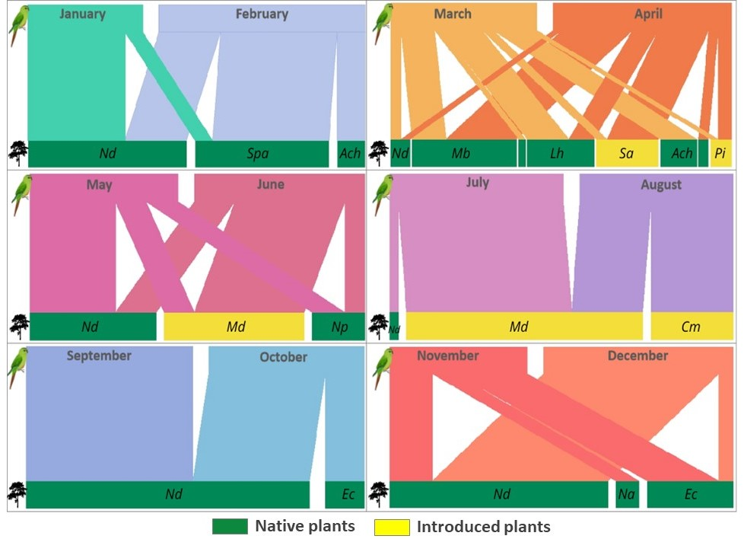
FIGURE 2. Set of bipartite networks representing the interactions between the pair of months and the plants preyed on by the Austral parakeet in urban environments (Bariloche, Argentina). Aa: Araucaria araucana; Ac: Acer sp.; Ach: Aristotelia chilensis; Asp: Acacia sp.; Bp: Betula pendula; Cf: Cotoneaster franchetii; Cm: Crataegus monogyna; Ec: Embothrium coccineum; Jr: Juglans regia; Na: Nothofagus antarctica; Nd: Nothofagus dombeyi; No: Nothofagus oblicua; Mb: Maytenus boaria; Md: Malus domestica; Spa: Schinus patagonicus; Ul: Ulmus sp.; Pc: Prunus cerazus; Pi: Pinus spp.; Po: Populus sp.; Ps: Prunus serrulata; Sa: Sorbus aucuparia.
