Supplementary Information for

Hyperintense signal on diffusion-weighted imaging for monitoring the acute response and local recurrence after photodynamic therapy in malignant gliomas

Yuichi Fujita∗, Hiroaki Nagashima, Kazuhiro Tanaka, Mitsuru Hashiguchi, Tomoo Itoh, Takashi Sasayama

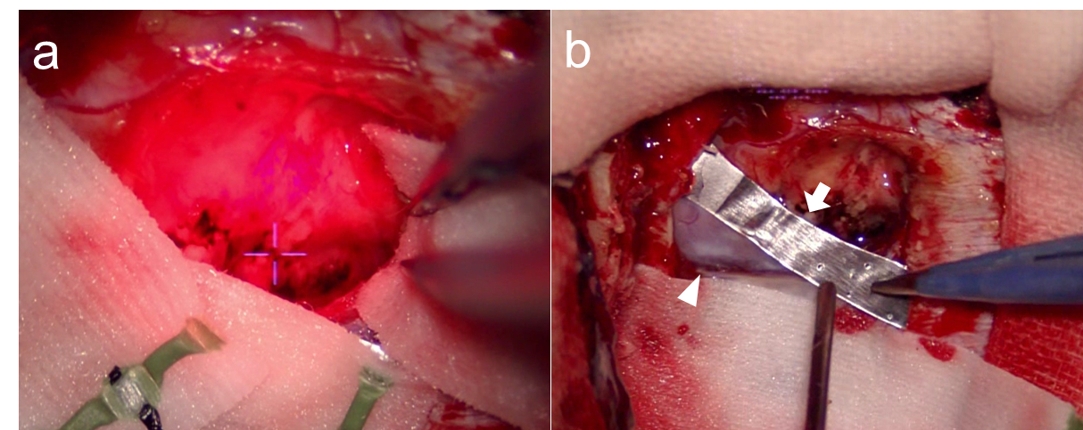
Supplementary Fig. 1 Intraoperative microscopic images during PDT. The resection cavity was irradiated with a semiconductor laser (a). The cross-hair indicates the focal point of the laser. The large blood vessel is protected by aluminum foil to avoid direct irradiation (b). PDT, photodynamic therapy

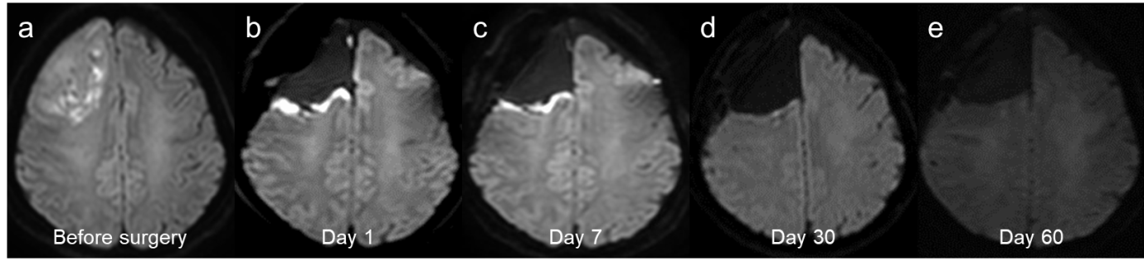
Supplementary Fig 2 Preoperative axial DWI of a representative case showing a mass lesion in the right frontal lobe (a). Postoperative DWI shows time-dependent changes after PDT (b–e). On day 1 after PDT, linear hyperintense signals were detected at the surface of the resected cavity (b). The hyperintense signals on DWI disappeared in about 30 days (c–e). DWI, diffusion-weighted imaging; PDT, photodynamic therapy

∗Corresponding author. Department of Neurosurgery, Kobe University Graduate School of Medicine, 7-5-1 Kusunoki-cho, Chuo-ku, Kobe, Hyogo 650-0017, Japan; Email: fyuichi@med.kobe-u.ac.jp

