Supplementary Figures
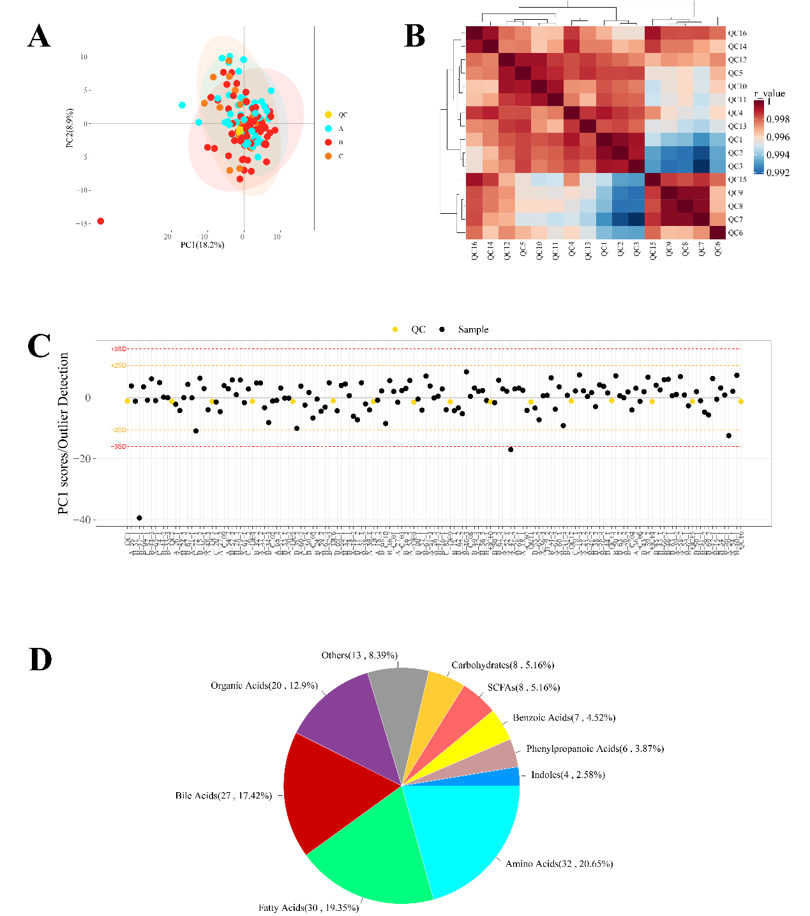
Figure S1: A to C, Quality control of metabolism sequence for fecal samples from MSS rectal cancer patients, compared to QC samples; D, specific type of metabolites from sequencing data, top 3 type were bile acids, fatty acids and amino acids.

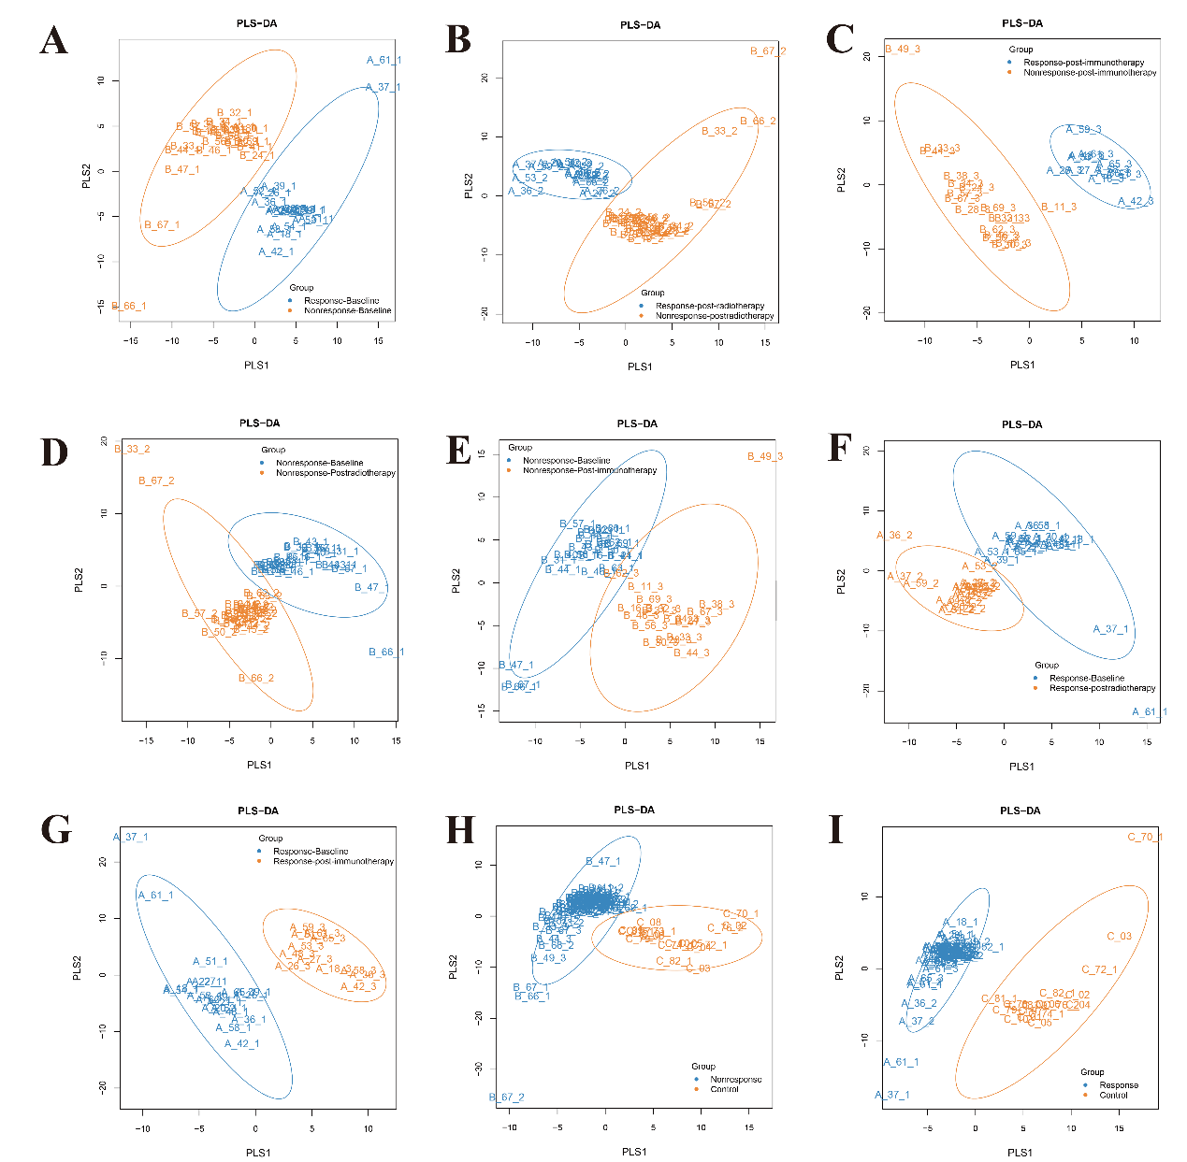
Figure S2: Partial Least Squares Discriminant Analysis for microbiota in rectal cancer fecal samples at different treatment stages among varied therapeutic treatment responses. Three cohorts included response, non-response and control group. A, Response-Baseline vs Non-response-Baseline; B, Response-Postradiotherapy vs Non-response-Postradiotherapy; C, Response-Postimmunotherapy vs Non-response-Postimmunotherapy; D, Non-response-Baseline vs Non-response-postradiotherapy; E, Non-response-Baseline vs Non-response-postimmunotherapy; F, Response-Baseline vs Response-postradiotherapy; G, Response-Baseline vs Response-postimmunotherapy; H, Non-response vs control; I, Response vs Control.

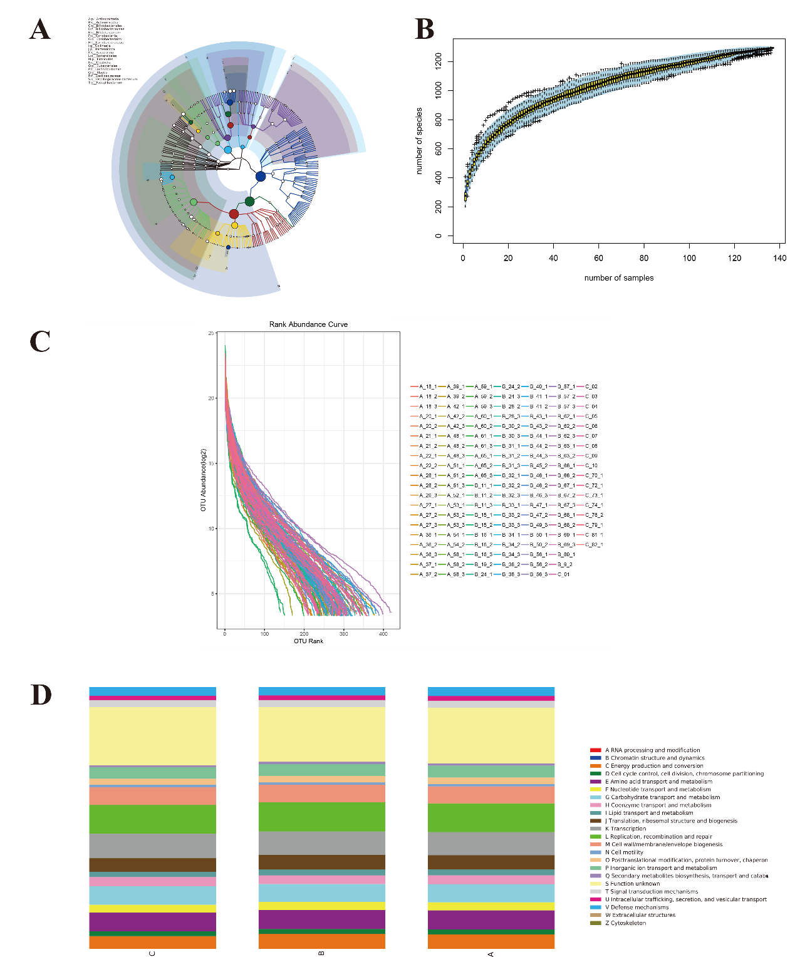
Figure S3: quality control and microbiota distribution from metagenomics analysis. A and B, lefse analysis for foundation of species and genus in fecal samples. C, OUT abundance for separate samples; D, Functional distribution of microbiota at different stages, Response, nonresponse and control cohorts.

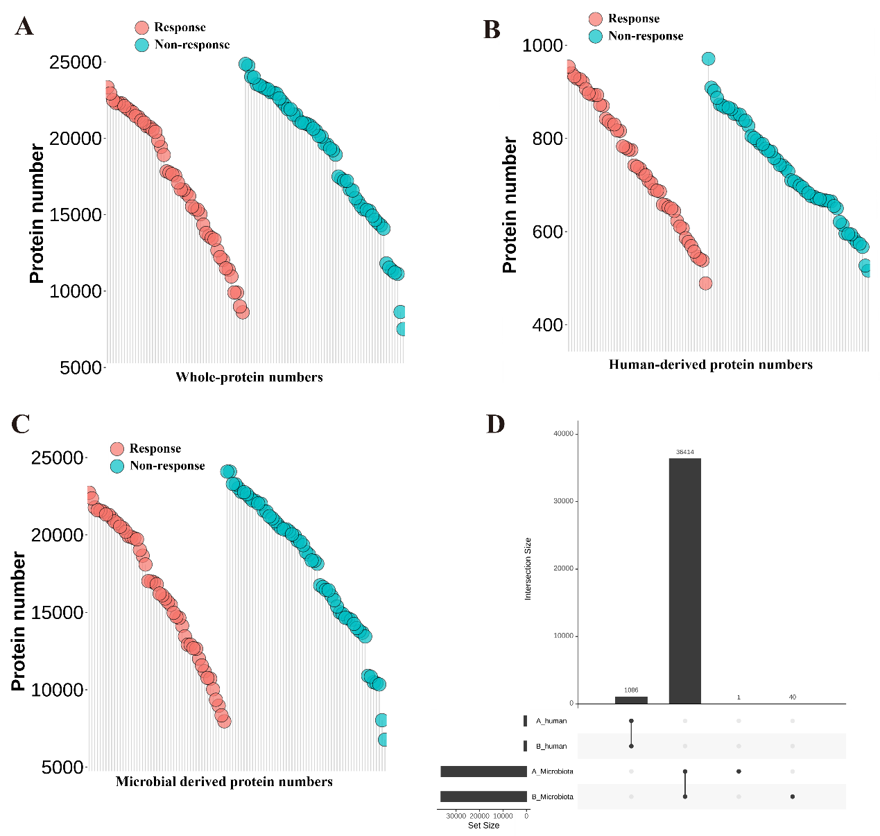
Figure S4: A to D, metaproteomic analysis demonstrated various proteins, including Whole-protein, Human-derived protein and microbial derived proteins.

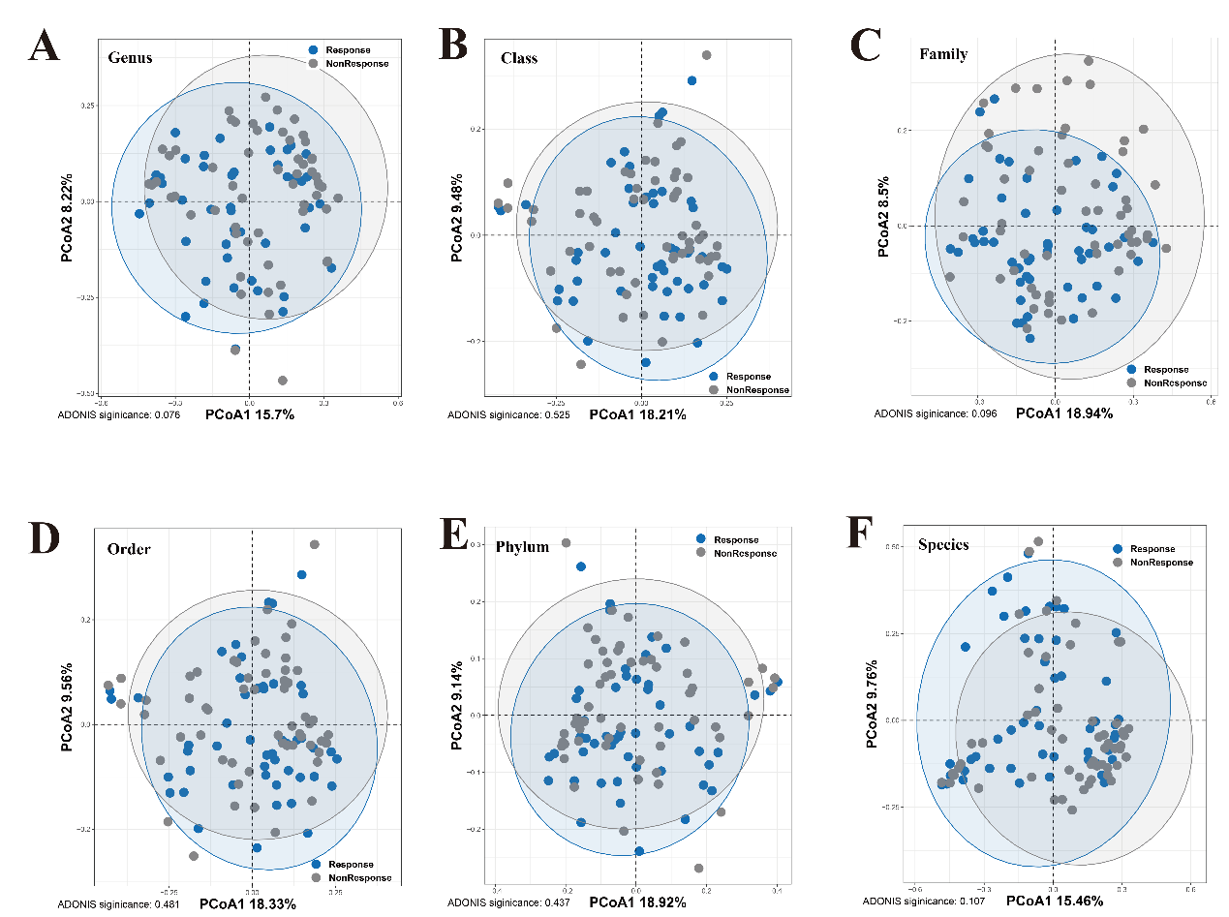
Figure S5: On basis of metaproteomic analysis, principal co-ordinates analysis for Response and non-response samples at different biological levels. A, genus level; B, Class level; C, Family level; D, Order level; E, Phylum level; F, Species level.

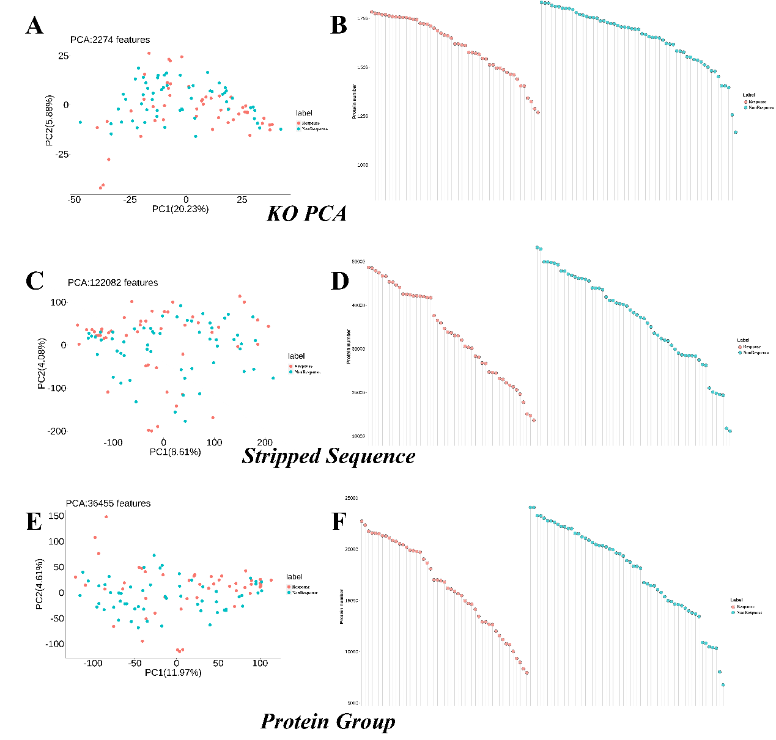
Figure S6: Principal component analysis for proteins between response and non-response cohorts. A, By KO PCA analysis; B, by stripped sequence; C, by protein group.

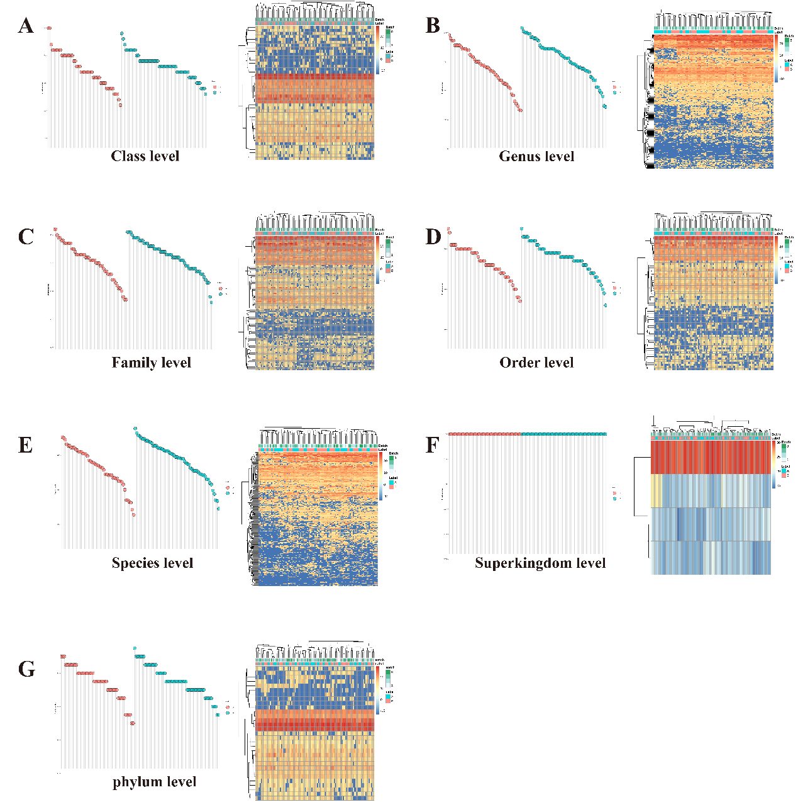
Figure S7: Protein number and heatmap distribution were shown at different levels. A, Class level; B, Genus level; C, Family level; D, Order level; E, Species level; F, Superkingdom level; G, Phylum level.

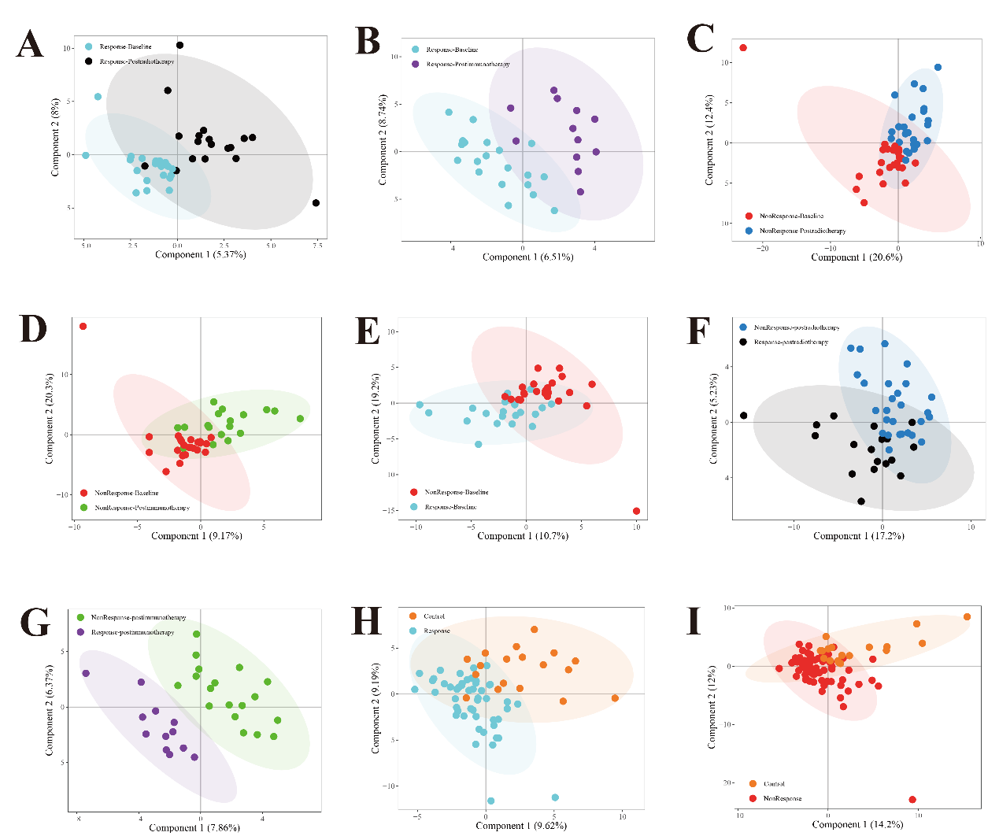
Figure S8: Principal Analysis for metabolism in rectal cancer fecal samples at different treatment stages among varied therapeutic treatment responses. Three cohorts included response, non-response and control group. A, Response-Baseline vs Response-postradiotherapy; B, Response-Baseline vs Response-postimmunotherapy; C, Non-Response-Baseline vs Non-Response-postradiotherapy; D, Non-response-Baseline vs Non-response-postradiotherapy; E, Non-response-Baseline vs Response-Baseline; F, Response-postradiotherapy vs Non-Response-postradiotherapy; G, Response-postimmunotherapy vs Non-Response-postimmunotherapy; H, Response vs control; I, Non-Response vs Control.

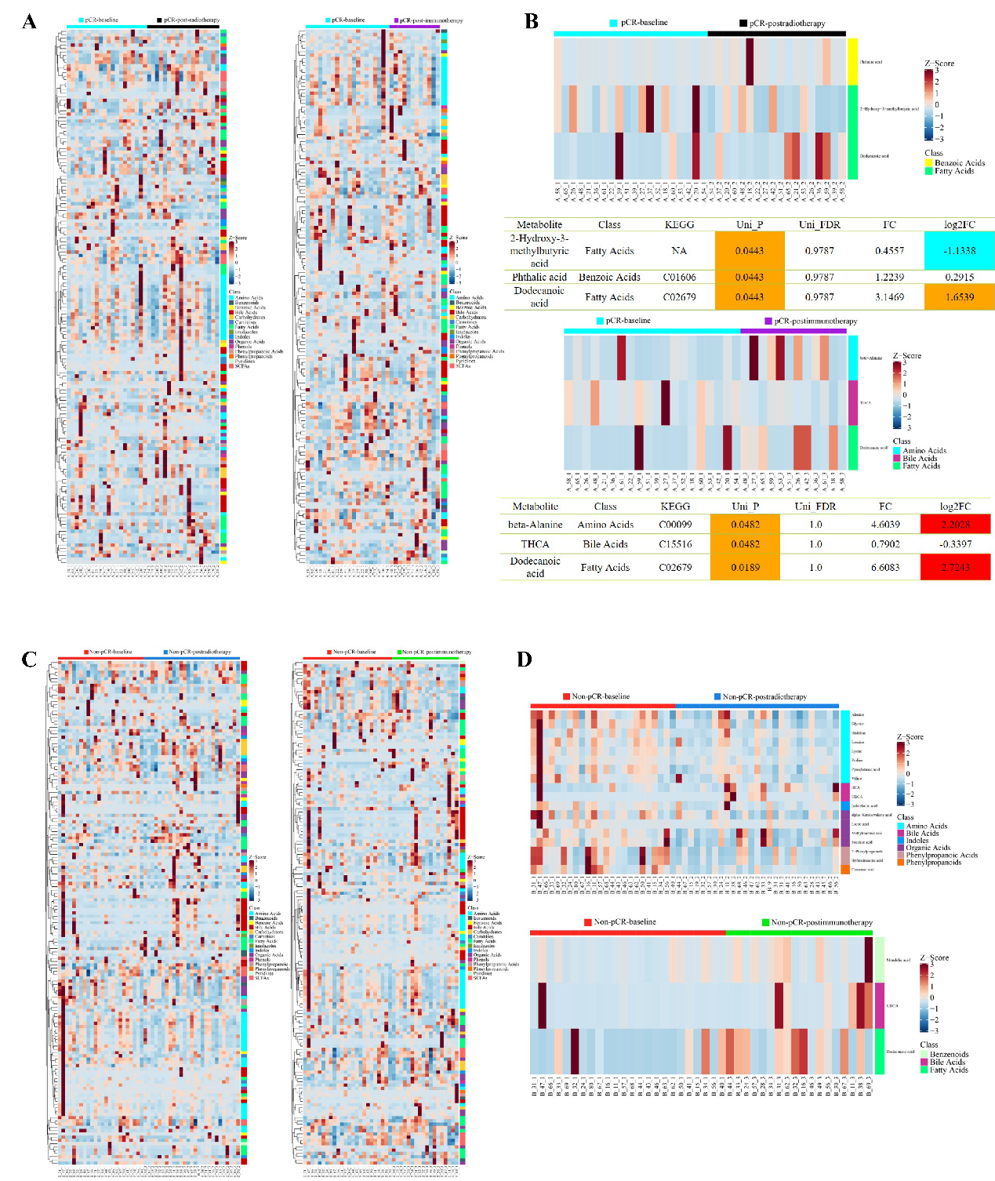
Figure S9: differential expressed metabolites landscape between response and non-response. A and B, in Response cohort, differentiated metabolites among baseline, postradiotherapy and postimmunotherapy; C and D, in Non-Response cohort, differentiated metabolites among baseline, postradiotherapy and postimmunotherapy;

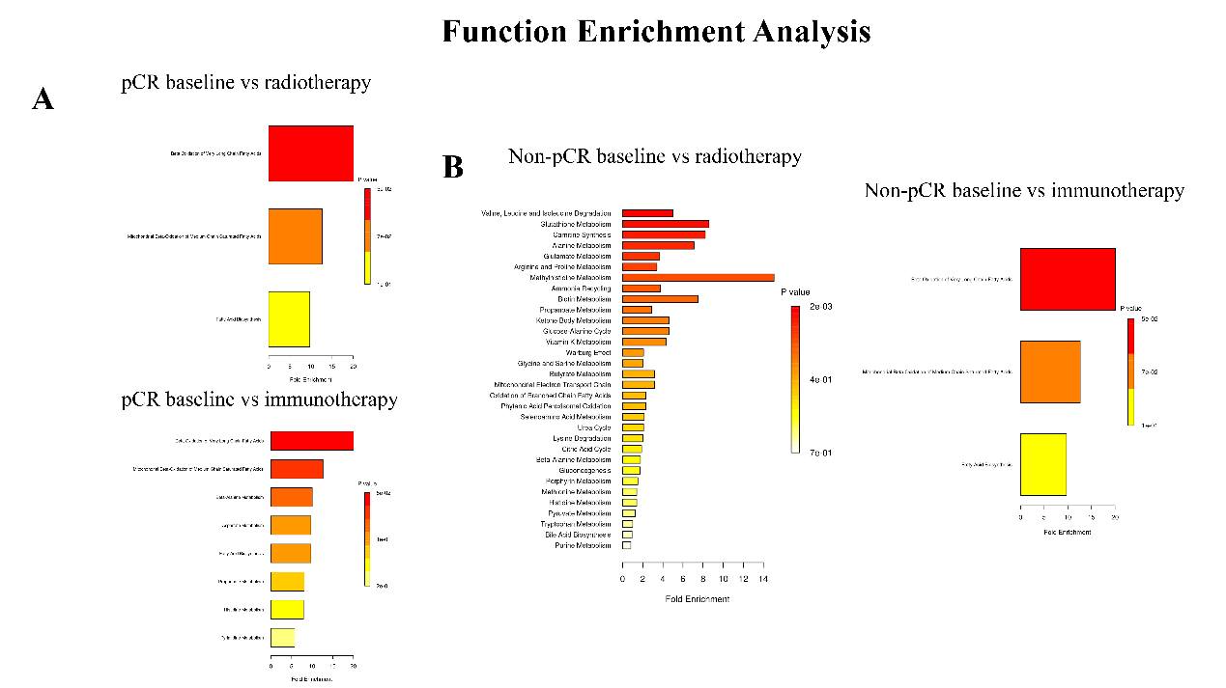
Figure S10: From metabolism sequencing analysis, Functional enrichment analysis demonstrated alterations. A, pCR cohort, baseline vs postradiotherapy and baseline vs postimmunotherapy; B, Non-pCR cohort, baseline vs postradiotherapy and baseline vs postimmunotherapy.

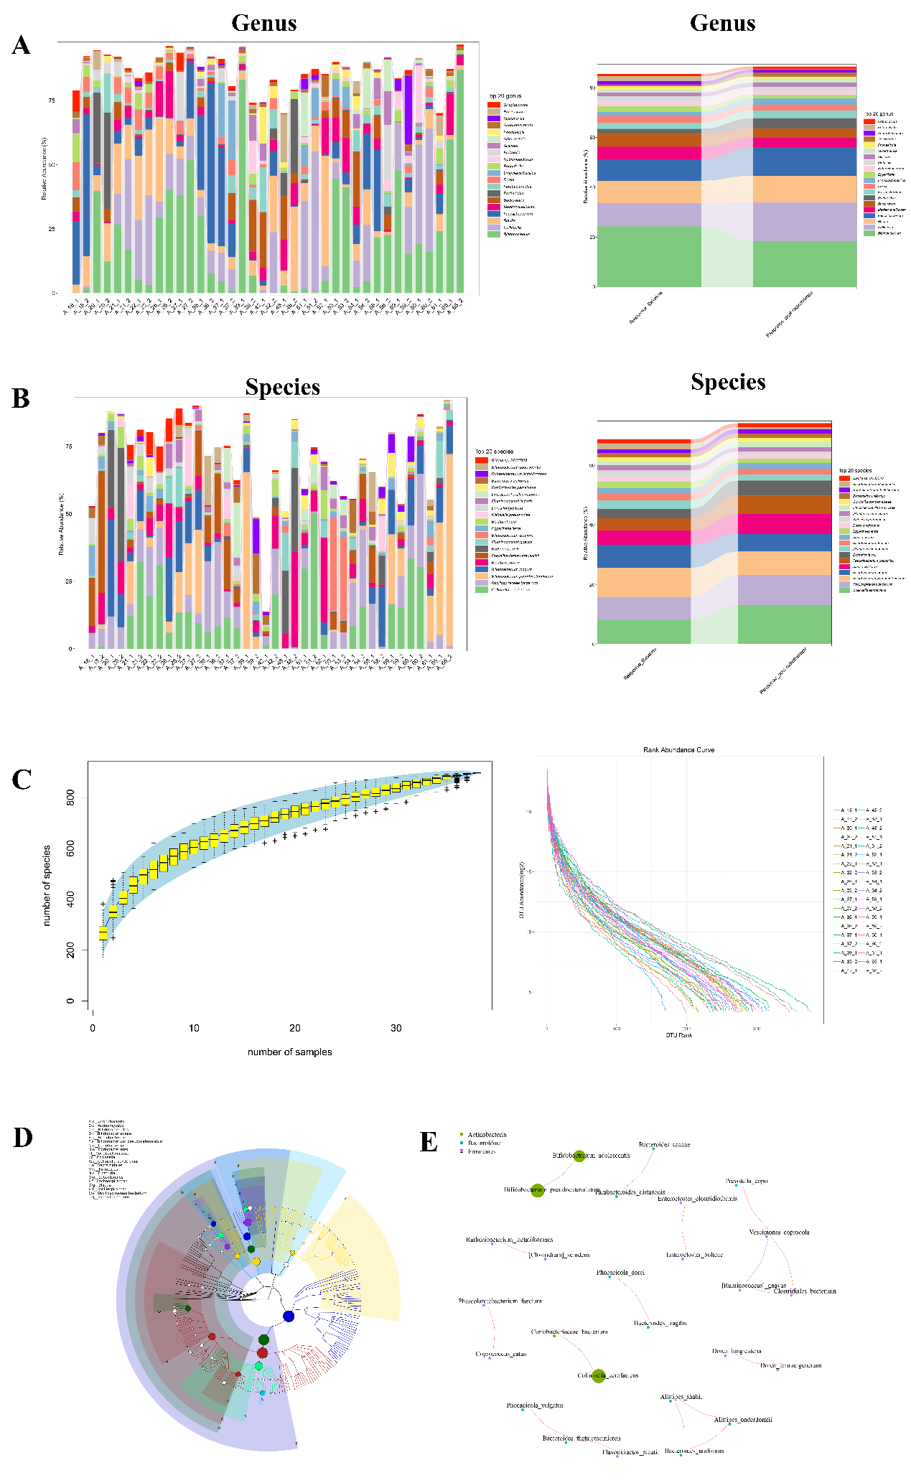
Figure S11: metagenomic analysis in Response cohort, Baseline vs postradiotherapy. A and B, separate genus and species signature in rectal cancer fecal samples; C, species number distribution of separate sample; D, lefse analysis distribution at different stages; E, functional correlation of microbiota.

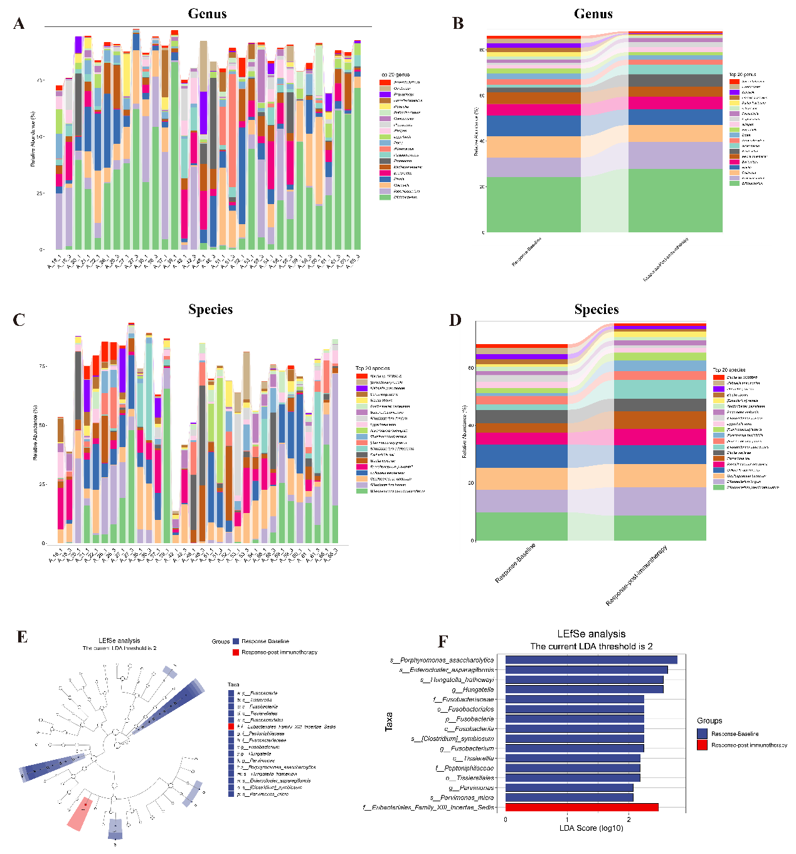
Figure S12: metagenomic analysis in Response cohort, Baseline vs postimmunotherapy. A and B, separate genus signature in rectal cancer fecal samples; C and D, separate species signature in rectal cancer fecal samples; E and F, lefse analysis distribution at different stages.

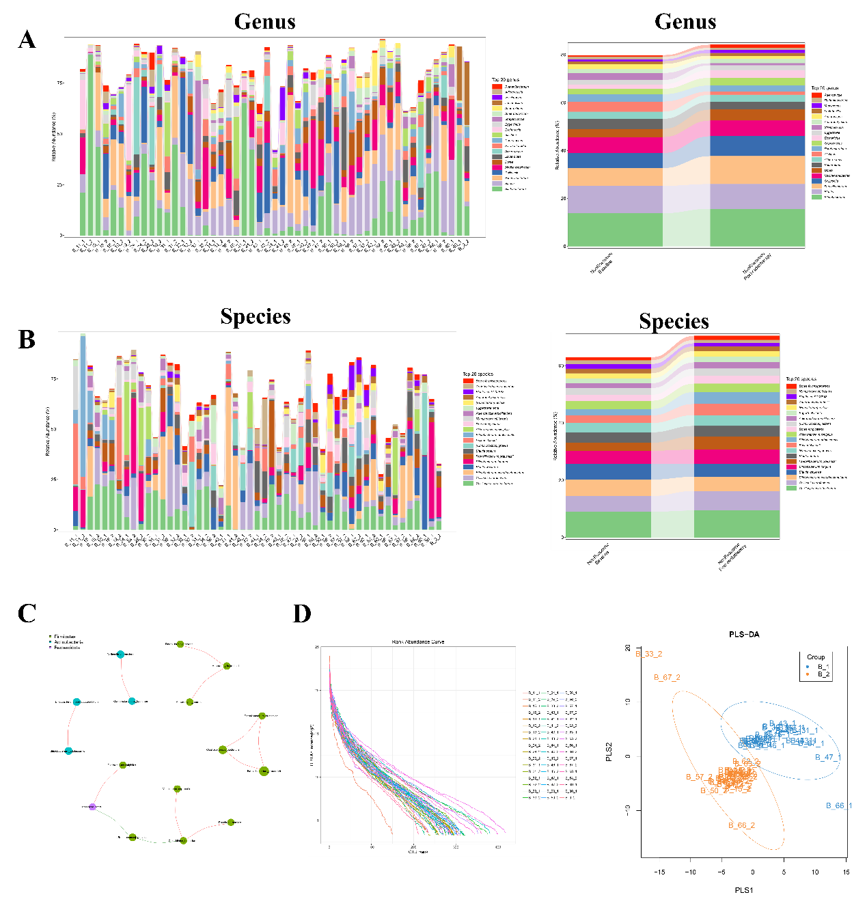
Figure S13: metagenomic analysis in Non-Response cohort, Baseline vs postradiotherapy. A and B, separate genus and species signature in rectal cancer fecal samples; C, functional correlation of microbiota; D, species number distribution and PLS-DA of separate sample.

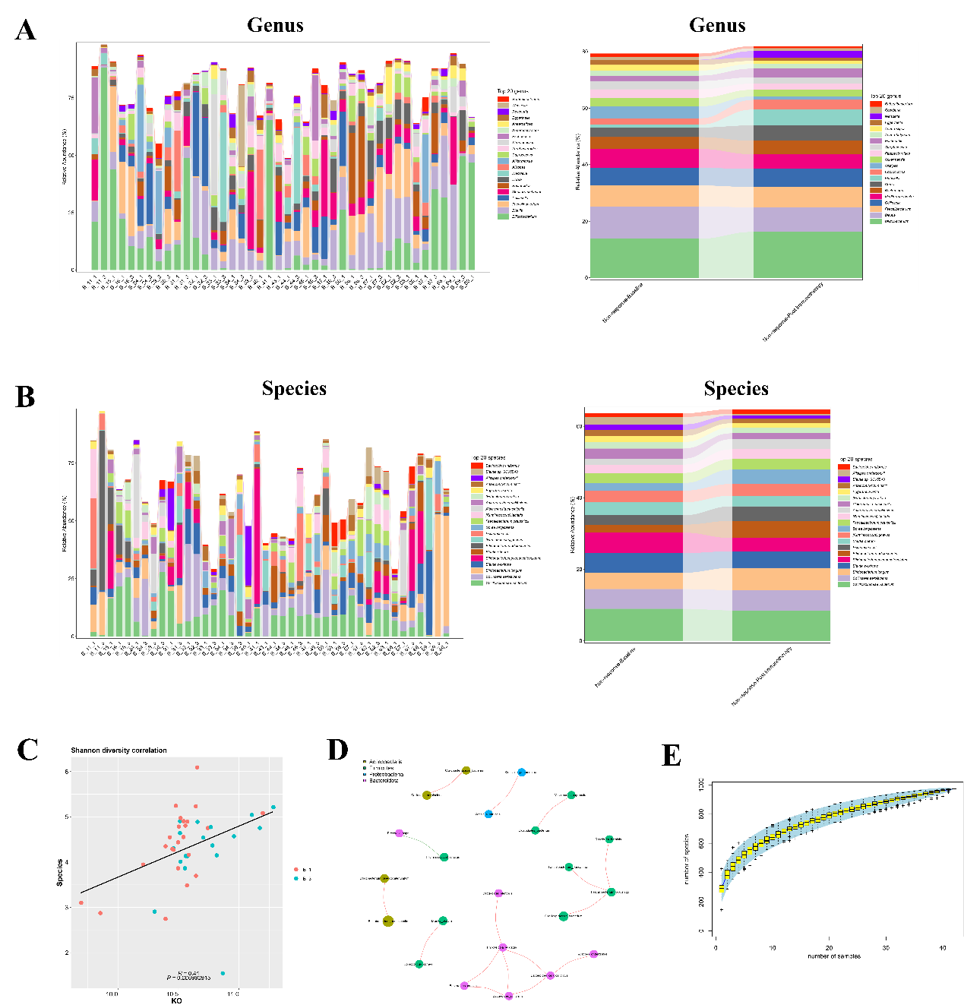
Figure S14: metagenomic analysis in Non-Response cohort, Baseline vs postimmunotherapy. A and B, separate genus and species signature in rectal cancer fecal samples; C, Shannon diversity correlation between Baseline vs postimmunotherapy groups; D, functional correlation of microbiota; E, species number distribution of separate sample.

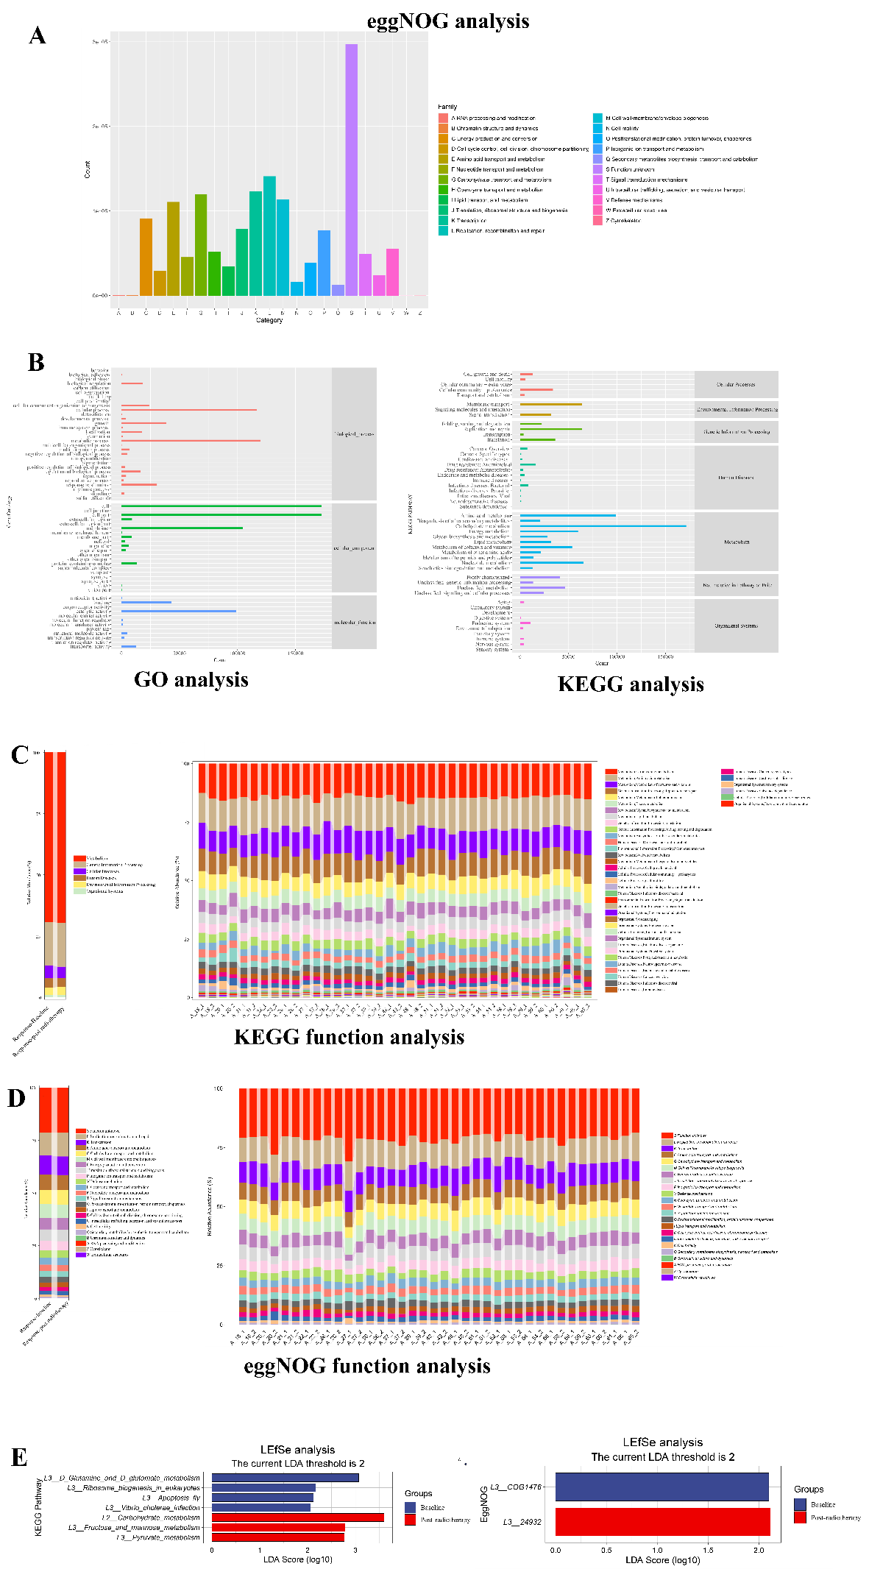
Figure S15: Functional analysis between baseline and postradiotherapy group in Response cohort samples. A, by eggnog analysis, functional alterations were shown on basis of category; B, GO and KEGG analysis demonstrated significant alterations among biological and molecular functions; C and D, functions for separate samples were shown by KEGG and eggnog analysis; E, functions for lefse analysis between baseline and postradiotherapy group were shown.

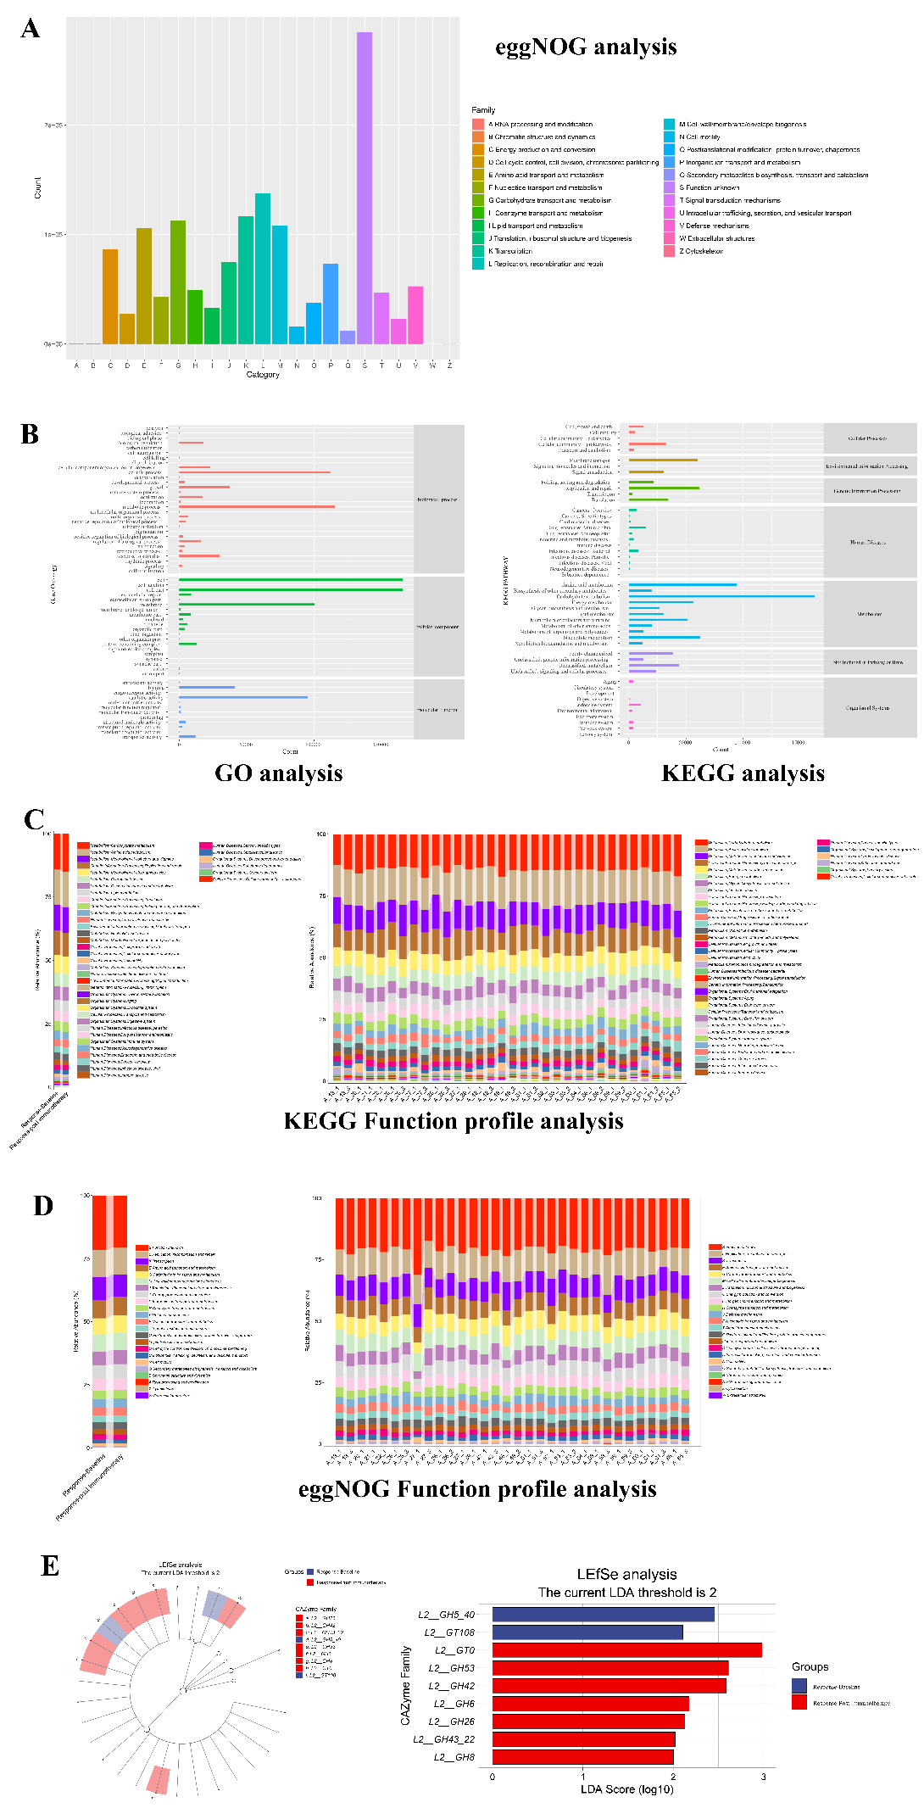
Figure S16: Functional analysis between baseline and postimmunotherapy group in Response cohort samples. A, by eggnog analysis, functional alterations were shown on basis of category; B, GO and KEGG analysis demonstrated significant alterations among biological and molecular functions; C and D, functions for separate samples were shown by KEGG and eggnog analysis; E, functions for lefse analysis between baseline and postimmunotherapy group were shown.

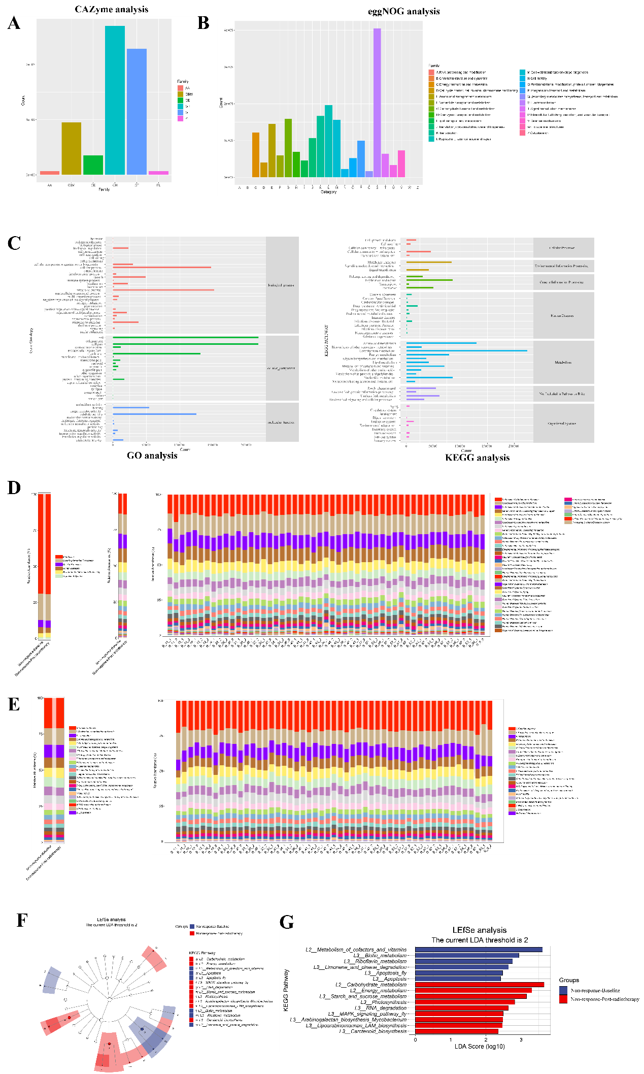
Figure S17: Functional analysis between baseline and postradiotherapy group in Non-Response cohort samples. A and B, by CAZYme and eggnog analysis, functional alterations were shown on basis of category; C, GO and KEGG analysis demonstrated significant alterations among biological and molecular functions; D and E, functions for separate samples were shown by KEGG and eggnog analysis; F and G, functions for lefse analysis between baseline and postradiotherapy group were shown.

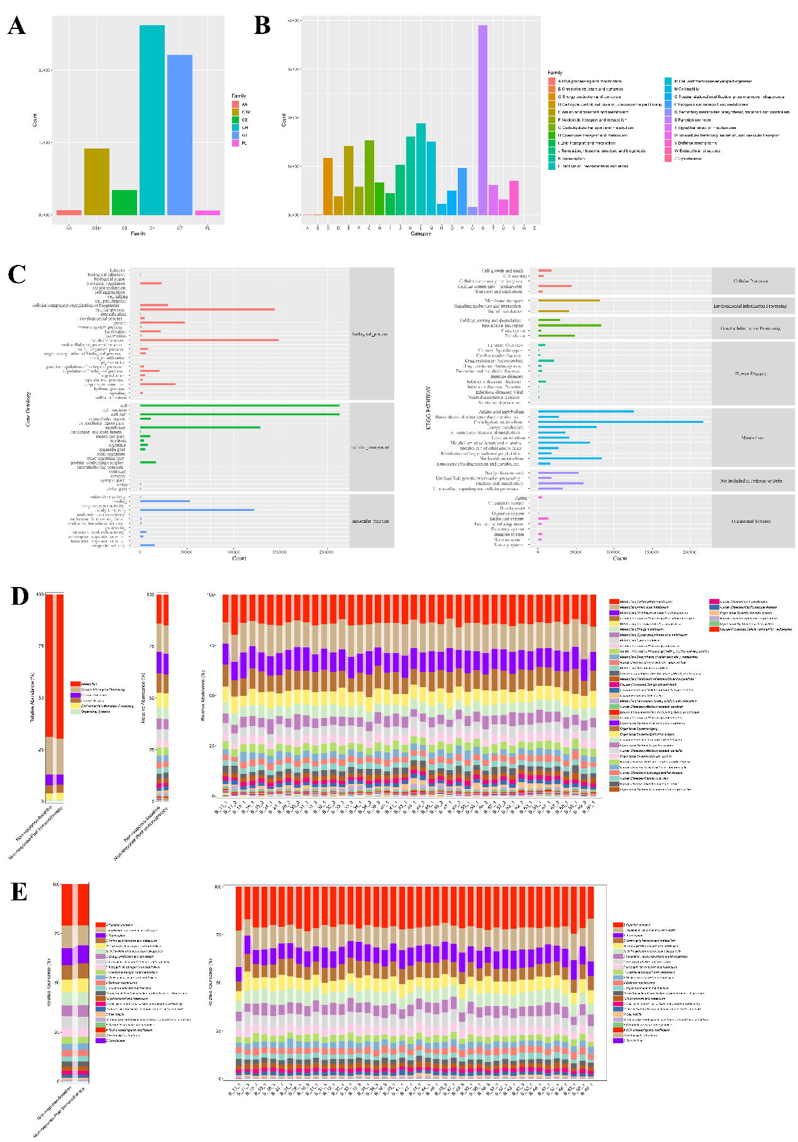 Figure S18: Functional analysis between baseline and postimmunotherapy group in Non-Response cohort samples. A and B, by CAZYme and eggnog analysis, functional alterations were shown on basis of category; C, GO and KEGG analysis demonstrated significant alterations among biological and molecular functions; D and E, functions for separate samples were shown by KEGG and eggnog analysis.

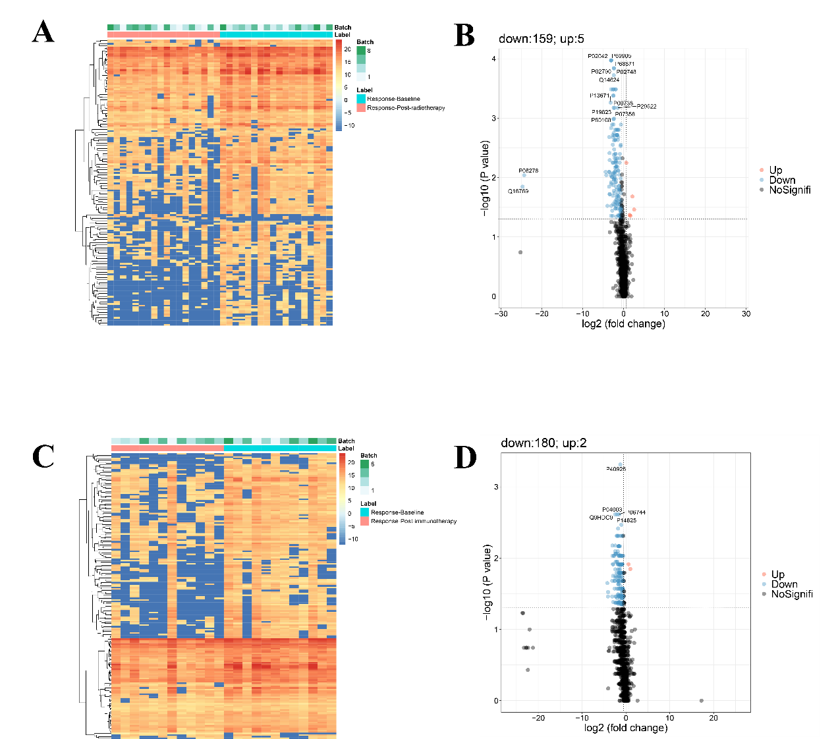
Figure S19: metaproteomic analysis for differential proteins in response cohorts. A and B, heatmap and volcano analysis between Baseline and post-radiotherapy cohort; C and D, heatmap and volcano analysis between Baseline and post-immunotherapy cohort.

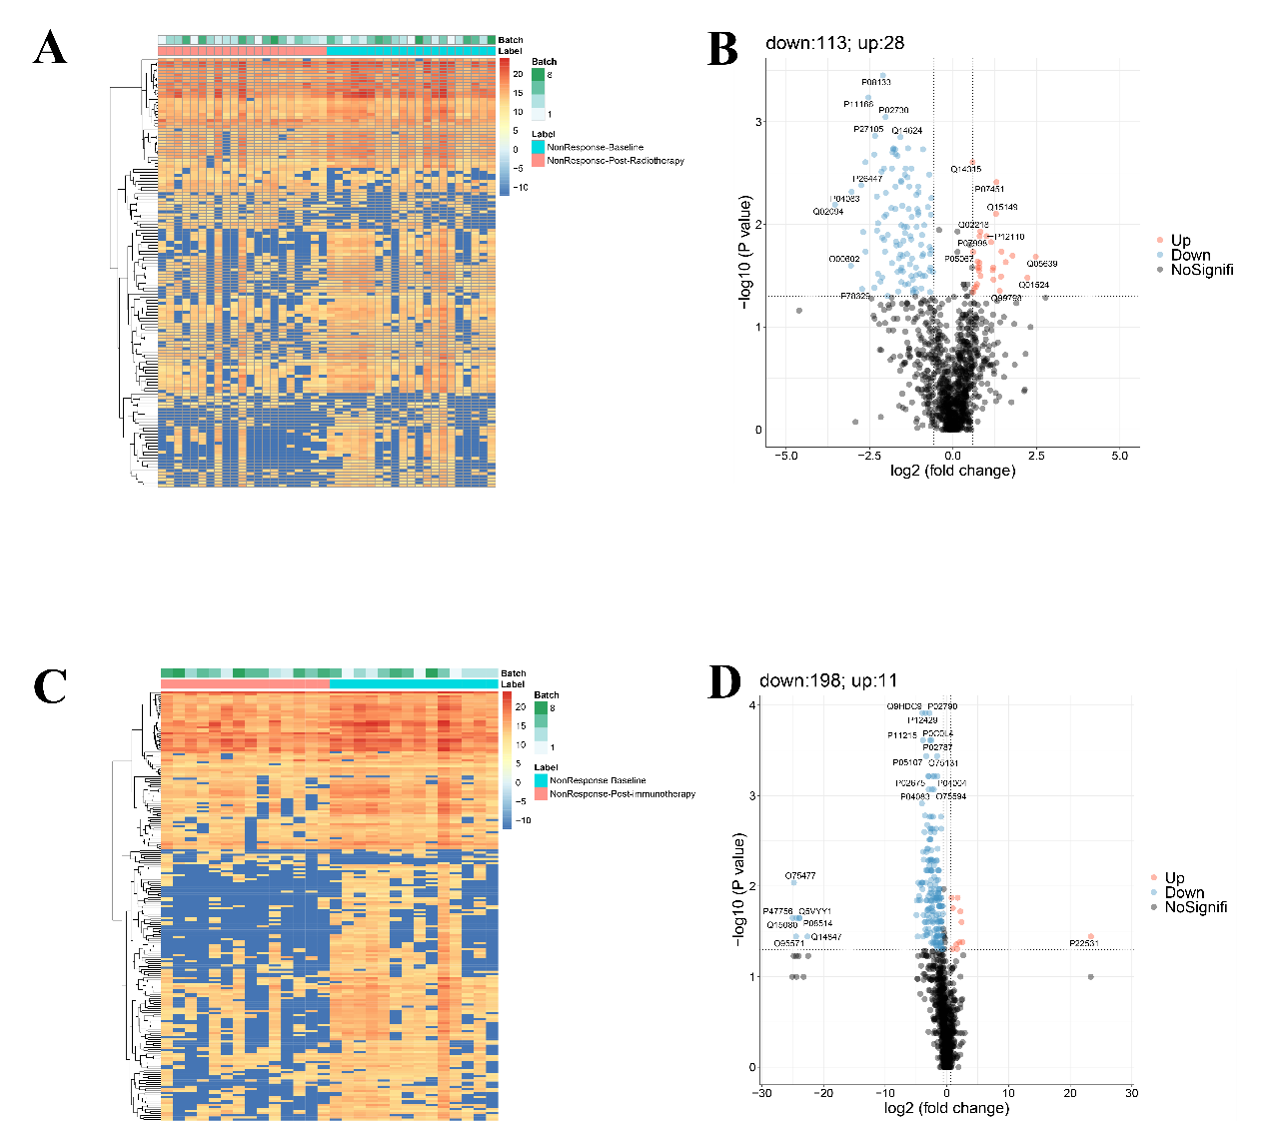
Figure S20: metaproteomic analysis for differential proteins in Non-response cohorts. A and B, heatmap and volcano analysis between Baseline and post-radiotherapy cohort; C and D, heatmap and volcano analysis between Baseline and post-immunotherapy cohort.

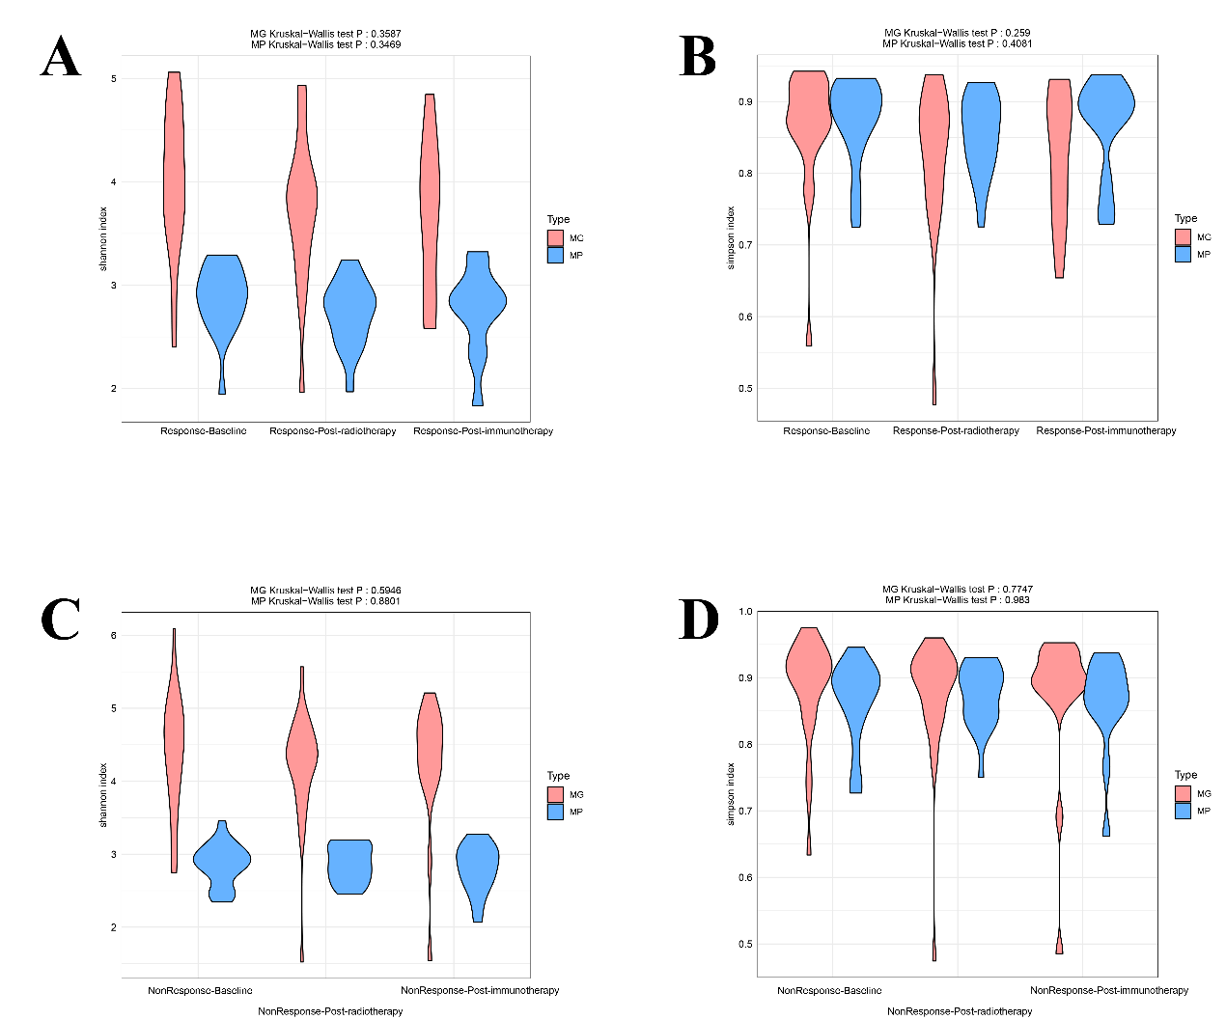
Figure 21: Shannon and Simpson index distribution among metaproteomic and metagenomic data.

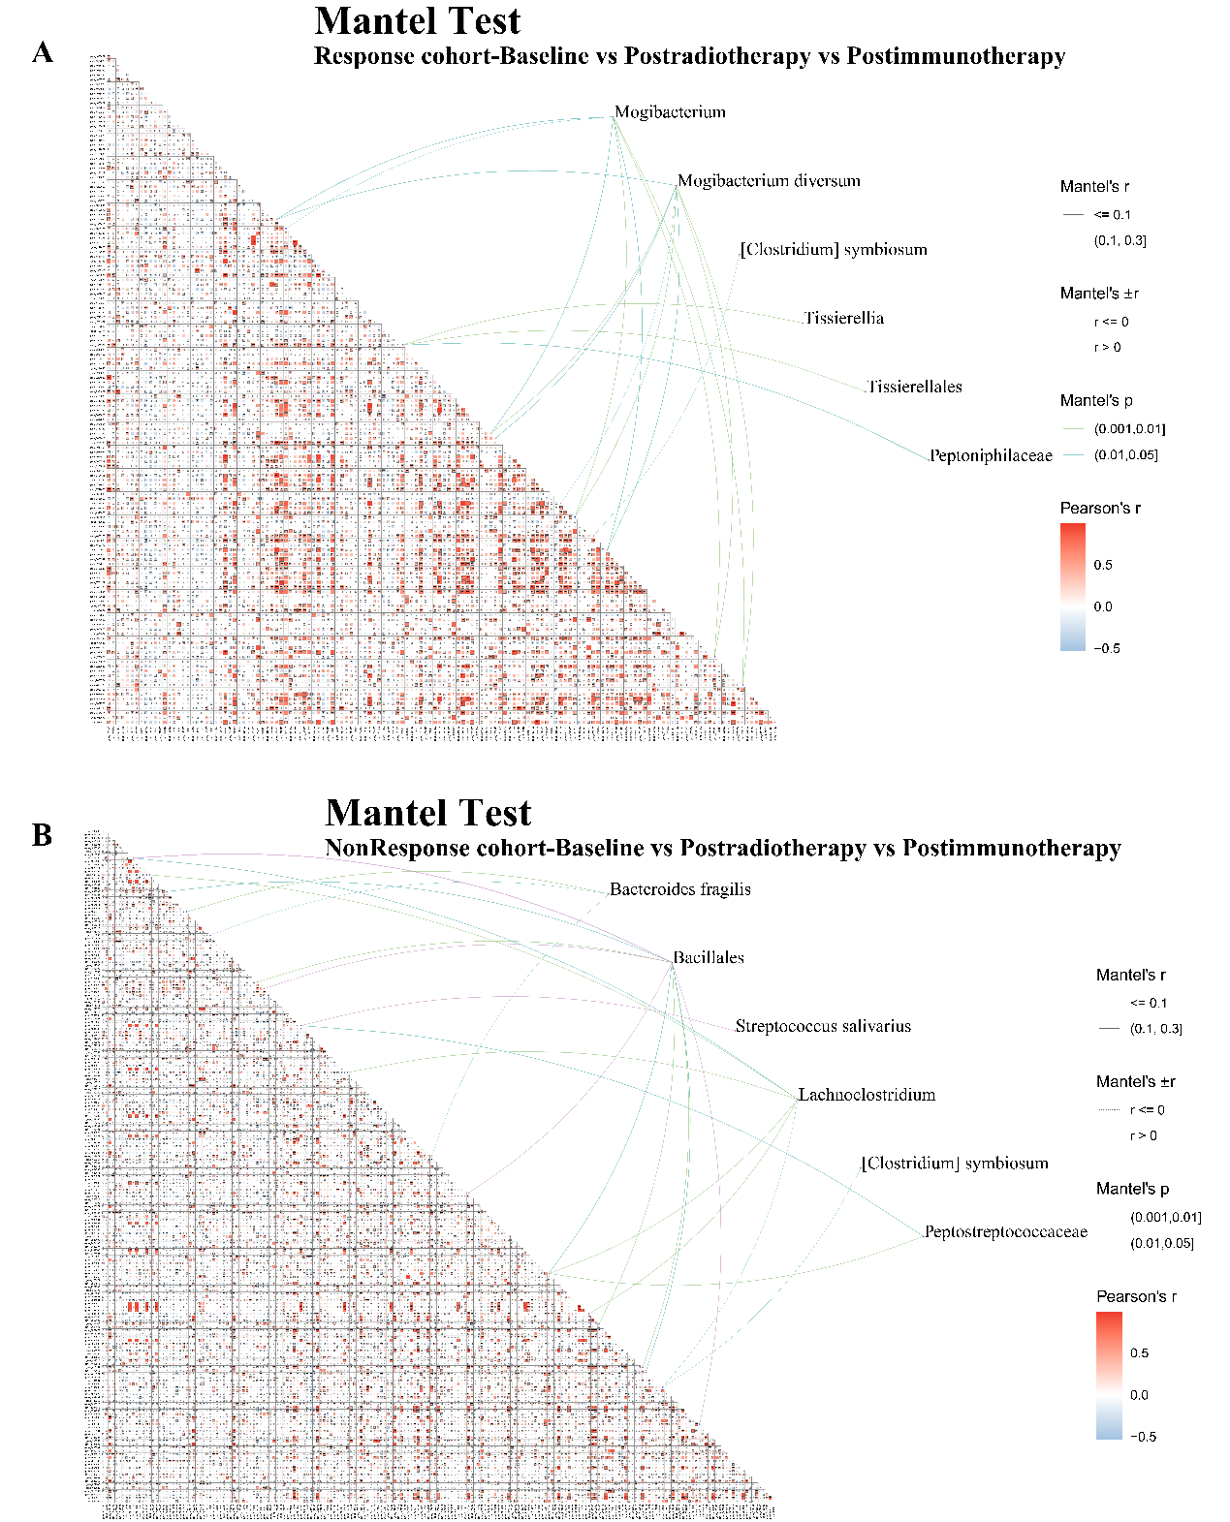
Figure S22: Mantel test between metagenomic and metaproteomic sequencing in Response and Non-response cohorts.

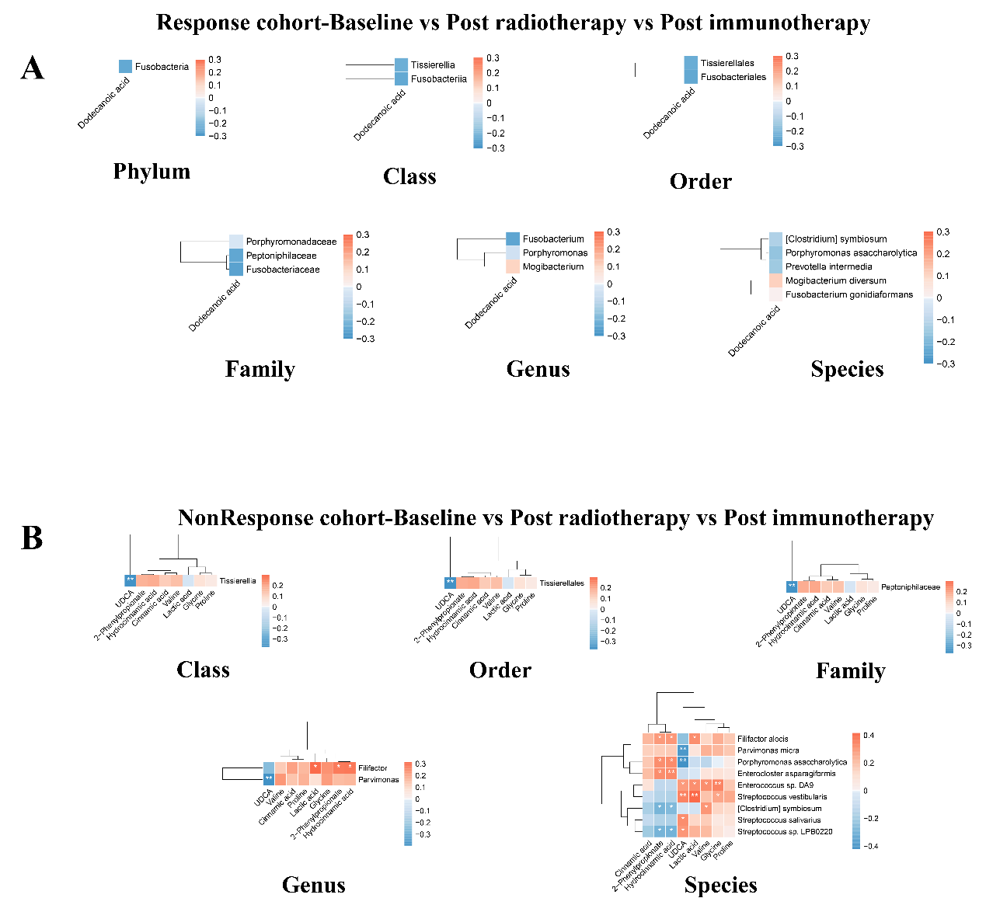
Figure 23: combined metabolites and microbiota analysis at different levels were shown in Response and Non-Response cohort, separately.

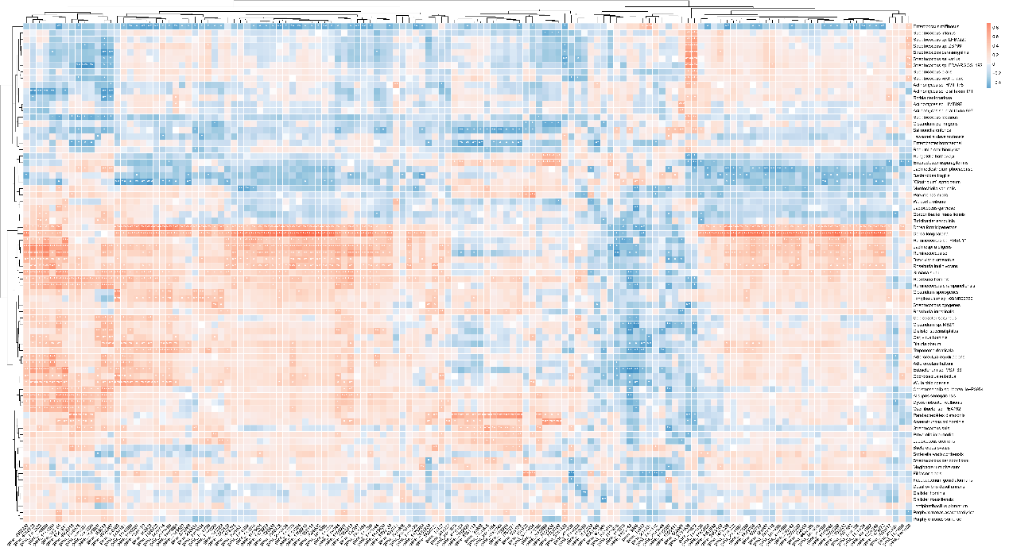
Figure S24: combined metabolism and metaproteomic analysis among all samples was shown.

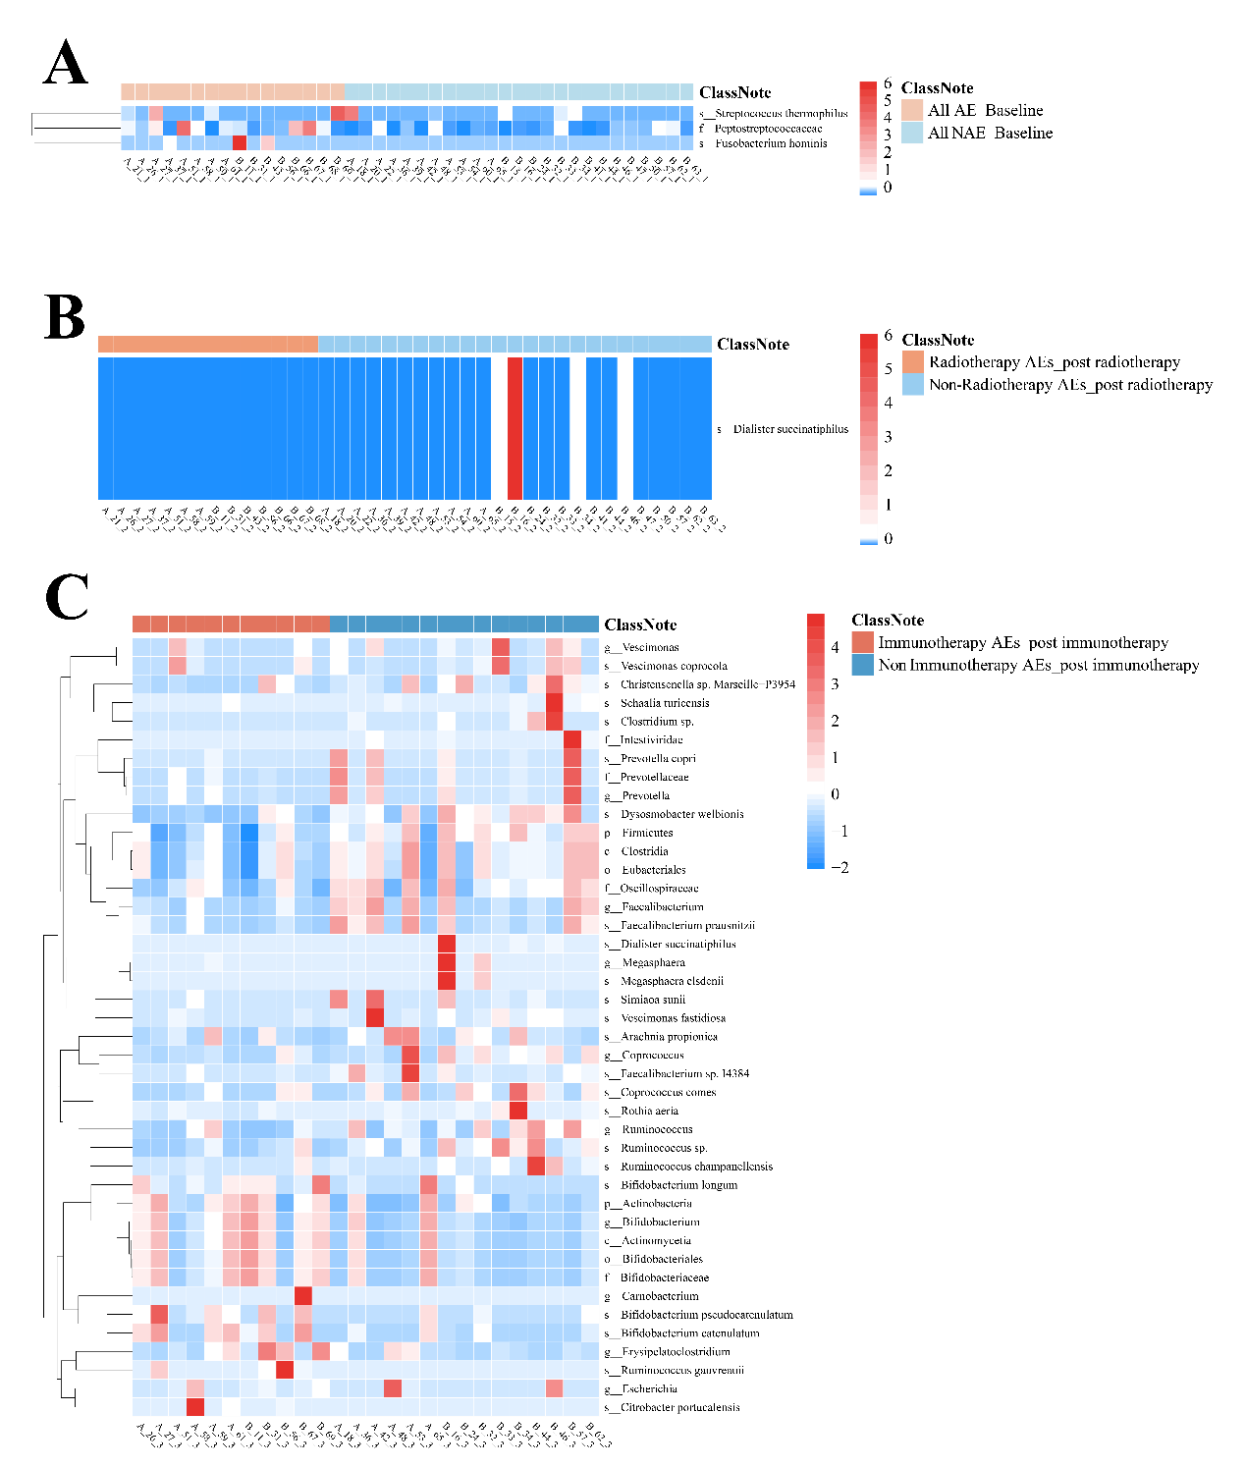
Figure S25: Correlation between microbiota and immunotherapy and chemoradiotherapy related adverse events at different treatment stages.

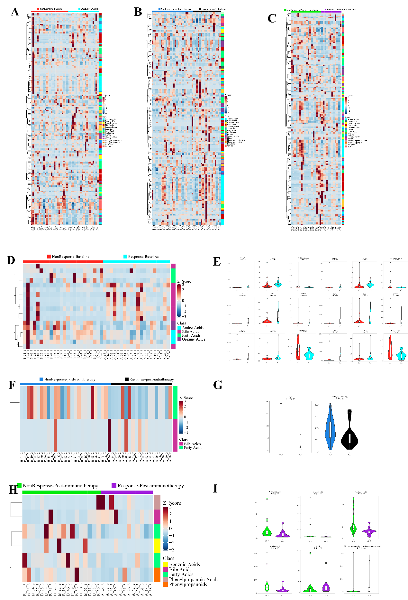
Figure S26: different metabolites among different responses were shown, separately.

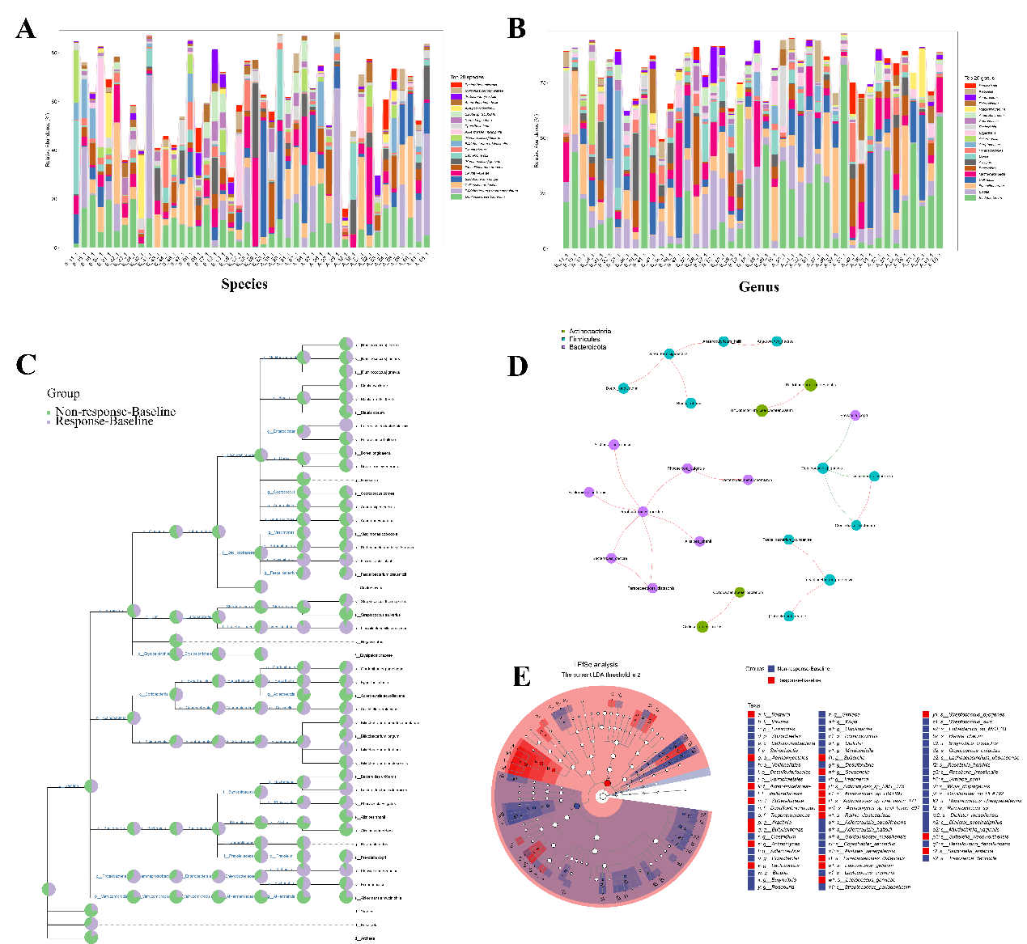
Figure S27: metagenomic alterations between Response Baseline and Non-response Baseline cohorts. A and B, species and Genus alterations; C, alterations at different levels; D, Functional correlations; E lefse analysis between two cohorts.

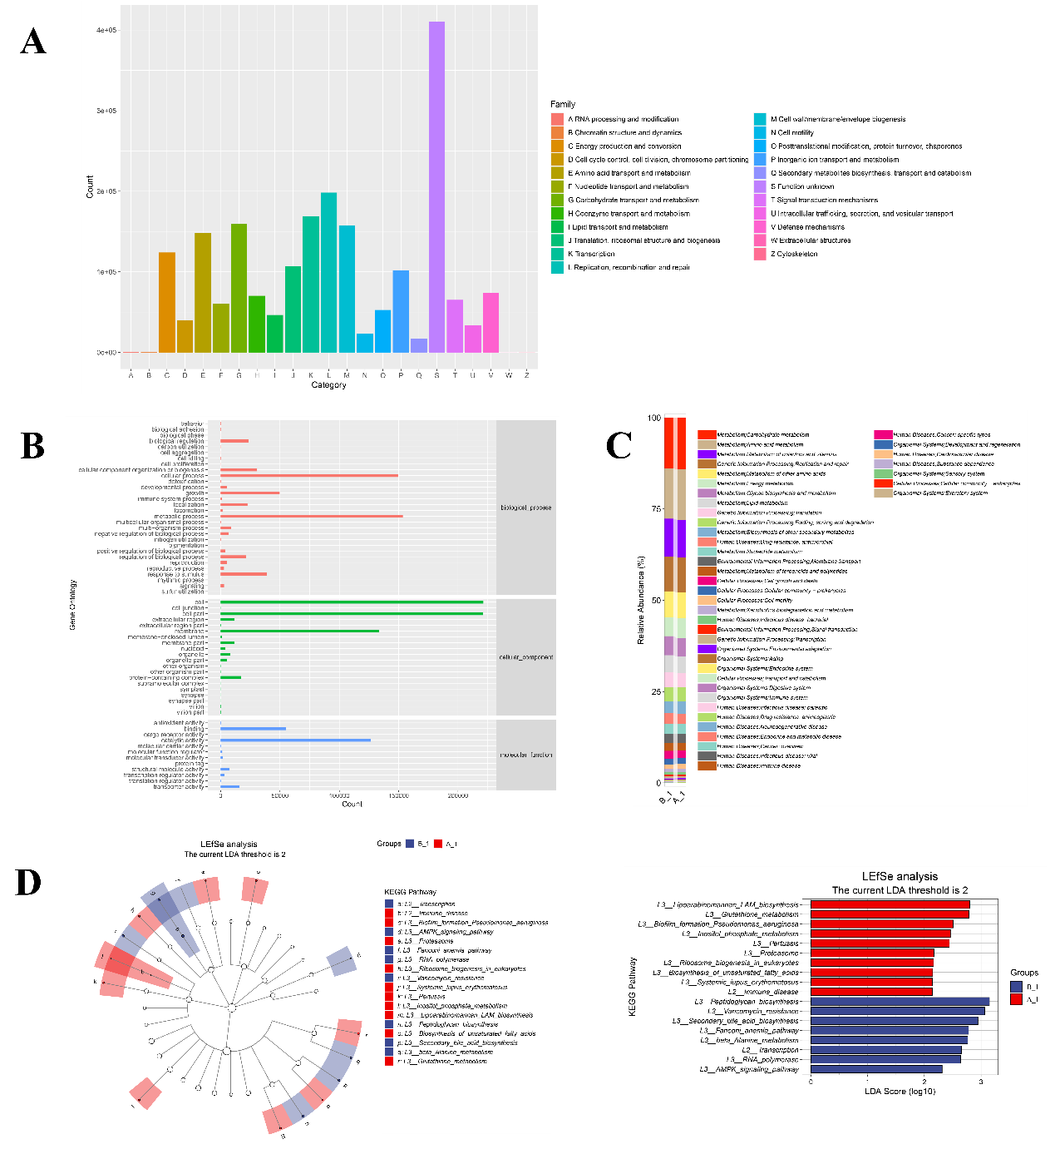
Figure S28: Functional alterations between Response Baseline and Non-response Baseline cohorts. A, eggnog analysis alterations; B and C, KEGG alterations at different levels; D, lefse analysis between two cohorts.

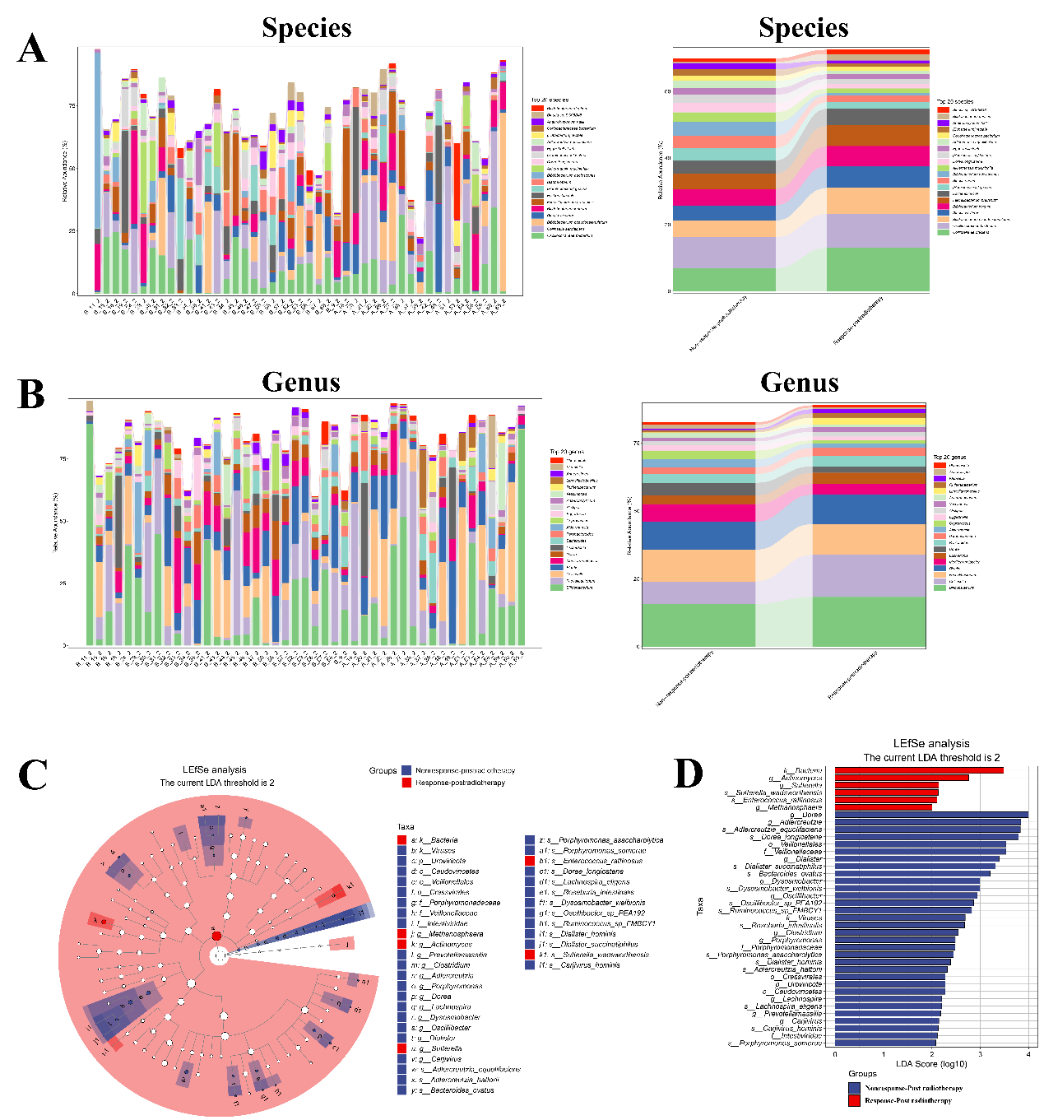
Figure S29: metagenomic alterations between Response postradiotherapy and Non-response postradiotherapy cohorts. A and B, species and Genus alterations between two groups; C and D, lefse analysis between two cohorts.

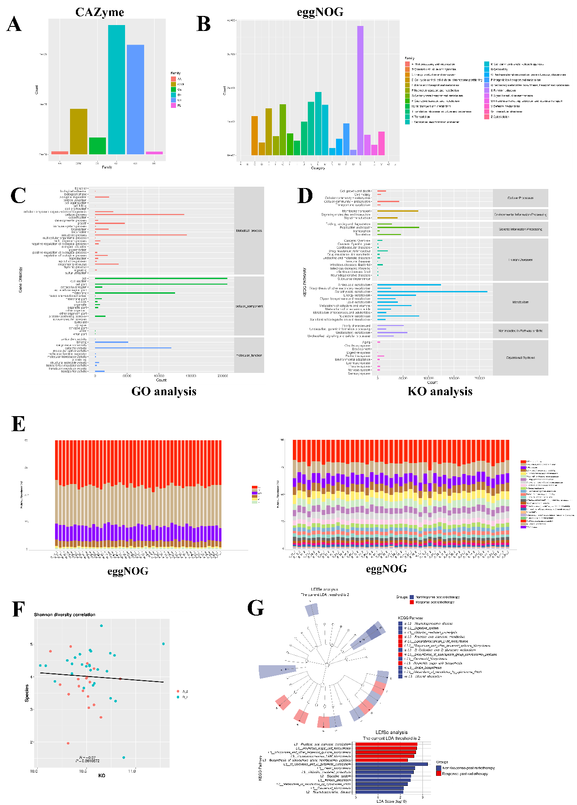
Figure S30: Functional alterations between Response postradiotherapy and Non-response postradiotherapy cohorts. A and B, Cazyme and eggnog analysis alterations; C and D, Go and KO functional alterations at different levels; E, eggnog funtional analysis for separate sample; F, Shannon diversity correlation between two cohorts; G, lefse analysis between two cohorts.

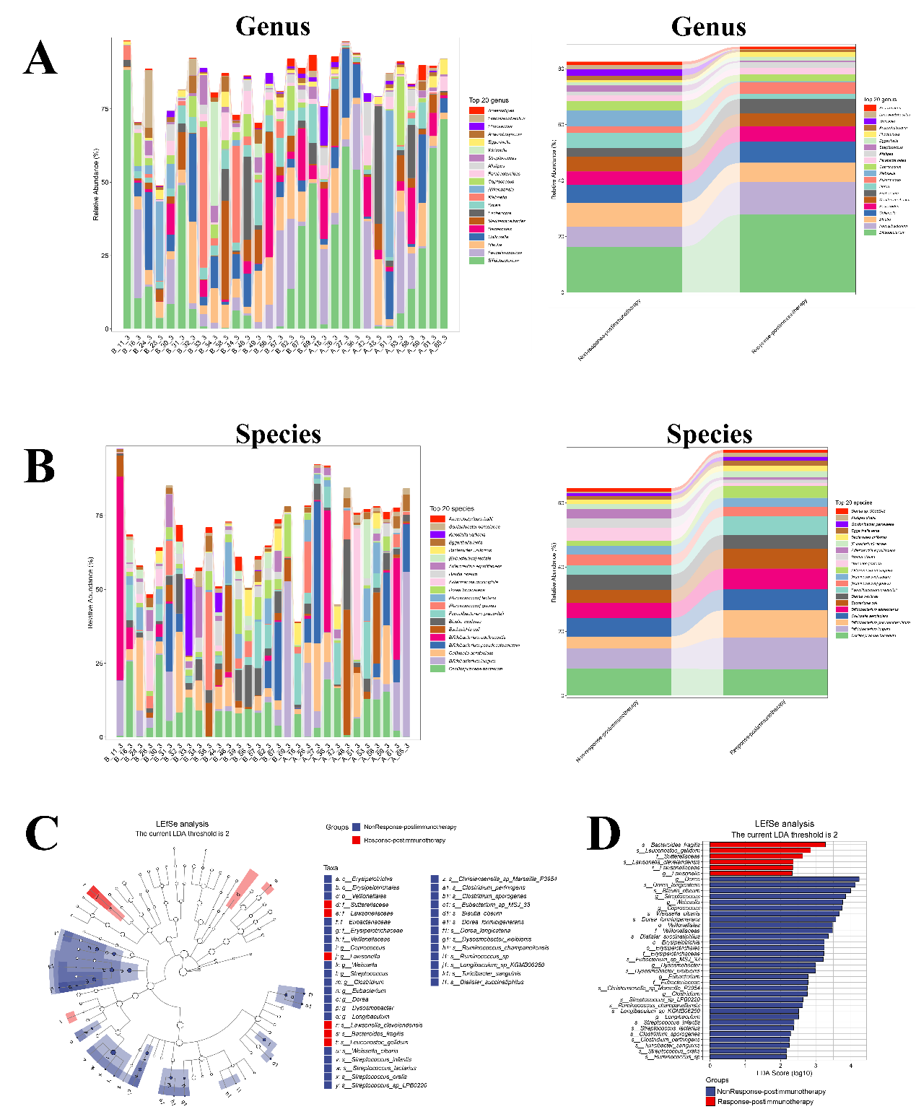

Figure S31: metagenomic alterations between Response postimmunotherapy and Non-response postimmunotherapy cohorts. A and B, species and Genus alterations between two groups; C and D, lefse analysis between two cohorts.

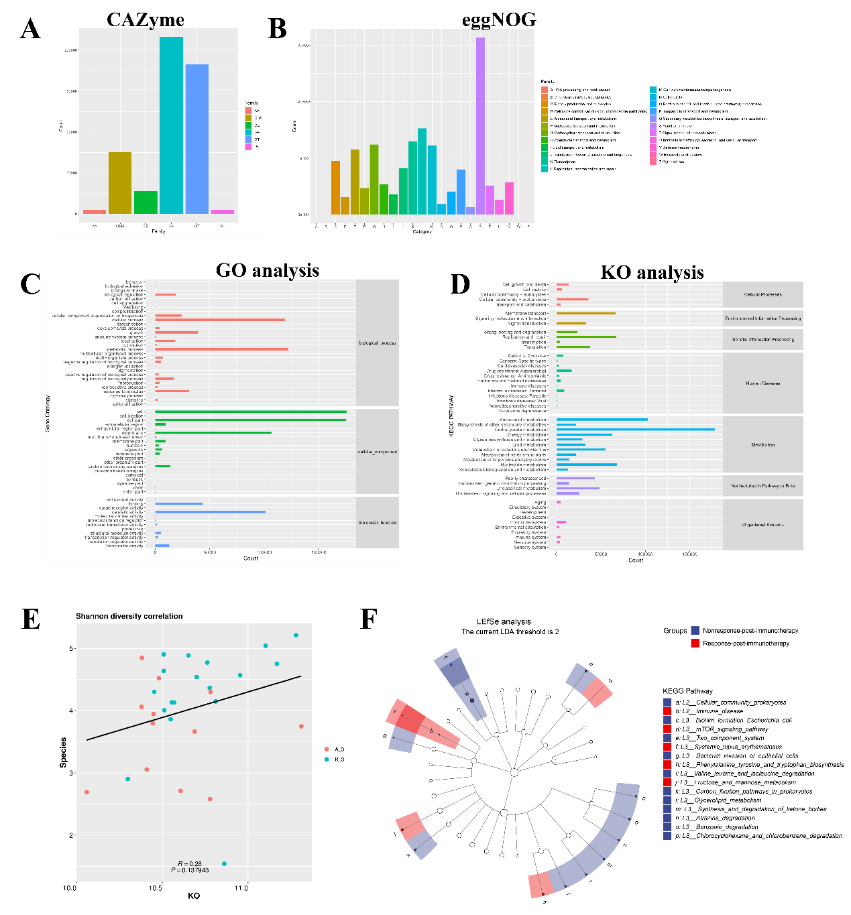
Figure S32: Functional alterations between Response postimmunotherapy and Non-response postimmunotherapy cohorts. A and B, Cazyme and eggnog analysis alterations; C and D, Go and KO functional alterations at different levels; E, Shannon diversity correlation between two cohorts; F, lefse analysis between two cohorts.

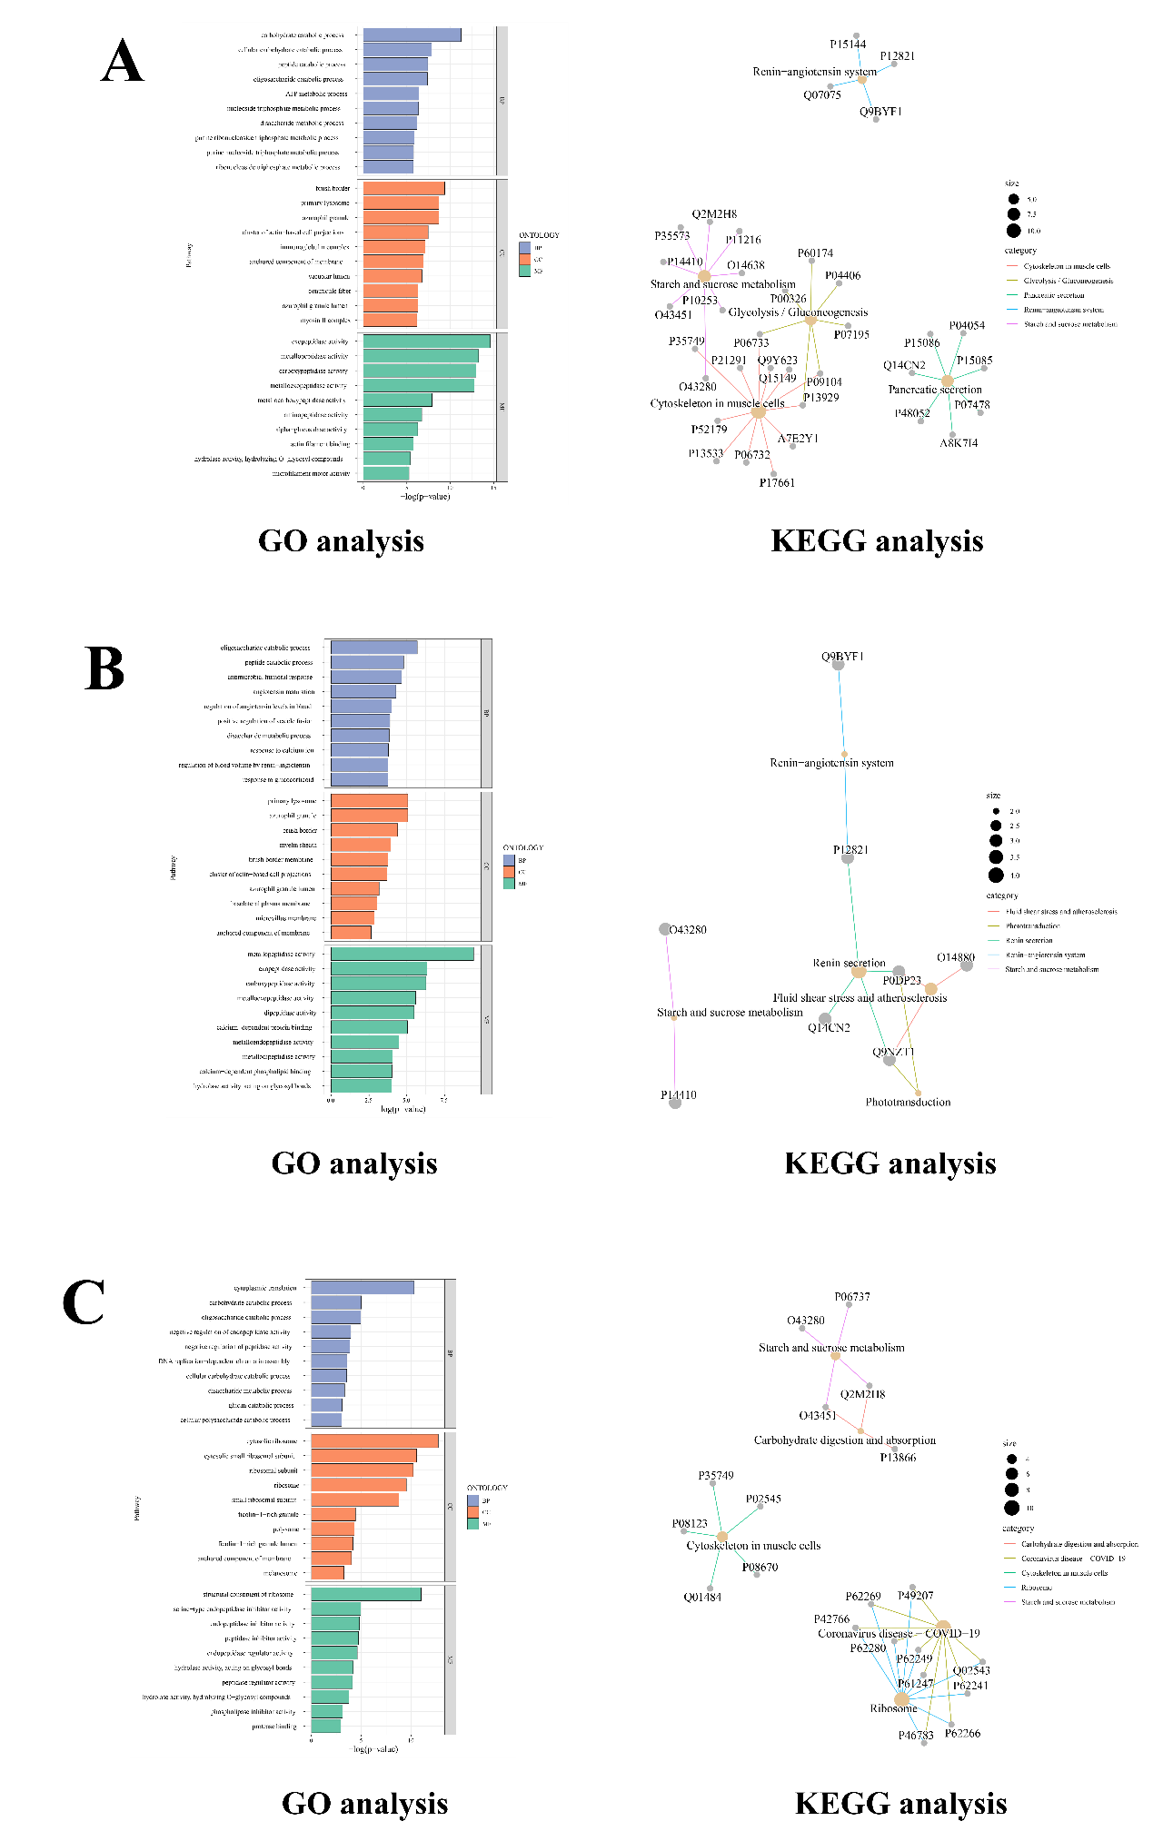
Figure S33: Functional analysis between response and non-response cohorts from metaproteomic data. A, Go and KEGG analysis between Response-baseline and Non-response Baseline; B, Go and KEGG analysis between Response-postradiotherapy and Non-response postradiotherapy; C, Go and KEGG analysis between Response-postimmunotherapy and Non-response postimmunotherapy.

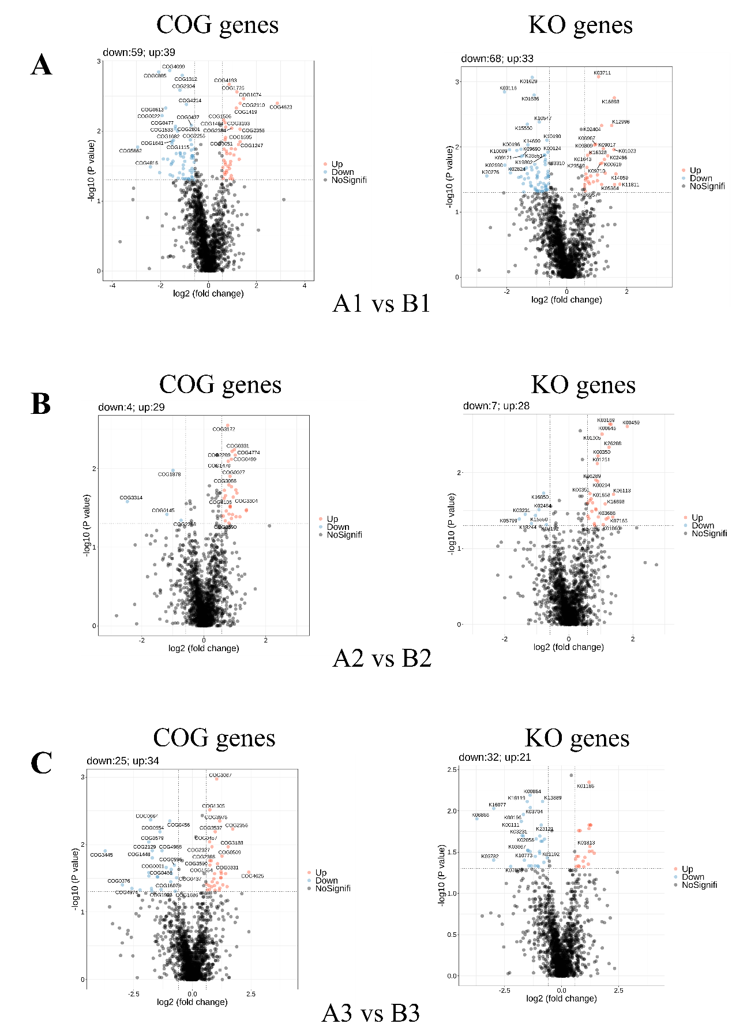
Figure S34: proteomic alterations between Response and Non-response cohorts. A, COG and KO genes volcano analysis between Response-baseline and Non-response Baseline; B, COG and KO genes volcano analysis between Response-postradiotherapy and Non-response postradiotherapy; C, COG and KO genes volcano analysis between Response-postimmunotherapy and Non-response postimmunotherapy.

Figure S35: random forest (RF), logistic regression (LR), and gradient boosting (GB) models were built to discriminate patients in the Response and Nonresponse groups, especially patients at baseline. Boruta feature selection was performed in the response cohort to select key discriminatory bacterial, metabolic and proteomic taxa. All the selected multiomics data were combined to build a predictive model.

