Appendix – A

Green Building Studio

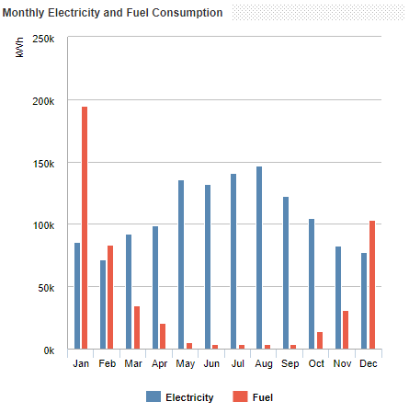

Figure_A.1 Monthly Electricity and Fuel Consumption

Autodesk® Green Building Studio is an optimized cloud-based service that enables users to run building performance simulations early in the design process in order to optimize energy efficiency and work toward carbon neutrality. This enables the design of high-performance buildings at a fraction of the time and cost associated with conventional methods. It is possible to get an idea of a building's total energy consumption and operating costs by using the DOE 2.2 dynamic thermal whole building energy simulation engine in Green Building Studio. This engine considers the interactions between the structure's form, materials, systems, use, and climate [1–3].

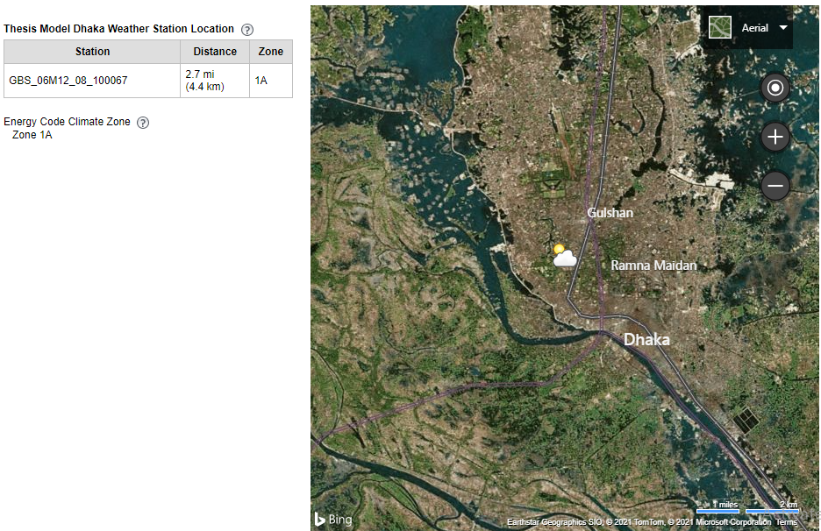
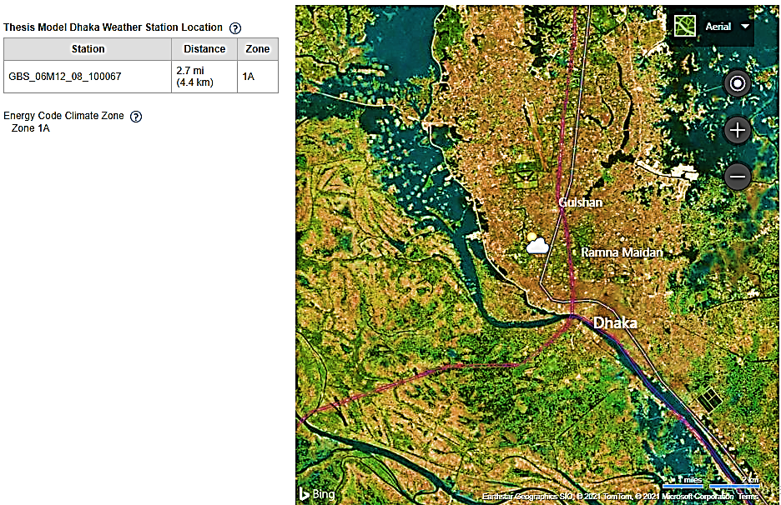

Figure_A.2 Model Weather Station Location at Dhaka
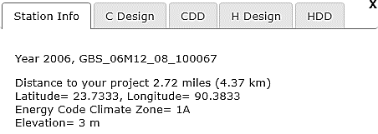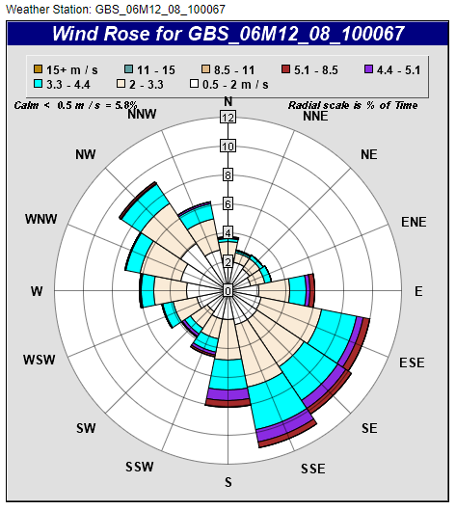Figure_A.3 Wind Roses Data (Dhaka Division)

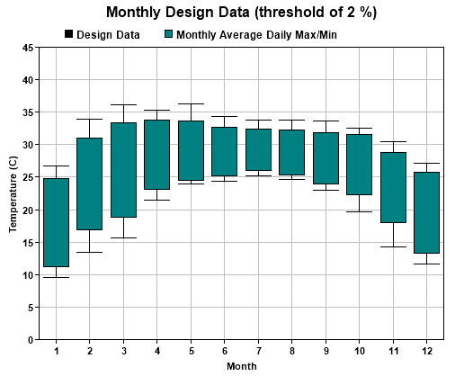Figure_A.4 Monthly Temperature Data, Threshold 2% (Dhaka Division)

Appendix – B

Autodesk Insight360

INSIGHT360 integrates several existing workflows, such as energy cost range analysis, lighting analysis, solar analysis, and EnergyPlus Cloud, while also expanding on these tools' existing capabilities to provide a comprehensive view of building performance. Better integration with Revit and INSIGHT360, as well as direct access to trusted simulation engines and industry benchmarks, enable us to approach the design process with a better understanding of the elements that contribute to improved building performance outcomes over time. This appendix depicts the performance of the energy use intensity range graph for various building elements. The graph generated by Autodesk INSIGHT360 is massive because the study analyzed the building emvelope for eight different locations in Bangladesh and used four scenarios as well. In this appendix, only shown the graph for the DHAKA location for four scenarios in order to make it easier to understand [1–4].

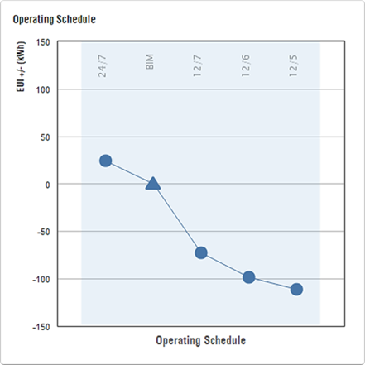 | 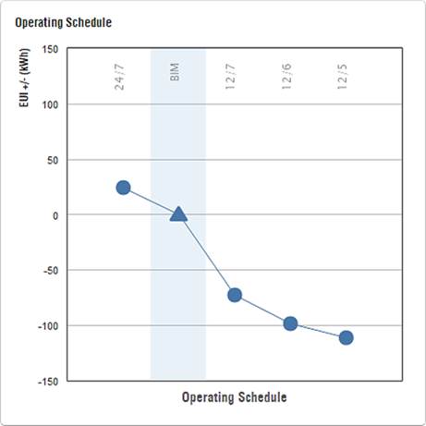
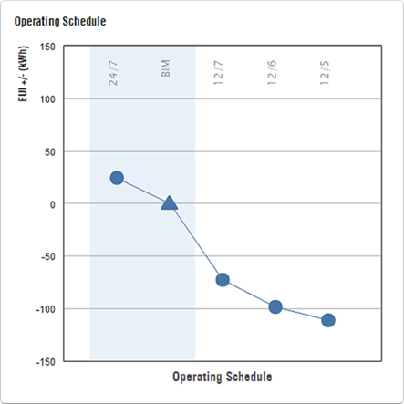 | 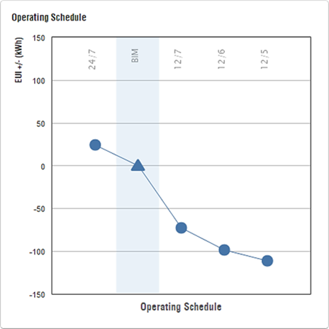

Figure_B.1 Operating Schedule (a) Baseline Scenarios (b) BIM Scenarios

(c) BNBC & Literature Scenarios (d) Optimization Scenarios

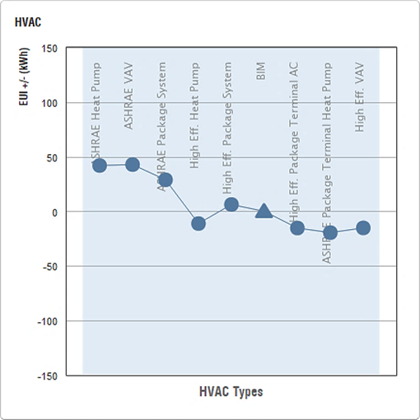 | 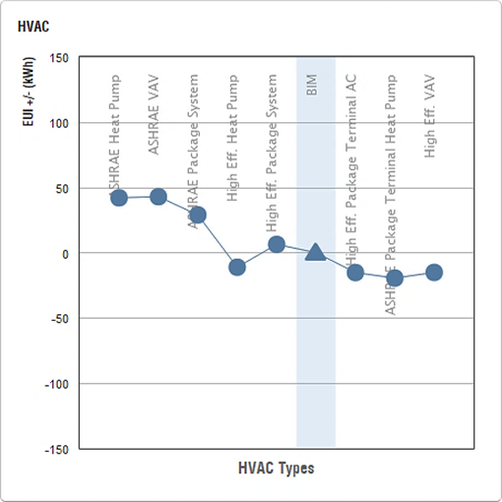
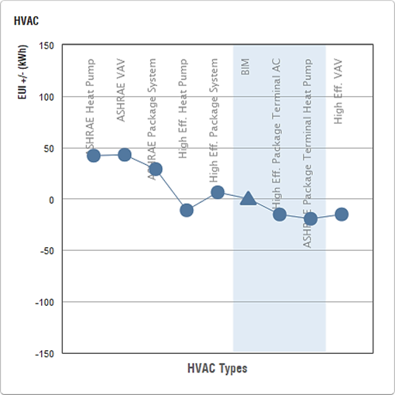 | 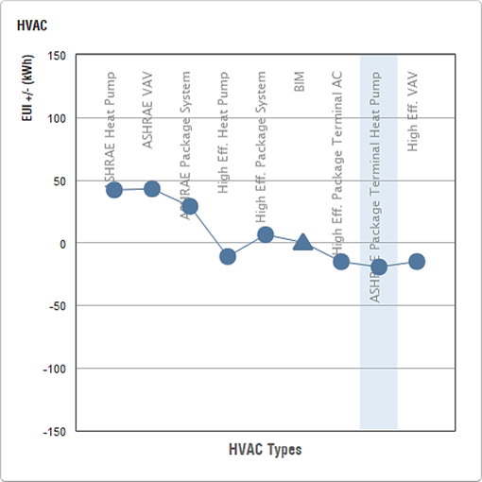

Figure B.2 HVAC System (a) Baseline Scenarios (b) BIM Scenarios

(c) BNBC & Literature Scenarios (d) Optimization Scenarios

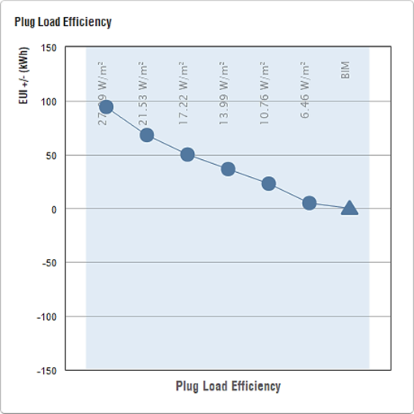 | 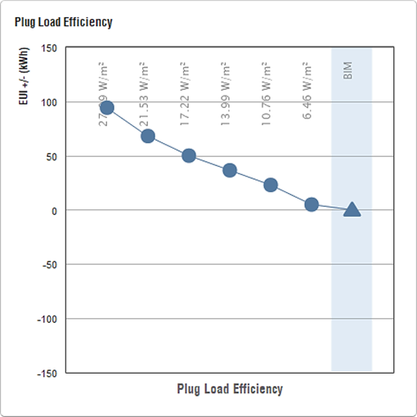
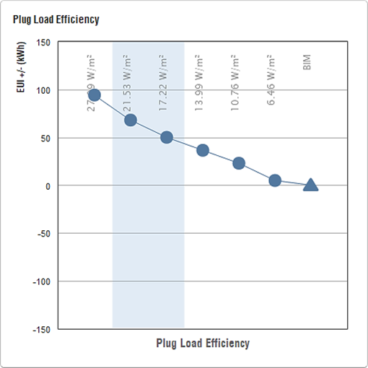 | 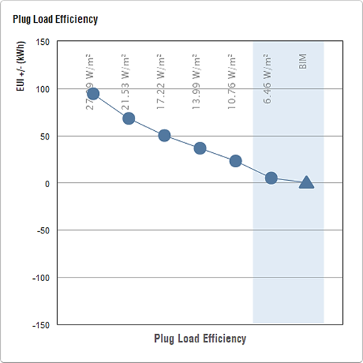

Figure B.3 Plug Load Efficiency (a) Baseline Scenarios (b) BIM Scenarios

(c) BNBC & Literature Scenarios (d) Optimization Scenarios

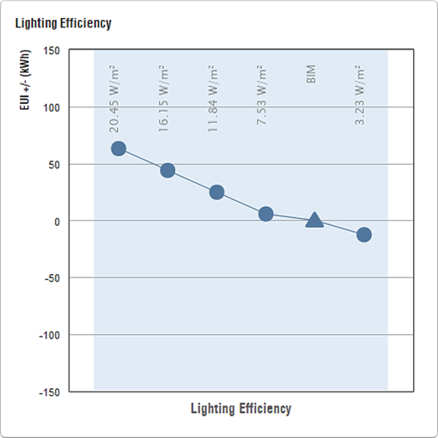 | 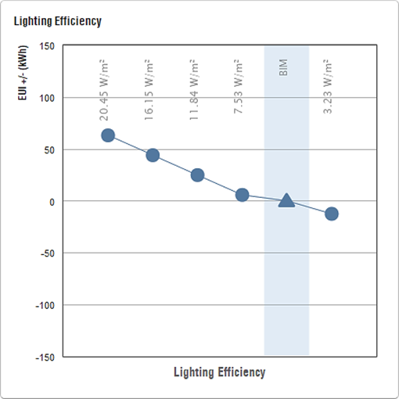
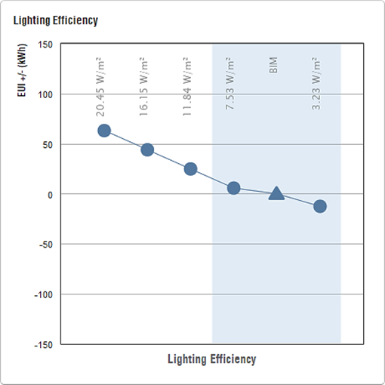

Figure B.4 Lighting Efficiency (a) Baseline Scenarios (b) BIM Scenarios

(c) BNBC & Literature Scenarios (d) Optimization Scenarios

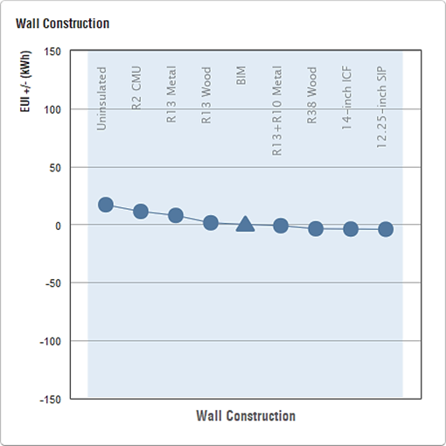 | 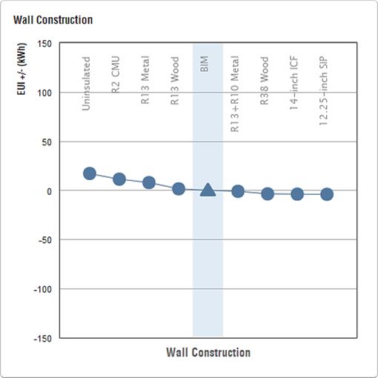
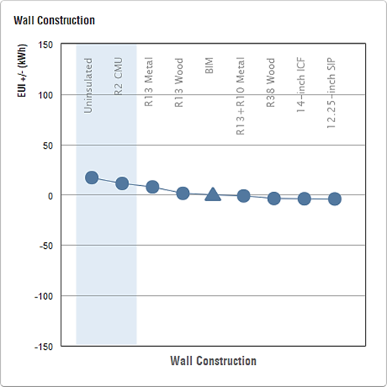

Figure B.5 Wall Construction (a) Baseline Scenarios (b) BIM Scenarios

(c) BNBC & Literature Scenarios (d) Optimization Scenarios

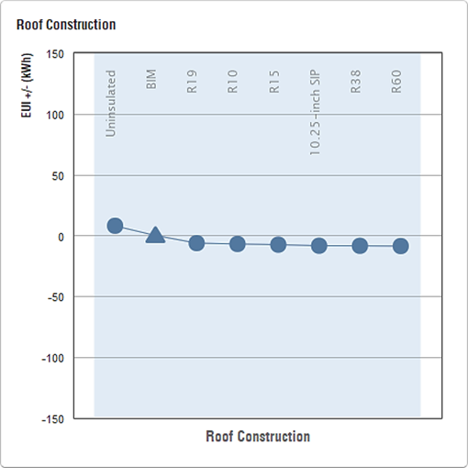 | 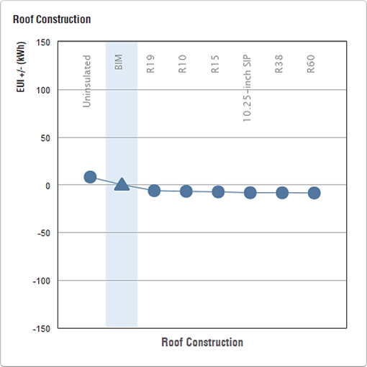
 | 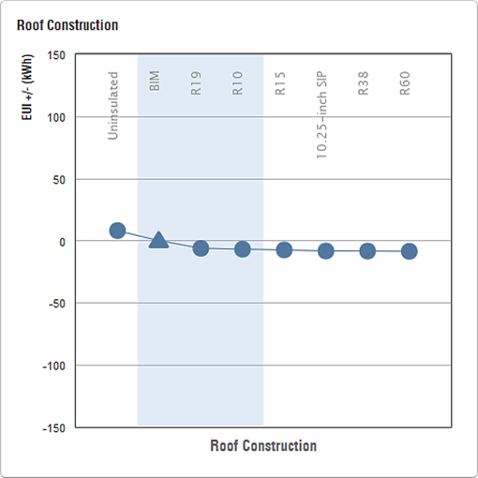

Figure B.6 Roof Construction (a) Baseline Scenarios (b) BIM Scenarios

(c) BNBC & Literature Scenarios (d) Optimization Scenarios

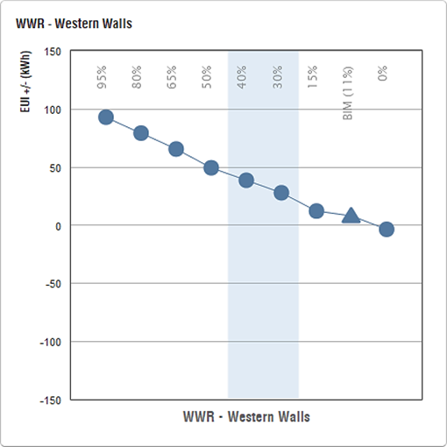 | 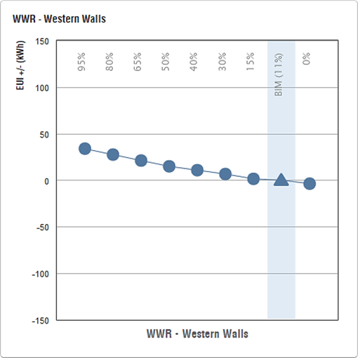
 | 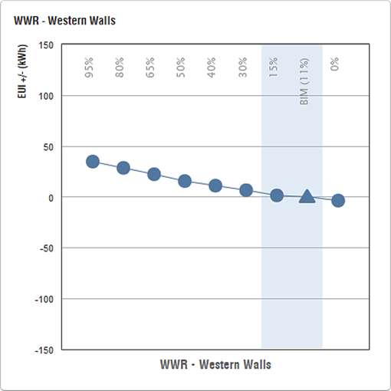

Figure B.7 WWR – Western Walls (a) Baseline Scenarios (b) BIM Scenarios

(c) BNBC & Literature Scenarios (d) Optimization Scenarios

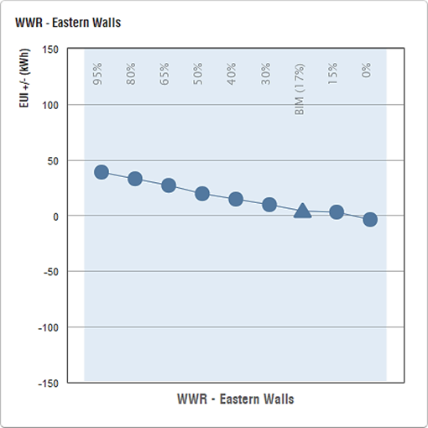 | 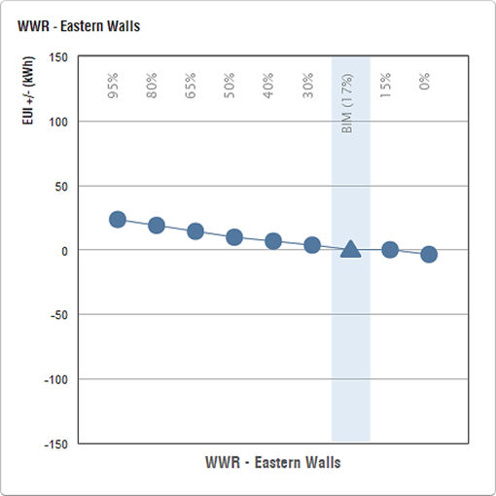
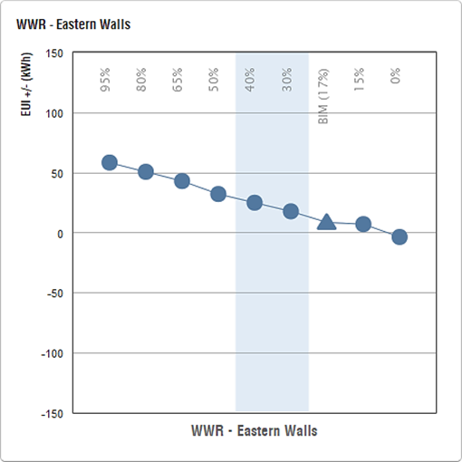 | 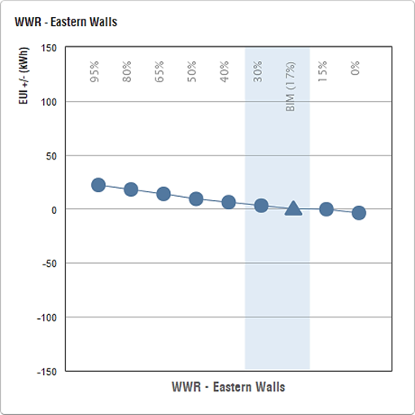

Figure B.8 WWR – Eastern Walls (a) Baseline Scenarios (b) BIM Scenarios

(c) BNBC & Literature Scenarios (d) Optimization Scenarios

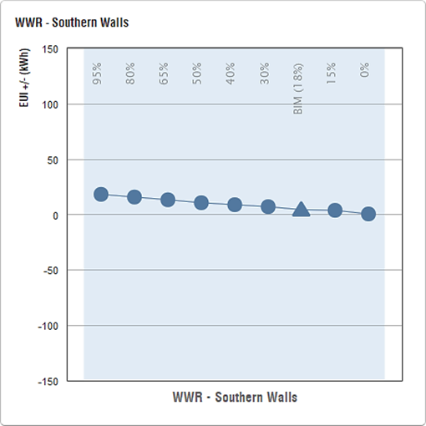 | 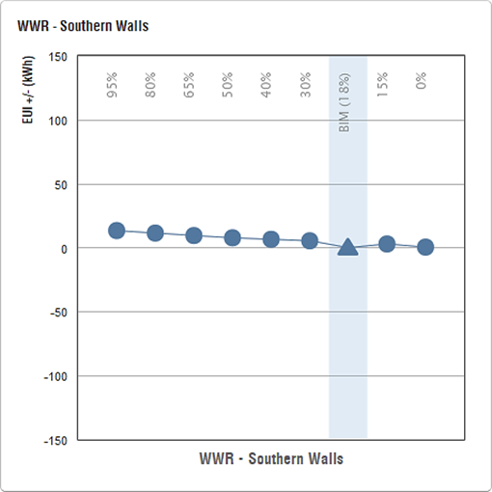
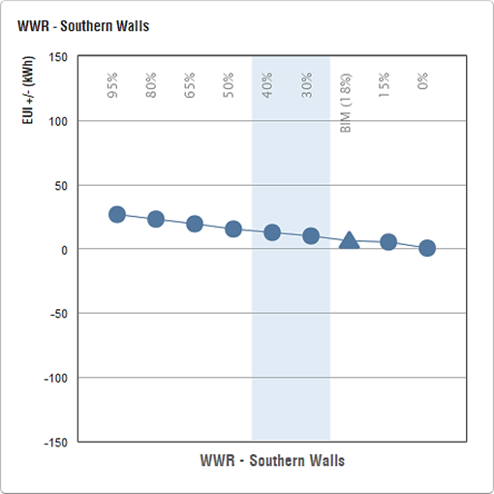 | 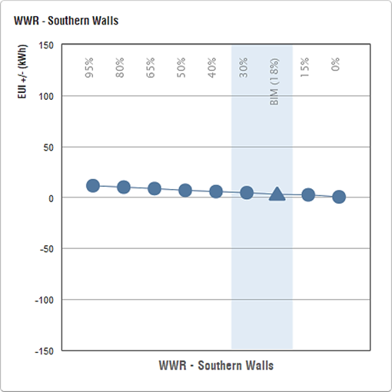

Figure B.9 WWR – Southern Walls (a) Baseline Scenarios (b) BIM Scenarios

(c) BNBC & Literature Scenarios (d) Optimization Scenarios

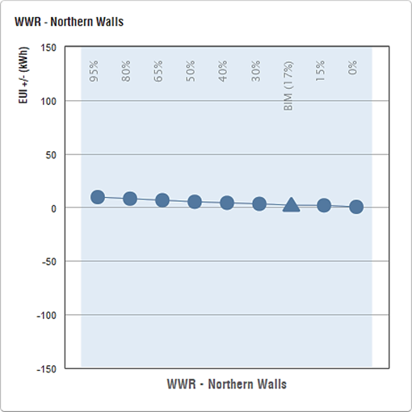 | 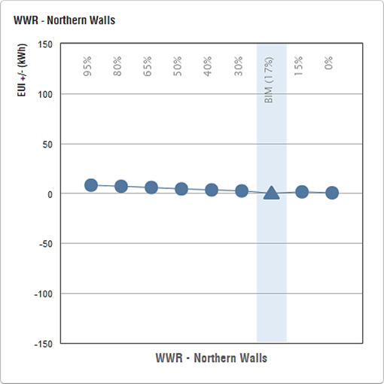
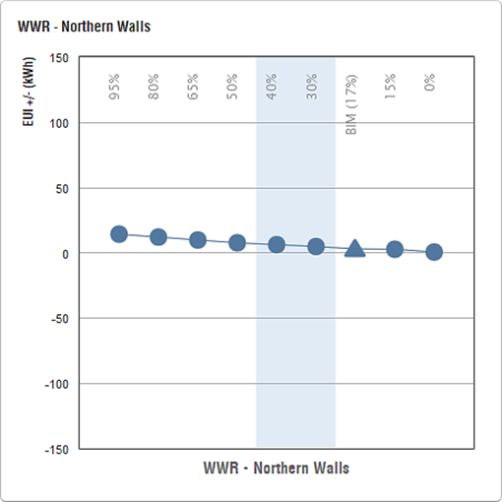 | 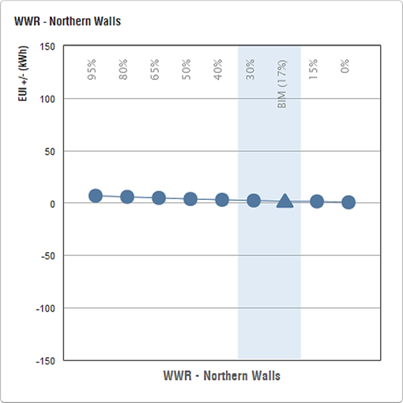

Figure B.10 WWR – Northern Walls (a) Baseline Scenarios (b) BIM Scenarios

(c) BNBC & Literature Scenarios (d) Optimization Scenarios

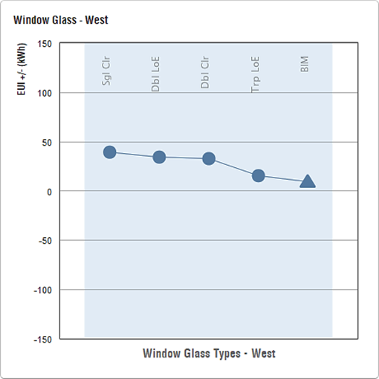 | 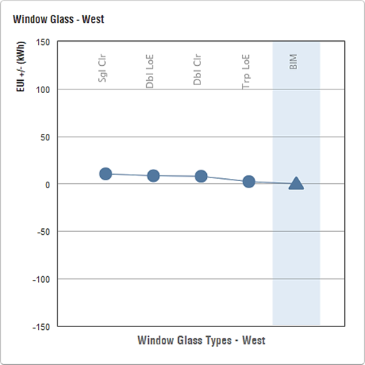
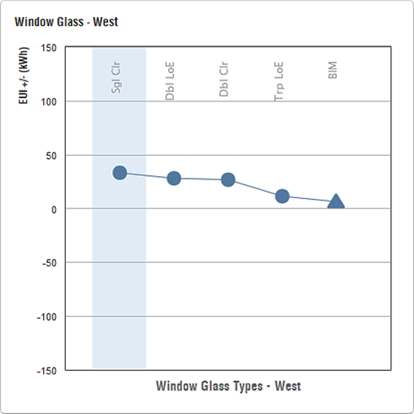 | 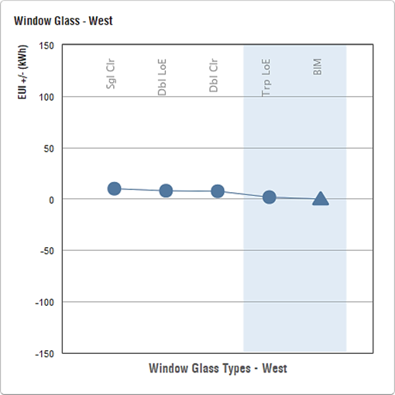

Figure B.11 Window Glass - West (a) Baseline Scenarios (b) BIM Scenarios

(c) BNBC & Literature Scenarios (d) Optimization Scenarios

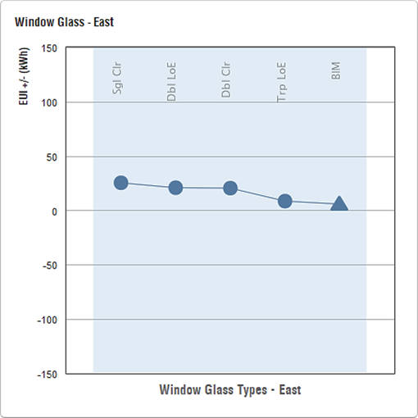 | 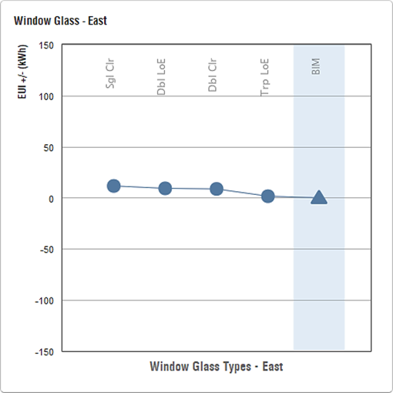
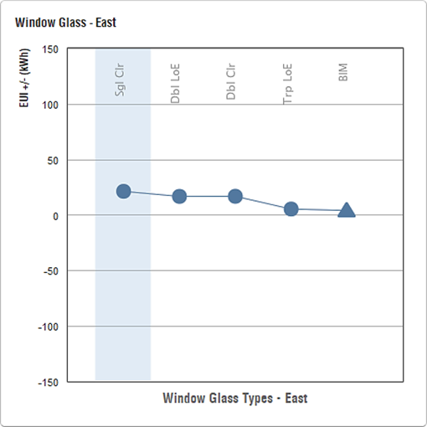 | 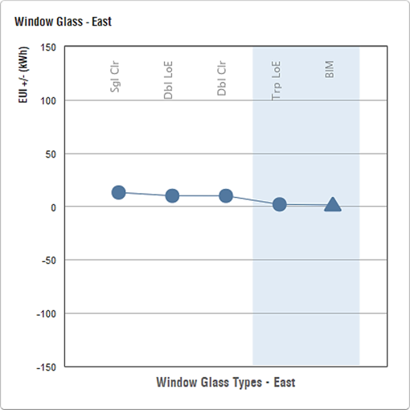

Figure B.12 Window Glass - East (a) Baseline Scenarios (b) BIM Scenarios

(c) BNBC & Literature Scenarios (d) Optimization Scenarios

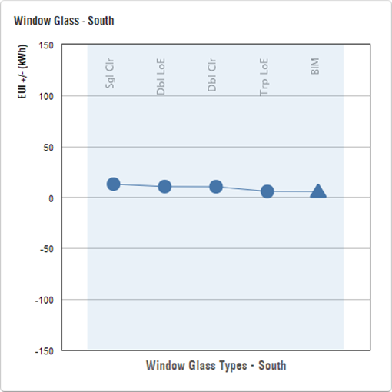 | 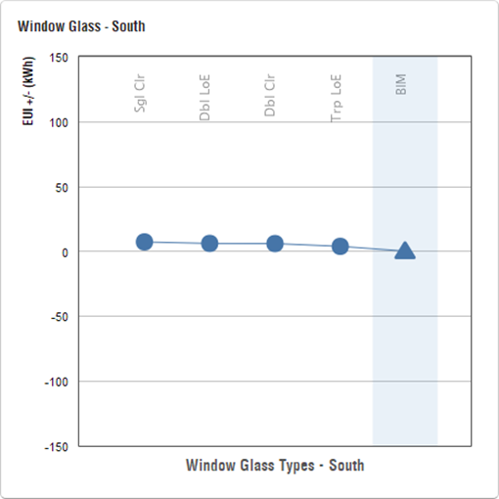
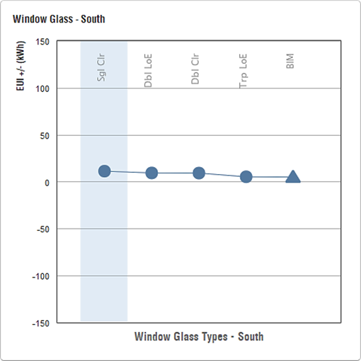 | 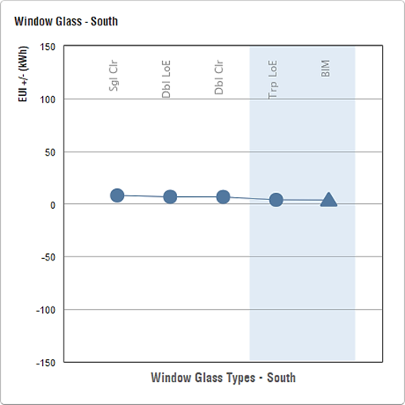

Figure B.13 Window Glass - South (a) Baseline Scenarios (b) BIM Scenarios

(c) BNBC & Literature Scenarios (d) Optimization Scenarios

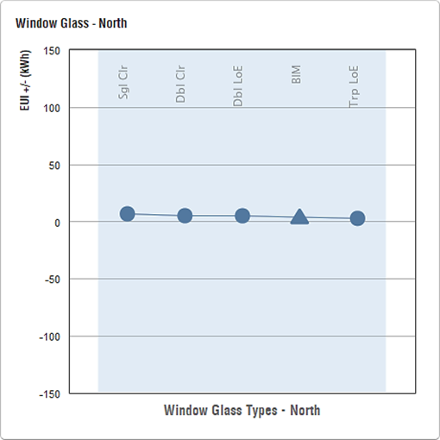 | 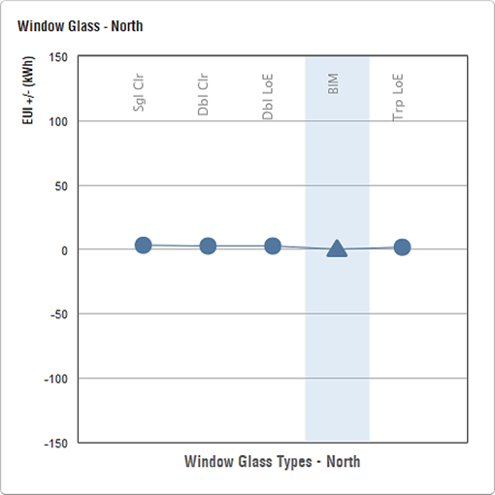
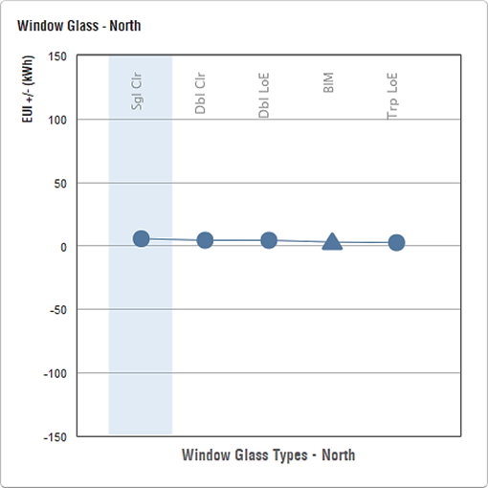 | 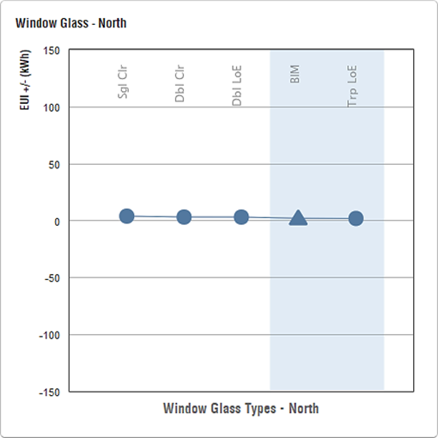

Figure B.14 Window Glass – North (a) Baseline Scenarios (b) BIM Scenarios

(c) BNBC & Literature Scenarios (d) Optimization Scenarios

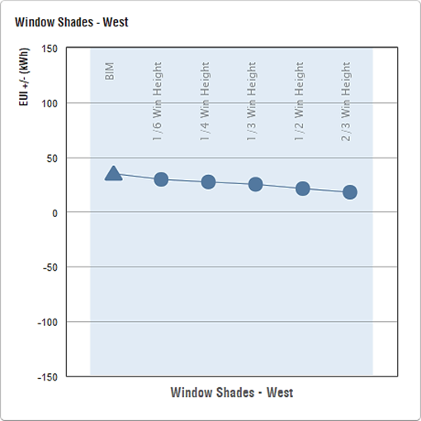 | 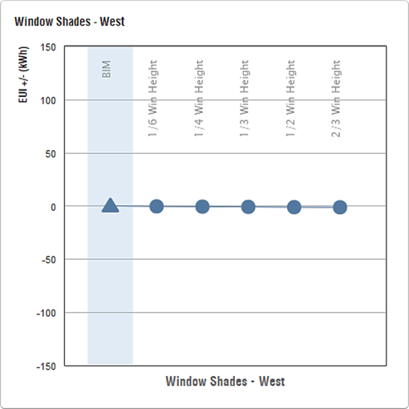
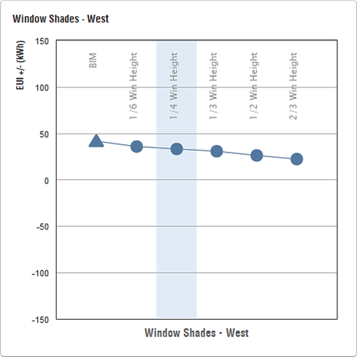 | 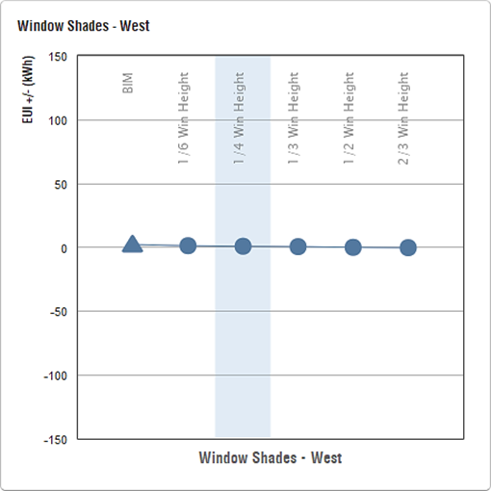

Figure B.15 Window Shades– West (a) Baseline Scenarios (b) BIM Scenarios

(c) BNBC & Literature Scenarios (d) Optimization Scenarios

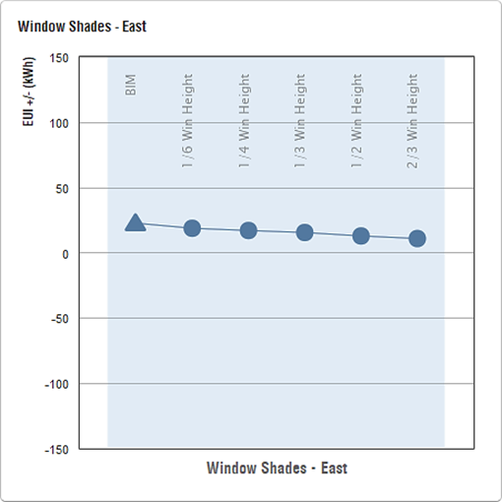 | 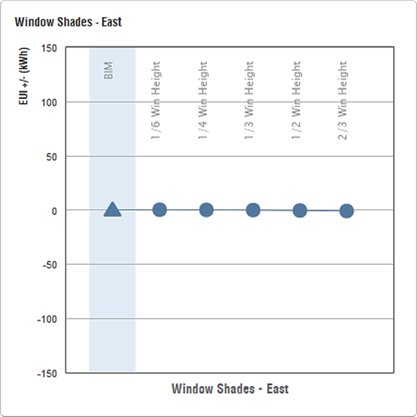
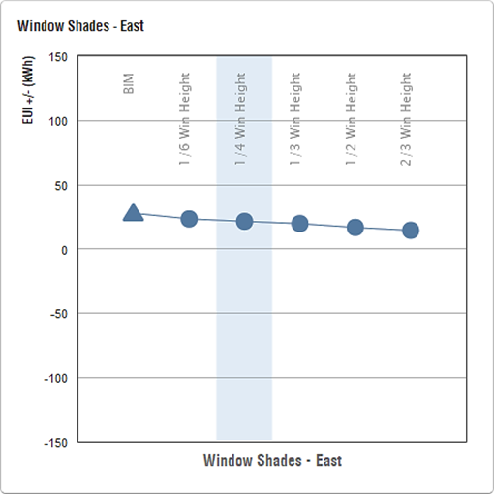 | 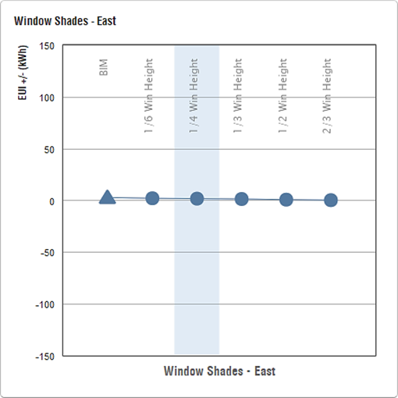

Figure B.16 Window Shades– East (a) Baseline Scenarios (b) BIM Scenarios

(c) BNBC & Literature Scenarios (d) Optimization Scenarios

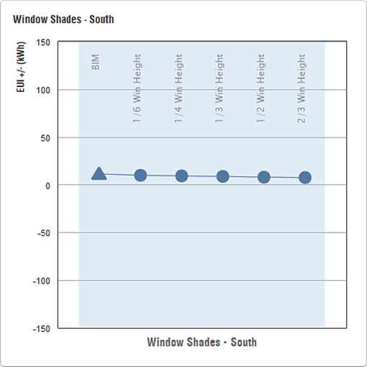 | 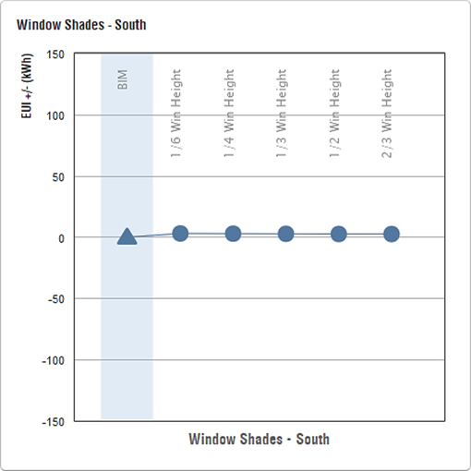
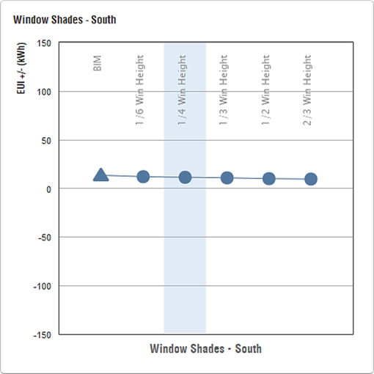 | 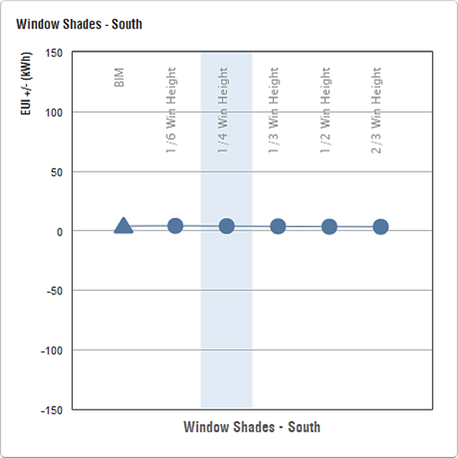

Figure B.17 Window Shades– South (a) Baseline Scenarios (b) BIM Scenarios

(c) BNBC & Literature Scenarios (d) Optimization Scenarios

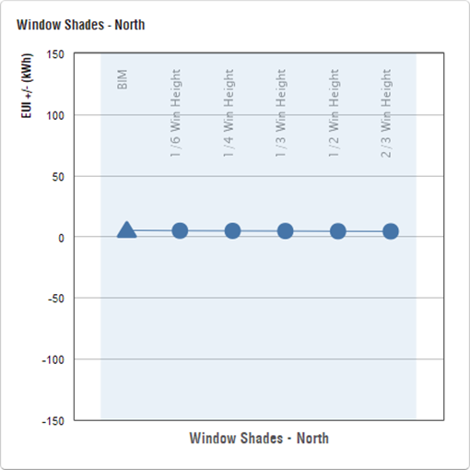 | 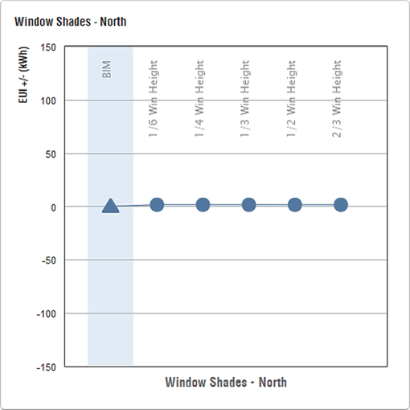
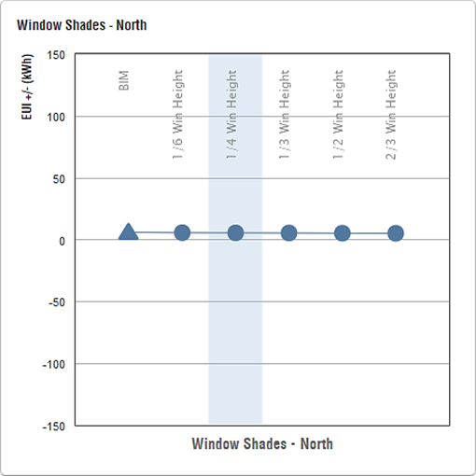 | 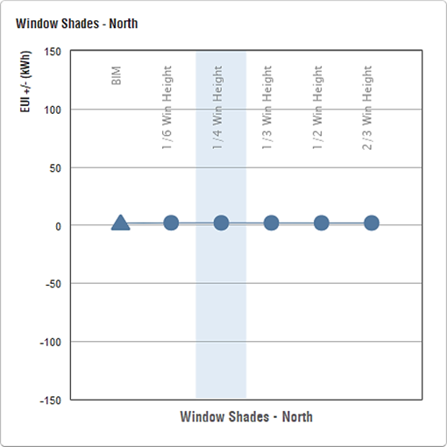

Figure B.18 Window Shades– North (a) Baseline Scenarios (b) BIM Scenarios

(c) BNBC & Literature Scenarios (d) Optimization Scenarios

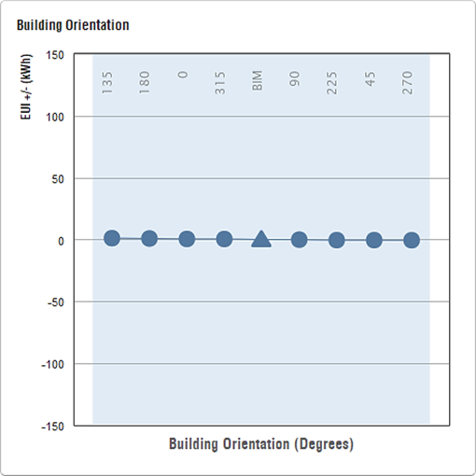 | 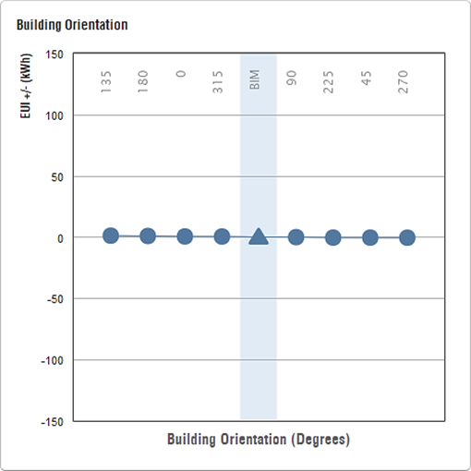
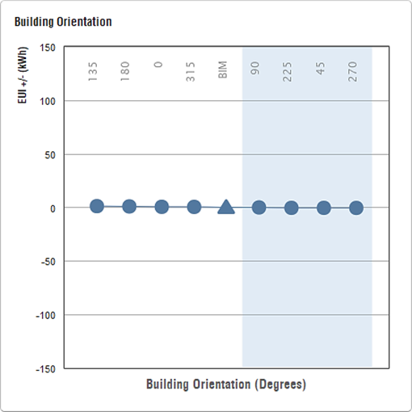 | 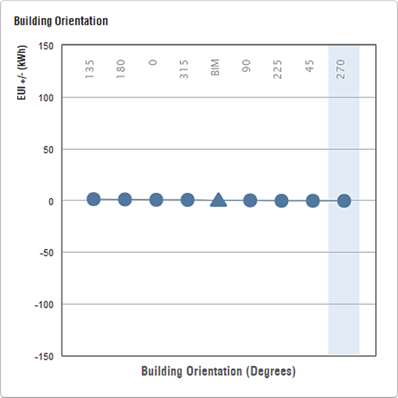

Figure B.19 Building Orientation (a) Baseline Scenarios (b) BIM Scenarios

(c) BNBC & Literature Scenarios (d) Optimization Scenarios

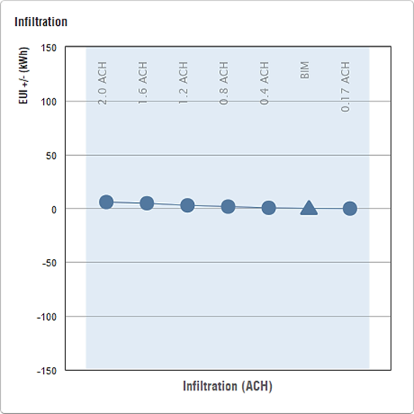 | 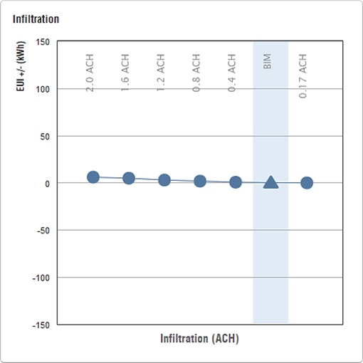
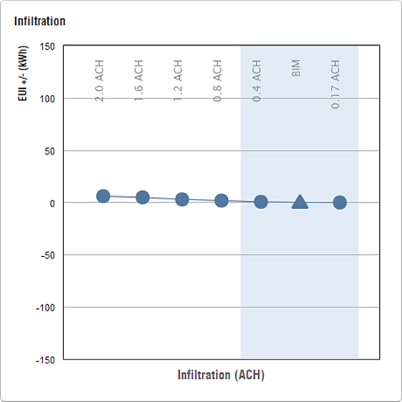

Figure B.20 Infiltration (a) Baseline Scenarios (b) BIM Scenarios

(c) BNBC & Literature Scenarios (d) Optimization Scenarios

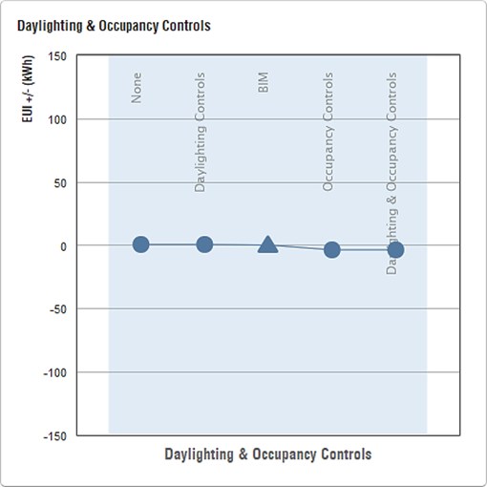 | 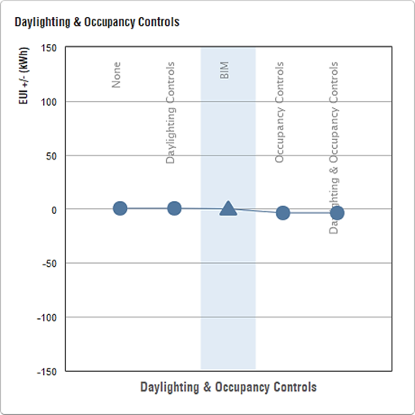
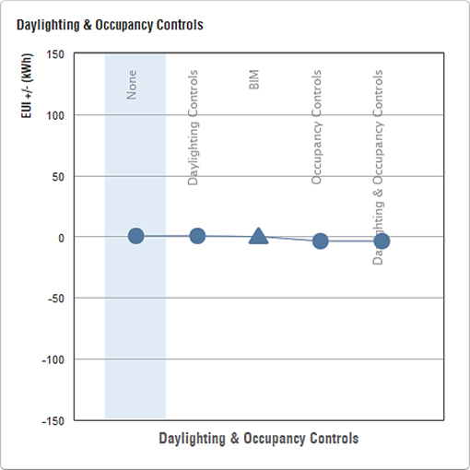

Figure B.21 Daylight & Occupancy Control (a) Baseline Scenarios

(b) BIM Scenarios (c) BNBC & Literature Scenarios (d) Optimization Scenarios

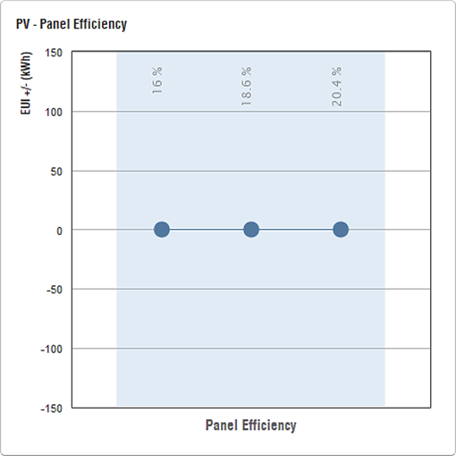 | 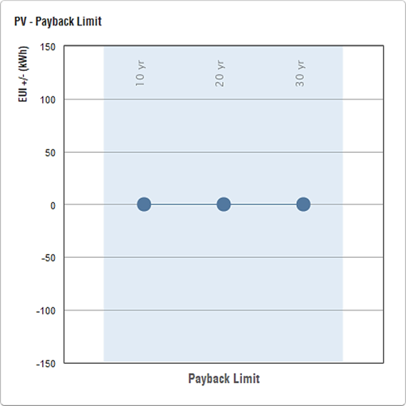
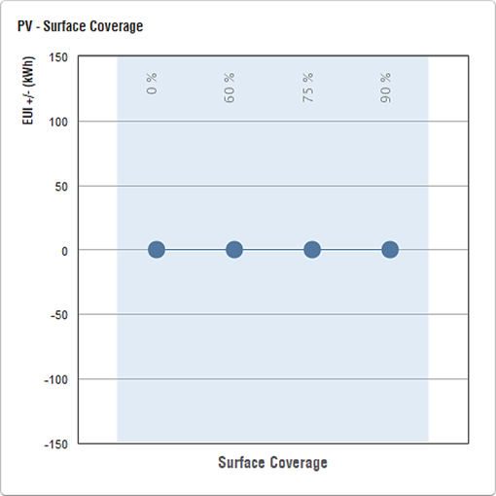

Figure B.22 PV Analysis (a) Payback Limit (b) Panel Efficiency

(c) Surface Coverage

REFERENCEs:
[1] Autodesk Inc., Green Building Studio (GBS), (2020). https://gbs.autodesk.com/gbs.
[2] Autodesk Inc., Autodesk Insight 360, (2020). https://www.autodesk.com/solutions/insight.
[3] Autodesk Inc., Autodesk Revit 2020, (2020). https://www.autodesk.com/products/revit/overview.
[4] Autodesk, Autodesk Insight - Energy Model 323764, Autodesk Insight (2025).

