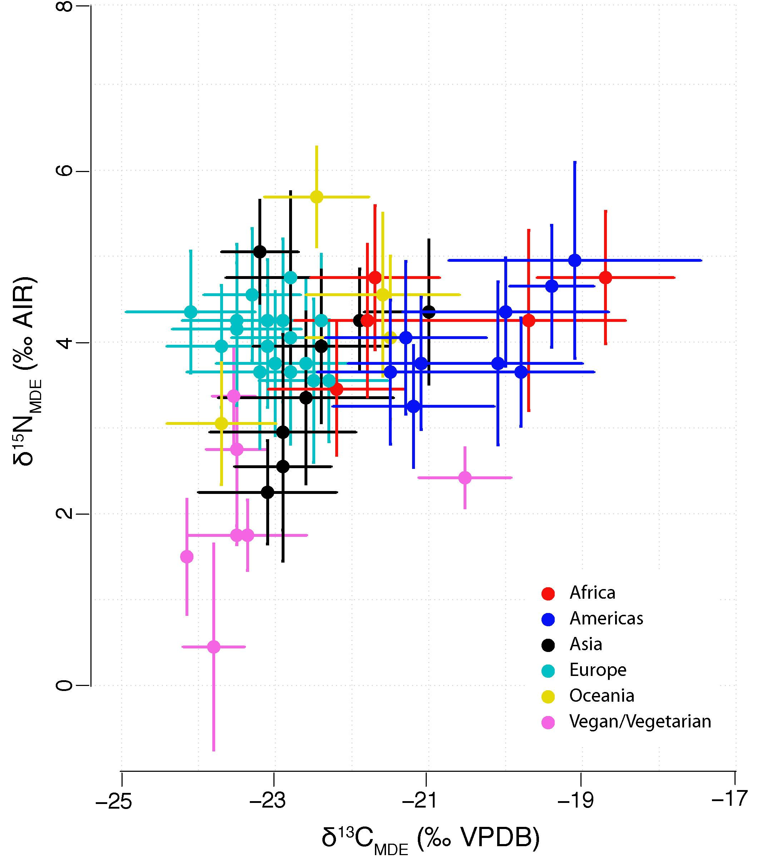
Supplementary Figure 2. δ¹³C_{MDE} and δ¹⁵N_{MDE} of modern non-subsistence populations (μ) with error bars (2σ) and grouped by continent, using the country groupings identified by Hulsemann et al, (2015). Vegans and vegetarians are shown separately (in pink).

