Supplemental figures
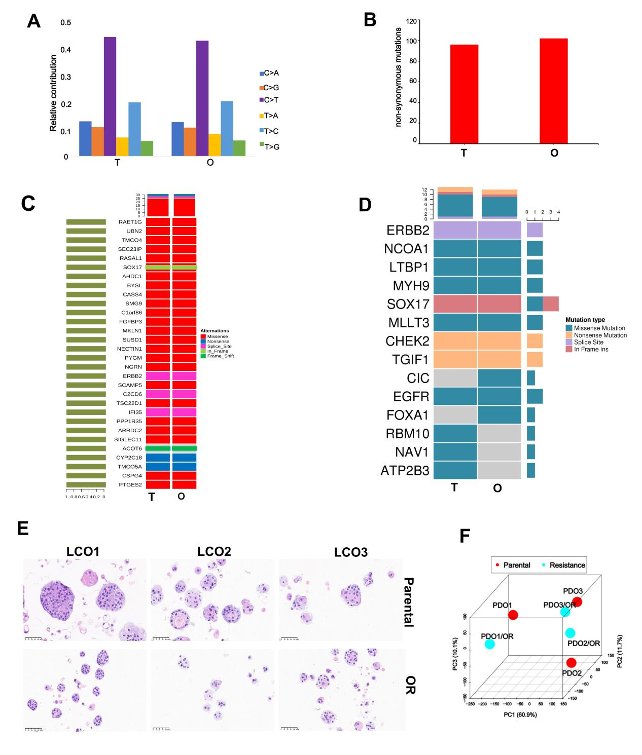
Supplemental Figure 1. Consistency verification of LCOs. A. The frequency of point mutation types in the LCOs and paired tumor. B. Tumor mutation burden (TMB) was estimated in the LCOs and paired tumor. C. The high-frequency mutations in organoid lines (O) and the corresponding tissues (T). D. Heatmap of CNVs in cancer driver genes. Gene copy numbers are transformed as log2 ratios per gene. E. HE staining analysis of morphological consistency of LCOs and LCOs/OR. O, LCOs; T, patients’ primary specimens, Scale bar = 50 μm. F. The PCA analysis of LCOs and LCOs/OR.

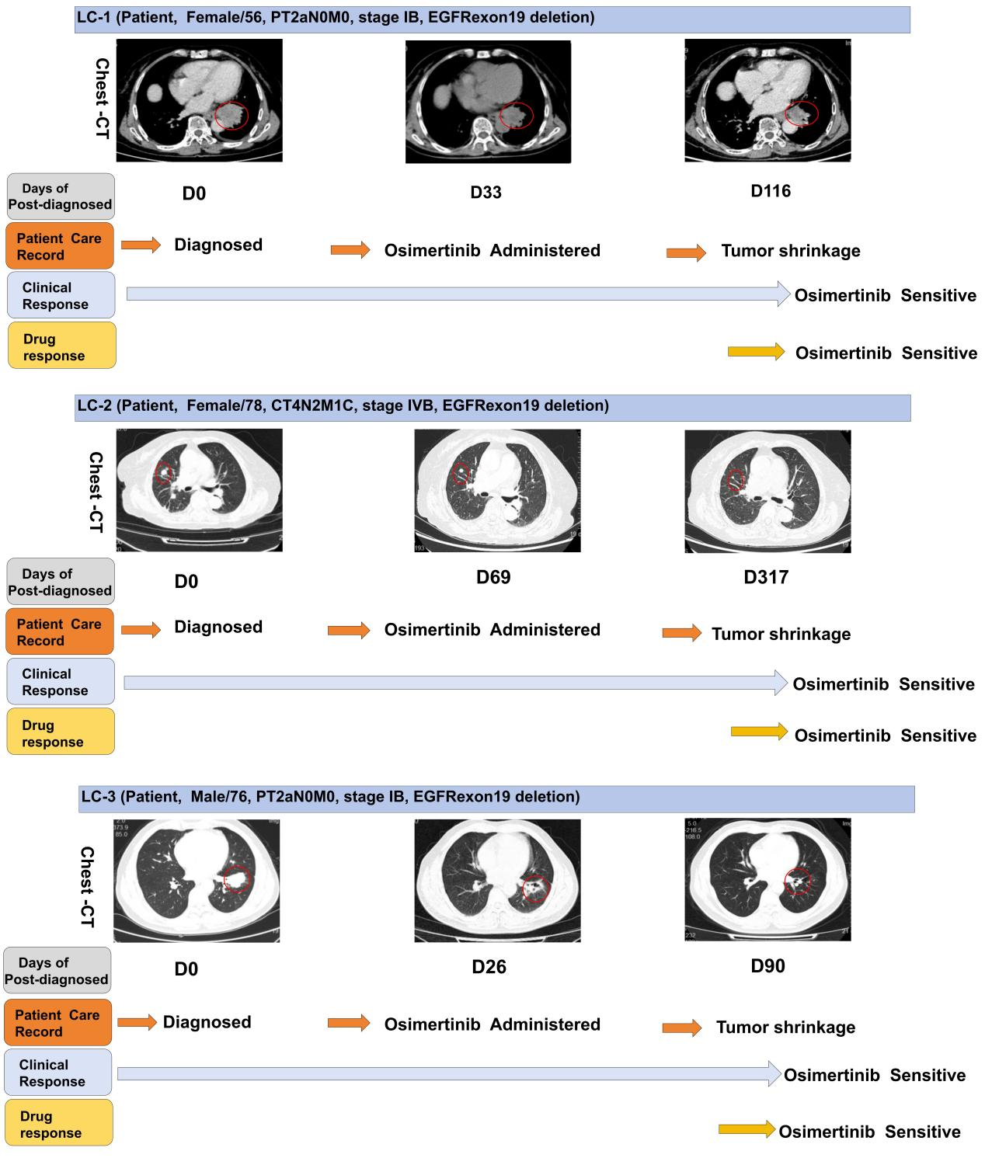
Supplemental Figure 2. LCO models predict clinical outcomes of three patients to targeted therapy. Patient #1 was diagnosed with stage IB lung cancer harboring an EGFR exon 19 deletion, and exhibited a notable reduction in tumor size following treatment with Osi. Consequently, drug sensitivity testing with LCO1 exhibited a sensitive response to Osi. Patients #2 and #3 were diagnosed with an EGFR exon 19 deletion, and also had significant lesion reduction after Osi treatment. Drug sensitivity tests displayed a robust positive response to Osi. The areas enclosed by the red circles represent the tumors before and after chemotherapy, as indicated by enhanced CT scans.

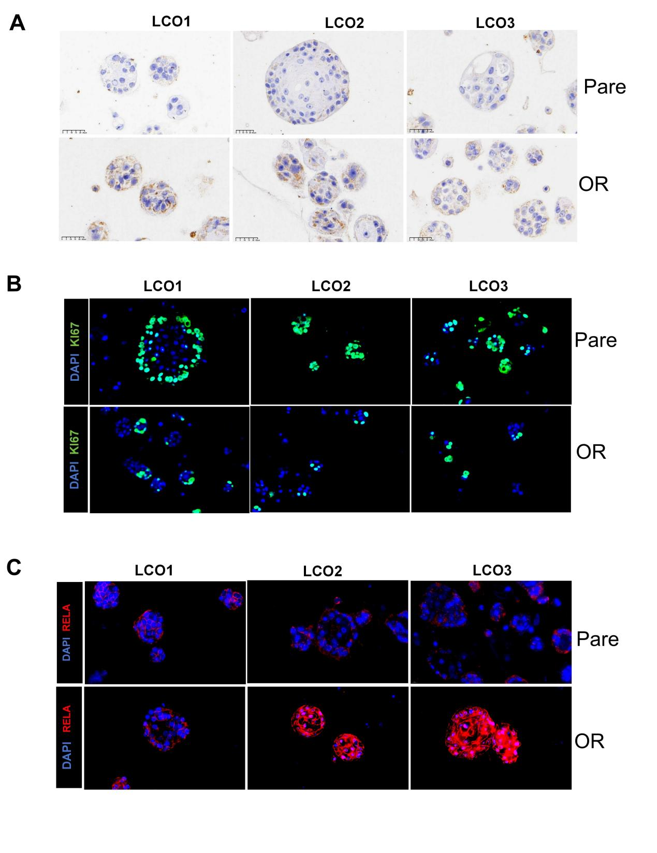
Supplemental Figure 3. Immunohistochemistry analysis of the expression of MDR1 (A), and immunofluorescence analysis of KI67 (B) and RELA (C) expression in LCO1-3 and LCO/OR1-3 (magnification x200).

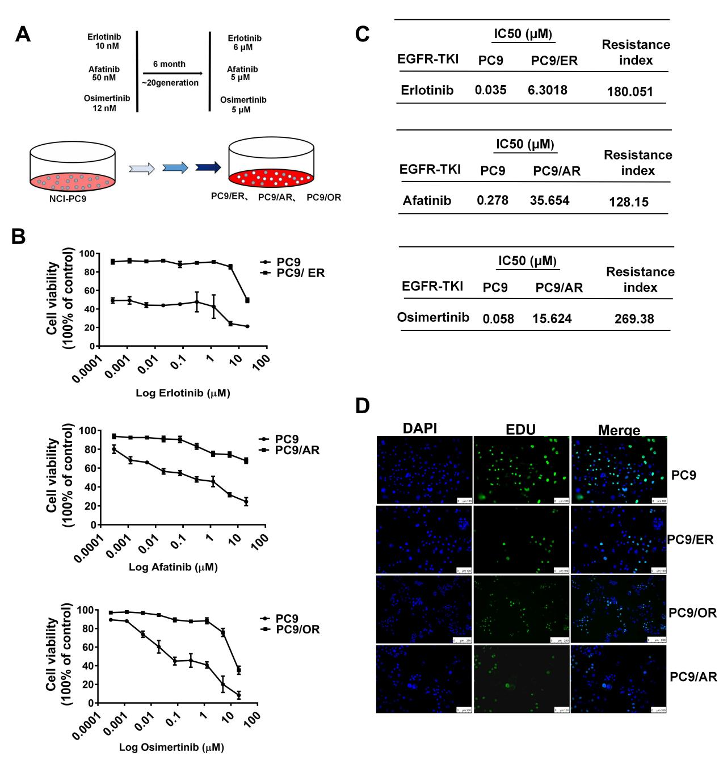
Supplemental Figure 4. Establishment of EGFR-TKI resistant R-PC9 cells in vitro. A. A schematic diagram illustrated the establishment of EGFR-TKI resistant R-PC9 cells. B. CCK8 assay analysis of the effect of TKI treatment for 72h on the viability of indicated cell lines. Each value is expressed as the mean ± SD (n=3). C. The IC₅₀ values of EGFR-TKIs in PC9, PC9/ER, PC9/AR and PC9/OR cells. D. The representative photographs of cells in the EDU assay, Scale bar = 100 μm.

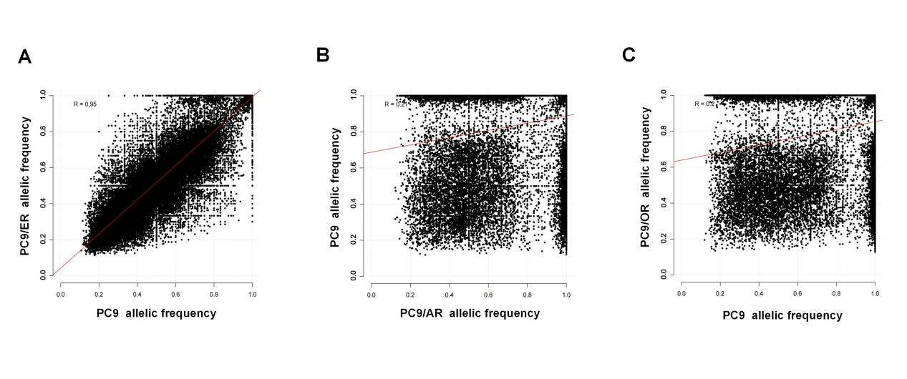Supplemental Figure 5. Two-dimensional density plot of single-nucleotide variant allelic frequencies from WES of PC9/ER (A), PC9/AR (B) and PC9/OR (C) versus treatment-naive PC9 cells.
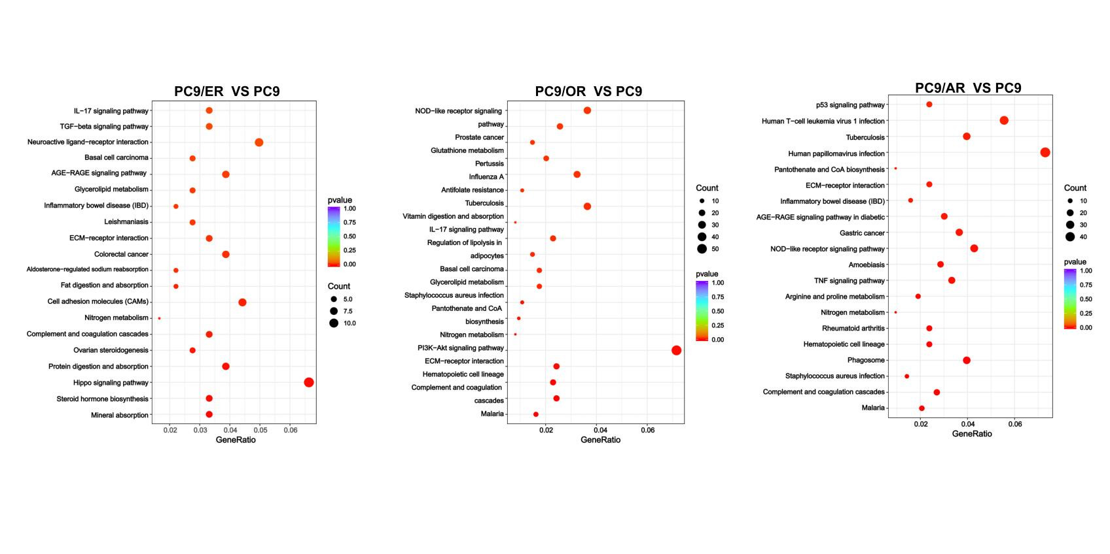
Supplemental Figure 6. KEGG analysis of the enriched pathways by the DEGs between cells after RNA-seq analysis. Enriched KEGG pathways, enrichment analysis of upregulated genes in PC9/AR, PC9/ER and PC9/OR.
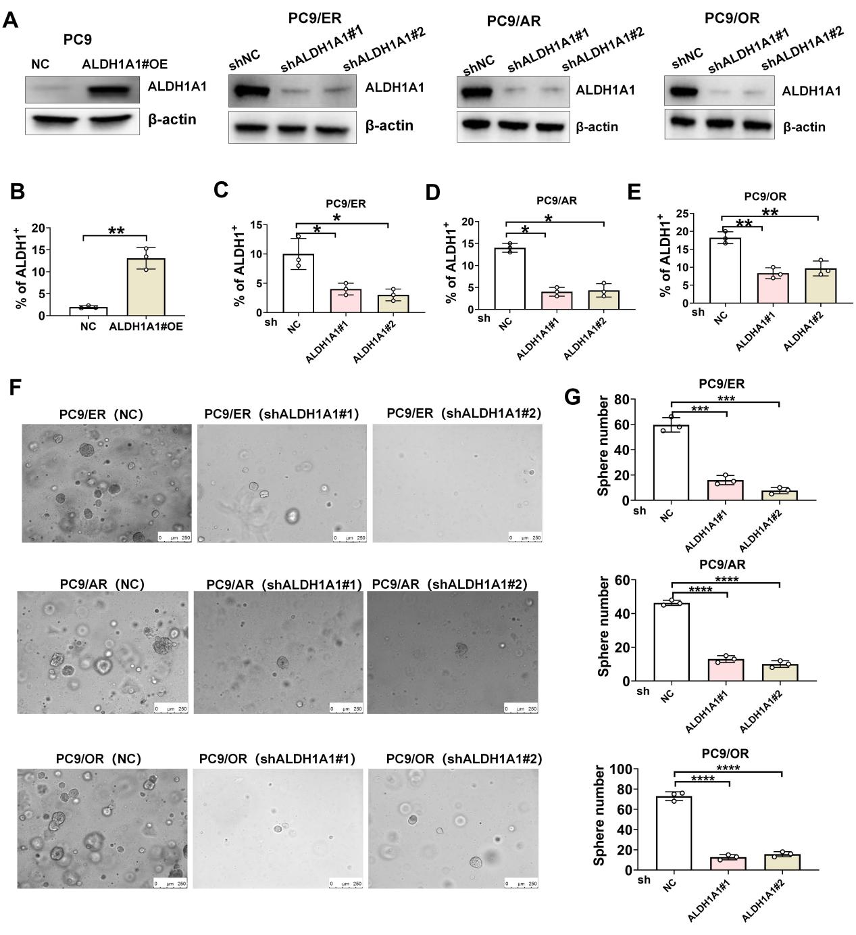
Supplemental Figure 7. Altered ALDH1A1 expression modulates the sphere formation of tumor cells. A. Western blot analysis of the efficacy of ALDH1A1 over-expressing or silencing cells. B. ALDH1A1 over-expression increased the proportion of ALDH1⁺ cells in PC9 cells. C-E. ALDH1A1 silencing decreased the proportion of ALDH1⁺ cells in PC9/ER (C), PC9/AR (D) and PC9/OR (E). F-G. ALDH1A1 silencing dramatically mitigated the sphere formation of R-PC9 cells. *P<0.05; **P<0.01; ***P<0.001; ****P<0.0001; ns, no significant.

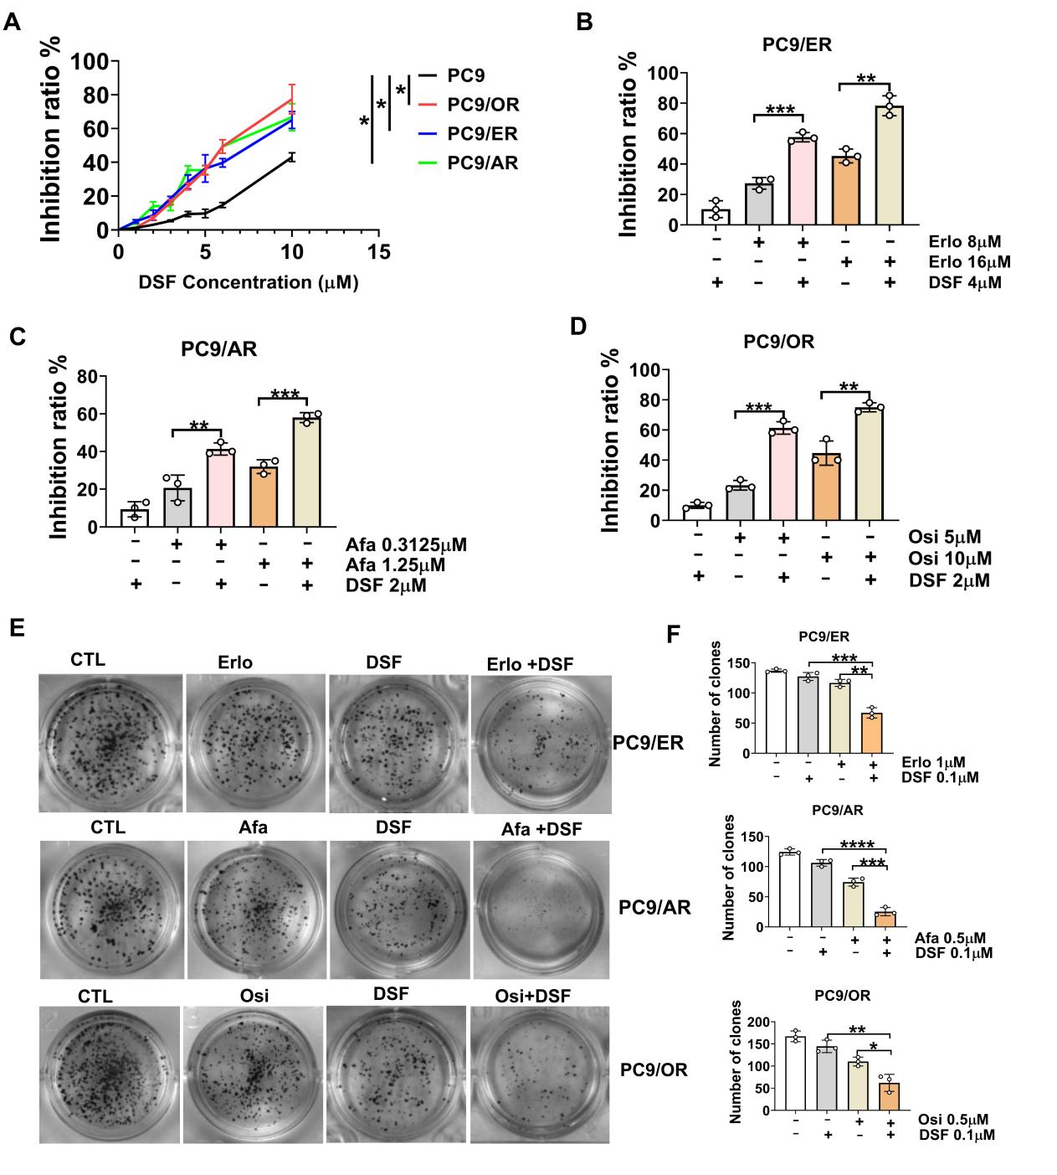
Supplemental Figure 8. Treatment with DSF partially restores the sensitivity to EGFR-TKI in R-PC9 cells. A. Treatment with different concentrations of DSF inhibited the proliferation of PC9 and R-PC9 cells. B-D. Treatment with DSF synergistically enhanced the antitumor effect of TKIs in R-PC9 cells. E-F. Clonal formation and quantitative analysis of the effect of DSF on the inhibition of TKIs on clonal formation in R-PC9 cells. *P<0.05; **P<0.01; ***P<0.001; ****P<0.0001.

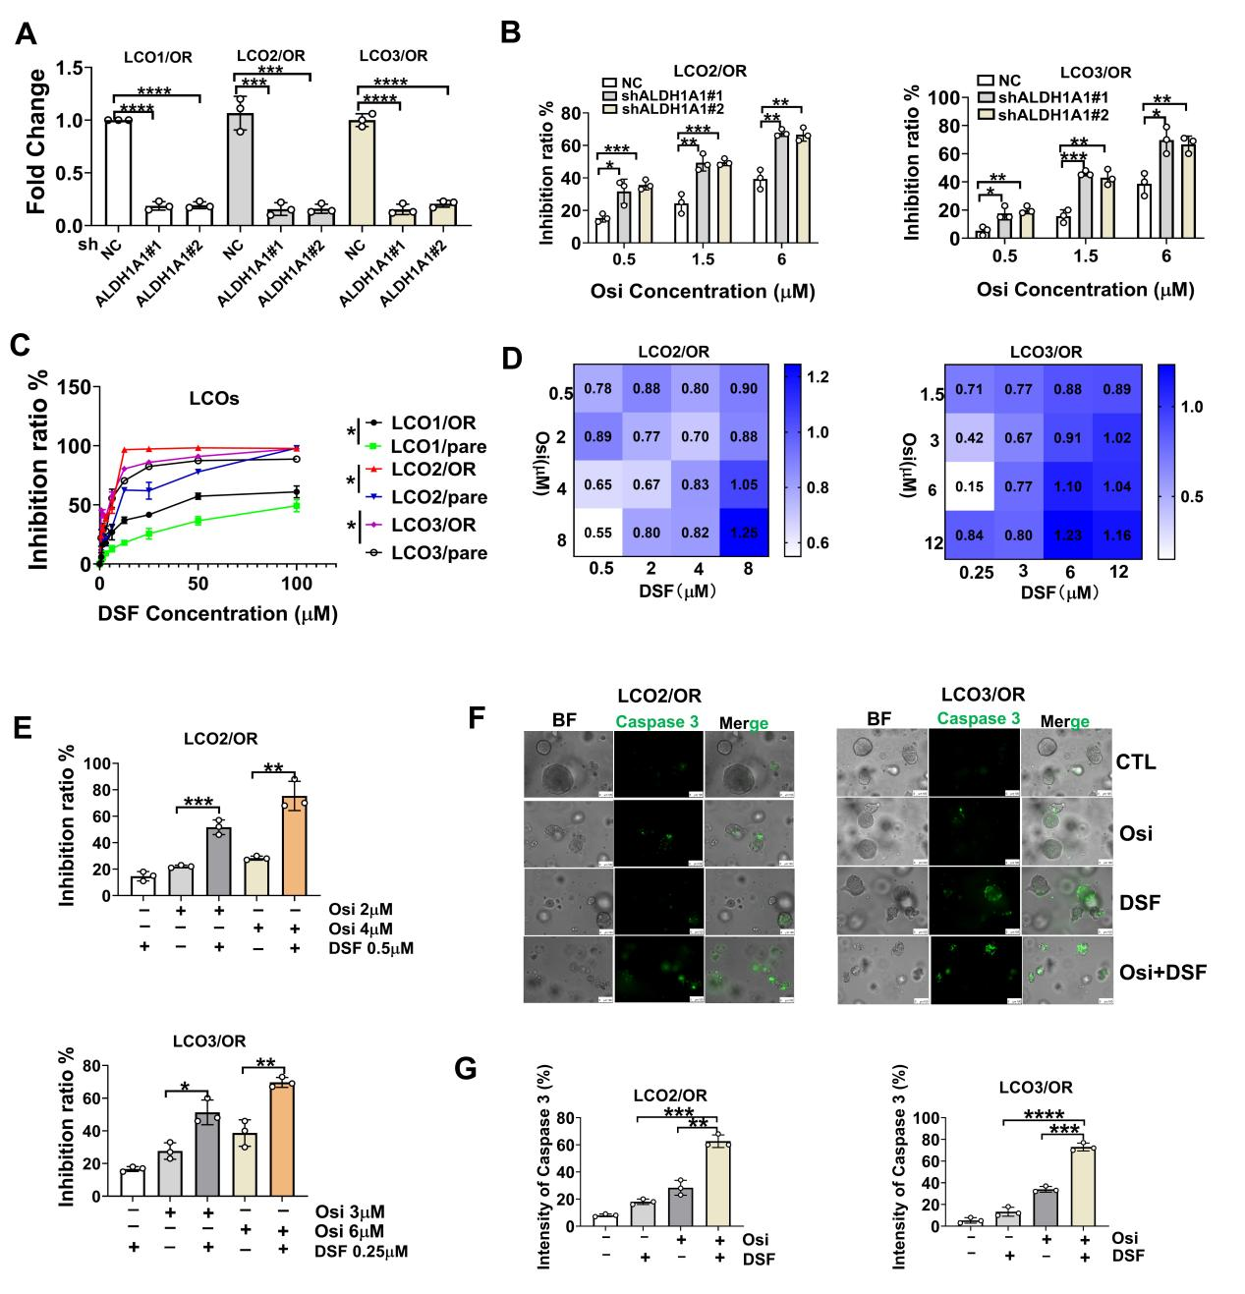
Supplemental Figure 9. Inhibition of ALDH1A1 enhances the sensitivity to EGFR-TKIs in LCOs/OR. A. RT-qPCR analysis of the relative levels of ALDH1A1 mRNA transcripts in LCO/OR. B. ALDH1A1 silencing enhanced the sensitivity to Osi in LCO2/OR and LCO3/OR. C. The inhibitory effect of different concentrations of DSF on LCOs and LCOs/OR cells. D. LCO2-3/OR were treated with different concentrations of Osi and/or DSF for 72h and cell viability was assessed by ATP assay; CI values were analyzed using CompuSyn software for non-constant drug ratio, CI <1 indicates synergism, CI > 1 indicates antagonism. E. Treatment with DSF enhanced the antitumor effect of Osi in LCO2-3 /OR. F-G. Treatment with DSF increased the Osi-up-regulated caspase3 expression in the LCO2-3/OR. *P<0.05; **P<0.01; ***P<0.001; ****P<0.0001.

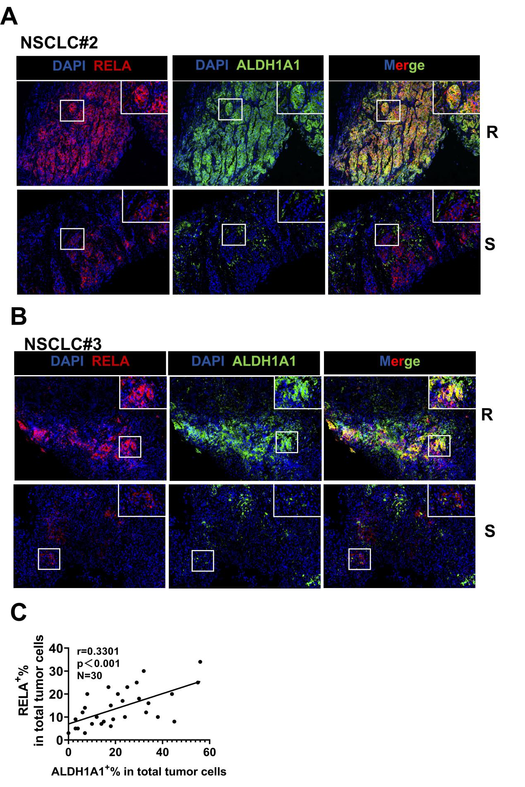
Supplemental Figure 10. UP-regulated RELA is correlated the frequency of ALDH1⁺ stem-like cells in human NSCLC tissues. A-B. Immunofluorescent analysis of ALDH1A1 and RELA expression in human TKI-sensitive or resistant NSCLC tissues (magnification x 40). The white box indicates the enlarged areas. S, sensitive; R, Resistant. C. The correlation between the percentages of RELA⁺ and ALDH1⁺ tumor cells in NSCLC samples (n=30).

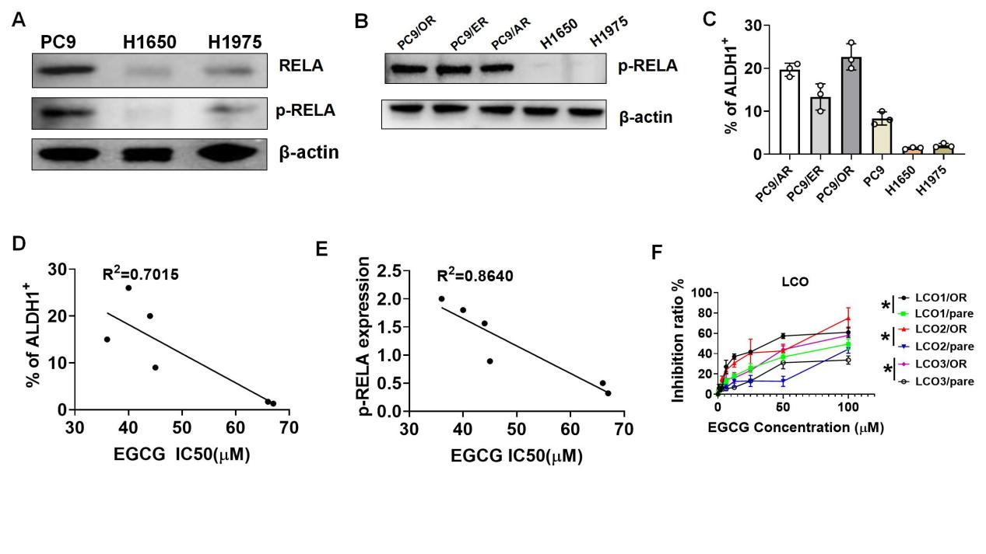
Supplemental Figure 11. Analyzing the correlation between RELA protein expression, ALDH1A1 enzyme activity, and the IC50 values of EGCG. A. Western blot analysis of the relative levels of RELA expression and phosphorylation in PC9, H1650, and H1975 cells. B. Western blot analysis of the relative levels of RELA phosphorylation in the indicated cells. C. Flow cytometry was used to detect the proportion of ALDH1⁺ cells among PC9/OR, PC9/AR, PC9/ER, H1650, and H1975 cells. D. The correlation between the percentages of ALDH1⁺ cells and the IC₅₀ values. E. The correlation between the levels of RELA phosphorylation and the IC₅₀ values. F. The inhibitory effects of different concentrations of EGCG on LCOs and LCOs/OR. *P<0.05.

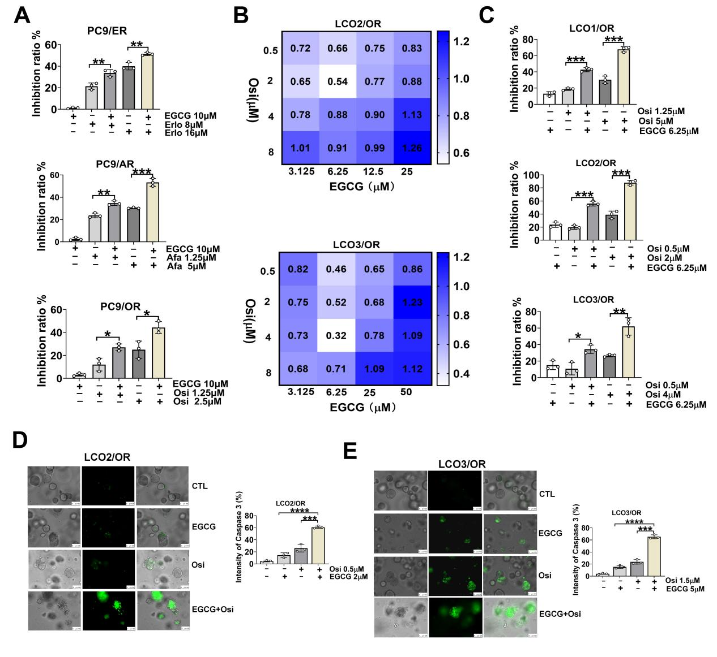
Supplemental Figure 12. Treatment with EGCG enhances the antitumor effect of TKIs on the growth of R-PC9 and LCOs/OR. A. Treatment with EGCG enhanced the inhibition of TKIs on the growth of R-PC9 cells. B. LCOs/OR cells were treated with different concentrations of Osi and/or EGCG for 72-h. The cells' viability was determined by ATP assay. CI <1 indicates synergism, CI =1 indicates additivity, CI > 1 indicates antagonism. C. Treatment with EGCG enhanced the inhibition of TKIs on the growth of LCOs. D-E. Immunofluorescence revealed that treatment with EGCG enhanced the Osi-up-regulated caspase3 expression in LCOs. **P<0.01; ***P<0.001; ****P<0.0001.
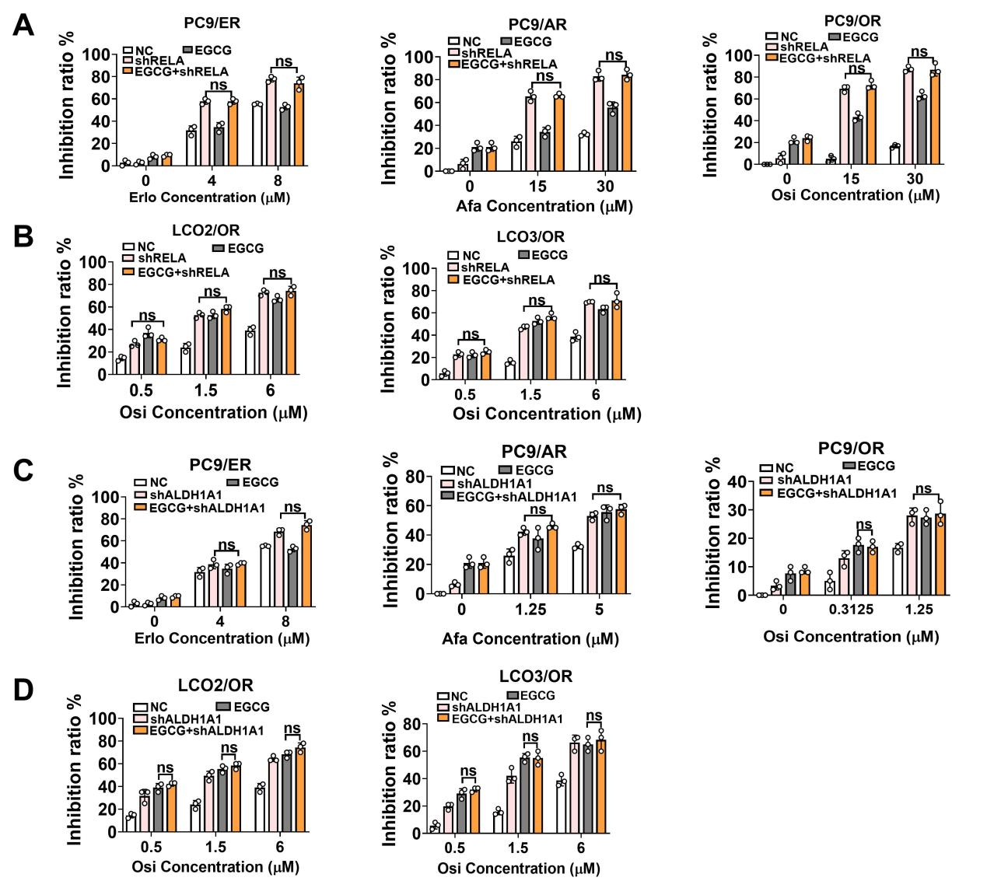
Supplemental Figure 13. Treatment with EGCG fails to modulate the TKI-mediated inhibition on the growth of RELA-silencing R/PC9 cells and LCOs/OR. A-D. Treatment EGCG enhanced the sensitivity to TKIs in R-PC9 cells and LCO2-3/OR, but not in the RELA- or ALDH1A1-silencing R-PC9 cells and LCO2-3/OR. ns, no significant.

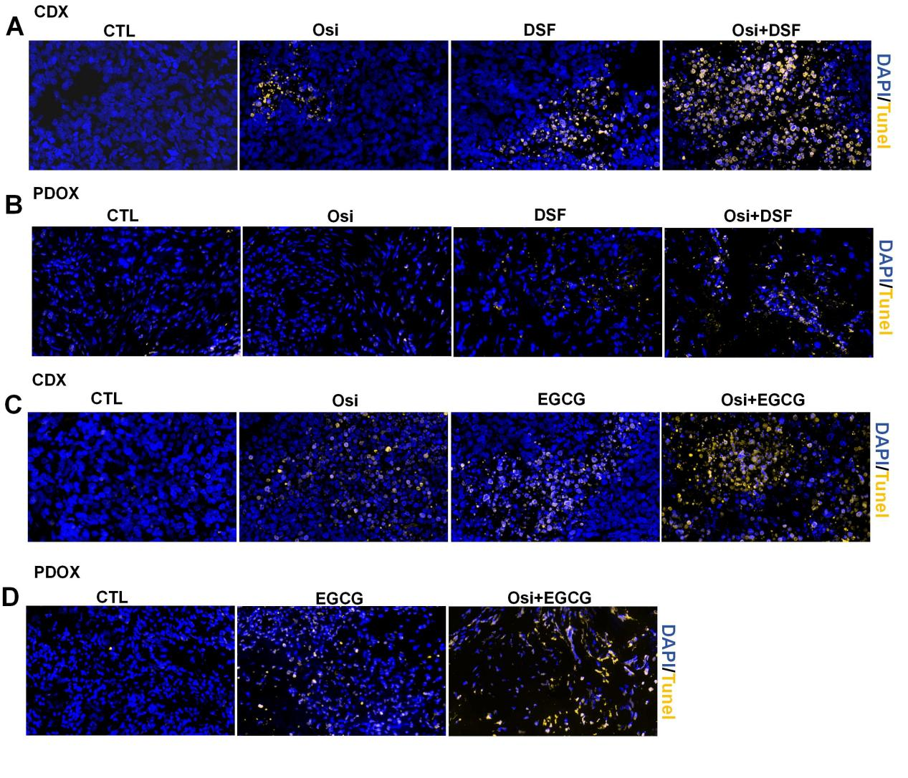
Supplemental Figure 14. TUNEL analysis of apoptotic cells in xenograft tumors (A, C) and PDOX tumors (B, D) (Magnification x 200).

Supplemental Table 1. The clinicopathological characteristics of the cases and LCOs subtype
Oranoid  line | SEX | Age | Tumor type | Tumor location | pT | pN | cM | stage | Mutation
 | Female | 65 | LC | Lung | cT2a | N2 | M1a | Ⅳa | EGFR L858R
 | Female | 60 | LC | Lung | cT1 | N0 | M1c | Ⅳb | EGFR 19del
 | Male | 52 | LC | Lung | T2a | N3 | M1c | Ⅳb | EGFR L858R
 | Female | 69 | LC | Lung | cT4 | N3 | M1a | Ⅳ | EGFR L858R
 | Male | 80 | LC | Lung | cT3 | N3 | M1a | Ⅳa | EGFR L858R
 | Female | 67 | LC | Lung | cT2b | N2 | M1b | Ⅳa | EGFR 19del
 | Female | 56 | LC | Lung | pT1b | N0 | M0 | ⅠA2 | EGFR 19del
 | Female | 40 | LC | Lung | pT1b | N0 | M0 | ⅠA2 | EGFR L858R
LCO1 | Female | 56 | LC | Lung | pT2a | N0 | M0 | ⅠB | EGFR 19del
LCO2 | Female | 78 | LC | Lung | cT4 | N2 | M1c | Ⅳb | EGFR 19del
LCO3 | Male | 76 | LC | Lung | pT2a | N0 | M0 | ⅠB | EGFR 19del
 | Female | 74 | LC | Lung | pT2a | N2a | M0 | Ⅲa | EGFR 19del
 | Female | 61 | LC | Lung | pT1b | N0 | M0 | ⅠA2 | EGFR 19del
 | Female | 75 | LC | Lung | cT2b | N1 | M1 | ⅣA | EGFR 19del
 | Female | 81 | LC | Lung | pT2a | N0 | M0 | ⅠB | EGFR 19del
 | Female | 61 | LC | Lung | T4 | N0 | M1 | Ⅳ | EGFR 19del
 | Male | 66 | LC | Lung | pT1b | N0 | M0 | ⅠA2 | EGFR 19del
 | Male | 73 | LC | Lung | pT1b | N0 | M0 | ⅠA2 | EGFR 19del

Supplemental Table 2. The detailed information on antibodies
Antibodies | Source | Application
NF-κB | Cell Signaling Technology (Cat #8242) | 1:1000 for WB  1:100 for IHC  1:100 for Chip
p-NF-κB | Cell Signaling Technology (Cat #3033) | 1:1000 for WB  1:1000 for IF
KI67 | ABclonal (Cat #A20018) | 1:200 for IF
MDR1 | Abcam (Cat #Ab71916) | 1:1000 for IF
β-actin | Abcam (Cat #Ab8146) | 1:5000 for WB
Lamin B | Proteintech (Cat #12987-1-AP) | 1:5000 for WB
CEA | Abcam (Cat #ab133633) | 1:500 for IF
CK20 | ABclonal (Cat #A1629) | 1:100 for IHC
TIFF1 | Abcam(Cat #Ab204411) | 1:500 for IHC
CK7 | Abcam(Cat #Ab181598) | 1:8000 for IHC
ALDH1A1 | ABclonal(Cat #A1802) | 1:500 for WB  1:200 for IF
Caspase 3 | Cell Signaling Technology (Cat #9662) | 1:1000 for WB
Cleaved Caspase-3 | Cell Signaling Technology (Cat #9664) | 1:1000 for WB
PARP | Cell Signaling Technology (Cat #9542) | 1:1000 for WB
Cleaved PARP | Cell Signaling Technology (Cat #5625) | 1:1000 for WB
PARP | Cell Signaling Technology (Cat #9532) | 1:1000 for WB

Supplemental Table 3: Target Sequences of lentivirus
Name | Target sequences
Negative Control Scramble | TTCTCCGAACGTGTCACGT
shRELA | GATTGAGGAGAAACGTAAA
shALDH1A1#1 | GCACCGATTTGAAGATTCAATA
shALDH1A1#2 | GCTGATTTAATCGAAAGAGAT

Supplemental Table 4 : The primers for ChIP-PCR
Gene name |  | Sequences
ALDH1A1 promoter | Forward | 5’-GTCCAAACACAGAGGGAGTTG-3’
ALDH1A1 promoter | Reverse | 5’-GTTTATTTACACGTGGCTTTAAACA-3’

Supplemental Table 5: The sequences of primers for RT-qPCR
Genes | Accession # | Sequences of Primers
GAPDH | NM_002046.7 | Forward: 5’-AAGGTGAAGGTCGGAGTCAAC-3’  Reverse: 5’-GGGGTCATTGATGGCAACAATA-3
RELA | NM_001145138.2 | Forward: 5’-TGTGAAGAAGCGGGACCTGGAG-3’  Reverse: 5’-AAGCAGAGCCGCACAGCATTC-3’
ABCG2 | NM_001257386.2 | Forward: 5’-GCAGCAGGTCAGAGTGTGGTTTC-3’  Reverse:5’-ACTGAAGCCATGACAGCCAAGATG-3’
KLF4 | NM_001314052.2 | Forward: 5’-TGACTGGGACGGCTGTGGATG-3’  Reverse: 5’-CTTCATGTGTAAGGCGAGGTGGTC-3’
EPCAM | NM_002354.3 | Forward: 5’-AAGGCCAAGCAGTGCAACGG-3’  Reverse: 5’-TCCAGTAGGTTCTCACTCGCTCAG-3’
SOX9 | NM_000346.4 | Forward: 5’-CACACGCTGACCACGCTGAG-3’  Reverse: 5’-GCTGCTGCTGCTCGCTGTAG-3’
CD133 | NM_001145847.2 | Forward: 5’-GTGGCGTGTGCGGCTATGAC-3’  Reverse:5’-CCAACTCCAACCATGAGGAAGACG-3’
AXIN2 | NM_001363813.1 | Forward: 5’-CACCACCACCACCACCATTCG-3’  Reverse:5’-ACATGCTTCGTCGTCTGCTTGG-3’
ALDH1A1 | NM_000689.5 | Forward:5’-ACGCCAGACTTACCTGTCCTACTC-3’  Reverse:5’-TCTTGCCACTCACTGAATCATGCC-3’
NANOG | NM_001297698.2 | Forward:5’-AGATGCCTCACACGGAGACTG-3’  Reverse:5’-GGGTTGTTTGCCTTTGGGACTG-3’

