Novel Monsoon Indices Based on Vector Projection and Directed Angle for Measuring East Asian Summer Monsoon

Yinan Yang^{1,2}, Jianping Li^{1,2*}

¹Frontiers Science Center for Deep Ocean Multi-spheres and Earth System (DOMES)/Key Laboratory of Physical Oceanography/Academy of Future Ocean/College of Oceanic and Atmospheric Sciences/Center for Ocean Carbon Neutrality, Ocean University of China, Qingdao 266100, China.
² Laboratory for Ocean Dynamics and Climate, Qingdao Marine Science and Technology Center, Qingdao 266237, China.

Supplementary Material

Submitted to Climate Dynamics

* Corresponding author: Jianping Li (ljp@ouc.edu.cn)

Supplementary Material

Figure S1
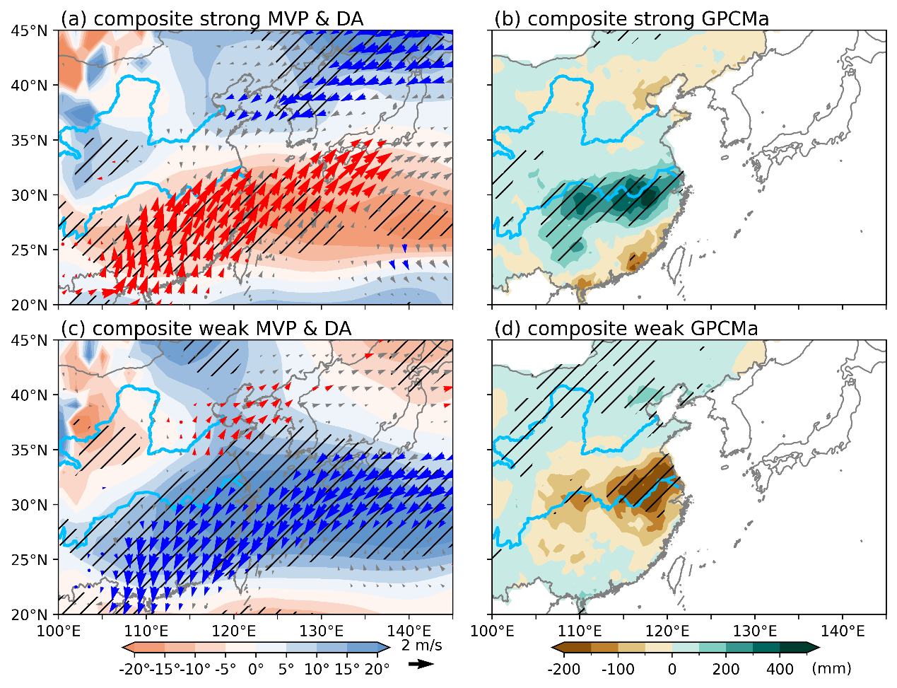
Fig. S1 (a) and (c) are the same as Fig. 6 (a), but for composite JJA MVPa and DA fields in strong and weak EASM years, respectively. (b) and (d) are the same as Fig. 6 (b), but for composite JJA GPCM precipitation anomalies fields in strong and weak EASM years, respectively.

Figure S2
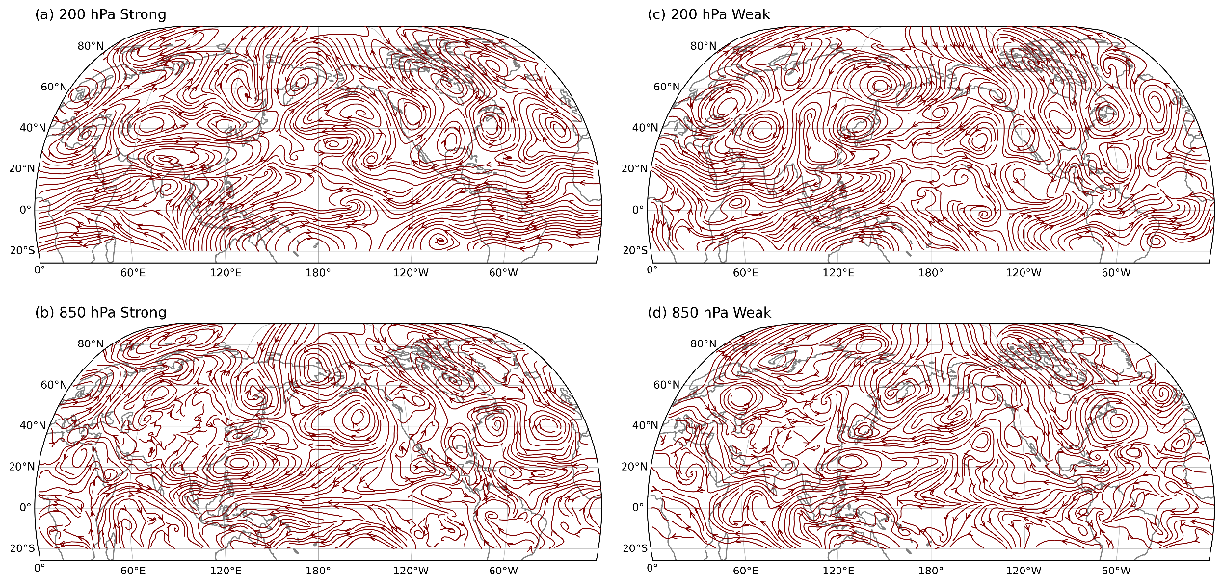
Fig. S2 Composite JJA streamlines of the anomalous wind fields at (a) 200 hPa and (b) 850 hPa in strong EASM years; (c) and (d) are the same as (a) and (b), respectively, but for weak EASM years.

