Supplementary Materials
Skin conductance. Approach period: Skin conductance level (SCL) was measured as participants navigated towards the flower. A 2x2x4 ANOVA (zone x group x block) analysis of tonic changes in skin conductance showed a main effect of zone with greater SCL when approaching flowers located in dangerous relative to safe zones (F(1,49)=16.24, p<0.01). No other significant main effects or interactions were observed (F’s<2, p’s>0.05). Based on the first hypothesis, that ANX would evidence overgeneralization,¹² within-group main effects of zone were explored and indicated that only HCs had significantly higher SCL towards dangerous flowers as compared to safe flowers (HC, t(27)=3.94, p<0.01; ANX, t(22)=1.99, p=0.06; Figure S1 C and F).
Stationary period: Next, skin conductance responses (SCR) were analyzed during the stationary periods immediately after participants touched a flower, using a 2x2x4 ANOVA (zone x group x block). This analysis revealed a main effect of zone with greater SCRs to flowers located in dangerous compared to safe zones (F(1,49)=4.13, p<0.05). A main effect of block was also observed with decreased SCRs over time (F(3,147)=17.62, p<0.001). No other significant effects were found (F’s<2, p’s>0.05). Within-group main effects of zone were explored, showing that only HC’s had significantly higher SCR towards dangerous flowers as compared to safe flowers (HC, t(27)=2.42, p<0.05; ANX, t(22)=0.98, p>0.05; Figure S1 D and G).
Shock expectancy. Assessing shock expectancy ratings, a 2x2x4 ANOVA (zone x group x block) revealed a significant zone x block interaction (F(3,147)=31.07, p<0.001). Also, significant main effects of zone (F(1,49)=121.08, p<0.01) and block (F(3,147)=21.01, p<0.001) were observed. No other significant effects were found (F’s<2, p’s>0.05). Further analysis of this interaction showed that within participants, danger zone shock expectancy ratings to flowers remained high from block 1 to block 4 (t(50)=0.06, p>0.05), while safe zone ratings significantly decreased (block 1 v block 4, t(50)=8.83, p<0.001). Within-group main effects of zone were explored, showing that both groups showed higher expectancy ratings towards dangerous flowers as compared to safe flowers (HC, F(1,27)=59.27, p<0.01; ANX, F(1,22)=67.73, p<0.01; Figure S1 E and H).

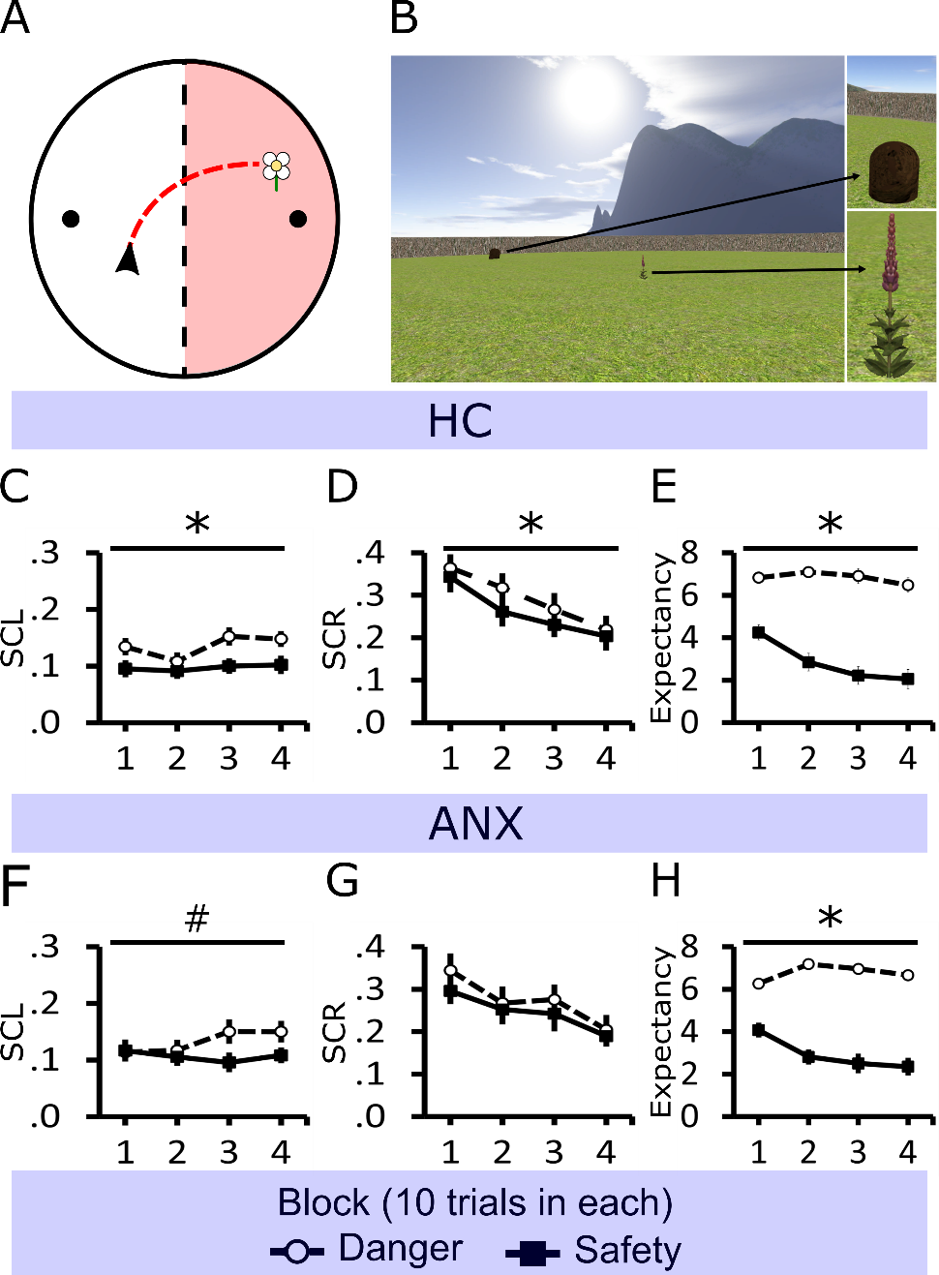
Figure S1. Task illustration and behavioral data across threat learning. (A) Helicopter view of the circular environment that participants (black arrow) explored (red trace) and how it was split into one-half associated with danger (red zone) and the other with safety. The environment included two beehives (black dots) located at opposite sides. Participants were required to collect flowers, which were generated within the environment. (B) Example of the participant’s viewpoint, showing a beehive and flower in the environment. (C) HCs’ and (F) ANXs’ mean tonic skin conductance level (SCL) as flowers were approached. (D) HCs’ and (G) ANXs’ mean phasic skin conductance responses (SCR) during the stationary periods when flowers were picked. (E) HCs’ and (H) ANXs’ shock expectancy ratings at the onset of stationary periods when picking a flower. Error bars show standard error mean, *p<0.05, #p<0.1.

The spatial memory task. Interleaved with these flower trials, participants performed a spatial memory task within the same environment (see Methods for further details). Participants were required to learn the location of four objects, with two objects appearing in each side of the environment (i.e., the safe or danger zones, although objects were never paired with shock). Participants were required to replace objects where they had been found, and distance error from the correct location provided a measure of performance.
A 2x2x4 ANOVA (zone x group x block) on mean distance error for the object placement showed no zone x group x block, zone x group, zone x block, or group x block interaction (all F’s<2, p’s>0.05). However, there was a significant effect of zone (F(1,49)=6.47, p<0.05) and block (F(3,147)=18.48, p<0.001).
A 2x4 ANOVA (zone x block) within each group on mean object placement distance error showed no zone x block interaction in either group (F’s<2, p’s>0.05), but a significant effect of block in both groups was found (HC, F(3,816)=10.40; ANX, F(3,66)=8.69, p’s<0.01; Fig. S2). A direct comparison of performance, of both groups together, across test blocks showed that distance error decreased from block 1 to block 4 (danger, t(50)=4.67; safe, t(50)=5.10, p’s<0.01) reflecting improved spatial memory performance irrespective of whether objects had been located in the danger or safe zones of the flower task. Main effects of zone analysis revealed no significant difference in the HC (F(1,27)=2.84, p=0.103) between error of objects placed in the danger and safe zone. A trend-level greater distance error in the safe zone was found for the ANX (F(1,22)=3.69, p=0.068). A direct comparison in learning between zones for ANX showed a significantly greater distance error in objects found in the safe compared to the danger zone in block 1 (t(22)=-2.61, p<0.05) but not in block 4 (t(22)=-0.74, p>0.05).

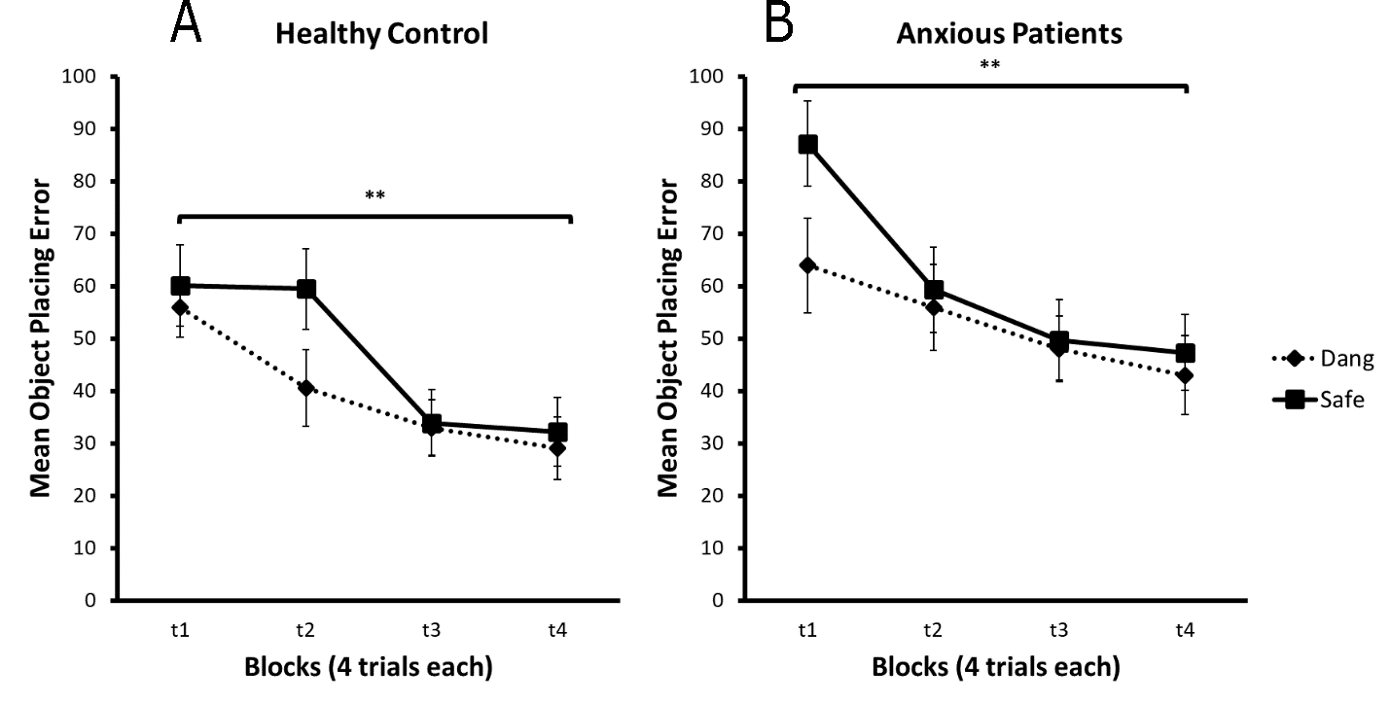
Fig. S2. Mean object placement error. A) HC and B) ANX mean object placement error, for the safe zone (Safe) and the dangerous zone (Dang) over block. Error bars show standard error mean, **p<0.01.
Approach periods: Differences between approaching flowers and object locations
As a control for movement and to understand participant’s approach to cues (emotional flowers vs. unemotional objects), brain activation changes were analyzed between groups when performing the two tasks. Approaching flowers during the threat learning task was collapsed across danger and safe conditions. Object-approach periods consisted of only trials when participants were instructed to collect the object and remember its spatial location (i.e., omitting object replacement trials). See Table S3 for full results from this analysis. Each period began at trial onset, when the flower or object appeared in the environment, and ended when that flower or object was “collected.”
The analysis was conducted after excluding the initial orienting period of the approach period focusing on the last 75% of the approach period (active navigation). To assess differences in learning between the flower and object task, trials were divided into early (first half of the experiment) and late blocks (second half of the experiment). The analysis was conducted on the full sample and in the same fashion as the approach and freezing period, which consited of a first level analysis (2x2 ANOVA) with two within-subjects factors (task: object, flower; block: early, late). The second level analysis consited of a the between-subjects factor (group: ANX, HC).
When approaching objects (objects > flowers; early > late) patients with pathological anxiety (ANX>HC) showed increased activation in the posterior cingulate cortex (PCC) from early to late blocks. The contrast in HC (HC>ANX) showed decreased activation in the PCC across blocks (p<0.05 FWE; see Fig. S3A).
When approaching flowers (flowers > objects; early > late), patients with pathological anxiety (ANX>HC) showed decreased activation in the orbitofrontal cortext (OFC) and anterior hippocampus from early to late blocks. The contrast in HC (HC>ANX) demonstrated increased activation from early to late blocks in OFC and anterior hippocampus (p<0.05 FWE SVC; see Fig. S3A).
During the second half of the experiment (late > early), the ANX (ANX > HC) showed increased dmPFC activation from the early to the late blocks irrespective of the task (p<0.05 FWE SVC; Fig. S3B). No other contrast revealed significant results.
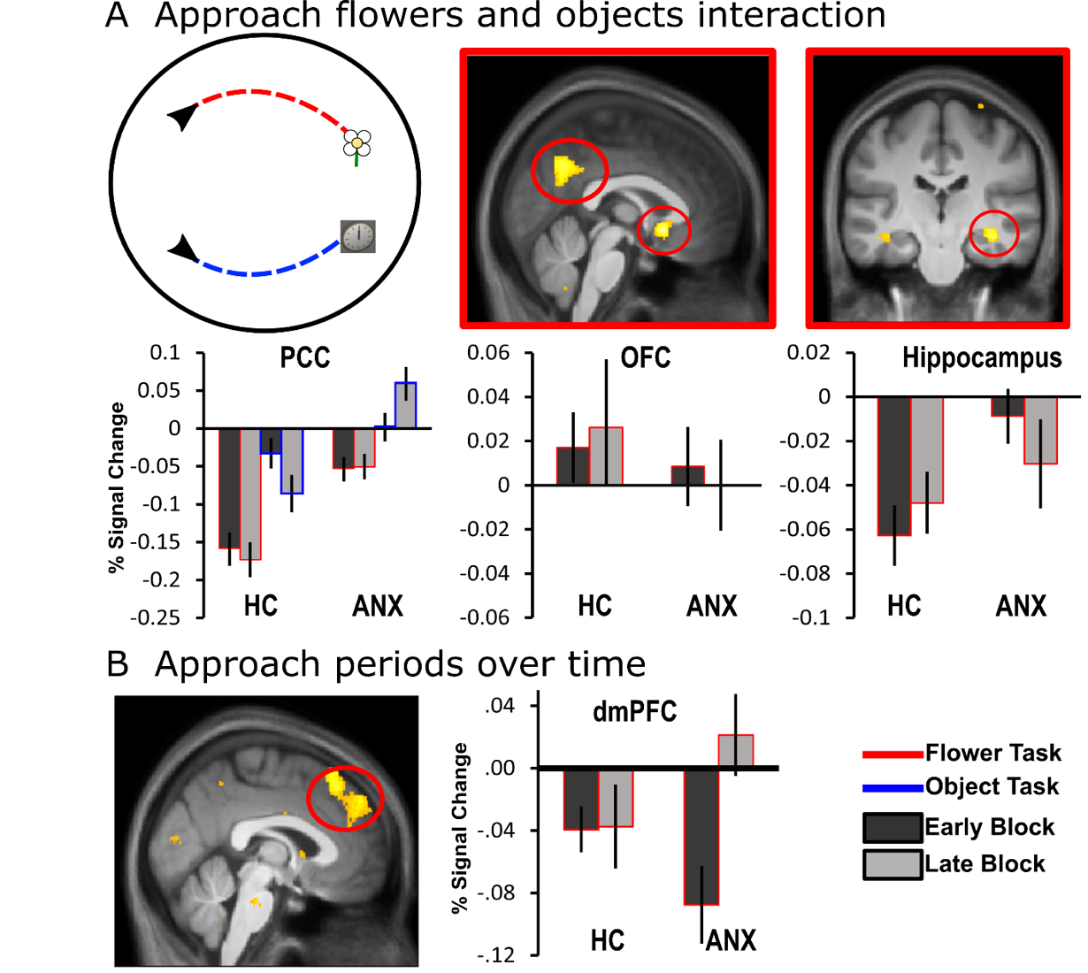
Figure S3. Activation differences between approaching flowers and objects during threat and spatial memory. (A) Circular illustration (left panel): helicopter view of the circular environment that participants (black arrow) explored and approach to emotional-flower (red-trace) and approach to unemotional object (blue-trace). Percentage signal change of task-by-block-by-group interaction when approaching flowers compared to objects in a range of brain areas, including the posterior cingulate cortex (PCC; p<0.05 FWE; middle panel), orbitofrontal cortex (OFC; p<0.05 FWE; middle panel), and hippocampus (p<.0.05 FWE SVC; right panel), (B) Activation change was greater from the first to the second half experiment in the dorsomedial prefrontal cortex (dmPFC) in ANX (p<0.05 FWE SVC; left panel). All images are presented at p<0.001 uncorrected for display purposes. Percentage signal changes for learning about threat and object locations across early and late periods of the task extracted from (A) PCC (MNI coordinates: -2, -63, 21; left panel), OFC (MNI coordinates: 0, 14, -8; middle panel), hippocampus (MNI coordinates: 23, -20, -14; right panel), and (B) dmPFC (MNI coordinates: 0, 29, 53; middle panel). Error bars show standard error mean.
Supplementary tables
Table S1. Summary of between-group imaging findings when approaching flowers predicting danger or safety.
 |  | MNI coordinates
Region | Laterality | x |  | y |  | z | z-score
Interaction threat (danger, safety) x block (early, late) x group (ANX, HC)
Orbitofrontal Cortex | R | 5 |  | 9 |  | -11 | 4.84
 | R | 5 |  | 29 |  | -12 | 4.58
Hippocampus | R | 23 |  | -17 |  | -18 | 4.62
 | L | -27 |  | -17 |  | -14 | 4.02
Ventromedial Prefrontal Cortex | R | 3 |  | 51 |  | 14 | 4.60
Posterior Cingulate Cortex┼ | L | -11 |  | -54 |  | 21 | 4.28
Interaction threat (danger > safe) x group (ANX > HC)
Insula┼ | L | -44 |  | 15 |  | 0 | 4.01
 | R | 41 |  | 20 |  | 3 | 3.33
Dorsomedial Prefrontal Cortex | R | 9 |  | 26 |  | 45 | 3.95
Interaction block (late > early) x group (HC > ANX)
Hippocampus | R | 26 |  | -29 |  | -8 | 3.04
Ventromedial Prefrontal Cortex | L | -9 |  | 50 |  | -18 | 2.67
Orbitofrontal Cortex | R | 9 |  | 39 |  | -12 | 2.52
p<0.05 FWE SVC unless stated; ┼p<0.05 FWE across whole brain; ANX, patients with with pathological anxiety; HC, healthy comparisons

Table S2. Summary of between-group imaging findings during freezing periods for flowers during danger and safety.
 |  | MNI coordinates
Region | Laterality | x |  | y |  | z | z-score
Interaction threat (danger, safety) x block (early, late) x group (ANX, HC)
Ventromedial Prefrontal Cortex | R | 12 |  | 47 |  | 2 | 4.31
 | L | -9 |  | 59 |  | 9 | 3.73
Posterior Cingulate Cortex┼ | R | 6 |  | -50 |  | 18 | 3.96
Orbitofrontal Cortex | L | -5 |  | 15 |  | -9 | 3.94
 | L | -5 |  | 36 |  | -12 | 3.94
Interaction threat (danger > safety) x group (ANX > HC)
Dorsomedial Prefrontal Cortex┼ |  | 0 |  | -8 |  | 71 | 4.68
 | R | 8 |  | 18 |  | 51 | 4.63
 | R | 6 |  | 38 |  | 24 | 4.51
Insula┼ | L | -39 |  | 21 |  | -5 | 4.44
 | R | 41 |  | -6 |  | 0 | 4.20
Amygdala┼ | R | 26 |  | -2 |  | -15 | 4.13
 | L | -20 |  | 2 |  | -15 | 4.10
Periaqueductal Grey┼ | R | 6 |  | -26 |  | -5 | 4.08
 | L | -2 |  | -29 |  | -8 | 3.37
Caudate┼ | L | -9 |  | 9 |  | 3 | 4.03
 | R | 11 |  | 9 |  | 2 | 3.63
Dorsal Anterior Cingulate Cortex┼ | L | -3 |  | 25.5 |  | 21 | 3.84
Thalamus┼ | R | 11 |  | -8 |  | 8 | 3.77
 | L | -9 |  | 9 |  | 3 | 3.30
Interaction threat (safety > danger) x group (HC > ANX)
Posterior Cingulate Cortex┼ | L | -3 |  | -60 |  | 27 | 4.66
Orbitofrontal Cortex | L | -3 |  | 54 |  | -17 | 4.64
 | R | 2 |  | 11 |  | -12 | 4.03
Hippocampus | R | 23 |  | -18 |  | -14 | 4.08
 | L | -32 |  | -29 |  | -12 | 3.85
Ventromedial Prefrontal Cortex | L | -3 |  | 65 |  | 14 | 3.24
Interaction block (late > early) x group (ANX > HC)
Dorsomedial Prefrontal Cortex | R | 3 |  | 32 |  | 44 | 3.65
Interaction block (late > early) x group (HC > ANX)
Orbitofrontal Cortex | R | 14 |  | 44 |  | -15 | 4.62
Ventromedial Prefrontal Cortex | R | 12 |  | 54 |  | -3 | 3.92
 | R | 11 |  | 47 |  | 17 | 3.72
Posterior Cingulate Cortex | R | 3 |  | -41 |  | 26 | 2.80
p<0.05 FWE SVC unless stated; ┼p<0.05 FWE across whole brain; ANX, patients with pathological anxiety; HC, healthy comparisons
Table S3. Summary of between-group imaging findings when approaching flowers during threat learning or objects during spatial memory encoding.
 |  | MNI coordinates
Region | Laterality | x |  | y |  | z | z-score
Interaction Task (flower, object) x block (early, late) x group (ANX, HC)
Posterior Cingulate Cortex┼ | L | -2 |  | -63 |  | 21 | 3.80
Orbitofrontal Cortex |  | 0 |  | 14 |  | -8 | 3.28
Hippocampus | R | 23 |  | -20 |  | -14 | 3.13
Interaction block (late > early) x group (ANX > HC)
Dorsomedial Prefrontal Cortex |  | 0 |  | 29 |  | 53 | 4.44
Interaction task (flower > object) x group (HC > ANX)
Orbitofrontal Cortex | L | -5 |  | 32 |  | -20 | 3.58
p<0.05 FWE SVC unless stated; ┼p<0.05 FWE across whole brain; ANX, patients with pathological anxiety; HC, healthy comparisons

