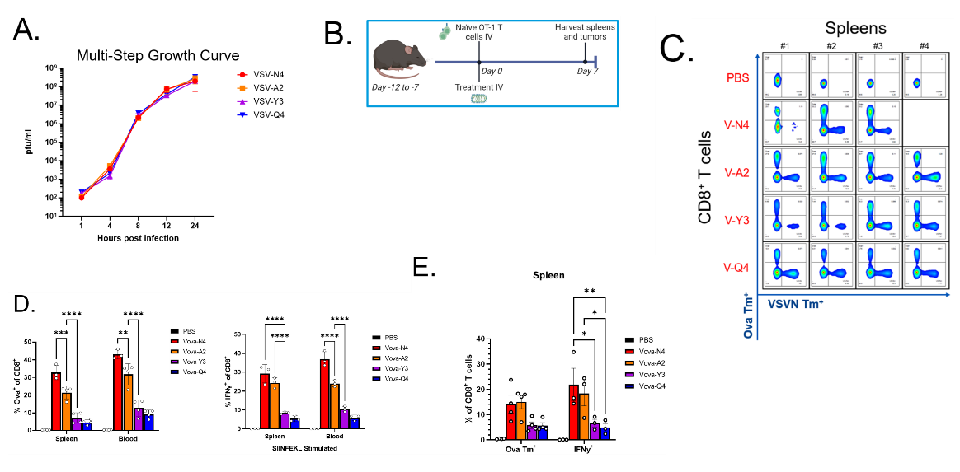
Extended Data Figure 1. A) Multi-step growth curve of VSV-APL variants on BHK cells infected at an MOI of 0.01. Titers were determine via plaque assay of clarified supernatants. n=3. B) Schematic of VSV and OT-1 T cell administration in tumor-free C57Bl/6J mice. C) Flow cytometry plots depicting SIINFEKL and VSVN T cell specificity in splenocytes. D) Enumeration of tetramer positive T cells in the spleen and blood (n=4). Cells were treated with SIINFEKL peptide in vitro and IFNγ secretion was detected via intracellular flow cytometry staining (n=3). E) Experimental repeat of (B) in RIP-mOVA mice. Enumeration of tetramer positive T cells and secretion of IFNy upon SIINFEKL stimulation were determined as before. n=4. P values were determined using a one-way ANOVA with a Tukey multiple-comparison posttest.
Target | Fluor | Dilution | Company | CAS
Anti-mouse CD8b.2 | PE/Cyanine7 | 1:500 | BioLegend | 140416
Anti-mouse IFNy | APC | 1:250 | BioLegend | 505810
Anti-mouse CD3 | Alexa Fluor 700 | 1:500 | BioLegend | 100216
Anti-mouse CD45.2 | PE/Dazzle 594 | 1:1000 | BioLegend | 109845
Anti-mouse CD44 | Brilliant Violet 785 | 1:1000 | BioLegend | 103059
Anti-mouse CD279 (PD-1) | APC/Fire 810 | 1:500 | BioLegend | 135251
Anti-mouse CD39 | PE | 1:1000 | BioLegend | 143804
Anti-mouse CD223 (LAG3) | PerCP/Cyanine5.5 | 1:500 | BioLegend | 125212
Anti-mouse CD4 | FITC | 1:250 | BioLegend | 103006
Anti-mouse CD366 (TIM3) | BV605 | 1:500 | BioLegend | 119721
Anti-mouse CD4 | PerCP | 1:250 | BioLegend | 100538
Anti-mouse CD8b.2 | Pacific Blue | 1:250 | BioLegend | 140414
Anti-mouse CD25 | APC/Fire 810 | 1:500 | BioLegend | 102075
Anti-mouse CD278 (ICOS) | PE/Fire 700 | 1:1000 | BioLegend | 107715
Anti-mouse KLRG1 (MAFA) | Brilliant Violet 711 | 1:500 | BioLegend | 138427
Anti-mouse CD62L | PE/Cyanine7 | 1:500 | BioLegend | 104417
Anti-mouse CD279 (PD-1) | Brilliant Violet 421 | 1:500 | BioLegend | 135217
Anti-mouse CD45 | Brilliant Blue 515 | 1:1000 | BD Horizon | 564590

Supplementary Table 1. Flow cytometry reagents and working concentrations.

