Supplementary Information for:

Apt_{ERA} 2 targets ERA from Staphylococcus aureus and limits GTP hydrolysis
Katherin Peñaranda^{1,2,*}, Nicolle Pereira¹, Orestis Savva ³, Dezemona Petrelli², Roberto Spurio², Rebecca M. Corrigan^{3,4}, and Pohl Milon^{1,*}

¹Laboratory of Biomolecules, Faculty of Health Sciences, Universidad Peruana de Ciencias Aplicadas (UPC), 15023 Lima, Peru
²Laboratory of Genetics, School of Biosciences and Veterinary Medicine, University of Camerino, 62032 Camerino, Italy.
³School of Biosciences, University of Sheffield, Sheffield, S10 2TN, United Kingdom.
⁴School of Medicine, University College Dublin, Belfield, Dublin 4, Ireland.
*pcmekape@upc.edu.pe, pmilon@upc.edu.pe

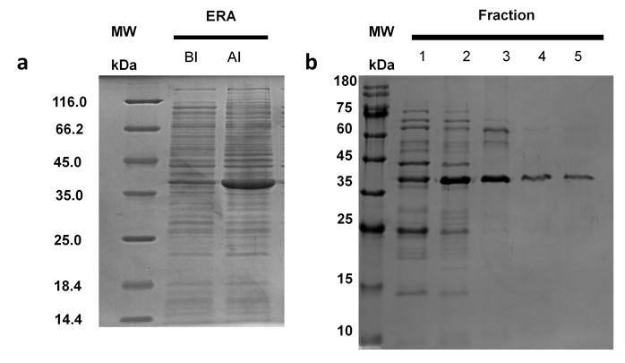

Figure S1: Production of recombinant ERA. (a) Expression of ERA in LB medium, where BI indicates before induction and AI after overnight induction with 0.5 mM IPTG. ERA (36.5 kDa) appears as a band between 35 and 45 kDa as analyzed by 15% SDS-PAGE. (b) ERA elution from His-trap HP column, analyzed by a 15% SDS-PAGE gel. Fraction 5 was selected, dialyzed and quantified.

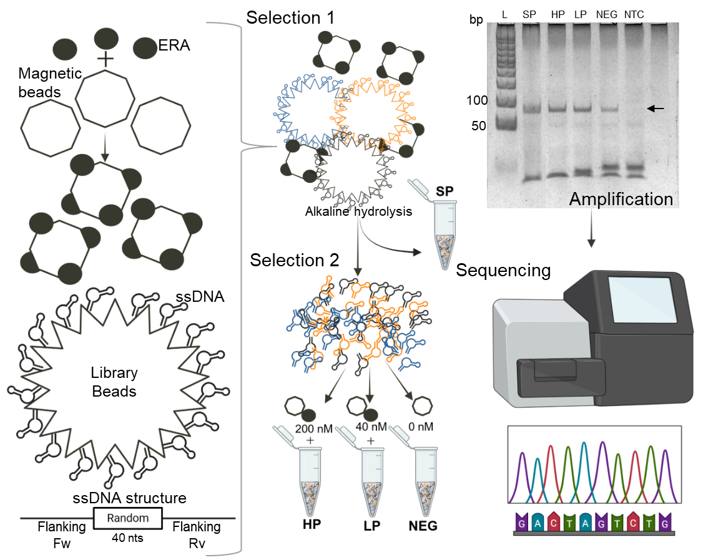

Figure S2: SELEX Workflow. The SELEX process consisted in two positive selections (1 and 2), followed by PCR amplification and a final high-throughput sequencing. For the first selection, ERA-coupled magnetic beads were used to present the target to an ssDNA library linked to polystyrene beads. Each ssDNA has a central 40nts random sequence and two constant flanking regions. Library sequence diversity is represented by color variation in beads. From this first selection, ssDNA-beads that bind target ERA were separated with a magnet and the selected ssDNA was released from polystyrene beads through alkaline hydrolysis. This new pool of released ssDNA is considered the Start Pool (SP) library, and a sample was directly used for amplification and sequencing. For the second selection, SP is used for a matrix-free target/ssDNA incubation with different ERA concentrations: 200 nM (High Protein, HP), 40 nM (Low Protein, LP), and 0 nM (Negative control) for 30 min. After this time, magnetic beads are used to pull down ssDNA aptamers that are able to bind ERA. The four libraries were amplified by PCR, using primers complementary to the flanking regions forward (Fw) and reverse (Rv). The results of electrophoretic separation by agarose gel, indicate the expected 74 bp product (black arrow) for samples SP, HP and LP. The lane labeled "NTC" corresponds to the no-template control for PCR, while L indicates the AmpliSize Molecular Ruler 50–2000 bp Ladder (# 1708200, Bio-Rad, USA). Finally, all amplified libraries were sequenced in the Illumina platform.
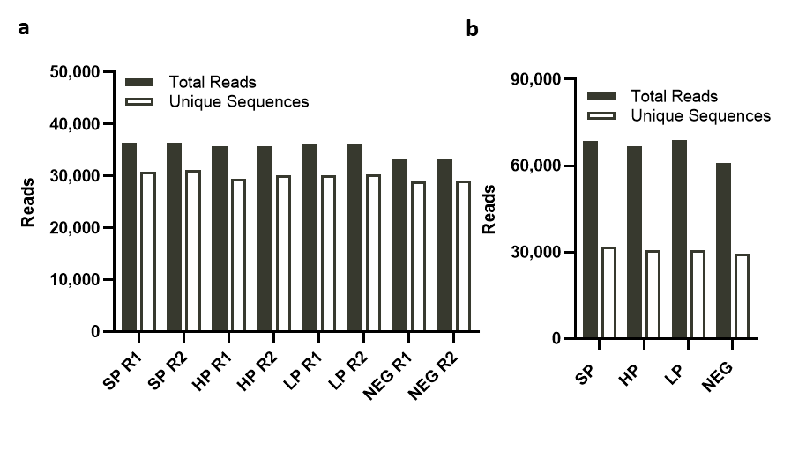
Figure S3: Galaxy project curation analysis. (a) Unique (White) vs. Total (Black) sequences in all four libraries. (b) Galaxy-curated libraries using merged R1 and R2 reads. Start Pool (SP), High Protein (HP), Low Protein (LP) and Negative control (NC) are indicated in the x-axis while total reads are plotted in the y-axis.
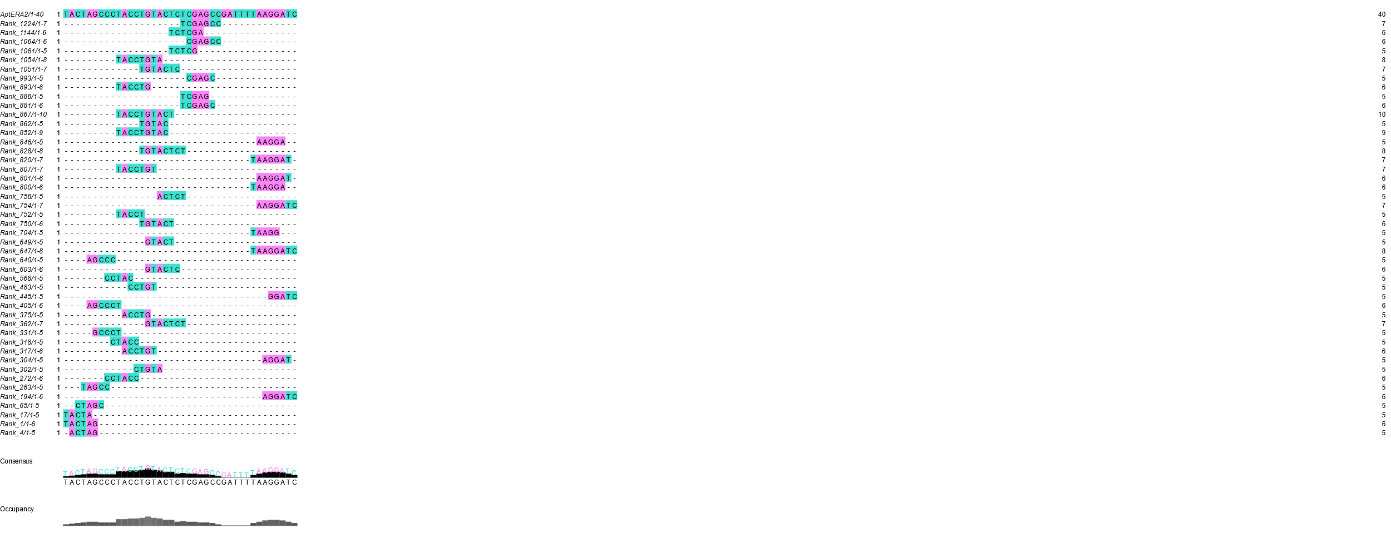
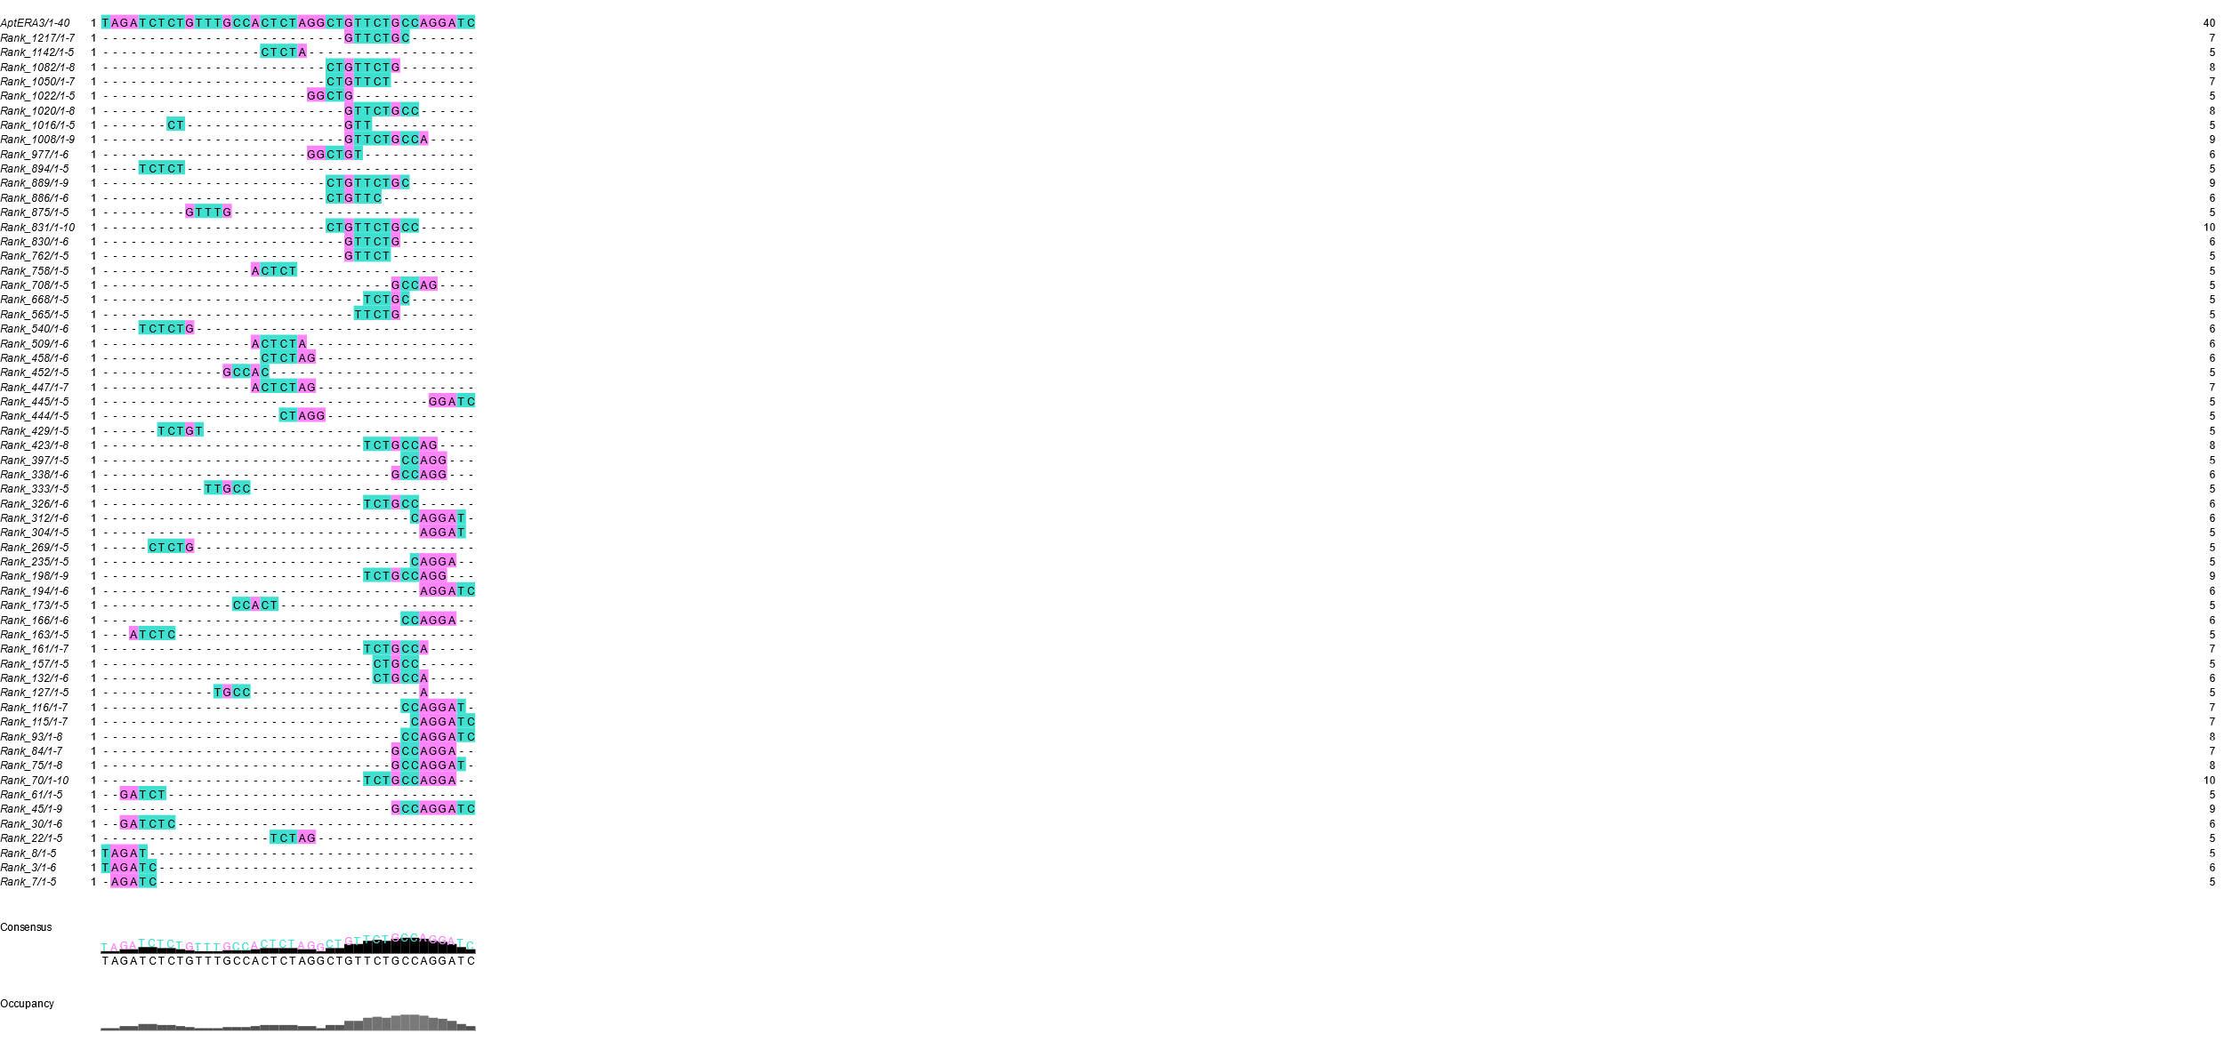
a
b

Figure S4: Multiple Alignment of the HP Library using Clustal Omega. (a) Motifs of Apt_{ERA} 2. (b) Motifs of Apt_{ERA} 3. Cyan indicate pyrimidines (C and T) while magenta indicates purines (A and G)

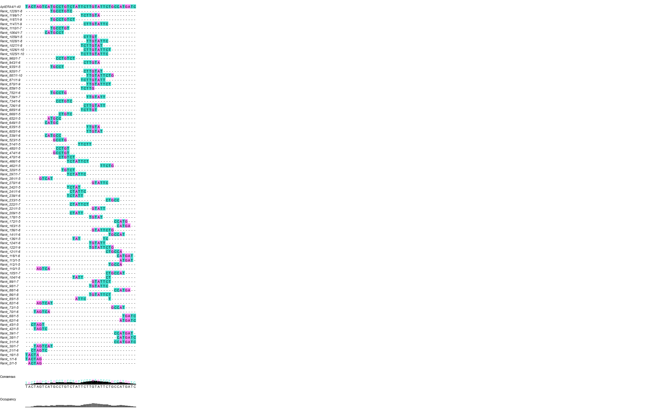
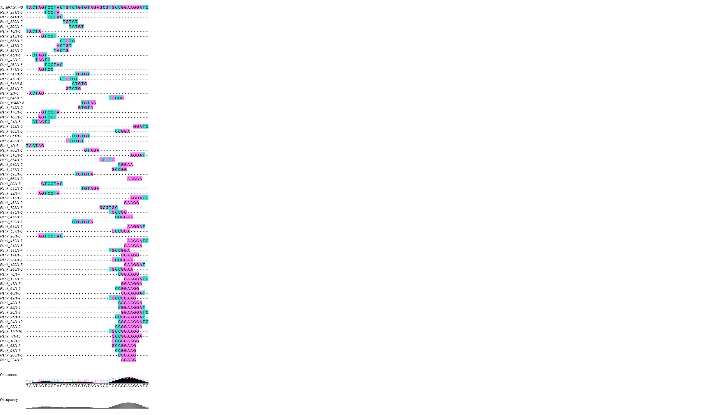
a
b

Figure S5: Multiple Alignment of the LP Library using Clustal Omega. (a) Motifs of Apt_{ERA} 4. (b) Motifs of Apt_{ERA} 5. Cyan indicate pyrimidines (C and T) while magenta indicates purines (A and G)

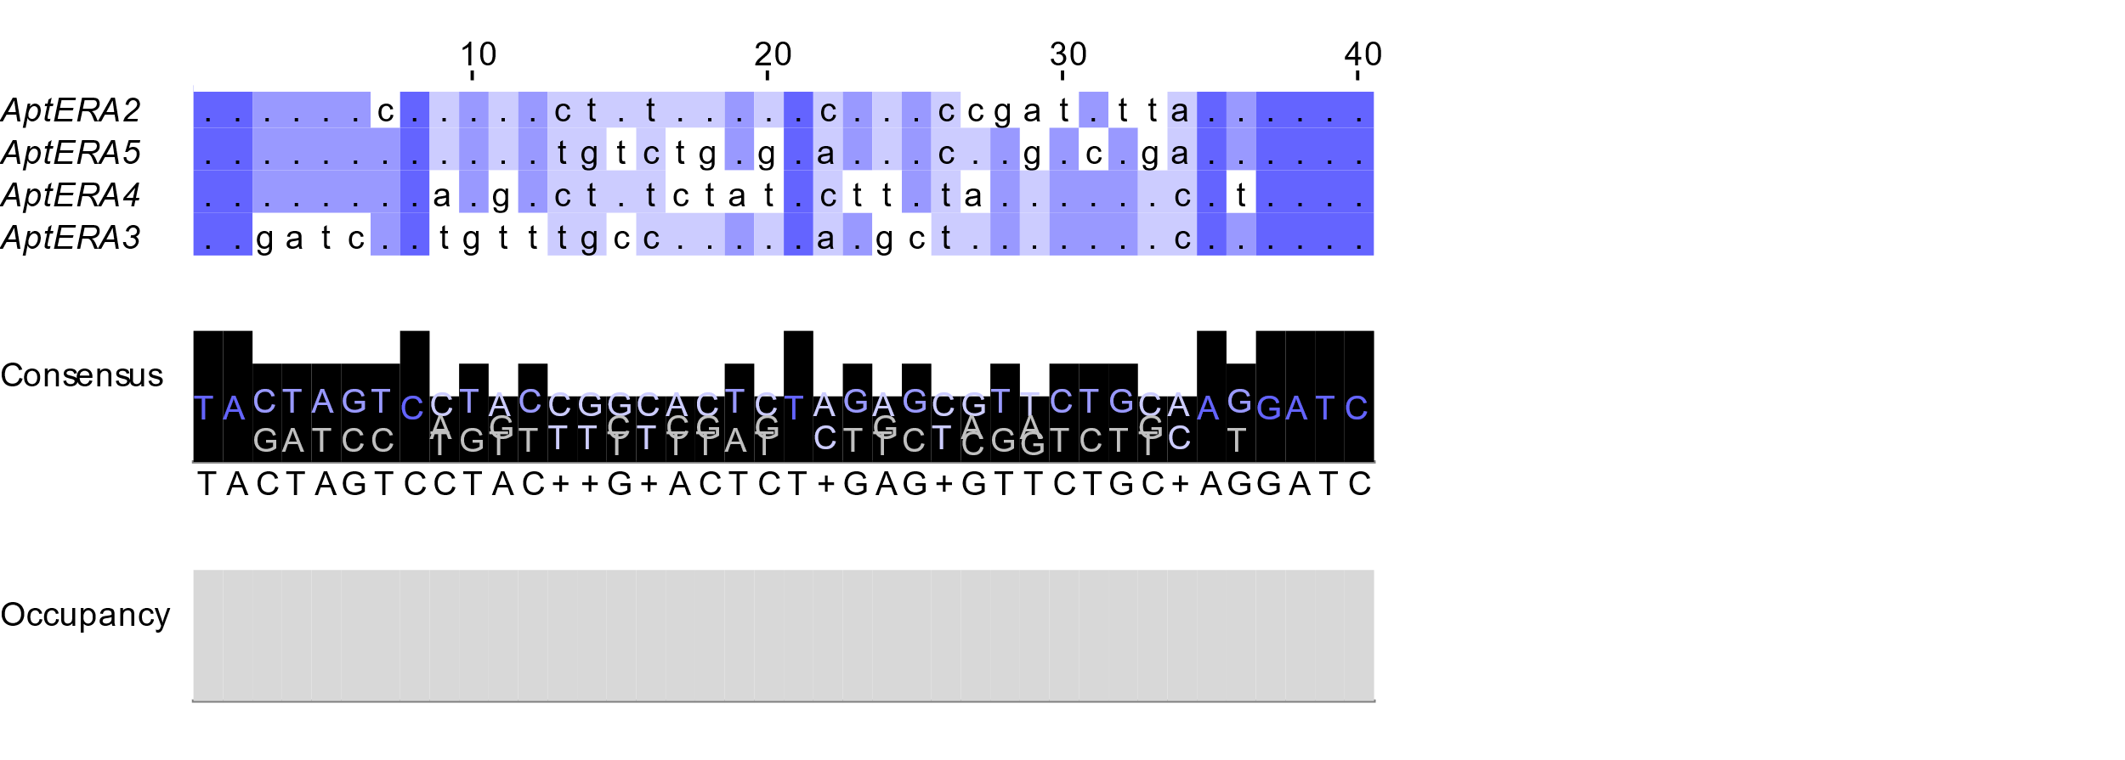
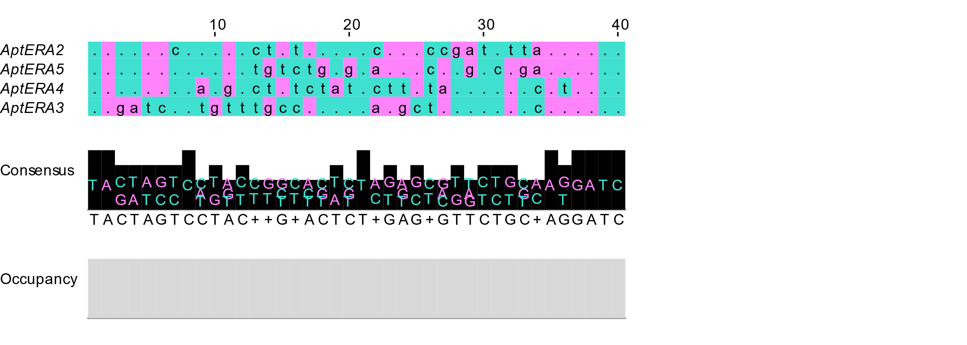
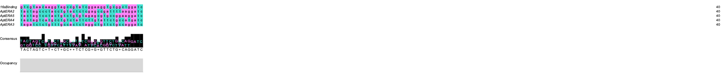
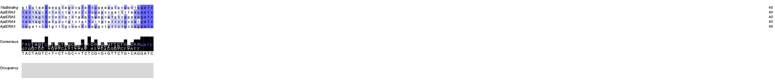
a
b
c
d

Figure S6: Multiple alignment of all Aptamers and the 16S rRNA using MAFFT v 7. (a) Aptamer alignment colored by conservation. (b) Aptamer alignment colored by Purine/Pyrimidine composition and conservation. (c) Alignment of Apt_{ERA} with the 16S rRNA region from 1494 to 1533 (40 nucleotides) by conservation. (d) Alignment of Apt_{ERA} with the 16S rRNA region from 1494 to 1533 (40 nucleotides) by Purine/Pyrimidine composition.

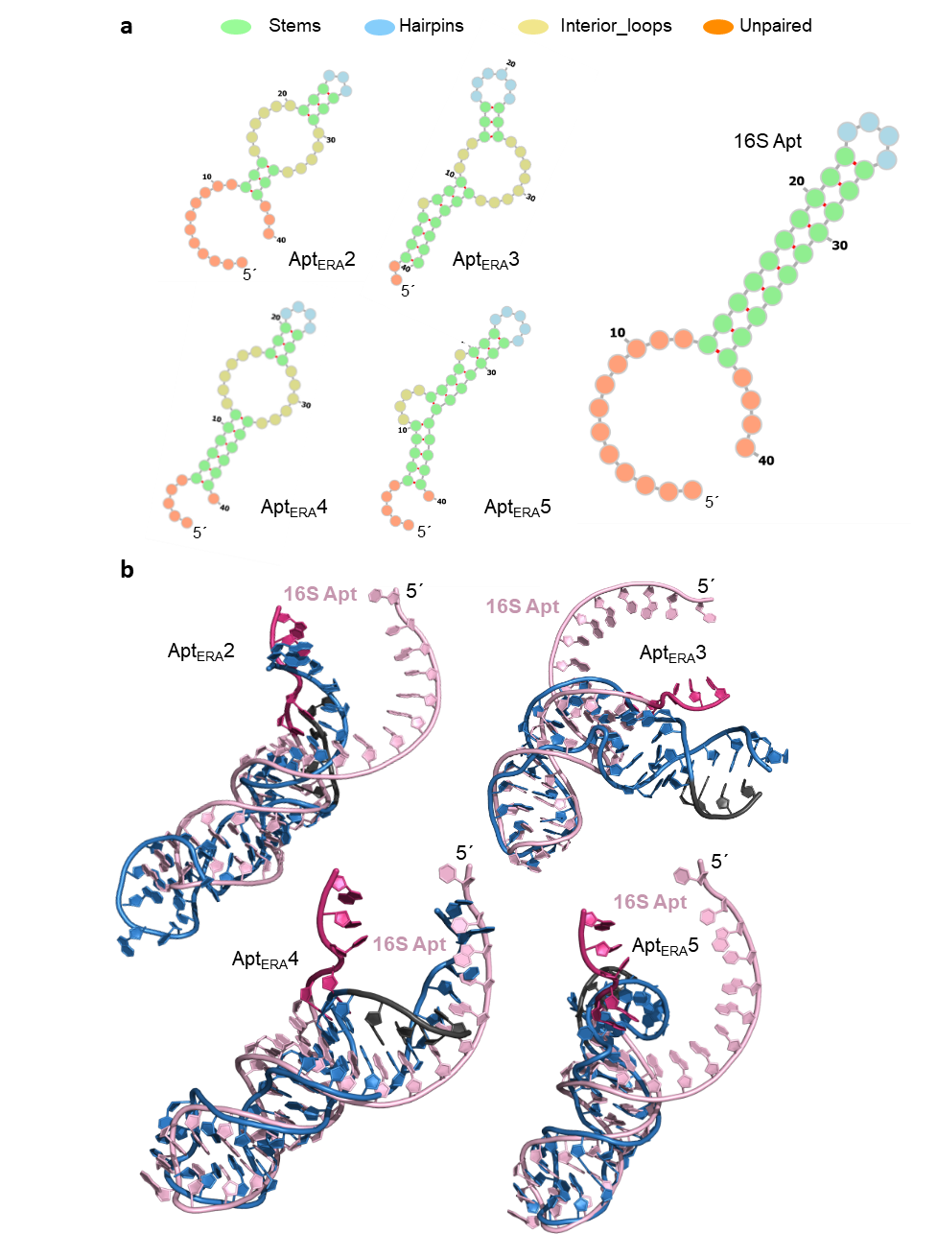
Figure S7: Structure of Apt_{ERA} compared to helix h45 of the 16S rRNA. (a) Comparison of aptamers against a 40 nucleotides simulated aptamer based on the 16S RNA (16S Apt, pink) ending in the conserved sequence GAUCA at 3´. Typical helix 45 is observed. (b) Structural alignment of E. coli 16S rRNA aptamer (pink) with different Apt_{ERA} aptamers (blue). GAUC motif in dark purple in 16S rRNA and black for Apt_{ERA}.

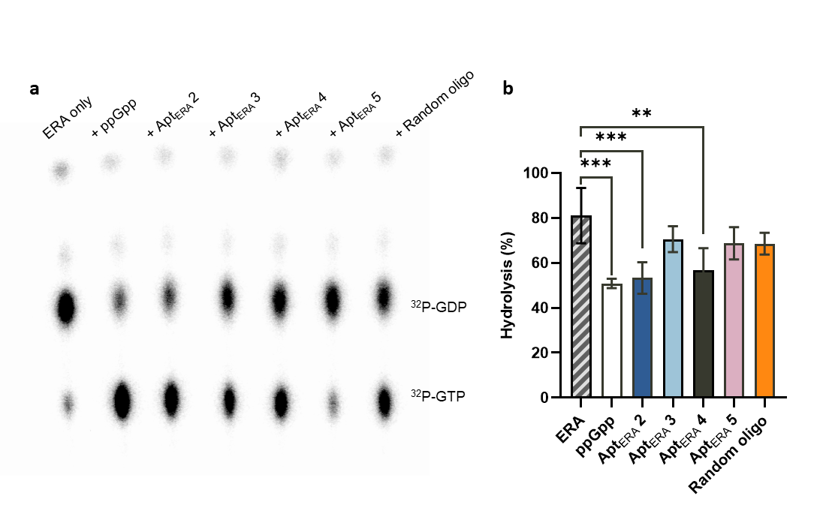

Figure S8: ERA GTPase activity in the presence of Apt_{ERA}. (a) Representative TLC showing GTP hydrolysis catalyzed by ERA. Hydrolysis was assayed for ERA only in the presence of the selected aptamers (50 μM), ppGpp, or a random oligonucleotide. Reaction mixtures contained ERA, S. aureus 70S ribosomes, and α-32P-GTP, incubated at 37°C for 1 hour. (b) Quantification of GTP hydrolysis expressed as the percentage of hydrolysis observed in three independent TLC assays. Data are presented as mean ± standard deviation (error bars). Statistical significance was assessed using one-way ANOVA (***P ≤ 0.001, **P ≤ 0.01).

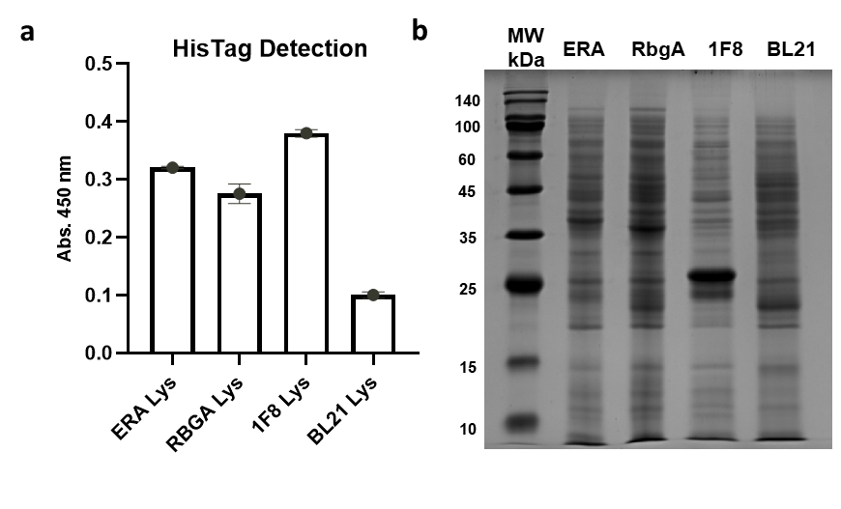Figure S9: Confirmation of His-Tagged ERA Protein presence in cell lysates by ELONA and SDS-PAGE. (a) The His-tagged GTPases ERA and RbgA were detected using an anti His-Tag aptamer (6H5, Patent US10,934,856.). The 1F8 protein from T. cruzi served as positive control, while non-expressing E. coli BL21 lysates were used as a negative control. Data are presented as mean ± standard deviation (error bars) of triplicate samples. (b) Protein expression induced by 0.5 mM IPTG was analyzed by 15% SDS-PAGE. Samples represent lysates from E. coli BL21 cells expressing the GTPases ERA, RbgA, and 1F8, induced with 0.5 mM IPTG. RbgA 35.7 kDa, ERA 36.5 kDa, 1F8 26 kDa.

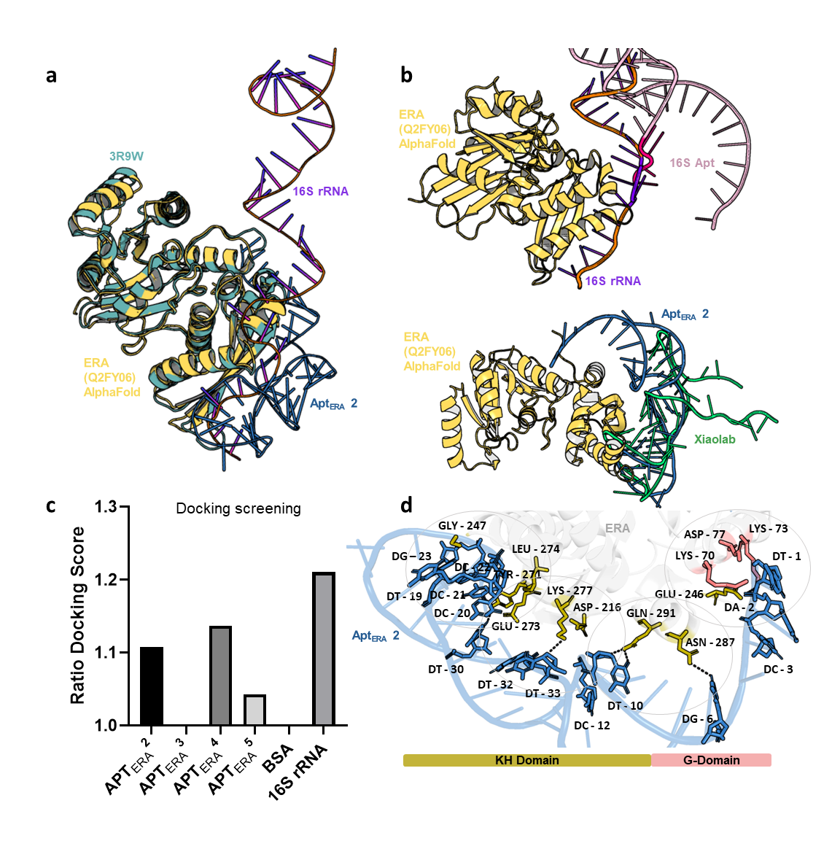

Figure S10: Structural modelling of the ERA–Apt_{ERA} 2 complex. (a) Structural alignment of the Alpha Fold ERA 3D model (Q2FY06, yellow) with the one derived from the crystal structure (PDB: 3R9W, turquoise) after docking them to Apt_{ERA} 2 or helix h45 from the 16SrRNA using HDOCK. The Apt_{ERA} 2 (Blue) modelled by our pipeline appears aligned with the 16S rRNA (PDB: 3R9W, purple), both interacting with the KH domain. (b) Upper: Docking of the 16S rRNA simulated aptamer (16S Apt, pink) to ERA and compared to the structure obtained by X-ray crystallography (PDB: 3R9W, purple). Bottom: Docking of Apt_{ERA} 2 with ERA comparing our aptamer 3D modelling pipeline to that obtained from the webserver Xiaolab (green). (c) Docking scores of Apt_{ERA} aptamers against ERA. 16S rRNA is used as positive control and BSA as negative protein control. The Ratio Docking Score is obtained as the ratio of the obtained value over that of the negative control (BSA). (d) Molecular interactions between ERA and Apt_{ERA} 2 as modelled using PLIP. ERA (grey) binding Apt_{ERA} 2 (blue) show nucleotides involved in dark blue and aminoacids (aa) in gold or red. Golden aa are part of the KH Domain, while red aa belong to the G-Domain.

