Supplementary Information
Open-source Sub-Nanometer Stabilization System for Super-resolution Fluorescence Microscopy

Florencia Edorna,^{1,2,#} Florencia D. Choque,^{1,2,#} Giovanni Ferrari,^{1,3} Luciano A. Masullo^{1§}, Piotr Zdańkowski,¹⁺ Guillermo Acuna,^{4,5} Philip Tinnefeld,³ Alan M. Szalai,¹ Lucía F. Lopez, ¹* Andrés Zelcer, ¹* and Fernando D. Stefani^{1,2}

¹ Centro de Investigaciones en Bionanociencias (CIBION), Consejo Nacional de Investigaciones Científicas y Técnicas (CONICET), Godoy Cruz 2390, C1425FQD Ciudad Autónoma de Buenos Aires, Argentina.
² Departamento de Física, Facultad de Ciencias Exactas y Naturales, Universidad de Buenos Aires, Güiraldes 2620, C1428EHA Ciudad Autónoma de Buenos Aires, Argentina.
³ Department of Chemistry and Center for NanoScience, Ludwig-Maximilians-Universität München, Munich, Germany, Butenandtstraße 13, 81377.
⁴ Department of Physics, University of Fribourg, Chemin du Musée 3, Fribourg, CH-1700, Switzerland
⁵ Swiss National Center for Competence in Research (NCCR) Bio-inspired Materials, University of Fribourg, Chemin des Verdiers 4, CH-1700 Fribourg, Switzerland.
# These authors contributed equally to this work.
* Corresponding authors: lucia.lopez@conicet.gov.ar, andres.zelcer@cibion.conicet.gov.ar
§ Present address: Max Planck Institute of Biochemistry, Am Klopferspitz 18, 82152 Planegg, Germany
⁺ Present address: Warsaw University of Technology, Institute of Micromechanics and Photonics, A. Boboli 8, 02-525 Warsaw, Poland

Table of Contents
Supplementary Text: Software description 2
Supplementary Figures 5
Figure S1. Sample X, Y and Z drifts of RASTMIN setup (non-stabilized). 5
Figure S2. Sample X, Y and Z drifts of p-MINFLUX setup (non-stabilized). 6
Figure S3. Sample X, Y and Z drifts of p-MINFLUX setup (Z stabilization only). 7
Figure S4. Performance of the stabilization system in the 3 dimensions for the p-MINFLUX setup. 8
Figure S5. p-MINFLUX measurement with no active stabilization. 9
Supplementary Tables 9

Supplementary Text: Software description
Requirements and technical details
The stabilization system only requires NumPy and SciPy packages. To use the provided GUI, PyQT5 and pyqtgraph are also required. We keep supporting Python from 3.7 onwards, as there are a lot of legacy programs that haven’t been updated to modern versions yet.
The stabilization loop runs on its own thread. The reference Python implementation (CPython) uses a Global Interpreter Lock (GIL) that makes it very easy for one thread of the same process to keep others from running. Therefore, care must be taken not to hog the CPU running large portions of Python code in another thread of the same process. Some libraries (notably numpy) release the GIL before performing many operations and will not interfere with the stabilization. As usual, I/O operations also release the GIL.
Application Program Interface (API)
The software provides a well-defined Application Program Interface (API) that controls the stabilization module. The provided GUI accesses this API to perform all required actions. Therefore, there is no need to directly access the API unless you want to implement a different GUI or use the stabilization software without one. The API provides methods for setting the ROIs, starting and stopping tracking and stabilization, initiating calibrations, adjusting the reference position, and adding callbacks for events like stabilization start and stop, and for each localization/tracking/correction cycle. See the documentation provided on the repository (https://github.com/Stefani-Lab/takyaq) for full description of the API. The main distinct features that are included are:
Calibration
To calibrate the pixel size of our imaging system, a reference sample can be used. In our laboratory, we use a high-quality reference grid sample (Thorlabs R1L3S3P). Our stabilization software offers a different, complementary possibility for calibration: using the piezo stage movement as the distance reference. The software will perform a series of controlled stage movements and localizations, reporting the results. In the case of X and Y calibration, the pixel size is reported.
In the case of the focus signal, one must always rely on the piezo movement as the distance reference. Depending on the relative position and angle of the focus beam with respect to the optical axis, the amount and direction of displacement of the reflection will vary. The procedure provided for Z calibration reports both values as the shift in nm per pixel and the direction as the angle from the +X direction. Therefore, the Z drift is determined using both the magnitude and direction of the reflected beam position shift. In this way, a maximum sensitivity is obtained as all available data is used.

Reference shift
Testing the performance of a super-resolution microscope is fundamental. A common procedure to test the resolving power is measuring the location of the same entity after performing small position shifts. In order to perform these movements keeping the precision provided by the stabilization, the software provides an instruction to shift the stabilization reference position while the stabilization is active, effectively forcing the stabilization system to move the stage. This feature provides a simple means to execute predefined patterns (e.g. square patterns with 20 nm sides).
Z-lock saving
Many techniques rely on structured illumination, with well-defined PSFs’ positions and shapes. Actually, in many cases like 2D MINFLUX or RASTMIN what is relevant is the PSF XY profile at the focus position. As small changes in the focus can lead to changes and shifts in the XY profile of the PSF, it is therefore necessary to ensure that the same axial position is used both for PSF characterization and for the actual measurements. Otherwise, using misleading PSFs’ profiles and/or relative positions within the excitation pattern would lead to undesired biased localizations. The program provides a function to save all relevant data (ROI, Z reflection center of mass position in the image) to perfectly recover the same focus position.

Supplementary Figures

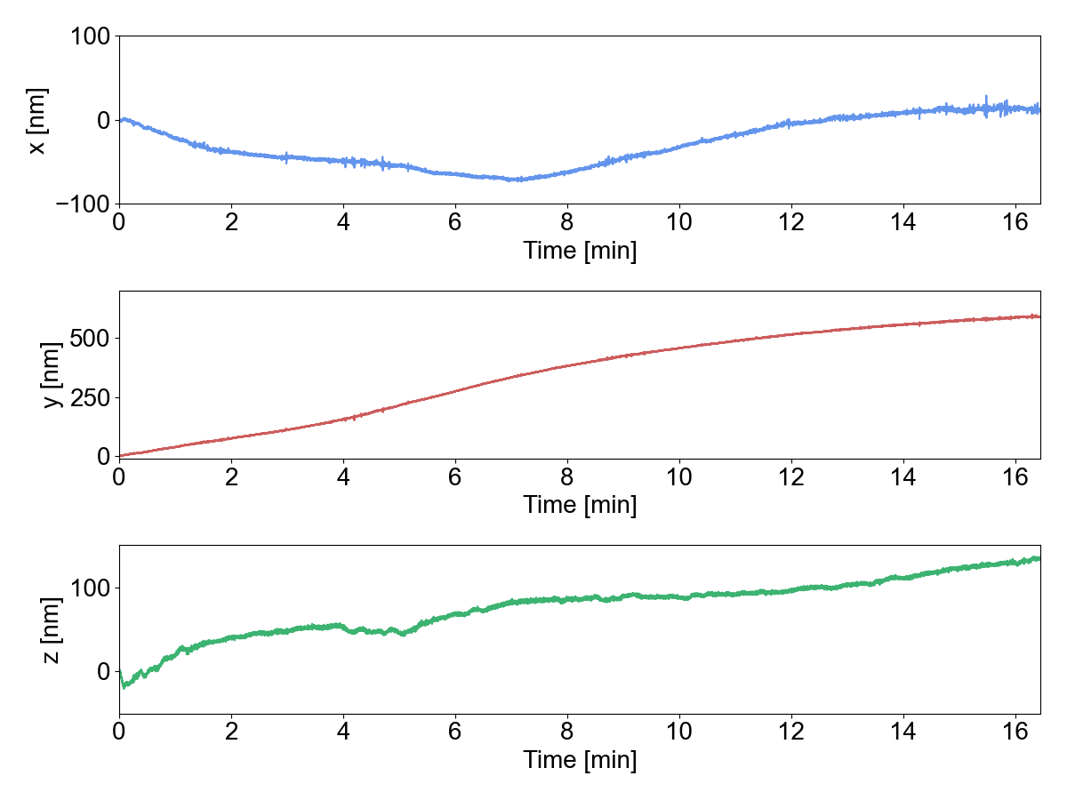
Figure S1. Sample X, Y and Z drifts of RASTMIN setup (non-stabilized). For X and Y, the average displacement shown corresponds to the tracking of 5 AuNPs.

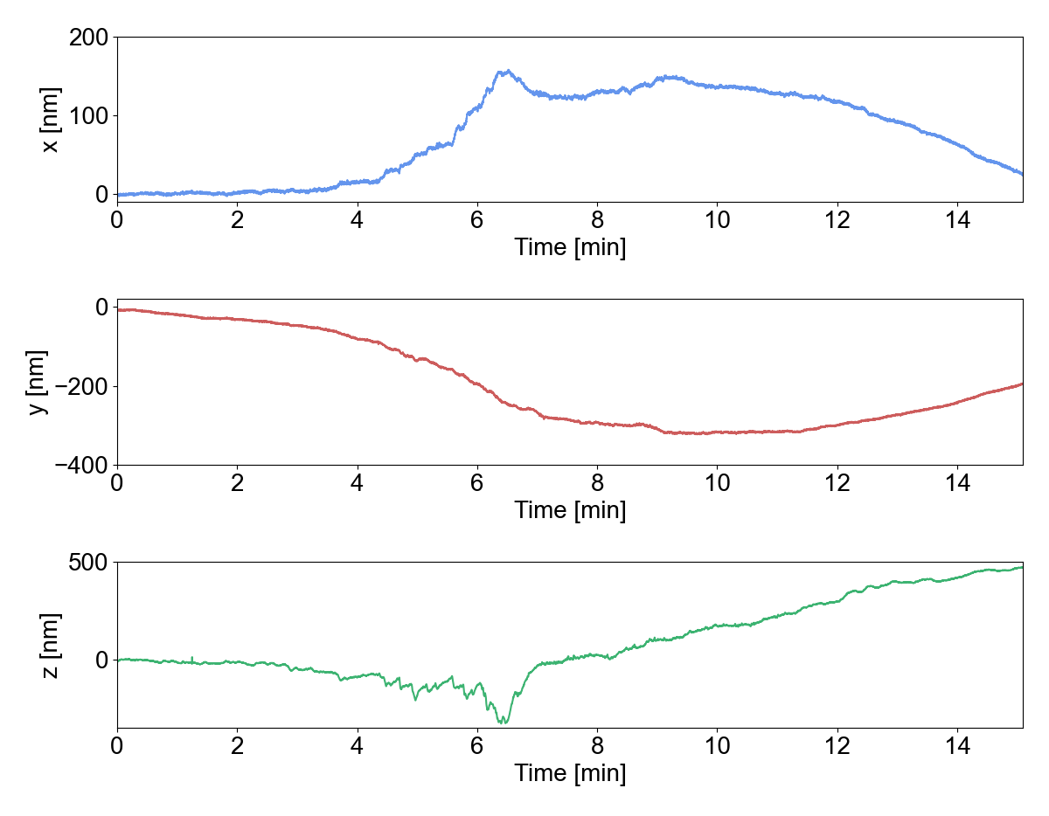
Figure S2. Sample X, Y and Z drifts of p-MINFLUX setup (non-stabilized). For X and Y, the average displacement shown corresponds to the tracking of 7 AuNPs.

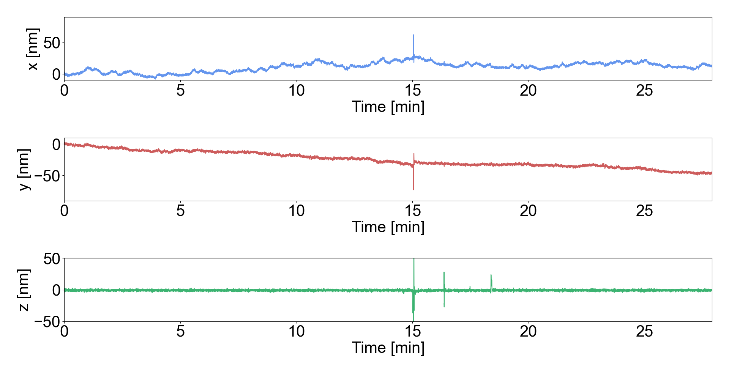
Figure S3. Sample X, Y and Z drifts of p-MINFLUX setup (Z stabilization only). For X and Y, the average displacement shown corresponds to the tracking of 6 AuNPs.

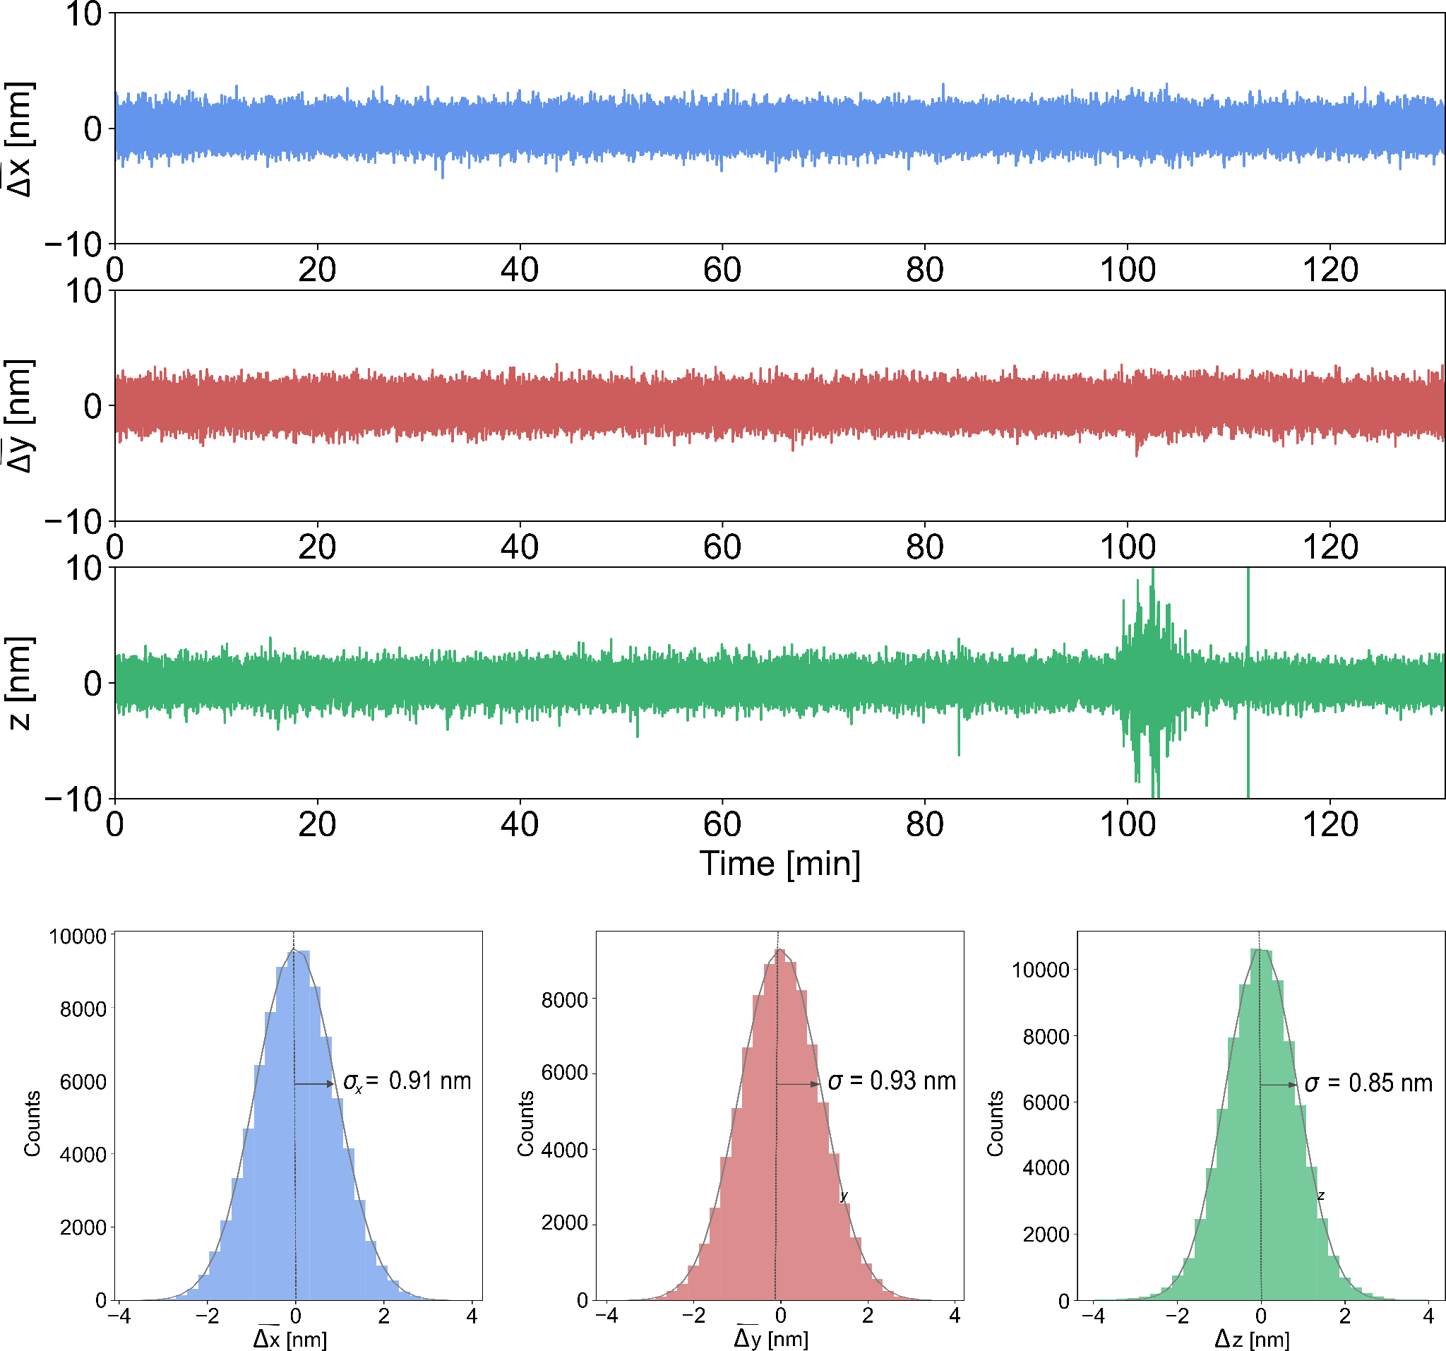

Figure S4. Performance of the stabilization system in the 3 dimensions for the p-MINFLUX setup. (A) Average displacements from the setpoint positions in X, Y and Z measured by the stabilization system for a period of 130 minutes using 7 AuNPs as fiducial markers. (B) Distribution of the displacements and gaussian fits (gray line) for each histogram. The parameter σ is the standard deviation of the gaussian fit and is indicated in each histogram.

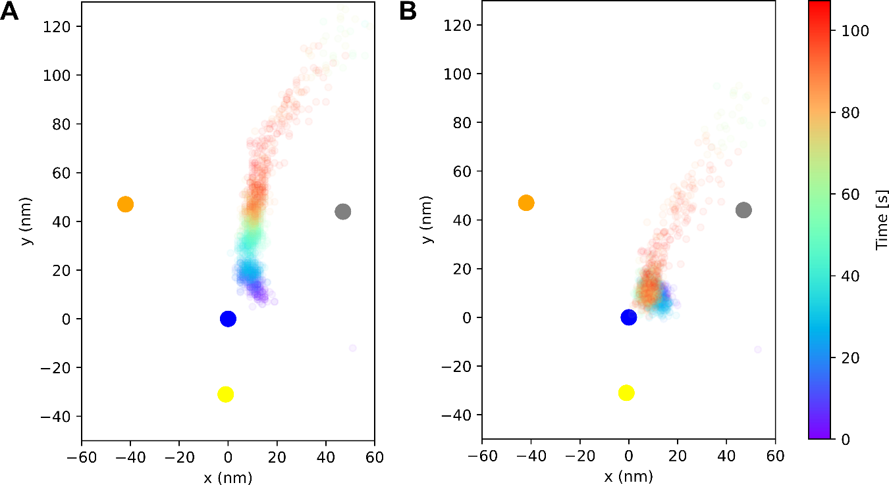
Figure S5. p-MINFLUX measurement with no active stabilization. (A) Localizations of a dynamic DNA origami structure with a single ATTO 643 fluorophore measured for 112 s (70 ms time bins, $\overline{N}=1800$). (B) Corrected localizations during post-processing using the measured XY drift data.

Supplementary Tables

Table S1: DNA origami with a single ATTO 647N
TAAAGACAAAGGCCGTAATAATTTTTTCAC
TACCTGAGAACAAAATAACTATATAAAGAACG
GCACCAACATGACAACTCGGTTTATCAGCTTG
AGTACATAATTGCTTTAATAATGGCGAACGTT
GTACCGACAGCCAGTACGCAAGACGTAAATGC
CAGGCAAACGAAACGTTGAAGGGACCAGAGCA
GAATTGAGGAGGTGAGCAGAGATAATCCAGAA
AAACTATCGATTTAGTGCGCGTAACCACCA
ATCAAGAACAAAAGAATTCCTGATGAAGGAGC
CCAAGAAGACCGTGTATAAAGCGTGAATAA
GTGAGCCTCCTCACAGCGTGCCAGGCGGTATG
TTAAAAATAACAACTATTTACAAATGCACGTA
GCCGCCACTGGGAAGGTCTGCCAGAATTCGCG
CTGCCAGCTGAAATGTAAAGCAGCGCTTTC
AATTTTATCAGATAGCAATAGCAATATCACCG
AACATAGCATAAAGAAGAATATACGAGCCGTC
AATTTACCCTGTTTAGGAATCATCCTTGAA
GTTGGGCGGTTGTGTATCACGACGGAGGTGTC
CTCAGAAAGGCGGATCGTTCCAGAGGCAGG
TTCGAGCTTTAGTTTGTGGGGCGCATGCAATG
AGAATTAAAACAGGGAGAAGGCTTCAATAGCA
CTGTTTCCCGAGATATGAGAGAGTTGCAGC
AAATGAATGAGCGCTGCATGATAGTTTATT
TAAATCCGAACCGAACAGGACGGCGACAGA
TGATGCAGGGAACAAATTAAGTAAACAAAC
AAATACCCGGGTATTTATCAACTCCCAATC
GCCAGGGTGCAAGGCGACGGCGGACGTCGGAT
TGATAATCGTTCTAGCCGCAAGGAAGTAGTAG
GAATAGCCTGTGTGAAGTGAGCCATAAACA
TTTTGCGGCAGTCACACCACGCTGGGATTTTA
CACTCCAGCTCCGTGGACAGCGCCCGTCAGCG
GACGAGAACATAACGCAGACGACGATCAAAAA
TCCCGTATCATCATAGATGATGTGGGTAAC
CAGTACCCCGCCACCTAGTAAATGAATTTT
GGAGCACTACCGAACGAAGAATACAAGAACTC
CATAGGCTAGGGGGTAGTAGAAAGGAGTACCT
GCAAGGCATCGGCATGGAGGTTGTAAGCGT
CAATCAATTAAACACCGTATCATATTAATTAA
GTTGATATCTCAGGAGTAAACAACTTTCAACA
ATGAATCGTGGGCGCCAAAGGGCGAAAAACCG
ACCGATTGCGCCACCCAGCCACCAATTCTGAA
TCTGGTCCAACAGTGCGACCAGACAGGAAA
TTAATTGGTACGGTGATCATACTTGCGGGA
TTGTCACACATTGACATTTCGGTCGTTTTGCT
GTCTCGTCCAGCGCATGCTCGTTAACTCAC
CAATCGTCACGCGTGGCGGGGAAGAGCGGG
CAGCAAATCAAATATCAACCACCATATCAGAT
AAGCGGTCGCCTAATGAATTGTTACCTGCATC
TAGCAATGGAGCGGGGAAAGGA
TAGTCAGCATCAATTCCCAATTAATATGAT
CAAGATTCCGAGGAATAAGCCCATTAGAGC
AGATTCACAACAAAGAAAACCCTCATTTCAAT
AACTTAAAACCGTGCAGCGATCGGACCCCGGT
AGGGTAGCCAGCGAAAGAATAGAAAGGAACAA
TCTTCGCCAGTGCCACATTTGCGATGCTGA
CCTTGCTTACATCGGGAAATTATTCAATTCGA
TTAGGTTGTTCATCAAAATTATTCAATCAATA
TCAGAGCCGATTAGGATGATACAGCCAGAGCC
ACGACGAGCCAACATAATATATCCTCCGGC
CCTGAGTATTGTTAAATTTAAATTCCGGAAAC
AATAAGAAAATCGGCTAATAATATCCAGTTAC
CAGTACAAACTACAACGTGCCCGTAACCTATTCCGGAACC
ATTTCATCAACAAGCAAACATGTTAACGTCAA
ATTGTATAAGTCAAATTATTTTAAGAGCTGAA
AGACGATCGCTGGCAAGCAGCACACCGGAA
AGCCGGGAACCAGCTGTTAAACCGCCAGCA
CAGTTTGGTCGAATTCTCACTGCCGCTGGTAA
AAACTCCAAGTTGATTCTACTAATTAAAAATT
CAGCAAAACGTTTGCCAACCACCAGAGTGTAC
AACTAAACTCCTTTTACGAGAAAATGTTTA
CAAATAAGAATTGAGTACGCAATATATGGTTT
TGTTTTTAGCGCTTAAATCGGAACCCTAAAGG
GATGGCAAGGTTATATTAATTACAGGCAGAGG
GAGGACAGATGAACGGTGCGATTTTTGAGGAC
ACCAGCGGCCACCAGATCTTTTGACTCCTC
GACAGGAATGGTTGCTTTTTGGGGTCGAGG
AGCTAAACTTCCTCGTGCCCACTACGTGAACC
GACGACGAAGAGACGATAACCTACCGCAAG
TTTAGAAGTTTTGAATCCCTAAAAAACCGTTG
AAACTAGTAGCTATTAATACTTAGGCAAGG
CCTGGGGTCACGCTGGCCCTTATAAATCAAAA
TACCTTTTCTGTAAATAGATTAAGAGGCGTTA
GAGCCCCCGGCCTTGGAGGCCAAGCAGAAG
AACATAAACTGAACACTTAGCAAATATAAAAG
CGTGGACTCCAACGTCAGGGTGGTTTTTCTTT
CTTCACCGCGTTGCGCGTAATCATGCGCGCCT
TTTTCCCCGTCAGATATTGCGTTTTGAGGA
GATTAAGATTTTCATTACCATTAGGAGAAAGG
AAGAGAAGACCACCCTACGATCTAAAGTTTTG
TGCCGTAACCGCCAGCCCAGAATCTATTAACA
AATAGATACTGATAGGGCTATTTTGATTAG
ACAACATTTACCTTATGTACAGCTCCATGT
GGGAGTTTTTTTCATCGACCTGACCAGGCG
CCCACGCTCACTGTTTGCGGCCTCCCCGGG
TAATAACACGTGGCGACGCTAGGGCGCTGGCA
CAAGCCCAGTATTAAGACGGGGTCACCACCCT
GAAGCCTTTCCTGTAGTCATATGTTGCGGGCC
AACATTATGACCCTGTTTTGAGAGAAATATGC
TGGTGCTGACTGGTGTCGGTGCCCTCCGCTCA
GTTTCAGCGGAGTGAGACAGCATAGGTGTA
TTGCCGTTTGTGGTGCGCCCTGCGCGCTTTCC
ATAACCGAAAATACGTTATCATCGGAGTAATC
AATCGCGTGAATTACTTTTTAATTTAGTTA
AACGCTCAAATCAAGTTTTGACGAGCACGTAT
AACGTGCTAGGAGGCCCCTACATTACATTGGC
CCGCCTGAGTTGGCATGAGTAACTGATTGT
GACAATATTATTAGACATAGATTAAGTAACAG
TTACCGATCCAGAGCTTACCAAGTAGAAAC
TCCCTTACGTCTGGTCGCCTCCGGTAGCTCTC
AATCAAAATCCAATAATCTGGAAGTAATGCCG
CAGAGCACAGATATAAGCGCATGCTGAATA
CAGTCTCTGATTTTGCGTTTAGTACCGCCACC
ATCAAGTTGCACCGTATGGCAACACGTAGAAA
CCCACAAGAAACGATTTTTTGAAGTACCGCAC
GGTCTGAGTACTTCTGGAATACCAGTTGAAAG
AGTGTAGCGTCCATCACTGAGTAGGTGGCACA
GAGCCTTGAGATTTGAATGCCAGTAAATTG
GAGAGGGCATGTCAACCAGCTTAGATGGGC
TCACCAGAAACCTGTTTGAGGAAGAATGCG
CTCAGAACAGGGAGGGAGGTGAATTAGCTATC
ACAAATTCACAAGAAAGTCTTTCCCCAGCTAC
GACTGGATAGCGTCCAAAAACGAAGTCATTTT
TTTAGAAGAACGCCACCCAAAACAGGCTGC
CCGGAGACAGCAAATATCAGCTCAGAAGATCG
GCCGCCAGATCAATAGAGCACCATAGAGATAA
TCTATCAGGGCGATGTAGAATCGAGGCGGT
TGAGTTTTATTTCGGATAAACACCGCCACC
TAACAACCAATAAACAGCCGTTGCGAACCT
GTGCACTCCCGGCAAACCGTCGGTGAGGTGGA
GCCTCCCTTCATTAAAAGGTAATTTTAAGA
CATTAACAATCAGGTCGGATTAGAATTCATCA
ACGGAAAACAGTATCCGCCATTACAGGAAG
TGGTAATTTAGCGTACATTTTCAGGGATAG
CTTATTAGTCACCAGTAAAATTCAATAACGGA
TTGTGAATATTACAGATAGTAATGACCATA
GCATCGTATTTCTGCTAGCTTTCAGGTGCCAT
ATACCCAAGCGGGAGGTTTTGTTTCAGCTAAT
AAGGAAAAGTTGCTATTATTTAAATAGATA
AAACAGAAGATAGCTTCGTCGCTATGCGTTAT
TCACCGACGGAACCAGTCAGAGCCAGTGCCTT
GATAGTTGCGCCGACACTAAAACGCAAGCGCGACCCAAAT
AAAAATCTATACCAGTCTGACCAACGGTCAAT
AAAATAAAAACAATGACGAACAAAGACATTCA
CTTATTACACGCGAGGCCTTTACACTGTCCAG
TTAAACAGTTCAGAAAGATAAGAGCTAACGGA
ATTAAATGTGAGCGAGATGAACGGGAAAGGGG
TTGGATTAAGACTACCCTTTTTTAGCCATATT
GTTGAGATATGGTTTATTCATCAACCTGATAA
GGGTAATAATAGCAGCGTTTTATTTATTTT
CAACGTAACGTTTACCCAAAAGGACGTTTTAA
ATAAATACATAAAGGATCAGTATTGGGAAG
CCAATAGCCCTCATACACCATCCTGCGAAC
CAATATTAAGCACTAATGCGCCGCTACAGGGC
TCATCGAGTTCTGACCTGAGAATCATGGAAAC
TACCGAGCAACAAGAGGCAACAGCTGATTGCC
CATCGTAGCTTTTTCAGTAATTTATTTAACAA
AAGAGTCCCATATCAAGAAACATATCTTTA
ATAAAACAGAAGGTTACCTTTGCCAAGGGTTA
ACCCTCAGAACGGCTAGGCGCAGACTTTGAAA
TACTTAGCCGGAACGACAGAGGCTTAAGAACT
CTCATAGAAGTTTTAAGGCTGACATAATCA
AGCAAATTAAAGCTAGCCTGAGAATATAAA
CTGACCTTATTAAATTCTAAAAATAACGGA
CTGTATGGGAATTTACAAGTGCCGCTGTAGCG
TACAACGTAATTGTAAACCATCGCCCACGC
GCGTACTACGGTACGCATTGCATAATAAAA
ATCACCCATGGAAATAGATTAAAGAGAGCCAG
AGTCCTGATTACCAGTGATAAATAACGCTGAG
TTCTAAGAGCAGTATGCCTGAACAGAAACCAT
TCACCGTAAAGTATAGGCCAGAATCAAACAAA
ATTCAACCAGAAAAGCTCAAAAATTTTGAGGG
CAGAGCCCCAAAGACTTTGGGAAATAATAA
CAATTCCAGGCAAAATTTTGCCCC
AACAGTAGCGCCTGTTAAACCAAGCCTTAAAT
CAGCATCATCCGCCGGGTCATACCTCGCGTCC
TTTGCCAGGGCTGACCATTTCAACTTCCATTA
GTTGAAAAGAAATCCGGAGGAAGTTTTAATCA
CCGGCGAATCACTTGCCGCAAATTCATCGCCA
TTGCGTATGCCAACGCCCTGTTCTGGGGGTTT
TTCGCCTGAATCAATAATTTATCAATGGTTTG
TCAGACGAAGACACCATCACCAATAAGTCAGA
CGACGGCTATTACGCTTGGTGTTCATCAAC
GCGGGCCGTTTTCACGGCGCGGTTCTGCATTA
CATTTTCGAAAAGGTAACCGCGCCATCCGGTA
GAGTAACAGCCTGTAGCCATGTACCGTAACAC
CAAAGAATTAGCAAAACATGTTTTATCTACAA
AAATCACCTTGAGCCAAAAAGGGCGTTACCAG
ACAATCGGGCGCCATTGGCCTCAGTTTTTTAA
CGAGAAAAGAATCATTAAGTAATTGAGAGAAT
TTTCATTCAGAGGCGTATAATCCATTATCA
CTAAAGGAATTGCGAACTTTTGCGGGATCGTC
AAGGTGGAAGCAAAGAACCAGATCAACTAA
GGAATTAAAAAAAGCATTGCAGTCACCTTG
CATACATGCCAGACGTCTCAGAACCGCCACCC
CGTTTTCCGGAAACGCGGAATATAAGACTC
GAGCAAGACAGCCATATTTTGCACTTATCATT
TGCGGATGTAGCTCAATTAAGCAAGTACCAAA
CACCCGCCTAATCAGTCTGGTAATGAACCCTT
CTTTCGAGGATTATACAAAGAGGCCTTGCCCT
GAACCTAAATAGTGATATGTGACAACGCTC
AATGGGATAGGTCACGCAGCTGGCTAATCGTA
AGGCTATCGAGAATCGTAACAACCTTGACCGT
ATACATATTCATTGACTTAATTTAGACGGG
TTGACAAGCGAGAGGACCACATCCGGAAGC
TCTGGCCTTATTTCAATGATAAATTTTCATTC
CGATAGCATGCCTTTAGATATTCAGGAAAGCG
TGCAGATAACACCAGATATTCATTAAACAAAG
TCTCCGTAATCCAATATAAGAGAGTCTGGA
GAGTAGATTCAAAGCGCGGATTGCATAAAAAC
CTGAACCTGAAAAATCGATTATTTTTGACGCT
ATTAATTTCTGGCCAAGCGGTCAGCTGAGAAG
AGTCGGGTGAGACGGTCCACTATTAAAGAA
AAACGCAATTGGCCTTGCGTCAGATCGAGAGG
ATTGTGTCTCTCCAAAGTCGCTGAGGCTTGCA
AGTGATGAAGGGTAAATACGGCTGTTGTAAAA
AATGCCAAGGTTTCTTGTGTCACTGGTCATAG
CATAAGGTCATTAAACCCGGAATCGGAACG
CATCCTCAAGCGGTGCGTTCAGCAGTGTAAAG
AAAGTAAGCCTGAATCCTAATTTGCCCATCCT
GGGACATTTAAAAGTTAATCAACAAGTTACAA
CCCGACTTAAGAACTGAATATCAGTACCATTA
TCGTCTTTGCTTTTGATTAGCGGGATAGCCCC
MODIFIED
CAACTCGGAAAGCGTAACCACCCCGAGTAATTT[ATTO542]
CAAAATAGAACCGGAACGAGTACTACGAAGTTT[ATTO647N]
[biotin]TTTAAGAGTCTGGTCACGCAGCTTGACGGGGAAAG
[biotin]TTTACATGAAAATAGGAACCATTCCACAGACAGCC
[biotin]TTTGCAGAACGGGCTTAATTAAATTTAAAATCATA
[biotin]TTTGCAAACAAAGGTCATTAATCGGTTTAAAGCCT
[biotin]TTTATTAATTGCCTGGCCCGGGTTGAGTGTTGTTC
[biotin]TTTAACGGGTATATATTCGAAAAAGGCTCCAAAAG

Table S2: Dynamic DNA origami with a single ATTO 643
TAAAGACAAAGGCCGTAATAATTTTTTCAC
TACCTGAGAACAAAATAACTATATAAAGAACG
GCACCAACATGACAACTCGGTTTATCAGCTTG
AGTACATAATTGCTTTAATAATGGCGAACGTT
GTACCGACAGCCAGTACGCAAGACGTAAATGC
CAGGCAAACGAAACGTTGAAGGGACCAGAGCA
GAATTGAGGAGGTGAGCAGAGATAATCCAGAA
AAACTATCGATTTAGTGCGCGTAACCACCA
ATCAAGAACAAAAGAATTCCTGATGAAGGAGC
CCAAGAAGACCGTGTATAAAGCGTGAATAA
GTGAGCCTCCTCACAGCGTGCCAGGCGGTATG
TTAAAAATAACAACTATTTACAAATGCACGTA
GCACTCAAGCGGGGTCCGCACAGGTAAAAAAA
CTGCCAGCTGAAATGTAAAGCAGCGCTTTC
TGGGTAAACGGCAGCACGCGGTCCGCGGATCA
AATTTTATCAGATAGCAATAGCAATATCACCG
AACATAGCATAAAGAAGAATATACGAGCCGTC
AATTTACCCTGTTTAGGAATCATCCTTGAA
GTTGGGCGGTTGTGTATCACGACGGAGGTGTC
CTCAGAAAGGCGGATCGTTCCAGAGGCAGG
TTCGAGCTTTAGTTTGTGGGGCGCATGCAATG
AGAATTAAAACAGGGAGAAGGCTTCAATAGCA
GAGAGGGCATGTCAACCAGCTTAGATGGGC
CTCAGAACAGGGAGGGAGGTGAATTAGCTATC
CTGTTTCCCGAGATATGAGAGAGTTGCAGC
AAATGAATGAGCGCTGCATGATAGTTTATT
TAAATCCGAACCGAACAGGACGGCGACAGA
TGATGCAGGGAACAAATTAAGTAAACAAAC
AAATACCCGGGTATTTATCAACTCCCAATC
GCCAGGGTGCAAGGCGACGGCGGACGTCGGAT
CAACTCGGAAAGCGTAACCACCCCGAGTAA
GAATAGCCTGTGTGAAGTGAGCCATAAACA
TTTTGCGGCAGTCACACCACGCTGGGATTTTA
CACTCCAGCTCCGTGGACAGCGCCCGTCAGCG
GACGAGAACATAACGCAGACGACGATCAAAAA
TCCCGTATCATCATAGATGATGTGGGTAAC
CAGTACCCCGCCACCTAGTAAATGAATTTT
GGAGCACTACCGAACGAAGAATACAAGAACTC
CATAGGCTAGGGGGTAGTAGAAAGGAGTACCT
GCAAGGCATCGGCATGGAGGTTGTAAGCGT
CAATCAATTAAACACCGTATCATATTAATTAA
GTTGATATCTCAGGAGTAAACAACTTTCAACA
ATGAATCGTGGGCGCCAAAGGGCGAAAAACCG
ACCGATTGCGCCACCCAGCCACCAATTCTGAA
TCTGGTCCAACAGTGCGACCAGACAGGAAA
TTGTCACACATTGACATTTCGGTCGTTTTGCT
GTCTCGTCCAGCGCATGCTCGTTAACTCAC
CAATCGTCACGCGTGGCGGGGAAGAGCGGG
CAGCAAATCAAATATCAACCACCATATCAGAT
AAGCGGTCGCCTAATGAATTGTTACCTGCATC
TAGCAATGGAGCGGGGAAAGGA
TAGTCAGCATCAATTCCCAATTAATATGAT
CAAGATTCCGAGGAATAAGCCCATTAGAGC
AGATTCACAACAAAGAAAACCCTCATTTCAAT
AACTTAAAACCGTGCAGCGATCGGACCCCGGT
AGGGTAGCCAGCGAAAGAATAGAAAGGAACAA
TCTTCGCCAGTGCCACATTTGCGATGCTGA
CCTTGCTTACATCGGGAAATTATTCAATTCGA
TTAGGTTGTTCATCAAAATTATTCAATCAATA
TCAGAGCCGATTAGGATGATACAGCCAGAGCC
ACGACGAGCCAACATAATATATCCTCCGGC
GCAACTGTGGGAACGGCAGAAACAGTTTTTTC
CCTGAGTATTGTTAAATTTAAATTCCGGAAAC
AATAAGAAAATCGGCTAATAATATCCAGTTAC
CAGTACAAACTACAACGTGCCCGTAACCTATTCCGGAACC
ATTTCATCAACAAGCAAACATGTTAACGTCAA
ATTGTATAAGTCAAATTATTTTAAGAGCTGAA
AGACGATCGCTGGCAAGCAGCACACCGGAA
AGCCGGGAACCAGCTGTTAAACCGCCAGCA
CAGTTTGGTCGAATTCTCACTGCCGCTGGTAA
CAGCAAAACGTTTGCCAACCACCAGAGTGTAC
AGGCTATCGAGAATCGTAACAACCTTGACCGT
AACTAAACTCCTTTTACGAGAAAATGTTTA
CAAATAAGAATTGAGTACGCAATATATGGTTT
TGTTTTTAGCGCTTAAATCGGAACCCTAAAGG
GATGGCAAGGTTATATTAATTACAGGCAGAGG
GAGGACAGATGAACGGTGCGATTTTTGAGGAC
ACCAGCGGCCACCAGATCTTTTGACTCCTC
GACAGGAATGGTTGCTTTTTGGGGTCGAGG
AGCTAAACTTCCTCGTGCCCACTACGTGAACC
GACGACGAAGAGACGATAACCTACCGCAAG
TTTAGAAGTTTTGAATCCCTAAAAAACCGTTG
CCTGGGGTCACGCTGGCCCTTATAAATCAAAA
TACCTTTTCTGTAAATAGATTAAGAGGCGTTA
GAGCCCCCGGCCTTGGAGGCCAAGCAGAAG
AACATAAACTGAACACTTAGCAAATATAAAAG
CGTGGACTCCAACGTCAGGGTGGTTTTTCTTT
CTTCACCGCGTTGCGCGTAATCATGCGCGCCT
TTTTCCCCGTCAGATATTGCGTTTTGAGGA
GATTAAGATTTTCATTACCATTAGGAGAAAGG
AAGAGAAGACCACCCTACGATCTAAAGTTTTG
TGCCGTAACCGCCAGCCCAGAATCTATTAACA
AATAGATACTGATAGGGCTATTTTGATTAG
ACAACATTTACCTTATGTACAGCTCCATGT
GGGAGTTTTTTTCATCGACCTGACCAGGCG
CCCACGCTCACTGTTTGCGGCCTCCCCGGG
CAAAATAGAACCGGAACGAGTACTACGAAG
TAATAACACGTGGCGACGCTAGGGCGCTGGCA
CAAGCCCAGTATTAAGACGGGGTCACCACCCT
GAAGCCTTTCCTGTAGTCATATGTTGCGGGCC
AACATTATGACCCTGTTTTGAGAGAAATATGC
TGGTGCTGACTGGTGTCGGTGCCCTCCGCTCA
GTTTCAGCGGAGTGAGACAGCATAGGTGTA
TTGCCGTTTGTGGTGCGCCCTGCGCGCTTTCC
ATAACCGAAAATACGTTATCATCGGAGTAATC
AATCGCGTGAATTACTTTTTAATTTAGTTA
AACGCTCAAATCAAGTTTTGACGAGCACGTAT
AACGTGCTAGGAGGCCCCTACATTACATTGGC
CCGCCTGAGTTGGCATGAGTAACTGATTGT
GACAATATTATTAGACATAGATTAAGTAACAG
TTACCGATCCAGAGCTTACCAAGTAGAAAC
TCCCTTACGTCTGGTCGCCTCCGGTAGCTCTC
AATCAAAATCCAATAATCTGGAAGTAATGCCG
CAGAGCACAGATATAAGCGCATGCTGAATA
CAGTCTCTGATTTTGCGTTTAGTACCGCCACC
ATCAAGTTGCACCGTATGGCAACACGTAGAAA
CCCACAAGAAACGATTTTTTGAAGTACCGCAC
GGTCTGAGTACTTCTGGAATACCAGTTGAAAG
AGTGTAGCGTCCATCACTGAGTAGGTGGCACA
GAGCCTTGAGATTTGAATGCCAGTAAATTG
TCACCAGAAACCTGTTTGAGGAAGAATGCG
ACAAATTCACAAGAAAGTCTTTCCCCAGCTAC
GACTGGATAGCGTCCAAAAACGAAGTCATTTT
TTTAGAAGAACGCCACCCAAAACAGGCTGC
CCGGAGACAGCAAATATCAGCTCAGAAGATCG
GCCGCCAGATCAATAGAGCACCATAGAGATAA
TCTATCAGGGCGATGTAGAATCGAGGCGGT
TGAGTTTTATTTCGGATAAACACCGCCACC
TAACAACCAATAAACAGCCGTTGCGAACCT
GTGCACTCCCGGCAAACCGTCGGTGAGGTGGA
GCCTCCCTTCATTAAAAGGTAATTTTAAGA
CATTAACAATCAGGTCGGATTAGAATTCATCA
ACGGAAAACAGTATCCGCCATTACAGGAAG
TGGTAATTTAGCGTACATTTTCAGGGATAG
CTTATTAGTCACCAGTAAAATTCAATAACGGA
TTGTGAATATTACAGATAGTAATGACCATA
GCATCGTATTTCTGCTAGCTTTCAGGTGCCAT
ATACCCAAGCGGGAGGTTTTGTTTCAGCTAAT
AAGGAAAAGTTGCTATTATTTAAATAGATA
AAACAGAAGATAGCTTCGTCGCTATGCGTTAT
TCACCGACGGAACCAGTCAGAGCCAGTGCCTT
GATAGTTGCGCCGACACTAAAACGCAAGCGCGACCCAAAT
AAAAATCTATACCAGTCTGACCAACGGTCAAT
AAAATAAAAACAATGACGAACAAAGACATTCA
CTTATTACACGCGAGGCCTTTACACTGTCCAG
TAATGCTGGCTTAGAGATCCCCCTGAATCGTC
TTAAACAGTTCAGAAAGATAAGAGCTAACGGA
ATTAAATGTGAGCGAGATGAACGGGAAAGGGG
AATGCCAAGGTTTCTTGTGTCACTGGTCATAG
TTGGATTAAGACTACCCTTTTTTAGCCATATT
GTTGAGATATGGTTTATTCATCAACCTGATAA
GGGTAATAATAGCAGCGTTTTATTTATTTT
CAACGTAACGTTTACCCAAAAGGACGTTTTAA
ATAAATACATAAAGGATCAGTATTGGGAAG
CCAATAGCCCTCATACACCATCCTGCGAAC
CAATATTAAGCACTAATGCGCCGCTACAGGGC
TCATCGAGTTCTGACCTGAGAATCATGGAAAC
TACCGAGCAACAAGAGGCAACAGCTGATTGCC
CATCGTAGCTTTTTCAGTAATTTATTTAACAA
AAGAGTCCCATATCAAGAAACATATCTTTA
ATAAAACAGAAGGTTACCTTTGCCAAGGGTTA
ACCCTCAGAACGGCTAGGCGCAGACTTTGAAA
TACTTAGCCGGAACGACAGAGGCTTAAGAACT
CTCATAGAAGTTTTAAGGCTGACATAATCA
AGCAAATTAAAGCTAGCCTGAGAATATAAA
CTGACCTTATTAAATTCTAAAAATAACGGA
CTGTATGGGAATTTACAAGTGCCGCTGTAGCG
TACAACGTAATTGTAAACCATCGCCCACGC
GCGTACTACGGTACGCATTGCATAATAAAA
ATCACCCATGGAAATAGATTAAAGAGAGCCAG
AGTCCTGATTACCAGTGATAAATAACGCTGAG
GCCGCCACTGGGAAGGTCTGCCAGAATTCGCG
TTCTAAGAGCAGTATGCCTGAACAGAAACCAT
GATGTGCTTTTCCCAGCATCGACACGGCCTTT
TCACCGTAAAGTATAGGCCAGAATCAAACAAA
ATTCAACCAGAAAAGCTCAAAAATTTTGAGGG
CAGAGCCCCAAAGACTTTGGGAAATAATAA
CAATTCCAGGCAAAATTTTGCCCC
AACAGTAGCGCCTGTTAAACCAAGCCTTAAAT
CAGCATCATCCGCCGGGTCATACCTCGCGTCC
TTTGCCAGGGCTGACCATTTCAACTTCCATTA
GTTGAAAAGAAATCCGGAGGAAGTTTTAATCA
CCGGCGAATCACTTGCCGCAAATTCATCGCCA
TTGCGTATGCCAACGCCCTGTTCTGGGGGTTT
TTCGCCTGAATCAATAATTTATCAATGGTTTG
TCAGACGAAGACACCATCACCAATAAGTCAGA
CGACGGCTATTACGCTTGGTGTTCATCAAC
GCGGGCCGTTTTCACGGCGCGGTTCTGCATTA
CATTTTCGAAAAGGTAACCGCGCCATCCGGTA
GAGTAACAGCCTGTAGCCATGTACCGTAACAC
CAAAGAATTAGCAAAACATGTTTTATCTACAA
AAATCACCTTGAGCCAAAAAGGGCGTTACCAG
ACAATCGGGCGCCATTGGCCTCAGTTTTTTAA
CGAGAAAAGAATCATTAAGTAATTGAGAGAAT
TTTCATTCAGAGGCGTATAATCCATTATCA
CTAAAGGAATTGCGAACTTTTGCGGGATCGTC
AAGGTGGAAGCAAAGAACCAGATCAACTAA
GGAATTAAAAAAAGCATTGCAGTCACCTTG
CATACATGCCAGACGTCTCAGAACCGCCACCC
CGTTTTCCGGAAACGCGGAATATAAGACTC
GAGCAAGACAGCCATATTTTGCACTTATCATT
TGCGGATGTAGCTCAATTAAGCAAGTACCAAA
CACCCGCCTAATCAGTCTGGTAATGAACCCTT
CTTTCGAGGATTATACAAAGAGGCCTTGCCCT
GAACCTAAATAGTGATATGTGACAACGCTC
AATGGGATAGGTCACGCAGCTGGCTAATCGTA
ATACATATTCATTGACTTAATTTAGACGGG
TTGACAAGCGAGAGGACCACATCCGGAAGC
TCTGGCCTTATTTCAATGATAAATTTTCATTC
CGATAGCATGCCTTTAGATATTCAGGAAAGCG
TGCAGATAACACCAGATATTCATTAAACAAAG
TCTCCGTAATCCAATATAAGAGAGTCTGGA
GAGTAGATTCAAAGCGCGGATTGCATAAAAAC
CTGAACCTGAAAAATCGATTATTTTTGACGCT
ATTAATTTCTGGCCAAGCGGTCAGCTGAGAAG
AGTCGGGTGAGACGGTCCACTATTAAAGAA
AAACGCAATTGGCCTTGCGTCAGATCGAGAGG
ATTGTGTCTCTCCAAAGTCGCTGAGGCTTGCA
AGTGATGAAGGGTAAATACGGCTGTTGTAAAA
CATAAGGTCATTAAACCCGGAATCGGAACG
GGCTCATTACGTTAATATACTGCGCAAATGCT
CATCCTCAAGCGGTGCGTTCAGCAGTGTAAAG
AAAGTAAGCCTGAATCCTAATTTGCCCATCCT
GGGACATTTAAAAGTTAATCAACAAGTTACAA
CCCGACTTAAGAACTGAATATCAGTACCATTA
TCGTCTTTGCTTTTGATTAGCGGGATAGCCCC
MODIFIED
AAACTCCAAGTTGATTCTACTAATAGTAGTAGTTTTTTTTTCGGGCATTTA [At643]
GGCTTGAGTTAGGAATCTTTTGCAAAAGAAGTTTTTAAATGC
AAACTAGTAGCTATTAATACTTTTGCGGGATTTTAAATGC
CATATAACACAGGTCATTTACCCTGACTATTA
TGATAATCGTTCTAGCCGCAAGGATAAAAATT
TTAATTGGTACGGTGATCATACAGGCAAGG
[biotin]TTTAAGAGTCTGGTCACGCAGCTTGACGGGGAAAG
[biotin]TTTACATGAAAATAGGAACCATTCCACAGACAGCC
[biotin]TTTGCAGAACGGGCTTAATTAAATTTAAAATCATA
[biotin]TTTGCAAACAAAGGTCATTAATCGGTTTAAAGCCT
[biotin]TTTATTAATTGCCTGGCCCGGGTTGAGTGTTGTTC
[biotin]TTTAACGGGTATATATTCGAAAAAGGCTCCAAAAG

