Bulletin of Volcanology
Supporting Information for
Understanding the Changing Dynamics of the 2016-2022 Nevados de Chillán, Chile Eruption through Erupted Volume and Surface Deformation
Elizabeth Eiden^{1*}, Matthew Pritchard¹, Paul Lundgren², Loreto Córdova³, Carlos Cardona³, Mary Grace Bato², Yves Moussallam⁴, Andie Gomez-Patron¹, Talfan Barnie⁵, Alvaro Amigo³
¹Cornell University
²Jet Propulsion Laboratory, California Institute of Technology,
³Observatorio Volcanológico de los Andes del Sur, Servicio Nacional de
Geología y Minería,
⁴Lamont-Doherty Earth Observatory, Columbia University
⁵Service and Research Division, Icelandic Meteorological Office,

Contents of this file

Text S1 to S3
Figures S1 to S13
Tables S1 to S3

Introduction
This document contains Supporting Information for the paper, “Understanding the Changing Dynamics of the 2016-2022 Nevados de Chillán, Chile Eruption through Erupted Volume and Surface Deformation.”
The following sections of the Supporting Information describe:
- Further information on Sentinel-1 InSAR processing
- Modeling process
- Difference DEM quality
- Time series of area derived from optical and thermal data
- Model fits and geometries for all time periods

Section S1: Further information on Sentinel-1 InSAR processing

Text S1: We select a coherence threshold of 0.7 and apply the ECMWF Reanalysis v5 (ERA5) weather model PyAPS correction to mitigate noise from tropospheric effects Jolivet et al. (2011, 2014)). We tested running ionospheric corrections based on modeled total electron content (TEC) but found that the lack of nearby open-access GNSS stations meant that TEC models were less accurate and not as useful (e.g., Yunjun et al. (2022); Fattahi et al. (2017)). We opted to not correct for the ionosphere with the awareness that the ascending data may be noisier due to the greater electron density in the ionosphere during the time of acquisition (Liang et al. (2019)).

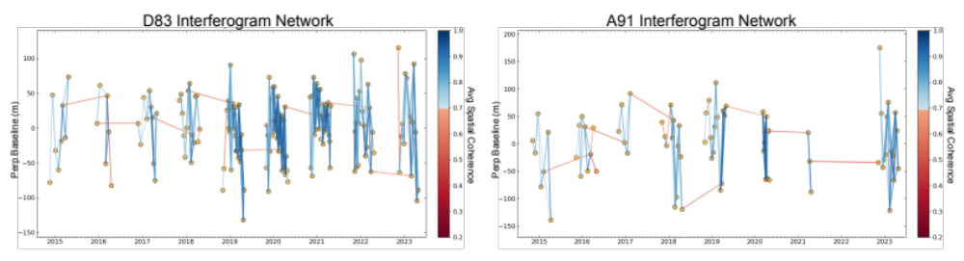
Figure S1: Perpendicular baseline plot for D83 (left) and A91 (right). Acquisitions are shown with orange circles and the average spatial coherence of each interferogram is shown with the color of the line.

Section S2: Modeling process

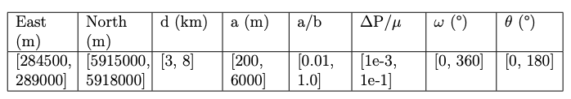
Table S1: Prior probability distributions for each model parameter in the Yang inversions. d: depth to ellipsoid center. a: semi-major axis. a/b: ratio of semi-major to semi-minor axis. ∆P/μ: ratio of overpressure to shear modulus. ω: strike angle clockwise from East. θ: dip angle.
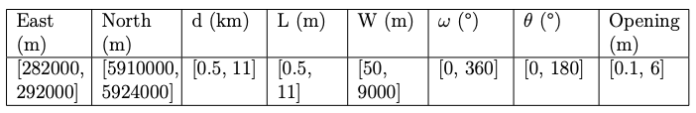
Table S2: Prior probability distributions for each model parameter in the Okada inversions. d: depth to top left corner of source. L: length. W: width. ω: strike angle clockwise from North. θ: dip angle. Opening: tensile opening of source.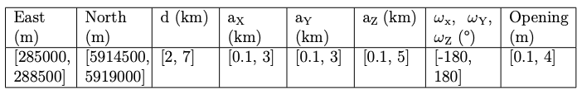
Table S3: Prior probability distributions for each model parameter in the CDM inversions. d: depth to CDM center. a_{X} : semi-axis of dislocation in the XZ plane. a_{Y} : semi-axis of dislocation in the XY plane. a_{Z} : semi-axis of dislocation in the YZ plane. ω: rotation angles. Opening: uniform opening of all dislocations.

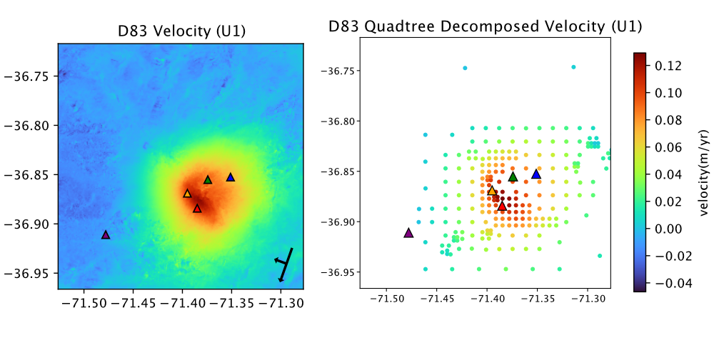
Figure S2: Original velocity map for Uplift 1 (7/2019-7/2020; left) and reduced data array (right). Positive values correspond to movement towards the satellite, negative values correspond to movement away from the satellite. Triangles show the locations of GNSS stations with the same color scheme as Fig. 1. Arrows in lower right corner shows the LOS.

Section S3: Difference DEM Quality
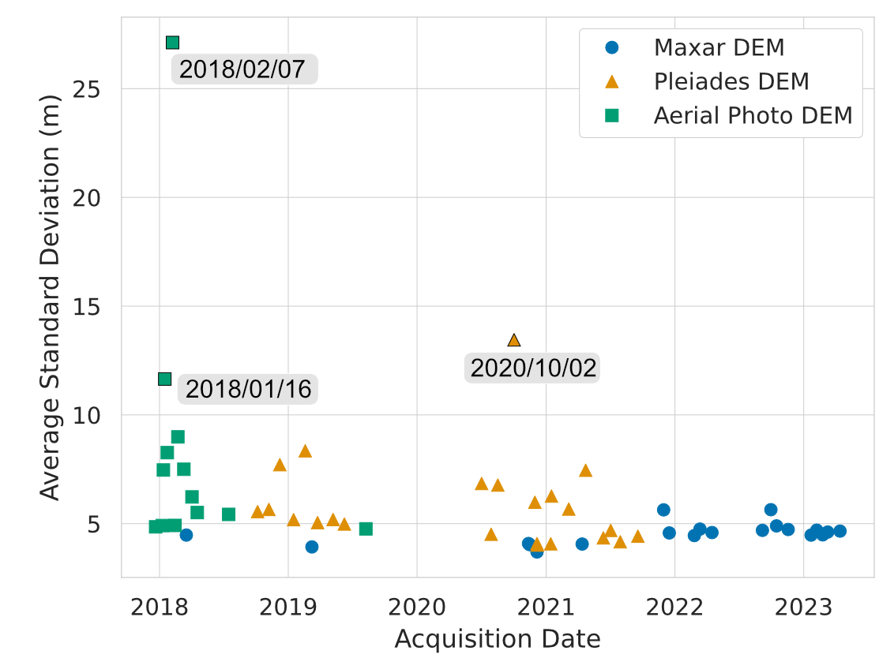
Figure S3: Average standard deviation for all DEMs, calculated in a region with no expected surface change marked in Fig. 3. Maxar (blue circle), Pléiades (orange triangle), and Aerial Photo (green square) data are distinguished. DEMs with a large average standard deviation are labeled with the date (Year/Month/Day).
Section S4: Time series of area derived from optical and thermal data

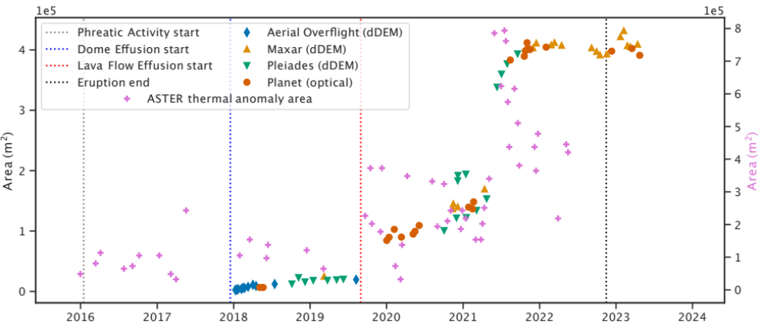
Figure S4: Area of lava erupted, derived from optical and thermal satellite and aerial data. Area of thermal features derived from ASTER is plotted as pink plus signs. Area derived from optical data from aerial overflights (blue diamonds), WorldView satellites (yellow triangles), Pléiades (green triangles) and Planet (red circles) are also plotted. Vertical dashed lines mark important transitions of eruptive activity according to Table 5.1.

Section S5: Model fits and geometries for all time periods
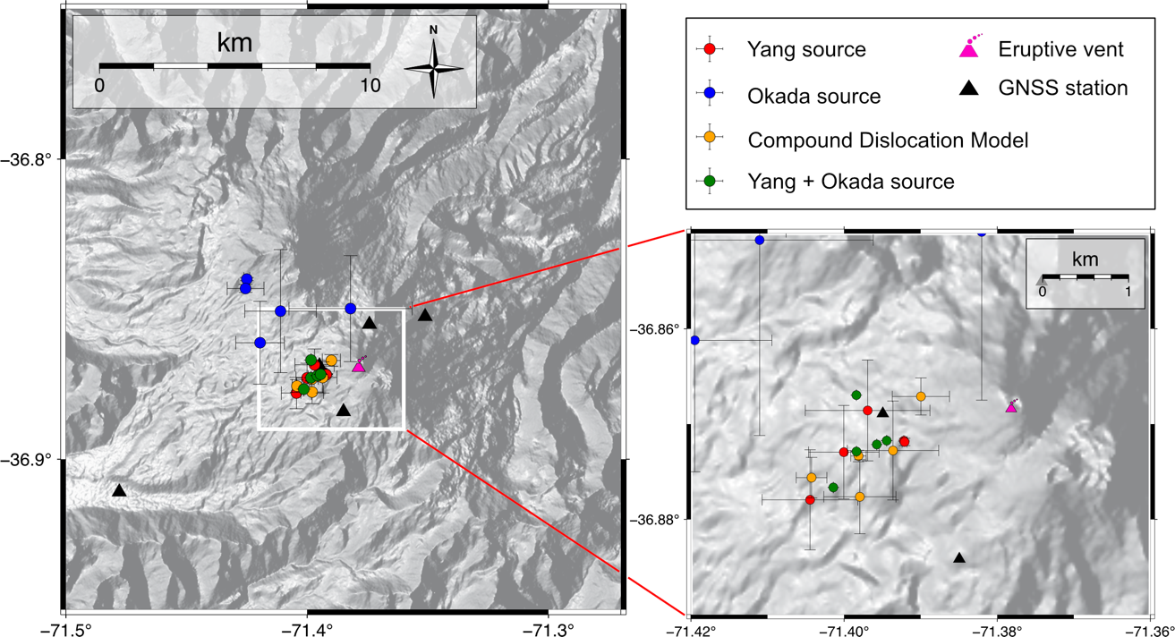

Figure S5: Map showing the surface location the source solved for with each inversion method. Color corresponds to the model used in the inversion. The Okada source (largest average RMSE) shows more spread in the surface locations compared to the other source types. The extent of the map is the same as shown in Figure 4.13. Hillshade data from SRTM1S [190].
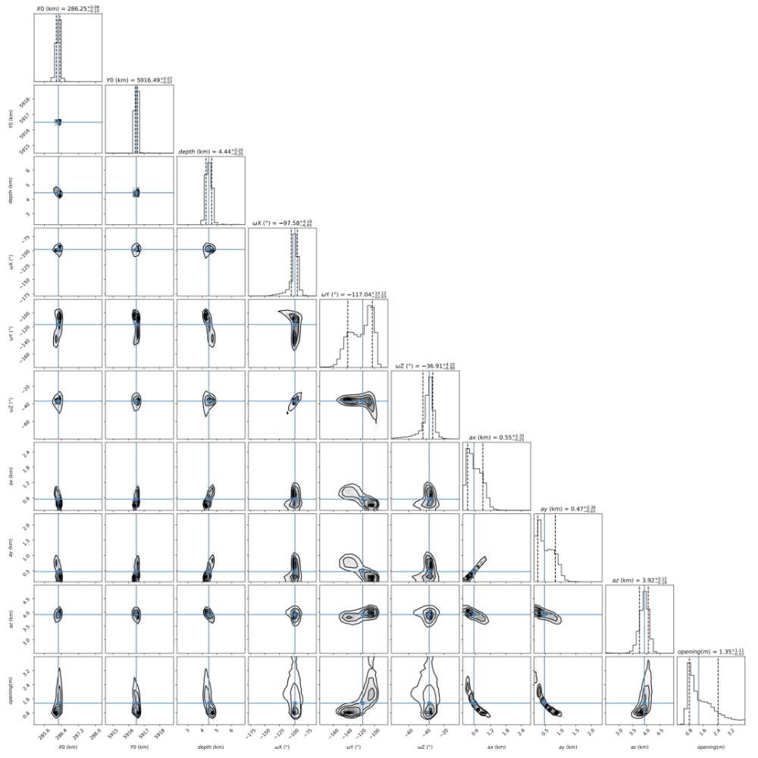
Figure S6: Corner plot for MCMC inversion with CDM and D83+A91. Each row and column correspond to one of the source model parameters we are solving for. The contour plots show the relationship between the source model parameters in that row/column. The histogram shows the distribution of likely model parameters, with the mean and 1-σ values marked.

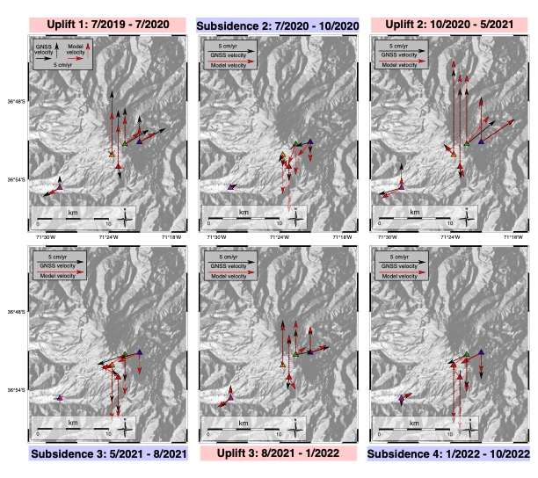
Figure S7: Plots of GNSS velocity (black) and model velocity (red) for co-eruptive surface deformation, using all best-fit models. Uplift 1 was modeled using the InSAR data and the CDM geometry. All other periods were modeled using GNSS data and the ellipsoid geometry. Vertical GNSS/model velocities are shown with dashed lines. Horizontal GNSS/model velocities are shown with solid lines. Hillshade data from Shuttle Radar Topography Mission 1 arc second resolution (SRTM1S) [190].

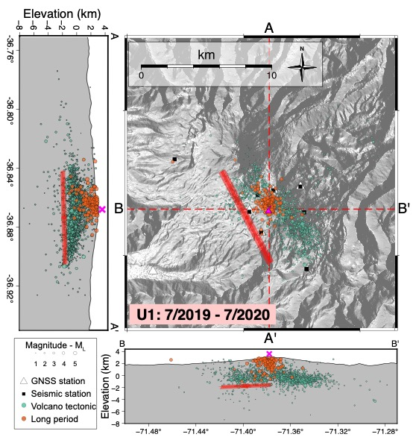Figure S8: Map and cross sections showing the location of the source of U1 (red). Earthquakes during the time period are plotted in seafoam (volcano tectonic: VT) and orange (long period: LP). Size of the earthquake symbol corresponds to the earthquake magnitude as processed by SERNAGEOMIN. The extent of the x-y map is the same as shown in Figure S9. GNSS stations are white triangles and seismic stations are black squares.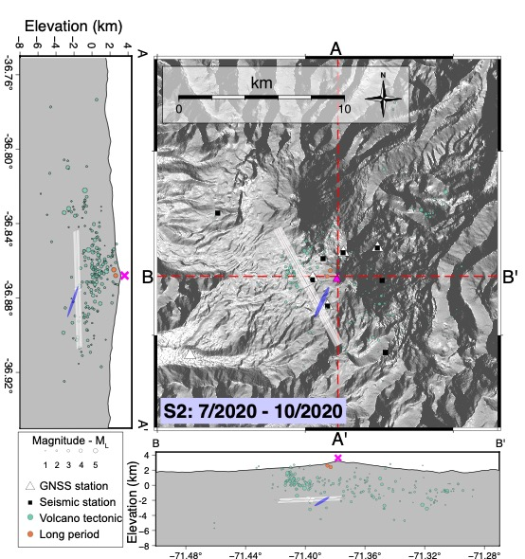Figure S9: Map and cross sections showing the location of the source of S2 (blue). Source location of U1 is shown in white. See caption of Figure S10 for remaining details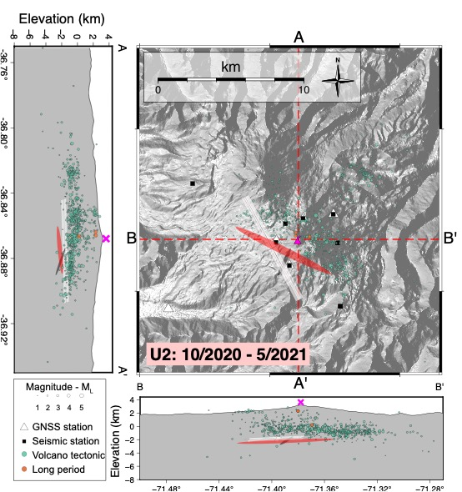Figure S10: Map and cross sections showing the location of the source of U2 (red). Source locations for previous uplift and subsidence events are shown in white and gray, respectively. See caption of Figure S10 for remaining details.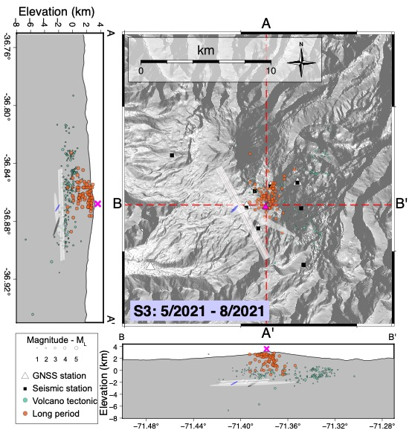Figure S11: Map and cross sections showing the location of the source of S3 (blue). Source locations for previous uplift and subsidence events are shown in white and gray, respectively. See caption of Figure S10 for remaining details.
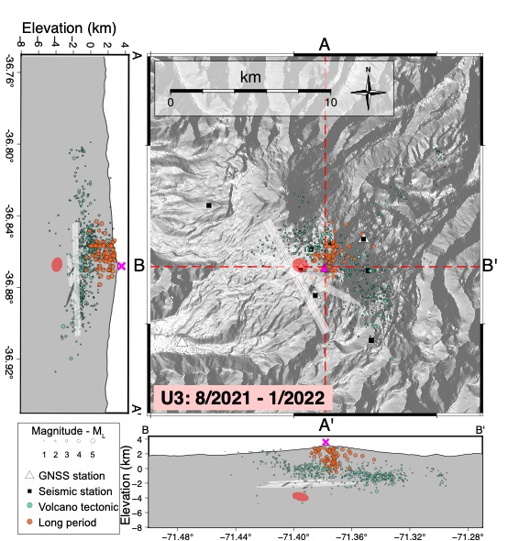
Figure S12: Map and cross sections showing the location of the source of U3 (red). Source locations for previous uplift and subsidence events are shown in white and gray, respectively. See caption of Figure S10 for remaining details.

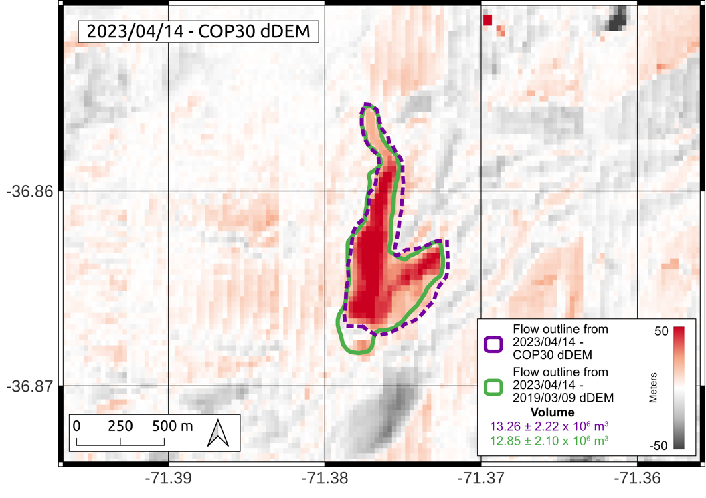
Figure S13: Difference DEM between a Maxar DEM (2 m/pixel) and Copernicus DEM (COP30; 30 m/pixel). Flow outline derived from this dDEM is shown in purple. Flow outline derived from Maxar-Maxar dDEM is shown in green. ©2024, Maxar, USG Plus.

