Supplementary Information

Comparing tangible retinal image characteristics with deep learning features reveals their complementarity for gene association and disease prediction
Michael J Beyeler^{1,2}, Olga Trofimova^{1,2}, Dennis Bontempi^{1,2}, Leah Böttger^{1,2}, Sacha Bors^{1,2},
Ilaria Iuliani^{1,2}, Sofia Ortin Vela^{1,2}, David M Presby^{1,2,&}, Sven Bergmann^{1,2,3,&}

¹Dept. of Computational Biology, University of Lausanne, Lausanne, Switzerland;
²Swiss Institute of Bioinformatics, Lausanne, Switzerland;
³Dept. of Integrative Biomedical Sciences, University of Cape Town, Cape Town, South Africa;
&joint corresponding (david.presby@unil.ch, sven.bergmann@unil.ch) and equal senior authors

Supplementary Tables 2
1. Pairwise comparisons across feature sets for linear and logistic regressions used to predict disease. 2
2. Details on baseline characteristics of present cohort and that of our previous study 3
Supplementary Figures 4
1. Analysis of leading PCs of RETFound’s baseline LVs 4
2. Predictive capacity of CFI features expanded 5
3. Image quality distribution. 6
4. Distributions of covariates 7
5. Distributions of diseases and risk factors 8
References 9

Supplementary Tables

1. Pairwise comparisons across feature sets for linear and logistic regressions used to predict disease.
Supplemental Table 1
Supplementary Table 1.

2. Details on baseline characteristics of present cohort and that of our previous study
 | Included participants  (N=41789) |  | Complete fundus dataset  (N=81848)
Characteristics | N | Mean±SD or % | N | Mean±SD or % | P-value
Covariates
Female | 41789 | 54.3% | 81848 | 53.3% | 0.001 (**)
Age | 41789 | 56.0±8.2 | 81848 | 57.7±8.2 | 7e-258 (***)
SNP array | 41789 | 90.70% | 81848 | 90.70% | 0.8
Instance | 41789 | 15.90% | 81848 | 20.60% | 9e-89 (***)
Spherical power | 41789 | -0.9±2.5 | 81848 | -0.8±2.8 | 1e-18 (***)
Cylindrical power | 41789 | 0.8±0.6 | 81848 | 0.9±0.7 | 2e-81 (***)
Genetic PC 1 | 41789 | 2.2±61.8 | 81848 | 4.8±68.0 | 5e-11 (***)
Genetic PC 2 | 41789 | -0.4±31.5 | 81848 | -0.7±33.3 | 0.1
Genetic PC 3 | 41789 | 0.1±16.6 | 81848 | 0.4±17.6 | 0.002 (**)
Genetic PC 4 | 41789 | -0.5±11.2 | 81848 | -0.4±11.4 | 0.017 (*)
Genetic PC 5 | 41789 | -1.0±7.4 | 81848 | -1.0±7.3 | 0.6
Risk factors
DBP | 41642 | 81.4±10.0 | 81575 | 81.4±10.0 | 0.6
SBP | 41642 | 136.1±18.1 | 81574 | 137.5±18.4 | 3e-36 (***)
PR | 41642 | 67.8±11.0 | 81575 | 67.9±11.0 | 0.037 (*)
PWASI | 41394 | 9.5±3.7 | 81078 | 9.6±4.0 | 2e-12 (***)
HDL | 36419 | 1.5±0.4 | 70944 | 1.5±0.4 | 0.07
LDL | 38561 | 3.5±0.9 | 75449 | 3.5±0.9 | 3e-04 (***)
Triglycerides | 38599 | 1.7±1.0 | 75506 | 1.7±1.0 | 5e-04 (***)
HbA1c | 37353 | 35.7±6.2 | 72179 | 36.2±6.7 | 8e-33 (***)
BMI | 41613 | 27.1±4.7 | 81516 | 27.3±4.7 | 5e-10 (***)
Alcohol | 41677 | 3.1±1.5 | 81607 | 3.0±1.5 | 0.004 (**)
N cigarettes | 2298 | 13.9±7.7 | 4567 | 14.3±7.9 | 0.021 (*)
Pack years | 41789 | 5.5±12.3 | 81848 | 6.2±13.5 | 4e-19 (***)
Supplementary Table 2 | Baseline characteristics. Comparison of covariates and risk factors between our study and complete UK Biobank fundus cohort. Two-sample t-tests were applied to compare continuous variables, tests of proportion were applied to compare binary variables. Note that CFIs from older and diseased subjects were more prone to be excluded, indicating that image quality is not independent from age and disease status.

Supplementary Figures

1. Analysis of leading PCs of RETFound’s baseline LVs
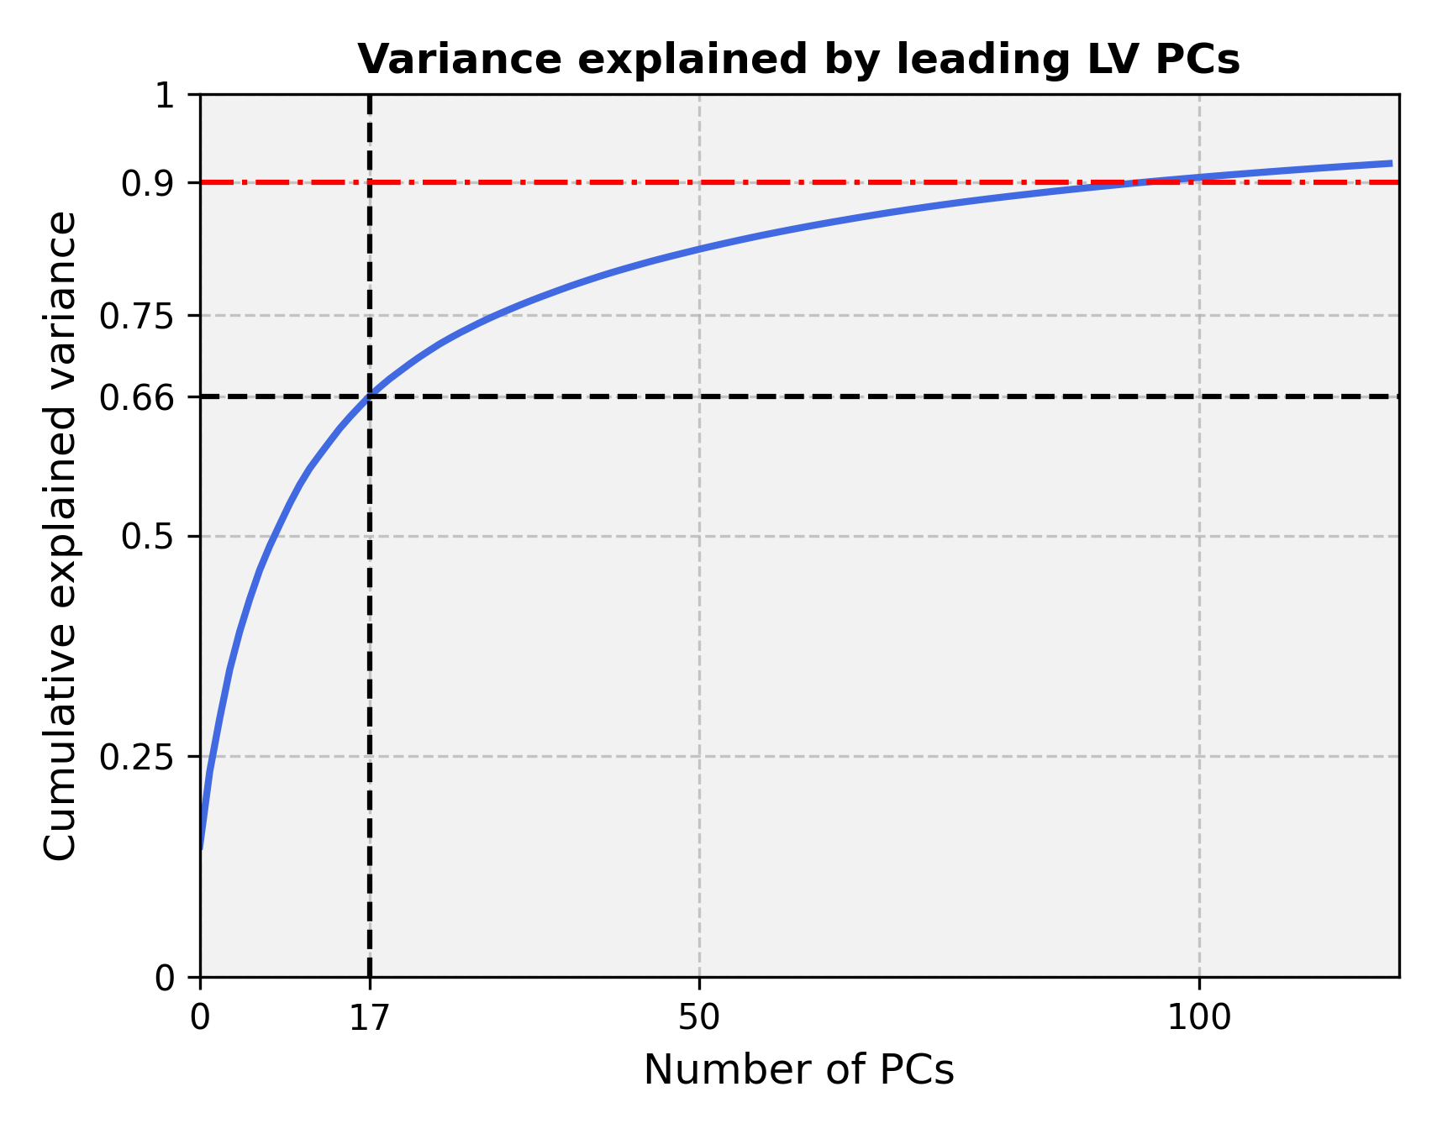
Supplementary Figure 1 | Variance explained by leading LV PCs. We applied principal component analysis to RETFound’s baseline LVs, and show the cumulative variance explained by the resulting leading PCs.
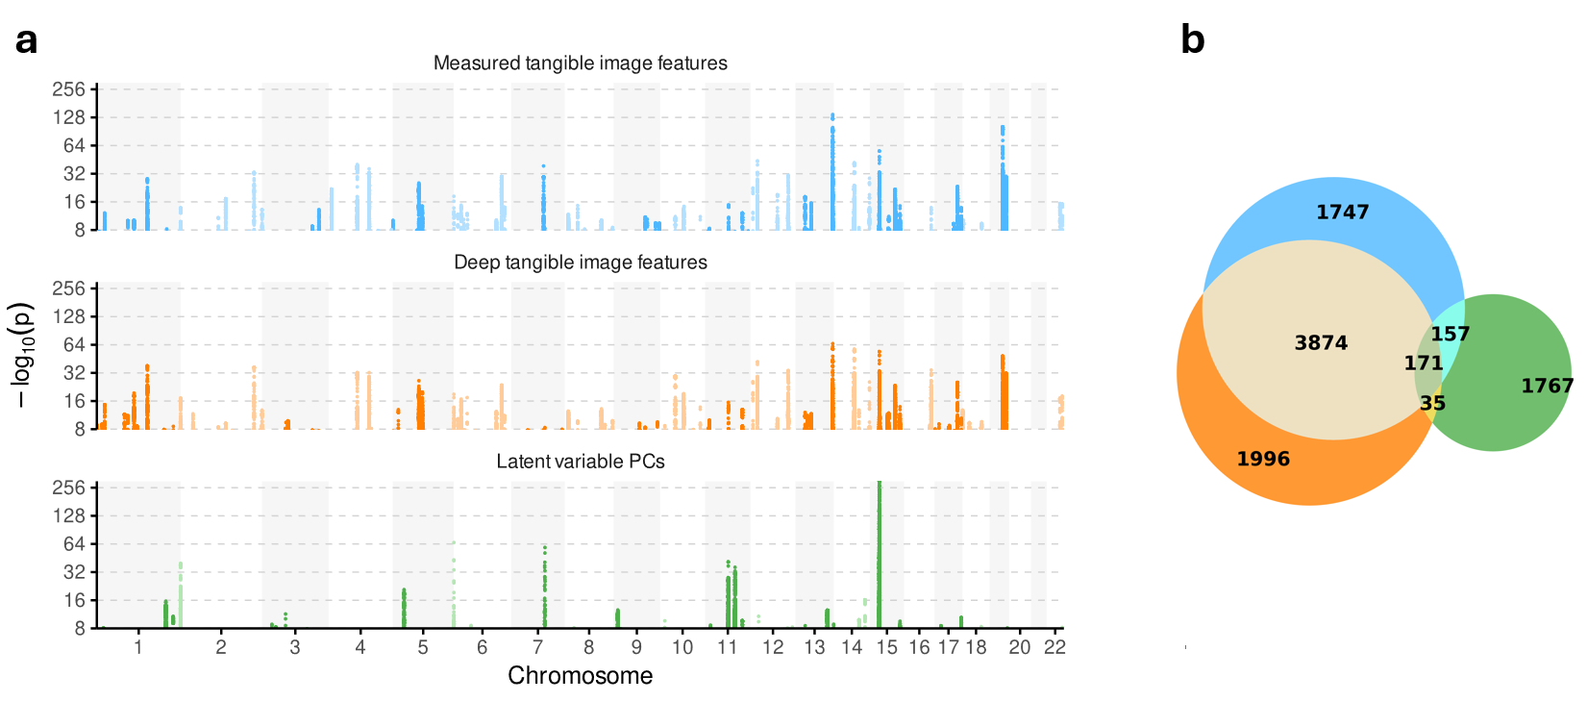
Supplementary Figure 2 | SNP-wise genetic hits of mTIFs, dTIFs, and leading 17 LV PCs. a Manhattan plot snowing SNPs with nominal Bonferroni-corrected genome-wide significance at p=5*10⁻⁸. b Venn diagram comparing overlap and unique SNP-wise discoveries for each method. Significance threshold for each method was set at p=5*10⁻⁸ / 17, 17 being the number of features included in each method. Color codes: Blue: mTIFs, orange: dTIFs, green: LV PCs

2. Predictive capacity of CFI features expanded
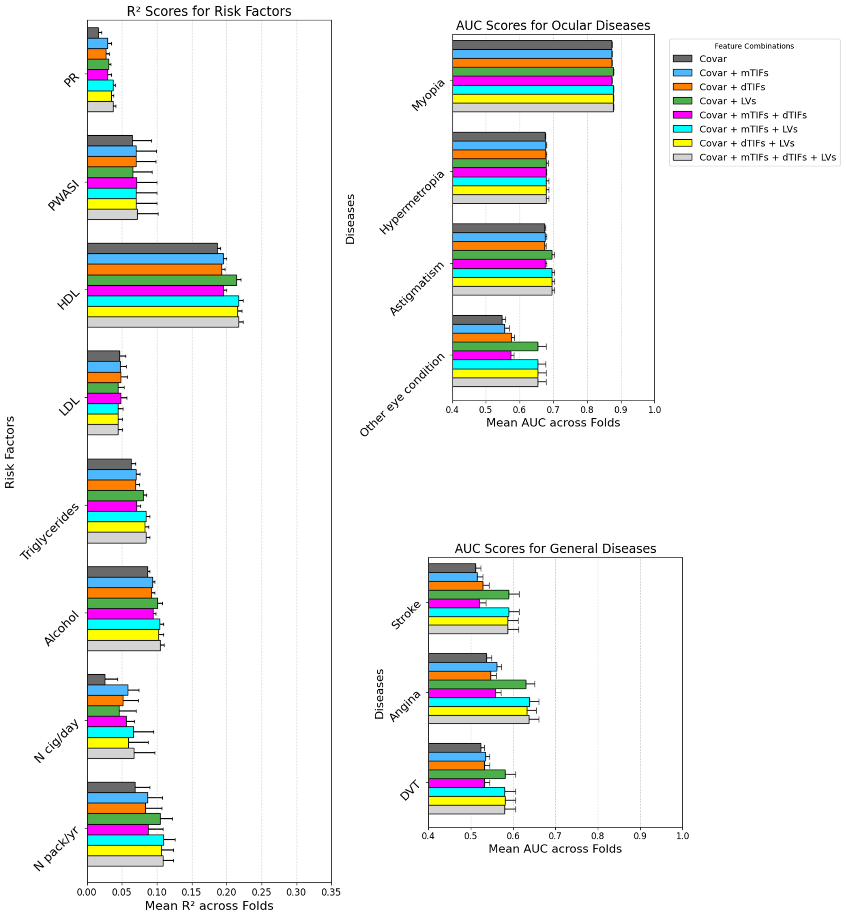
Supplementary Figure 3 | Predictive capacity of CFI features in assessing risk factors, diseases, and events. (a) Explained variance achieved by linear models built to predict risk factors. (b) Area under the receiver operating characteristic curve (AUC) achieved by logistic regression models built to predict ocular diseases. (c) AUC achieved by logistic regression models built to predict diseases or events. Feature sets include: (i) a baseline model including only covariates (see methods for list), (ii) all 17 mTIFs, (iii) all 17 dTIFs, (iv) from 1024 RETFound LVs, (v) all mTIF and 1024 RETFound LVs, (vi) all dTIFs and 1024 RETFound LVs, (vii) all mTIFs and dTIFs, (viii) all features combined. Abbreviations: Covar = Covariates; dTIF = Deep Tangible Image Feature; mTIF = Measured Tangible Image Feature; LV = Latent Variable; AUC = Area Under the Curve; PR = Pulse Rate; PWASI = Pulse Wave Arterial Stiffness Index; HDL = High-Density Lipoprotein; LDL = Low-Density Lipoprotein; N cig/day = self-reported number of cigarettes per day; N pack/yr = self-reported number of packs of cigarettes per year. Error bars reflect 95% confidence intervals.

3. Image quality distribution.
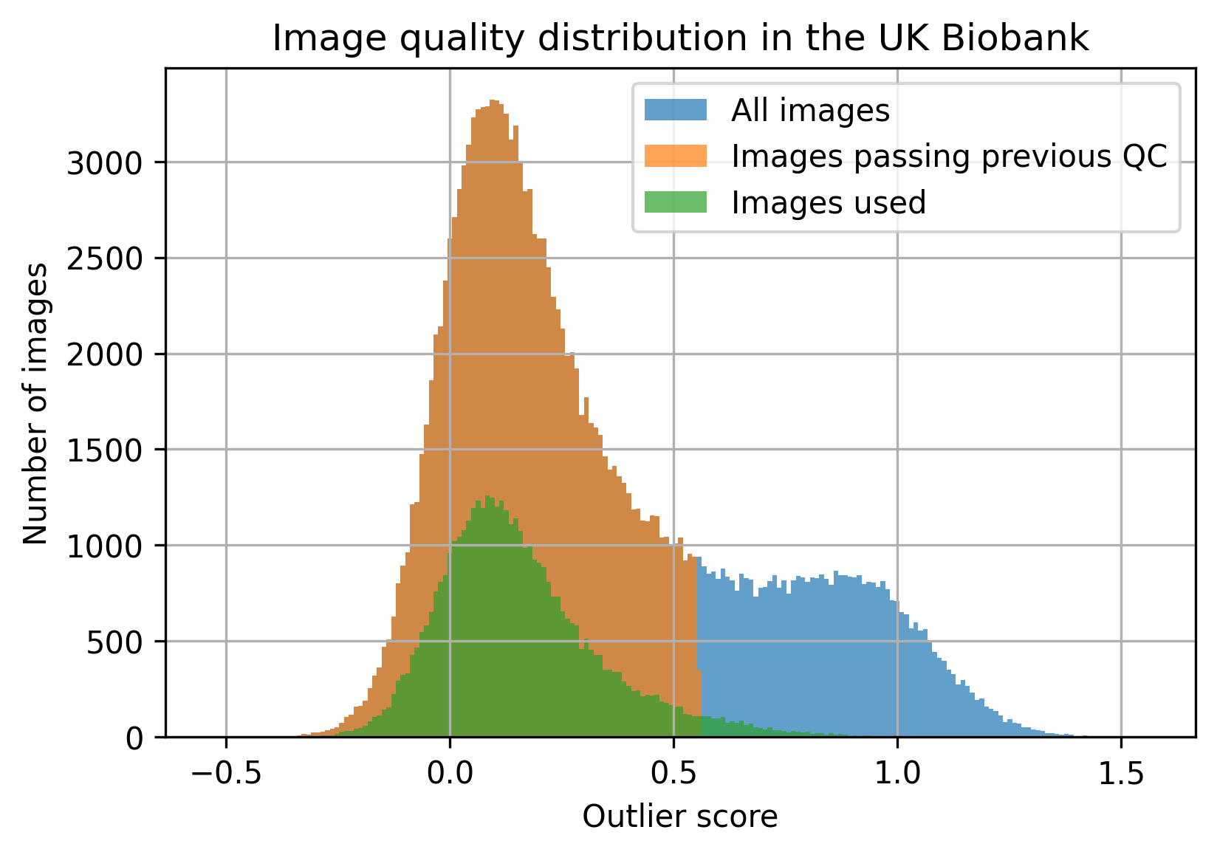Supplementary Figure 4 | Image quality distribution. Image quality distribution in the UK Biobank according to a previously published quality assessment method [1]. The “outlier score” is higher for images of lower quality.

4. Distributions of covariates
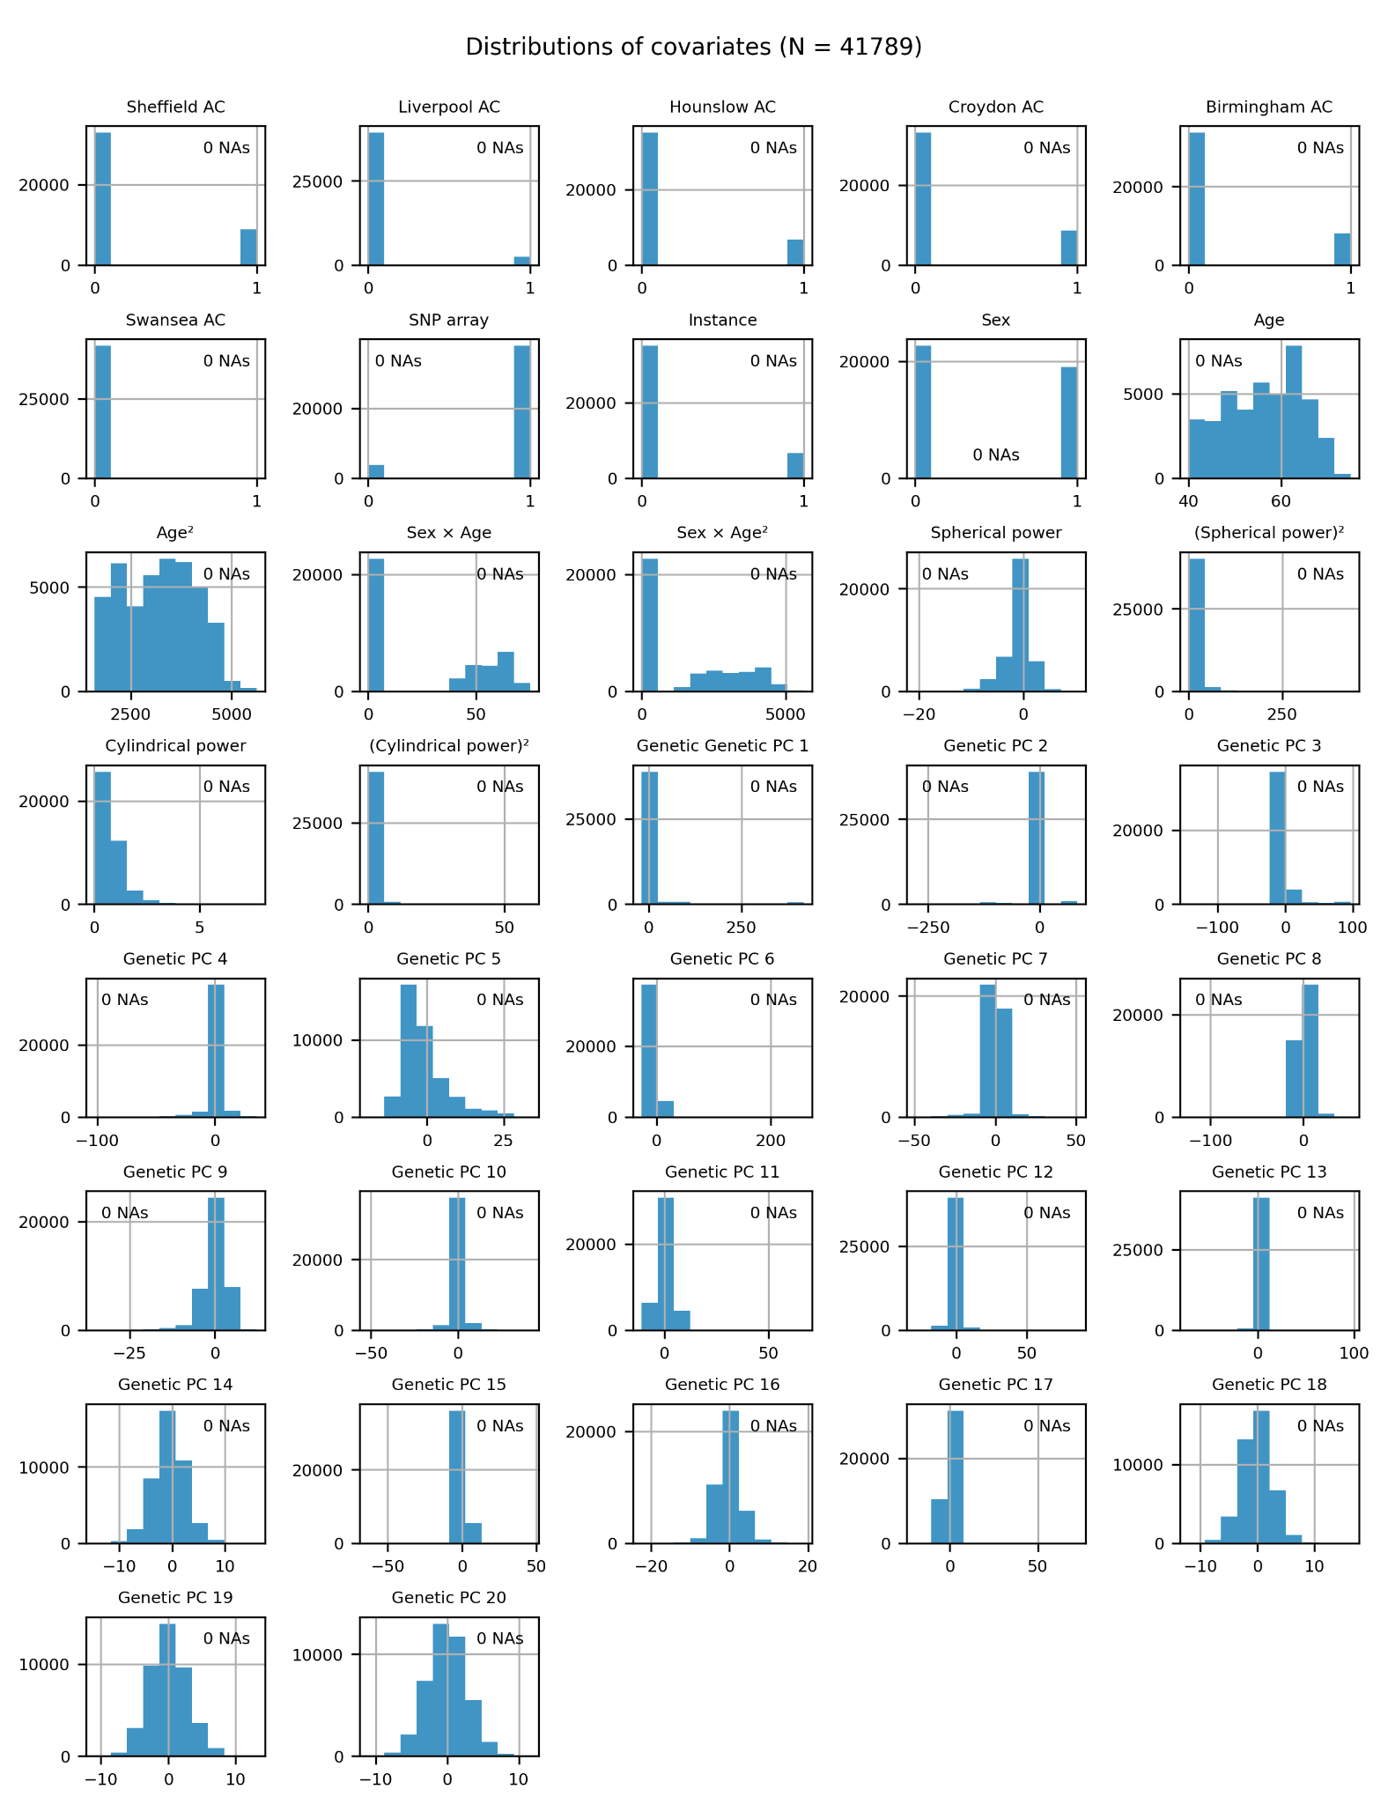
Supplementary Figure 5 | Distribution of covariates. Raw distributions of covariates that were used to correct TIFs and LVs in our genetic analyses and disease associations. No covariates had any missingness.

5. Distributions of diseases and risk factors
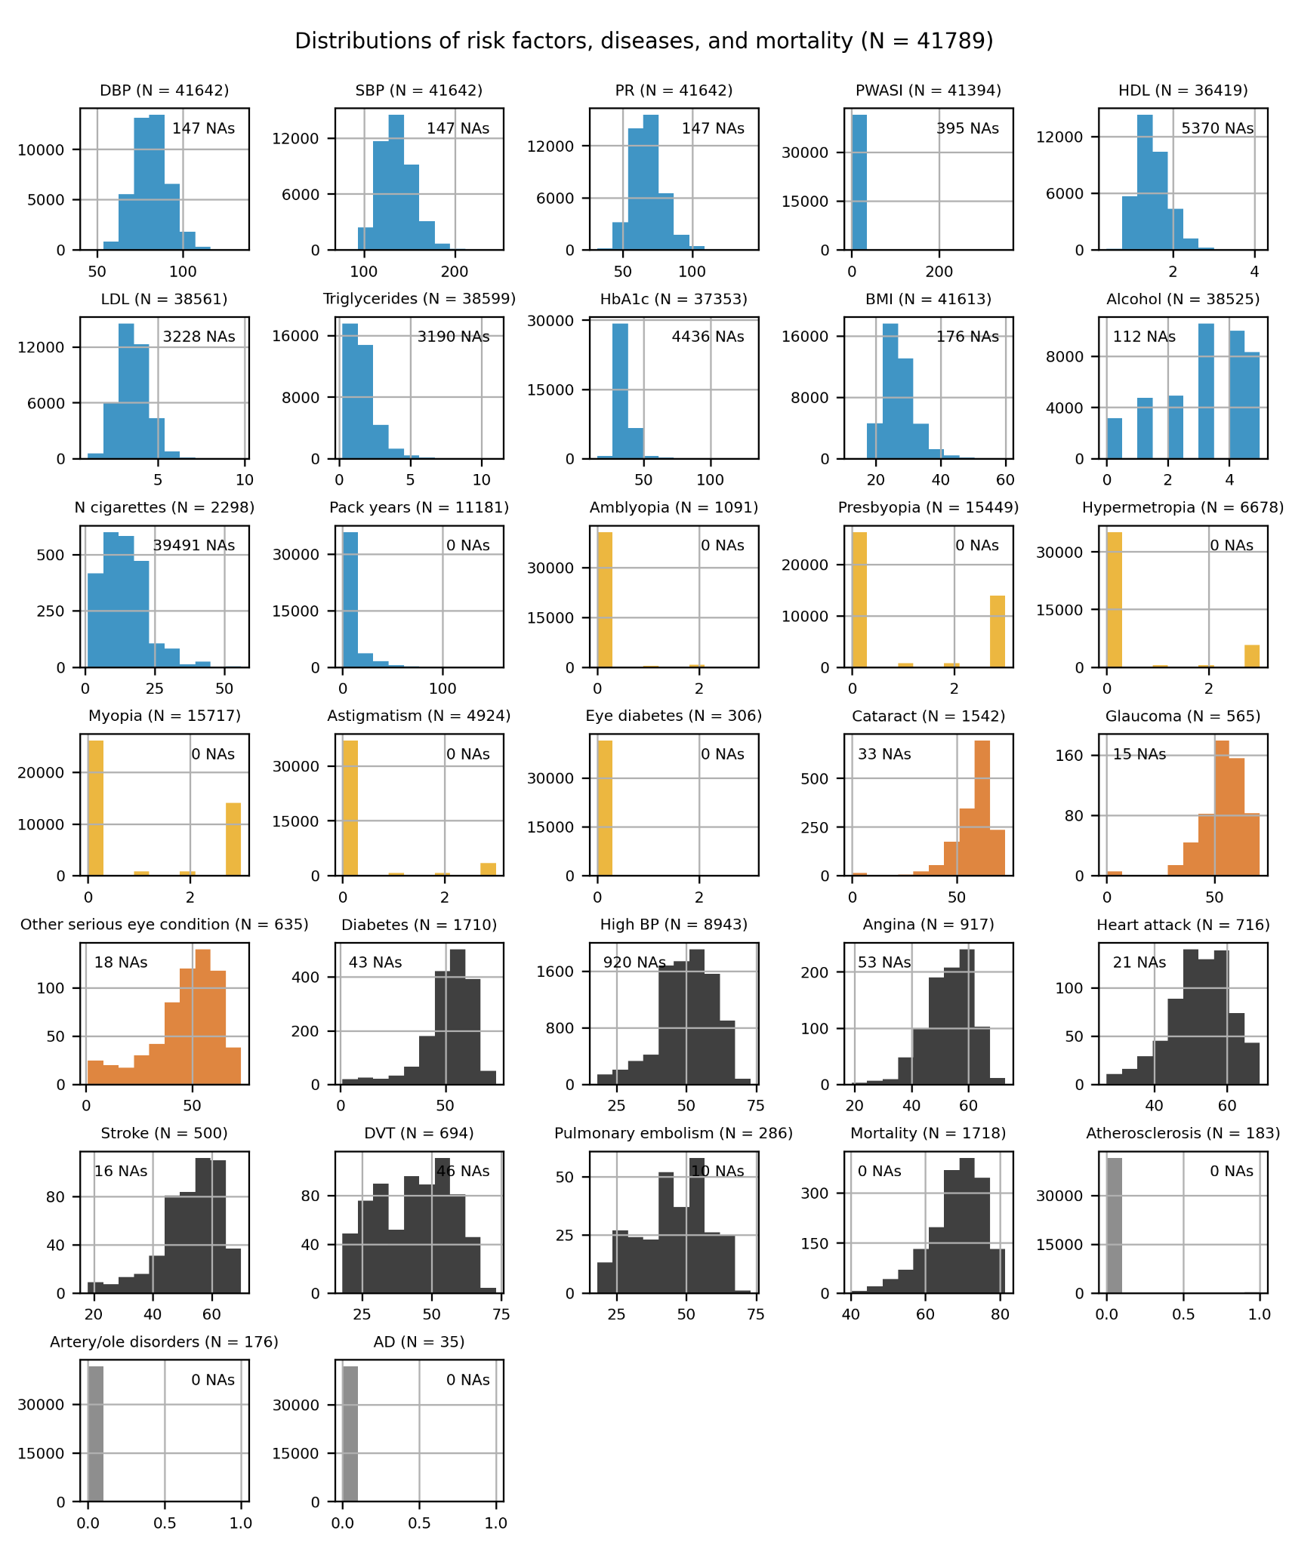
Supplementary Figure 6 | Distribution of diseases. Blue: risk factors, orange: ocular diseases, dark orange: ocular diseases with age-at-onset data, dark gray: systemic diseases with age-at-onset data and mortality, light gray: binary systemic diseases.

References
1. Zekavat SM, Raghu VK, Trinder M, Ye Y, Koyama S, Honigberg MC, et al. Deep Learning of the Retina Enables Phenome- and Genome-wide Analyses of the Microvasculature. Circulation. 2021. doi:10.1161/CIRCULATIONAHA.121.057709

