^{Supplementary Information}

Factor H related 2 levels dictate FHR dimer composition

Bert R.J. Veuskens^{1,2}, Mieke C. Brouwer¹, Gerard van Mierlo¹, Judy Geissler¹, Karin van Leeuwen^{1,4}, Maaike Derlagen⁴, Nadia C.H. Keijzer⁴, Mark Hoogenboezem¹, Taco W. Kuijpers^{1,3}, Richard B. Pouw^{1,2,4*}

- Sanquin Research and Landsteiner Laboratory of the Academic University Medical Centers, University of Amsterdam, Amsterdam 1066 CX, Netherlands.
- Amsterdam institute for Immunology and Infectious Diseases, Inflammatory diseases, Amsterdam 1105 AZ, Netherlands
- Department of Paediatric Immunology, Rheumatology and Infectious Diseases, Emma Children's Hospital, AUMC, University of Amsterdam, Amsterdam 1105 AZ, Netherlands.
- Sanquin Diagnostic Services, Amsterdam 1066 CX, Netherlands

*Corresponding author:
Richard B. Pouw, PhD
Sanquin Research
Plesmanlaan 125, 1066 CX, Amsterdam, The Netherlands
richard.pouw@sanquin.nl

Keywords: Complement system/FHR-1/FHR-2/Dimerization
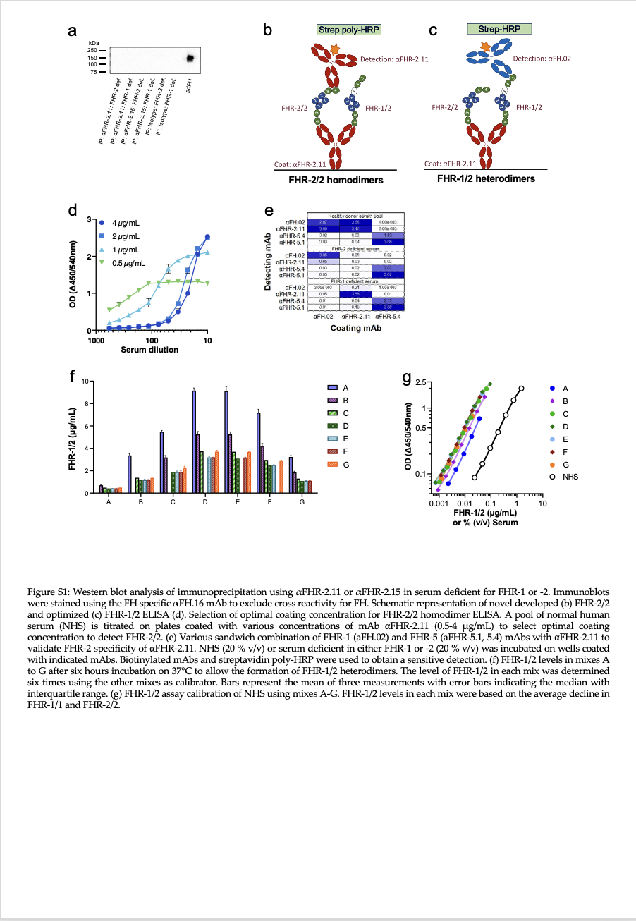

Figure S1: Western blot analysis of immunoprecipitation using αFHR-2.11 or αFHR-2.15 in serum deficient for FHR-1 or -2. Immunoblots were stained using the FH specific αFH.16 mAb to exclude cross reactivity for FH.²³ Schematic representation of novel developed (b) FHR-2/2 and optimized (c) FHR-1/2 ELISA. (d)Various sandwich combination of FHR-1 (αFH.02) and FHR-5 (αFHR-5.1, 5.4) mAbs with αFHR-2.11 to validate FHR-2 specificity of ⍺FHR-2.11. NHS (20%, v/v) or serum deficient in either FHR-1 or -2 (20%, v/v) were incubated on wells coated with indicated mAbs. Indicated biotinylated detection mAbs (0.2 µg/mL) and streptavidin poly-HRP (0.01%, v/v) were used to obtain a sensitive detection. (f) FHR-1/2 levels in mixes A to G after six hours incubation on 37°C to allow the formation of FHR-1/2 heterodimers. Mixes A to G contain various ratios (95-5%, 85-15%, 75-25%, 50-50%, 25-75%, 15-85% and 5-95%, v/v) FHR-2 deficient plasma and CFHR3/CFHR1 deficient, respectively. The level of FHR-1/2 in each mix was determined six times using the other mixes as calibrator. Bars represent the mean of three measurements with error bars indicating the median with interquartile range. (g) FHR-1/2 assay calibration of NHS using mixes A-G. FHR-1/2 levels in each mix were based on the average decline in FHR-1/1 and FHR-2/2 as determined by measuring the remaining FHR-1 and -2 homodimers by ELISA. The mixtures, now with a known amount of native FHR-1/2 heterodimers, were used to calibrate the NHS standard.
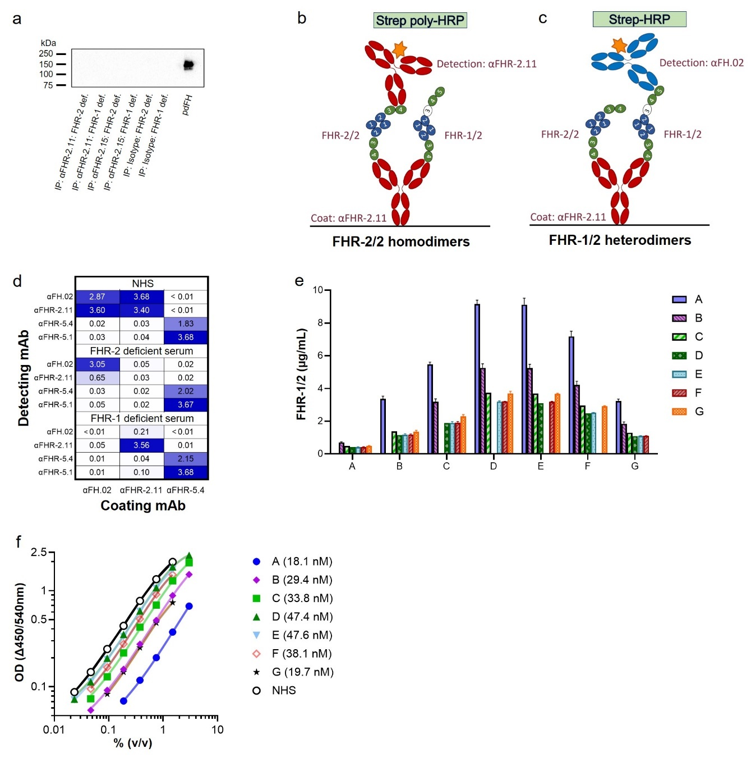
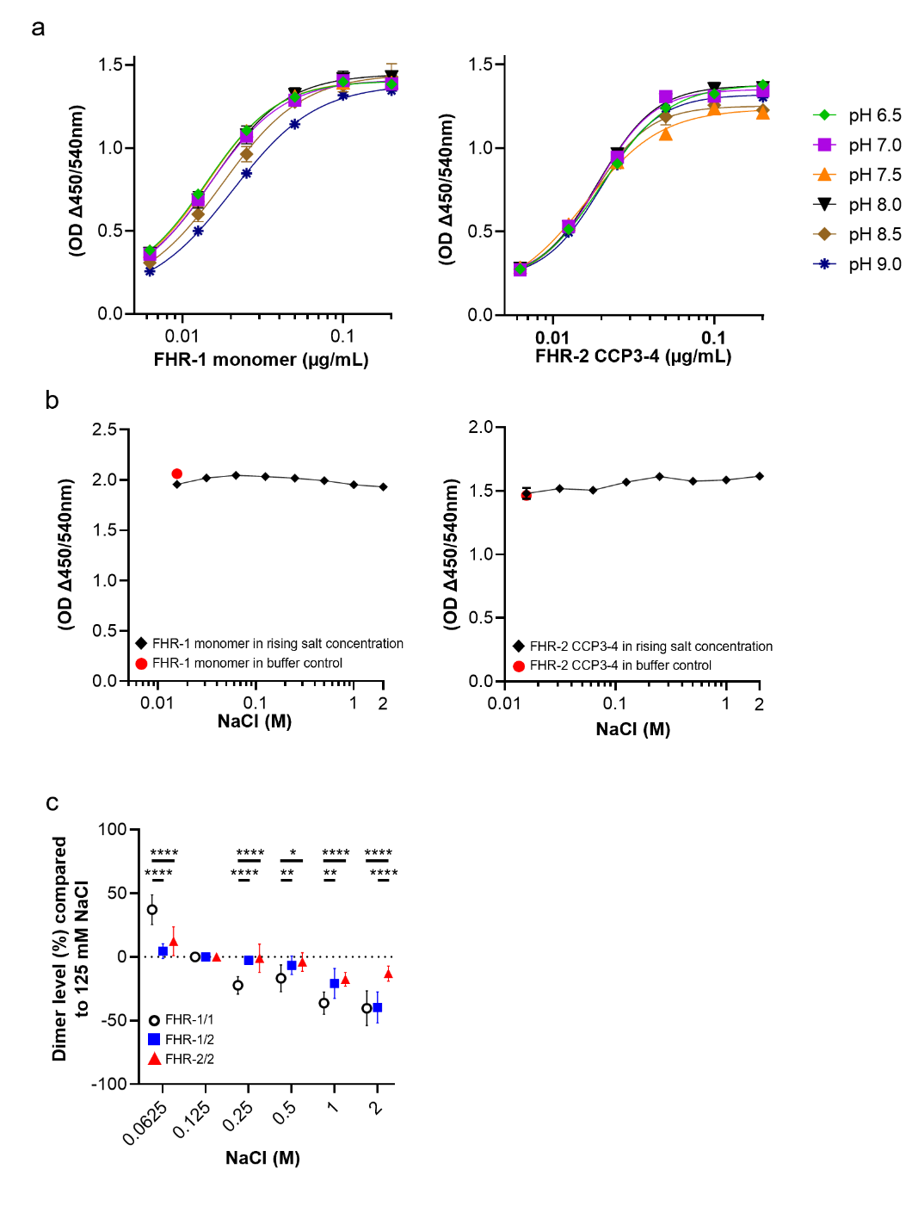
Figure S2: Investigating the influence of pH (a) or a rising salt concentration (b) on antigen binding to αFH.02 or αFHR-2.11. Monomeric FHR-1 or FHR-2 CCP3-4 were incubated under different pH levels and NaCl concentrations on αFH.02 and αFHR-2.11 coated plates respectively, showing no significant impact on antigen binding. (c) Impact of sodium chloride on dimer stability. NHS (3%, v/v) was incubated with increasing concentrations of NaCl ranging from 0.0625-2 M. 125 mM NaCl was used as a 100% reference. Results are presented as percentage of change in dimer levels compared to 0.125 M NaCl. (c) The Shapiro-Wilk test was used to test for normal distribution of the population. A Brown-Frosythe and Welch ANOVA test with the Dunnett's T3 multiple comparisons test was used to test for significant differences between the FHR-1 and -2 dimers at a given NaCl concentration. Symbols represent the mean of multiple measurements with error bars the SD. (* p< 0.05; ** p <0.01; *** p <0.001; **** p <0.0001)

Figure S3: Spearman correlations of FHR-1/2 with FHR-1/1 (a) or -2/2 (b) stratified on CFHR1 CNV. (d) Showing the impact of indicated SNPs on total levels of FHR-1. Data is not corrected for CFHR1 CNV. (c) Validation of MLPA probe developed to identify and determine the copy number variation of rs4085749. Donors are categorized being wild type, hetero -or homozygous for the c.420C>T mutation. Colored symbols represent donors identified by NGS to carry additional low frequency CFHR2 mutations (heterozygous): red= p.Cys72Tyr.; blue= p.Tyr264Cys.; green= p.Cys72Tyr & p.Glu199Ter. (d) Showing the impact of indicated SNPs on total FHR-1 levels. (e) Pearson correlations between inferred and directly measured FHR-2/2 levels. Inferred levels were computed as previously outlined in Rispens T et al. (2011) and van Beek et al. (2017). (c, d) the one-way ANOVA test with the Tukey corrections test for multiple testing was used to test for significant differences. Symbols represent the mean of two measurements with (c, d) error bars indicating the median with interquartile range. (* p< 0.05; ** p <0.01; *** p <0.001; **** p <0.0001)

Figure S4: Original images (a-d) of Western blots and markers of figure 1c (NHS), 1d (CFHR3/CFHR1 deficient serum pool) and 1e (FHR-2 deficient serum pool) and supplemental figure 1a, respectively. Images of the blot and marker were exported for publication using Image lab 6.0 software of Biorad.

Supplemental tables:
Table S1: Normal serum levels of FHR-1, -2 and their dimer species.
FHR | CFHR1 CNV (n=) | Median (CI) in µg/mL | IQR in µg/mL | 95% range in µg/mL | Mean (CI) in µg/mL | SD in µg/mL | Age^{a,b}: Pearson r  (p-value) | Sex^{a,b}  Median (CI) in µg/mL
 |  |  |  |  |  |  |  | Female |  | Male
FHR-1/1 | 0 (9) | <LOD= 0.70 µg/mL
FHR-1/1 | 1 (58) | 6.50 (5.88-6.92) | 5.19-7.68 | 4.59-8.98 | 6.51 (6.14-6.89) | 1.43
FHR-1/1 | 2(133) | 14.20 (13.50-14.80) | 12.45-15.80 | 10.26-19.41 | 14.28 (13.80-14.77) | 2.84
FHR-1/1 | 3 (1) | n.a. (19.30 µg/mL)
FHR-1/1 | Total (201) | 12.45 (11.36-13.00) | 7.37-15.05 | 3.66-18.80 | 11.46 (10.78-12.14) | 4.88 | 0.21  (p= 0.0037) | 12.55  (11.30-13.55) |  | 12.70  (11.05-13.75)
 |  |  |  |  |  |  |  | p= 0.67
FHR-1/2 | 0 (9) | <LOD= 0.27 µg/mL
FHR-1/2 | 1 (58) | 3.72 (3.30-4.18) | 2.89-4.60 | 1.93-5.73 | 3.76 (3.45-4.07) | 1.18
FHR-1/2 | 2 (133) | 4.88 (4.58-5.29) | 3.68-6.17 | 1.57-7.81 | 4.81 (4.49-5.13) | 1.87
FHR-1/2 | 3 (1) | n.a. (3.67 µg/mL)
FHR-1/2 | Total (201) | 4.34 (4.10-4.64) | 3.04-5.41 | 0.27-7.60 | 4.30 (4.03-4.57) | 1.92 | 0.12  (p= 0.11) | 4.59  (3.98-5.13) | 4.48  (4.21-4.67)
 |  |  |  |  |  |  |  | p= 0.19
FHR-2/2 | 0 (9) | 4.09 (2.76-4.56) | 3.20-4.49 | 1.83-5.67 | 3.87 (3.03-4.71) | 1.10
FHR-2/2 | 1 (58) | 1.36 (1.13-1.83) | 0.94-2.06 | 0.34-2.48 | 1.46 (1.28-1.64) | 0.67
FHR-2/2 | 2 (133) | 0.96 (0.82-1.29) | 0.61-1.57 | 0.17-1.87 | 1.05 (0.95-1.17) | 0.58
FHR-2/2 | 3 (1) | n.a. (0.32 µg/mL)
FHR-2/2 | Total (201) | 1.20 (1.02-1.36) | 0.71-1.71 | 0.19-2.72 | 1.29 (1.17-1.41) | 0.86 | -0.022  (p= 0.77) | 1.29  (1.11-1.49) | 1.02  (0.84-1.37)
 |  |  |  |  |  |  |  | p= 0.091
Total FHR-1  (calculated) | 0 (9) | <LOD= 0.70 µg/mL
Total FHR-1  (calculated) | 1 (58) | 8.89 (7.99-9.48) | 7.15-10.15 | 5.78-12.02 | 8.76 (8.28-9.24) | 1.84
Total FHR-1  (calculated) | 2 (133) | 17.21 (16.79-17.66) | 14.55-19.47 | 11.98-22.89 | 17.16 (16.57-17.75) | 3.45
Total FHR-1  (calculated) | 3 (1) | n.a. (21.50 µg/mL)
Total FHR-1  (calculated) | Total (201) | 14.59 (13.63-15.79) | 9.65-17.95 | 5.28-22.30 | 14.02 (13.24-14.80) | 5.63 | 0.21  (p= 0.0039) | 15.07  (13.63-16.83) | 15.22  (13.45-16.87)
 |  |  |  |  |  |  |  | p= 0.57
Total FHR-2  (calculated) | 0 (9) | 4.09 (2.76-4.56) | 3.20-4.49 | 1.83-5.67 | 3.87 (3.03-4.71) | 1.10
Total FHR-2  (calculated) | 1 (58) | 2.84 (2.43-3.55) | 2.06-3.91 | 1.16-4.52 | 2.97 (2.68-3.26) | 1.09
Total FHR-2  (calculated) | 2 (133) | 2.92 (2.65-3.39) | 2.21-3.98 | 0.80-4.97 | 2.99 (2.76-3.21) | 1.29
Total FHR-2  (calculated) | 3 (1) | n.a. (1.76 µg/mL)
Total FHR-2  (calculated) | Total (201) | 3.03 (2.74-3.39) | 2.19-3.96 | 0.91-4.92 | 3.01 (2.84-3.19) | 1.24 | 0.074  (p= 0.32) | 3.19  (2.76-3.64) | 2.75  (2.52-3.40)
 |  |  |  |  |  |  |  | p= 0.11
a: Donors lacking FHR-2 as previously validated by NGS were excluded in the statistical analysis.¹¹
b: Donors lacking FHR-1 as determined by MLPA were excluded in the statistical analysis.
Abbreviations: Gene copy number variation (CNV), Interquartile range (IQR), Standard deviation (SD)
Table S2: Sequence of MLPA probe to detect the minor alle variant of the SNP rs4085749 in CFHR2.
Left probe oligo: | GGGTTCCCTAAGGGTTGGACCGACGTGTCTCTGAGAGAACAACATTGCACTTACTAGTGGACCTA
Right probe oligo: | CATTTGGGAGGAGTGGACCAGCCCCGTTCTACAGCCTCTAGATTGGATCTTGCTGGCAC

