A 3D Gut-Brain-Vascular Platform for Bidirectional Crosstalk in Gut-Neuropathogenesis

Minh Tran¹⁻³†, Hoe Won Jeong^{1,2,4}†, Chaeyoen Been^{1,2}, Ariunzaya Jamsranjav^{1,2}, Minjoon An^{1,2,5}, Van Thi Ai Tran^{1,2}, Luke P. Lee^{1,2,6-8*}, Hansang Cho^{1-3*}

¹Institute of Quantum Biophysics, Sungkyunkwan University, Suwon, Korea.
²Department of Biophysics, Sungkyunkwan University, Suwon, Korea.
³Department of Intelligent Precision Healthcare Convergence, Sungkyunkwan University, Suwon, Korea.
⁴School of Mechanical Engineering, Sungkyunkwan University, Suwon, Korea.
⁵Department of Metabiohealth, Sungkyunkwan University, Suwon, 16419 Republic of Korea
⁶Department of Medicine, Harvard Medical School, Brigham and Women’s Hospital, Boston, MA, 02115, USA.
⁷Department of Bioengineering, University of California at Berkeley, Berkeley, CA, 94720, USA.
⁸Department of Electrical Engineering and Computer Science, University of California at Berkeley, Berkeley, CA, 94720, USA.

Email: Minh Tran (minhtran@g.skku.edu); Hoe Won Jeong (dkesjung@naver.com); Chaeyoen Been ( qlscodus@g.skku.edu); Ariunzaya Jamsranjav (ariunzaya95@g.skku.edu); Minjoon An (amj010403@g.skku.edu); Van Thi Ai Tran (ttaivan@g.skku.edu)

†These authors contributed equally to this work.
*Corresponding author: Hansang Cho (h.cho@g.skku.edu); Luke P. Lee (lplee@bwh.harvard.edu)

Supplementary Information
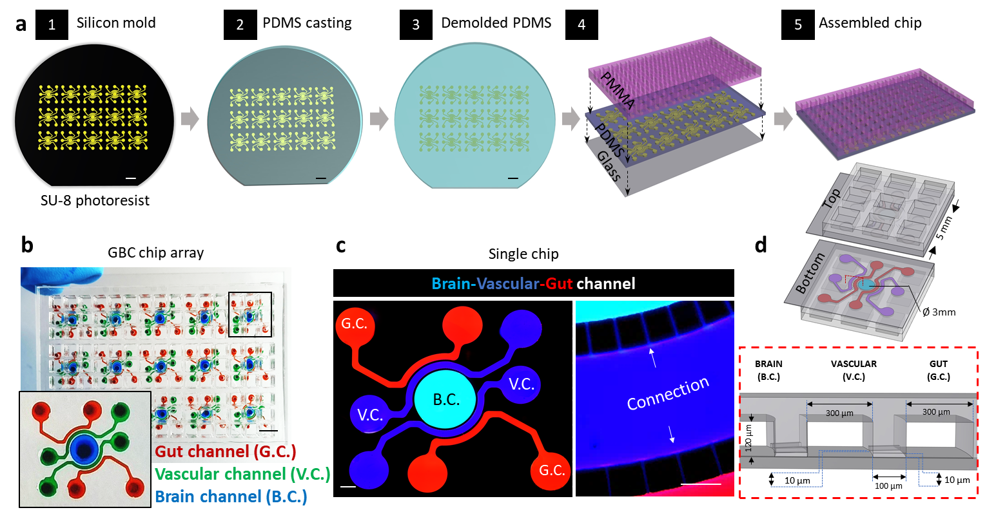
Supplementary Figure 1: Microfluidic chip fabrication and configuration. (a) Microfabrication process of the Gut-Brain-Vascular (GBV) chip. (1) A silicon mold is prepared using SU-8 photoresist lithography, defining the microfluidic channel architecture. (2) Polydimethylsiloxane (PDMS) casting is performed by pouring PDMS over the mold and curing it in 65ºC for 2 hours. (3) The cured PDMS layer is demolded to reveal the microchannel structures. (4) The PDMS chip is aligned with acrylic (PMMA) as media reservoir and bonded with a glass substrate using oxygen plasma treatment to create a sealed microfluidic network. (5) The final assembled chip consists of interconnected compartments, allowing dynamic perfusion and real-time observation of gut-brain interactions. (b) GBV Chip Array for Parallel Experiments, each chip consists of three distinct microfluidic channels representing gut channel (G.C., red), vascular channel (V.C., blue), and brain channel (B.C., green). The inset image shows a zoomed-in view of a single unit, demonstrating the tri-channel used for gut-brain interaction modeling. (c) Fluorescence images of a single chip configuration illustrating the three-compartment design. The brain compartment (B.C.) (central cyan) is connected to two vascular compartments (V.C.) (blue), which are in turn connected to two gut compartments (G.C.) (red), enabling bidirectional gut-brain-vascular communication. The right panel provides a zoom-in image of microchannel connections, confirming the interconnectivity of compartments. (d) The 3D schematic representation highlights the compartmental layout. A cross-sectional and dimensional overview of the GBV Chip. The chip consists of microfluidic channels with defined dimensions, including brain compartment (B.C.): 3000 μm in diameter; vascular compartment (V.C.): 300 μm width; gut compartment (G.C.): 300 μm width. Intercompartmental connections: 10 μm width in microchannel, allowing controlled molecular transport and cellular interactions between compartments.
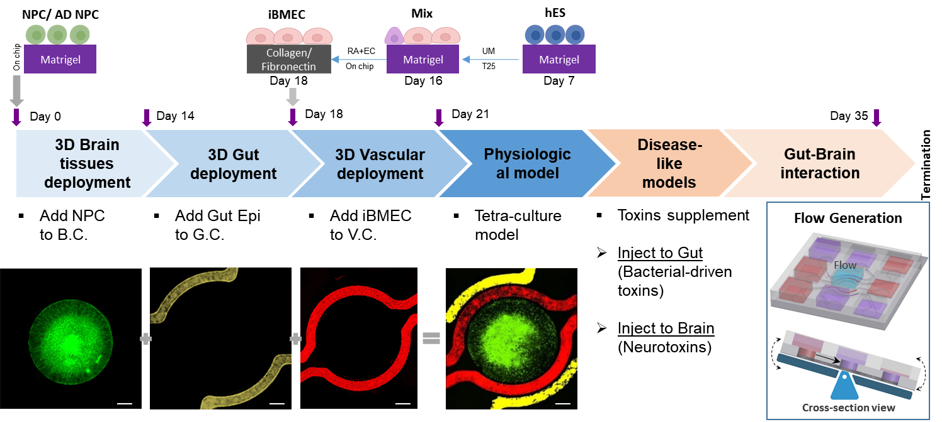
Supplementary Figure 2. Experimental workflow for gut-brain-vascular (hGBV) model development and disease modeling. Day 0: Seeding of neural progenitor cells (NPCs) for brain compartment differentiation. Day 7: Initiation of brain endothelial cells differentiation from human embryonic stem cells (hESCs) in T25. Day 14: Maturation of brain neurons and astrocytes, followed by introduction of gut CaCo-2 into the gut compartment. Day 18: Vascular compartment development, where harvested brain microvascular endothelial cells (iBMECs) and seeded into the vascular compartment to form a permeable blood-brain barrier (BBB)-like structure. Day 21: The completed hGBV system, enabling gut-brain-vascular connectivity, ready for physiological and pathological inducing disease model. Day 28-42: Maturation of hGBV model assembly, transitioning to experimental conditions for gut-brain interaction studies.
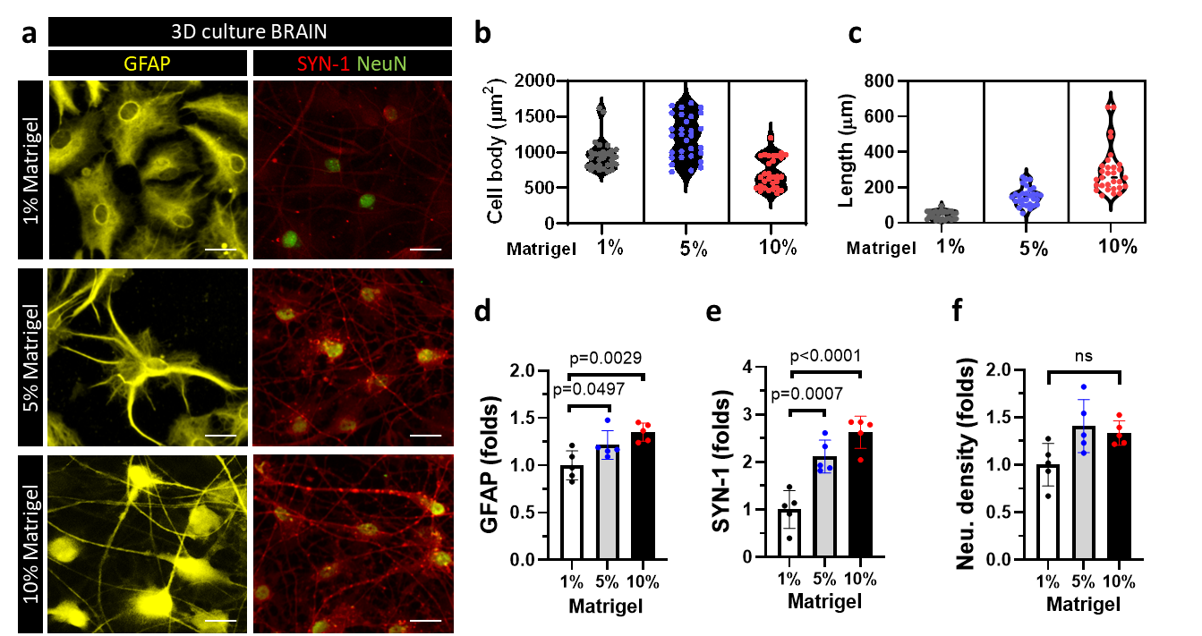
Supplementary Figure 3: Optimization of matrigel composition for 3D brain microenvironment in the hGBV model. (a) Representative images of NPC-derived neurons and astrocytes grown in 1%, 5%, and 10% Matrigel, where astrocytes (GFAP, yellow), neuron (NeuN, green) and synaptic marker (SYN-1, red) show matrigel concentrations (5% and 10%) promote astrocytic elongation and interconnectivity with neuron via synaptic network complexity. (b-c) Quantification of astrocytis morphology. (d-f) Quantification of GFAP expression, SYN-1 expression, and neuronal density.
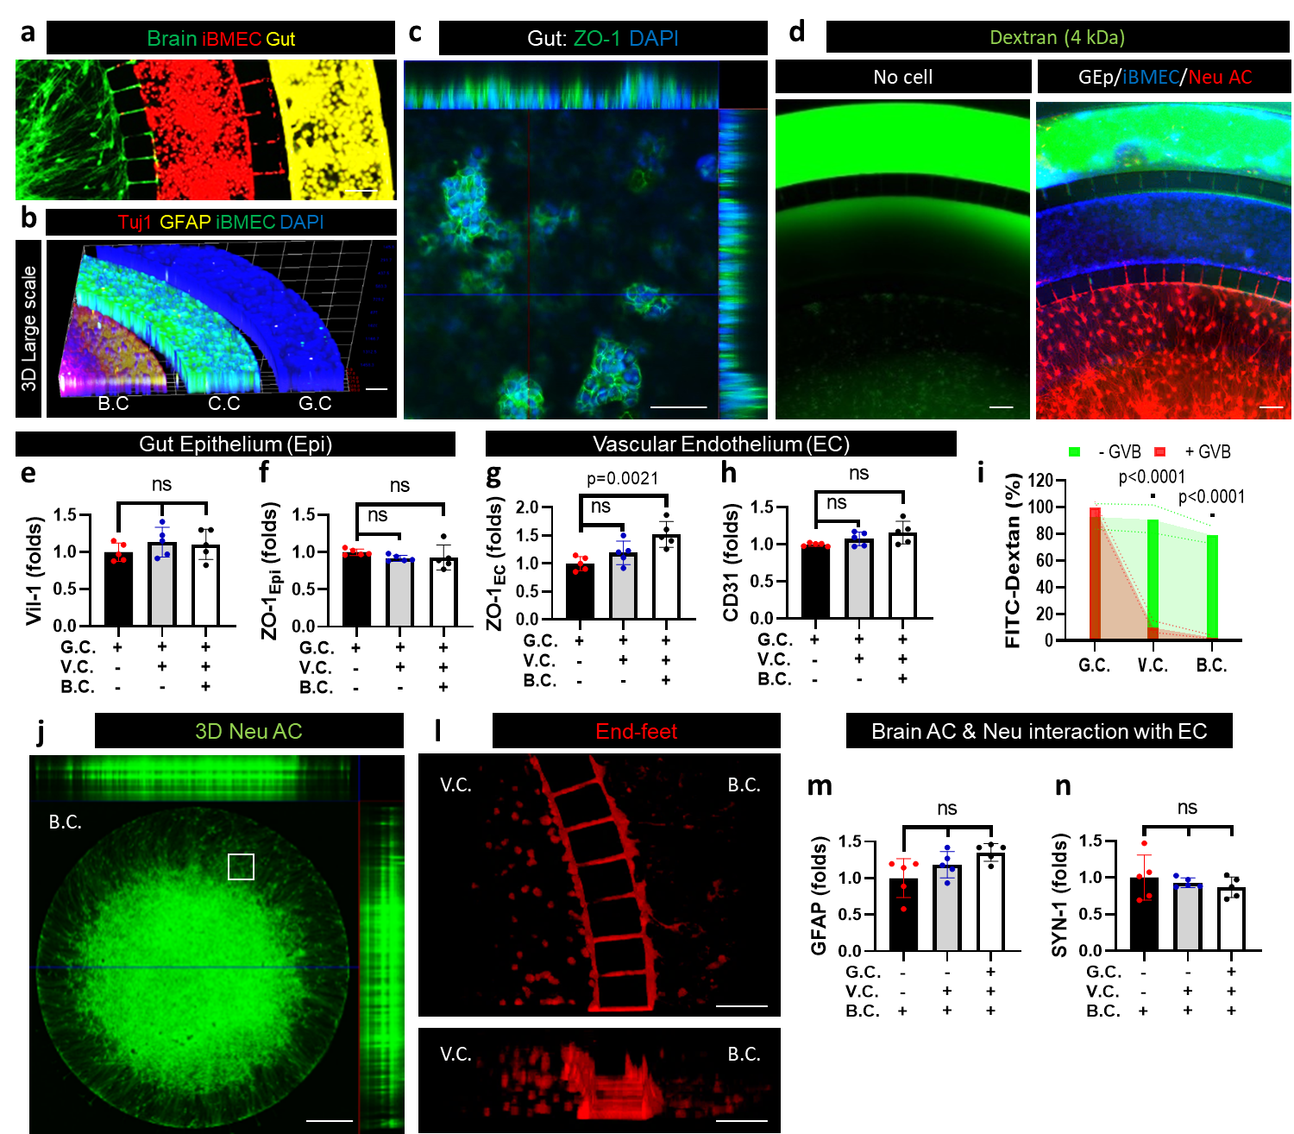
Supplementary Figure 4: 3D structural integrity of the hGBV model and validation of stable culture conditions. This figure demonstrates the 3D structural organization of the hGBV model and confirms the absence of media shock during the culture period, ensuring stable compartmentalization and physiological integrity. (a) Fluorescence composite image showing the compartmentalized architecture of the brain (B.C., green), vascular endothelium (V.C., red), and gut epithelium (G.C., yellow), illustrating their distinct yet interconnected microenvironments. (b) Cross-sectional 3D reconstruction displaying neuronal (Tuj1, red), astrocytic (GFAP, yellow), endothelial (iBMEC, blue with green) and gut epithelium (Caco-2, blue) layers, confirming proper layered spatial organization within the microfluidic platform. c) Confocal imaging of gut epithelium (ZO-1, green) confirms the formation of villus-like structures, indicating intact epithelial organization without disruption. d) Dextran permeability assay (4 kDa) comparing an empty chip (control, no cells) vs. a fully seeded chip (Gut Epi/iBMEC/Neu and AC). The seeded chip maintains structural integrity, preventing non-specific leakage across compartments. Quantification of barrier integrity (e-f) Gut epithelium (G.C.) shows no significant changes in villus marker (ViL1) and epithelial tight junction (ZO-1) expression, indicating stable gut barrier integrity in multi-cellular culture system. (g-h) Endothelial (V.C.) show ZO-1 significantly increases (p = 0.0021), confirming proper endothelial barrier function in tetra-culture model while CD31 expression remains stable, suggesting consistent vascular integrity throughout multi-cellular culture system. (i) FITC-Dextran permeability assessment shows a significant reduction in diffusion across the vascular and brain compartments. (j) Whole-brain compartment (B.C.) image confirms the preserved 3D structure of neurons and astrocytes. (l) Astrocytic end-feet (GFAP, red) wrap around endothelial structures, demonstrating neurovascular interactions without disruption. (m) GFAP expression remains unchanged, indicating stable astrocyte function without culture-induced reactivity. (n) Synapsin-1 (SYN-1) expression is maintained, confirming neuronal network stability in the chip throughout the culture period.
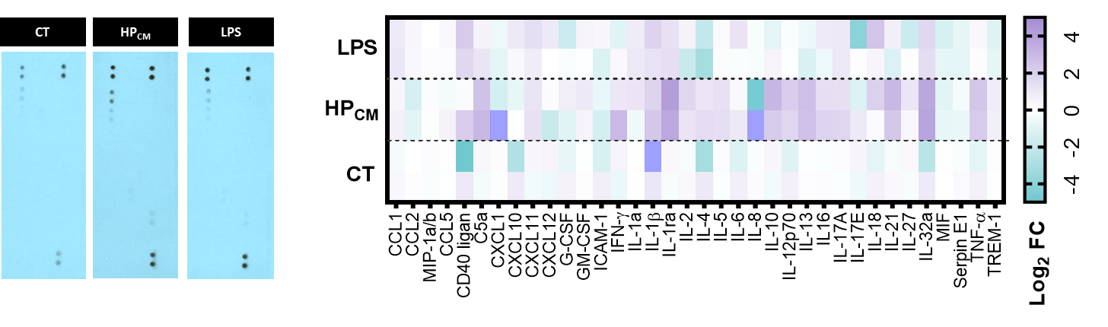
Supplementary Figure 5: Cytokine profile of gut epithelium following exposure to bacterial-derived toxins. This figure presents the cytokine secretion profile from the gut epithelium (G.C.) in response to bacterial-derived toxins, including Helicobacter-conditioned media (HP_{CM}, 10%) and lipopolysaccharide (LPS, 1 µg/mL), compared to control (CT) conditions. (a) Dot blot human cytokine array comparing the secreted inflammatory factors from the control (CT), HP_{CM}-treated, and LPS-treated gut epithelium. Increased spot intensity in HPCM and LPS conditions indicates an upregulation of multiple cytokines and chemokines compared to control. (b) A heatmap visualization of cytokine secretion from gut epithelium (Log₂ Fold Change, FC) in response to HP_{CM} and LPS exposure, compared to control. LPS exposure upregulated CCL2, CXCL1, IL-6, IL-21, and TNF-α, suggesting a strong pro-inflammatory response. HP_{CM} exposure induced IFN-γ, IL-5, IL-12, IL-16, and C5a, indicating activation of gut-specific immune pathways associated with microbial interactions. Both conditions led to the upregulation of IL-1β, IL-6, IL-18, and CXCL10, confirming an inflammatory signature linked to gut barrier dysfunction and immune activation. Some cytokines (e.g., IL-10, IL-27) remained unchanged, highlighting differential regulation of inflammatory signaling in gut epithelium upon bacterial toxin exposure.
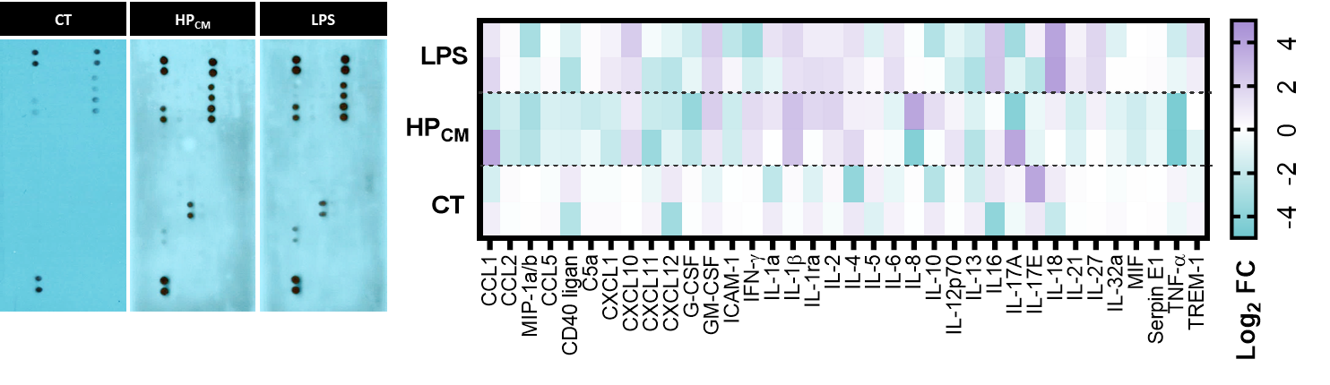
Supplementary Figure 6: Cytokine profile of vascular endothelium following exposure to bacterial-derived toxins. This figure presents the cytokine secretion profile from the vascular endothelium after exposure to bacterial-derived toxins, including Helicobacter-conditioned media (HP_{CM}, 10%) and lipopolysaccharide (LPS, 1 µg/mL), compared to control (CT) conditions. (a) Dot blot cytokine array comparing the secreted inflammatory factors from the control (CT), HPCM-treated, and LPS-treated gut epithelium. Increased spot intensity in HP_{CM} and LPS conditions indicates an upregulation of multiple cytokines and chemokines compared to control. (b) A heatmap visualization of cytokine secretion from vascular endothelial cell (Log₂ Fold Change, FC) in response to HP_{CM} and LPS exposure, compared to control. LPS exposure upregulated CCL2, CXCL1, IL-6, IL-21, and TNF-α, suggesting a strong pro-inflammatory response. HP_{CM} exposure induced IFN-γ, IL-5, IL-12, IL-16, and C5a, indicating activation of gut-specific immune pathways associated with microbial interactions. Both conditions led to the upregulation of IL-1β, IL-6, IL-18, and CXCL10, confirming an inflammatory signature linked to gut barrier dysfunction and immune activation. Some cytokines (e.g., IL-10, IL-27) remained unchanged, highlighting differential regulation of inflammatory signaling in gut epithelium upon bacterial toxin exposure.
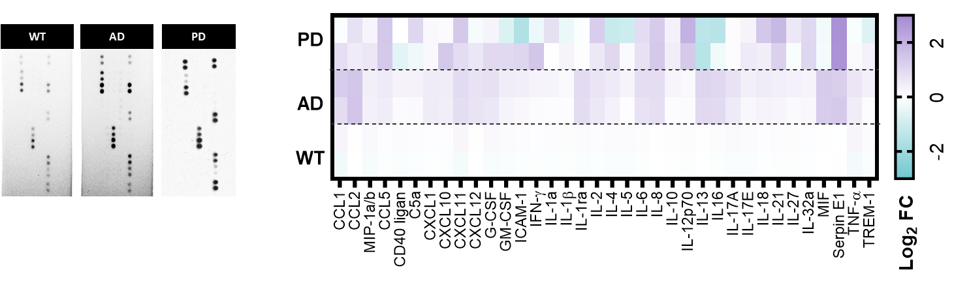
Supplementary Figure 7: Cytokine profile of brain compartment in Alzheimer’s disease (AD) and Parkinson’s disease (PD) conditions. This figure presents the cytokine secretion profile from the brain compartment (B.C.) in wild-type (WT), Alzheimer’s disease (AD), and Parkinson’s disease (PD) conditions, highlighting neuroinflammatory signatures associated with neurodegenerative disease progression. (a) Dot blot cytokine array comparing the secreted inflammatory factors from WT, AD-like, and PD-like brain compartments. Increased dot intensity in AD and PD conditions indicates upregulated multiple cytokines and chemokines expression in disease models. (b) A heatmap visualization of cytokine secretion from brain-derived cytokine secretion (Log₂ Fold Change, FC) in WT, AD-like, and PD-like neurons and astrocytes. AD-like conditions exhibited increased secretion of IL-16, MIF, and TNF-α, which are associated with microglial activation, neurotoxicity, and amyloid-driven inflammation. PD-like conditions showed upregulation of CXCL10, CCL5, and IFN-γ, indicative of chronic neuroinflammation and dopaminergic neuronal stress. Both AD and PD conditions led to upregulated IL-1β, IL-6, IL-12, and IL-18, suggesting a shared neuroinflammatory response contributing to neurodegeneration. Certain anti-inflammatory cytokines, such as IL-10 and IL-27, remained unchanged, reinforcing the dominance of a pro-inflammatory environment in AD and PD.

Table S1. Key resources tables.
REAGENT or RESOURCE | SOURCE | IDENTIFIER (Cat#)
Chemicals, reagents, media and supplements
9:1 PDMS and Curing reagent | Dowhitech | Sylgard 184 A/B
Glass | MatRek Corporation | P384G-1.5-10872-C
DMEM/F12 | Thermofisher | 11320-033
DMEM/F12 (high glucose) | Sigma Aldrich | D5796
B27 Serum free supplement | Thermofisher | 17500-4001
Heparin | Stemcell technologies | 7980
EGF | Sigma Aldrich | E9644-.2MG
FGF-basic, human recombinant | Stemgent | 03-0002
EBM-2 | Lonza | 190860
mTESR plus media kit | Stemcell technologies | 100-0276
FBS | Sigma Aldrich | F2442
Penicilin/streptomycin | Sigma Aldrich | P4333
HEPES buffer solution (1M) | Gibco | 15630-106
DPBS | Sigma Aldrich | D8537
PBS 10X | Sigma Aldrich | 11666789001
Accutase | Gibco | A11105-01
Trypsin | Sigma Aldrich | T3924
20% Matrigel | Corning™ | 356235
2 mg/ml p.H 7.5 Collagen I | Corning™ | 354249
1 mg/ml Poly D-lysine | Sigma Aldrich | A-003-M
FITC-dextran  wt 3,000-5000  wt 10,000  wt 40,000  wt 60,000-70,000 | Sigma Aldrich | FD4  SLCD1383  SLCB8958  SLCB8500
OGB-1 | Thermofisher | O6806
DAF-FM Diacetate (NO indicator) | Invitrogen | D23844
LPS | Invitrogen | 00-4976-93
DAPI | Merck | D9542
Hoechst (DAPI) | Invitrogen | H21486
4% paraformaldehyde solution | 바이오세상 | PC2031-100-00
BSA | Bovogen | BSAS 0.1
Critical commercial assays
Human Alpha-Synuclein simpleStep ELISA kit | Abcam | Ab260052
Amyloid Beta 42 Human ELIA kit | Abcam | Ab289832
Proteome profiler human cytokine array | R&D System | ARY005B
Antibodies
1:100 ZO-1 | Invitrogen | 40-2200
PECAM/CD31 | Invitrogen | 48-0319-42
GFAP | Sigma Aldrich | AB5541
ALDH1L1 | Abcam | AB190298
Tuj1 | Novus Biologicals | NBP1-42568
NeuN | Abcam | Ab177487
pTau Ser202, Thr205 | Invitrogen | MN1020
iNOS | Thermofisher | PA1-036
Synapsin-1 | Abcam | AB254349
1:500 Anti-mouse  AlexaFluor™ 488  AlexaFluor™ 594  AlexaFluor™ 647 | Abcam | ab150113  ab150116  ab150115
1:500 Anti-rabbit  AlexaFluor™ 488  AlexaFluor™ 594  AlexaFluor™ 647 | Abcam | ab150077  ab150080  ab150079
1:500 Anti-chicken  AlexaFluor™ 647 | Abcam | ab150171
1:500 Anti-goat  AlexaFluor™ 594 | R&D System | NL003
Equipment
96-well absorbance reader | Bio Tek Instrument, Inc | Take3 Micro-Volume Plate
Confocal microscope | Nanoscope Systems Co., Ltd. | K1-Fluo[ABM] RT-SD
Microscope | Nikon Corporation Tokyo, Japan | Eclipse Ti2-E
Oxygen Plasma machine | Plasma Etch benchtop system | PE 50XL with standard accessoties
Experimental models: Cell lines
Human Embryonic stem cell | Wi-Cell | H9
ReN cell VM human neural progenitor cells (NPCs) | MilliporeSigma | SCC008
Immortalized Human Caco-2 cell | ATCC, Inc. | HTB-37
Software
Graphpad Prism | GraphPad Software | https://www.graphpad.com/
Fiji (ImageJ) | National Institutes of Health | https://imagej.nih.gov/ij/
Shapr3D | Shapr3D Software | https://www.shapr3d.com/
NIS-elements | NIS-element Nikon Software | https://www.microscope.healthcare.nikon.com/en_EU/products/software/nis-elements
BioRender | BioRender | https://www.biorender.com/

