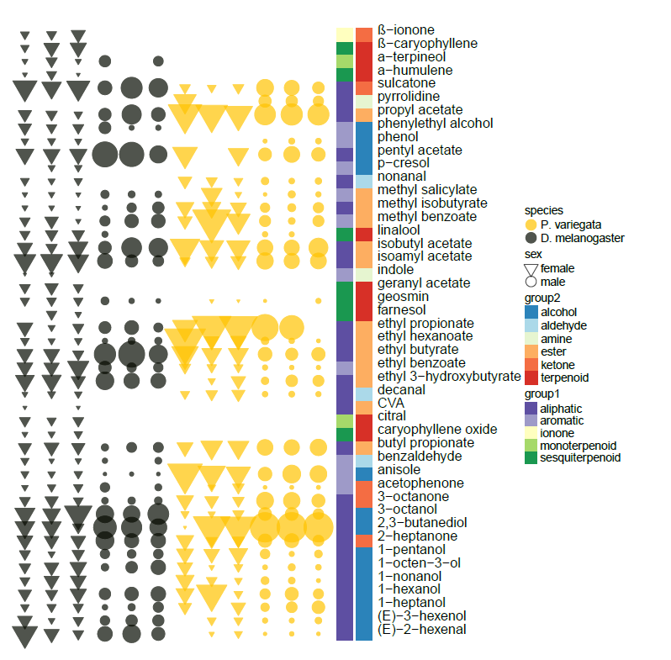Additional file 1: Fig S1. Heat map of raw responses comparing D. melanogaster and P. variegata individuals to the panel of tested synthetic volatiles.

