Supplementary Table 1: Screening of wild and weedy rice accessions against BPH and imazethapyr application
Sl. No | Species | Germplasm Identity | BPH SES Score | Imazethapyr response
1 | Oryza sativa ssp. Japonica | Nipponbare | 9.0 | Susceptible
2 | Oryza sativa ssp. Japonica | Kit-a-Kee | 9.0 | Susceptible
3 | Oryza sativa ssp. Indica | Salkathi | 1.2 | Susceptible
4 | Oryza sativa ssp. Indica | Dhobanumberi | 1.4 | Susceptible
5 | Oryza sativa ssp. Indica | CR 3006-8-2 | 1.6 | Susceptible
6 | Oryza sativa ssp. Indica | CR Dhan 317 | 1.8 | Susceptible
7 | Oryza sativa ssp. Indica | PTB33 | 1.1 | Susceptible
8 | Oryza sativa ssp. Indica | TN1 | 9.0 | Susceptible
9 | Oryza sativa ssp. Indica | Naveen | 8.7 | Susceptible
10 | Oryza sativa ssp. Indica | Robin (HTM-N22) | 9.0 | Tolerant
11 | O. sativa f. spontanea | WeR-01 | 8.4 | Susceptible
12 | O. sativa f. spontanea | WeR-02 | 7.9 | Susceptible
13 | O. sativa f. spontanea | WeR-03 | 9.0 | Susceptible
14 | O. glaberrima | IRGC 100983 | 7.5 | Susceptible
15 | O. glaberrima | IRGC101800 | 7.6 | Susceptible
16 | O. nivara | IRGC 102463A | 9.0 | Susceptible
17 | O. nivara | IRGC 101508 | 7.7 | Susceptible
18 | O. rufipogon | IRGC 104404 | 9.0 | Susceptible
19 | O. rufipogon | AC 100444 | 5.0 | Susceptible
20 | O. barthii | IRGC 100934 | 8.4 | Susceptible
21 | O. barthii | IRGC100936 | 8.2 | Susceptible
22 | O. longistaminata | IRGC 81954 | 9.0 | Susceptible
23 | O. longistaminata | IRGC110404 | 8.5 | Susceptible
24 | O. meridionalis | IRGC 86538 | 7.9 | Susceptible
25 | O. meridionalis | IRGC 10520 | 7.0 | Susceptible
26 | O. glumaepatula | IRGC 88802 | 6.9 | Susceptible
27 | O. schweinfurthiana (Allotetraploid)- earlier considered as O. punctata | IRGC 88828 | 1.2 | Susceptible
28 | O. punctata | IRGC 101434 | 9.0 | Susceptible
29 | O. minuta | IRGC 101128 | 7.1 | Susceptible
30 | O. minuta | IRGC 105130 | 6.8 | Susceptible
31 | O. officinalis | IRGC 80727 | 7.2 | Susceptible
32 | O. officinalis | IRGC 80735 | 7.4 | Susceptible
33 | O. rhizomatis | SL 193 | 7.6 | Susceptible
34 | O. rhizomatis | SL 194 | 6.7 | Susceptible
35 | O. eichengeri | Reference sample in Oryza garden | 6.9 | Susceptible
36 | O. latifolia | IRGC 103787 | 7.2 | Susceptible
37 | O. latifolia | IRGC 80771 | 7.8 | Susceptible
38 | O. alta | SL 01 | 8.5 | Susceptible
39 | O. alta | SL 03 | 9.0 | Susceptible
40 | O. grandiglumis | IRGC 101405 | 6.7 | Susceptible
41 | O. grandiglumis | SL 59 | 7.2 | Susceptible
42 | O. australiensis | IRGC 86533 | 6.9 | Susceptible
43 | O. australiensis | IRGC 1051565 | 9.0 | Susceptible
44 | O. meyeriana | SL 73 | 8.4 | Susceptible
45 | O. granulata | SL 129 | 9.0 | Susceptible
46 | O. ridleyi | IRGC 100821 | 9.0 | Susceptible
47 | O. ridleyi | SL 199 | 9.0 | Susceptible
48 | O. longiglumis | IRGC 105148 | 8.5 | Susceptible
49 | O. longiglumis | SL 86 | 7.4 | Susceptible
50 | O. brachyantha | IRGC 101232 | 7.3 | Susceptible
51 | O. brachyantha | SL 41 | 7.1 | Susceptible
The germplasm reported in this study were obtained from ICAR-NRRI, Cuttack; Punjab Agricultural University, Ludhiana and International Rice Research Institute, Philippines. The weedy rice samples (WeR-01 to 03) were collected from local farmer fields of Cuttack district for the study.

Supplementary Table 2: List of standard markers used for transfer QTLs (qBph4.3 and qBph4.4) for brown plant hopper resistance from CR 3006-8-2 to Naveen
Target QTLs/ Genes and their physical position | Marker (s) | Sequences/ Functional Polymorphism | AT (°C) | Resistant/ Susceptible allele size (bp) | Chr.  (Physical position) | Reference
qBph4.3 (Chr 4: 0.18 Mb to 0.69 Mb) | RM551 | F: AGCCCAGACTAGCATGATTG  R: GAAGGCGAGAAGGATCACAG | 58 | 260 bp/ 190 bp | 4  (0.18 Mb) | Mohanty et al. 2017
qBph4.3 (Chr 4: 0.18 Mb to 0.69 Mb) | RM335 | F: GTACACACCCACATCGAGAAG  R: GCTCTATGCGAGTATCCATGG | 55 | 115bp/ 105bp | 4  (0.69 Mb) | Mohanty et al. 2017
qBph4.4 (Chr 4: 0.69 Mb to 13.07 Mb) | RM335 | F: GTACACACCCACATCGAGAAG  R: GCTCTATGCGAGTATCCATGG | 55 | 115bp/ 105bp | 4  (0.69 Mb) | Mohanty et al. 2017
qBph4.4 (Chr 4: 0.69 Mb to 13.07 Mb) | RM5633 | F: GTGTAGCTGCTAGGCCGAAC  R: TTCCTTTCGCTACGTTGGAC | 55 | 230bp/ 210bp | 4  (13.07 Mb) | Mohanty et al. 2017

Supplementary Table 3: Additional polymorphic STMS and INDEL markers between CR 3006-8-2 and Naveen identified from genomic region regions of qBph4.3 and qBph4.4 and other genomic regions of chromosome 4 used in the study
Name of marker | Primer sequences | Marker types | Physical position (Mb)* | Reference/ Source
Markers located within qBph4.3 and qBph4.4
RM16261 | F: CTCGCATCTGCACACTGTATTCG  R: GGGCAAGGATAAGTAGGTGGAAGC | STMS | 0.18 | www.gramene.org
H101 | F: AGGTGACCAATACATTTTGG  R: GGGAGAGATCTACTATTCC | Indels | 0.97 | Hu et al. (2018)
RM518 | F: CTCTTCACTCACTCACCATGG  R: ATCCATCTGGAGCAAGCAAC | STMS | 2.03 | www.gramene.org
RM16424 | F: ACTAATAGTGGTGGGTGCTGTTAGC  R: CCACTTTGCTGAGAGTGTGAAGC | STMS | 4.29 | www.gramene.org
RM8213 | F: AGCCCAGTGATACAAAGATG  R: GCGAGGAGATACCAAGAAAG | STMS | 4.44 | www.gramene.org
RM8212 | F: CCACCGCACTTGTCTATG  R: TCCAATCTCACTCTCGACTC | STMS | 4.46 | www.gramene.org
RH007 | F: CTTGCGTTCCGTAGGAGAAG  R: TGAGTGTAACCCGAAGTGGC | Indels | 5.66
MS1 | F: catggacccacttgtcatcc  R: agcatgagagactgccaag | Indels | 6.57 | Yang et al. (2004)
S13 | F: AGCCCAAATGGAACAAACAA  R: GCTCACGGTTAAGCAATGGT | Indels | 6.57 | Li et al. (2019)
RM5633 | F: GTACACACCCACATCGAGAAG  R: GCTCTATGCGAGTATCCATGG | STMS | 13.07 | www.gramene.org
Markers located outside qBph4.3 and qBph4.4 in Chromosome 4 |  |  |  | www.gramene.org
AUT16656 | F: AACAGCAACCTGACAGAAGAATGG  R: TATGTGGCTTCTCGTTGAGTTGG | STMS | 13.65 | www.gramene.org
RM16835 | F: CATTGCCAACCCGTAAAGCTACC  R: GGTGAGCTGAAGATGTTCTTTCATGG | STMS | 18.8 | www.gramene.org
RM471 | F: ACGCACAAGCAGATGATGAG  R: GGGAGAAGACGAATGTTTGC | STMS | 18.82 | www.gramene.org
j19782 | F: TTTCACAATCTCCAATGC  R: AAACCGTGTCAAAACAAG | Indels | 20.79 | Huang et al. (2013)
Q31 | F: GTTCCCTCATACGGATAG  R: AGATTTGACAAGGCTTACT | Indels | 20.79 | Huang et al. (2013)
RM5757 | F: CCTGAGACCATATGCTGCTG  R: GAGGGAGCATCATTAGCTGG | STMS | 21.244 | www.gramene.org
RM17007 | F: CTTCCCACGCGAAACTTCATGG  R: TCCGGCCAAGACAATATCAACG | STMS | 21.3 | www.gramene.org
RM17063 | F: ACGGAGACCGACCCAAGTAAGC  R: CCACAGGTCAAGATGGAACAGC | STMS | 22.12 | www.gramene.org
AUT17111 | F: TGGTCATCTACCAGAGCAAATTCC  R: CCGTCATGTCATTGATCTTCTTGC | STMS | 23.35 | www.gramene.org
RM17 | F: TGCCCTGTTATTTTCTTCTCTC  R: GGTGATCCTTTCCCATTTCA | STMS | 26.95 | www.gramene.org
RM17362 | F: CTTTGCTGTGTTGAAGTCGTTGG  R: GGAAGACCAAACATGAAGCAACC | STMS | 27.57 | www.gramene.org
RM17506 | F: AGGTCGTCACGCTAGGAGATGC  R: ATGCCTGCATAGGCTGTAGACG | STMS | 31.52 | www.gramene.org
* Based on Nipponbare reference genome sequence IRGSP 1.0
Supplementary Table 4: Details of station trials and multilocation trials conducted for different experiments
Trial Name | Year of trial | Experimental design | Replications | Number* of genotypes/entries tested | No. of Trial Locations | Trial Locations
Station Trial-1 | 2019  (WS) and 2020 (DS) | RCBD | 3 | 16 | 1 | CTC
AICRPR Trial-1ª  (AVT1-IME) | 2020 | RCBD | 3 | 43 | 4 | CTC, JYP, CHP
AICRPR Trial-2^{b}  (AVT1-NIL-Yield) | 2021 | RCBD | 3 | 15 | 2 | CTC, BKRG
AICRPR Trial-3^{c}  (AVT1-IME) | 2022 | RCBD | 3 | 30 | 9 | CTC, JYP, CHP, SBR, BKRG, PAT, RNC, CHN, VAR
AICRPR Trial-4^{d}  (AVT2-IME) | 2023 | RCBD | 3 | 18 | 10 | CTC, CHP, SBR, BKRG, RNC, PAT, CHN, HTW, VAR, LEM, TBR
AICRPR- Agronomy^{e}  (AVT1-NIL-Herbicide Tolerance) | 2021 | Split plot  (With 04 main plots) | 3 | 7 | 3 | CTC, RNC, HZB
NSN1 Trial (BPH) | 2021 | Augmented | - | 303 | 4 | HYD, CBT, LDN, MND
NSN1 Trial (BPH) | 2022 | Augmented | - | 338 | 4 | HYD, CBT, LDN, MND
NSN1 Trail (BPH) | 2023 | Augmented | - | 432 | 4 | HYD, CBT, LDN, MND
*Besides the NILs of Naveen nominated for AICRP, other entries tested in AICRPR include NILs, recurrent parents, recombinant entries and checks (national, zonal and local) of similar maturity durations nominated by different rice research centers of India; NILs are compared with recurrent parents based on CD-values of respective experiments with CV ranging from 5-20%. AVT: Advance Varietal Trials; IME: Irrigated Medium Early, NSN: National Screening Nursery.
a: Only BPH resistant NIL CR 4331-85-1-1-1 (IET 29203) and recurrent parent Naveen were tested among the NILs reported in this manuscript. Data for Odisha only is represented as genotype was considered for state specific release only.
b & c: Two BPH resistant NILs CR 4331-85-1-1-1 (IET 29203) and CR 4331-74-2-2-1 (IET 30282) besides two imazethapyr tolerant NILs CR 4332-37-2-1-1 (IET 30281 and CR 4332-184-2-2-1 (IET 30284) were tested along with Naveen.
d: Only BPH resistant NIL CR 4331-74-2-2-1 (IET 30282) and recurrent parent Naveen were tested among the NILs reported in this manuscript.
e: Two imazethapyr tolerant NILs CR 4332-37-2-1-1 (IET 30281) and CR 4332-184-2-2-1 (IET 30284) were tested along with Naveen.
Location abbreviations
CTC: ICAR-Central Rice Research Institute, Cuttack, State-Odisha; JYP: AICRP on Rice, Odisha University of Agriculture and Technology, Jeypore, District- Koraput, State- Odisha; CHP: AICRP on Rice, Odisha University of Agriculture and Technology, Chiplima, District- Sambalpur, State-Odisha; BKRG: Botanical Research Unit, Bihar Agricultural University, Bikramganj, District- Rohtas, State-Bihar; SBR: Bihar Agricultural University, Sabour, District- Bhagalpur, State-Bihar; PAT: ICAR- Research Complex for Eastern Region, Patna, State-Bihar; RNC: Birsa Agricultural University, Ranchi, State-Jharkhand; CHN: Rice Research Station, Department of Agriculture, Chinsura, District- Hooghly, State-West Bengal; HTW: Rice Research Station, Department of Agriculture, Hathwara, District-: Purulia, State-West Bengal; VAR: Banaras Hindu University, Varanasi, State-Uttar Pradesh; LEM: ICAR- Research Complex for North Eastern Region, Tripura Centre, Lembuchhera, District- West Tripura, State-Tripura; TBR: Assam Rice Research Institute, Titabar; District-Jorhat, State- Assam; HYB: ICAR- Indian Institute of Rice Research; CBT: Tamil Nadu Agricultural University, Coimbatore, State- Tamil Nādu; LDN: Punjab Agricultural University, Ludiana, State- Punjab; MND: Zonal Agricultural Research Station, University Agricultural Sciences- Bangalore, Mandya campus, District- Mandya, State- Karnataka.

Supplementary Table 5: Resistance assays of near isogenic lines carrying qBph4.3 and qBph4.4 vis-à-vis the recurrent parent and checks against brown planthopper, N. lugens Cuttack population.
Sl.No | Accessions | Percent Damage (%) | Nymphal Survival (%) | Honeydew excretion (mm) | Feeding Mark  (3 females/plant)
1 | CR-4331-84-3-2-1 | 8.65 (17.02) | 18.67 (25.50) | 68.67 (8.35) | 22.67 (4.86)
2 | CR-4331-85-1-1-1 | 12.51 (20.67) | 21.33 (27.49) | 75.00 (8.72) | 20.33 (4.62)
3 | CR 4331-74-2-2-1 | 8.33 (16.54) | 18.00 (24.31) | 67.10 (8.15) | 19.30 (4.51)
4 | Naveen | 98.81 (86.37) | 86.67 (69.44) | 427.00 (20.68) | 9.33 (3.21)
5 | TN1 | 100 (90.00) | 89.33 (71.01) | 442.00 (21.03) | 7.67 (2.94)
6 | Salkathi | 6.36 (14.43) | 17.33 (24.47) | 38.00 (6.24) | 32.00 (5.74)
7 | PTB33 | 6.08 (11.66) | 16.00 (23.47) | 32.00 (5.74) | 34.00 (5.91)
8 | CR-3006-8-2 | 7.42 (15.42) | 17.55 (24.69) | 61.33 (7.89) | 25.33 (5.13)
Data in parenthesis of percent damage and nymphal survival are arc sin transformed; values of feeding mark and honeydew excretion were √+1 transformed.

Supplementary Table 6: Test of heterogeneity of error variance and analysis of variance (ANOVA) of the yield trial conducted with Naveen and its near isogenic lines in Randomized Complete Block Design (RCBD) under trials conducted at ICAR-NRRI, Cuttack for performance assessment in station trials.
Season | Mean | Range |  | SD | SE | Levene statistic
Season | Mean | Min | Max | SD | SE | Levene statistic
Wet Season -2019 | 4.88 | 4.56 | 5.09 | 0.14 | 0.04 | 1.70^{NS}
Dry Season-2020 | 5.01 | 4.37 | 5.29 | 0.24 | 0.07 | 1.70^{NS}
NS: Not Significant

Source of variation | Df | Wet Season -2019 | Dry Season-2020 | Pooled
Replication | 2 | 0.018^{NS} | 0.13^{NS} | 0.15^{NS}
Genotypes | 15 | 0.91* | 2.38** | 5.16**
Error | 30 | 0.42 | 1.02 | 1.29
CV |  | 6.96 | 7.84 | 7.02
NS: Not Significant; * Significant at 5% level; ** Significant at 1% level.

Supplementary Table 7: Grain quality traits of selected near isogenic lines for BPH resistance when compared to recurrent parent Naveen and donor line CR 3006-8-2 based on test carried out at ICAR-NRRI, Cuttack for inhouse testing. The values are based on three replications for each genotype in each season except alkali spreading value, water uptake, kernel length after cooking and gel consistency where data is based on samples from one test only
Quality parameters | Genotypes
Quality parameters | IET 30282  (CR Dhan 809) |  | IET 29203  (Naveen Shakti) |  | Naveen |  | CR 3006-8-2
Quality parameters | Wet season (2019) | Dry Season (2020) | Wet season (2019) | Dry Season (2020) | Wet season (2019) | Dry Season (2020) | Wet season (2019) | Dry Season (2020)
Head Rice Recovery (%) | 61.00 | 60.33 | 62.00 | 61.33 | 62.33 | 60.33 | 61.66 | 56.33
Kernel Length | 5.11 | 5.17 | 5.16 | 5.20 | 5.13 | 5.09 | 5.38 | 5.36
Kernel Breadth | 2.11 | 2.12 | 2.09 | 2.10 | 2.11 | 2.09 | 2.03 | 2.04
L/B | 2.42 | 2.44 | 2.47 | 2.48 | 2.43 | 2.44 | 2.65 | 2.63
Chalkiness | NO | NO | NO | NO | NO | NO | NO | NO
Alkali Spreading Value | 3.00 | 3.00 | 3.00 | 3.00 | 3.00 | 3.00 | 3.00 | 3.00
Water Uptake (ml) | 45.00 | 45.00 | 50.00 | 45.00 | 50.00 | 45.00 | 55.00 | 50.00
Volume Expansion Ratio | 4.25 | 4.25 | 4.25 | 4.25 | 4.25 | 4.25 | 3.75 | 3.75
Kernel Length After Cooking | 7.80 | 7.90 | 8.10 | 8.10 | 7.80 | 7.90 | 8.50 | 8.60
Elongation ratio | 1.53 | 1.53 | 1.57 | 1.56 | 1.52 | 1.55 | 1.58 | 1.60
Amylose content (%) | 22.12 | 22.27 | 21.62 | 22.35 | 23.62 | 22.80 | 21.30 | 20.77
Gel Consistency value | 35 | 39 | 36 | 34 | 38 | 36 | 35 | 36

Supplementary Table 8: Grain quality traits of selected near isogenic lines for herbicide tolerance when compared to recurrent parent Naveen based on test carried out at ICAR-NRRI, Cuttack for inhouse testing on the basis of samples drawn in dry season 2020. The values are based on three replications for each genotype in each season except alkali spreading value, water uptake, kernel length after cooking and gel consistency where data is based on samples from one test only
Quality parameters | Genotypes
Quality parameters | CR 4332-37-2-1-1 (IET 30281) | CR 4332-184-2-2-1 (IET 30284) | Naveen
Head Rice Recovery (%) | 54.33 | 53.66 | 60.33
Kernel Length (mm) | 5.01 | 5.08 | 5.09
Kernel Breadth (mm) | 2.05 | 2.06 | 2.09
L/B | 2.44 | 2.46 | 2.44
Chalkiness | Occasional | Occasional | NO
Alkali Spreading Value | 3 | 3 | 3.00
Water Uptake (ml) | 45 | 45 | 45.00
Volume Expansion Ratio | 4.25 | 4.25 | 4.25
Kernel Length After Cooking (mm) | 8.00 | 8.00 | 7.90
Elongation ratio | 1.59 | 1.57 | 1.55
Amylose content (%) | 24.12 | 24.45 | 22.80
Gel Consistency value | 35 | 39 | 36

Supplementary Table 9: Grain quality traits of the selected dual improved near isogenic lines for herbicide tolerance (BPHRIT-NIL-10) when compared to recurrent parent CR Dhan 809 besides Naveen based on test carried out at ICAR-NRRI, Cuttack for inhouse testing on the basis of samples drawn in dry season 2024. The values are based on three replications for each genotype in each season except alkali spreading value, water uptake, kernel length after cooking and gel consistency where data is based on samples from one test only
Quality parameters | Genotypes
Quality parameters | BPHRIT-NIL-10 | IET 30282  (CR Dhan 809) | Naveen
Head Rice Recovery (%) | 61.00 | 60.33 | 60.33
Kernel Length | 5.14 | 5.12 | 5.14
Kernel Breadth | 2.09 | 2.12 | 2.10
L/B | 2.46 | 2.42 | 2.45
Chalkiness | NO | NO | NO
Alkali Spreading Value | 3.00 | 3.00 | 3.00
Water Uptake (ml) | 50.00 | 45.00 | 45.00
Volume Expansion Ratio | 4.25 | 4.25 | 4.25
Kernel Length After Cooking | 7.90 | 7.80 | 7.90
Elongation ratio | 1.54 | 1.52 | 1.54
Amylose content (%) | 23.54 | 24.26 | 23.48
Gel Consistency value | 38.00 | 35.00 | 35.00

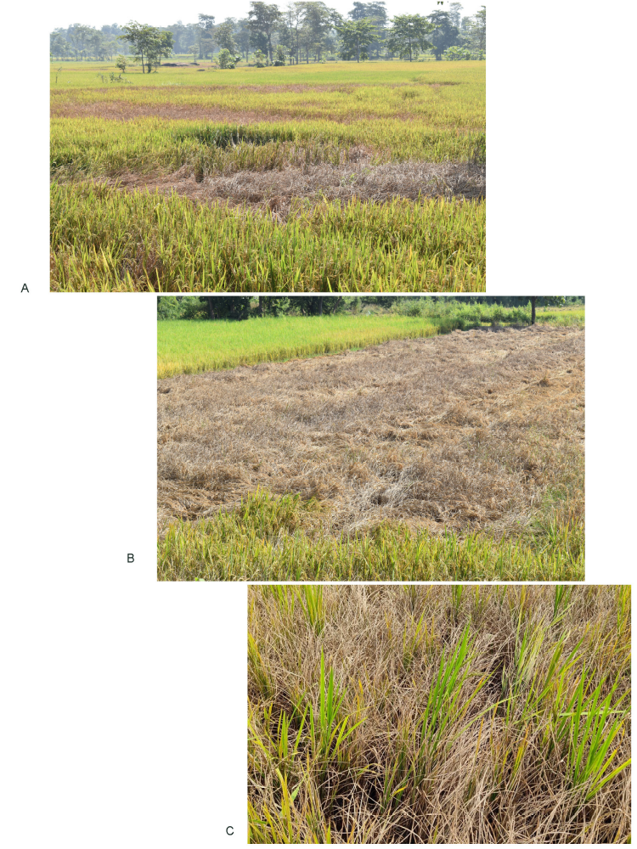

Supplementary Fig. 1: Natural incidences of hopper burns caused by brown planthopper (Nilaparvata lugens) on rice crop at a hotspot location (Chiplima village, Sambalpur district, Odisha, India).

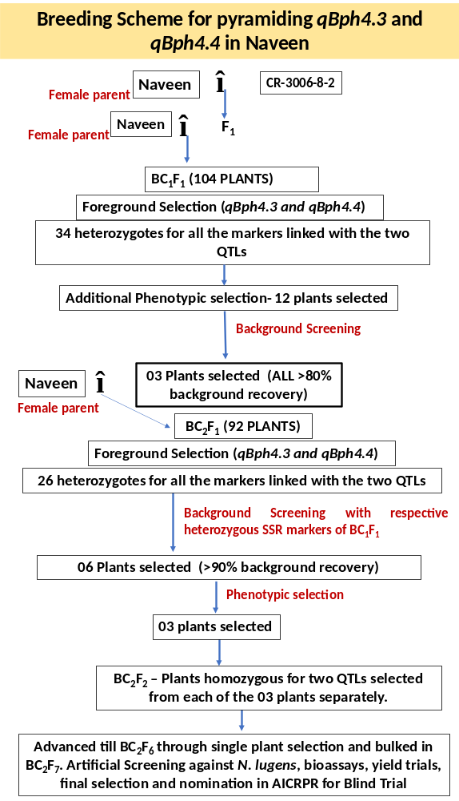
Supplementary Fig. 2: Breeding scheme followed for introgression of brown plant hopper (BPH) resistance QTLs qBph4.3 and qBph4.4 through marker assisted backcross breeding
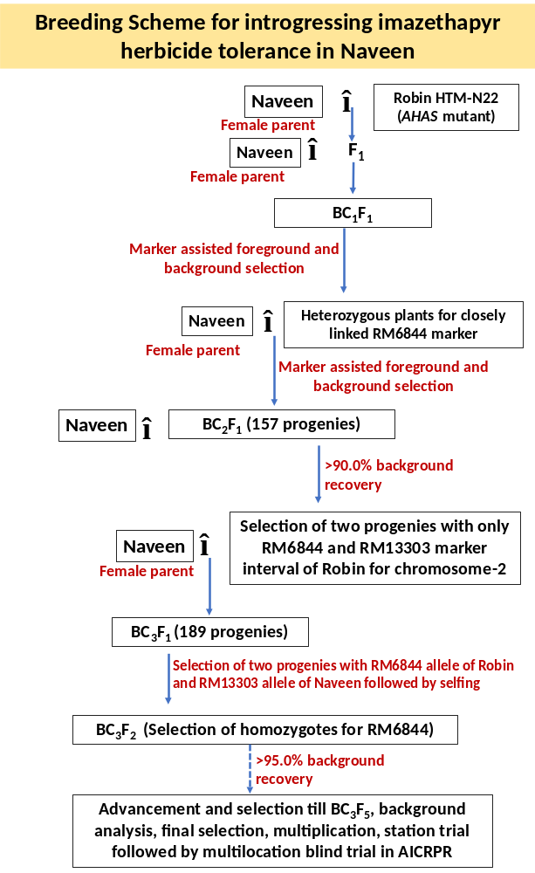
Supplementary Fig. 3: Breeding scheme followed for introgression of imazethapyr herbicide tolerant NILs of Naveen through marker assisted backcross breeding
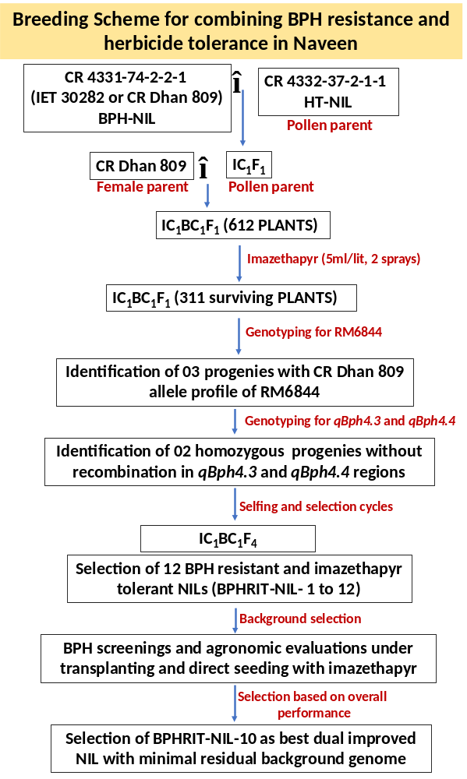
Supplementary Fig. 4: Breeding scheme followed for combining imazethapyr tolerance and BPH resistance in Naveen through combined use of novel phenotypic selection and marker assisted backcross breeding to minimize linkage drag

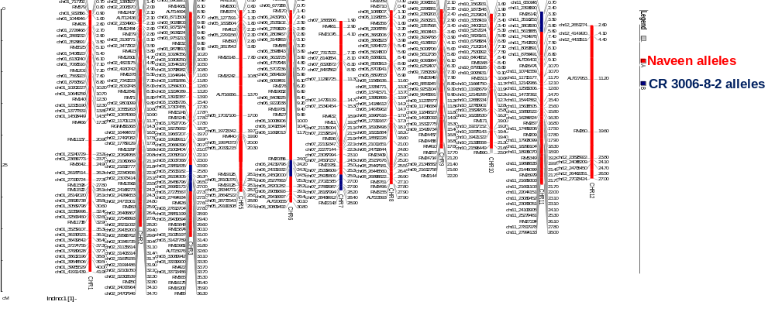
Supplementary Fig. 5: Graphical genotyping for background recovery of CR Dhan 809 based on polymorphic STMS and SNP (1K-RiCA) markers.
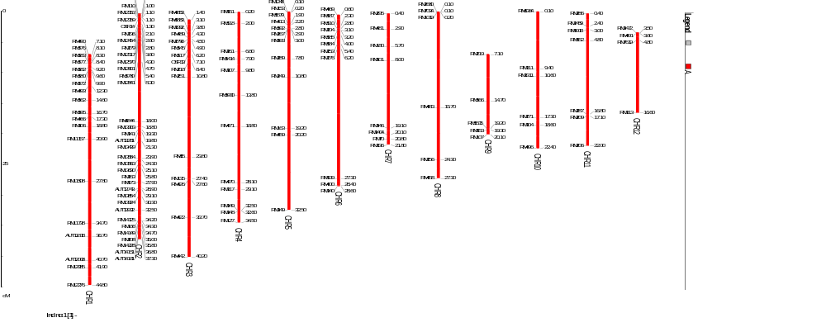
Supplementary Fig. 6: The 140 polymorphic STMS markers identified between Naveen and Robin which were utilized for background selection purpose. The polymorphic markers were identified from screening of 1103 STMS markers

