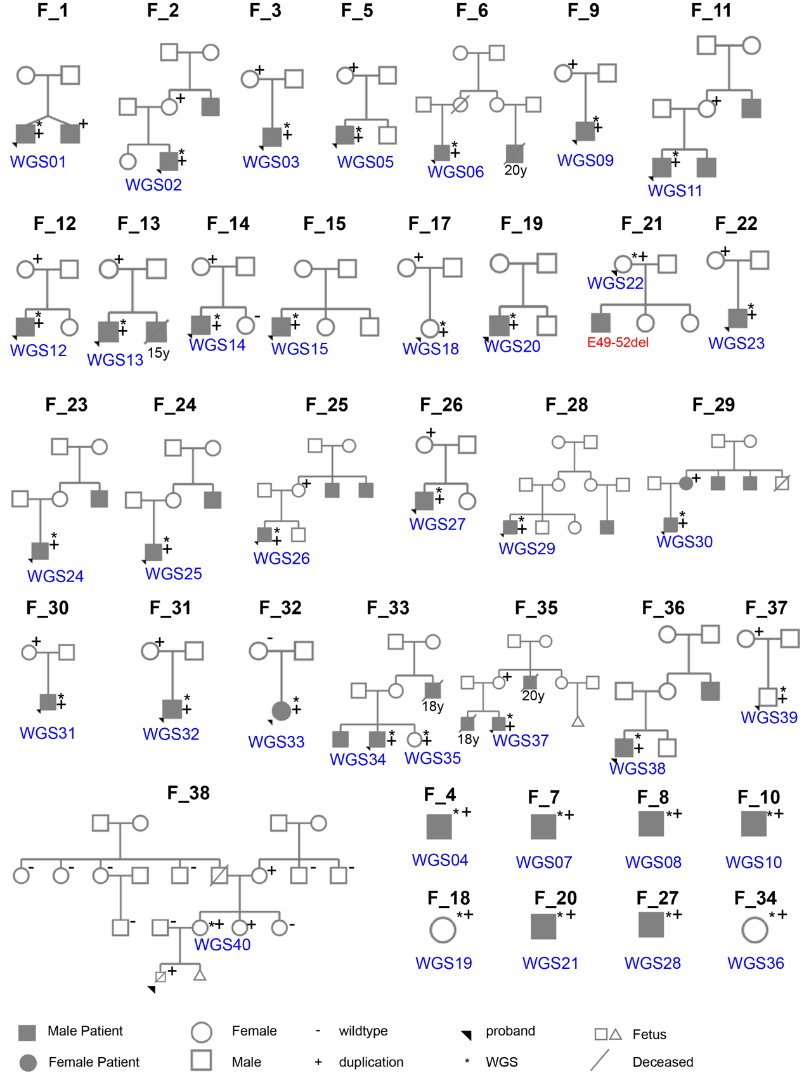
Supplementary Fig.1. Pedigree Diagram of the 38 Families in Our Cohort.
Text with “y” below deceased individuals indicates the age at death (e.g., “15y” = deceased at age 15). “E49-52del” refers to a deletion of exons 49–52 in DMD.

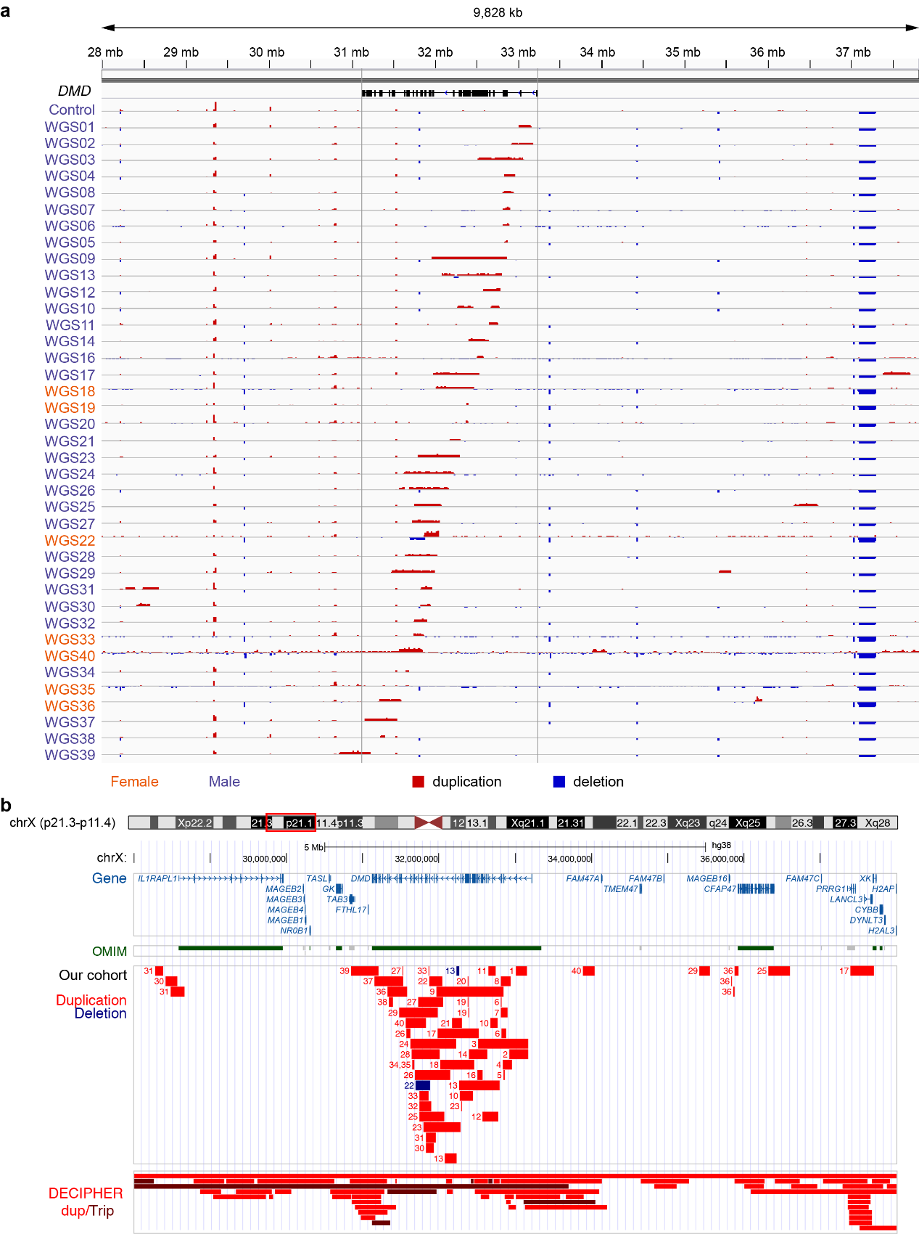
Supplementary Fig.2. Duplications in Our Cohort
a. IGV browser views showing read-depth fold change for 39 samples in chrX[GRCh38]:28000000-38000000.
b. UCSC browser views illustrating structural variants in our cohort alongside pathogenic or likely pathogenic duplications/triplications in DECIPHER.
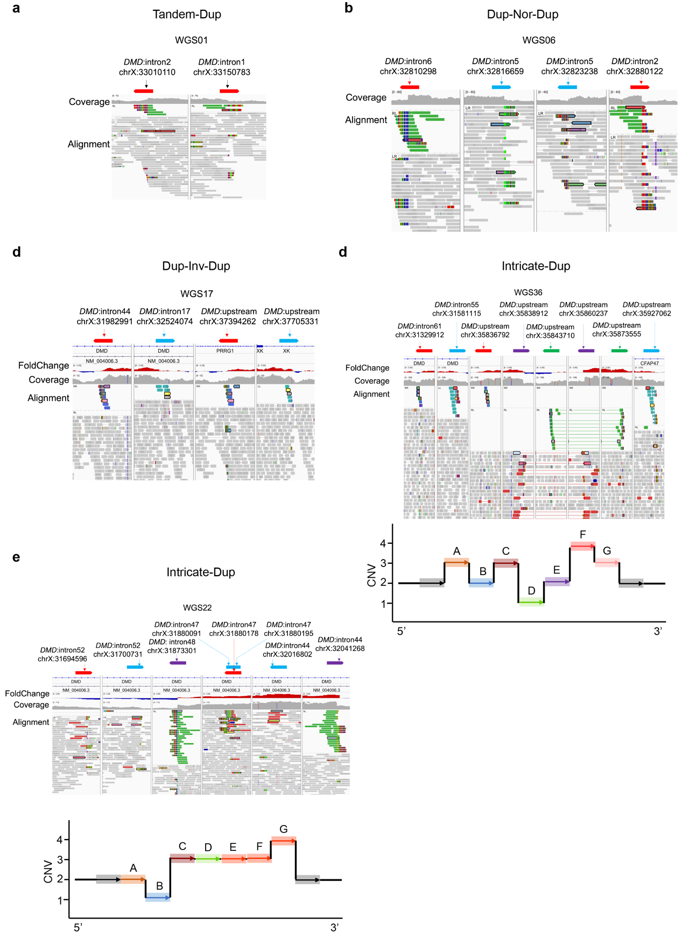
Supplementary Fig.3. Examples of Different DMD Duplication Patterns
a. IGV diagram of a Tandem-Dup pattern.
b. IGV diagram of a Dup-Nor-Dup pattern.
c. IGV diagram of a Dup-Inv-Dup pattern.
d, e. IGV diagrams of Intricate-Dup patterns.

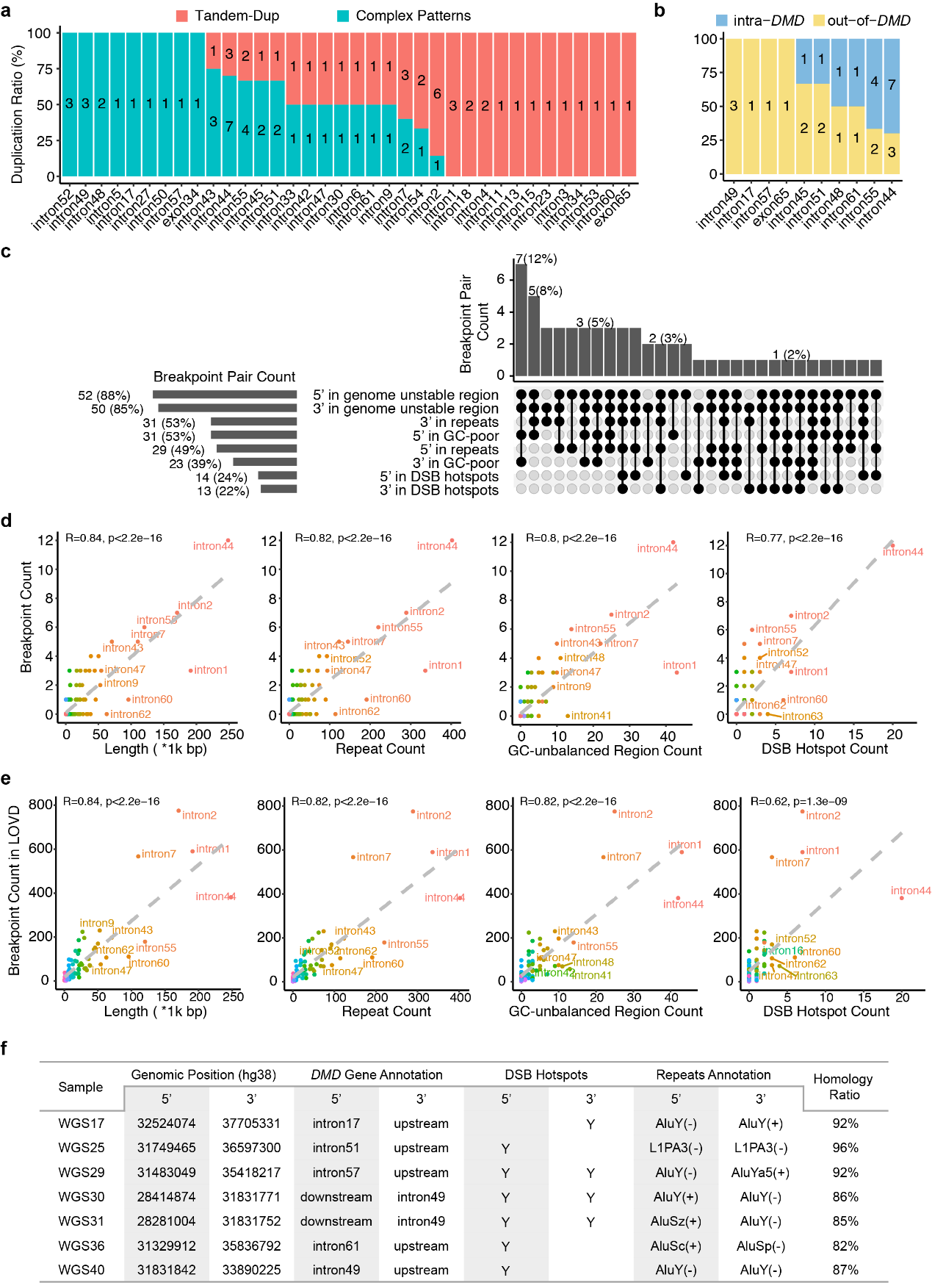
Supplementary Fig.4. Breakpoint Features of DMD Duplications
a. Distribution of duplication patterns across introns. The number in the bar plot represents duplication count. The y-axis represents the ratio of duplication patterns in all duplications involving the introns. Red color represents Tandem-Dup patterns, whereas blue color represents Complex Patterns (Dup-Nor-Dup, Dup-Inv-Dup and Intricate-Dup).
b. Distribution of duplication ranges across introns. The number in the bar plot represents duplication count. The y-axis represents the ratio of duplications with out-of-DMD and intra-DMD in all duplications involving the introns.
c. UpSet plot annotating breakpoint-pair ends. 5’ and 3’ represent the breakpoint order on the forward strand.
d, e. Scatterplot showing positive correlations of the number of breakpoints in our cohort (d) and the number of breakpoints in LOVD (e) with lengths, repeat counts, GC-unbalanced region counts, and DSB hotspot counts of these introns. GC-unbalanced region counts were calculated by placing 10,000 randomly generated 200-bp intervals within introns. “R” and “p” represent the coefficient of determination and the statistical significance of linear regression, respectively.
f. Table listing samples with high-homology repeats at breakpoints.

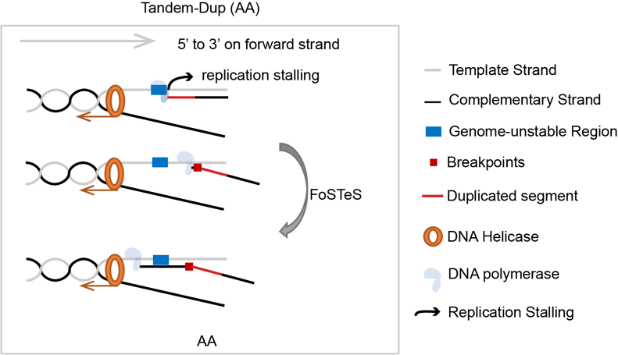
Supplementary Fig.5. The formation of tandem duplication.
Schematic diagram of tandem duplication formation, hypothesizing that replication fork stalling in unstable genomic regions (e.g., GC-poor regions, DSB hotspots, repeat elements) triggers template switching, resulting in tandem duplications.

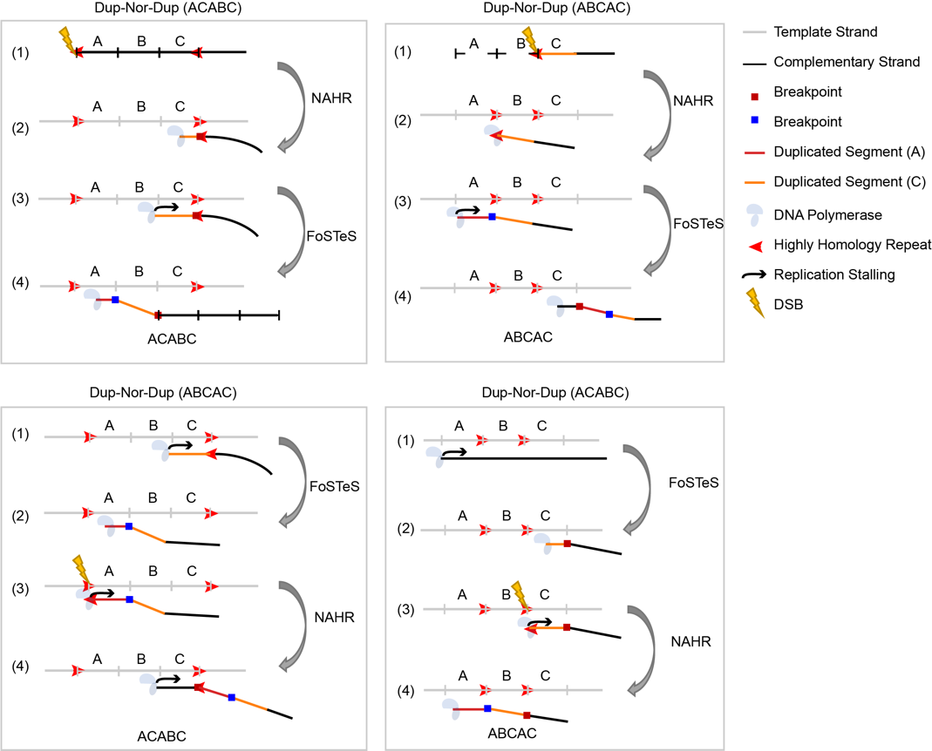
Supplementary Fig.6. Schematic diagram for the formation of Dup-Nor-Dup with highly homology repeats.
Schematic diagram illustrating multiple replication-based template switching events in Dup-Nor-Dup formation: one mediated by reverse complementary repeats of the complementary strand and others driven by microhomology sequence, leading to two potential haplotypes (ACABC, ABCAC).

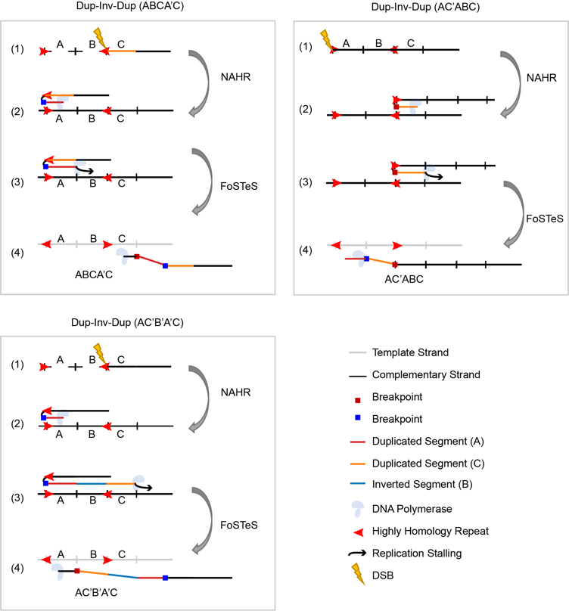
Supplementary Fig.7. Schematic diagram for the formation of Dup-Inv-Dup with highly homology repeats.
Schematic diagram illustrating multiple replication-based template switching events in Dup-Inv-Dup formation: one mediated by reverse complementary repeats of the same strand (inducing an inverted duplication) and others via microhomology sequence, leading to three possible haplotypes (ABCA’C, AC’ABC, AC’B’A’C).

Supplementary Table 1. Summary of patient statistics
Total Number of Patients (n=39) | Gender | Male | 32 (82%)
Total Number of Patients (n=39) | Gender | Female | 7 (18%)
Total Number of Patients (n=39) | Phenotype | DMD | 27 (69%)
Total Number of Patients (n=39) | Phenotype | BMD | 5 (13%)
Total Number of Patients (n=39) | Phenotype | Asymptomatic Male | 1 (3%)
Total Number of Patients (n=39) | Phenotype | Asymptomatic Female | 6 (15%)
Total Number of Families (n=38) | Family History Related to MD¹ | Positive | 14 (37%)
Total Number of Families (n=38) | Family History Related to MD¹ | Negative | 11 (29%)
Total Number of Families (n=38) | Family History Related to MD¹ | Unavailable | 13 (34%)
Total Number of Families (n=38) | SV Origin | Maternal Inheritance | 25 (66%)
Total Number of Families (n=38) | SV Origin | De novo | 1 (3%)
Total Number of Families (n=38) | SV Origin | Unavailable | 12 (32%)
¹ Family history specifically refers to muscular dystrophy (MD) related phenotypes, such as calf pseudohypertrophy, muscle weakness and atrophy, compromised or lost ambulation, and myocarditis.

Supplementary Table 3. Summary of SV statistics
Total number of duplications  (n=38) | breakpoints number | 2 | 22 (58%)
Total number of duplications  (n=38) | breakpoints number | 4 | 12 (32%)
Total number of duplications  (n=38) | breakpoints number | >4 | 4 (11%)
Total number of duplications  (n=38) | Pattern | Tandem-Dup | 22 (58%)
Total number of duplications  (n=38) | Pattern | Dup-Nor-Dup | 6 (16%)
Total number of duplications  (n=38) | Pattern | Dup-Inv-Dup | 6 (16%)
Total number of duplications  (n=38) | Pattern | Intricate-Dup | 4 (11%)
Total number of duplications  (n=38) | Range | ﻿Intragenic | 29 (76%)
Total number of duplications  (n=38) | Range | ﻿Extragenic | 9 (24%)
Total number of duplications  (n=38) | Duplication length¹ | <100K | 9 (24%)
Total number of duplications  (n=38) | Duplication length¹ | 100K-500K | 19 (50%)
Total number of duplications  (n=38) | Duplication length¹ | 500K-1M | 8 (21%)
Total number of duplications  (n=38) | Duplication length¹ | Unknown² | 2 (5%)
¹ Duplication length refers to the accumulated length of all duplicated segments in the duplications. ² Unknown refers to two female samples (WGS22 and WGS36) with intricate duplication patterns and the corresponding duplication structures remain unclear due to the unavailability of corresponding OGM results.

Supplementary Table 5. Summary of difference of different technology
MLPA vs WGS | concordant | 23 (88%)
MLPA vs WGS | missed a non-contiguous exon | 1 (4%)
MLPA vs WGS | combined results in female carrier | 1 (4%)
MLPA vs WGS | missed exon with breakpoints | 1 (4%)
WES vs WGS | concordant | 11 (69%)
WES vs WGS | one-exon discrepancies at duplication boundaries | 3 (19%)
WES vs WGS | missed a non-contiguous exon | 1 (6%)
WES vs WGS | missed exon with breakpoints | 1 (6%)
OGM vs WGS | concordant | 4 (67%)
OGM vs WGS | missed small segment | 1 (17%)
OGM vs WGS | discrepancies at duplication boundaries | 1 (17%)

