Supplementary Information
Investigating the performance of UV/PS/TiO₂NPs and UV/PI/TiO₂NPs processes on paraquat herbicide degradation in aqueous media: statistical optimization, kinetic study, and estimation of electrical energy consumption

Azam Ghavi ^{a*}, Ghadamali Bagherian ª, Hadi Rezaei Vahidian ^{b}

ª Research Laboratory of Faculty Chemistry, Shahrood University of Technology, P.O. Box 316-3619995161, Shahrood, Iran.
^{b} Space transportation research institute, Iranian space research center, Tehran, Iran.
*Corresponding author: azamghavi@ymail.com

Paraquat
Paraquat (PQ), discovered in 1882, has been used as an oxidation-reduction indicator under the name of methyl virologen since 1932; it was registered in the United States in 1964 for use as a non-selective contact herbicide in order to control or suppress a broad spectrum of emerged weeds. The solubility of PQ in water is 625 g/L at 25 °C [1]. It has been marketed under the brand name Gramoxone by different manufacturers, and sold under different names. It is a green liquid with the boiling point of 175–180 ˚C, is easily soluble in water, and is relatively stable at normal temperature, pressure, and pH to stay longer in the soil. Its molecular structure is shown in Figure 1[2,3].

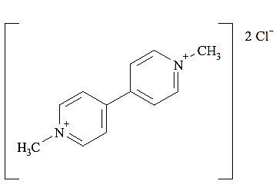
Figure 1. Molecular structure of PQ [4].

Characterization of TiO₂ nanoparticles
The TiO₂ nanoparticles (TiO₂NPs) were characterized using the TEM and XRD analyses. A TEM image of TiO₂NPs is demonstrated in Figure 2. It reveals a widespread size distribution in the range of 10–25 nm.
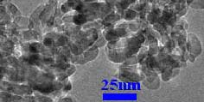
Figure. 2. TEM image of TiO₂NPs.

The crystal phase of TiO₂NPs was examined by XRD. Figure 3 shows the XRD pattern of the synthesized nanoparticles in comparison with the anatase Titania pattern. The formation of TiO₂ was confirmed via a good accordance of its XRD pattern with the anatase (Reference code: 01-073-1764) cases.

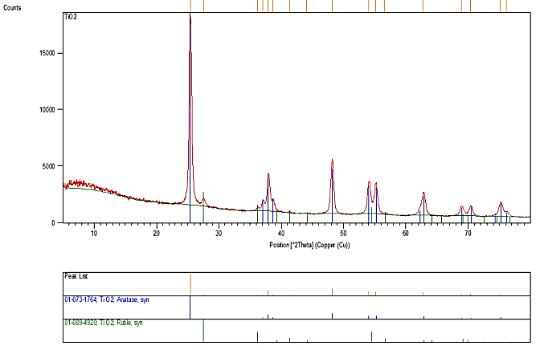

Figure. 3. XRD pattern of the anatase TiO₂ nanoparticles.

Mineralization study
In order to investigate the mineralization, the total organic carbon (TOC) test should be used. This test was performed on the treated PQ solution by the photo-catalytic processes. The results of measuring the TOC test of the samples were compared with those for measuring the TOC graph of the initial PQ concentration (30 mg L⁻¹) (Figure 4).
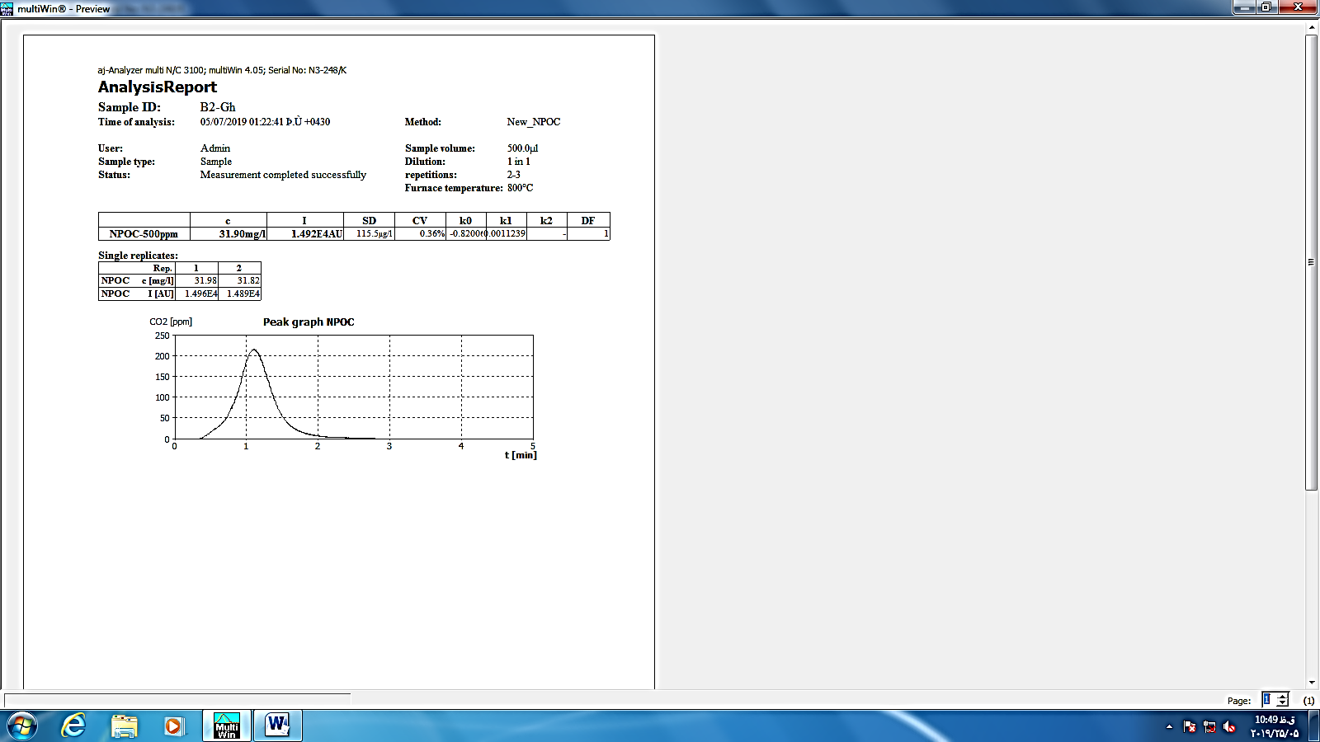
Figure 4. TOC graph of [PQ] = 30 mg L⁻¹.

Evaluation of model adequacy by diagnostic plots
In order to evaluate the adequacy of the model graphically, the diagnostic plots could be utilized. Most of the plots display the residuals, which show the difference between the experimental and predicted responses. In the DOE software, the normal probability, “residuals versus predicted”, “residuals versus run”, and “actual versus predicted” are widely used to evaluate the adequacy of the model. The diagnostic plots for the PQ degradation model are demonstrated in Figure 5. The normal probability plot indicates whether the residuals follow a normal distribution, in which case the points will follow a straight line. The plot that has a definite pattern like an "S-shaped" indicates that a transformation of the response may provide a better analysis. “Residuals versus predicted” is a plot of the residuals versus the ascending predicted response values. It tests the assumption of constant variance. The plot should be a random scatter. The plot of “residuals versus run” is a plot of the residuals versus the experimental run order. It checks for the lurking variables that may have influenced the response during the experiment. The plot should show a random scatter. The trends indicate a time-related variable lurking in the background. Blocking and randomization provide insurance against the trends ruining the analysis. The plot of “actual versus predicted” detects a value or a group of values not easily predicted by the model. As it can be seen, the diagnostic plots approve a well-adequacy of the PQ degradation model [5].

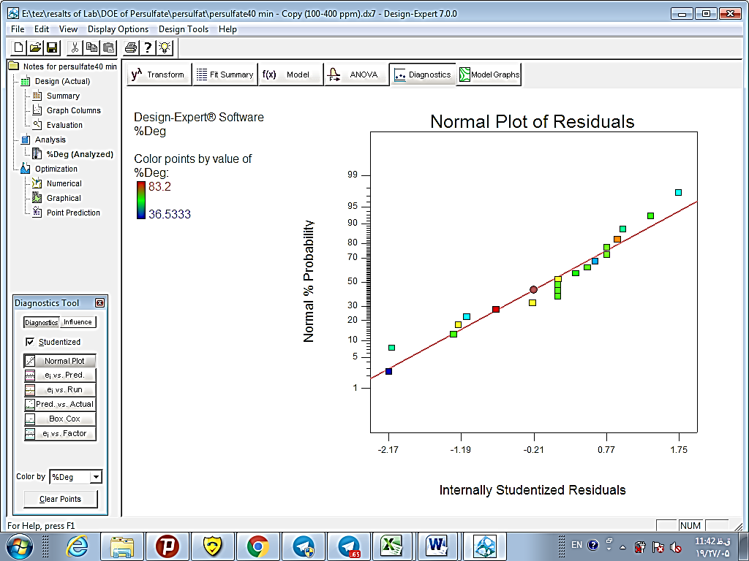 |  | 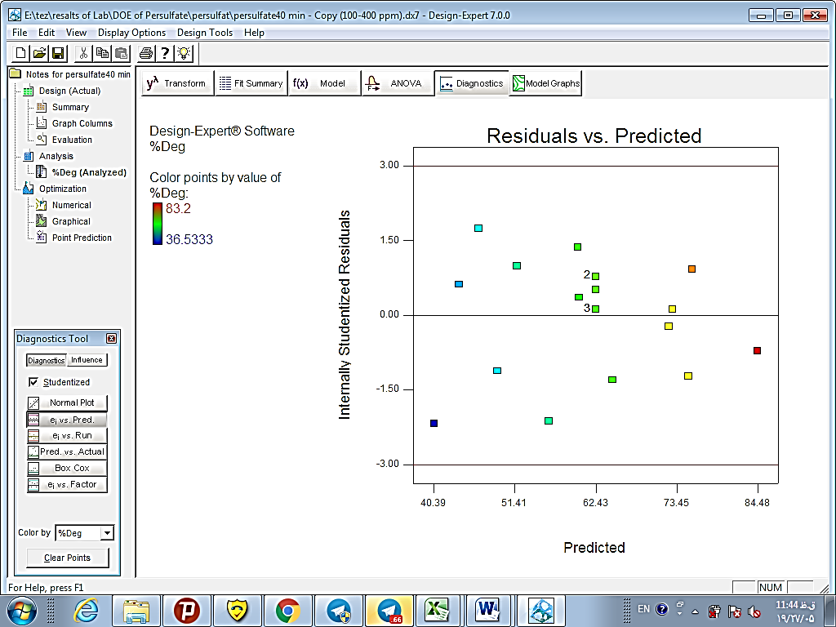
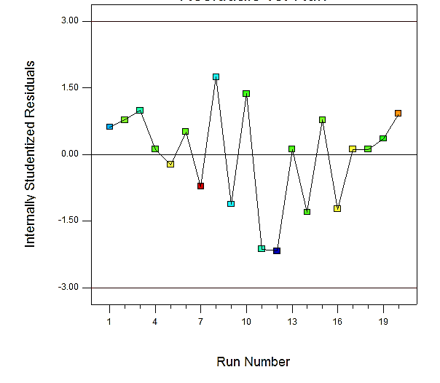 |  | 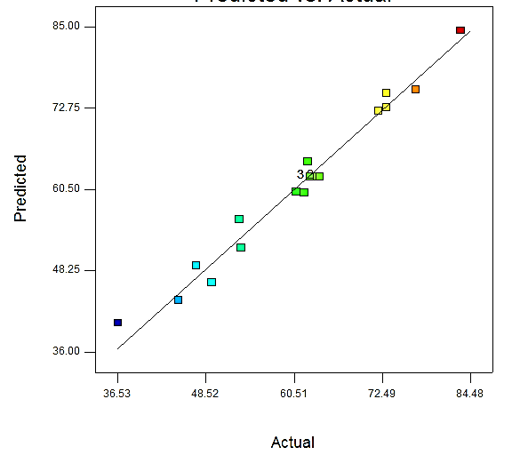
- PS process

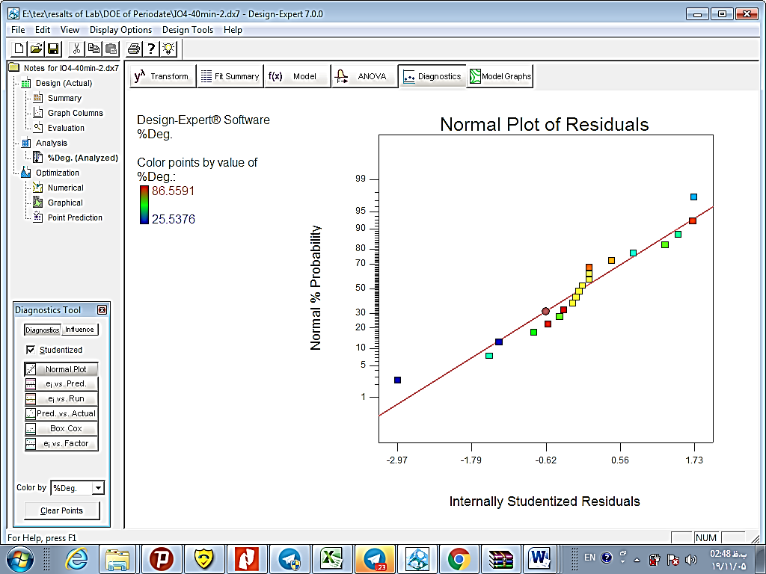 | 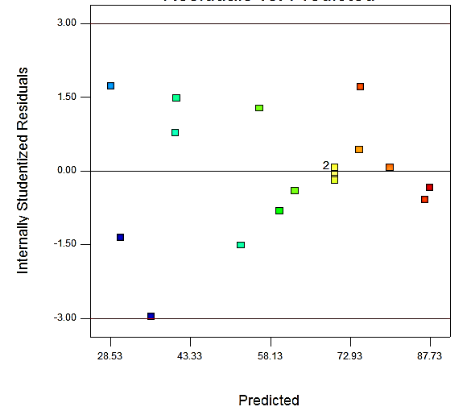
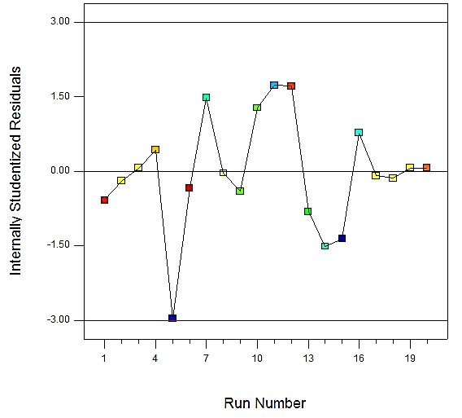 | 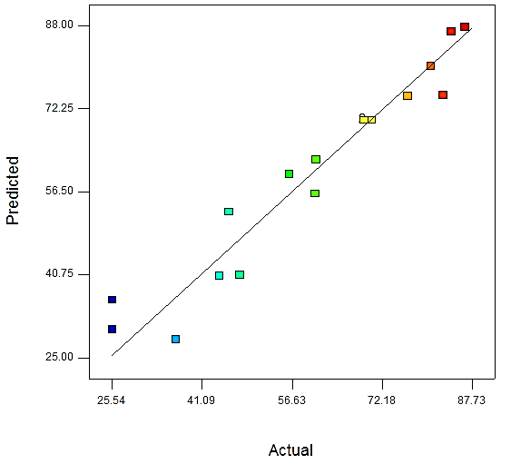
- PI process

Figure 5. Adequacy diagnostic plots of normal probability, “residuals versus predicted”, “residuals versus run”, and “actual versus predicted” for the (a) persulfate (PS) process and (b) periodate (PI) process.

Optimum conditions
The predicted optimum values were 400 mg L⁻¹, 150 mg L⁻¹, and 6.3 for the PS dose, TiO₂NPs dose, and initial pH, respectively, for the PS process. Under the optimum conditions, a degradation efficiency equal to 77% was predicted by the model. In order to assess the accuracy of the model prediction, under the supposed values of the parameters, the photo-catalytic degradation efficiency reached 83% empirically (i.e. 6% error). Also the predicted optimum values were 90 mg L⁻¹, 125 mg L⁻¹, and 6 for the PI dose, TiO₂NPs dose, and initial pH, respectively, for the PI process. Under the optimum conditions, a degradation efficiency equal to 90% was predicted by the model. In order to assess the accuracy of the model prediction, under the supposed values of the parameters, the photo-catalytic degradation efficiency reached 90% empirically (i.e. 0 % error) (Figure 6 and 7).
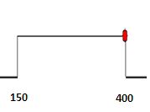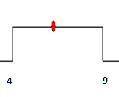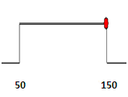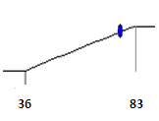
[PS] = 400 mg L⁻¹ pH = 6.3 [TiO₂NPs] = 150 mg L⁻¹ %DE = 77
Figure 6. Desirability ramp of the numerical optimization for the PS process.

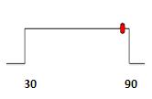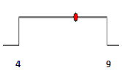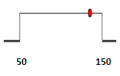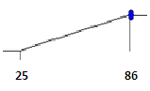
[PI] = 90 mg L⁻¹ pH = 6 [TiO₂NPs] = 125 mg L⁻¹ %DE =90
Figure 7. Desirability ramp of the numerical optimization for the PI process.

References
1. Bromilow RH (2004) Paraquat and sustainable agriculture. Pest manag. sci. 60:340-349.
2. Jafarinejad S (2017) Cost-Effective catalytic materials for AOP treatment units in applications of advanced oxidation processes (AOPs) in drinking water treatment. Springer International Publishing AG: The Handbook of Environmental Chemistry, 309-343.
3.Agency, U.S.E.P. (1997) Paraquat Dichloride. In Reregistration Eligibility Decision (RED). Washington, D.C. 20460..
4. Watts M (2010) Paraquat. Pesticied Action Network Asia and the Pacific, Malaysia..
5. Montgomery DC (2009) Design and Analysis of Experiments. 9 ed., Arizona State University: Wiley.

