Supplementary information for
Electrical resistivity anisotropy in brine-saturated rocks during triaxial deformation
Takeshi Suzuki, So Jiei, Yuya Akamatsu, Kazuki Sawayama, Ikuo Katayama

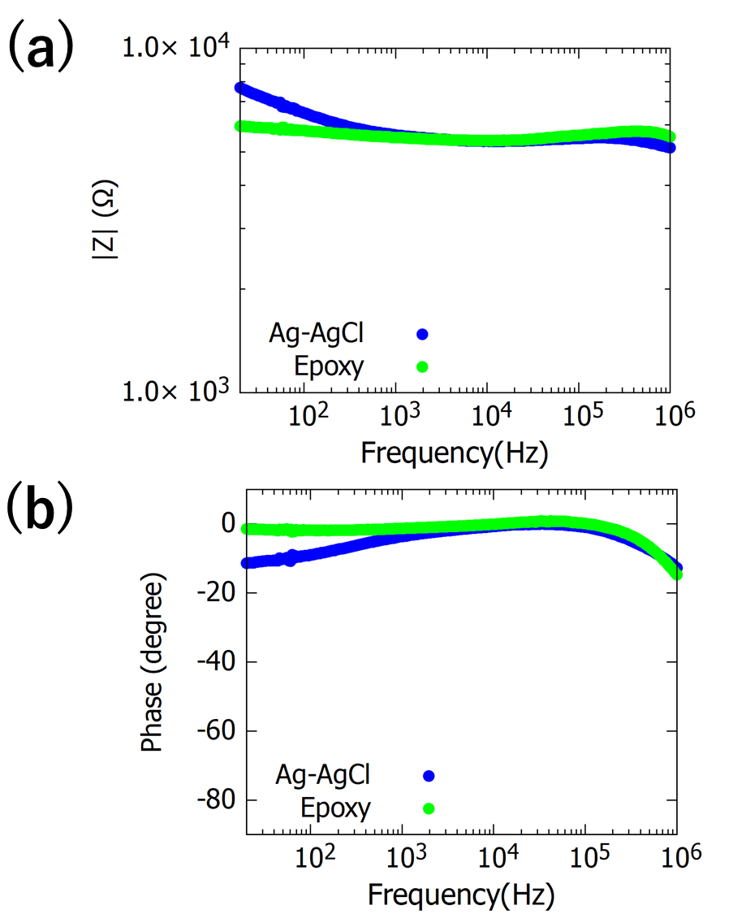
Additional Fig. S1 Impedance spectra obtained under atmospheric pressure. (a) Amplitude of impedance $|Z|$ as a function of frequency. (b) Phase shift as a function of frequency. The green and blue dots indicate the results of Epoxy electrodes and Ag-AgCl electrodes, respectively.

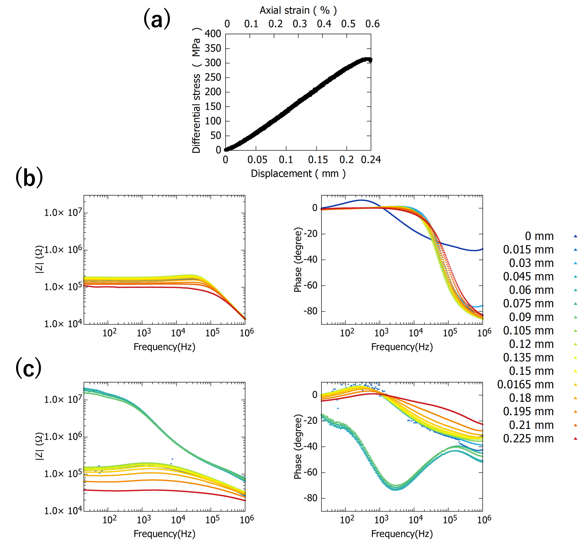
Additional Fig. S2 Reproducibility test results for the impedance spectra measurements during the deformation test. (a) Stress and displacement curves for the experiments under brine-saturated conditions. Axial strain is inferred from the displacement and displayed on the upper axis. (b) Amplitude of impedance and phase shift as a function of frequency for axial direction during deformation. (c) Amplitude of impedance and phase shift as a function of frequency for radial direction during deformation. Color of dots indicates the sample axial displacement

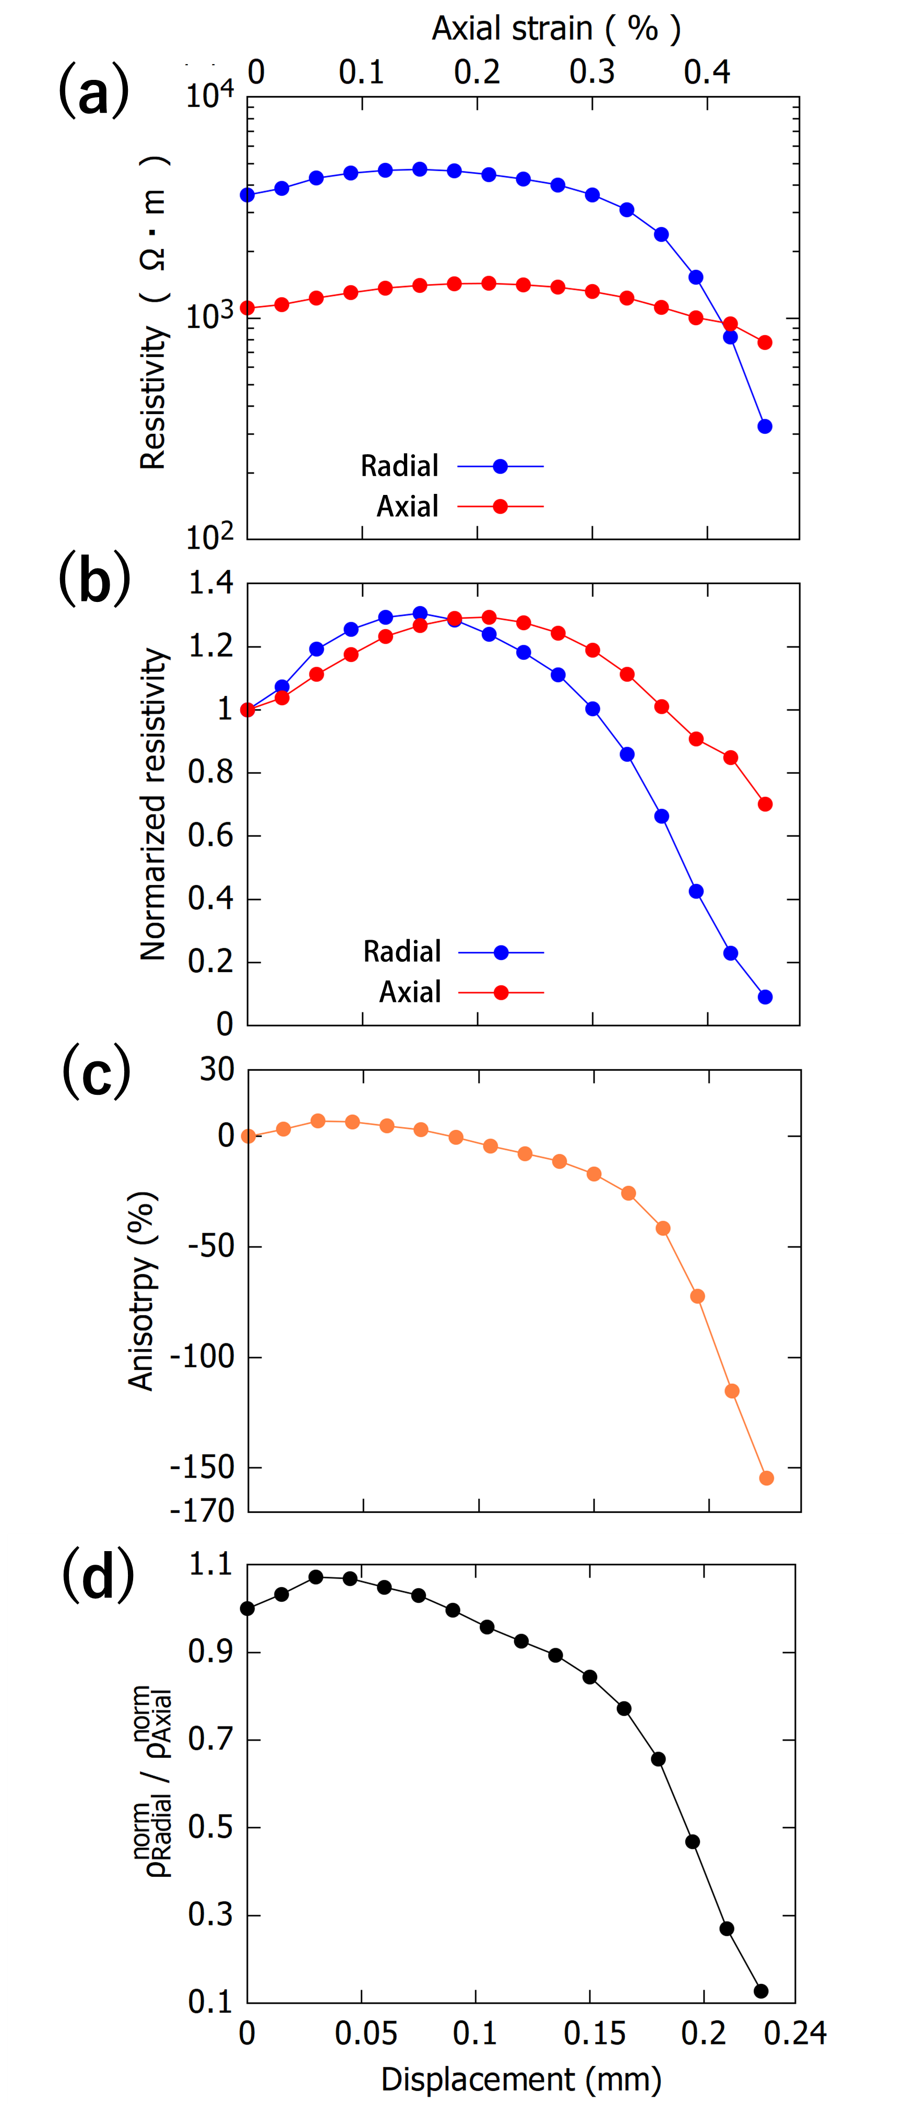
Additional Fig. S3 Reproducibility test results for the resistivity anisotropy measurements during the deformation test. (a) Electrical resistivity of axial and radial direction during deformation and (b) normalized to the initial value prior to deformation. (c) Anisotropy of resistivity during deformation determined from normalized resistivity. (d) Ratio of radial to axial resistivity ($ρ_{Radial}$/$ρ_{Axial}$)

