Table 1. Description of LTCI nursing staff and governmental staff
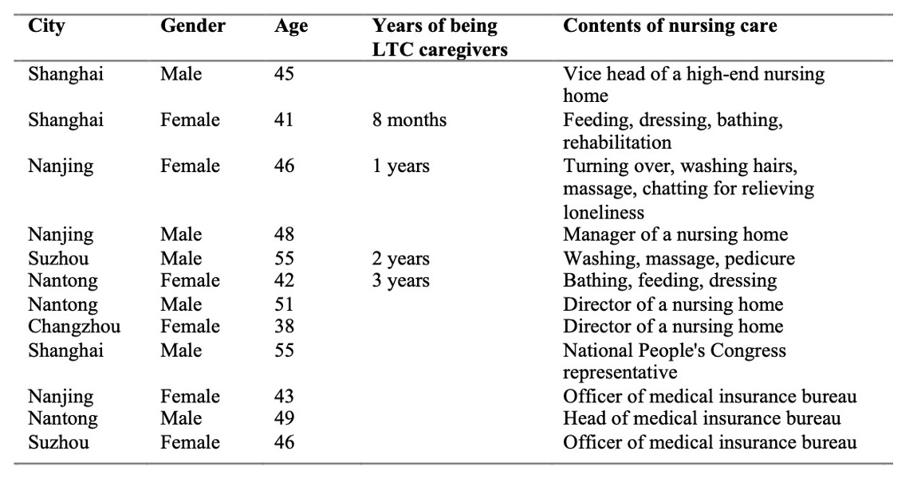

Table 2. Description of LTCI participants
