Thermal conductive networks constructed by Sialon fibers in-situ synthesized in barium aluminosilicate glass-ceramic
Supporting Information
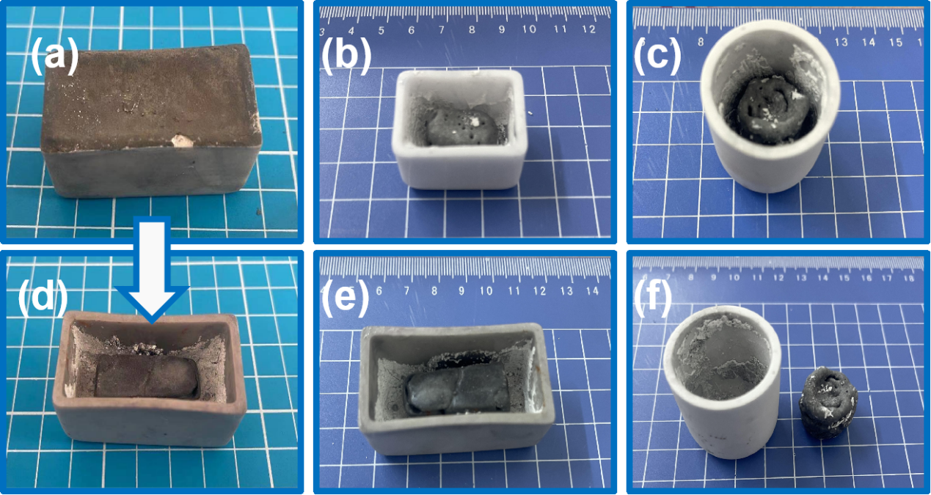
Fig. S1 (a)The powder sample in the crucible before sintering; (b)The sample in smaller rectangular shaped crucible after sintering; (c)The sample in cylindrical shaped crucible after sintering; (d)The sample in larger rectangular shaped crucible after sintering; (d)The sample in the crucible after sintering corresponding figure S1(a); (f) The sample has a certain degree of imitation to the cylindrical crucible.
,
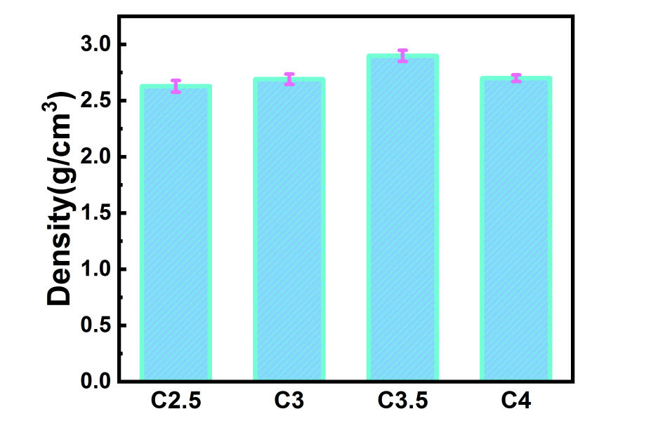

Fig. S2 The density of samples with different Sialon contents

Table S1 Detailed information of semi-quantitative calculataion

Sample | I_{Sialon} | I_{BAS} | K_{Sialon}(RIR) | K _{BAS}(RIR)
C2.5 | 56 | 589 | 1.3 | 1.18
C3 | 96 | 706 | 1.3 | 1.18
C3.5 | 251 | 687 | 1.3 | 1.18
C4 | 187 | 829 | 1.3 | 1.18

Theoretical modeling of thermal conductivity in composites
The thermal conductivity of two-phase composites in parallel conductions can be estimated using the following equations:
$K_{c}=W_{f}λ_{f}+\left(1-W_{f}\right)λ_{p}$ (Ⅰ)
The series conduction for two-phase system could be evaluated by:
$K_{c}=\frac{1}{W_{f}{/K}_{f}+\left(1-W_{f}\right){/K}_{p}}$ (Ⅱ)
Where $K_{c}$ is the thermal conductivity of the composite, W_{f} is the weight fractions of filler phases in the composite, $λ_{p }$is the thermal conductivity of the matrix, and $λ_{f}$is thermal conductivity of the filler. In this work, based on the phase content, the composition of samples can be roughly divided into BAS and β-Sialon. Then BAS glass-ceramic were employed as matrix with the heat conductivity value of 2.52 W/mK and the β-Sialon phases as filler with the heat conductivity value of 16.48 W/mK.
The determined factor X_{interconnectivity} and η could be calculated by following Eq. (Ⅲ) and (Ⅳ)[S1,S2],

$X_{interconnectivity}=\frac{K_{c}-K^{HS-}}{K^{HS+}-K^{HS-}}$ (Ⅲ)

$η=\frac{K_{c}-K_{m}}{W_{f}K_{m}}×100\%$ (Ⅳ)
Where $K_{c}$ is the thermal conductivity of the composite, K_{m} is the thermal conductivity of the matrix, K^{HS+}is the upper boundary of The Hashin-Shtrikman model, K^{HS-}is the lower boundary, W_{f} is the weight loading of thermal conductive fillers.
The lnp in Eq. (6) in the main body can be calculated by following equation[S3]:

$lnp=\frac{ln⁡(p+\sqrt{p^{2}-1)}p}{\sqrt{{{(p}^{2}-1)}^{3}}}$-$\frac{1}{p^{2}-1}$ (Ⅴ)
Where p is the aspect ratio of the Sialon fiber.

Table S2 Fitting parameters for model and contact thermal resistance model

Agari model |  |  | Interfacial thermal resistance model |  |  | Contact thermal  resistance model
C1 | C2 | R² | t(p) | Kx | R² | t(p) | K₀ | R²
0.60592 | 1.04893 | 0.972 | 0.3209 | 16.8796 | 0.976 | 2.54465 | 15.4594 | 0.968
Table S3 Engineering data of the materials for finite element simulation

Material | Density(g/cm3) | Young’s modulus(GPa) | Poisson’s ratio | Isotropic thermal conductivity(W m⁻¹)
BAS | 2.5 | 100 | 0.26 | 2.5
Sialon | 2.2 | 100 | 0.22 | 16.48

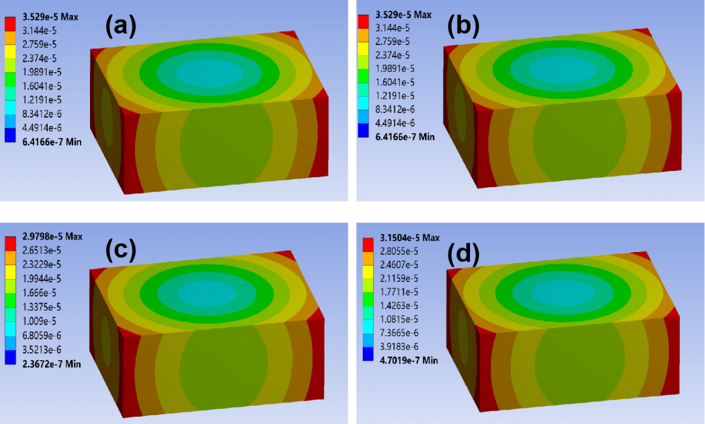
Fig. S3 The deformation distribution of samples with different Sialon contents based on finite element method: (a) C2.5; (b) C3; (c) C3.5; (d) C4

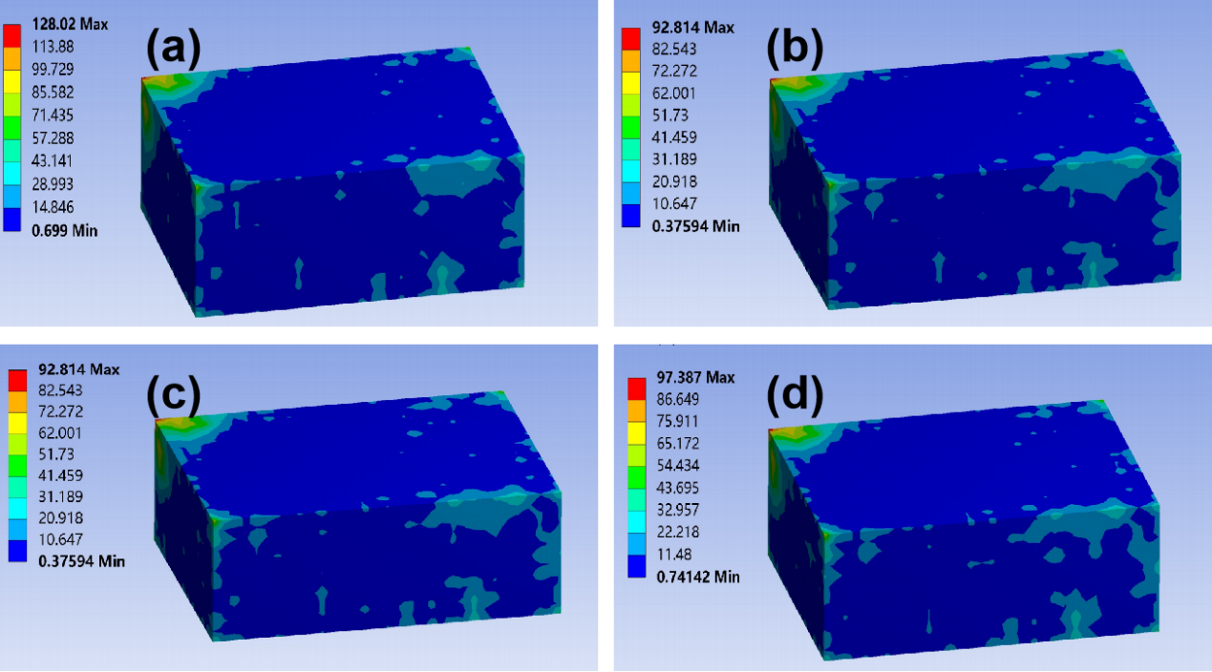
Fig. S4 The thermal stress distribution of samples with different Sialon contents based on finite element method: (a) C2.5; (b) C3; (c) C3.5; (d) C4

References:
- Schilling FR, Partzsch GM. Quantifying partial melt fraction in the crust beneath the Central Andes and the Tibetan plateau. Physics and Chemistry of the Earth Part a-Solid Earth and Geodesy 2001;26(4-5): 239-46.
- Zhang X, Zheng J, Fang H, Zhang Y, Bai S, He G. Al2O3/graphene reinforced bio-inspired interlocking polyurethane composites with superior mechanical and thermal properties for solid propulsion fuel. Composites Science and Technology 2018;167: 42-52.
- Hu L, Desai T, Keblinski P. Thermal transport in graphene-based nanocomposite. J Appl Phys 2011;110(3):033517.

