New Modeling of AgFeNi₂S₄-Graphene-TiO₂ Ternary Nanocomposite synthesized via the Pechini Method for the Enhanced Electrophotocatalytic Reduction of CO₂

Zambaga Otgonbayar ¹, Won-Chun Oh ^{1. 2∗}

¹ Department of Advanced Materials Science & Engineering, Hanseo University, Seosan-si, Chungnam, Korea, 356-706
² Anhui International Joint Research Center for Nano Carbon-based Materials and Environmental Health, College of Materials Science and Engineering, Anhui University of Science & Technology, Huainan 232001, PR China

- Characterization
The crystal structure of the synthesized samples was characterized using X-ray diffraction measurements (SHIMADZU XRD-6000) equipped with a Cu Ka X-ray source (1.5406 Å). We used the Debye-Scherrer equation to measure the particle size of AgFeNi₂S₄ and TiO₂ based on the data acquired via XRD analysis.
$$L=\frac{Kλ}{β\cos{θ}} \left[d=\frac{0.9 λ}{β\cos{θ}}\right]$$
where L is the particle size, λ is the wavelength of X-ray radiation (1.5406 Å), β is the full-width at half maximum (FWHM) of the peak (in radians) and 2θ is the Bragg angle. The surface morphology of the nanocomposite was observed using an energy-dispersive X-ray (EDX) analyzer incorporated into the SEM. The transmission electron microscopy (TEM) and high-resolution transmission electron microscopic (HRTEM) images of the samples using a (Hitachi HT7700, Hitachi H9500) operated at 300 kV. The X-ray photoelectron spectra (XPS) with a monochromatized Al Ka X-ray source (10 kV, 1500 W, pass energy = 40 eV) was adopted to determine the surface chemical state. UV–vis diffuse reflectance spectra (DRS) of nanocomposites were acquired from a SHIMADZU UV-2600 UV-vis spectrometer ranging from 200 to 800 nm. The bandgap energies by applying a modified Kubelka–Munk function obtained from the UV–vis DRS data. The raman spectroscopy conducted using a Confocal-Raman imaging system with a 633-nm excitation laser (Renishaw in Via Reflex). The photocurrent analysis conducted using a computer-controlled Versa-STAT-3 electrochemical analyzer. Photoluminescence spectroscopy (PL) carried out at RT in a conventional PL system. The ND 10% filter united 514-nm laser as the excitation source and noted the measurement range at the 530-1000 nm region. The electrochemical impedance spectroscopy (EIS) conducted on an electrochemical analyzer (Zahner, Germany) in a standard three-electrode system using the prepared samples as the working electrodes with an active area of ca. 0.25 cm², a Pt wire as the counter electrode, and Ag/AgCl (saturated KCl) as a reference electrode. The electrolytes were a mixed aqueous solution containing K₃[Fe(CN)₆] (1 mmol/L), K₄[Fe(CN)₆] (1 mmol/L), and KCl (0.1 mol/L). We fitted impedance data with ZSimpWin software (Princeton Applied Research).
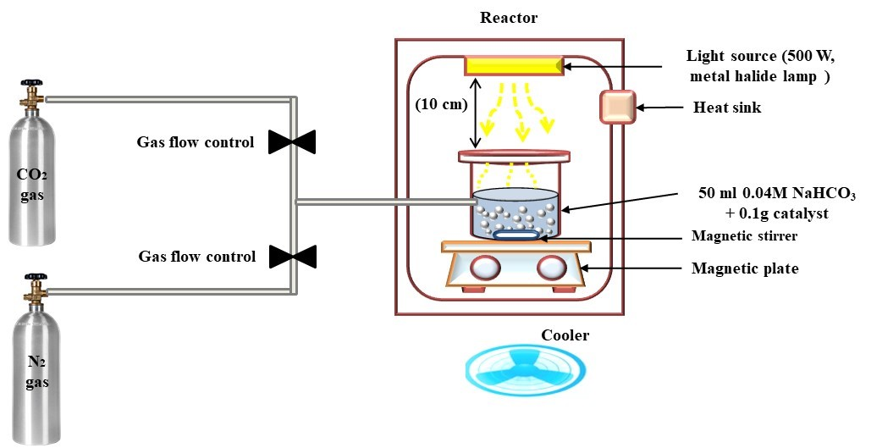
Scheme S1. Schematic diagram of the device of photocatalytic CO₂ reduction with AgFeNi₂S₄-Graphene-TiO₂.
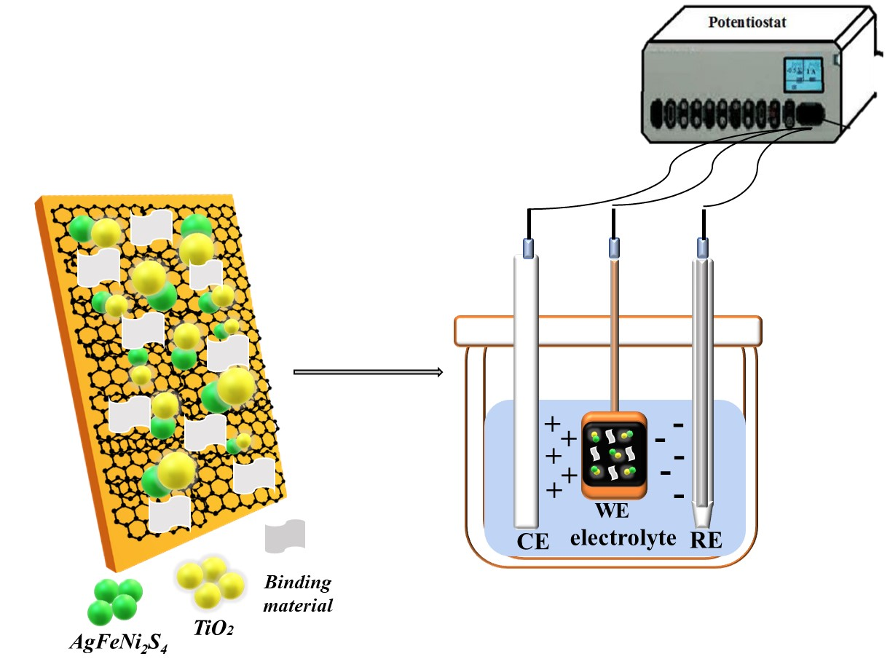
Scheme S2. Schematic diagram of the working electrode preparation and electrochemical CO₂ reduction with AgFeNi₂S₄-Graphene-TiO₂.
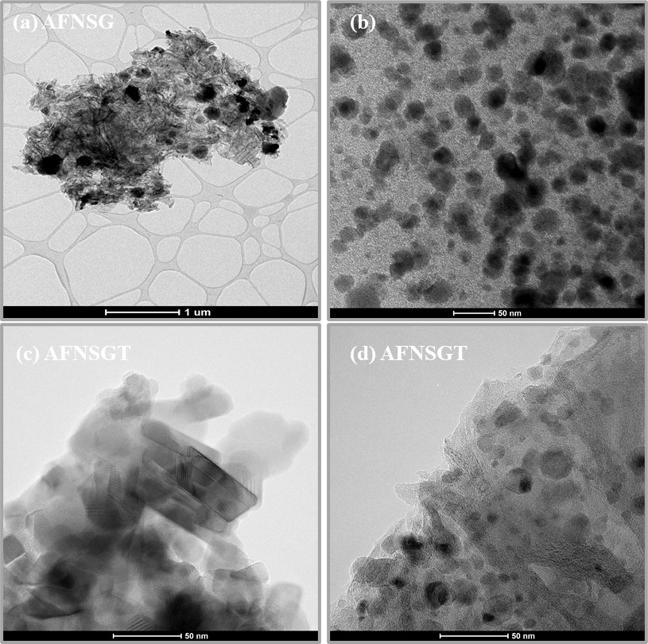
Figure S1. Supplementary TEM images of (a-b) AgFeNi₂S₄-Graphene, (c-d) AgFeNi₂S₄-Graphene-TiO₂.
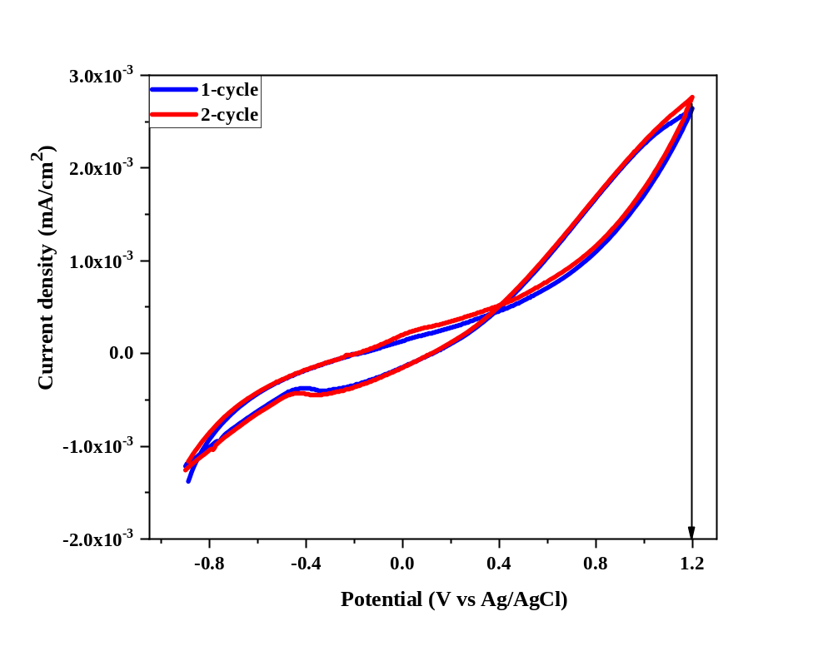
Figure S2. Cyclic voltammetry test of AgFeNi₂S₄-Graphene-TiO₂ in pure methanol electrolyte under 100 mV s⁻¹ scan rate.
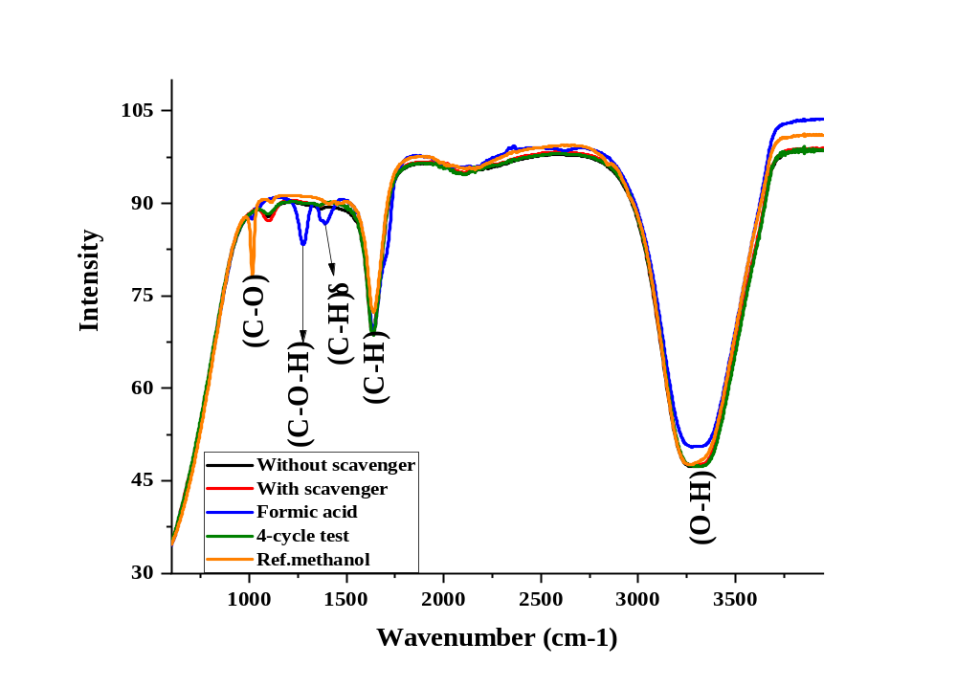
Figure S3. The FTIR result of the final product: reference (olive line), final methanol product (blue and red line).

Table S1. Characteristic vibrational group of the final-product from the FTIR measurement
№ | Vibrational state | Mode | Experimental (cm⁻¹) | Theoretical (cm⁻¹)
1 | Hydroxyl group | (O-H) | 3293.82 cm⁻¹ | 3400-3300 cm⁻¹
2 | Alcohol group | C-O-H | 1267.003 cm⁻¹ | 1440-1220 cm⁻¹
3 | Methyl group | (C-H) in (CH₃) $δ$ | 1643.053 cm⁻¹ | 1450 cm⁻¹
4 | Carbonyl group | C-O | 1020.15 cm⁻¹ | 1300-1000 cm⁻¹

∗Corresponding author E-mail: wc_oh@hanseo.ac.kr Tel: +82-41-660-1337, Fax: +82-41-688-3352

