Supplementary Information

Psychomotor stimulant effects of α-pyrrolidinovalerophenone (αPVP) enantiomers correlate with drug binding kinetics at the dopamine transporter

Marco Niello^{1,*}, Spyros Sideromenos², Ralph Gradisch¹, Ronan O´Shea³, Jakob Schwazer¹, Walter Sandtner¹, Julian Maier¹, Kathrin Jäntsch¹, Carl R Lupica³, Alexander F Hoffmann³, Thomas Stockner¹, Daniela D Pollak², Michael H Baumann³, Harald H Sitte^{1,4,*}

Affiliations:
¹ Center for Physiology and Pharmacology, Institute of Pharmacology, Medical University of Vienna, Vienna, Austria.
² Center for Physiology and Pharmacology, Department of Neurophysiology and Neuropharmacology, Medical University of Vienna, Vienna, Austria.
³ Designer Drug Research Unit, Intramural Research Program, National Institute on Drug Abuse, National Institutes of Health, Baltimore, MD 21224, USA.
⁴ AddRess, Center for Addiction Research and Science, Medical University of Vienna, Vienna, Austria.

*Address correspondence to:
harald.sitte@meduniwien.ac.at
marco.niello@meduniwien.ac.at

Supplementary Figures
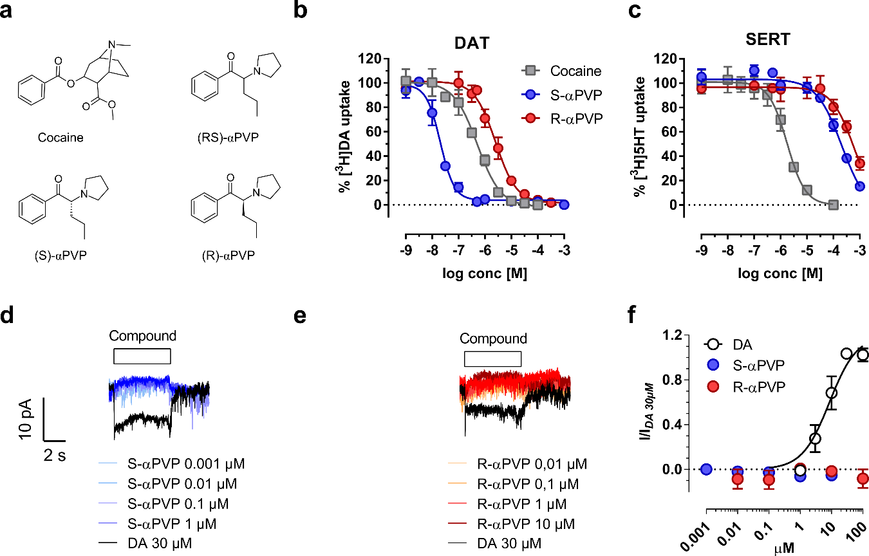
Supplementary Figure 1. a) Chemical structure of cocaine, (R/S) αPVP, (S)-αPVP and (R)-αPVP. b) Uptake-inhibition of ³H-DA uptake in DAT. c) Uptake-inhibition of ³H-5HT uptake in SERT. d) representative traces of DAT-mediated currents recordings in the case of S-αPVP and e) R-αPVP. f) quantification of S- and R-αPVP on DAT-mediated currents. Currents are normalized on a saturating concentration of DA (30µM)..

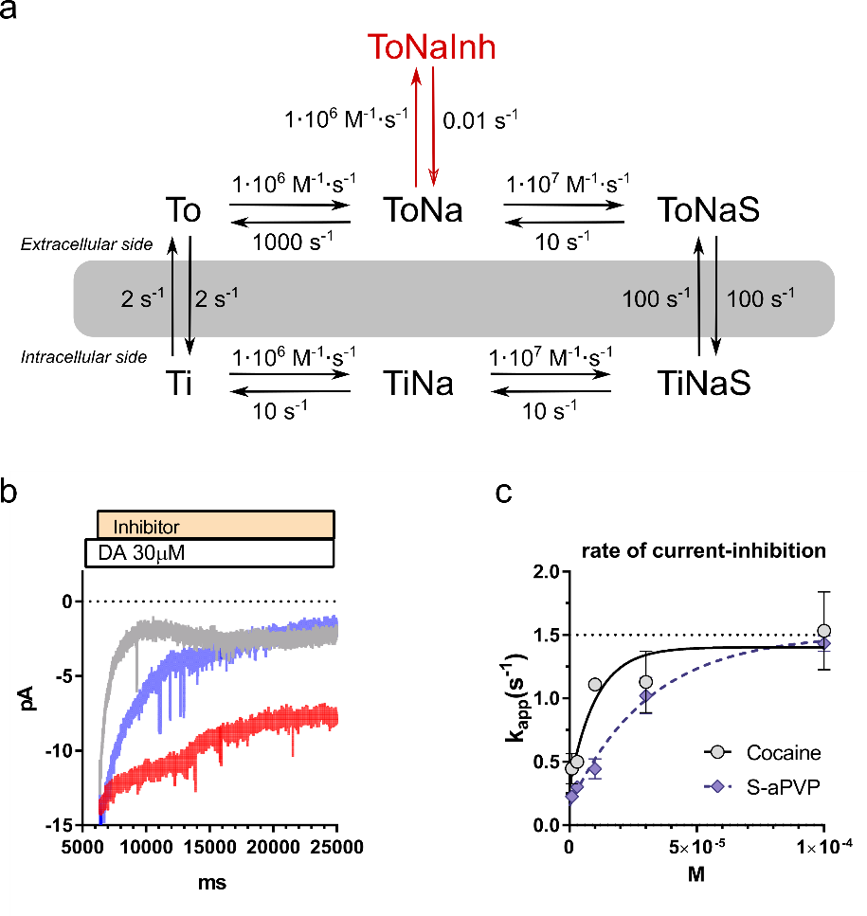
Supplementary Figure 2. a) Modified-version of DAT-kinetic model with an inhibitor-bound state (red). b) Representative traces of the kinetics of current-inhibition by cocaine 10µM (grey), S-αPVP 3µM (blue) and R-αPVP 10µM (red). c) Rate of current inhibition (s⁻¹) as function of the inhibitor concentration applied for cocaine and S-αPVP. For both compounds the rate of currents inhibition saturates around value close to the rate limiting step of DAT (TiCl ToCl; ~1s⁻¹).

Supplementary Tables

 | ³H-DA uptake
Mutant | N | Km(µM) | ± | SEM
DAT-WT | 5 | 1.7 | ± | 0.3
DAT-F76Y | 4 | 3.6 | ± | 1.6
DAT-S149A | 3 | 1.7 | ± | 0.6
DAT-S149A_S429G | 3 | 2.3 | ± | 1.1
DAT-V152I | 3 | 10.2 | ± | 3.9
SERT-WT | 4 | 1.6 | ± | 0.3
SERT-Y95F | 3 | 1.9 | ± | 0.7
Supplementary Table 1. Km values (± SEM) obtained from saturation of uptake experiments conducted in HEK293 cells. The respective construct was expressed transiently and the experiment conducted at least three times, in triplicate, and from two separate transfections.

 | Cocaine |  |  |  | S-αPVP |  |  |  | R-αPVP
Mutant | N | Ki (µM) | ± | SEM | N | Ki (µM) | ± | SEM | N | Ki (µM) | ± | SEM
DAT-WT | 3 | 0.202 | ± | 0.044 | 3 | 0.009 | ± | 0.001 | 3 | 0.373 | ± | 0.052
DAT-F76Y | 3 | 0.322 | ± | 0.068 | 3 | 0.064 | ± | 0.006 | 3 | 2.189 | ± | 0.353
DAT-WT | 3 | 0.229 | ± | 0.022 | 4 | 0.012 | ± | 0.002 | 3 | 0.581 | ± | 0.217
DAT-S149A | 4 | 0.251 | ± | 0.074 | 4 | 0.027 | ± | 0.008 | 4 | 2.336 | ± | 1.191
DAT-WT | 3 | 0.229 | ± | 0.022 | 4 | 0.012 | ± | 0.002 | 3 | 0.581 | ± | 0.217
DAT-S149A_S429G | 3 | 0.365 | ± | 0.107 | 4 | 0.026 | ± | 0.008 | 4 | 0.579 | ± | 0.122
DAT-WT | 4 | 0.482 | ± | 0.117 | 4 | 0.048 | ± | 0.024 | 3 | 0.927 | ± | 0.060
DAT-V152I | 4 | 0.162 | ± | 0.052 | 4 | 0.016 | ± | 0.006 | 3 | 0.295 | ± | 0.024
SERT-WT | 3 | 2.703 | ± | 0.543 | 3 | 386.3 | ± | 81.05 | 3 | 653.1 | ± | 106.0
SERT-Y95F | 3 | 0.613 | ± | 0.070 | 3 | 125.5 | ± | 5.503 | 3 | 317.5 | ± | 51.57
Supplementary Table 2. Ki (± SEM) values derived from uptake inhibition experiments, using Cheng-Prusoff equation. The effect of the mutants was evaluated against the wild-type transporter in very experiments in order to account for inter-day and transfection-related variability.

Material and Methods

Cell culture
Cells were kept in culture as described previously (Mayer et al. 2016). In brief, human embryonic kidney 293 cells (HEK293 cells) were cultivated in Dulbecco's Modified Eagle Medium (DMEM), containing 10% fetal calf serum (FCS). For the transient expression cells were transfected 48 hours before the experiment by combining DAT-containing plasmid DNA with polyethylenimine (Santa Cruz) at a ratio of 1:3 (w/w) in serum-free DMEM. Stable cell lines were generated using Geneticin. Cell lines were maintained in a sub-confluent state in 10 cm dishes and in humidified atmosphere (37 °C, 5% CO₂). For uptake or uptake-inhibition experiments cells were seeded the day before the experiment onto poly-D-lysine coated 96-well plates. In the case of transporter-electrophysiology cells were instead seeded at low density onto PDL-coated 3cm dishes.

Radiotracer assay
Experiments were conducted as described previously (Mayer et al. 2016).
In brief, the day of experiment, cell culture medium was replaced with Krebs-HEPES buffer. In the case of saturation of uptake experiment, cells were pre-incubated with sub-saturating concentrations of the inhibitor. After 10min the cells were exposed for 1min or 6min with tritiated substrates (0.2µM [³H]DA for DAT and 0.2µM [³H]5-HT for SERT), in presence of the inhibitor, then washed with of ice-cold KHB and lysed with 1% sodium dodecyl sulphate (SDS). The radioactivity was determined with a beta-scintillation counter. Nonspecific uptake was determined in the presence of 30μM methylphenidate (DAT) or 10μM paroxetine (SERT) and subtracted. For uptake-inhibition experiments, the uptake in the absence of the substance of interest was defined as 100% uptake. IC50, Km and Vmax were determined by non-linear regression fits (GraphPad Prism 5.0). Ki values were calculated using Cheng Prusoff equation as Ki=IC₅₀/(1+(S/Km)), with S=0.2µM [³H]DA or [³H]5-HT (Yung-Chi and Prusoff 1973).
Radioligand Binding Assays were conducted in membranes. HEK293 stably expressing the human DAT were harvested and prepared as described previously (Sucic and Bönisch 2016). In brief, membranes were prepared in buffer containing 10mM Tris-HCl pH=7.5, and 2mM MgCl₂. DAT membranes (10µg/assay) were incubated at RT in 50µL of buffer (20mM Tris-HCl pH=7.5, 2mM MgCl₂, 3mM KCl, 120mM NaCl and 10µM ZnCl₂) containing 10nM [³H]WIN35428 (82.4 Ci/mmol). After 1h, the preparation was diluted 1:50 in assay buffer containing the indicated concentrations of cocaine, S- and R-αPVP, and the binding reactions terminated at different time point by harvesting the membranes on glass fiber filters precoated with polyethyleneimine followed by washing with ice-cold buffer (10mM TrisHCl pH 7.4, 120mM NaCl, 2mM MgCl₂). The radioactivity was quantified by liquid scintillation counting. Nonspecific binding was defined in the presence of 10µM Methylphenidate for 30min.

Electrophysiology
Transporter-mediated currents were recorded in whole cell configuration using HEK293 cell line stably expressing DAT previously developed (Sitte et al. 1998). Cells were clamped at -60mV and continuously superfused with a physiological external solution (140mM NaCl, 2.5mM CaCl₂, 2mM MgCl₂, 20mM glucose and 10mM HEPES, pH=7.4). The pipette solution contained 133mM potassium gluconate, 6mM NaCl, 1mM CaCl₂, 0.7mM MgCl₂, 10mM HEPES, 10mM EGTA, pH=7.2. Currents elicited by DA, were measured at room temperature (20-24°C) using an Axopatch 700B amplifier and pClamp 11.2 software (MDS Analytical Technologies). All the solutions perfused onto the cell were applied using a DAD-12 superfusion system and a 8-tube perfusion manifold (ALA Scientific Instruments). Current traces were filtered at 1kHz and digitized at 10kHz using a Digidata 1550 (MDS Analytical Technologies). Current amplitudes in response to substrate application were quantified using Clampfit 10.2 software (Molecular Devices). For the analysis, passive holding currents were subtracted, and the traces were filtered using a 100-Hz digital Gaussian low-pass filter.

Kinetic Modeling
We have adapted a previously published kinetic model of DAT (Erreger et al. 2008) to include an inhibitor bound state and account for our data (Supp. Fig1a). The time-dependent changes in state occupancies were evaluated by numerically integrating the resulting system of differential equations using Systems Biology Toolbox and Matlab 2015a (Mathworks). The voltage dependence of individual rates was modeled according to Laüger (Läuger 1991) assuming a symmetric barrier as k_{ij} = k⁰_{ij}exp(-z_{Qi,j}FV/2RT), with F =96,485 coulombs·mol⁻¹, R = 8.314 JK⁻¹ mol⁻¹, V is the membrane voltage in volts, and T = 293 K. Coupled membrane currents in response to substrate application were calculated as I = (-FΣzQ,ij(p_{i} k_{ij} - p_{j}k_{ji}))NC/N_{A} , where z_{Q,ij} is the net charge transferred during the transition, NC is the number of trans- porters set to 4 X 10⁶, and NA if 6.022 X 10²³. The uncoupled current was modeled as a current through a Na⁺-permeable channel with I = P_{c}γNC(V-V_{rev}), where Pc is the occupancy of the channel state, γ is the single-channel conductance of 2.4 picosiemens, NC is the number of channels (4 X 10⁶), V is the membrane voltage, and V_{rev} is the reversal potential of Na⁺ at 80 mV. The extra- and intracellular ion concentrations were set to the values used in patch clamp experiments.

Molecular modeling
To create a hDAT model fit for docking studies, we used the outward-open crystal structure of hSERT as template (PDB ID: 5I71, Coleman, Green, and Gouaux 2016) for homology modeling. To obtain a binding competent hDAT structure, we first inserted the best hDAT model into an POPC:cholesterol containing membrane (70:30 mol%), equilibrated the membrane surround hDAT using the coarse grained Martini force field (Monticelli et al. 2008; De Jong et al. 2013; Wassenaar et al. 2015), followed by 50 ns long all atom simulations using the amber99sb-ildn force field (Lindorff-Larsen et al. 2010). Importantly, the MD simulations were carried out in the presence of the substrate dopamine. The binding pose of dopamine to hDAT was derived from the crystal structure of dDAT in complex with dopamine. The importance of adding dopamine, or any other ligand of similar size and with a related chemical structure, is linked to biasing side chain orientations and thereby creating a binding-competent substrate binding site.
Using the docking program GOLD we created 300 S-αPVP poses bound to the S1 of the simulation optimised hDAT model and clustered the poses according to RMSD applying a cut-off of 1 Å. The best pose of the five best scoring clusters were identified by using the chemPLP scoring function (Korb, Stützle, and Exner 2009). The orientation of S-αPVP of the best scoring cluster (Figure 2H) is also consistent with the conformation observed for related ligands co-crystallised with dDAT, while the poses of the other 4 cluster deviated in at least one of the structural features.

Protein preparation
A homology model of the human dopamine transporter (hDAT) was created using MODELLER 9.20 (Shen and Sali 2006; Webb and Sali 2014) by building 100 model structures from which the best was selected based on the DOPE score. The outward-open human SERT crystal structure was used (PDB ID: 5I71, (Coleman, Green, and Gouaux 2016) as template. During modeling the bound ions (2 Na⁺ and a Cl⁻) as well as dopamine were inserted into their respective binding site as observed in crystal structure of dopamine bound dDAT (K. H. Wang, Penmatsa, and Gouaux 2015). All side chains were protonated by their default protonation state except GLU491, which was protonated as indicated by a structural analysis of the dDAT and the hSERT structures. The model was converted into the coarse grained (CG) representation of the MARTINI force field (De Jong et al. 2013) and embedded into a POPC:cholesterol membrane (70:30 mol%) to obtain an equilibrated membrane lipid environment. The simulation box was filled with water and 150 mM NaCl. The coarse grained system was simulated for 1 μs with the protein structure restrained to avoid conformational changes while equilibrating the lipid membrane surrounding the protein. Membrane, water and ions of the equilibrated coarse grained system was converted to an all-atom representation (Wassenaar et al. 2014). The original protein model was re-inserted into the membrane using the membed procedure (Wolf et al. 2010) to relax possible local atom overlaps. hDAT, ions and solvent were described using the amber99sb-ildn force field (Lindorff-Larsen et al. 2010), POPC and cholesterol by Slipid (Jämbeck and Lyubartsev 2013, 2012). Force field parameters of the dopamine molecule were obtained by using the dopamine conformation in the dDAT crystal structure (PDB ID: 4XP1; Wang, Penmatsa, and Gouaux 2015) using the general amber force field (GAFF) (J. Wang et al. 2004) and ACPYPE (Sousa Da Silva and Vranken 2012). Partial charges of the dopamine atoms were determined by the R.E.D. Server (Vanquelef et al. 2011).
After the all atom conversion the simulation was performed using GROMACS version 2018.1 (Abraham et al. 2015). The assembled system was energy-minimized and equilibrated in four steps of 2.5 ns each by slowly releasing the position restraints (1000, 100, 10, 1 kJ/mol/nm) that are active on the Cα atoms and bound ions. The production run were carried for 50 ns with all restrains removed. Temperature was maintained at 310 K using the v-rescale (τ = 0.5 ps) thermostat (Bussi, Donadio, and Parrinello 2007), while separately coupling protein, membrane and solvent. Pressure was maintained at 1 bar using the Parrinello-Rahman barostat (Parrinello and Rahman 1981) in a semiisotropic manner and applied a coupling constant of 20.1 ps. Long range electrostatic interactions were described using the smooth particle mesh Ewald method (Darden, York, and Pedersen 1993) applying a cutoff of 0.9 nm. The van der Waals interactions were described using the Lennard Jones potentials applying a cutoff of 0.9 nm. Long range correction for energy and pressure were applied. The complete set of parameters of the production run can be found in the supporting information. The final conformation of hDAT was used as hDAT model for docking of S-αPVP.

Ligand preparation
The structure of αPVP (alpha-pyrrolidinovalerophenone; 1-Phenyl-2-(pyrrolidin-1-yl)pentan-1-one; PubChem CID: 11148955) was downloaded as SDF file, which describes the R-enantiomer of the racemic compound. The 3D structure that includes all hydrogen atoms was generated using Openbabel (O’Boyle et al. 2011). Thereby, the pyrrolidin nitrogen (pKa 7.89) was protonated in accordance to its pKa values (7.89) as predicted by Chemicalize. The S-enantiomer was created by generating the mirror image through symmetry inversion of the R-enantiomer.

Computational docking
The three dimensional structure of hDAT (including the two bound sodium ions and the chloride ion) was extracted from the last frame of the MD simulation. The program GOLD (version 2020.3) was used to perform the molecular docking (Jones et al. 1997). Protein and ligand preparation was carried out according to the standard procedure of GOLD. The binding site for docking was defined by selecting all residues of the S1 and the outer vestibule up to the salt bridge of the outer gate. The ligand was fully flexible during docking, while hDAT was kept rigid. 300 S-αPVP binding poses were generated. The poses were ranked using the chemPLP scoring function (Korb, Stützle, and Exner 2009) and clustered based on RMSD using a cut-off of 1 Å. All other settings were set to default values. The best predicted pose was extracted from each of the 5 highest scoring clusters and visually analysed using Pymol (version 1.8.4, The PyMOL Molecular Graphics System, Version 2.0 Schrödinger, LLC.).

Site-directed mutagenesis
Mutants were created with the QuikChangeII site-directed mutagenesis kit (Agilent Technologies) with the cDNA encoding the YFP–hDAT and confirmed by sequencing.

Animals
Adult male wild-type C57Bl6/N mice (10-12 weeks old at the initiation of experiments) were obtained from Charles River (Sulzfeld, Germany) and used for all behavioral experiments. All animal experiments were conducted in agreement with the ARRIVE guidelines and the U.K. Animals (Scientific Procedures Act, 1986 and associated guidelines, EU Directive 2010/63/EU for animal experiments) and approved by the national ethical committee on animal care and use (Bundesministerium für Wissenschaft und Forschung: BMBWF-2020-0.193.053). Mice were kept on a 12/12 hour light/dark cycle, housed in group of four mice per cage in a climate-controlled facility with ad libitum access to food and water.

FSCV

Slice preparation

Long-Evans rats were anesthetized with isoflurane and the brains rapidly removed and placed in ice-cold modified aCSF consisting of (in mM): 93 NMDG, 93 HCl, 2.5 KCl, 1.2 NaH2PO4, 30 NaHCO3, 20 HEPES, 25 Glucose, 5 Na-ascorbate, 2 Thiourea, 3 Na-pyruvate, 10 MgSO4, 0.5 CaCl2. Coronal hemisections (280 μm) containing the striatum were cut using a vibratome (Leica VT1000S). Slices were incubated in standard oxygenated aCSF at 34-35°C for 10-15 min, then allowed to stabilize at room temperature for > 30 min prior to initiating recordings. During recordings, slices were continuously superfused at a rate of 2 ml/min with aCSF consisting of (in mM): 126 NaCl, 2.5 KCl, 1.2 MgCl2, 2.4 CaCl2, 1.2 NaH2PO4, 21.4 NaHCO3, 11.1 glucose, and maintained at 30-32°C.

Voltammetric recordings

Carbon fibers (7 μm diameter) were vacuum-aspirated into borosilicate pipette glass. Pipettes were pulled using a conventional patch-pipette puller, and the ends of the carbon fiber were cut to allow ∼25-30 μm exposed length protruding from the pipette tip. Pipettes were back filled with a 4 M potassium acetate/150 mM KCl solution and connected to a standard patch pipette holder/head stage assembly. A patch clamp amplifier (HEKA EVA-8, Digitimer, Ft. Lauderdale, FL) was used to deliver voltage and measure current from the head stage. Voltammetric scan and stimulation timing protocols were performed using PCI-based A/D boards (National Instruments) and LabView-based software (TarHeel CV, University of North Carolina, Chapel Hill, NC). Scans consisted of sweeps from −0.4 to 1.3 V and back to −0.4 V, at a rate of 400 V/s, and were obtained at 50 Hz. A 5 s control period preceded each electrically-evoked response and was used to obtain a background current that was digitally subtracted from the current obtained during the peak of the response. All signals used in analyses matched the expected voltammetric profile for dopamine.

Electrically-evoked signals in brain slices
Under stereoscopic magnification, carbon fibers were lowered to a depth of ∼100 μm in the dorsolateral striatum. A bipolar stimulating electrode was positioned ∼75-100 from the carbon fiber. A single, constant current pulse (10-180 μA, 1 ms duration) was delivered every 90 s to elicit dopamine release. A pre-drug input-output curve was first generated by varying the stimulus intensity. Following construction of the input-output curve, 3-4 baseline signals were obtained at maximal stimulus intensity. Uptake inhibitors were then added into the recording chamber for 10-15 min, until a stable post-drug response was observed. Pre and post-drug signals were averaged (3-4 signals) and analyzed using a non-linear regression that distinguishes dopamine release from DAT-mediated uptake (Hoffman, Spivak, and Lupica 2016).

Mouse behavior
Behavioral tests were adapted from previously published procedures (Steinkellner et al. 2014; Reisinger et al. 2020; Gabriel et al. 2020). Experiments were performed during the light phase of the light-dark cycle. Mice were allowed to habituate to the experimental room for at least 1h before starting the experiments. The compounds were freshly dissolved in saline the day of the experiments. The open field test (OFT) was carried out using four arenas (27.3×27.3cm², MedAssociates Inc.) equipped with infrared. At the start of the behavioral assessment, the animals were gently placed in one corner of the arena and left undisturbed for 30min in order to measure the baseline activity. After 30min they were removed from the arena, injected intraperitoneally (i.p.) with the substance of interest and quickly placed back into the arena to monitor their activity following compound administration. The distance travelled during 90min session was recorded in 5min bins. After behavioral assessment the animals were returned to their home cage. The arenas were cleaned with water and 70% ethanol between individual session.

Data Analysis
For multiple comparison we have first verified equal variances across samples using Bartelett’s test. Thus, one-way ANOVA followed by Dunnett’s multiple comparison test was conducted to assess statistically significant differences compared to control group with α=0.05. For the open-field locomotor activity, animal sample size was confirmed using a post-hoc analysis of the achieved power using G*Power3.1 (Erdfelder et al. 2009). Using a significance level (α) of 0.05 and an effect size f=1.92 and a sample size of 7.5 animals (5-10)/group we achieved the commonly accepted statistical power (1-β) of 0.8.

References
Abraham, Mark James, Teemu Murtola, Roland Schulz, Szilárd Páll, Jeremy C. Smith, Berk Hess, and Erik Lindah. 2015. “Gromacs: High Performance Molecular Simulations through Multi-Level Parallelism from Laptops to Supercomputers.” SoftwareX 1–2 (September): 19–25. https://doi.org/10.1016/j.softx.2015.06.001.
Bussi, Giovanni, Davide Donadio, and Michele Parrinello. 2007. “Canonical Sampling through Velocity Rescaling.” Journal of Chemical Physics 126 (1). https://doi.org/10.1063/1.2408420.
Coleman, Jonathan A., Evan M. Green, and Eric Gouaux. 2016. “X-Ray Structures and Mechanism of the Human Serotonin Transporter.” Nature 532 (7599): 334–39. https://doi.org/10.1038/nature17629.
Darden, Tom, Darrin York, and Lee Pedersen. 1993. “Particle Mesh Ewald: An N·log(N) Method for Ewald Sums in Large Systems.” The Journal of Chemical Physics 98 (12): 10089–92. https://doi.org/10.1063/1.464397.
Erdfelder, Edgar, Franz FAul, Axel Buchner, and Albert Georg Lang. 2009. “Statistical Power Analyses Using G*Power 3.1: Tests for Correlation and Regression Analyses.” Behavior Research Methods 41 (4): 1149–60. https://doi.org/10.3758/BRM.41.4.1149.
Erreger, Kevin, Christof Grewer, Jonathan A Javitch, and Aurelio Galli. 2008. “Currents in Response to Rapid Concentration Jumps of Amphetamine Uncover Novel Aspects of Human Dopamine Transporter Function.” The Journal of Neuroscience : The Official Journal of the Society for Neuroscience 28 (4): 976–89. https://doi.org/10.1523/JNEUROSCI.2796-07.2008.
Gabriel, Michael O., Maria Nikou, Oluwole B. Akinola, Daniela D. Pollak, and Spyridon Sideromenos. 2020. “Western Diet-Induced Fear Memory Impairment Is Attenuated by 6-Shogaol in C57BL/6N Mice.” Behavioural Brain Research 380 (February). https://doi.org/10.1016/j.bbr.2019.112419.
Hoffman, Alexander F, Charles E Spivak, and Carl R Lupica. 2016. “Enhanced Dopamine Release by Dopamine Transport Inhibitors Described by a Restricted Diffusion Model and Fast-Scan Cyclic Voltammetry.” ACS Chemical Neuroscience 7 (6): 700–709. https://doi.org/10.1021/acschemneuro.5b00277.
Jämbeck, Joakim P.M., and Alexander P. Lyubartsev. 2012. “An Extension and Further Validation of an All-Atomistic Force Field for Biological Membranes.” Journal of Chemical Theory and Computation 8 (8): 2938–48. https://doi.org/10.1021/ct300342n.
Jämbeck, Joakim P.M., and Alexander P. Lyubartsev. 2013. “Another Piece of the Membrane Puzzle: Extending Slipids Further.” Journal of Chemical Theory and Computation 9 (1): 774–84. https://doi.org/10.1021/ct300777p.
Jones, Gareth, Peter Willett, Robert C. Glen, Andrew R. Leach, and Robin Taylor. 1997. “Development and Validation of a Genetic Algorithm for Flexible Docking.” Journal of Molecular Biology 267 (3): 727–48. https://doi.org/10.1006/jmbi.1996.0897.
Jong, Djurre H. De, Gurpreet Singh, W. F.Drew Bennett, Clement Arnarez, Tsjerk A. Wassenaar, Lars V. Schäfer, Xavier Periole, D. Peter Tieleman, and Siewert J. Marrink. 2013. “Improved Parameters for the Martini Coarse-Grained Protein Force Field.” Journal of Chemical Theory and Computation 9 (1): 687–97. https://doi.org/10.1021/ct300646g.
Korb, Oliver, Thomas Stützle, and Thomas E. Exner. 2009. “Empirical Scoring Functions for Advanced Protein-Ligand Docking with PLANTS.” Journal of Chemical Information and Modeling 49 (1): 84–96. https://doi.org/10.1021/ci800298z.
Läuger, Peter. 1991. Electrogenic Ion Pumps. Sinauer Associates.
Lindorff-Larsen, Kresten, Stefano Piana, Kim Palmo, Paul Maragakis, John L. Klepeis, Ron O. Dror, and David E. Shaw. 2010. “Improved Side-Chain Torsion Potentials for the Amber Ff99SB Protein Force Field.” Proteins: Structure, Function and Bioinformatics 78 (8): 1950–58. https://doi.org/10.1002/prot.22711.
Mayer, Felix P., Anton Luf, Constanze Nagy, Marion Holy, Rainer Schmid, Michael Freissmuth, and Harald H. Sitte. 2016. “Application of a Combined Approach to Identify New Psychoactive Street Drugs and Decipher Their Mechanisms at Monoamine Transporters.” In Current Topics in Behavioral Neurosciences, 32:333–50. https://doi.org/10.1007/7854_2016_63.
Monticelli, Luca, Senthil K. Kandasamy, Xavier Periole, Ronald G. Larson, D. Peter Tieleman, and Siewert Jan Marrink. 2008. “The MARTINI Coarse-Grained Force Field: Extension to Proteins.” Journal of Chemical Theory and Computation 4 (5): 819–34. https://doi.org/10.1021/ct700324x.
O’Boyle, Noel M., Michael Banck, Craig A. James, Chris Morley, Tim Vandermeersch, and Geoffrey R. Hutchison. 2011. “Open Babel: An Open Chemical Toolbox.” Journal of Cheminformatics 3 (10): 1–14. https://doi.org/10.1186/1758-2946-3-33.
Parrinello, M., and A. Rahman. 1981. “Polymorphic Transitions in Single Crystals: A New Molecular Dynamics Method.” Journal of Applied Physics 52 (12): 7182–90. https://doi.org/10.1063/1.328693.
Reisinger, Sonali N., Spyros Sideromenos, Orsolya Horvath, Sophia Derdak, Ana Cicvaric, Francisco J. Monje, Martin Bilban, Martin Häring, Micaela Glat, and Daniela D. Pollak. 2020. “STAT3 in the Dorsal Raphe Gates Behavioural Reactivity and Regulates Gene Networks Associated with Psychopathology.” Molecular Psychiatry. https://doi.org/10.1038/s41380-020-00904-2.
Shen, Min-yi, and Andrej Sali. 2006. “Statistical Potential for Assessment and Prediction of Protein Structures.” Protein Science 15 (11): 2507–24. https://doi.org/10.1110/ps.062416606.
Sitte, H. H., S. Huck, H. Reither, S. Boehm, E. A. Singer, and C. Pifl. 1998. “Carrier-Mediated Release, Transport Rates, and Charge Transfer Induced by Amphetamine, Tyramine, and Dopamine in Mammalian Cells Transfected with the Human Dopamine Transporter.” Journal of Neurochemistry 71 (3): 1289–97. https://doi.org/10.1046/j.1471-4159.1998.71031289.x.
Sousa Da Silva, Alan W., and Wim F. Vranken. 2012. “ACPYPE - AnteChamber PYthon Parser InterfacE.” BMC Research Notes 5. https://doi.org/10.1186/1756-0500-5-367.
Steinkellner, Thomas, Liudmilla Mus, Birgit Eisenrauch, Andreea Constantinescu, Damiana Leo, Lisa Konrad, Mattias Rickhag, et al. 2014. “In Vivo Amphetamine Action Is Contingent on ΑCaMKII.” Neuropsychopharmacology 39 (11): 2681–93. https://doi.org/10.1038/npp.2014.124.
Sucic, Sonja, and Heinz Bönisch. 2016. “Classical Radioligand Uptake and Binding Methods in Transporter Research: An Emphasis on the Monoamine Neurotransmitter Transporters.” Neuromethods 118: 1–21. https://doi.org/10.1007/978-1-4939-3765-3_1.
Vanquelef, Enguerran, Sabrina Simon, Gaelle Marquant, Elodie Garcia, Geoffroy Klimerak, Jean Charles Delepine, Piotr Cieplak, and François Yves Dupradeau. 2011. “R.E.D. Server: A Web Service for Deriving RESP and ESP Charges and Building Force Field Libraries for New Molecules and Molecular Fragments.” Nucleic Acids Research 39 (SUPPL. 2). https://doi.org/10.1093/nar/gkr288.
Wang, Junmei, Romain M. Wolf, James W. Caldwell, Peter A. Kollman, and David A. Case. 2004. “Development and Testing of a General Amber Force Field.” Journal of Computational Chemistry 25 (9): 1157–74. https://doi.org/10.1002/jcc.20035.
Wang, Kevin H, Aravind Penmatsa, and Eric Gouaux. 2015. “Neurotransmitter and Psychostimulant Recognition by the Dopamine Transporter.” Nature 521 (7552): 322–27. https://doi.org/10.1038/nature14431.
Wassenaar, Tsjerk A., Helgi I. Ingólfsson, Rainer A. Böckmann, D. Peter Tieleman, and Siewert J. Marrink. 2015. “Computational Lipidomics with Insane: A Versatile Tool for Generating Custom Membranes for Molecular Simulations.” Journal of Chemical Theory and Computation 11 (5): 2144–55. https://doi.org/10.1021/acs.jctc.5b00209.
Wassenaar, Tsjerk A., Kristyna Pluhackova, Rainer A. Böckmann, Siewert J. Marrink, and D. Peter Tieleman. 2014. “Going Backward: A Flexible Geometric Approach to Reverse Transformation from Coarse Grained to Atomistic Models.” Journal of Chemical Theory and Computation 10 (2): 676–90. https://doi.org/10.1021/ct400617g.
Webb, Benjamin, and Andrej Sali. 2014. “Protein Structure Modeling with MODELLER.” Methods in Molecular Biology 1137. https://doi.org/10.1007/978-1-4939-0366-5_1.
Wolf, Maarten G., Martin Hoefling, Camilo Aponte-SantamaríA, Helmut Grubmüller, and Gerrit Groenhof. 2010. “G-Membed: Efficient Insertion of a Membrane Protein into an Equilibrated Lipid Bilayer with Minimal Perturbation.” Journal of Computational Chemistry 31 (11): 2169–74. https://doi.org/10.1002/jcc.21507.
Yung-Chi, Cheng, and William H. Prusoff. 1973. “Relationship between the Inhibition Constant (KI) and the Concentration of Inhibitor Which Causes 50 per Cent Inhibition (I50) of an Enzymatic Reaction.” Biochemical Pharmacology 22 (23): 3099–3108. https://doi.org/10.1016/0006-2952(73)90196-2.

