Supplementary Tables
Supplementary Table 1: Metrics of presence/absence calculated on the synthetic datasets. Values are expressed as mean ± standard deviation.
 | Meteor2 | Meteor2_fast | MetaPhlAn4 | sylph | mOTUs3 | KMCP | SingleM | Kraken2 | ganon2
Sensitivity (%) | 99.9 ± 0.2 | 98.9 ± 1.2 | 94.4 ± 2.7 | 93.2 ± 2.8 | 94.5 ± 2.4 | 99.3 ± 0.7 | 45.9 ± 6.7 | 99.3 ± 0.6 | 94.5 ± 2.7
Specificity (%) | 98.8 ± 0.9 | 96.2 ± 1.9 | 99.9 ± 0.2 | 99.2 ± 0.7 | 94.8 ± 2.7 | 63 ± 11.3 | 94.2 ± 4 | 26.4 ± 5.7 | 55.5 ± 12.2
True Positives | 162.7 ± 39.2 | 161 ± 38.9 | 153.9 ± 38.3 | 151.9 ± 37.4 | 151.6 ± 35.8 | 161.7 ± 39.1 | 74.2 ± 19 | 161.6 ± 38.9 | 153.9 ± 37.8
False Positives | 1.9 ± 1.6 | 5.9 ± 2.5 | 0.1 ± 0.3 | 1.1 ± 1.1 | 8.4 ± 4.9 | 99.9 ± 45.4 | 4.7 ± 3.6 | 460.8 ± 115.1 | 128.1 ± 48.9
False Negatives | 0.1 ± 0.4 | 1.8 ± 1.7 | 8.9 ± 4.3 | 10.9 ± 4.7 | 9.1 ± 4.9 | 1.1 ± 1.1 | 88.6 ± 25.4 | 1.2 ± 1 | 8.9 ± 4.6

Supplementary Table 2: Performance in terms of time and memory usage of the different tools on the synthetic datasets. Values are expressed as mean ± standard deviation.
Level | Tool | Ecosystem | Mean wall time (min) | Max memory (GB)
taxonomy+functional | Meteor2 | Human gut | 39.8 ± 2.7 | 51.5 ± 0.6
taxonomy+functional | Meteor2 | Mouse gut | 20.4 ± 1.8 | 32.8 ± 0.5
taxonomy | Meteor2_fast | Human gut | 2.1 ± 0.1 | 3.6 ± 0.1
taxonomy | Meteor2_fast | Mouse gut | 2.1 ± 0.1 | 3.1 ± 0.2
taxonomy | MetaPhlAn4 | Human gut | 11.8 ± 0.2 | 17.9 ± 0
taxonomy | MetaPhlAn4 | Mouse gut | 11.6 ± 0.2 | 18 ± 0
taxonomy | sylph | Human gut | 1.5 ± 0.3 | 9.8 ± 0.1
taxonomy | sylph | Mouse gut | 1.5 ± 0.3 | 9.8 ± 0.1
taxonomy | mOTUs3 | Human gut | 9 ± 0.6 | 4.6 ± 0
taxonomy | mOTUs3 | Mouse gut | 7.7 ± 0.3 | 4.6 ± 0
taxonomy | KMCP | Human gut | 587.8 ± 4.3 | 84.3 ± 0.5
taxonomy | KMCP | Mouse gut | 579.7 ± 4.2 | 83.5 ± 0.7
taxonomy | SingleM | Human gut | 9.9 ± 0.5 | 2.7 ± 0.1
taxonomy | SingleM | Mouse gut | 9.9 ± 0.5 | 2.6 ± 0.1
taxonomy | Kraken2 | Human gut | 9.8 ± 2.7 | 301.7 ± 0.1
taxonomy | Kraken2 | Mouse gut | 18.2 ± 0.4 | 301.7 ± 0.1
taxonomy | ganon2 | Human gut | 26.2 ± 3.7 | 172.9 ± 0
taxonomy | ganon2 | Mouse gut | 24.9 ± 1.9 | 172.9 ± 0
functional | HUMAnN3 | Human gut | 127.6 ± 13 | 17.9 ± 0
functional | Humann3 | Mouse gut | 162.9 ± 27.5 | 18.5 ± 0.4
strain | Meteor2 | Human gut | 41.1 ± 9.2 | 26.9 ± 0.4
strain | Meteor2 | Mouse gut | 26.8 ± 5.9 | 14.5 ± 0.2
strain | Meteor2_fast | Human gut | 12.9 ± 2.4 | 3.5 ± 0
strain | Meteor2_fast | Mouse gut | 10.5 ± 2.1 | 2.8 ± 0
strain | StrainPhlAn4 | Human gut | 13.5 ± 0.4 | 4.9 ± 0
strain | StrainPhlAn4 | Mouse gut | 13.4 ± 0.3 | 4.9 ± 0
strain | inStrain | Human gut | 76.8 ± 6.7 | 63.6 ± 0
strain | inStrain | Mouse gut | 50.8 ± 6.7 | 26.4 ± 3

Supplementary Table 3: Area Under the Curve (AUC) of tools’ ability to discriminate between identical genomes (100% ANI) and distinct genomes (< 100% ANI).
ecosystem | tool | auc
human | Meteor2 (mixed) | 0.99
human | Meteor2 (dominant) | 0.98
human | Meteor2 fast (mixed) | 0.99
human | Meteor2 fast (dominant) | 0.99
human | StrainPhlAn4 | 0.99
human | inStrain (popANI) | 0.99
human | inStrain (conANI) | 0.96
mouse | Meteor2 (mixed) | 0.94
mouse | Meteor2 (dominant) | 0.93
mouse | Meteor2 fast (mixed) | 0.94
mouse | Meteor2 fast (dominant) | 0.92
mouse | StrainPhlAn4 | 0.94
mouse | inStrain (popANI) | 0.98
mouse | inStrain (conANI) | 0.94

Supplementary Table 4: List of gene catalogues currently available through Meteor2.
Microbial gene catalogue | Name | Genes count (M) | Metagenomic Species  Pan-genomes (MSPs) | Size (full) (GB) | Size (light) (GB) | Description
Felis catus | cat_gut | 1.3 | 344 | 2.0 | 0.2 | https://zenodo.org/records/14181283
Gallus gallus domesticus | chicken_caecal | 13.6 | 2420 | 19.6 | 1.2 | https://zenodo.org/records/14181300
Canis lupus familiaris | dog_gut | 0.95 | 234 | 1.4 | 0.1 | https://zenodo.org/records/14180833
Homo sapiens gut | human_gut | 10.4 | 1990 | 12.6 | 0.7 | https://zenodo.org/records/14181329
Homo sapiens oral | human_oral | 8.4 | 853 | 13.7 | 0.5 | https://zenodo.org/records/14181351
Homo sapiens skin | human_skin | 2.9 | 392 | 3.9 | 0.2 | https://zenodo.org/records/14181341
Mus musculus | mouse_gut | 5.0 | 1252 | 10.3 | 0.6 | https://zenodo.org/records/14184128
Oryctolagus cuniculus | rabbit_gut | 5.7 | 1053 | 8.0 | 0.4 | https://zenodo.org/records/14184141
Rattus norvegicus | rat_gut | 5.9 | 1627 | 7.0 | 0.6 | https://zenodo.org/records/14184150
Sus domesticus | pig_gut | 9.3 | 1523 | 11.3 | 0.7 | https://zenodo.org/records/14184158

Supplementary Table 5: List of Bioprojects whose samples were used to construct the synthetic samples from the mouse gut ecosystem.
bioproject | # samples | ref
PRJEB7759 | 25 | https://doi.org/10.1038/nbt.3353
CNP0000619 | 7 | https://doi.org/10.1128/msphere.01119-20
PRJNA783624 | 7 | https://doi.org/10.1158/2159-8290.CD-21-0808
PRJEB40719 | 14 | https://doi.org/10.1073/pnas.2219431120
PRJNA397886 | 9 | https://doi.org/10.1128/msystems.00036-17
total | 62

Supplementary Table 6: List of GTDB species to merge into a single species for mOTU gold standard.

MOTU | motu_definition | GTDB.R207 | new_gtdb
ref_mOTU_v3_03695 | Methanobrevibacter smithii [ref_mOTU_v3_03695] | d__Archaea;p__Methanobacteriota;c__Methanobacteria;o__Methanobacteriales;f__Methanobacteriaceae;g__Methanobrevibacter_A;s__Methanobrevibacter_A smithii | d__Archaea;p__Methanobacteriota;c__Methanobacteria;o__Methanobacteriales;f__Methanobacteriaceae;g__Methanobrevibacter_A;s__Methanobrevibacter_A smithii
ref_mOTU_v3_03695 | Methanobrevibacter smithii [ref_mOTU_v3_03695] | d__Archaea;p__Methanobacteriota;c__Methanobacteria;o__Methanobacteriales;f__Methanobacteriaceae;g__Methanobrevibacter_A;s__Methanobrevibacter_A smithii_A | d__Archaea;p__Methanobacteriota;c__Methanobacteria;o__Methanobacteriales;f__Methanobacteriaceae;g__Methanobrevibacter_A;s__Methanobrevibacter_A smithii
ref_mOTU_v3_03622 | Clostridium sp. [ref_mOTU_v3_03622] | d__Bacteria;p__Firmicutes_A;c__Clostridia;o__Lachnospirales;f__Lachnospiraceae;g__Copromonas;s__Copromonas sp900066535 | d__Bacteria;p__Firmicutes_A;c__Clostridia;o__Lachnospirales;f__Lachnospiraceae;g__Copromonas;s__Copromonas sp900066535
ref_mOTU_v3_03622 | Clostridium sp. [ref_mOTU_v3_03622] | d__Bacteria;p__Firmicutes_A;c__Clostridia;o__Lachnospirales;f__Lachnospiraceae;g__Copromonas;s__Copromonas sp900066055 | d__Bacteria;p__Firmicutes_A;c__Clostridia;o__Lachnospirales;f__Lachnospiraceae;g__Copromonas;s__Copromonas sp900066535
ref_mOTU_v3_03475 | Bacteroides sp. [ref_mOTU_v3_03475] | d__Bacteria;p__Bacteroidota;c__Bacteroidia;o__Bacteroidales;f__Bacteroidaceae;g__Bacteroides;s__Bacteroides ovatus | d__Bacteria;p__Bacteroidota;c__Bacteroidia;o__Bacteroidales;f__Bacteroidaceae;g__Bacteroides;s__Bacteroides ovatus
ref_mOTU_v3_03475 | Bacteroides sp. [ref_mOTU_v3_03475] | d__Bacteria;p__Bacteroidota;c__Bacteroidia;o__Bacteroidales;f__Bacteroidaceae;g__Bacteroides;s__Bacteroides xylanisolvens | d__Bacteria;p__Bacteroidota;c__Bacteroidia;o__Bacteroidales;f__Bacteroidaceae;g__Bacteroides;s__Bacteroides ovatus
ref_mOTU_v3_03442 | [Clostridium] clostridioforme/bolteae [ref_mOTU_v3_03442] | d__Bacteria;p__Firmicutes_A;c__Clostridia;o__Lachnospirales;f__Lachnospiraceae;g__Enterocloster;s__Enterocloster clostridioformis | d__Bacteria;p__Firmicutes_A;c__Clostridia;o__Lachnospirales;f__Lachnospiraceae;g__Enterocloster;s__Enterocloster clostridioformis
ref_mOTU_v3_03442 | [Clostridium] clostridioforme/bolteae [ref_mOTU_v3_03442] | d__Bacteria;p__Firmicutes_A;c__Clostridia;o__Lachnospirales;f__Lachnospiraceae;g__Enterocloster;s__Enterocloster bolteae | d__Bacteria;p__Firmicutes_A;c__Clostridia;o__Lachnospirales;f__Lachnospiraceae;g__Enterocloster;s__Enterocloster clostridioformis
ref_mOTU_v3_03437 | [Clostridium] scindens [ref_mOTU_v3_03437] | d__Bacteria;p__Firmicutes_A;c__Clostridia;o__Lachnospirales;f__Lachnospiraceae;g__Clostridium_AP;s__Clostridium_AP sp000509125 | d__Bacteria;p__Firmicutes_A;c__Clostridia;o__Lachnospirales;f__Lachnospiraceae;g__Clostridium_AP;s__Clostridium_AP sp000509125
ref_mOTU_v3_03437 | [Clostridium] scindens [ref_mOTU_v3_03437] | d__Bacteria;p__Firmicutes_A;c__Clostridia;o__Lachnospirales;f__Lachnospiraceae;g__Clostridium_AP;s__Clostridium_AP scindens | d__Bacteria;p__Firmicutes_A;c__Clostridia;o__Lachnospirales;f__Lachnospiraceae;g__Clostridium_AP;s__Clostridium_AP sp000509125
ref_mOTU_v3_03342 | Blautia massiliensis [ref_mOTU_v3_03342] | d__Bacteria;p__Firmicutes_A;c__Clostridia;o__Lachnospirales;f__Lachnospiraceae;g__Blautia_A;s__Blautia_A massiliensis | d__Bacteria;p__Firmicutes_A;c__Clostridia;o__Lachnospirales;f__Lachnospiraceae;g__Blautia_A;s__Blautia_A massiliensis
ref_mOTU_v3_03342 | Blautia massiliensis [ref_mOTU_v3_03342] | d__Bacteria;p__Firmicutes_A;c__Clostridia;o__Lachnospirales;f__Lachnospiraceae;g__Blautia_A;s__Blautia_A sp900066205 | d__Bacteria;p__Firmicutes_A;c__Clostridia;o__Lachnospirales;f__Lachnospiraceae;g__Blautia_A;s__Blautia_A massiliensis
ref_mOTU_v3_03342 | Blautia massiliensis [ref_mOTU_v3_03342] | d__Bacteria;p__Firmicutes_A;c__Clostridia;o__Lachnospirales;f__Lachnospiraceae;g__Blautia_A;s__Blautia_A sp900066335 | d__Bacteria;p__Firmicutes_A;c__Clostridia;o__Lachnospirales;f__Lachnospiraceae;g__Blautia_A;s__Blautia_A massiliensis
ref_mOTU_v3_02367 | Bacteroides dorei/vulgatus [ref_mOTU_v3_02367] | d__Bacteria;p__Bacteroidota;c__Bacteroidia;o__Bacteroidales;f__Bacteroidaceae;g__Phocaeicola;s__Phocaeicola vulgatus | d__Bacteria;p__Bacteroidota;c__Bacteroidia;o__Bacteroidales;f__Bacteroidaceae;g__Phocaeicola;s__Phocaeicola vulgatus
ref_mOTU_v3_02367 | Bacteroides dorei/vulgatus [ref_mOTU_v3_02367] | d__Bacteria;p__Bacteroidota;c__Bacteroidia;o__Bacteroidales;f__Bacteroidaceae;g__Phocaeicola;s__Phocaeicola dorei | d__Bacteria;p__Bacteroidota;c__Bacteroidia;o__Bacteroidales;f__Bacteroidaceae;g__Phocaeicola;s__Phocaeicola vulgatus
ref_mOTU_v3_02190 | Anaerotignum lactatifermentans [ref_mOTU_v3_02190] | d__Bacteria;p__Firmicutes_A;c__Clostridia;o__Lachnospirales;f__Anaerotignaceae;g__Anaerotignum;s__Anaerotignum sp001304995 | d__Bacteria;p__Firmicutes_A;c__Clostridia;o__Lachnospirales;f__Anaerotignaceae;g__Anaerotignum;s__Anaerotignum sp001304995
ref_mOTU_v3_02190 | Anaerotignum lactatifermentans [ref_mOTU_v3_02190] | d__Bacteria;p__Firmicutes_A;c__Clostridia;o__Lachnospirales;f__Anaerotignaceae;g__Anaerotignum;s__Anaerotignum lactatifermentans | d__Bacteria;p__Firmicutes_A;c__Clostridia;o__Lachnospirales;f__Anaerotignaceae;g__Anaerotignum;s__Anaerotignum sp001304995
ref_mOTU_v3_01657 | Bacteroides thetaiotaomicron [ref_mOTU_v3_01657] | d__Bacteria;p__Bacteroidota;c__Bacteroidia;o__Bacteroidales;f__Bacteroidaceae;g__Bacteroides;s__Bacteroides thetaiotaomicron | d__Bacteria;p__Bacteroidota;c__Bacteroidia;o__Bacteroidales;f__Bacteroidaceae;g__Bacteroides;s__Bacteroides thetaiotaomicron
ref_mOTU_v3_01657 | Bacteroides thetaiotaomicron [ref_mOTU_v3_01657] | d__Bacteria;p__Bacteroidota;c__Bacteroidia;o__Bacteroidales;f__Bacteroidaceae;g__Bacteroides;s__Bacteroides faecis | d__Bacteria;p__Bacteroidota;c__Bacteroidia;o__Bacteroidales;f__Bacteroidaceae;g__Bacteroides;s__Bacteroides thetaiotaomicron
ref_mOTU_v3_01350 | Streptococcus salivarius [ref_mOTU_v3_01350] | d__Bacteria;p__Firmicutes;c__Bacilli;o__Lactobacillales;f__Streptococcaceae;g__Streptococcus;s__Streptococcus salivarius | d__Bacteria;p__Firmicutes;c__Bacilli;o__Lactobacillales;f__Streptococcaceae;g__Streptococcus;s__Streptococcus salivarius
ref_mOTU_v3_01350 | Streptococcus salivarius [ref_mOTU_v3_01350] | d__Bacteria;p__Firmicutes;c__Bacilli;o__Lactobacillales;f__Streptococcaceae;g__Streptococcus;s__Streptococcus vestibularis | d__Bacteria;p__Firmicutes;c__Bacilli;o__Lactobacillales;f__Streptococcaceae;g__Streptococcus;s__Streptococcus salivarius
ref_mOTU_v3_00856 | Anaerostipes hadrus [ref_mOTU_v3_00856] | d__Bacteria;p__Firmicutes_A;c__Clostridia;o__Lachnospirales;f__Lachnospiraceae;g__Anaerostipes;s__Anaerostipes sp900066705 | d__Bacteria;p__Firmicutes_A;c__Clostridia;o__Lachnospirales;f__Lachnospiraceae;g__Anaerostipes;s__Anaerostipes sp900066705
ref_mOTU_v3_00856 | Anaerostipes hadrus [ref_mOTU_v3_00856] | d__Bacteria;p__Firmicutes_A;c__Clostridia;o__Lachnospirales;f__Lachnospiraceae;g__Anaerostipes;s__Anaerostipes hadrus_A | d__Bacteria;p__Firmicutes_A;c__Clostridia;o__Lachnospirales;f__Lachnospiraceae;g__Anaerostipes;s__Anaerostipes sp900066705
ref_mOTU_v3_00096 | Citrobacter sp. [ref_mOTU_v3_00096] | d__Bacteria;p__Proteobacteria;c__Gammaproteobacteria;o__Enterobacterales;f__Enterobacteriaceae;g__Citrobacter;s__Citrobacter freundii | d__Bacteria;p__Proteobacteria;c__Gammaproteobacteria;o__Enterobacterales;f__Enterobacteriaceae;g__Citrobacter;s__Citrobacter freundii
ref_mOTU_v3_00096 | Citrobacter sp. [ref_mOTU_v3_00096] | d__Bacteria;p__Proteobacteria;c__Gammaproteobacteria;o__Enterobacterales;f__Enterobacteriaceae;g__Citrobacter;s__Citrobacter braakii | d__Bacteria;p__Proteobacteria;c__Gammaproteobacteria;o__Enterobacterales;f__Enterobacteriaceae;g__Citrobacter;s__Citrobacter freundii
ref_mOTU_v3_00086 | Klebsiella michiganensis/oxytoca [ref_mOTU_v3_00086] | d__Bacteria;p__Proteobacteria;c__Gammaproteobacteria;o__Enterobacterales;f__Enterobacteriaceae;g__Klebsiella;s__Klebsiella oxytoca | d__Bacteria;p__Proteobacteria;c__Gammaproteobacteria;o__Enterobacterales;f__Enterobacteriaceae;g__Klebsiella;s__Klebsiella oxytoca
ref_mOTU_v3_00086 | Klebsiella michiganensis/oxytoca [ref_mOTU_v3_00086] | d__Bacteria;p__Proteobacteria;c__Gammaproteobacteria;o__Enterobacterales;f__Enterobacteriaceae;g__Klebsiella;s__Klebsiella michiganensis | d__Bacteria;p__Proteobacteria;c__Gammaproteobacteria;o__Enterobacterales;f__Enterobacteriaceae;g__Klebsiella;s__Klebsiella oxytoca
ref_mOTU_v3_00086 | Klebsiella michiganensis/oxytoca [ref_mOTU_v3_00086] | d__Bacteria;p__Proteobacteria;c__Gammaproteobacteria;o__Enterobacterales;f__Enterobacteriaceae;g__Klebsiella;s__Klebsiella grimontii | d__Bacteria;p__Proteobacteria;c__Gammaproteobacteria;o__Enterobacterales;f__Enterobacteriaceae;g__Klebsiella;s__Klebsiella oxytoca
ref_mOTU_v3_00085 | Klebsiella pneumoniae [ref_mOTU_v3_00085] | d__Bacteria;p__Proteobacteria;c__Gammaproteobacteria;o__Enterobacterales;f__Enterobacteriaceae;g__Klebsiella;s__Klebsiella pneumoniae | d__Bacteria;p__Proteobacteria;c__Gammaproteobacteria;o__Enterobacterales;f__Enterobacteriaceae;g__Klebsiella;s__Klebsiella pneumoniae
ref_mOTU_v3_00085 | Klebsiella pneumoniae [ref_mOTU_v3_00085] | d__Bacteria;p__Proteobacteria;c__Gammaproteobacteria;o__Enterobacterales;f__Enterobacteriaceae;g__Klebsiella;s__Klebsiella quasipneumoniae | d__Bacteria;p__Proteobacteria;c__Gammaproteobacteria;o__Enterobacterales;f__Enterobacteriaceae;g__Klebsiella;s__Klebsiella pneumoniae
ref_mOTU_v3_00085 | Klebsiella pneumoniae [ref_mOTU_v3_00085] | d__Bacteria;p__Proteobacteria;c__Gammaproteobacteria;o__Enterobacterales;f__Enterobacteriaceae;g__Klebsiella;s__Klebsiella variicola | d__Bacteria;p__Proteobacteria;c__Gammaproteobacteria;o__Enterobacterales;f__Enterobacteriaceae;g__Klebsiella;s__Klebsiella pneumoniae
ref_mOTU_v3_00077 | Enterobacter sp. [ref_mOTU_v3_00077] | d__Bacteria;p__Proteobacteria;c__Gammaproteobacteria;o__Enterobacterales;f__Enterobacteriaceae;g__Enterobacter;s__Enterobacter hormaechei_A | d__Bacteria;p__Proteobacteria;c__Gammaproteobacteria;o__Enterobacterales;f__Enterobacteriaceae;g__Enterobacter;s__Enterobacter hormaechei_A
ref_mOTU_v3_00077 | Enterobacter sp. [ref_mOTU_v3_00077] | d__Bacteria;p__Proteobacteria;c__Gammaproteobacteria;o__Enterobacterales;f__Enterobacteriaceae;g__Enterobacter;s__Enterobacter roggenkampii | d__Bacteria;p__Proteobacteria;c__Gammaproteobacteria;o__Enterobacterales;f__Enterobacteriaceae;g__Enterobacter;s__Enterobacter hormaechei_A
ref_mOTU_v3_00077 | Enterobacter sp. [ref_mOTU_v3_00077] | d__Bacteria;p__Proteobacteria;c__Gammaproteobacteria;o__Enterobacterales;f__Enterobacteriaceae;g__Enterobacter;s__Enterobacter kobei | d__Bacteria;p__Proteobacteria;c__Gammaproteobacteria;o__Enterobacterales;f__Enterobacteriaceae;g__Enterobacter;s__Enterobacter hormaechei_A
ref_mOTU_v3_00077 | Enterobacter sp. [ref_mOTU_v3_00077] | d__Bacteria;p__Proteobacteria;c__Gammaproteobacteria;o__Enterobacterales;f__Enterobacteriaceae;g__Enterobacter;s__Enterobacter ludwigii | d__Bacteria;p__Proteobacteria;c__Gammaproteobacteria;o__Enterobacterales;f__Enterobacteriaceae;g__Enterobacter;s__Enterobacter hormaechei_A

Supplementary Table 7: List of species (GTDB r207 definition) removed from specific mOTUs taxonomical annotation.
GTDB r207 | mOTU
d__Bacteria;p__Bacteroidota;c__Bacteroidia;o__Bacteroidales;f__Bacteroidaceae;g__Phocaeicola;s__Phocaeicola vulgatus | ext_mOTU_v3_18052
d__Bacteria;p__Bacteroidota;c__Bacteroidia;o__Bacteroidales;f__Bacteroidaceae;g__Phocaeicola;s__Phocaeicola vulgatus | ext_mOTU_v3_17856
d__Bacteria;p__Bacteroidota;c__Bacteroidia;o__Bacteroidales;f__Bacteroidaceae;g__Phocaeicola;s__Phocaeicola vulgatus | ext_mOTU_v3_17779
d__Bacteria;p__Cyanobacteria;c__Vampirovibrionia;o__Gastranaerophilales;f__Gastranaerophilaceae;g__CAG-196;s__CAG-196 sp002102975 | ref_mOTU_v3_02367
d__Bacteria;p__Cyanobacteria;c__Vampirovibrionia;o__Gastranaerophilales;f__Gastranaerophilaceae;g__CAG-196;s__CAG-196 sp002102975 | ref_mOTU_v3_02376
d__Bacteria;p__Cyanobacteria;c__Vampirovibrionia;o__Gastranaerophilales;f__Gastranaerophilaceae;g__Zag111;s__Zag111 sp002102825 | ref_mOTU_v3_02375
d__Bacteria;p__Actinobacteriota;c__Coriobacteriia;o__Coriobacteriales;f__Eggerthellaceae;g__Adlercreutzia;s__Adlercreutzia celatus_A | ext_mOTU_v3_15441
d__Bacteria;p__Actinobacteriota;c__Coriobacteriia;o__Coriobacteriales;f__Eggerthellaceae;g__Adlercreutzia;s__Adlercreutzia equolifaciens | ext_mOTU_v3_15443
d__Bacteria;p__Bacteroidota;c__Bacteroidia;o__Bacteroidales;f__Bacteroidaceae;g__Phocaeicola;s__Phocaeicola coprocola | ext_mOTU_v3_17856
d__Bacteria;p__Firmicutes_A;c__Clostridia;o__Christensenellales;f__UBA3700;g__MGBC100798;s__MGBC100798 sp910588545 | ext_mOTU_v3_18750

Supplementary Figures
Supplementary Figure 1: Distribution of the coverage of true positive and false negative species for MetaPhlAn4 and sylph.
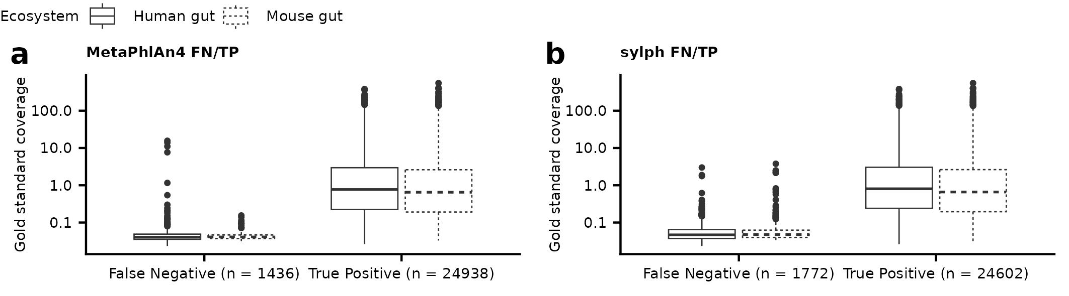

a, b, The results showed that 1436 and 1772 species in total, respectively, were not detected by these tools, despite being present in the metagenomic samples. These false negative species detections were characterized by a low relative abundance, with majority of them having a coverage below 1X.

Supplementary Figure 2: Meteor2 accurately profiles high- and low-coverage species abundances from synthetic metagenomes.
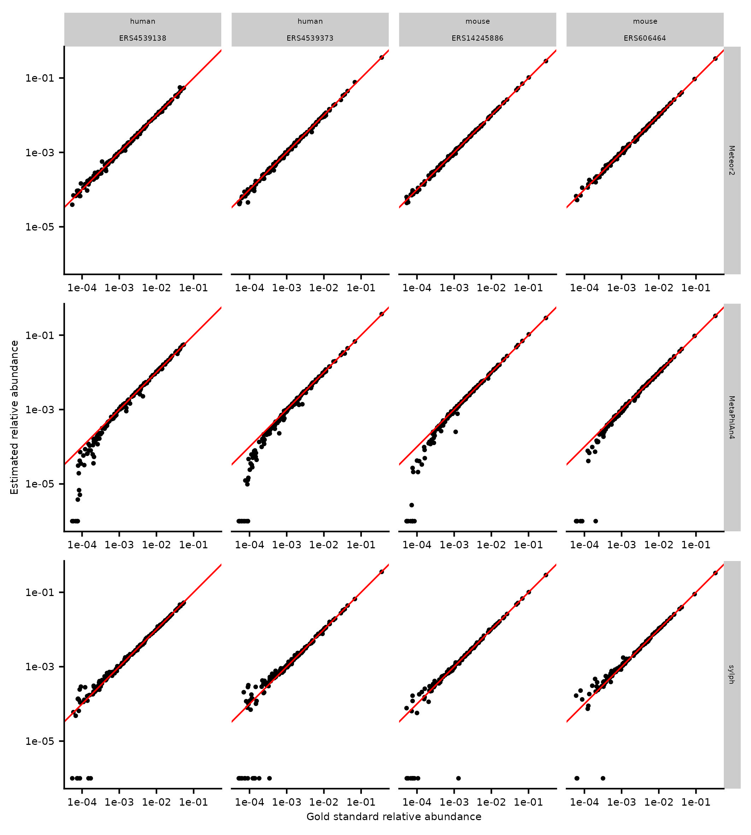
Taxonomic profiles of four synthetic metagenomic samples from human and mouse gut ecosystems, generated using MetaPhlAn4, Meteor2, and sylph. The estimated abundance is compared to the gold standard, with ideal performance indicated by a correlation along the line y=x (red line).

Supplementary Figure 3: Taxonomic profiling performance of Meteor2 in comparison to MetaPhlAn4 and sylph for low sequencing depths.
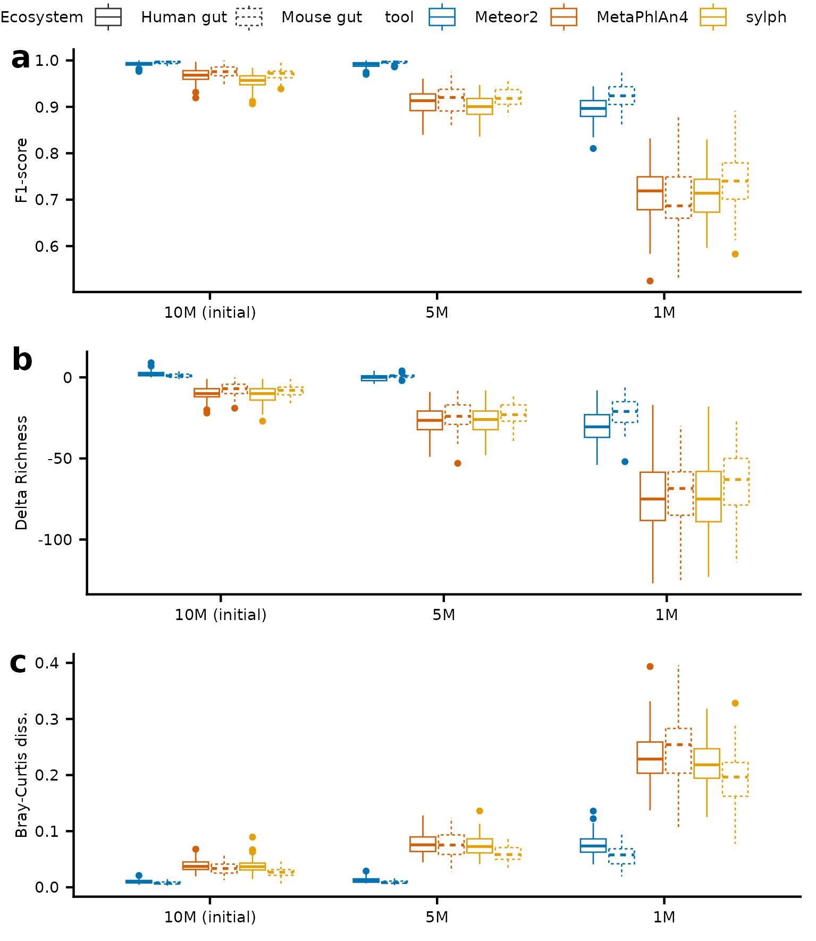

a, Taxonomic profiling performance according to F1-score of Meteor2, MetaPhlAn4, and sylph at low sequencing depths (5 or 1 million paired read depth) compared to original depth (10 million paired read depth) for synthetic dataset. b, Richness delta, corresponding to the difference between gold standard richness and tools’ estimated richness. c, Bray-Curtis dissimilarity values computed between the log10-transformed estimated profiles and the abundances in the gold standard.

Supplementary Figure 4: Functional profiling performance of Meteor2 in comparison to HUMAnN3
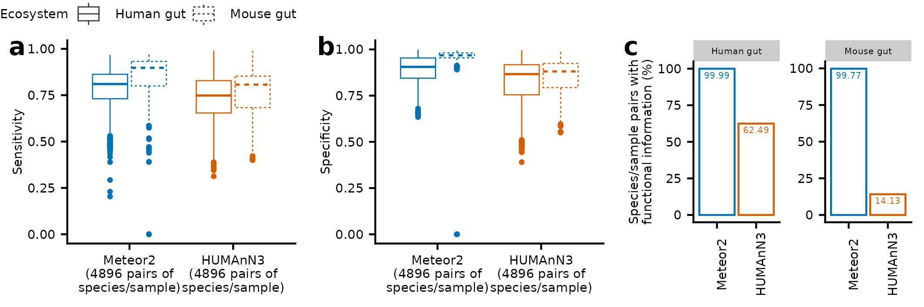

Evaluation of (a) sensitivity and (b) specificity for functional content detection for Meteor2 and HUMAnN3 for human and mouse synthetic metagenome. (c) Percentage of species/sample pairs for which functional information could be retrieved, among all species/sample pairs with gold standard coverage above 1X.

Supplementary Figure 5: Relationship between pairwise ANI and mutation rate distributions.
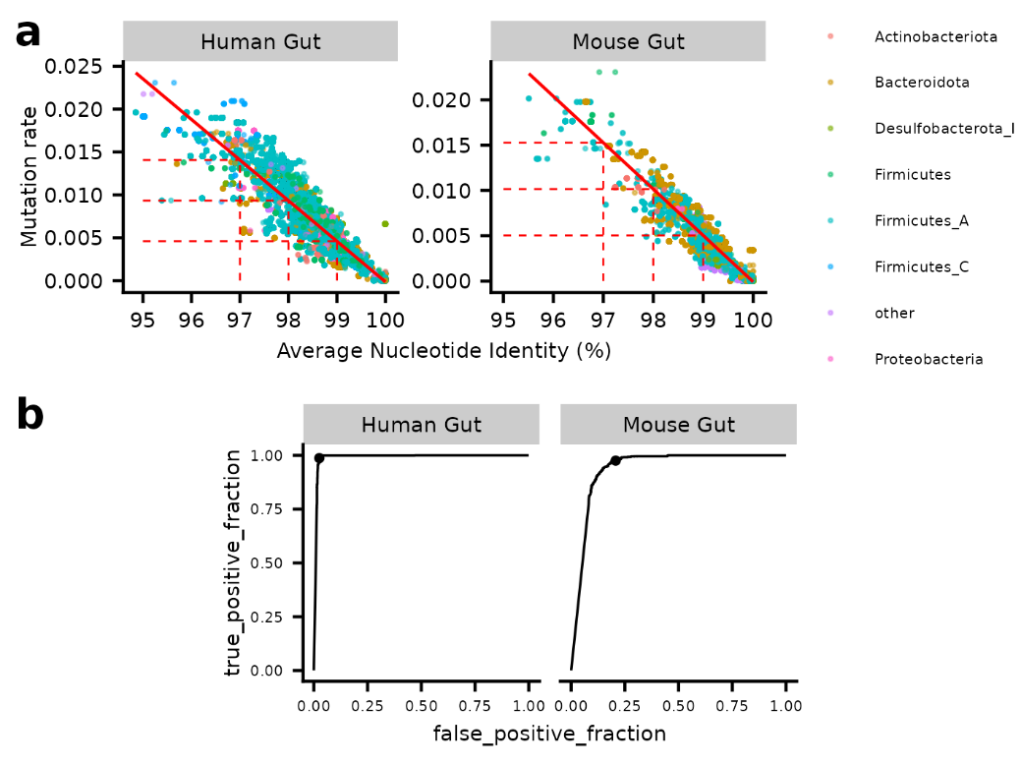

a, Relationship between the gold standard ANI and the mutation rates estimated by Meteor2 (considering all alleles - mixed configuration). The solid red line represents the linear regression between ANI and the mutation rate, while the dashed red segments indicate the estimated mutation rate corresponding to 97%, 98% and 99% ANI thresholds. The points are colored according to the phylum of the MSP, with phyla having fewer than 1,000 points categorized as “other”. b, The Receiver Operating Characteristic (ROC) curve evaluates the ability of Meteor2-estimated mutation rate to distinguish between identical genomes (ANI = 100%) and non-identical genomes (ANI < 100%), with the point on the curve indicating the chosen cut-off at 1e-04.

Supplementary Figure 6: Meteor2 provides insights into a real FMT dataset at diversity, taxonomic, functional and strain level.
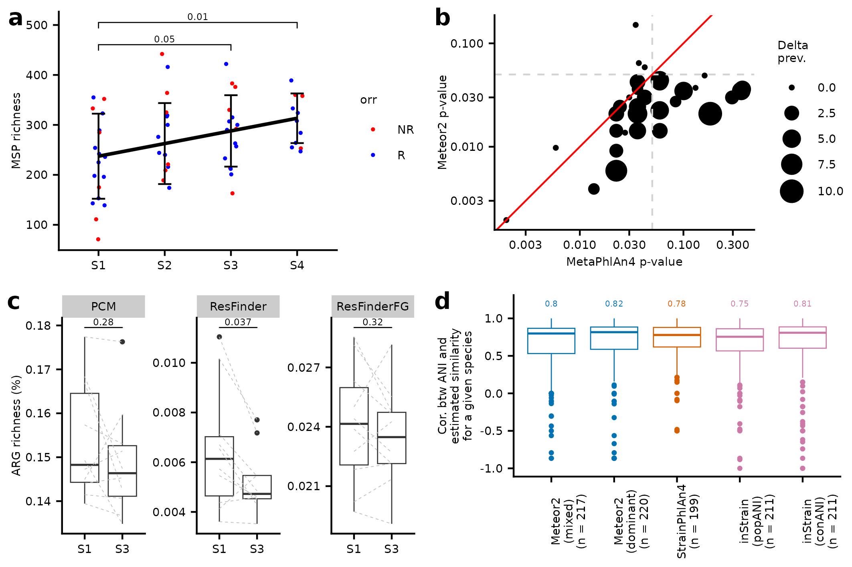
a, Alpha-diversity, estimated by MSP richness in gut microbiota of recipients across different timepoints. Wilcoxon tests p-values are displayed. b, P-values for species differentially abundant between S1 and S3 (in responders only), computed via Wilcoxon signed-rank tests using either MetaPhlAn4 or Meteor2. The correspondence between MSP (Meteor2) and SGB (MetaPhlan4) is based on GTDB r207. c, Distribution of ARG richness, expressed as a percentage of total gene richness, comparing S1 and S3 (responders only). Wilcoxon signed-rank tests p-values are displayed. ARG richness is determined by gene functional annotation using three complementary ARG databases integrated into Meteor2. d, Distribution of species-wise Spearman’s rho between ANI (estimated from MAGs built for each sample) and inferred similarity metrics (1 - mutation rate for Meteor2 and StrainPhlAn4, ANI for inStrain).

Supplementary Figure 7: Engraftment rate computed on real FMT dataset using ANI or mutation rate provided by different tools and different configurations.
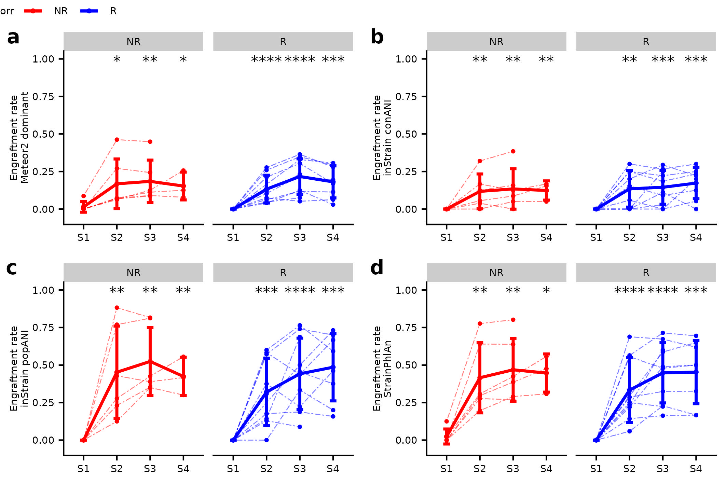
Engraftment rate in responder (R) and non-responders (NR) are shown at all timepoints, for a, Meteor2 dominant configuration, b, inStrain conANI, c, inStrain popANI, d, StrainPhlAn4. Each point represents an individual sample, with samples from the same individual connected by dashed lines. The solid line indicates the mean engraftment rate across all samples at each time point, and error bars represent the standard deviation. P-values from Wilcoxon tests (relative to S1) are displayed. * indicates 0.01 < p-value ≤ 0.05, **: 0.001 < p-value ≤ 0.01, ***: 0.0001 < p-value ≤ 0.001, ****: p-value ≤ 0.0001.

Supplementary Figure 8: TFSP integration: clinical, taxonomic, functional and strain information on Bacteroides stercoris (msp_0032).
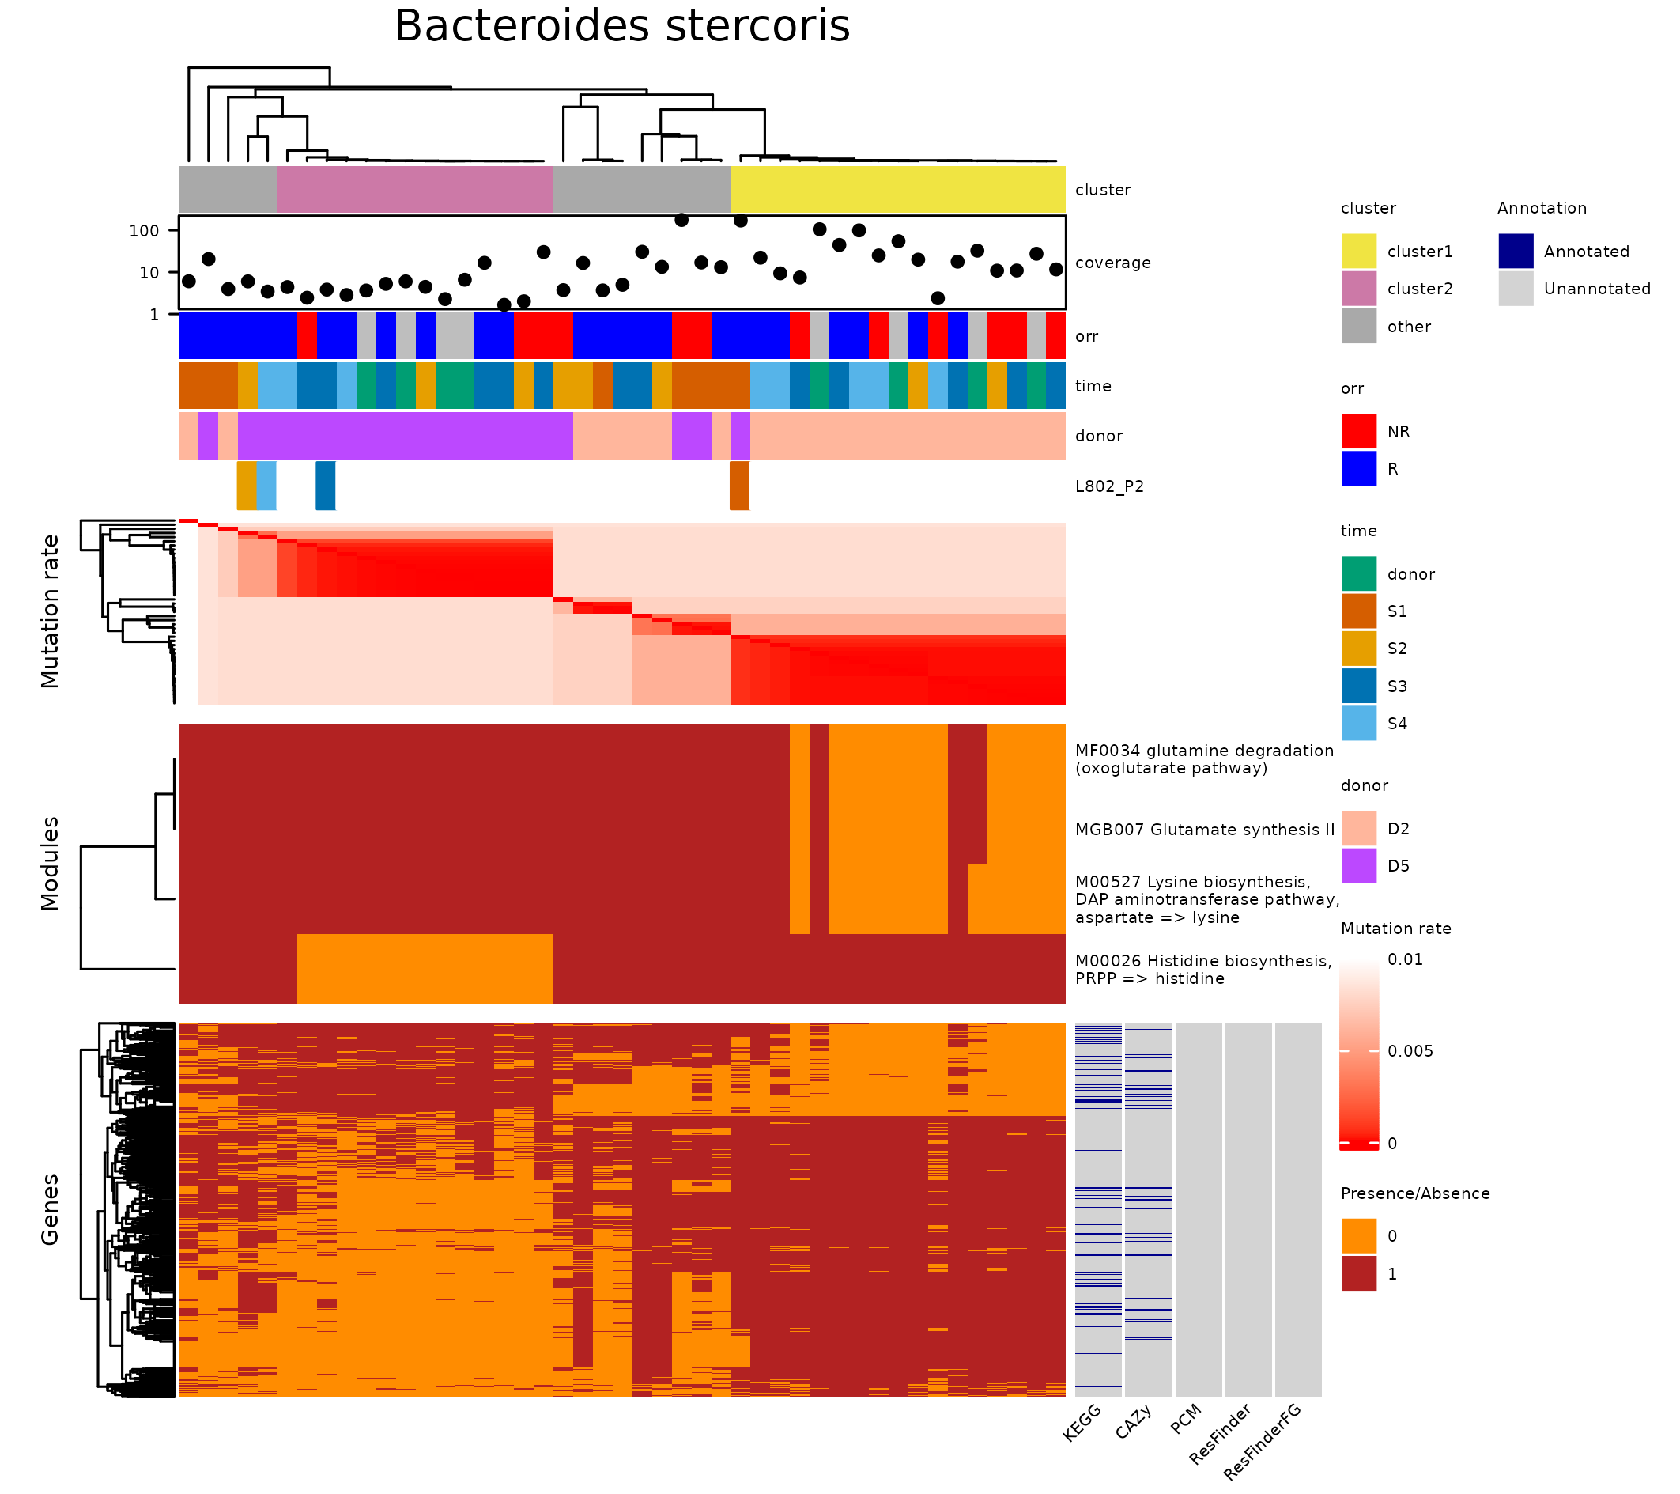
A total of 45 samples were available for strain analysis. Hierarchical clustering of the mutation rate matrix was performed using complete linkage, and clusters were defined by cutting the dendrogram at h = 0.005 (corresponding to 99% ANI). The two largest clusters (n = 17 and n = 14) are highlighted in yellow and pink, respectively, while the remaining samples are grouped under 'other' (grey). For each sample, MSP coverage is shown along with the objective response rate (ORR) status (responder or non-responder), timepoint, and donor information. Donor samples are marked with ORR = NA (grey) and labelled as ‘donor’ timepoints (green). Samples from individual L802_P2 are highlighted by their respective timepoints. Below the mutation rate matrix, presence/absence matrices of functional modules and accessory genes of the MSP are displayed, contrasting the yellow and pink clusters (Chi-squared test, p < 0.05). On the right, annotation of the contrasted genes is provided from all available databases.

Supplementary Information

Le French Gut Consortium Members
Mathieu Almeida¹, Anne-Sophie Alvarez¹, Monique Axelos², Mourad Benallaoua³, Robert Benamouzig³, Oana Bernard⁴, Sylvie Binda⁵, Hervé M. Blottière^{1,6}, Elise Borezée^{1,7}, Alexandre Cavezza¹, Pierre Cressard⁸, Chloe Connan¹, Anne-Marie Davila-Gay⁹, Christophe d’Enfert¹⁰, Joël Doré^{1,7}, Assia Dreux-Zigha¹¹, Erik Eckhardt¹², S Dusko Ehrlich¹, Etienne Formstecher¹³, Sebastien Fromentin¹, Amine Ghozlane¹⁴, Florence Haimet^{1,15}, Maina Houssaye¹⁶, Milan Lazarevic¹⁷, Sophie Legrain¹⁸, Françoise Levacon¹⁹, Christian Morabito¹, Pedro H. Oliveira²⁰, Raish Oozeer²¹, Florian Plaza-Onate¹, Nicolas Pons¹, Benoît Quinquis¹, Karine Roget²², Florence Thirion¹, Karine Valeille¹, Patrick Veiga^{1,7}

¹ Université Paris-Saclay, INRAE, MetaGenoPolis (MGP), 78350 Jouy-en-Josas, France
² INRAE, Paris, France.
³ Department of Gastroenterology, Avicenne Hospital, Assistance Publique-Hôpitaux de Paris, Université de Paris, Bobigny, France.
⁴ Biocodex, Compiegne, France.
⁵ Lallemand Health Solutions, Toulouse, France.
⁶ Nantes Université, INRAE, UMR 1280, PhAN, F-44000 Nantes, France
⁷ Université Paris-Saclay, INRAE, AgroParisTech, Micalis Institute, 78350 Jouy-en-Josas, France
⁸ Nahibu, Rennes, France.
⁹ Université Paris-Saclay, AgroParisTech, INRAE, UMR PNCA, 91120, Palaiseau, France.
¹⁰Institut Pasteur, Direction Générale Adjointe Scientifique, F-75015 Paris, France.
¹¹Greentech, Saint-Beauzire, France.
¹²Adare Biome, Houdan, France.
¹³GMT Science, Rouen, France.
¹⁴Institut Pasteur, Université Paris Cité, Bioinformatics and Biostatistics Hub, F-75015 Paris, France.
¹⁵ Mica division, 78350 Jouy-en-Josas, France
¹⁶INSERM, Paris, France.
¹⁷APHP, Paris, France.
¹⁸Gnosis by Lesaffre, Marcq-en-Baroeul, France
¹⁹Biofortis, Saint-Herblain, France.
²⁰Génomique Métabolique, Genoscope, Institut François Jacob, CEA, CNRS, Université Evry, Université Paris-Saclay, Evry, France.
²¹Danone Nutricia Research, Gif-sur-Yvette, France.
²²Nextbiome Therapeutics, Clermont-Ferrand, France.

