Supplementary Information
Nanobodies as Novel Tools to Modulate Human Frataxin Stability and Function
María Florencia Pignataro^{1,2,3}*, Natalia Brenda Fernández^{1,2,3,#}, Alba Garay-Alvarez^{4,#} María Florencia Paván⁵, Rafael Molina⁴, Ines G. Muñoz⁶, Julián Grossi^{1,2}, Martín Noguera⁷, Antonella Vila^{1,2}, Augusto García^{1,2}, Hernán Gentili^{1,2,3}, Naira Antonia Rodríguez^{1,2}, Martín Aran⁸, Viviana Parreño^{9,10}, Marina Bok^{9,10}, Juan A. Hermoso^{4,}*, Lorena Itatí Ibañez^{5,}*, Javier Santos^{1,2,3,11}*

¹Instituto de Biociencias, Biotecnología y Biología Traslacional (iB3), Universidad de Buenos Aires, Buenos Aires, Argentina.
²Departamento de Fisiología, Biología Molecular y Celular (DFBMC), Facultad de Ciencias Exactas y Naturales (FCEN), Universidad de Buenos Aires (UBA), Buenos Aires, Argentina.
³Consejo Nacional de Investigaciones Científicas y Técnicas (CONICET). Godoy Cruz 2290 (C1425FQB) CABA – República Argentina.
⁴Department of Crystallography and Structural Biology, Instituto de Química-Física "Blas Cabrera", Consejo Superior de Investigaciones Científicas. Madrid. Spain.
⁵Instituto de Química Física de los Materiales, Medio Ambiente y Energía (INQUIMAE), CONICET, FCEN, UBA, Intendente Güiraldes 2160, Ciudad Universitaria, C1428EGA, Buenos Aires, Argentina.
⁶Protein Crystallography Unit. Structural Biology Programme. Spanish National Cancer Research Centre (CNIO). Melchor Fernández Almagro 3, 28009 Madrid, Spain.
⁷Instituto de Química y Físico-Química Biológicas, Universidad de Buenos Aires. CONICET. Junín 956, 1113AAD, Buenos Aires, Argentina.

⁸Fundación Instituto Leloir, IIBBA‐CONICET. Buenos Aires. Argentina.
⁹Incuinta, Instituto Nacional de Tecnología Agropecuaria (INTA), Hurlingham, Buenos Aires ZC 1686, Argentina.
¹⁰Instituto de Virología e Innovaciones Tecnológicas, Consejo Nacional de Investigaciones Científicas y Técnicas (IVIT-CONICET), Hurlingham, Buenos Aires ZC 1686, Argentina.
¹¹Departamento de Química Biológica, Facultad de Ciencias Exactas y Naturales, Universidad de Buenos Aires. Intendente Güiraldes 2160, Ciudad Universitaria, C1428EGA, Buenos Aires, Argentina.

# These Authors similarly contributed to this work.

*Corresponding Authors: María Florencia Pignataro at mariaflorenciapignataro@gmail.com, Lorena Itatí Ibañez at loreitati@gmail.com, Juan A. Hermoso at xjuan@iqfr.csic.es and Javier Santos at javiersantosw@gmail.com

Running Title: Modulation of Frataxin Function by Nanobody Interaction

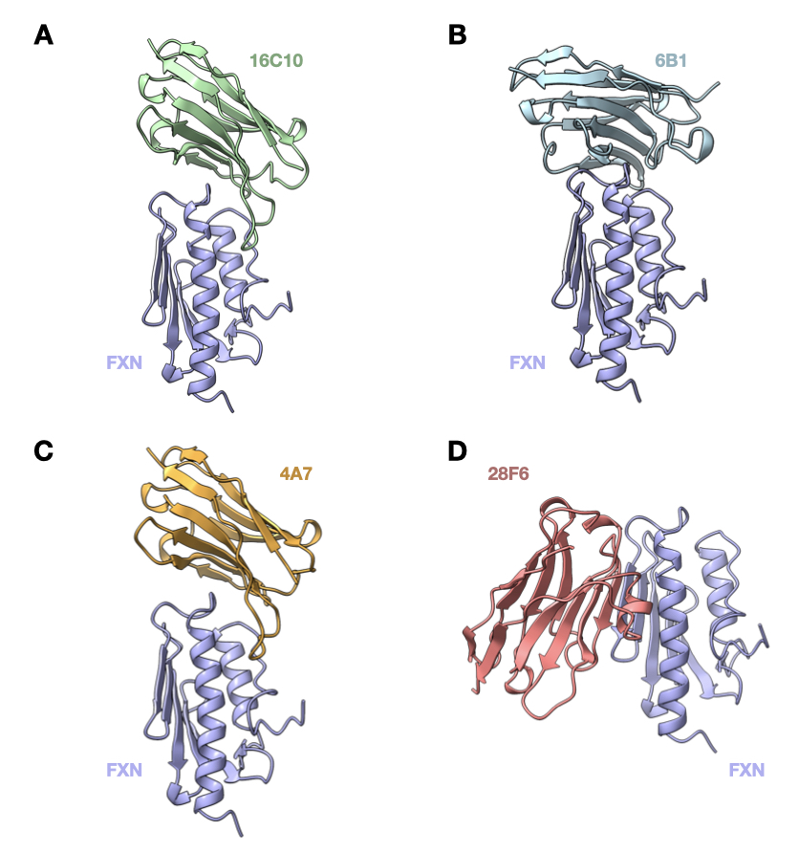
Figure S1. AlphaFold3 Predictions. Complexes between frataxin (colored by secondary structure) and nanobodies NB_4A7 (orange), NB_6B1 (cyan), NB_16C10 (green) and NB_28F6 (magenta). Structure predictions using AlphaFold3.

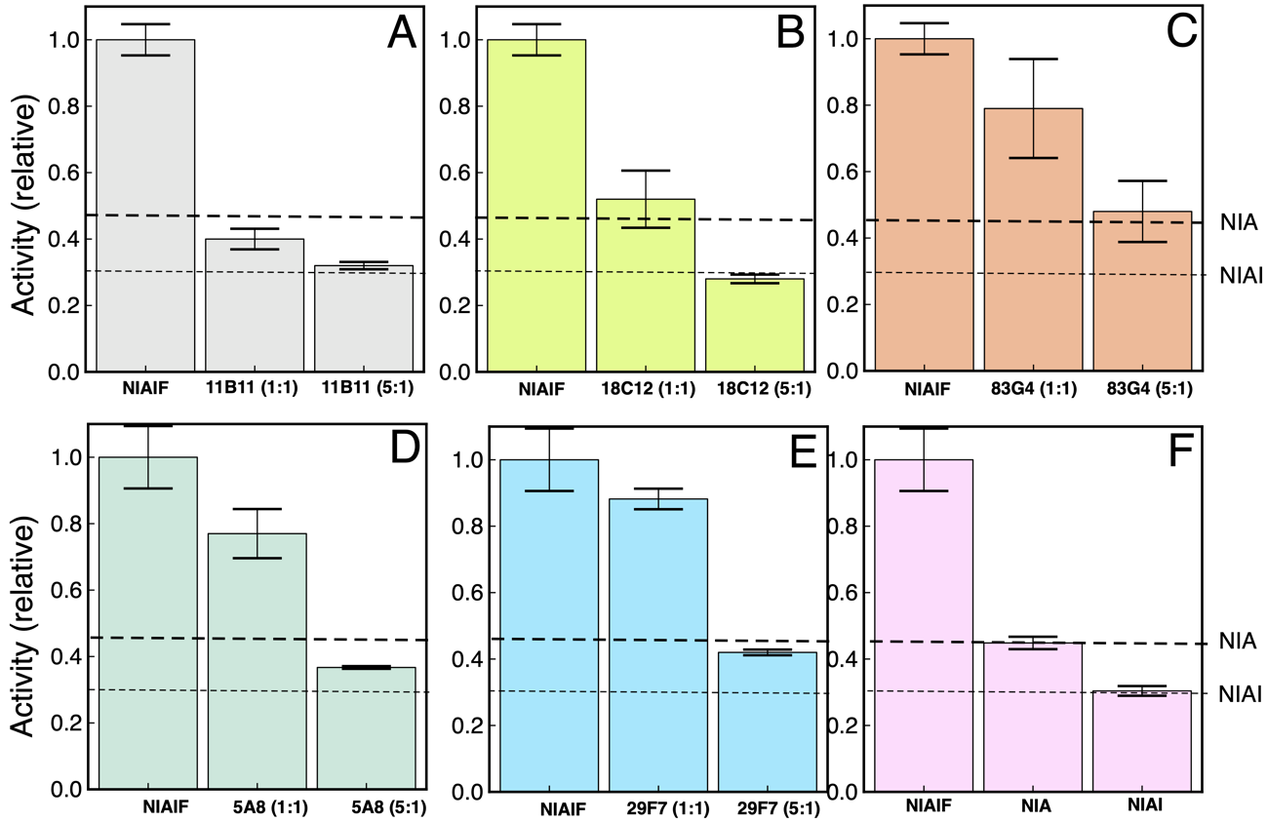

Figure S2. Cys Desulfurase Activity Inhibition by Nanobody:Frataxin Interaction. The effect of the addition of nanobodies on the Cys-desulfurase supercomplex activity NIA refers to the activity of a sample without ISCU, FXN and NB (thick dashed line) and corresponds to the activity of the core (NFS/ACP-ISD11)₂, whereas NIAI corresponds to the activity of core plus ISCU, but without frataxin (thin dashed line, and panel F).

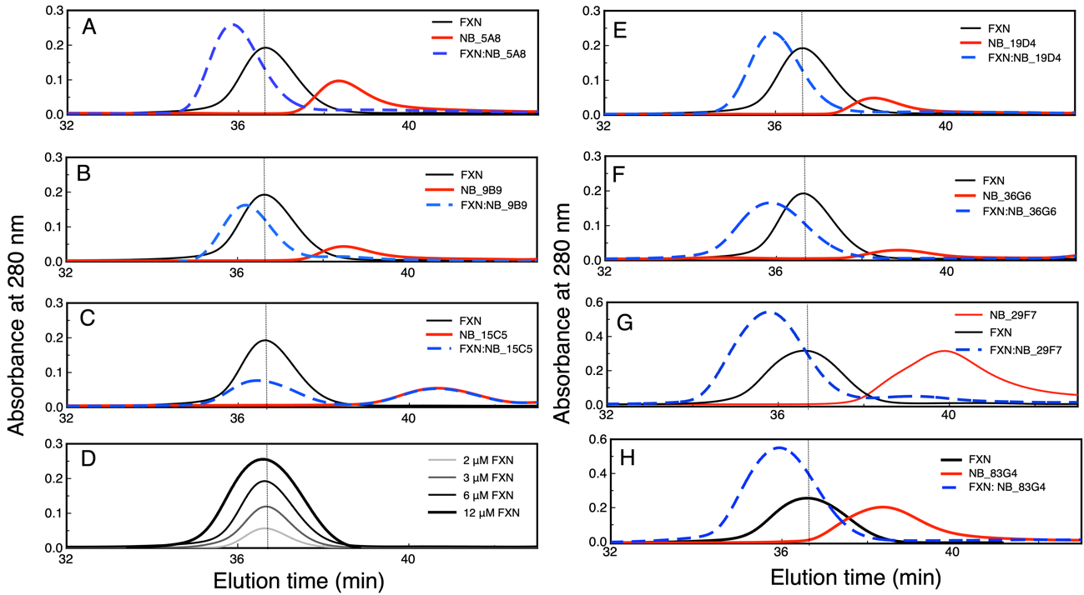

Figure S3. NB:FXN Interaction followed by size exclusion chromatography (SEC). SEC profiles for (A) NB_5A8, (B) NB_9B9, (C) NB_15C5, (D) FXN alone, (E) NB_19D4, (F) NB_36G6, (G) NB_29F7, (H) NB_83G4. The SEC profiles correspond to the isolated FXN (black and gray, having four different concentrations at 2, 3, 6, and 12 μM) or NBs (red color lines). Dashed blue lines show the profiles corresponding to a 1:1 NB:FXN mixture. The lower elution volume for the mixture indicates the formation of a stable complex. In panels G and H, samples contained 12 μM FXN, 12 μM NB or 12μM of each protein to form the complexes. The vertical dotted gray line indicates the elution time of FXN.

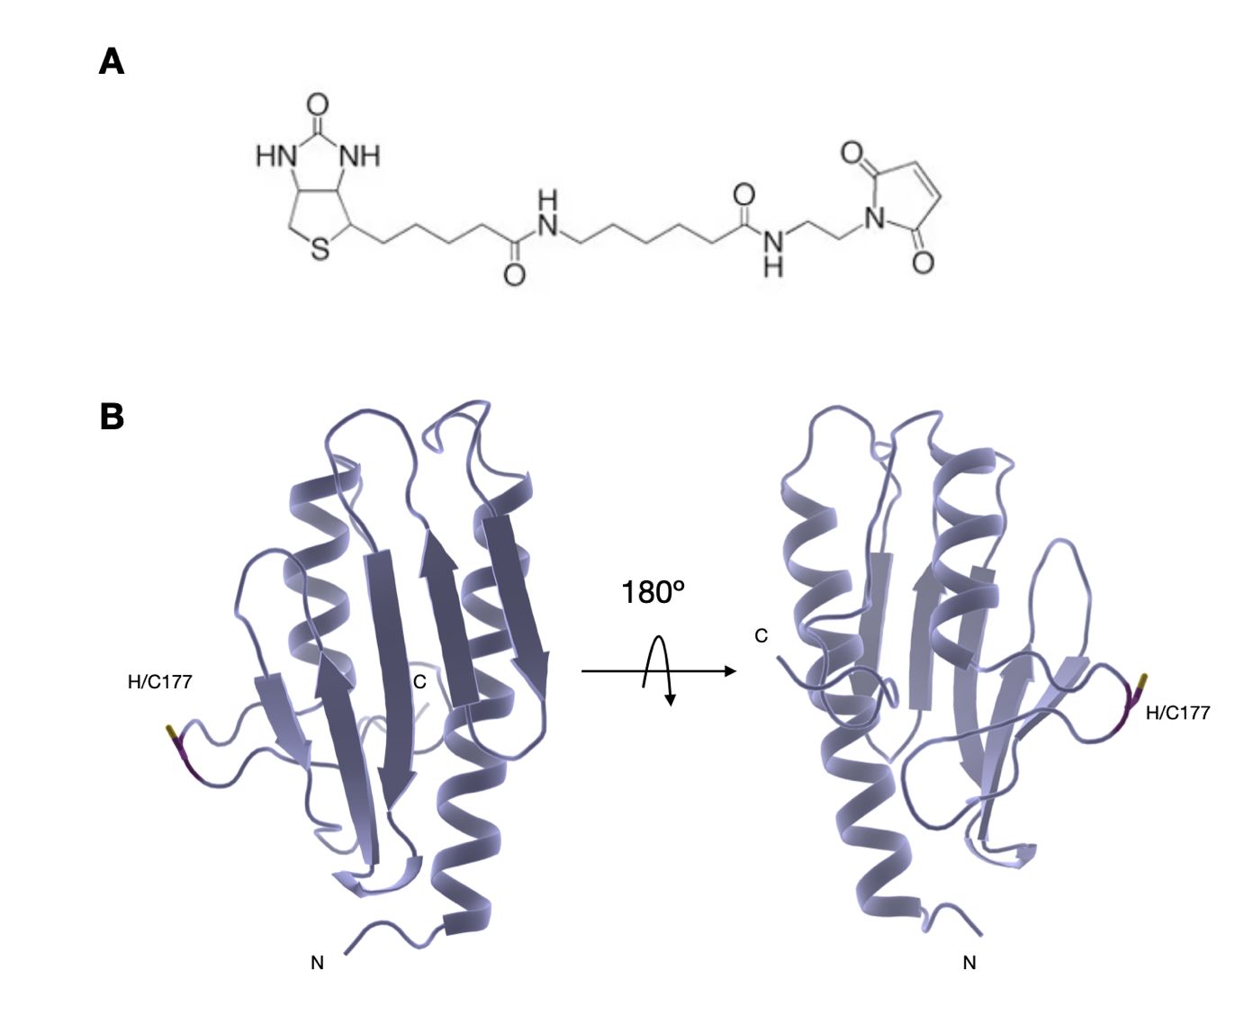

Figure S4. (A) Bifunctional long arm biotin maleimide (B) Two views of the human FXN ribbon model in which the His177 was replaced by Cys.

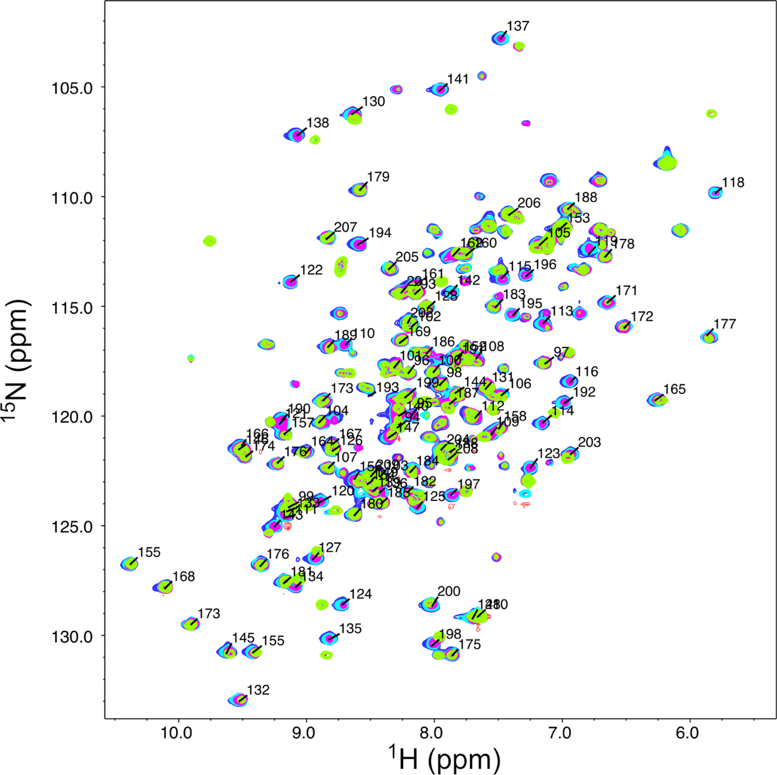

Figure S5. NB Interaction Sites on FXN surface Studied by NMR. FXN was titrated with NB_4A7 at molar ratios of 0:1, 0.33:1, 0.66:1 and 1:1 (NB:¹⁵N-FXN), shown in blue, cyan, magenta and light green, respectively. The experiment was performed in a 25mM Tris-HC, 150 mM NaCl, pH 7.4 buffer. ¹H-¹⁵N HSQC experiments were performed. (A): NB_4A7, (B): NB6B1, and (C): NB_16C10.

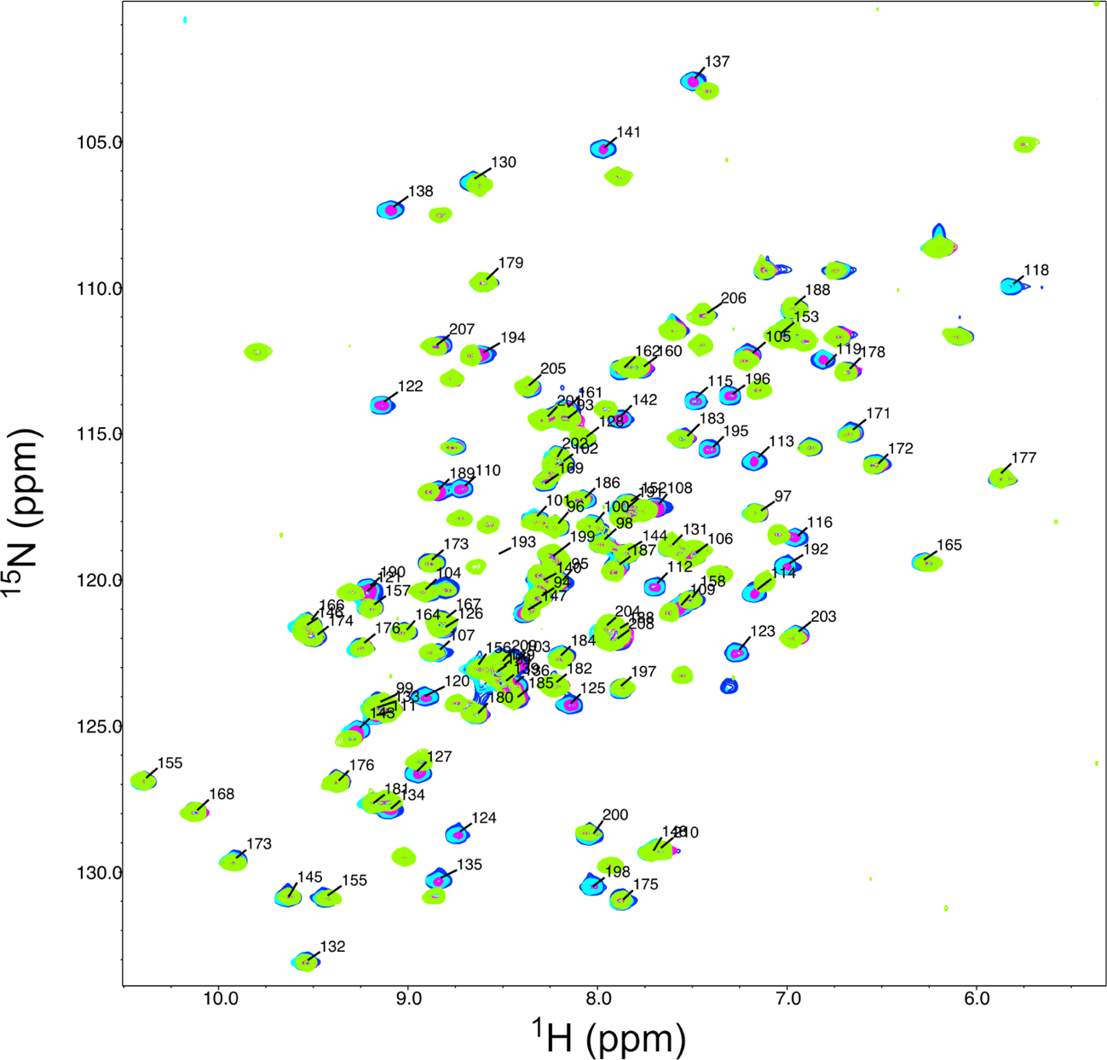

Figure S6. NB Interaction Sites on FXN surface Studied by NMR. FXN was titrated with NB6B1 at molar ratios of 0:1, 0.33:1, 0.66:1 and 1:1 (NB:¹⁵N-FXN), shown in blue, cyan, magenta and light green, respectively. The experiment was performed in a 25mM Tris-HC, 150 mM NaCl, pH 7.4 buffer. ¹H-¹⁵N HSQC experiments were carried out.
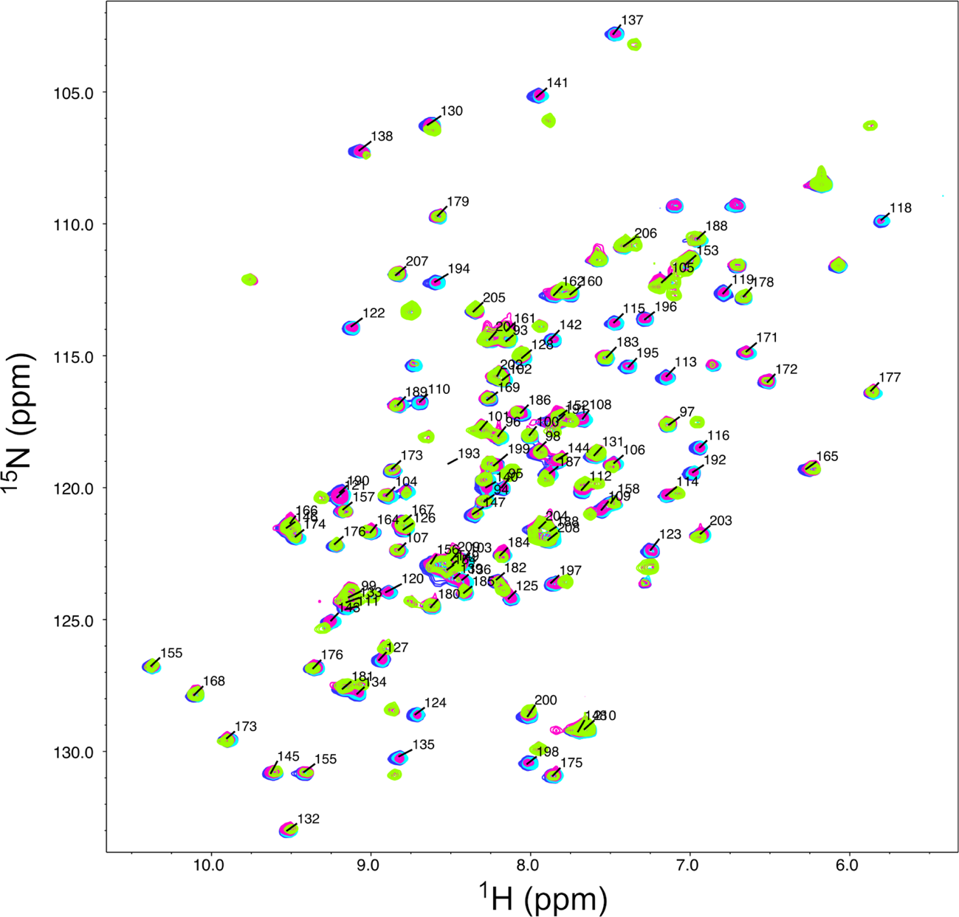
Figure S7. NB Interaction Sites on FXN surface Studied by NMR. FXN was titrated with NB_16C10 at molar ratios of 0:1, 0.33:1, 0.66:1 and 1:1 (NB:¹⁵N-FXN), shown in blue, cyan, magenta and light green, respectively. The experiment was performed in a 25 mM Tris-HC, 150 mM NaCl, pH 7.4 buffer. ¹H-¹⁵N HSQC experiments were carried out.

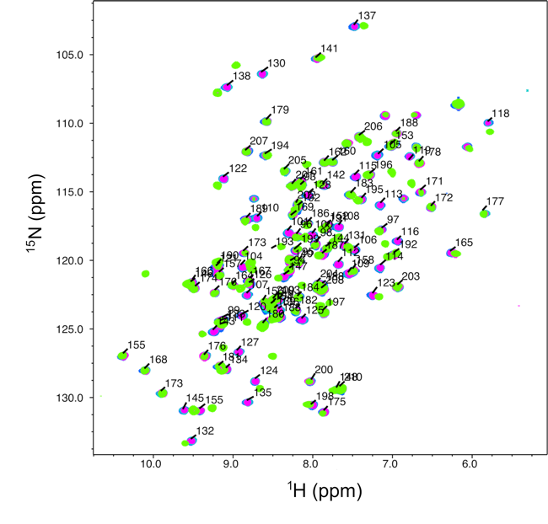

Figure S8. NB Interaction Sites on FXN surface Studied by NMR. FXN was titrated with NB_28F6 at molar ratios of 0:1, 0.25:1, 0.5:1, and 0.9:1 (NB:¹⁵N-FXN), shown in blue, cyan, magenta and light green, respectively. The experiment was performed in a 25 mM Tris-HC, 150 mM NaCl, pH 7.4 buffer. ¹H-¹⁵N HSQC experiments were carried out.

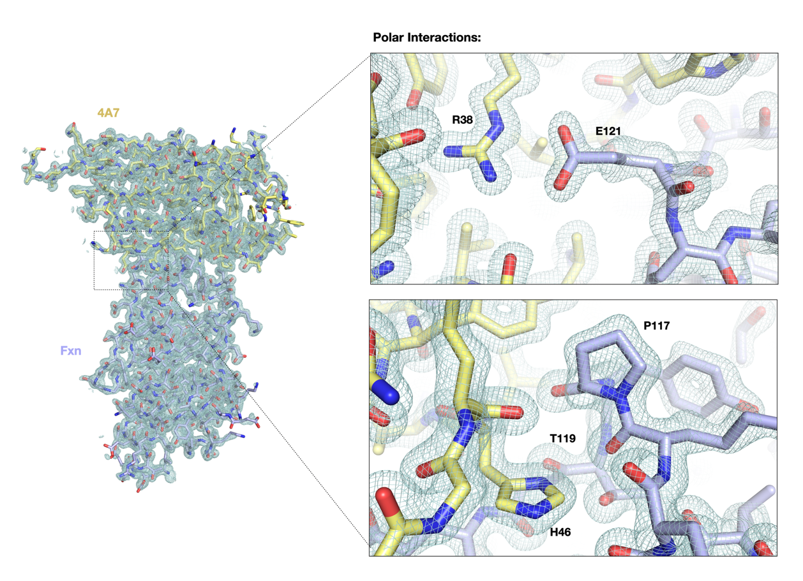
Figure S9. 2Fo-Fc electron density map contoured at 1σ for the FXN:NB_4A7 complex. The right panels show detailed views of the regions involved in the FXN-NB interaction. Nanobody sequence numbering is as in Figure 2A (main text).

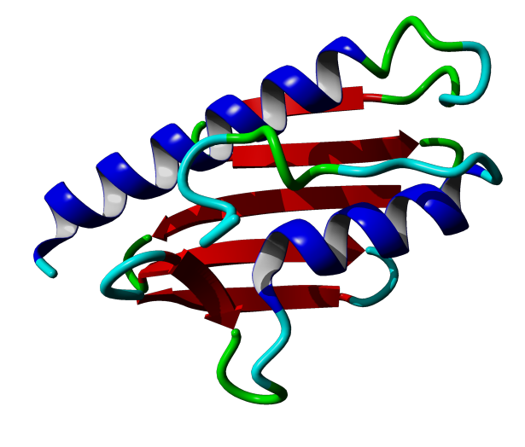

Figure S10. RMSD of residues of FXN in complex with NB and FXN alone. The RMSD was calculated using the X-ray structures of the FXN in the context of the complex and the X-ray structure of FXN alone (PDB ID: 1EKG). The standard deviation of RMSD for all alpha carbon was calculated (0.23Å), and the cutoff value considering two standard deviations is shown (dashed line), whereas a light blue background shows values below this cutoff. Some residues involved in inter-subunit contacts (NB:FXN) showed high RMSD values and are in Loop1 (α1-β1), and Loop2 (-β2-β3). Other crystallographic contacts of FXN and NB (the interaction of this second NB subunit is not detected in solution by NMR) comprise loop β6-α2.

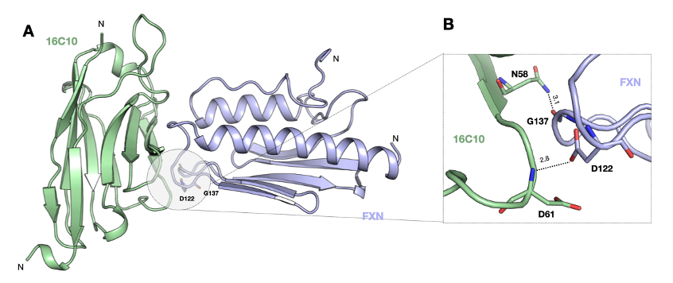

Figure S11. FRDA mutations mapped on the structure of the NB_16C10:FXN complex. A) The interaction between FXN and NB_16C10 is shown. B) Zoom of the residues Asp122 and Gly137, mutations that result in FRDA.

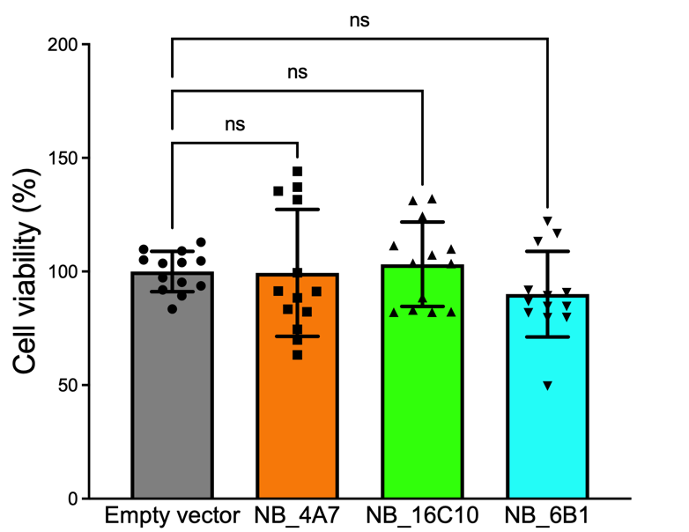

Figure S12. Cell Viability Levels Determined by Crystal Violet Assay. Three independent experiments were done, and the numbers correspond to the average and the standard deviation relative to non-transfected cells (No transf). Non-significant differences between treatments (One-Way ANOVA) were found between empty vector, NB_4A7, NB_6B1, or NB_16C10. Three independent experiments were done, and the numbers correspond to the average and the standard deviation relative to non-transfected cells (No transf).

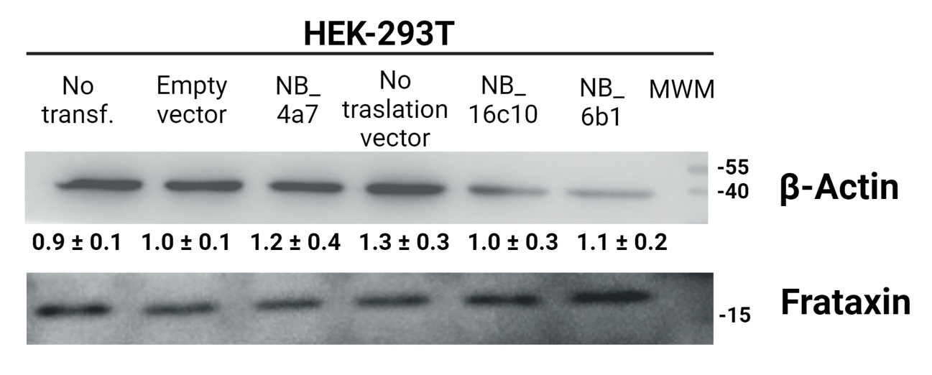
A
B

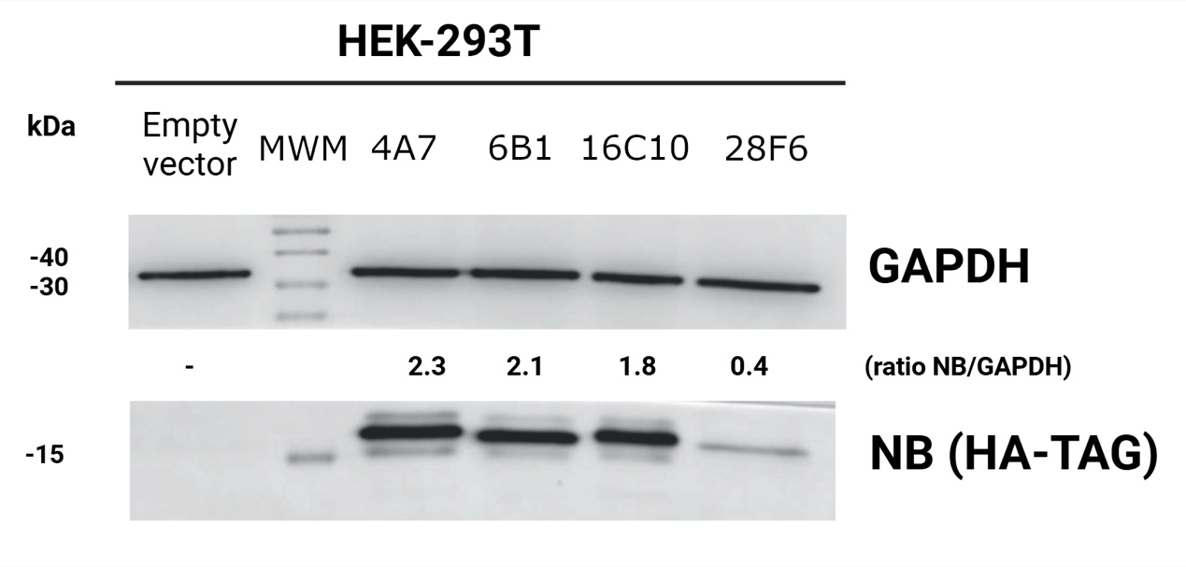

Figure S13. (A) Expression of FXN in HEK-293T Cells Producing NB_4A7, NB_6B1, or NB_16C10. The empty vector is the same vector without NB DNA insert, whereas no translation vector is a control in which the Kozak sequence is incomplete. MWM, the molecular weight markers. Three independent experiments were done, and the numbers correspond to the average and the standard deviation relative to non-transfected cells (No transf.). (B) Evaluation of the expression of NB_4A7, NB_6B1, or NB_16C10 in transfected HEK-293T. The enzyme GAPDH was detected as a loading control. NBs were detected using an anti-His tag monoclonal antibody. Recombinant NBs were also loaded as a control (pure nanobodies). (C) Expression of NB_28F6.

Table S1. X-ray crystallographic data collection and refinement statistics of FXN-Nanobodies complexes.

 | FXN:16C10 | FXN:6B1 | FXN:4A7
Data collection
Space group | P2₁2₁2₁ | P6₃ 2 2 | P2₁2₁2₁
Cell dimensions
a, b, c (Å) | 57.90, 81.10, 107.55 | 97.253 97.253 128.105 | 38.523, 48.151, 111.425
α, β, γ (°) | 90.00, 90.00, 90.00 | 90.00, 90.00, 120.00 | 90.00, 90.00, 90.00
Wavelength | 0.97926 | 0.97926 | 0.97926
Resolution (Å) | 64.75-1.99 (2.18-1.99) * | 84.22-1.48 (1.58-1.48) * | 55.71-1.25 (1.33-1.25) *
CC(1/2) | 0.99 (0.39) | 0.99 (0.57) | 0.99 (0.60)
Mean I / σ(I) | 14.2 (1.4) | 33.5 (1.5) | 23.6 (1.3)
Completeness (%) | 91.7 (53.2) | 96.8 (74.5) | 89.3 (43.0)
Redundancy | 11.5 (5.4) | 38.4 (41.1) | 10.7 (3.8)
Refinement
Resolution (Å) | 64.75-2.00 | 50.98-1.48 | 55.71-1.50
No. Reflections | 25977 | 50812 | 34017
R_{work} / R_{free} | 0.17/0.22 | 0.21/0.22 | 0.18/0.20
Molecules per a.u. | 2 | 1 | 1
No. Atoms
Protein | 1888 | 1935 | 1852
Ligands | 0 | 0 | 0
Water | 902 | 161 | 196
Ramachandran
Favored/Allowed (%) | 96.67/2.71 | 97.56/2.03 | 98.71/0.86
Disallowed (%) | 0.62 | 0.41 | 0.43
R.m.s. deviations
Bond lengths (Å) | 0.007 | 0.006 | 0.006
Bond angles (°) | 0.996 | 0.799 | 0.845
PDB code | 9HO6 | 9HO4 | 9HO5
*Values in parentheses are for highest-resolution shell. One crystal was used to solve the structure.

Table S2. Characterization of NBs.
NB | Predicted mass ¹ (Da) | Experimental mass¹  (Da) | Amino acids | pI | ε_{280nm}²  (M⁻¹ cm⁻¹) | Theoretical Formula³
4A7 | 15259.37 | 15259.40 | 139 | 7.22 | 30035.0 | C₆₆₉H₁₀₁₂N₁₉₈O₂₀₇S₄
6B1 | 15490.36 | 15488.42 | 142 | 7.17 | 29005.0 | C₆₈₂H₁₀₁₇N₁₉₅O₂₁₄S₄
16C10 | 15127.32 | 15125.35 | 139 | 7.21 | 24535.0 | C₆₆₃H₁₀₀₈N₁₉₄O₂₀₇S₄
28F6 | 15289.23 | 15288.68  13747.72⁴  15305.31⁵ | 142 | 7.18 | 30035.0 | C₆₆₄H₁₀₀₂N₁₉₆O₂₁₃S₅

(1) The monoisotopic masses calculated using Free Style program (Thermo Fisher) using the sequence of the mature nanobodies (after the processing by signal peptidase).
(2) Assuming all pairs of Cys residues form S-S bonds.
(3) All NBs contain two Cys that form a structural S-S bond.
(4) When 1.0 mM EDTA was not added to NB_28F6 after purification, the protein was presumably digested (SDS-PAGE showed 2 bands and after a 7-d incubation at 4 °C).
(5) Oxidized forms of NB_28F6 were also found (mass+16Da, or even mass+32Da).

Table S3. NB Analysis of NB Interaction¹.
NB | K_{D} (M) | k_{a} (M⁻¹ S⁻¹) | k_{d} (S⁻¹) | χ²
NB_4A7 | 33×10⁻⁹ | 1.062×10⁵±1.77×10³ | 3.532×10⁻³±2.4×10⁻⁵ | 0.78
NB_6B1 | 6.0×10⁻⁹ | 1.010×10⁵±7.4×10² | 6.078×10⁻⁴±4.8×10⁻⁶ | 1.48
NB_16C10 | 3.4×10⁻⁹ | 1.293×10⁵±7.6×10² | 4.389×10⁻⁴±9.6×10⁻⁶ | 2.69
NB_28F6 | 1.0×10⁻⁹ | 1.692×10⁵±1.7×10² | 1.688×10⁻⁴±4.9×10⁻⁶ | 0.93

¹These results were obtained from BLI experiments after a global fitting of a one-site binding model to the BLI data.

Table S4. FXN Residues Involved in NB Interaction.

Nanobody | FXN Residues
NB_4A7 | Phe110, Leu113, Ala114, Asp115, Lys116, Tyr118, Thr119, Phe120, Asp122, Tyr123, Asp124, Val125, Phe127, Lys135, Gly138, Gly141, Tyr143, Leu190, Lys192, Leu194, Lys195, Thr196, Lys197, Leu198.
NB_6B1 | Ser105, Phe109, Phe110, Asp112, Leu113, Ala114, Asp115, Lys116, Tyr118, Thr119, Phe120, Glu121, Asp122, Tyr123, Asp124, Val125, Phe127, Lys135, Gly137, Gly138, Gly141, Tyr143, Lys192, Leu194, Lys195, Thr196.
NB_16C10 | Phe110, Leu113, Ala114, Asp115, Lys116, Phe120, Asp122, Tyr123, Asp124, Phe127, Lys135, Gly137, Gly138, Gly141, Thr142, Tyr143, Lys192, Leu194, Lys195, Thr196, Lys197, Leu198.
NB_28F6¹ | Glu100, Glu101, Asp104, Ser105, Leu106, Ala107, Glu108, Phe110, Asp112, Leu113, Ala114, Asp115, Lys116, Tyr118, Thr119, Phe120, Asp122, Tyr123, Asp124, Val125, Phe127, Gly128, Gly130, Val131, Leu132, Lys135, Leu136, Gly137, Gly138, Thr142, Tyr143, Ile145, Lys147, Trp155,

¹Residues with lower CSP (or CSP compatible with fast equilibrium) for NB_28F6 are Arg97, Arg165, Lys195, and Leu198.
²Residues in bold are apolar residues from the core of FXN that exhibited significant CSP.

Table S5. FXN Residues involved in the interaction with NB.
NB | FXN residues | Structure element | Molecular Surface area¹  (Å²)
4A7 | Pro117  Thr119  Glu121  Asp122  Lys135  Gly138  Asp139  Ala193 | α1-β1 Loop  α1-β1 Loop  α1-β1 Loop  α1-β1 Loop  β2- strand  β2-β3 β-loop  β2-β3 β-loop  α2 | 581.7
6B1 | Pro 117  Thr119  Glu121  Gly 138  Ala193 | α1-β1 Loop  α1-β1 Loop  α1-β1 Loop  β2-β3 β-loop  α2 | 592.2
16C10 | Ala114  Lys116  Pro117  Thr119  Glu121  Asp122  Lys135  Gly138  Asp139  Ala193 | α1-β1 Loop  α1-β1 Loop  α1-β1 Loop  α1-β1 Loop  α1-β1 Loop  α1-β1 Loop  β2- strand  β2-β3 β-loop  β2-β3 β-loop  α2 | 579.3

¹Intermolecular molecular surface between NB and FXN.
²Residues that showed high RMSD values (Figure S10) when comparing FXN in the context of the NB:FXN complex and FXN alone (PDB ID: 1EKG) are highlighted in bold.

Table S6. SAXS sample details, data collection, analysis, and 3D modeling details for biomolecules in solution.
Scattering particle composition
Protein | FXN:16C10 | FXN:28F6
Sample environment/configuration
Solvent composition | 20 mM Tris pH 7.0, 150 mM NaCl
Sample temperature | 4ºC
In beam sample cell | 18ºC
Size Exclusion Chromatography SEC-SAS
Sample injection concentration, (mg/ml) | 7 | 4
Sample injection volume, mL | 45
SEC column type | SRT-C SEC-300 (Sepax)
SEC flowrate, mL/min | 0,16
Data acquisition/reduction software | GDA/Scåtter
Source/instrument description or reference | B21, Diamond Light Source (Harwell Campus, UK)
Measured q-range (q_{min} – q_{max}; Å⁻¹) | 0.0031-0.37
Exposure time (s) and final number of sample frames | 3, 600
Relevant details
Methods/Software | PRIMUS, AUTORG, GNOM
Guinier Analysis
I (0) ± σ (cm⁻¹) | 0,03377 | 0.03332
R_{g} ± σ (Å) | 23,88±0,05 | 22,39±0,06
Data point range | 67-368 | 114-407
PDDF/P(r) analysis
I (0) ± σ (cm⁻¹) | 0,03377 | 0.03332
R_{g} ± σ (Å) | 24,13±0,03 | 22,65±0,03
d_{max} (Å) | 80 | 74
Data point range | 58-2,100 | 44-2,100
q-range (Å⁻¹) | 0,011-0,2783 | 0.0101-0.2783
Methods/Software
Volume estimates
Porod volume, V_{p} (Å³) | 36600 | 36100
Molecular weight (M) estimates (kDa)
From chemical composition | 28,72 | 28,88
From SAS, concentration independent method (MoW) | 29,25 | 25.52
Shape modelling method
Software | DAMMIN, DAMMIF, FoXS
q-range for fit (q_{min} – q_{max}; Å⁻¹) | 0,0044-0,3398 | 0,0044-0,3398
Symmetry/anisotropy assumptions | P1
Number of individual model reconstructions | 20
χ ², CorMap P-values for fit | 0.78, 1.05 | 0.64, 1.05
Atomistic modelling methods
Software | FoXS
q-range for fit (q_{min} – q_{max}; Å⁻¹) | 0,0044-0,3398 | 0,0044-0,3398
Symmetry/anisotropy assumptions | N/A
Number of individual model reconstructions | 1 (Based on PDBs: 9HO6, 1EKG) | 1 (Based on AlphaFold3 model)
χ ², CorMap P-values for fit | 3.41, 1,02 | 2.22, 1.02
Data and model deposition
SASBDB IDs | SASDWT6 | SASDWS6

Table S7. Mass Spectrometry Analysis of the Co-immunoprecipitation of NB_16C10¹.

Samples | Accession | Description | Coverage [%] | # Unique Peptides | Peptide sequences | Chemical modification | Score
1 | F8VU34 | Citrate synthase OS=Homo sapiens | 13 | 2 | MALLTAAAR | Oxidation | 4.67
 |  |  |  |  | NASCLVLAAR | Carbamidomethyl | 4.67
1 | Q16595 | Frataxin, mitochondrial OS=Homo sapiens | 13 | 2 | SGTLGHPGSLDETTYER | None | 5.86
 |  |  |  |  | LDLSSLAYSGK | None | 5.86
1 | NB_16C10 | NB_16C10 | 21 | 2 | LNDDGSTNYADSVK | None | 28.5
 |  |  |  |  | LSCAATGSIFSINNMGWYR | Carbamidomethyl  Oxidation | 28.5
 |  |  |  |  | LSCAATGSIFSINNMGWYR | Carbamidomethyl | 28.5
2 | F8VU34 | Citrate synthase OS=Homo sapiens | 6 | 1 | MALLTAAAR | Oxidation | 2
2 | Q16595 | Frataxin, mitochondrial OS=Homo sapiens | 19 | 3 | QIWLSSPSSGPK | None | 8.68
 |  |  |  |  | SGTLGHPGSLDETTYER | None | 8.68
 |  |  |  |  | LDLSSLAYSGK | None | 8.68
2 | NB_16C10 | NB_16C10 | 21 | 2 | LNDDGSTNYADSVK | None | 14.38
 |  |  |  |  | LSCAATGSIFSINNMGWYR | Carbamidomethyl  Oxidation | 14.38

¹HEK-293T cells were transfected with an empty vector or a vector encoding the NB_16C10 sequence for protein expression as a control experiment. Nanobody-interacting proteins were co-immunoprecipitated by using an anti-His tag antibody. Duplicated experiments (1 and 2, using 250 and 500 μg of total protein) were performed. In the control experiment with an empty vector a mass of 500 μg of total protein was used.

