Supplemental Material for

Impact of Colloidal Forces and Broken Symmetry on the Design of a Protein-Material Interface
Sakshi Yadav Schmid^{1,2†‡§}, Benjamin Helfrecht^{1†}, Amy Stegmann^{3†}, Benjamin A. Legg¹, Harley Pyles^{4,5}, Jiajun Chen^{2#}, John R. Edison⁶**, Maxim Ziatdinov^{1,7}, Zdenek Preisler^{6††}, Orion Dollar^{8‡‡}, Stephen Whitelam⁶, Sergei Kalinin^{7,9}, David Baker^{4,5,10}, Christopher J. Mundy^{1,8, *}, Shuai Zhang^{1,2,*} and James De Yoreo^{1,2,*}

¹Physical Sciences Division, Pacific Northwest National Laboratory, Richland, WA 99354, USA. ²Materials Science and Engineering, University of Washington, Seattle, WA 98105, USA. ³Molecular Engineering and Science Institute, University of Washington, Seattle, WA 98105, USA. ⁴Department of Biochemistry, University of Washington, Seattle, WA 98195, USA. ⁵Institute for Protein Design, University of Washington, Seattle WA 98105, USA. ⁶Molecular Foundry, Lawrence Berkeley National Laboratory, California 94720, USA. ⁷Center for Nanophase Materials Sciences, Oak Ridge National Laboratory, Oak Ridge, Tennessee 37831, USA, ⁸Department of Chemical Engineering, University of Washington, Seattle, WA 981915, USA. ⁹Department of Materials Science and Engineering, University of Tennessee, Knoxville, TN 37996, USA. ¹⁰Howard Hughes Medical Institute, University of Washington, Seattle, WA 98105, USA.

†These authors contributed equally.

*Corresponding author Email: james.deyoreo@pnnl.gov (JJDY); shuai.zhang@pnnl.gov (SZ); chris.mundy@pnnl.gov (CJM)

Current addresses:
‡ Institute of Materials and Interfaculty Bioengineering Institute, Ecole Polytechnique Fédérale de Lausanne (EPFL), 1015 Lausanne, Switzerland.
§National Center of Competence in Research Bio-Inspired Materials, University of Fribourg, Chemin des Verdiers 4, 1700 Fribourg, Switzerland.
# Mattson Technology, Fremont, CA 94538, USA
**Department of Chemical and Biomolecular Engineering, Johns Hopkins University, Baltimore, Maryland 21218, USA
††CNR-ISPC, Via Biblioteca 4, 95124 Catania, Italy
‡‡Flagship Pioneering, Cambridge, MA 02142, USA
This PDF file Includes:
Materials and Methods
Supplementary Text
Figs. S1 to S12

Other Supplementary Materials for this manuscript include the following:

Additional Simulation Figures
Movies M1 to M2

Materials and Methods
HS-AFM

The protein stock solution (detailed protein design and purification protocol is discussed by Pyles et al (5)) was diluted to the desired concentration with an incubation buffer. The incubation buffer contained 20 mM Tris-HCl (pH 7) and 3 M KCl. Then, 10 µl of diluted protein solution was dropped onto freshly cleaved substrates, muscovite mica (Ted Pella) and fluorophlogopite (SPI Supplies) at room temperature. Note, substrates used were attached on a specially designed pillar for high-speed AFM imaging (Oxford Instruments, Asylum Research). High speed imaging mode of Cypher ES Environmental AFM (Oxford Instruments, Asylum Research) was used. Ultra-high frequency cantilever was used for imaging (Arrow™ UHFAuD and USC-F1.2-k.15, Nanoworld). Tris-HCl buffer (pH 7, 1 M) and KCl were bought from Sigma-Aldrich.

Machine Learning Workflow for HS-AFM Data Analysis
The experimental data was denoised using AtomAI (29 - 31) to obtain a semantically segmented image. This image was then used as the input for instance segmentation using methods described previously and shown in S1(29). The locations of rod centers obtained in this manner were then used to calculate the order of the assembled rods as described below.
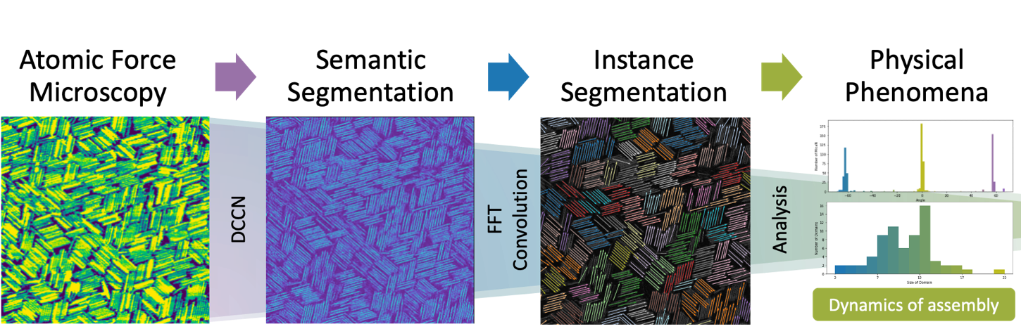
Figure S1: Schematic describing the workflow of experimental analysis where the raw data is denoised using a deep convolutional neural network (DCCN). Individual rods are then recognized using FFT convolution which provides the position and angle of each rod for each frame in the experimental movies.

Supplementary Text
Order Parameters
We quantify nematic order for a given system configuration as the maximum eigenvalue of the matrix N,
$$\begin{aligned}N=\left[\begin{matrix}\frac{1}{n_{rods}}\sum_{i}^{n_{rods}}{{2\left(\cos{θ_{i}}\right)}^{2}-1} & \frac{1}{n_{rods}}\sum_{i}^{n_{rods}}{2\sin{θ_{i}}\cos{θ_{i}}} \\ \frac{1}{n_{rods}}\sum_{i}^{n_{rods}}{2\sin{θ_{i}}\cos{θ_{i}}} & \frac{1}{n_{rods}}\sum_{i}^{n_{rods}}{2{\left(\sin{θ_{i}}\right)}^{2}-1}\end{matrix}\right]\#\left(S1\right)\end{aligned}$$
Where q_{i} is the orientation of rod i, and n_{rods} is the total number of rods in the configuration.
To calculate the discrete translational symmetry of the smectic arrangement of rods in 2D, we calculate the ratio between the peaks corresponding to the number of rods in the image and the longitudinal spacing between rows of rods in a Fourier transform (FFT). The center peak of the FFT corresponds to the total number of rods in the image.
For the simulation-based data, we compute a pixelated representation of the rod configuration (500 x 500 pixels) by marking for each rod the single pixel that corresponds to the rod center. We then pad these single pixels so that each rod center is instead represented by a 5 x 5 block of pixels. Padding the rod centers in this way helps make the images of rod centers and the associated FFTs more visually clear and interpretable. The top row of Fig. S2 shows the image resulting from this process for four different configurations. We then compute the Fourier transform of these pixelated representations (Fig. S2, middle row), and normalize the FFT intensities so that the maximum intensity for each image is one. The maximum intensity in the FFT is in the center of the transform image and corresponds to the total number of rods in the original image. We then aim to extract the features from the FFT that correspond to the end-to-end spacings of the rods. For the simulation data, we achieve this by applying a peak-finding algorithm within three thin, ten-pixel-wide strips centered at the zero-frequency FFT rotated by 0, 60, and 120 degrees. The second highest FFT intensity within these strips corresponds to this spacing and serves as the smectic order parameter (Fig. S2, bottom row). This construction allows us to take advantage of the fact that, in the simulation data, rods are only aligned along 0, 60, and 120 degrees, so we only need to search these directions in the FFT to find features corresponding to the end-to-end rod spacing between rows of rods. Moreover, this also allows us to assign smectic order parameters even to disordered configurations. While not perfect, constructing the order parameter in this way makes it possible to capture the translational order as well as rotational order, and subsequently distinguish smectic order from nematic order.

Figure S2: The smectic order parameter for a given rod configuration is calculated by taking the Fourier transform (FFT) of the rod centers; the FFT intensities are normalized so that the maximum intensity is equal to one, and the second highest FFT intensity found exclusively within thin “strips” of pixels passing through the zero-frequency component and having rotation angles of 0, 60, and 120 degrees then serves as the smectic order parameter. To illustrate this process, the top row of the figure shows images of the rod centers for four distinct rod configurations. The bottom row shows the FFT of these rod-center images with circles indicating the five locations in the relevant FFT strip with the highest intensities; the circles are colored according to their intensity (purple lowest, yellow highest). The (un-normalized) value of the smectic order parameter is provided at the top right of each FFT image. (The smectic order parameters in the main text are normalized so that the highest value obtained across the simulations or experiments, separately, is equal to one.)

In the experimental data, rod centers were plotted for each frame of the experimental data videos and an FFT image was generated for each plot. The FFT peak corresponding to end-to-end rod row spacing was found manually as this location does not vary throughout the video. The intensity of the highest peak within a 20 x 20 pixel window around this peak was used to calculate the smectic order parameter (Fig. S3). Looking within a window allows for finding the maxim value even if the peak location changes slightly within the experiment due to noise.

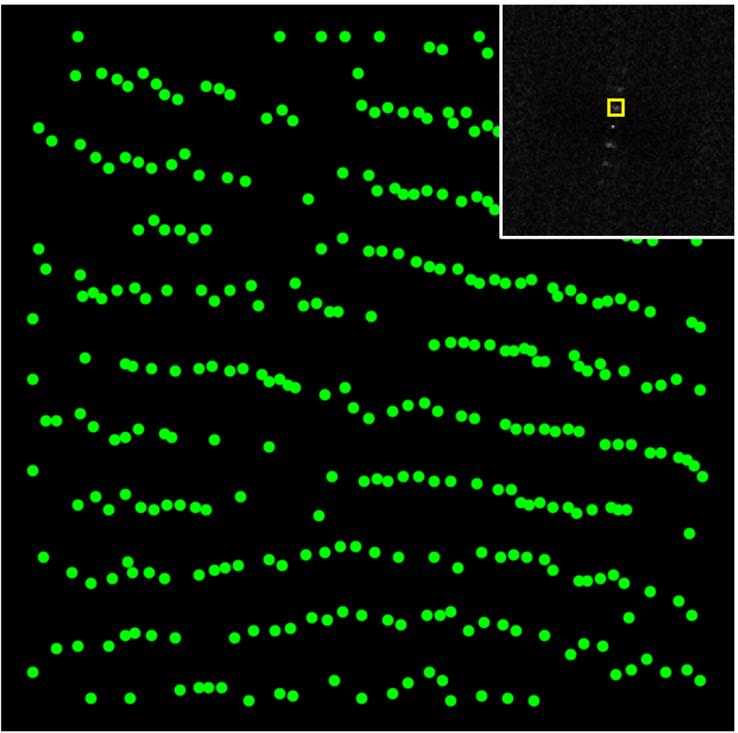
Figure S3: Example of the process to obtain the smectic order parameter from experimental data showing a plot of the rod centers from the 650th frame of the experimental video obtained on m-mica (left) and the FFT of the rod centers with the window containing the detected peak which corresponds to the distance between rows of rods marked in yellow (inset).

Defining two-dimensional smectic order as a ratio between the intensities of two FFT peaks is a start towards quantifying the order of liquid crystal-like films but is a simplification that discards information contained in the FFT such as the width of the peaks which could be used in the future to further define the order of two-dimensional smectic assemblies. Furthermore, this analysis does not consider the lateral spacing between rods which did not vary in our experiments because the data is normalized. But the FFT peak corresponding to lateral spacing might need to be considered for different systems.

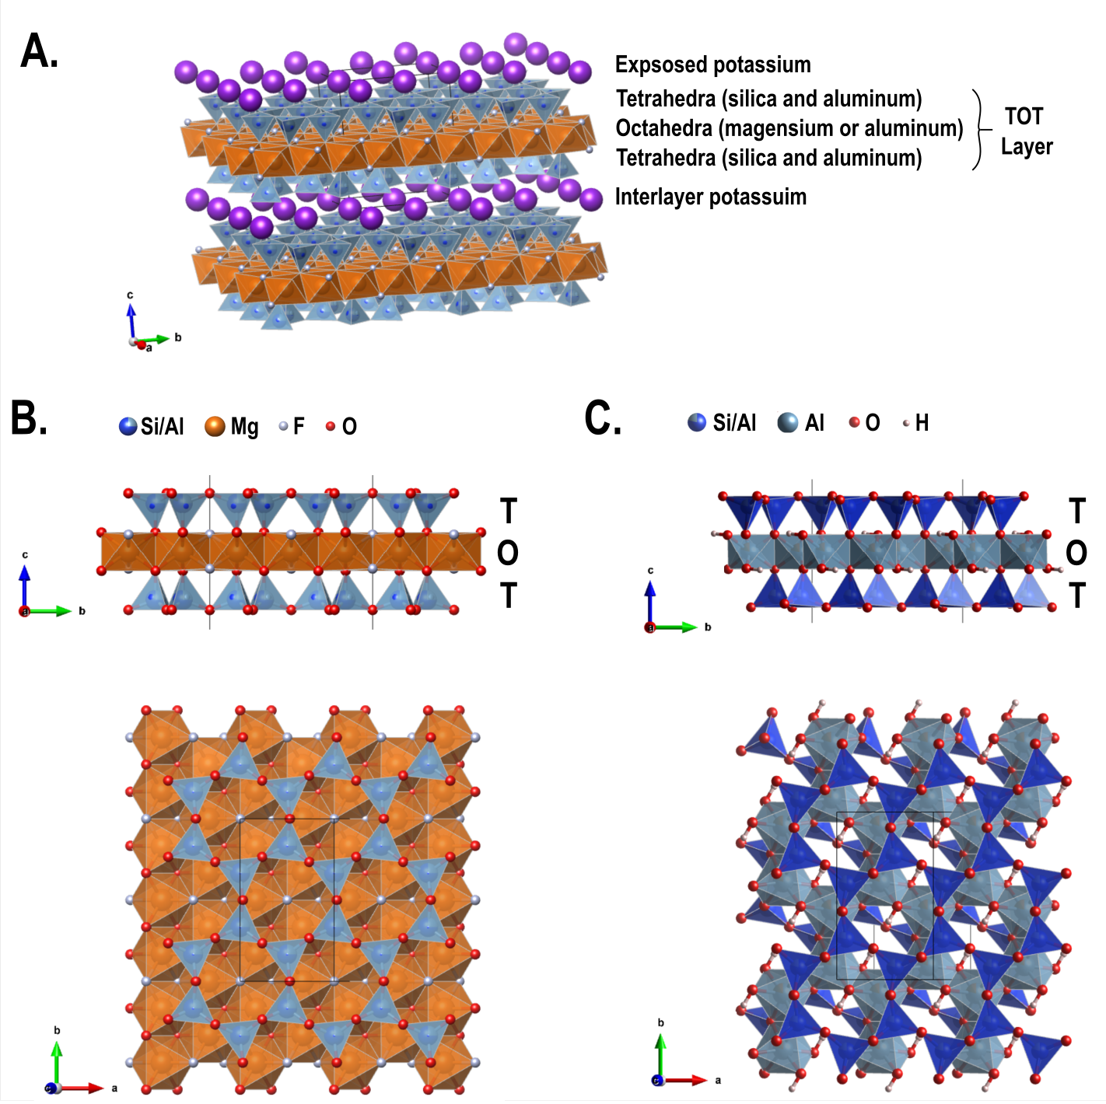
Figure S4: (A) Micas are typically comprised of tetrahedral-octahedral-tetrahedral (TOT) sheets, bound together by a potassium interlayer. When cleaved, micas split at the interlayer, to expose the tetrahedral surface of the TOT sheets, and the free potassium ions that adsorb onto cavities of that surface. (B) Fluorphlogopite (i.e. f-mica) TOT sheets are shown here in cross-section and top view. The tetrahedral layer (blue) is comprised of silica tetrahedra with ¼ aluminum substitution. The octahedral layer is comprised of Mg octahedra (orange). All octahedral sites are filled, making this a trioctahedral mica. The tetrahedra form cavities on the surface from a nominally hexagonal lattice, but careful inspection shows that the TOT sheet of f-mica has trigonal symmetry, rather than true hexagonal symmetry. (C) Muscovite (i.e. m-mica) TOT sheets are shown here in cross-section and top view. The tetrahedral layers are still comprised of silica and alumina tetrahedral (dark blue), but the octahedral layer is comprised of Al octahedra (light blue). Only 2/3 of the octahedral sites are filled, making this a ‘dioctahedral’ mica. Although the cavities still form a nominally hexaganol lattice, the missing octahedral sites in m-mica cause strong symmetry breaking of the TOT sheet. Couplings between the oxygens of the tetrahedral layer, and the hydroxyls attached to the octahedral layer cause distortions of the tetrahedral network. The direction along the hydroxyl (running from lower left to upper right, in the lower image) is unique from all other directions, and the sheet has no rotational symmetry.

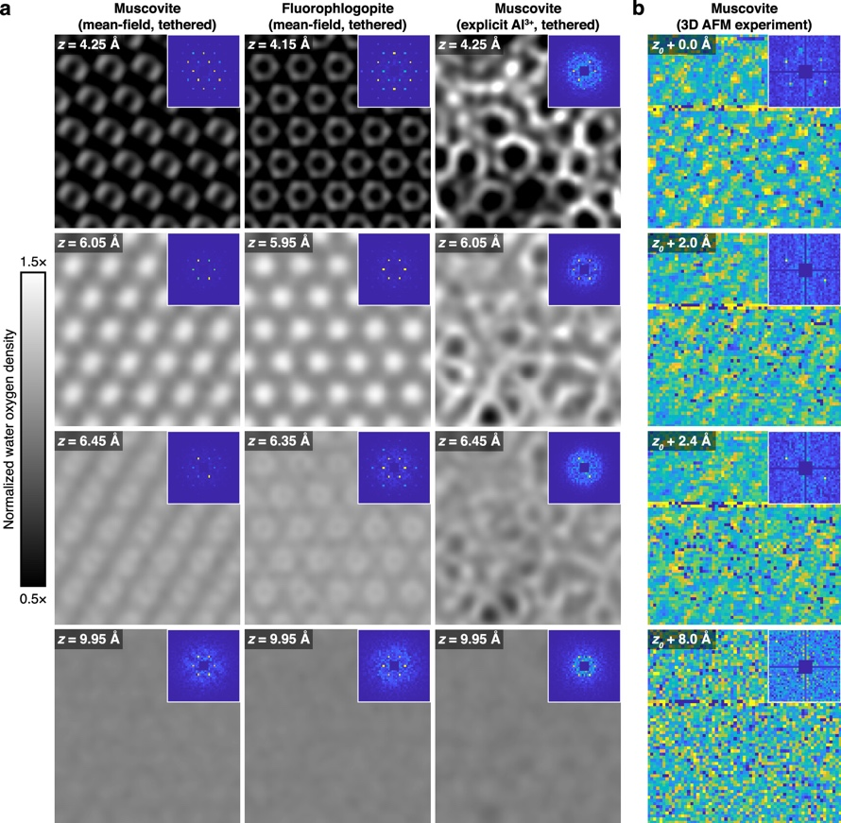
Figure S5: Distinct solvent structure induced by the underlying mineral surface (a) Solution structure predicted by simulation. (b) Solution structure above muscovite mica corroborated experimentally by 3D Fast Force Mapping (3D FFM) (image reproduced with permission from Alberstein et al J. Phys. Chem. Lett. 2023, 14, 1, 80–87).

Simulation methods
We perform a collection of Monte Carlo simulations in the grand canonical ensemble, systematically exploring the combined effects of chemical potential, rod aspect ratio, rod mobility, and orientational bias. In particular, we perform a Monte Carlo simulation for each combination of:
- Chemical potential, ranging from 1.0 to 9.0 in steps of 0.5.
- Rod aspect ratio, equal to 3, 5, 7, or 10.
- Rod mobility, ranging from 0.0 to 1.0 in steps of 0.1.
- Orientational bias, where the horizontal rods are either equally energetically favorable or twice as energetically favorable as rods in the other two orientations.
We additionally perform a smaller subset of simulations with other orientational biases, making the horizontal rods 1.25, 1.5, 1.75, 3, or 4 times more energetically favorable than the rods in the other two orientations. This smaller subset includes simulations for rods with an aspect ratio $l=7$and for each combination of:
- Chemical potential, ranging from 1.0 to 9.0 in steps of 1.0.
- Rod mobility, ranging from 0.0 to 1.0 in steps of 0.2.
In all of the simulations we perform, we run the Monte Carlo algorithm for 10⁷ steps, recording data every 10³ steps and recording rod configurations (“snapshots”) every 10⁵ steps. We use a simulation box size of 100 x 100 units with periodic boundary conditions and free placement of the rods (i.e., the rods are not restricted to a lattice). The baseline rod energy is set to -2 kT so that, for example, rods that are 1.5 times more energetically favorable have an energy of -3 kT. The Monte Carlo code we use was originally developed by Stephen Whitelam of Lawrence Berkely National Laboratory.

Discussion of Simulation Methods
Each Monte Carlo simulations begins with an empty box. At each Monte Carlo step, an attempt is made to move each existing rod (if any are present in the box) by randomly picking a new proposed location for the rod. If, at the proposed location, the rod would overlap with any other rod, the translation is rejected; otherwise, the translation is accepted. After the rod translation attempts, 2000 attempts are made to deposit or evaporate a rod. In the case of deposition, a random location and orientation is chosen for the new rod. If this proposed location would have the rod overlap with any other existing rods, the deposition is rejected. Otherwise, the deposition is accepted according to the Boltzmann criterion, $RAND\left[0, 1\right)≤ \frac{{Ae}^{βμ-E}}{n+1}$, where RAND[0, 1) indicates the choice of a random number between 0 (inclusive) and 1 (exclusive) from a uniform distribution, A is the area of the simulation box, $μ$ is the chemical potential, E is the energy of the rod, and n is the current number of rods on the surface. In the case of evaporation, a rod is selected at random and is removed from the box also in accordance with the Boltzmann criterion $RAND\left[0, 1\right)≤ \frac{n}{Ae^{βμ-E}}$.
As a result of the energy balances in our Monte Carlo setup, orientational biases only begin to affect the rod configurations after the surface has reached full or near-full coverage. In other words, the Monte Carlo simulations typically first acquire a disordered configuration, which either remains throughout the simulation (based on the rod mobility) or anneals to a more ordered configuration, whether that be nematic, smectic, or having large, ordered domains.

Figure S6: Average nematic order parameter, S, for an ensemble of Monte Carlo simulations with chemical potentials, µ, ranging from 1.0 to 9.0; rod mobilities, dr, ranging from 0.0 to 1.0; and for which the horizontally oriented rods have been biased to be up to four times as energetically favorable as rods in the other two orientations. The baseline rod energy is set at -2 kT, and all simulations use a rod aspect ratio $l$ = 7. Each box represents a single Monte Carlo simulation. The nematic order parameter for a given snapshot is calculated according to Eqn. S1; plotted values correspond to the order parameter averaged over all snapshots from the last fifth of the Monte Carlo simulation. A snapshot of the final rod configuration for each of the simulations in the ensemble is given in Figs. S13-S17.

Figure S7: Average nematic order parameter for an ensemble of Monte Carlo simulations with chemical potentials, µ, ranging from 1.0 to 9.0; rod mobilities, dr, ranging from 0.0 to 1.0; rod aspect ratios $l$ of 3, 5, 7, and 10; and for which the horizontally oriented rods have been biased to be twice as energetically favorable as rods in the other two orientations. The baseline rod energy is set at -2 kT. Each box represents a single Monte Carlo simulation. The nematic order parameter for a given snapshot is calculated according to Eqn. S1; plotted values correspond to the order parameter averaged over all snapshots from the last fifth of the Monte Carlo simulation. A snapshot of the final rod configuration for each of the simulations in the ensemble is given in Fig. S22-S25.

Figure S8: Average nematic order parameter for an ensemble of Monte Carlo simulations with chemical potentials, µ, ranging from 1.0 to 9.0; rod mobilities, dr, ranging from 0.0 to 1.0; rod aspect ratios $l$ of 3, 5, 7, and 10; and for which all three rod orientations are equally favorable. Each box represents a single Monte Carlo simulation. The nematic order parameter for a given snapshot is calculated according to Eqn. S1; plotted values correspond to the order parameter averaged over all snapshots from the last fifth of the Monte Carlo simulation. A snapshot of the final rod configuration for each of the simulations in the ensemble is given in Fig. S18-S21.

Figure S9: Relationship between smectic order parameter, S_{S}, and packing fraction, $η$, for the ensemble of Monte Carlo simulations with rod aspect ratio $l$ = 7 and with the horizontal rod orientation twice as energetically favorable as the other two orientations (the baseline rod energy is -2 kT). Smectic order achieves a local maximum at a packing fraction of approximately 0.70, momentarily decreases, and then rapidly increases with packing fractions above approximately 0.76.

Figure S10: Relationship between nematic order parameter, S_{N}, and packing fraction, $η$, for the ensemble of Monte Carlo simulations with rod aspect ratio $l$ = 7 and with all rod orientations equally favorable. Nematic order peaks at a packing fraction of approximately 0.70.

Figure S11: Evolution of the smectic order parameter, S_{S}, over the course of a Monte Carlo Simulation with $μ$= 8.0, dr = 0.6, $l$ = 7, and where one rod orientation is twice as energetically favorable as the other two.

Figure S12: The nematic order parameters for a collection of Monte Carlo simulations of hard rods with aspect ratio $l=7$ are presented in grids, where each box in the grid represents a single simulation defined its chemical potential and rod mobility; the coloring indicates the value of the nematic order parameter. Separate grids are plotted for simulation collections where all three rod orientations are equally favorable (B, “Unbiased”), and where the horizontal rods are twice as energetically favorable as the other orientations (A, “2x Bias”). Several select simulations are annotated with a snapshot of the final rod configuration (C-J).

Movie M1
(A) HS-AFM video showing the translational motion of protein rods and their assembly on muscovite mica in 3MKCl. Scan size: 200nm. (B) Machine learning semantic segmentation. (C) Machine recognized centers of rods. (D) Fast fourier transform (FFT) of image.
Movie M2
(A) HS-AFM video showing the translational motion of protein rods and their assembly on fluorophlogopite mica in 3MKCl. Scan size: 200nm. (B) Machine learning semantic segmentation. (C) Machine recognized centers of rods. (D) Fast fourier transform (FFT) of image.

Additional Monte Carlo Simulations Figures
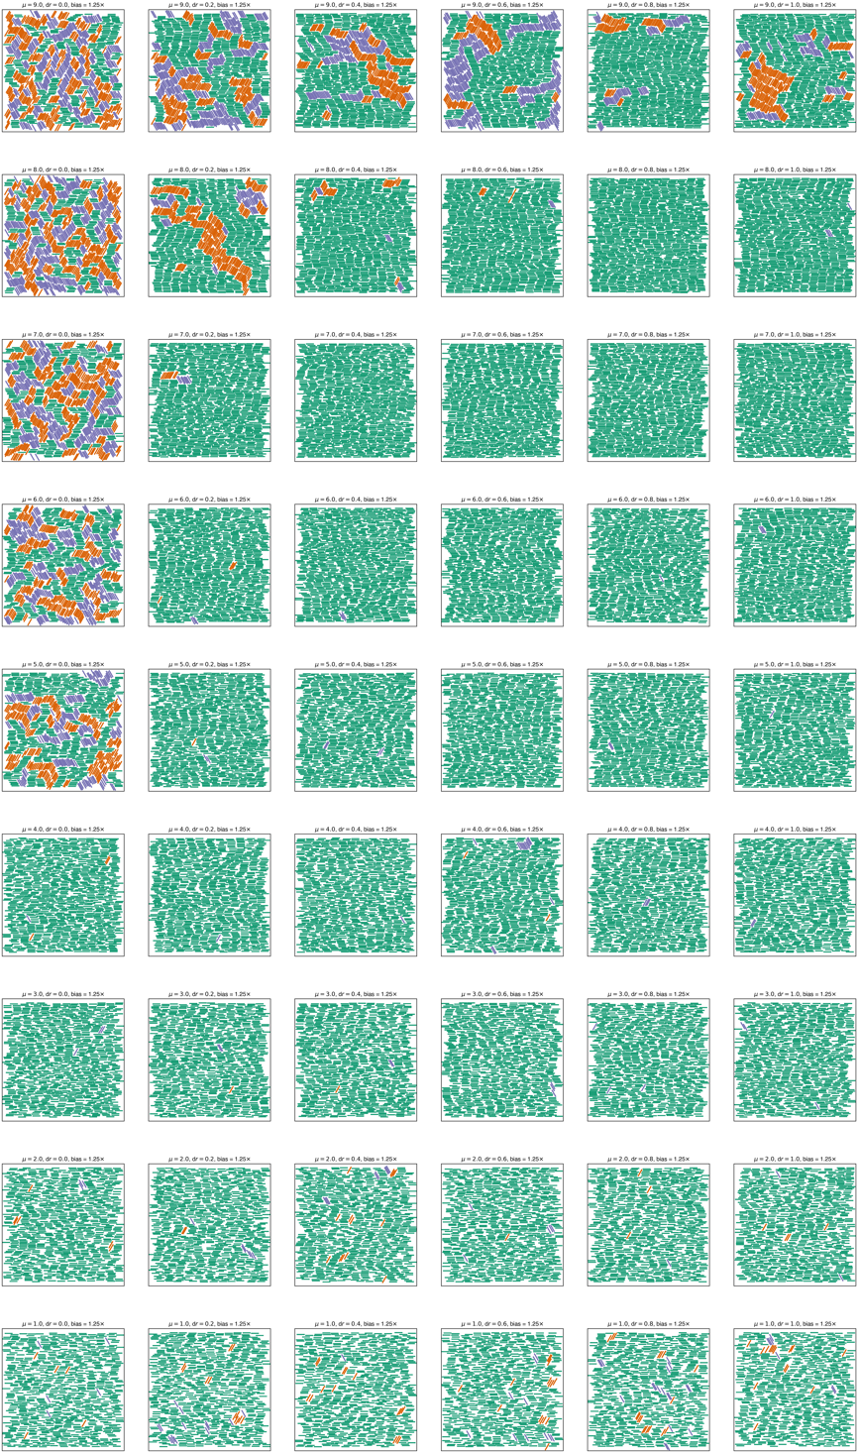
Figure S13: Snapshots of the final rod configurations from Monte Carlo simulations with different chemical potentials and rod mobilities where the horizontal rods are 1.25x as energetically favorable as rods in other orientations: the baseline rod energy is -2 kT, and the horizontal rods have energy -2.5 kT. All rods have aspect ratio $l$ = 7.

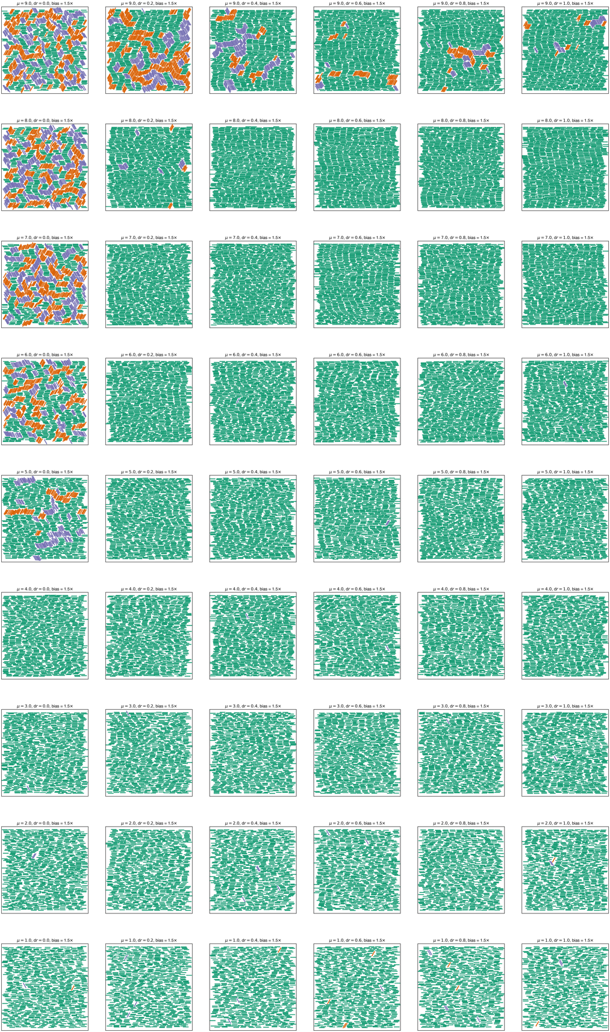
Figure S14: Snapshots of the final rod configurations from Monte Carlo simulations with different chemical potentials and rod mobilities where the horizontal rods are 1.5x as energetically favorable as rods in other orientations: the baseline rod energy is -2 kT, and the horizontal rods have energy -3 kT. All rods have aspect ratio $l$ = 7.

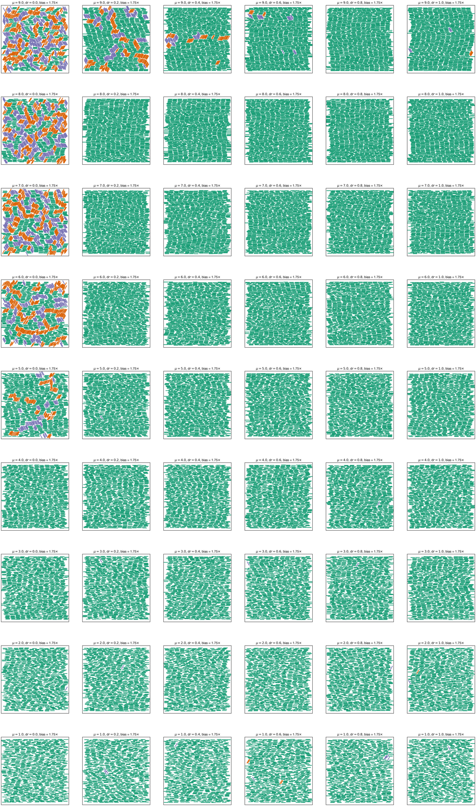
Figure S15: Snapshots of the final rod configurations from Monte Carlo simulations with different chemical potentials and rod mobilities where the horizontal rods are 1.75x as energetically favorable as rods in other orientations: the baseline rod energy is -2 kT, and the horizontal rods have energy -3.5 kT. All rods have aspect ratio $l$ = 7.
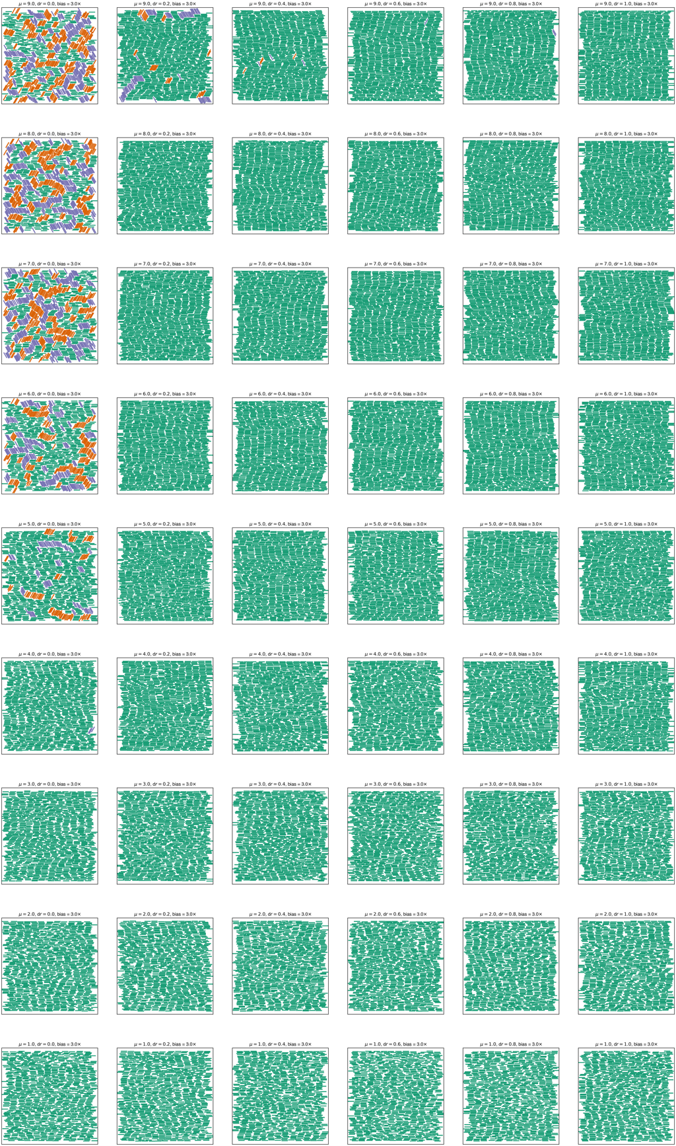
Figure S16: Snapshots of the final rod configurations from Monte Carlo simulations with different chemical potentials and rod mobilities where the horizontal rods are 3x as energetically favorable as rods in other orientations: the baseline rod energy is -2 kT, and the horizontal rods have energy -6 kT. All rods have aspect ratio $l$ = 7.
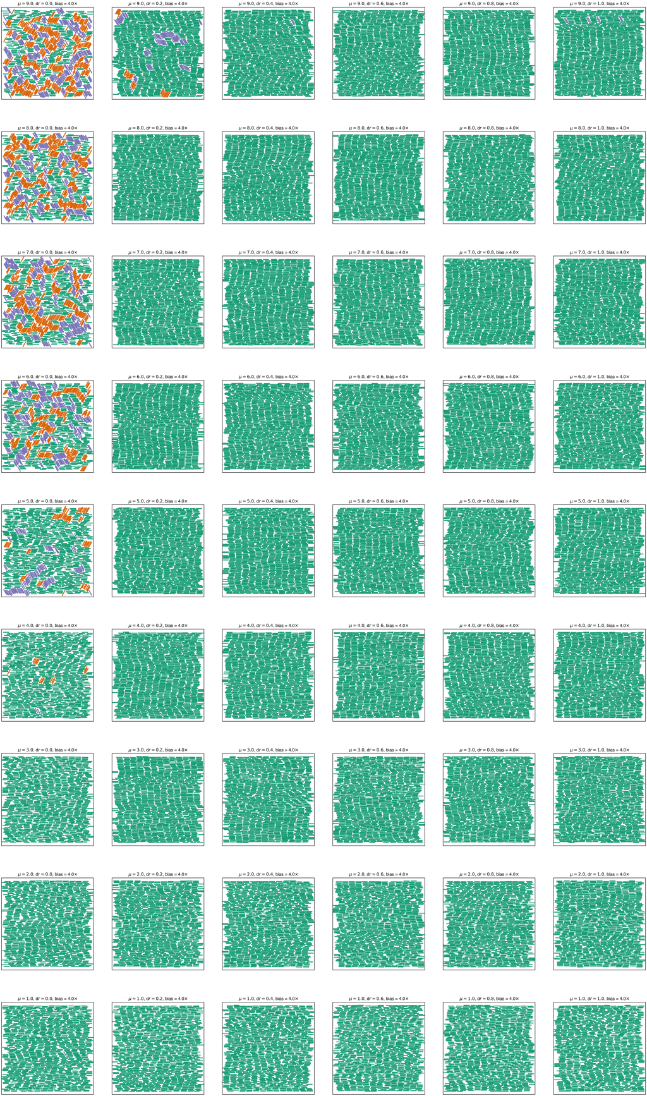
Figure S17: Snapshots of the final rod configurations from Monte Carlo simulations with different chemical potentials and rod mobilities where the horizontal rods are 4x as energetically favorable as rods in other orientations: the baseline rod energy is -2 kT, and the horizontal rods have energy -8 kT. All rods have aspect ratio $l$ = 7.
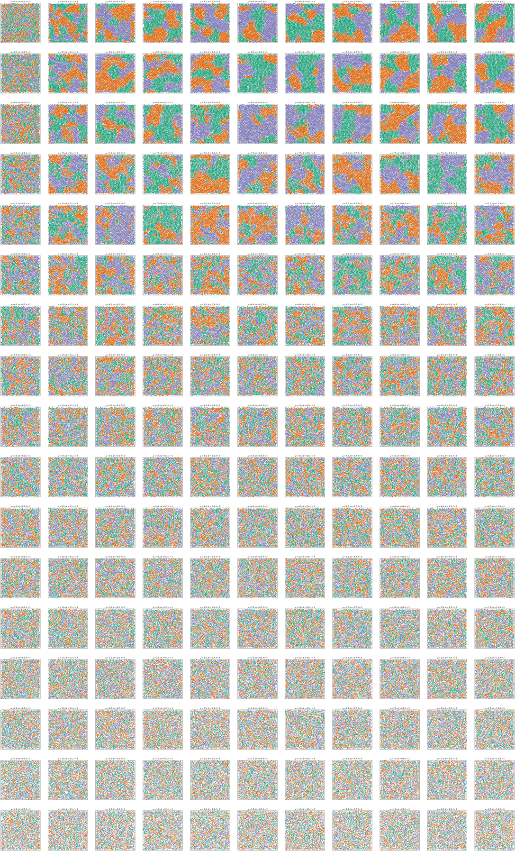
Figure S18: Snapshots of the final rod configurations from Monte Carlo simulations with different chemical potentials and rod mobilities where all three rod orientations are equally favorable, and all rods have aspect ratio $l=3$.
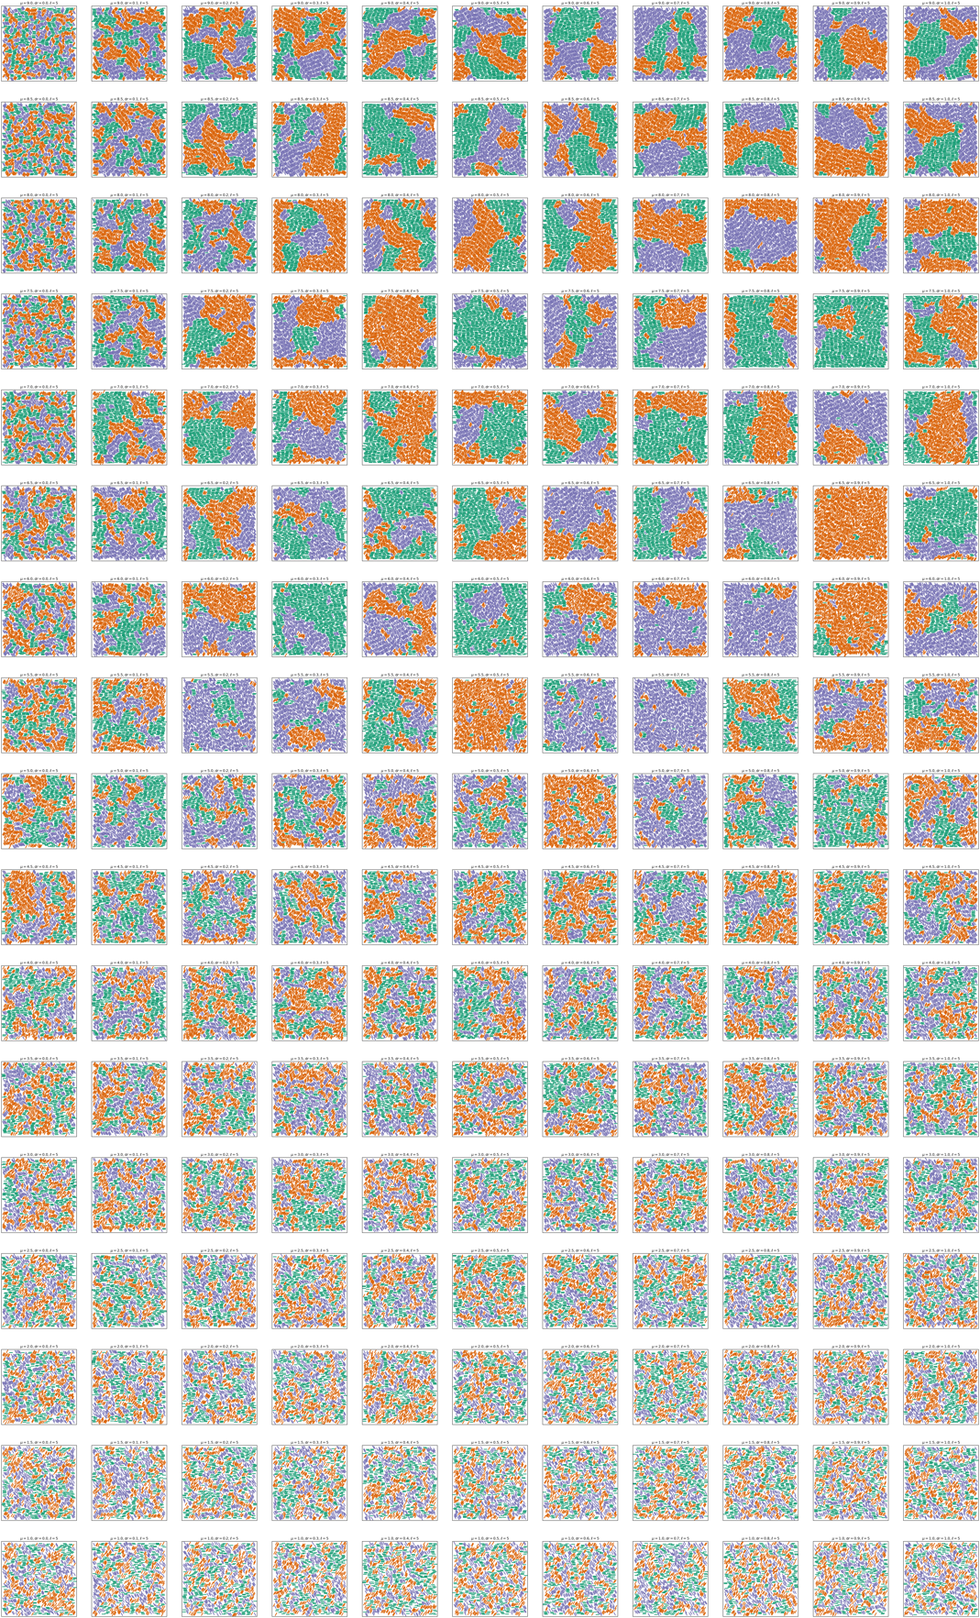
Figure S19: Snapshots of the final rod configurations from Monte Carlo simulations with different chemical potentials and rod mobilities where all three rod orientations are equally favorable, and all rods have aspect ratio $l=5$.
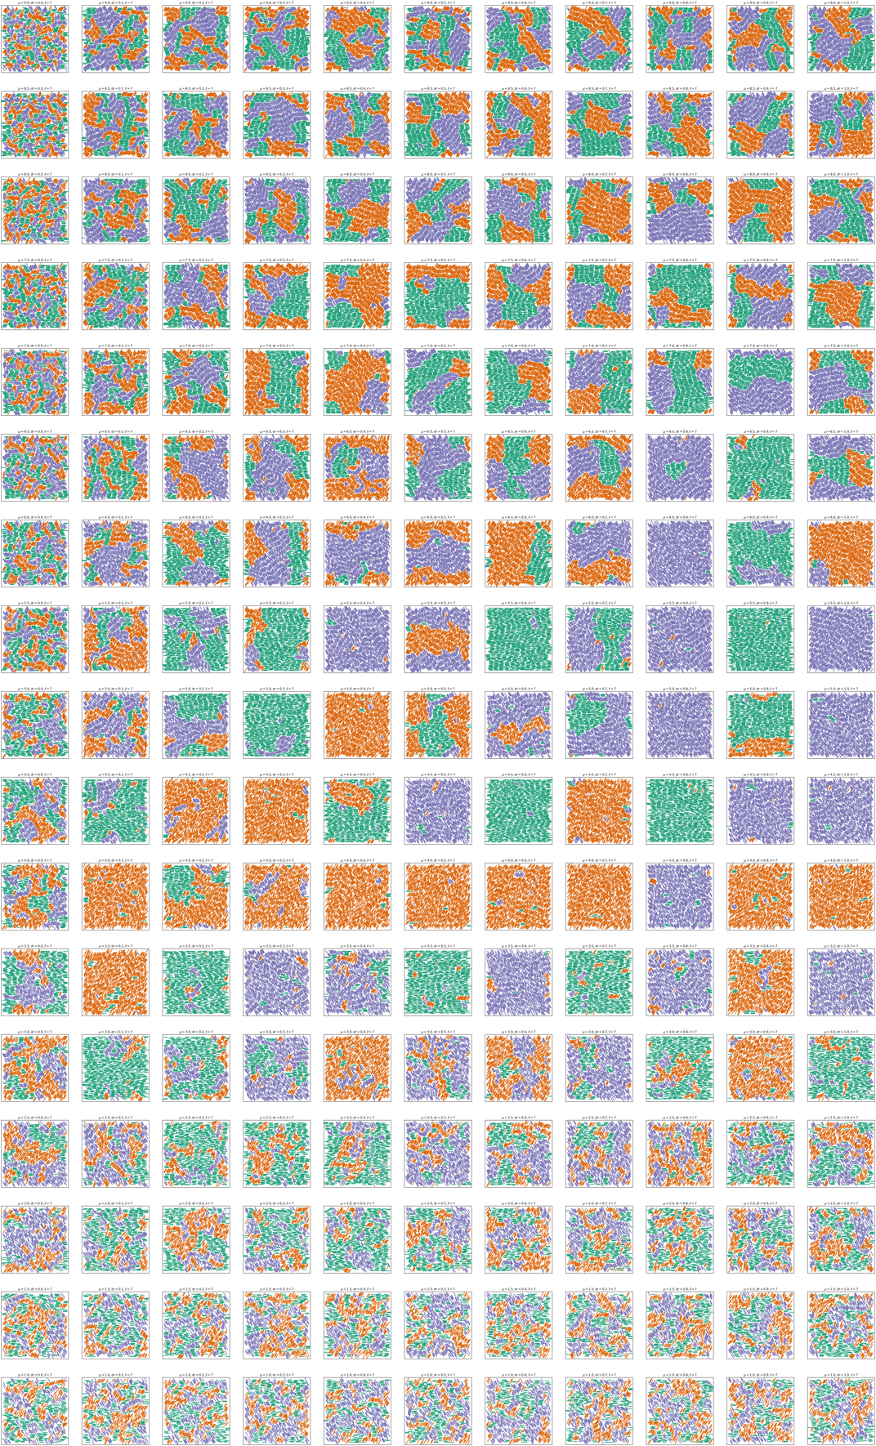
Figure S20: Snapshots of the final rod configurations from Monte Carlo simulations with different chemical potentials and rod mobilities where all three rod orientations are equally favorable, and all rods have aspect ratio $l=7$.
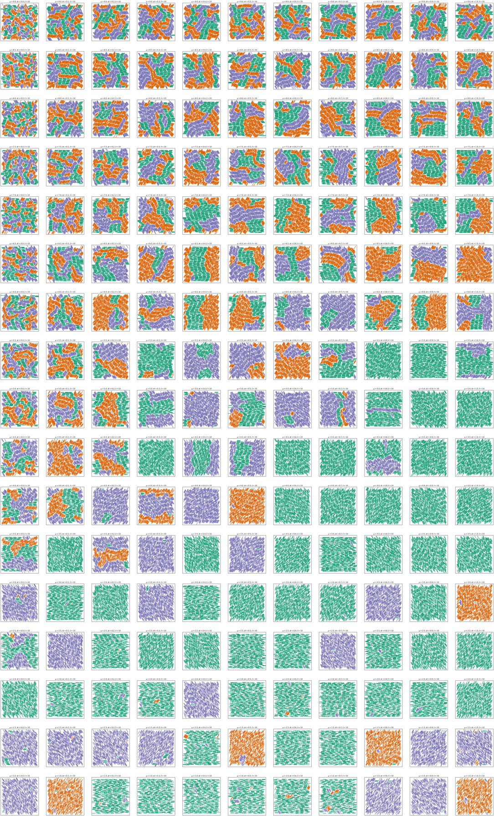
Figure S21: Snapshots of the final rod configurations from Monte Carlo simulations with different chemical potentials and rod mobilities where all three rod orientations are equally favorable, and all rods have aspect ratio $l=10$.
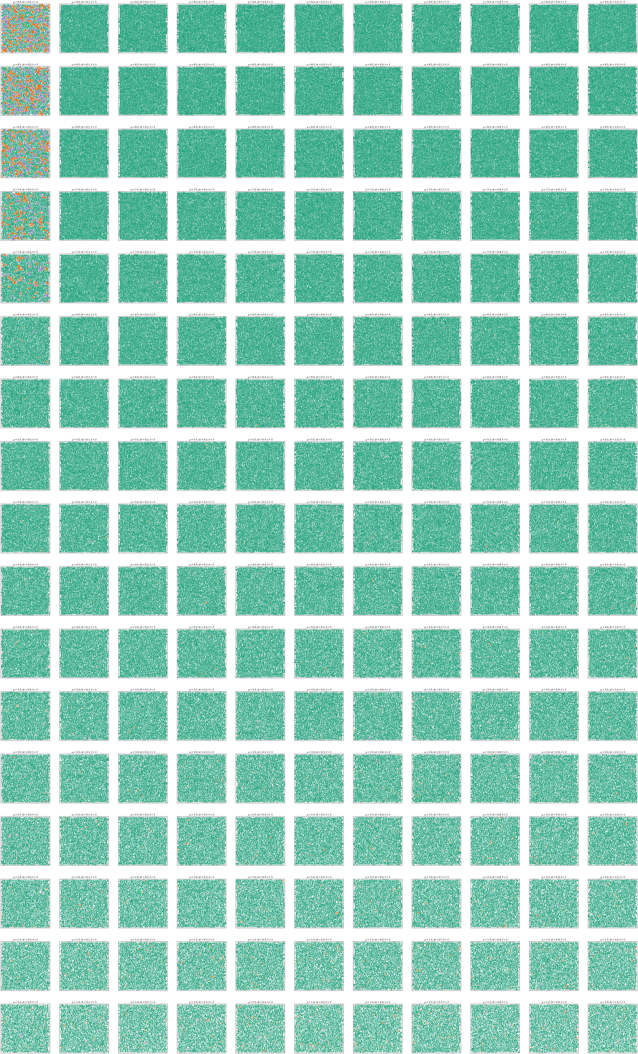
Figure S22: Snapshots of the final rod configurations from Monte Carlo simulations with different chemical potentials and rod mobilities where the horizontal rods are twice as energetically favorable as the other orientations and all rods have aspect ratio $l=3$.
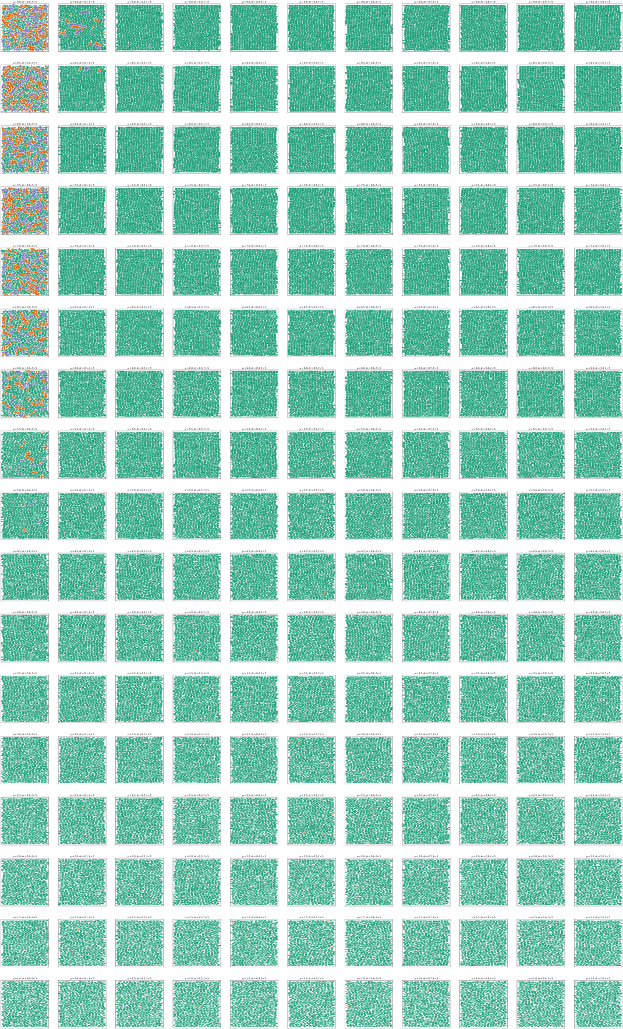
Figure S23: Snapshots of the final rod configurations from Monte Carlo simulations with different chemical potentials and rod mobilities where the horizontal rods are twice as energetically favorable as the other orientations and all rods have aspect ratio $l=5$.
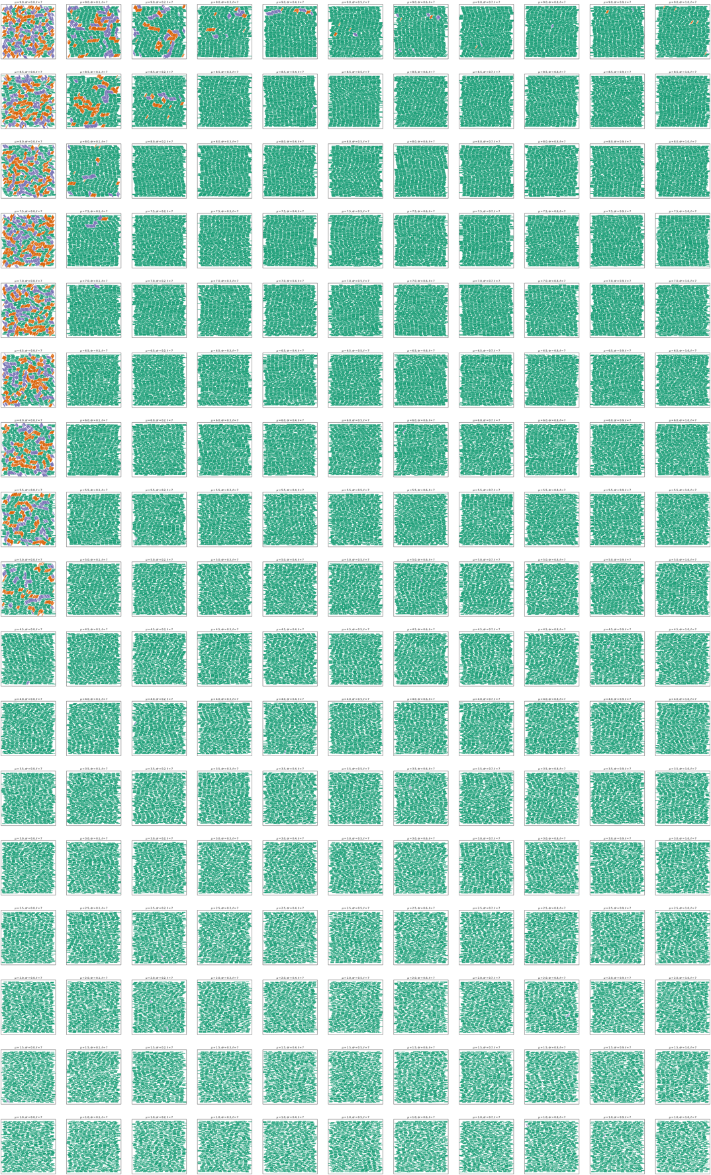
Figure S24: Snapshots of the final rod configurations from Monte Carlo simulations with different chemical potentials and rod mobilities where the horizontal rods are twice as energetically favorable as the other orientations and all rods have aspect ratio $l=7$.
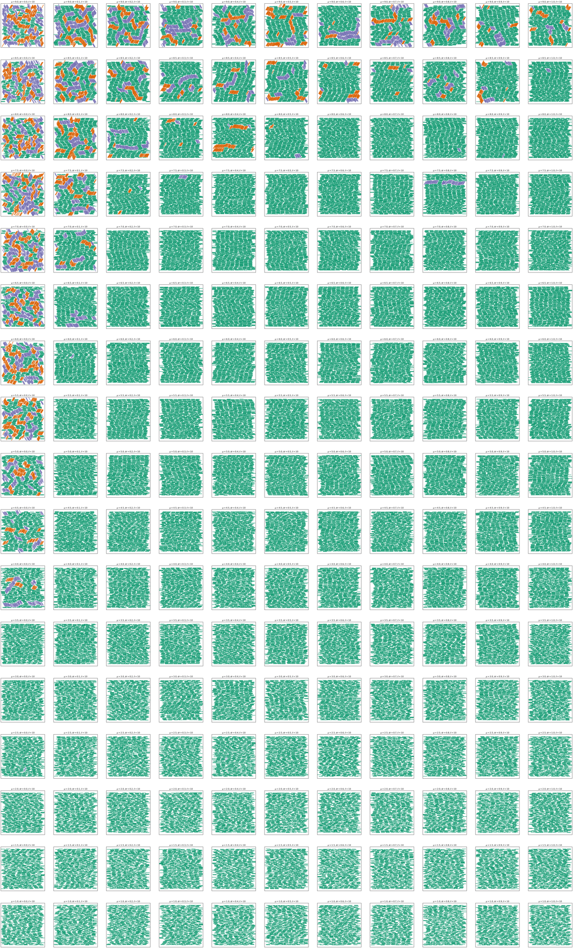
Figure S25: Snapshots of the final rod configurations from Monte Carlo simulations with different chemical potentials and rod mobilities where the horizontal rods are twice as energetically favorable as the other orientations and all rods have aspect ratio $l=10$.

