Extended Data

Extended Data Table 1. Individual dataset demographics, scanning details, and preprocessing method.
 | Demographics |  |  |  | Imaging
 | Total Scans | Analysis Sample | Ages | Sex | dMRI Parameters  (b-value: # directions) | Preprocessing
Developing Human Connectome Project (dHCP) (Edwards et al., 2022) | 447 | 446 | 0 – 7w  M = 0.02  SD = 0.02 | F = 46%  M = 54% | 400 s/mm²: 64  1000 s/mm²: 88  2600 s/mm²: 128⁸¹ | https://brain.labsolver.org/hcp_d2.html
Baby Connectome Project (BCP) (Howell et al., 2019) | 179 | 92 | 1 – 5y  M = 1.74  SD = 0.08 | F = 45%  M = 55% | 500 s/mm²: 9  1000 s/mm²: 12  1500 s/mm²: 17  2000 s/mm²: 24  2500 s/mm²: 1234  3000 s/mm²: 48  or  700 s/mm²: 36  1500 s/mm²: 48  3000 s/mm²: 60 | Processed in-house (QSIprep)
Centre for Attention Learning and Memory (CALM) (Holmes et al., 2019) | 392 | 77 | 6 – 18y  M = 10.28  SD = 2.18 | F = 66%  M = 34% | 1000 s/mm²: 64 | Processed in-house (QSIprep)
Resilience in Education and Development (RED) (Johnson et al., 2022) | 75 | 74 | 7 – 12y  M = 8.58  SD = 1.01 | F = 58%  M = 42% | 1000 s/mm²: 68 | Processed in-house (QSIprep)
Attention and Cognition in Education (ACE) (Bathelt et al., 2019) | 85 | 84 | 7 – 13y  M = 10.04  SD = 1.58 | F = 50%  M = 50% | 1000 s/mm²: 60 | Processed in-house (QSIprep)
Human Connectome Project Development (HCPd) (Somerville et al., 2018) | 633 | 633 | 6 – 22y  M = 14.50  SD = 4.06 | F = 54%  M = 46% | 1500 s/mm²: 92, 93  3000 s/mm²: 92, 93⁸ | https://brain.labsolver.org/hcp_d.html
Human Connectome Project Young Adult (HCPya) (Van Essen et al., 2013) | 1065 | 1062 | 22 – 37y  M = 28.74  SD = 3.67 | F = 54%  M = 46% | 1000 s/mm²: 90  2000 s/mm²: 90  3000 s/mm²: 90⁸ | https://brain.labsolver.org/hcp_ya.html
Human Connectome Project Ageing (HCPa) (Bookheimer et al., 2019) | 706 | 705 | 36 – 90y  M = 59.76  SD = 14.92 | F = 56%  M = 44% | 1500 s/mm²: 92, 93  3000 s/mm²: 92, 93⁸ | https://brain.labsolver.org/hcp_a.html
Cambridge Centre for Ageing and Neuroscience (CamCAN) (Shafto et al., 2014) | 634 | 629 | 19 – 89y  M = 55.34  SD = 18.55 | F = 50%  M = 50% | 1000 s/mm²: 30  2000 s/mm²: 30 | https://brain.labsolver.org/camcan.html
Note: The analysis sample size indicates all scans retained after removing longitudinal scans (BCP), neurodivergent participants (CALM), and density outliers. For age, ‘y’ indicates years, ‘w’ indicates weeks, ‘M’ is the mean age, and ‘SD’ is the standard deviation. For sex, ‘F’ indicates female, and ‘M’ indicates male.

Extended Data Table 2. GAMs of graph theory metrics with variable density networks.
 |  | F(metric,age) | Estimated df | p-value
Integration | Global efficiency | 231.40 | 8.91 | p < 2.00 x 10⁻¹⁶
Integration | Characteristic path length | 219.90 | 8.89 | p < 2.00 x 10⁻¹⁶
Integration | Small-Worldness | 132.80 | 8.81 | p < 2.00 x 10⁻¹⁶
Integration | Average strength | 33.10 | 5.46 | p < 2.00 x 10⁻¹⁶
Segregation | Modularity | 66.57 | 8.13 | p < 2.00 x 10⁻¹⁶
Segregation | Core/Periphery | 16.35 | 8.18 | p < 2.00 x 10⁻¹⁶
Segregation | S-Core | 38.77 | 5.36 | p < 2.00 x 10⁻¹⁶
Segregation | Local efficiency | 60.28 | 4.50 | p < 2.00 x 10⁻¹⁶
Segregation | Clustering coefficient | 67.44 | 5.18 | p < 2.00 x 10⁻¹⁶
Segregation | K-Core | 135.30 | 8.85 | p < 2.00 x 10⁻¹⁶
Centrality | Betweenness centrality | 37.73 | 6.66 | p < 2.00 x 10⁻¹⁶
Centrality | Subgraph centrality | 19.15 | 8.53 | p < 2.00 x 10⁻¹⁶
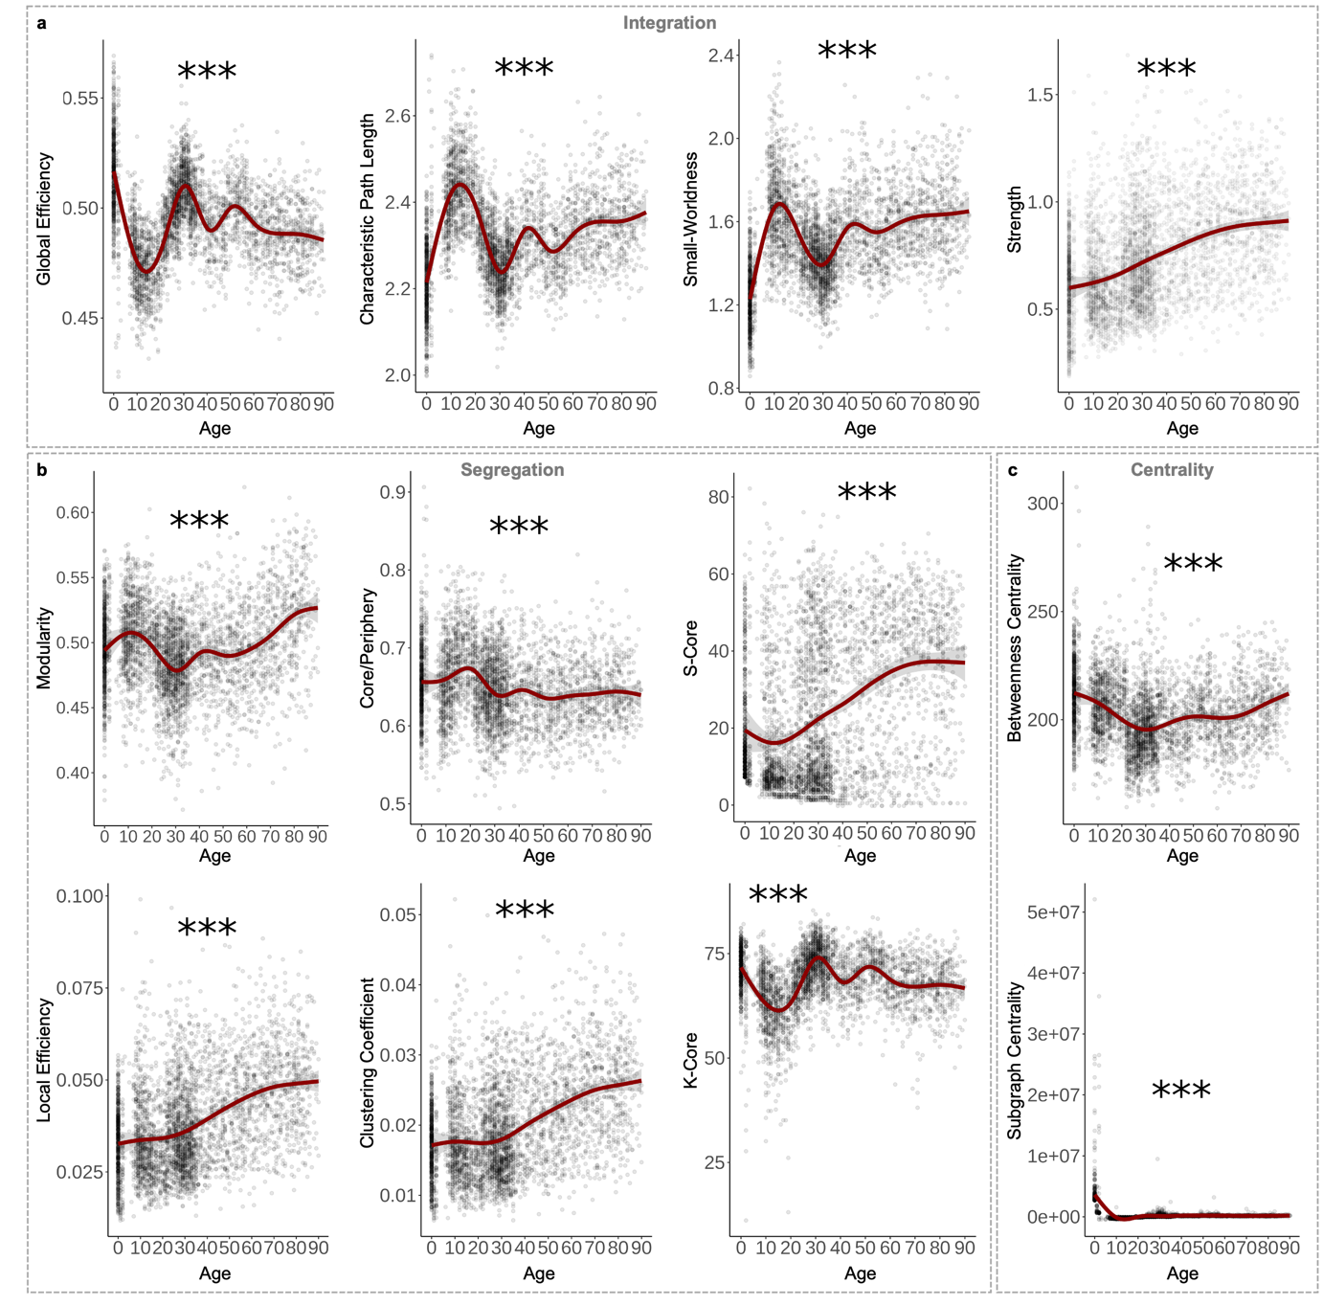
Extended Data Figure 1. Topological changes across the lifespan with variable density networks. (a) Global efficiency fluctuates across the lifespan, with high points at birth and 30 years old and declining in late life. Characteristic path length and small-worldness display the inverse pattern of global efficiency. The average strength of networks significantly increases across the lifespan. (b) Modularity hits a lifetime low around 30 years old before steadily increasing for the rest of the lifespan. Core/periphery structure peaks around 20 years old. S-core significantly increases across the lifespan. Average local efficiency and clustering coefficient significantly increase across the lifespan. K-core varies across the lifespan with relative peaks around 30 and 50 years old. (c) Average betweenness centrality displays a lifetime low around 30 years old. Average subgraph centrality starts high at birth and significantly decreases across the lifespan. Shaded area around best fit lines represent 95% confidence intervals. *** indicates p < 0.001, ** indicates p < 0.01, * indicates p < 0.05.
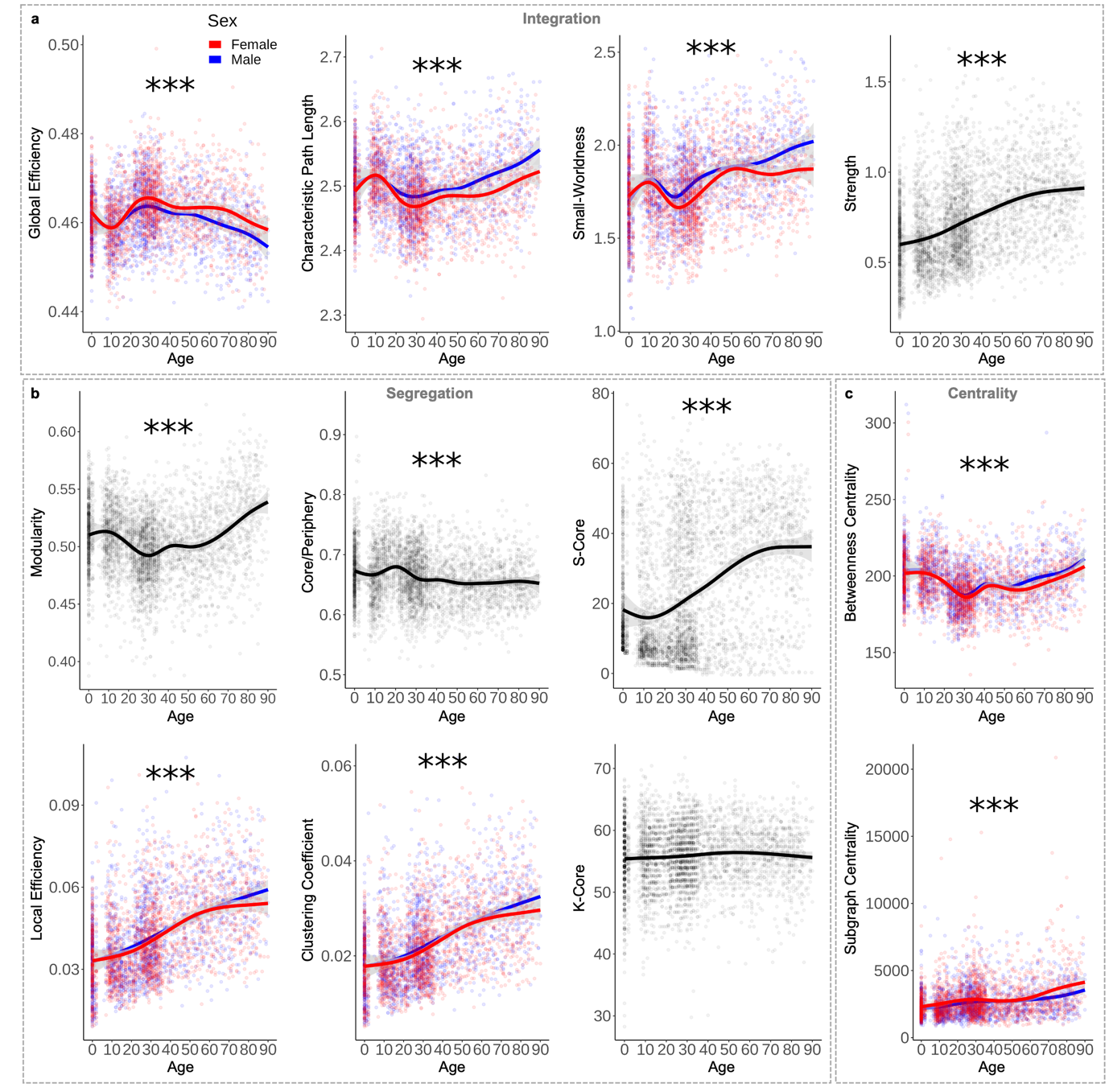
Extended Data Figure 2. Significant sex effects in controlled-density network topology. (a) Global efficiency (group estimate = 1.44 x 10⁻⁰³, t-value = 6.71, p = 2.18 x 10⁻¹¹), characteristic path length (group estimate = -0.01, t-value = -6.92, p = 5.14 x 10⁻¹²), and small-worldness (group estimate = -0.06, t-value = -9.34, p < 2.00 x 10⁻¹⁶) had significant sex effects across the lifespan with females showing higher efficiency, shorter path lengths and lower small-worldness than males from about 20 years old. Average network strength, however, had no significant effects of sex (p = 0.543). (b) Neither modularity (p = 0.083) nor core/periphery structure (p = 0.110) showed a significant effect of sex. S-core (p = 0.258) and K-core (p = 0.146) did not have significant effects of sex. Average local efficiency (group estimate = -1.05 x 10⁻⁰³, t-value = -2.42, p = 0.016) and clustering coefficient (group estimate = -6.37 x 10⁻⁰⁴, t-value = -2.68, p = 0.007) did have significant effects of sex, with females showing lower clustering and local efficiency compared to males particularly in late life (70 years old and older). (c) Both centrality metrics had significant effects of sex. Females had lower average betweenness centrality (group estimate = -1.12, t-value = -2.33, p = 0.020) compared to males after about 50 years old and significantly higher subgraph centrality after about 60 years of age (group estimate = 207.23, t-value = 4.99, p = 6.24 x 10⁻⁰⁷). Shaded area around best fit lines represent 95% confidence intervals. *** indicates p < 0.001, ** indicates p < 0.01, * indicates p < 0.05.
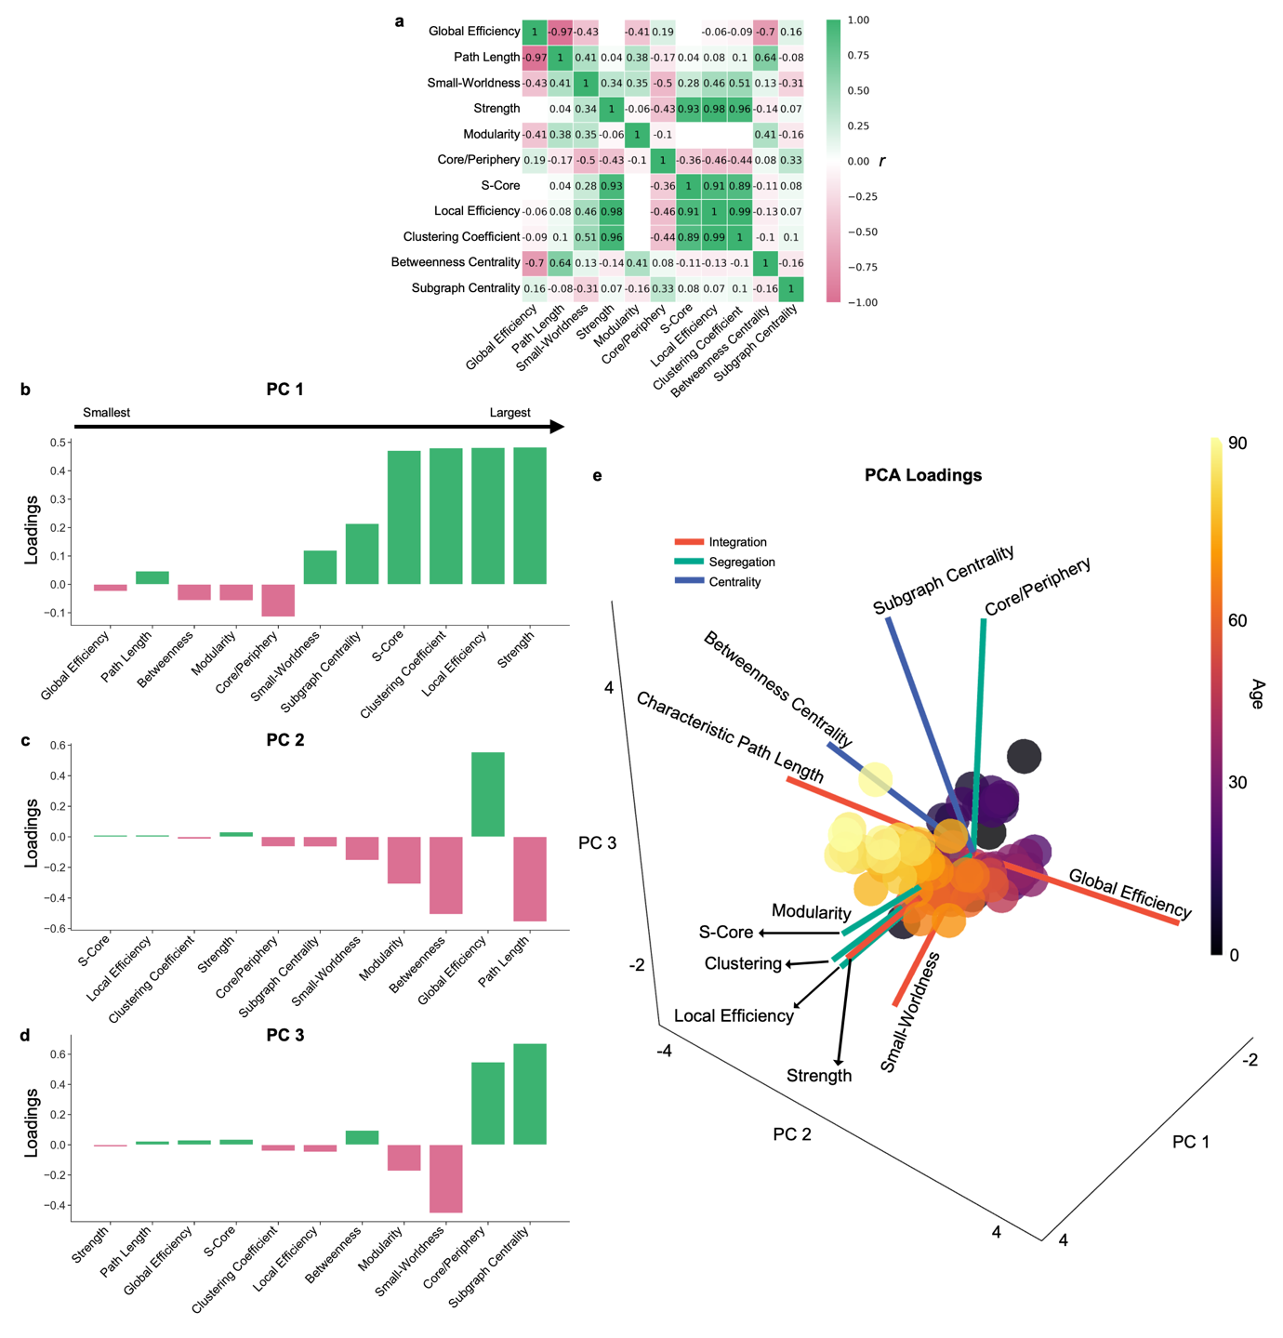
Extended Data Figure 3. Principal components analysis of network organisation. (a) Graph theory measures convey unique and redundant network topology information, as significant Pearson correlations indicate. White boxes indicate no significant correlation. All loading scores ordered from smallest to largest for (b) PC 1, (c) PC 2, and (d) PC 3. (e) Three-dimensional biplot showing PCA loadings with the age-averaged PCA scores.
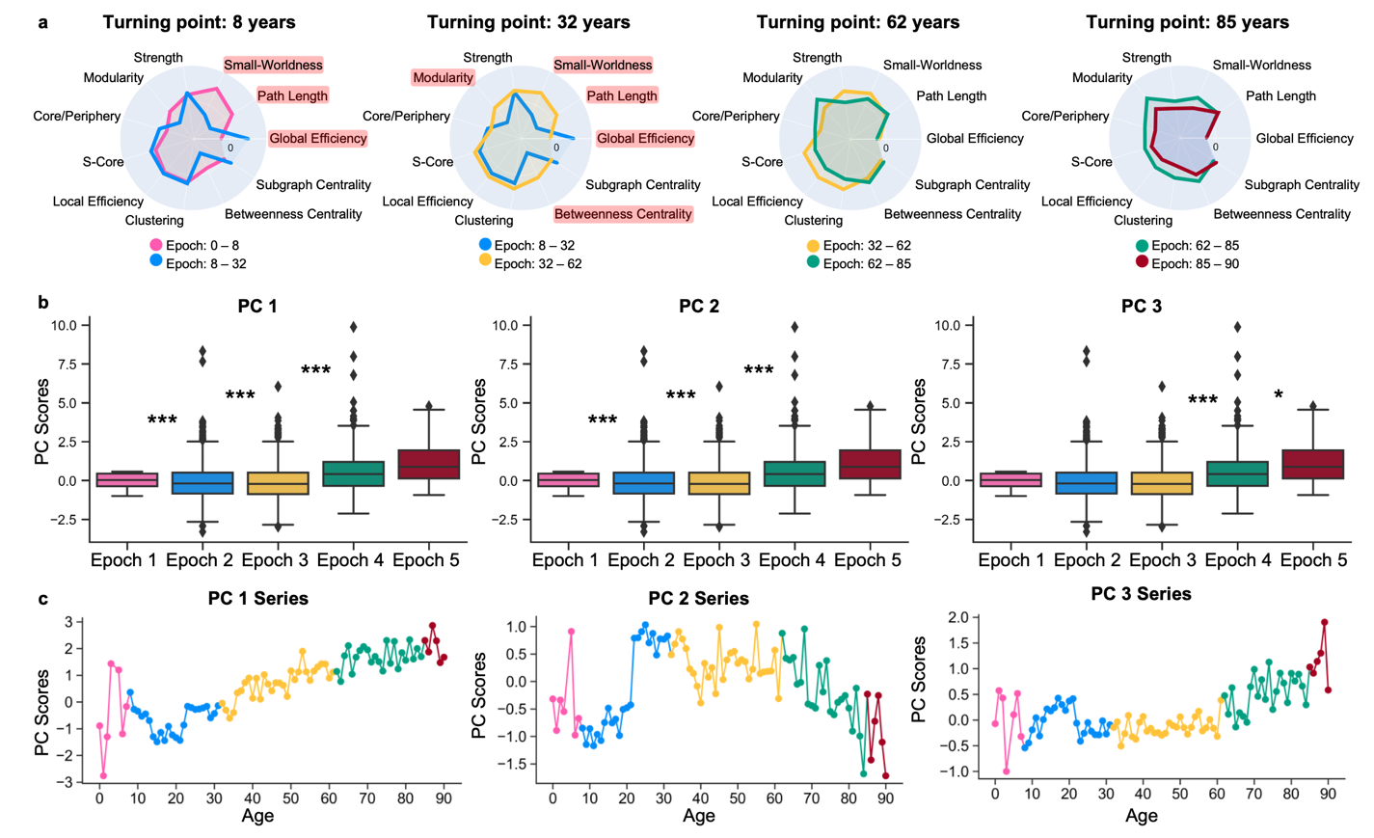Extended Data Figure 4. (a) Spider plots of Pearson’s r values for each graph theory measure in consecutive epochs highlight the epochs where the direction of significant age-topology relationship (indicated by red highlighted measures. (b) PCA scores per epoch across each PC. Across PC 1 scores, epochs one and two (p = 4.80 x 10⁻⁰⁴), two and three (p < 1.00 x 10⁻³²³), and three and fourth (p = 6.54 x 10⁻¹³) all are significantly different. Similarly, for PC 2 score, epochs one and two (p = 6.66 x 10⁻⁰⁸), two and three (p = 1.39 x 10⁻⁰⁷), and three and fourth (p = 1.83 x 10⁻⁰⁸). Lastly, epochs three and four (p < 1.00 x 10⁻³²³) and epochs four and five (p = 0.018) significantly differ across PC 3 scores. Average PCA scores for each epoch are plotted in 3-dimensional space. Additionally, kernel density plots highly distribution of scores for each epoch across the principal components. (c) PC score series were created from average score for each age. These were the series used in the Dynamic Time Warping analysis. *** indicates p < 0.001, ** indicates p < 0.01, * indicates p < 0.05.

Extended Data Table 2. Games-Howell statistics for comparison of PCA scores between epochs.
 | Group A | Group B | Mean Diff. | SE | T-value | df | p-value | Cohen’s D
PC1 | Epoch 1 | Epoch 2 | -0.35 | 0.09 | -4.07 | 1087.35 | 4.80 x 10⁻⁰⁴ | -0.19
PC1 | Epoch 1 | Epoch 3 | -1.37 | 0.1 | -13.95 | 1436.85 | 0 | -0.69
PC1 | Epoch 1 | Epoch 4 | -2.58 | 0.11 | -22.69 | 1080.38 | 0 | -1.35
PC1 | Epoch 1 | Epoch 5 | -3.01 | 0.26 | -11.78 | 65.42 | 3.26 x 10⁻¹⁴ | -1.63
PC1 | Epoch 2 | Epoch 3 | -1.02 | 0.08 | -13.13 | 1886.45 | 0 | -0.53
PC1 | Epoch 2 | Epoch 4 | -2.24 | 0.1 | -23.09 | 797.04 | 0 | -1.2
PC1 | Epoch 2 | Epoch 5 | -2.66 | 0.25 | -10.72 | 58.47 | 6.22 x 10⁻¹⁵ | -1.46
PC1 | Epoch 3 | Epoch 4 | -1.21 | 0.11 | -11.21 | 1089.29 | 6.54 x 10⁻¹³ | -0.6
PC1 | Epoch 3 | Epoch 5 | -1.64 | 0.25 | -6.48 | 62.95 | 1.56 x 10⁻⁰⁷ | -0.8
PC1 | Epoch 4 | Epoch 5 | -0.43 | 0.26 | -1.65 | 69.54 | 0.472 | -0.22
PC2 | Epoch 1 | Epoch 2 | -0.43 | 0.07 | -5.84 | 1214.41 | 6.66 x 10⁻⁰⁸ | -0.26
PC2 | Epoch 1 | Epoch 3 | -0.81 | 0.08 | -10 | 1405.78 | 0 | -0.5
PC2 | Epoch 1 | Epoch 4 | -0.21 | 0.1 | -2 | 994.91 | 0.267 | -0.12
PC2 | Epoch 1 | Epoch 5 | 0.37 | 0.28 | 1.32 | 60.97 | 0.680 | 0.23
PC2 | Epoch 2 | Epoch 3 | -0.38 | 0.07 | -5.7 | 2144.76 | 1.39 x 10⁻⁰⁷ | -0.22
PC2 | Epoch 2 | Epoch 4 | 0.22 | 0.09 | 2.39 | 781.64 | 0.118 | 0.13
PC2 | Epoch 2 | Epoch 5 | 0.8 | 0.27 | 2.93 | 57.56 | 0.037 | 0.46
PC2 | Epoch 3 | Epoch 4 | 0.6 | 0.1 | 6.07 | 932.1 | 1.83 x 10⁻⁰⁸ | 0.34
PC2 | Epoch 3 | Epoch 5 | 1.18 | 0.27 | 4.29 | 59.28 | 6.12 x 10⁻⁰⁴ | 0.7
PC2 | Epoch 4 | Epoch 5 | 0.57 | 0.28 | 2.03 | 66.27 | 0.261 | 0.3
PC3 | Epoch 1 | Epoch 2 | 0.06 | 0.05 | 1.28 | 1113.66 | 0.706 | 0.06
PC3 | Epoch 1 | Epoch 3 | 0.08 | 0.05 | 1.53 | 1360.41 | 0.540 | 0.08
PC3 | Epoch 1 | Epoch 4 | -0.57 | 0.07 | -7.98 | 1008.01 | 0 | -0.48
PC3 | Epoch 1 | Epoch 5 | -1.18 | 0.19 | -6.26 | 61.1 | 4.18 x 10⁻⁰⁷ | -1.07
PC3 | Epoch 2 | Epoch 3 | 0.02 | 0.04 | 0.48 | 2061.13 | 0.990 | 0.02
PC3 | Epoch 2 | Epoch 4 | -0.63 | 0.06 | -10.12 | 745.06 | 1.77 x 10⁻¹³ | -0.56
PC3 | Epoch 2 | Epoch 5 | -1.24 | 0.18 | -6.71 | 57.17 | 9.49 x 10⁻⁰⁸ | -1.14
PC3 | Epoch 3 | Epoch 4 | -0.65 | 0.07 | -9.79 | 913.37 | 0 | -0.56
PC3 | Epoch 3 | Epoch 5 | -1.26 | 0.19 | -6.77 | 58.99 | 6.63 x 10⁻⁰⁸ | -1.13
PC3 | Epoch 4 | Epoch 5 | -0.61 | 0.19 | -3.18 | 66.03 | 0.018 | -0.47
Note: ‘Mean Diff.’ is the difference between mean Epoch PCA scores. ‘SE’ is the standard error, and ‘df’ is the degrees of freedom.

Extended Data Table 3. p-values for all correlations in each epoch.
 |  | Pearson correlation p-values
 |  | Epoch 1 | Epoch 2 | Epoch 3 | Epoch 4 | Epoch 5
Integration | Global efficiency | 4.80 x 10⁻⁰⁶ | 3.26 x 10⁻⁵⁰ | 6.14 x 10⁻⁰⁵ | 3.39 x 10⁻⁰⁵ | 0.180
Integration | Characteristic path length | 2.10 x 10⁻⁰⁵ | 2.44 x 10⁻⁴⁶ | 1.59 x 10⁻⁰⁵ | 6.15 x 10⁻⁰⁵ | 0.159
Integration | Small-Worldness | 2.44 x 10⁻¹⁹ | 1.11 x 10⁻¹⁶ | 4.37 x 10⁻¹⁶ | 0.001 | 0.568
Integration | Strength | 2.57 x 10⁻⁰⁴ | 8.25 x 10⁻¹⁶ | 2.92 x 10⁻¹² | 0.944 | 0.325
Segregation | Modularity | 0.727 | 5.59 x 10⁻³⁷ | 0.017 | 7.05 x 10⁻¹² | 0.838
Segregation | Core/Periphery | 2.76 x 10⁻⁰⁵ | 0.323 | 0.004 | 0.628 | 0.155
Segregation | S-Core | 0.186 | 1.19 x 10⁻⁰⁹ | 1.45 x 10⁻¹⁴ | 0.651 | 0.398
Segregation | Local efficiency | 3.41 x 10⁻⁰⁴ | 3.36 x 10⁻¹³ | 1.43 x 10⁻¹⁶ | 0.414 | 0.244
Segregation | Clustering coefficient | 0.001 | 3.86 x 10⁻¹¹ | 4.16 x 10⁻¹⁷ | 0.148 | 0.216
Centrality | Betweenness centrality | 0.022 | 3.55 x 10⁻⁷⁰ | 3.33 x 10⁻⁰⁴ | 4.96 x 10⁻⁰⁶ | 0.645
Centrality | Subgraph centrality | 0.958 | 4.94 x 10⁻¹¹ | 0.438 | 0.044 | 0.257
Note: Gray highlights the not significant p-values.

