Supplementary Information
Topological turning points across the human lifespan

Alexa Mousley^{1*}, Richard A.I. Bethlehem², Fang-Cheng Yeh³ & Duncan E. Astle^{1,4}

¹MRC Cognition and Brain Sciences Unit, University of Cambridge, Cambridge, UK
²Department of Psychology, University of Cambridge, Cambridge, UK
³Department of Neurological Surgery, University of Pittsburgh, Pittsburgh, PA, USA
⁴Department of Psychiatry, University of Cambridge, Cambridge, UK

*Corresponding author: Alexa Mousley
Email: alexa.mousley@mrc-cbu.cam.ac.uk
Address: 15 Chaucer Road, Cambridge, CB2 7EF UK
Supplementary Table 1. Brief summary of all graph theory metrics used.
 | Metric | Brief Description | BCT function
Global Measures | Density | Percent of connections present | density_und()
Global Measures | Modularity | Subdivision of network into nonoverlapping nodes (Neman’s Spectral Community Detection) | modularity_und()
Global Measures | Global Efficiency | Average inverse shortest path length | charpath() – second output
Global Measures | Characteristic Path Length | Average shortest path length | charpath() – first output
Global Measures | Core/Periphery Structure | Subdivide network into two nonoverlapping groups: (1) dense core and (2) sparse periphery | core_periphery_dir()
Global Measures | Small-Worldness | Ratio between clustering coefficient and characteristic path length, normalized with null models (values > 1 indicates presence of small-worldness) | custom function using randmio_und() for null models
Global Measures | K-Core | Largest subnetwork comprising of nodes with degree k or larger (k = 6) | kcore_bu()
Global Measures | S-Core | Largest subnetwork comprising of nodes with strength s or larger (s = 0.6) | score_wu()
Local Measures | Strength | Sum of edge weights | strengths_und()
Local Measures | Local Efficiency | Global efficiency calculated in neighborhood of nodes | efficiency_wei()
Local Measures | Clustering Coefficient | Fraction of neighbors that are neighbors with each other | clustering_coef_wu()
Local Measures | Betweenness Centrality | Fraction of all shortest paths that pass through each node | betweenness_wei()
Local Measures | Subgraph Centrality | Weighted sum of all close walks starting and ending at the node | subgraph_centrality()
Note: Brief descriptions are based on definitions from Rubinov and Sporns (2010).

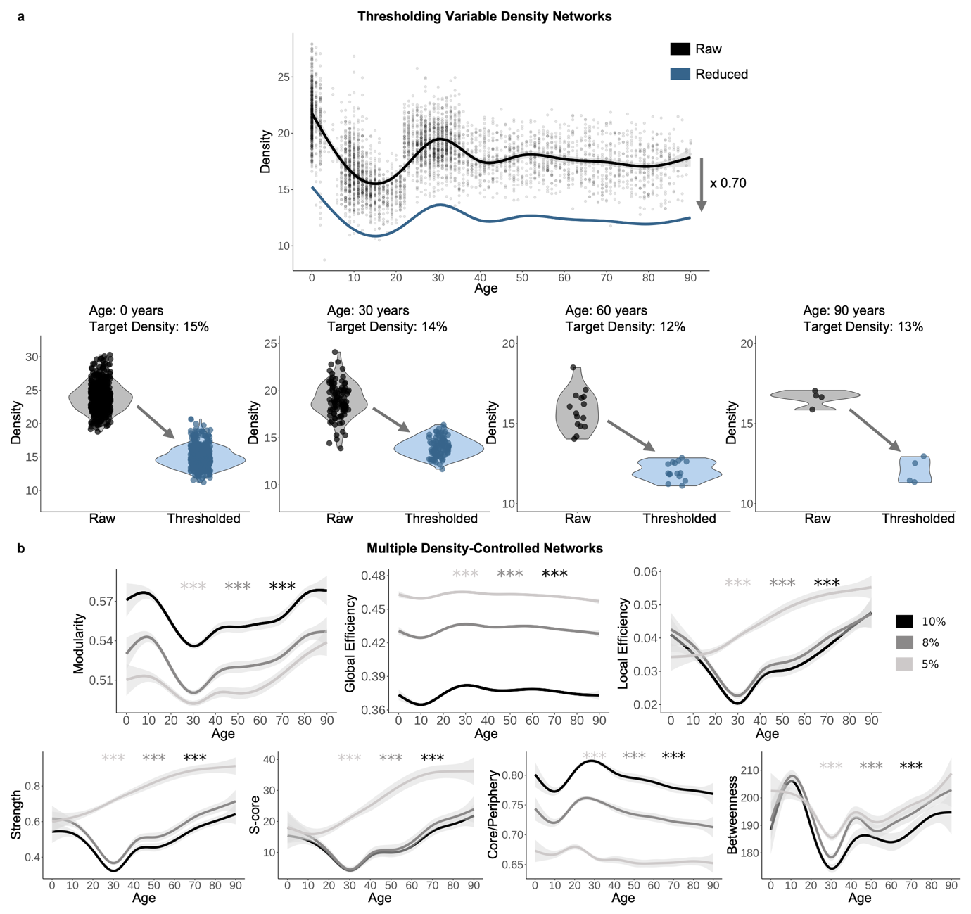
Supplementary Figure 1. Variable density thresholding procedure and exploration of multiple controlled-density levels. (a) Generalized additive model of unthresholded network density (‘Raw’) while controlling for sex, dataset, atlas, and neurodiversity group (neurotypical or neurodiverse). This regression was reduced by 30% (multiplied by 0.70), which was used to get age-specific target densities for thresholding (‘Reduced’). Violin plots show examples of density for age bins 0, 30, 60, and 90 years before thresholding (black) and after thresholding to target density (blue). (b) Sensitivity analysis for density-controlled thresholding where all networks have the same exact density. Seven topological measures significantly change across age across controlled density to 10%, 8%, and 5%. Trajectories indicate 10% and 8% have similar patterns, whereas very sparse networks (5%) show different patterns on some but not all metrics. *** indicates p < 0.001.

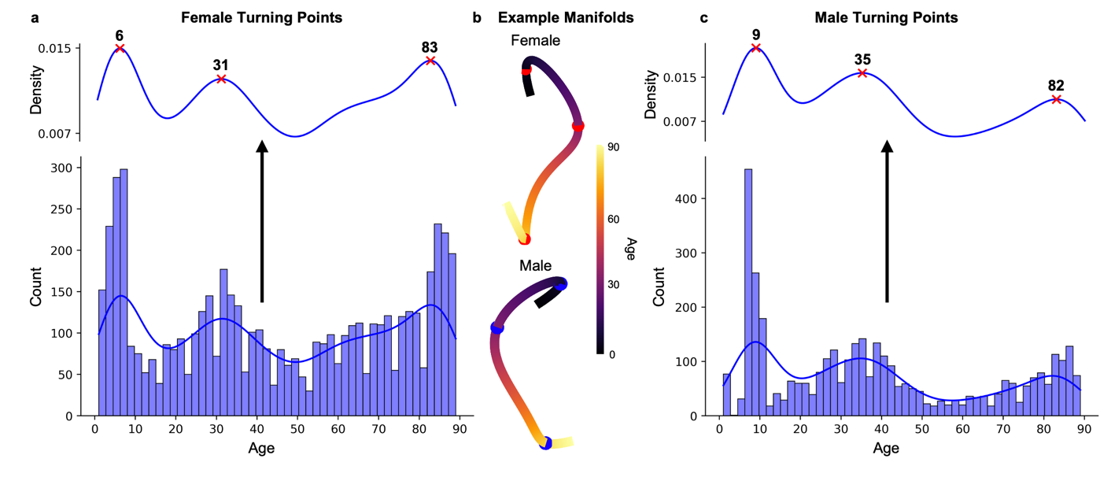Supplementary Figure 2. Sex-stratified turning points. (a) Across all turning points identified in female manifolds, major turning points converge around six, 31, and 83 years old. (b) Lines of best fit through example female and male manifolds. Red spheres identify turning points for females and blue spheres for males. (c) Major turning points occurred around nine, 35, and 82 years old across all turning points for males.

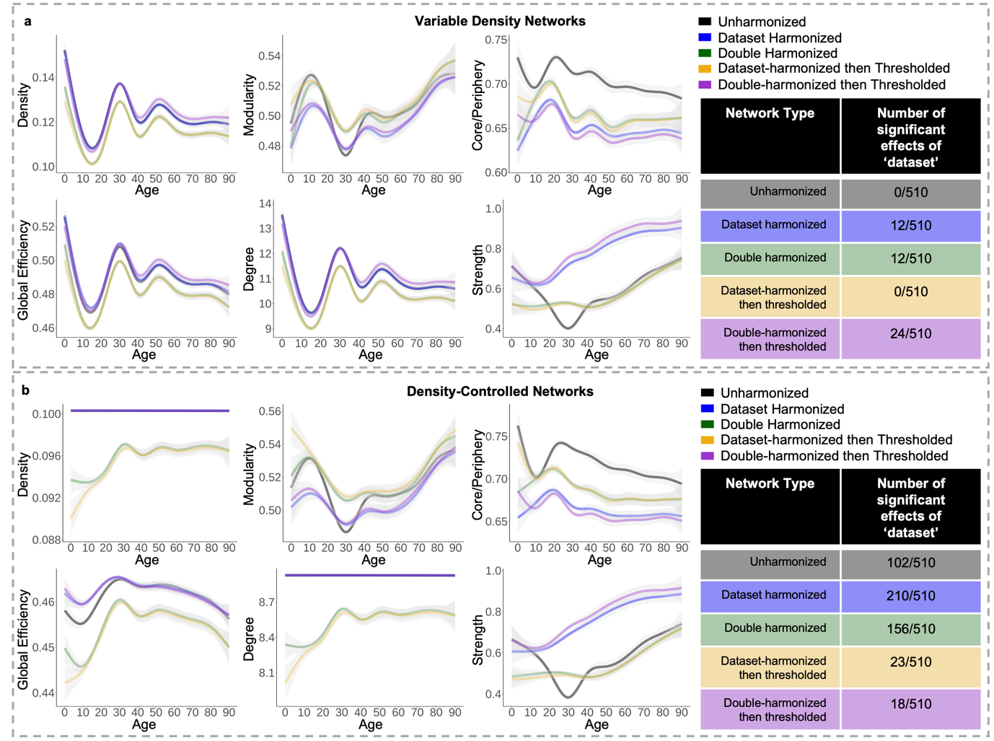
Supplementary Figure 3. Assessment of harmonization methods. (a) Variable density networks and (b) density-controlled networks with five different harmonization methods compared across density, modularity, core/periphery, global efficiency, average degree, and average strength across age. ‘Double’ harmonized refers to harmonizing across atlas and then dataset. The tables include the number of significant effects of dataset within age bins across all six measures after FDR correction.

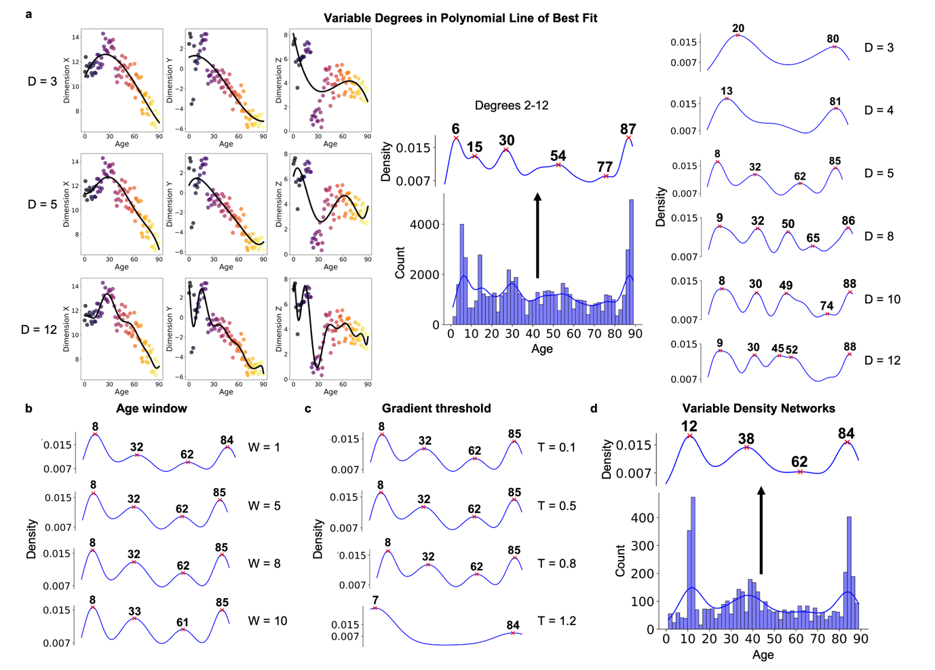
Supplementary Figure 4. Sensitivity analyses for turning points. (a) On the left is the manifold space with polynomial lines of best fit with degrees three, five, and 12. Visual inspection of these lines led to the decision to run the primary analysis with degree five. In the center, a histogram and density plot for all turning points identified with lines of best fit with degrees 2-12. Turning point density plots for lines of best fit with specific degrees on the right. These highlight that low degree lines (< 5) capture a teen to 20-year-old turning point, which disappears for higher degree lines – likely separating into the 8–9-year-old and 30–32-year-old turning points. High degree lines (> 8) additionally include two middle-to-late age turning points, falling between 50-74 years old, whereas a degree of 5 only has 62 years old as a turning point. (a) Multiple turning point density plots with various age windows demonstrate that from one to 10-year age windows, the four major turning points are highly consistent. (c) Multiple turning point density plots with various gradient thresholds highlight that the four turning points are stable across most thresholds. (d) Histogram and density plots for turning points identified in UMAP projection of variable density network topology. These sensitivity analyses suggest robust identification of turning points falling around 8, 32, 62, and 85 years old.

