Extended Data Figures
Extended Data Fig. 1 Flowchart for simulation of monthly species distribution. The methodology for this study is divided into three main parts. First, occurrences data were sourced from the Global Biodiversity Information Facility (GBIF), and environmental data were derived from global climate and weather data (WorldClim), as well as data layers representing water proportion and elevation. Range data for each species were utilized to eliminate outliers. Second, we thinned species data, followed by a careful process of filtering, cleaning, and selection. Environmental variables were subjected to rigorous selection to avoid collinearity and resampling to a common spatial resolution. Third, simulations were conducted on a monthly basis to capture temporal variation in species distribution. We employed an ensemble approach, averaging the outcomes of three models—random forests, maximum entropy, and extreme gradient boosting—to derive predictions. Then, the receiver operating characteristic (ROC) curve was used to assess performance of the simulations. Ultimately, this approach allowed successfully modelling of 779 waterbird species, resulting in 9036 monthly distribution maps.
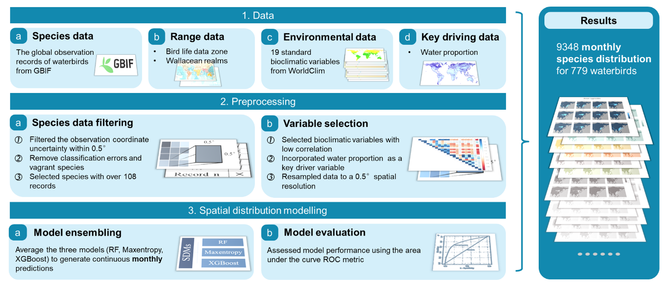

Extended Data Fig. 2 The process of waterbird species selection. Initially, we collected data on 1177 species across 15 orders. We excluded species not classified as waterbirds or those with fewer than 9 unique records in each month in the Global Biodiversity Information Facility (GBIF). We successfully modeled 779 waterbird species, among which 180 were confirmed hosts. Furthermore, we categorized the 779 species into five functional groups: seabirds, shorebirds, waterfowl, large wading birds, and others. Numerals in the figure correspond to the species count.
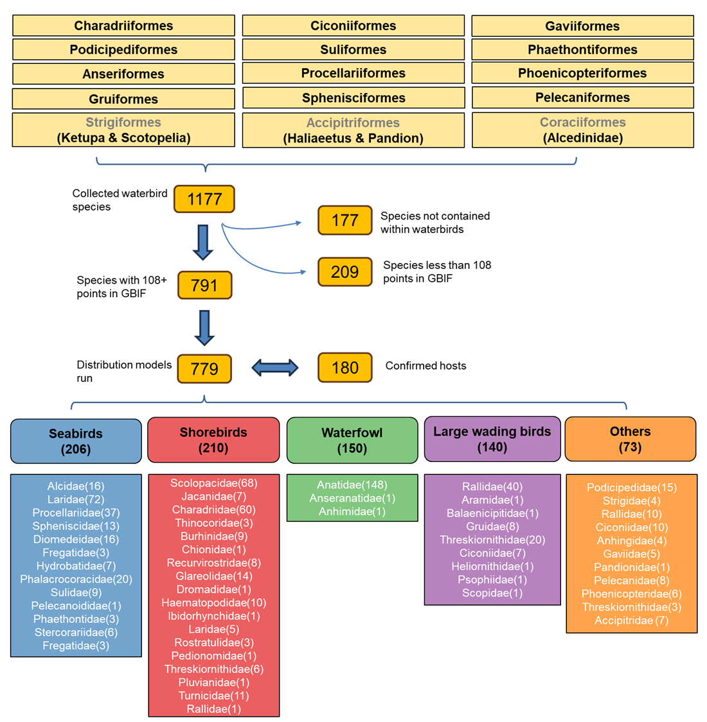

Extended Data Fig. 3 Monthly waterbird species richness and simulation of monthly distribution results. (a) Monthly waterbird species richness patterns. (b) Simulated monthly distribution results for the swan goose (Anser cygnoides). The titles in the figure correspond to the respective months, providing a clear temporal representation of species’ distribution patterns throughout the year.d
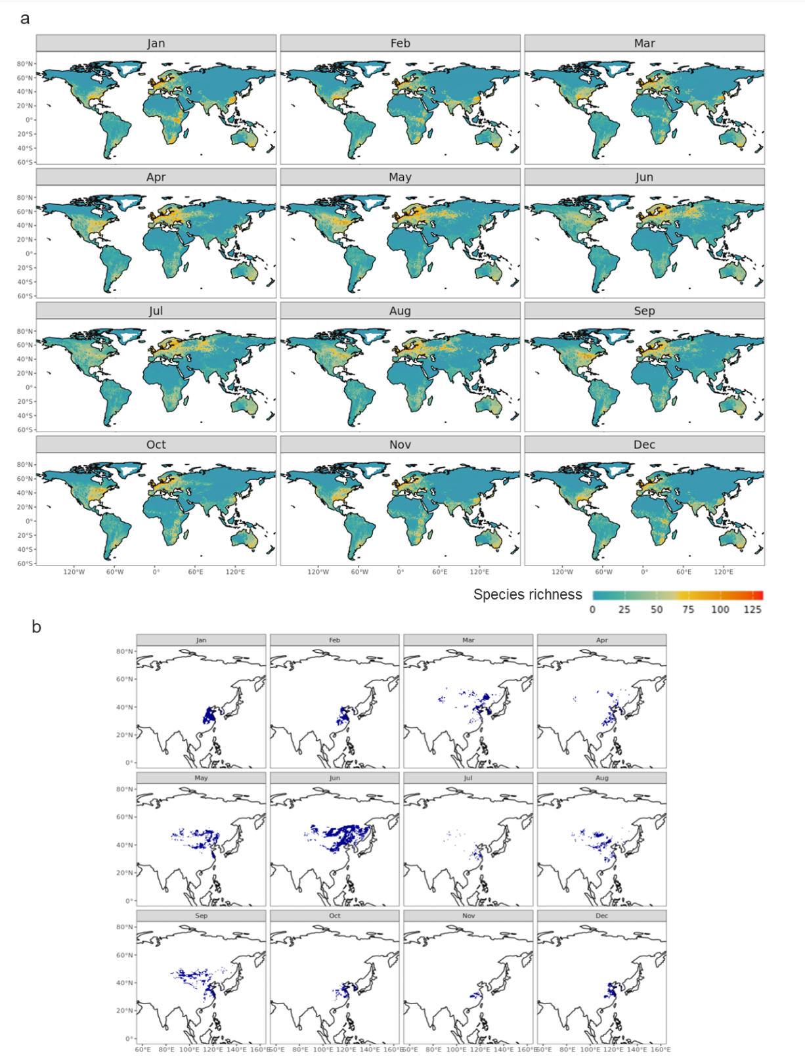

Extended Data Fig. 4 Scheme for definition of waterbird activity entropy (WAE) and identification of exposure risk hotspots. The diagram's top section illustrates concept of WAE, highlighting three risk dimensions: accumulated residence time, duration match (alignment of species' residency periods), and host species richness. Three scenarios are outlined: (1) Low WAE: high species richness but non-overlapping residence times, resulting in low AIV cross-species transmission risk. (2) Medium WAE: low species richness and residence time, with brief species encounters, leading to moderate AIV transmission risk. (3) High WAE: high species richness and residence time, increasing AIV transmission risk due to frequent species interactions. The middle section depicts AIV spillover risk from natural to artificial ecosystems, where WAE levels correlate with spillover magnitude, potentially causing outbreaks in artificial systems. The lower section identifies exposure risk hotspots by overlaying WAE with cattle, poultry, and human populations. Using the Youden index, high-risk areas were identified, with high-density populations based on the top 15th percentile of grid cells. Three exposure risk scenarios are shown: (1) Low exposure risk: low WAE areas, regardless of population density. (2) Specific population exposure risk: medium WAE with high cattle/poultry density but low human density, increasing exposure risk for livestock. (3) High exposure risk: high WAE with dense human, cattle, and poultry populations, representing the highest AIV transmission risk.
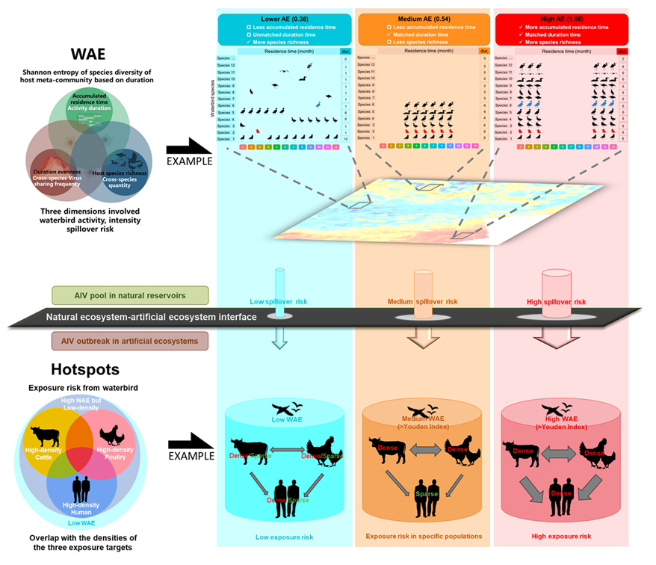

Extended Data Fig. 5 Seasonal analysis of global waterbird species richness based on monthly species distribution models. (a) Global waterbird pattern of peak months with highest seasonal variation in one year based on monthly species distribution models. The pie chart illustrates the percentage of each peak month. The locations of the eight typical cities on the drawing are on the map. (b) Monthly variation of seasonal migration of waterbirds and city examples with different migration seasons. Changes in species richness of eight typical cities are shown and classified into four types using an augmented Dickey-Fuller test. (c) Spatial distribution of classification of monthly changes in species richness. “Breeding Season Risk” refers to areas where the peak month occurs in the summer, whereas “Overwinter Season Risk” refers to areas where the peak month occurs in the winter. ‘NH’ denotes the Northern Hemisphere, and ‘SH’ denotes the Southern Hemisphere. “Other” indicates relatively smooth changes in monthly species richness.

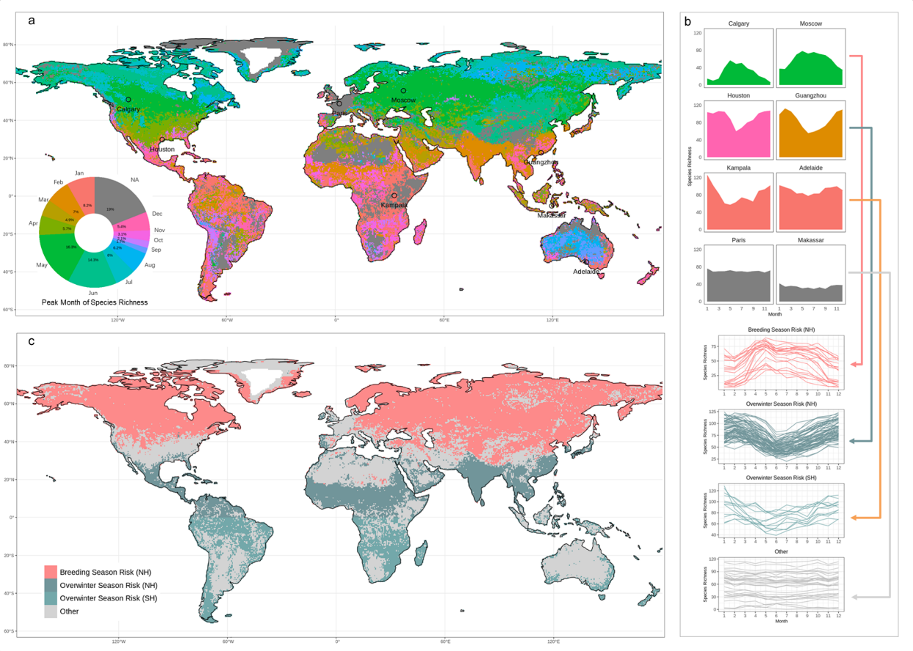

Extended Data Fig. 6 The relationship between species richness coefficient of variation (CV), gross primary productivity (GPP) coefficient of variation (CV), and between species richness CV and frost days. (a) The linear relationship between species richness CV and GPP CV across different Wallace’s realms. Red points and bars represent pixels derived from the Northern Hemisphere, while blue points and bars represent pixels derived from the Southern Hemisphere. Different shapes of points correspond to the six Wallace’s realms. (b) A detailed demonstration of the linear relationship between species richness CV and GPP CV within different Wallace’s realms, shown through sub-interfaces. (c) The linear relationship between species richness CV and frost days across different Wallace’s realms. Red points and bars represent pixels derived from the Northern Hemisphere, while blue points and bars represent pixels derived from the Southern Hemisphere. Different shapes of points correspond to the six Wallace’s realms. (d) A detailed demonstration of the linear relationship between species richness CV and frost days within different Wallace’s realms, shown through sub-interfaces.

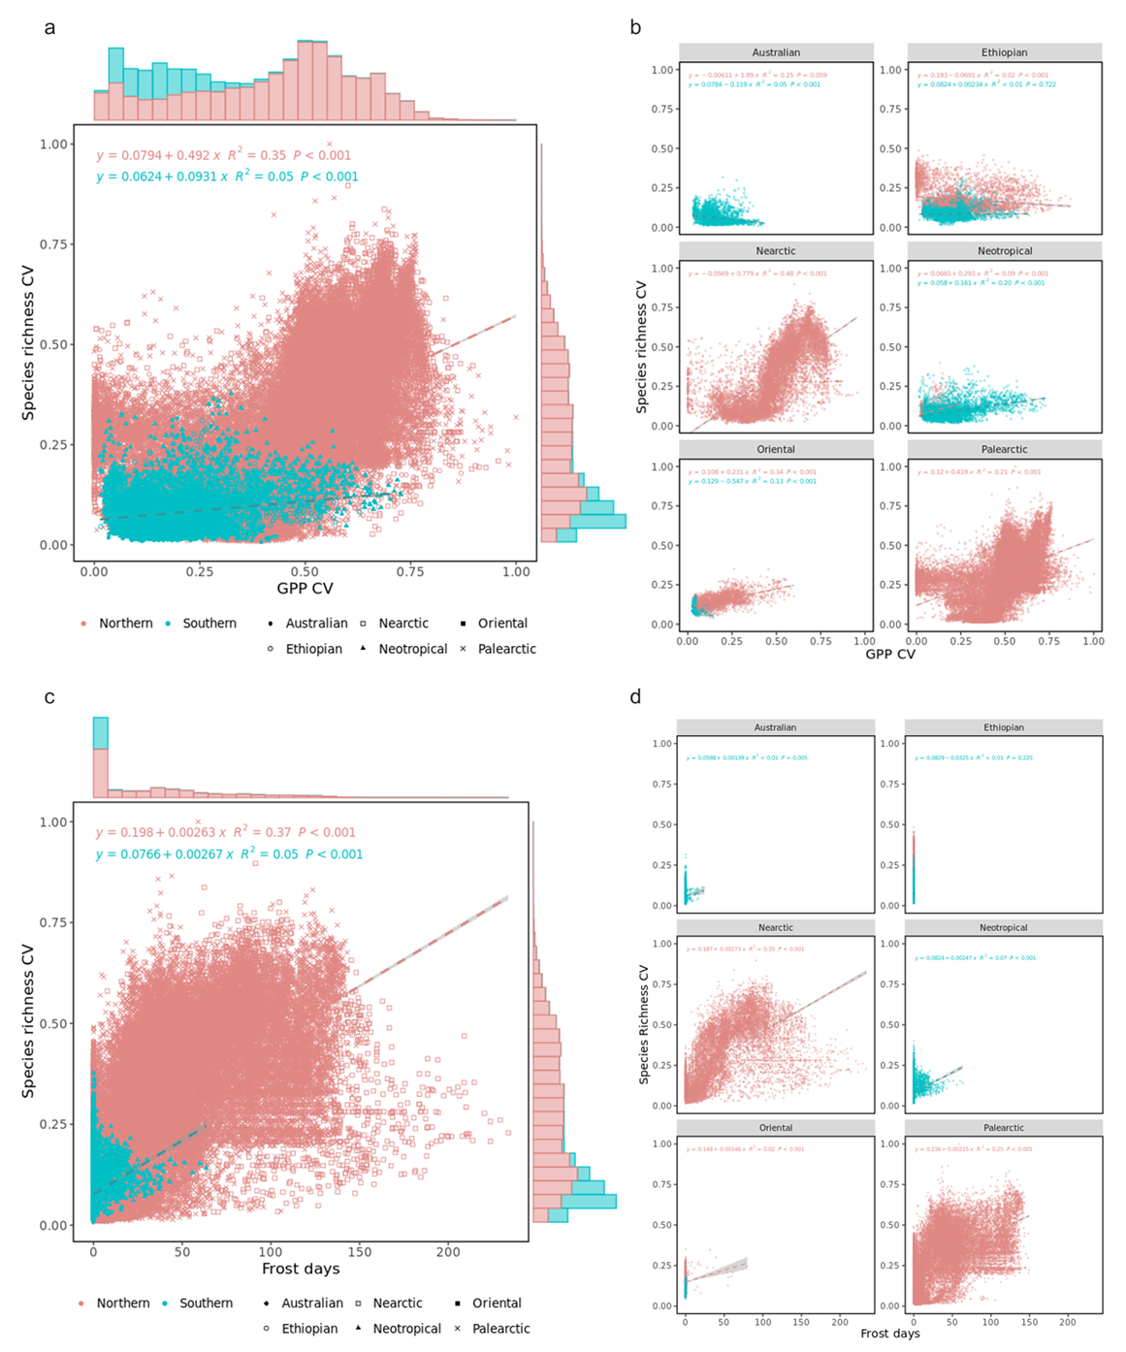

Extended Data Fig. 7 Validation of waterbird activity entropy (WAE) for predicting avian influenza. (a) Spatial distribution of high and low binary exposure risk areas and locations of reported different subtype cases. The high and low exposure risk areas has been divided by the optimal threshold of WAE (4.2), determined from the receiver operating characteristic (ROC) curve using the Youden Index. The red points represent the reported cases of H5N1 HPAI; violet points denote H5N5 HPAI cases; blue triangles indicate occurrences of H9N2 LPAI; and dark green points signify H7N3 HPAI reports. Cases of H5N2 HPAI are shown as dark red points, and H5N6 HPAI is represented by orange points. The purple points reflect H5N8 HPAI instances, and light green triangles mark reported cases of H7N9 LPAI. (b) Spatial distribution of high and low binary exposure risk areas and locations of different infected animals, humans and the environmental samples. Red points represent cases in poultry, whereas the dark red triangles indicate cases in wild birds. Domestic mammals are shown with purple points, and human-affected cases are marked with blue points. Environmental samples are represented by dark green squares, and wild mammal cases are shown with violet triangles. (c) The probability density of WAE. The histogram is colored gray for values ≤ 4.11 and yellow for values > 4.11. (d) Predictive sensitivity of different subtypes and various pathogenicities. The size of the circles indicates the number of reported cases. The dotted line represents the overall sensitivity. (e) Predictive sensitivity across different infected animals, humans and the environmental samples. The size of the circles indicates the number of reported cases. The dotted line represents the overall sensitivity.
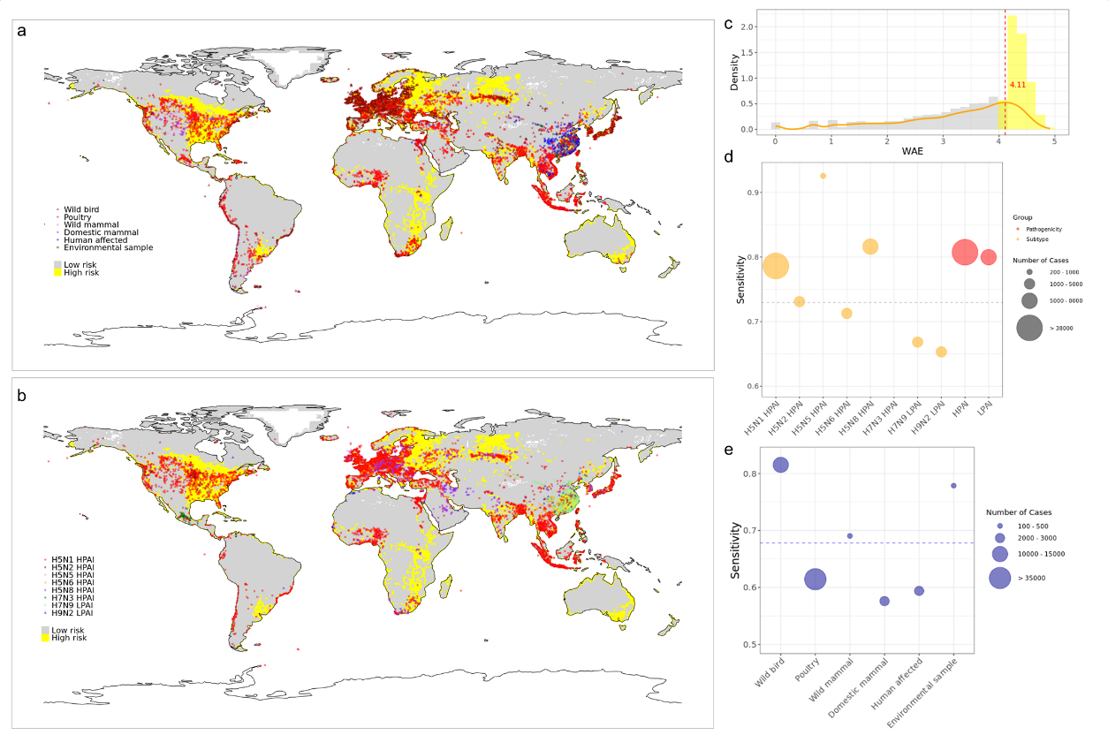

Extended Data Fig. 8 Global overlap patterns between waterbirds activity entropy (WAE) and human density, cattle density, and poultry density. The bivariate color maps illustrate the relationships among WAE and human density (a), cattle density (b), and poultry density (c). Regions in purple indicate areas with high activity entropy concurrent with high human, cattle, or poultry density. All variables are separated by the tenth percentile. Exposure risk areas for human density (WAE-Human) (d), cattle density (WAE-Cattle) (e), and poultry density (WAE-Poultry) (f) are identified. Statistics are provided on the area of WAE-Human, WAE-Cattle, and WAE-Poultry among different continents (g) and countries (h). Additionally, statistics on numbers of exposed populations within regions of WAE-Human, WAE-Cattle, and WAE-Poultry across different continents (i) and countries/regions (j).
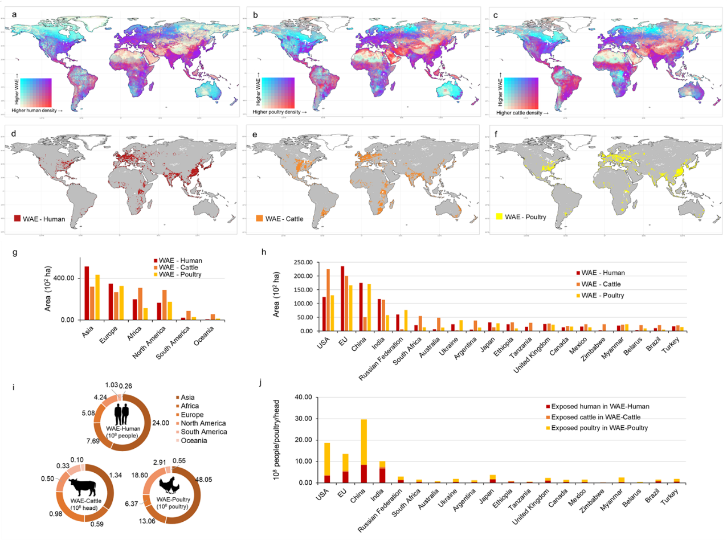

Extended Data Fig. 9 Statistics of area and exposed population in exposure hotspots. (a) Statistics on the number of exposed humans, cattle, and poultry within hotspots among different continents. Hotspots are categorized into poultry-exposed-zones, cattle- exposed-zones, human-exposed-zones, cattle-and-poultry-exposed zones, cattle-and-human-exposed zones, human-and-poultry-exposed zones, and human-cattle-and-poultry-exposed zones. (b) Statistics on the number of exposed humans, cattle, and poultry populations within hotspots among the key exposure countries/regions.
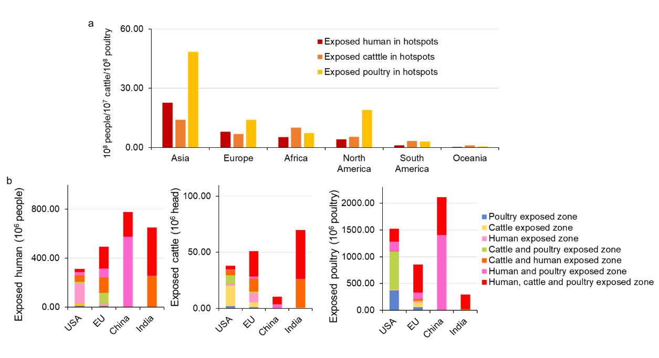

Extended Data Fig. 10 Waterbird functional groups with highest water activity entropy (WAE) in hotspots among key exposure countries/regions (USA, EU, China and India ). Each pixel is identified as one of the following functional groups with the highest WAE: seabirds, shorebirds, waterbirds, large wading birds, and others. This identification is based on confirmed avian influenza virus carrying hosts (a) or all suspected hosts (c). The numbers represent the count of pixels among waterbird functional group of confirmed hosts (b) or all suspected hosts (d) with highest WAE across hotspots in the different key exposure countries/regions.
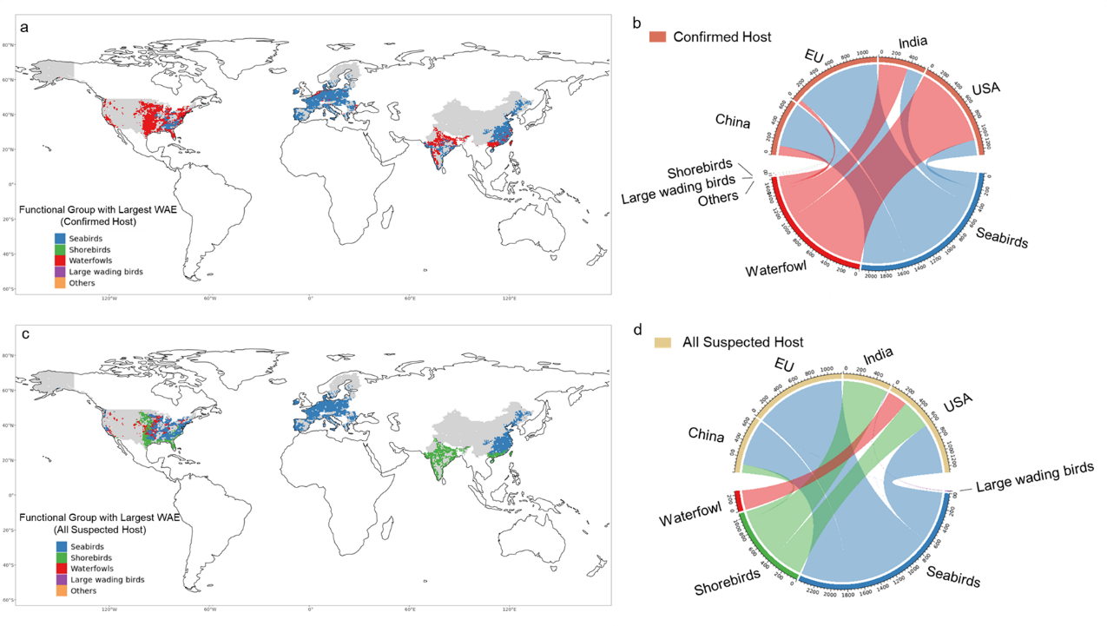

Extended Data Fig. 11 Comparative efficacy of different models in simulating waterbird species distribution. (a) Comparative analysis. Red boxplots/bars represent SDM models without water, while green boxplots/bars represent SDM models with water. This panel compares the overall AUC of SDM models with and without water bodies, facilitating an evaluation of model performance and predictive accuracy across different orders. (b) Comparison of the AUC for three distinct SDM models with and without water bodies. (c) Comparison of the AUC for simulations targeting different species with and without water bodies. We combined the outcomes of various modeling approaches to simulate the distribution patterns of waterbird species, enabling a comprehensive evaluation of model performance and predictive accuracy.
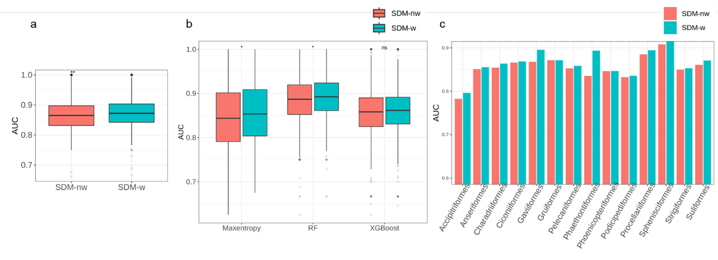

Extended Data Fig. 12 Drive analysis of waterbird activity entropy (WAE) in the key exposure countries/regions. (a) The Pearson correlation statistic between WAE and three groups of drivers. It was conducted across of key exposure countries/regions: the United States (USA), the European Union (EU), China, and India. These drivers were categorized into three groups: geographic and climate factors, vegetation indicator, and human activity factors. (b) The relationship between WAE and human density, cattle density, and poultry density, respectively; both populations density were log-transformed. (c) Mantel tests and Pearson's correlation matrix illustrate relationships between WAE of different waterbird functional group and three types of drivers in the USA, EU, China, and India. Mantel tests quantified the correlation between WAE and dependent drivers at five waterbird functional groups (seabirds, shorebirds, large wading birds, waterfowl and others). The line width corresponds to the partial Mantel's r-statistic for the corresponding correlation, and the solid lines indicate statistical significance. Pearson's correlation coefficient matrix shows the relationships among dependent drivers. Warm and cold colors represent the negative and positive correlations, respectively. The significant levels of Pearson's correlation among dependent drivers were indicated by square size. The three types of drivers include longitude (°), latitude (°), precipitation (mm), temperature (ºC), numbers of days below 0 ºC (Frost days), gross primary productivity (GPP, g C m⁻² day⁻¹), gross primary productivity coefficient of variation (CV of GPP), net primary productivity (NPP, g C m⁻² day⁻¹), normalized difference vegetation index (NDVI), normalized difference water index (NDWI), leaf area index (LAI), nighttime lights (Light density), road density (m per km²), human density (log-transformed, number per km²), and poultry density (log-transformed, number per km²).
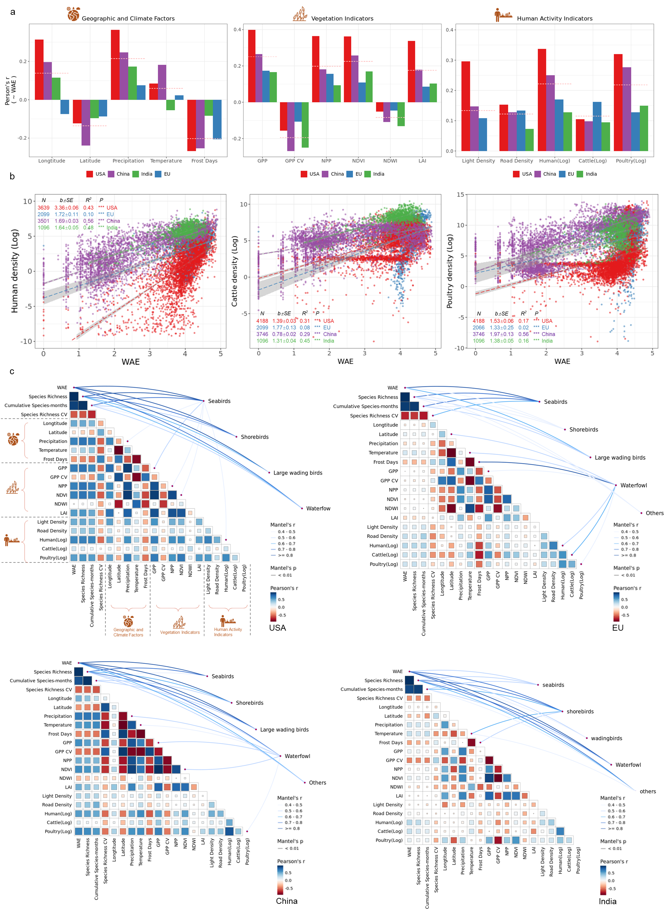

Extended Data Tables
Extended Data Table 1 List of waterbird species. This table provides a detailed enumeration of specific names and respective orders of the 779 waterbird species successfully simulated in this study.
Functional group  (numbers of species) | Species
seabirds  (206) | Alca torda, Alle alle, Anous minutus, Anous stolidus, Aphrodroma brevirostris, Aptenodytes forsteri, Aptenodytes patagonicus, Brachyramphus marmoratus, Bulweria bulwerii, Calonectris diomedea, Calonectris leucomelas, Cepphus carbo, Cepphus columba, Cepphus grylle, Cerorhinca monocerata, Chlidonias albostriatus, Chlidonias hybrida, Chlidonias leucopterus, Chlidonias niger, Chroicocephalus brunnicephalus, Chroicocephalus bulleri, Chroicocephalus cirrocephalus, Chroicocephalus genei, Chroicocephalus hartlaubii, Chroicocephalus novaehollandiae, Chroicocephalus philadelphia, Chroicocephalus ridibundus, Daption capense, Diomedea antipodensis, Diomedea epomophora, Diomedea exulans, Diomedea sanfordi, Eudyptes chrysocome, Eudyptes chrysolophus, Eudyptes pachyrhynchus, Eudyptula minor, Fratercula arctica, Fratercula cirrhata, Fratercula corniculata, Fregata ariel, Fregata magnificens, Fregata minor, Fregetta tropica, Fulmarus glacialis, Fulmarus glacialoides, Garrodia nereis, Gelochelidon macrotarsa, Gelochelidon nilotica, Glareola cinerea, Glareola ocularis, Gygis alba, Halobaena caerulea, Hydrobates melania, Hydrobates pelagicus, Hydrocoloeus minutus, Hydroprogne caspia, Ichthyaetus audouinii, Ichthyaetus hemprichii, Ichthyaetus ichthyaetus, Ichthyaetus leucophthalmus, Ichthyaetus melanocephalus, Larus argentatus, Larus armenicus, Larus cachinnans, Larus californicus, Larus canus, Larus crassirostris, Larus delawarensis, Larus dominicanus, Larus fuscus, Larus glaucescens, Larus glaucoides, Larus heermanni, Larus hyperboreus, Larus livens, Larus marinus, Larus michahellis, Larus occidentalis, Larus pacificus, Larus schistisagus, Larus smithsonianus, Larus vegae, Leucophaeus atricilla, Macronectes giganteus, Macronectes halli, Megadyptes antipodes, Microcarbo africanus, Microcarbo coronatus, Microcarbo melanoleucos, Microcarbo niger, Microcarbo pygmaeus, Morus bassanus, Morus capensis, Morus serrator, Oceanites gracilis, Oceanites oceanicus, Onychoprion anaethetus, Onychoprion fuscatus, Pachyptila belcheri, Pachyptila desolata, Pachyptila salvini, Pachyptila turtur, Pagodroma nivea, Pagophila eburnea, Pelagodroma marina, Pelecanoides urinatrix, Phaethon aethereus, Phaethon lepturus, Phaethon rubricauda, Phaetusa simplex, Phalacrocorax aristotelis, Phalacrocorax auritus, Phalacrocorax brasilianus, Phalacrocorax capensis, Phalacrocorax capillatus, Phalacrocorax carbo, Phalacrocorax fuscescens, Phalacrocorax fuscicollis, Phalacrocorax lucidus, Phalacrocorax pelagicus, Phalacrocorax penicillatus, Phalacrocorax punctatus, Phalacrocorax sulcirostris, Phalacrocorax urile, Phalacrocorax varius, Phoebastria albatrus, Phoebastria immutabilis, Phoebastria nigripes, Phoebetria palpebrata, Procellaria aequinoctialis, Procellaria cinerea, Procellaria parkinsoni, Procellaria westlandica, Pseudobulweria rostrata, Pterodroma cookii, Pterodroma inexpectata, Pterodroma lessonii, Pterodroma leucoptera, Pterodroma macroptera, Pterodroma nigripennis, Pterodroma solandri, Ptychoramphus aleuticus, Puffinus assimilis, Puffinus gavia, Puffinus huttoni, Puffinus lherminieri, Puffinus mauretanicus, Puffinus opisthomelas, Puffinus persicus, Puffinus puffinus, Puffinus yelkouan, Pygoscelis adeliae, Pygoscelis antarcticus, Pygoscelis papua, Rissa tridactyla, Spheniscus demersus, Spheniscus humboldti, Spheniscus magellanicus, Stercorarius antarcticus, Stercorarius longicaudus, Stercorarius maccormicki, Stercorarius parasiticus, Stercorarius pomarinus, Stercorarius skua, Sterna dougallii, Sterna forsteri, Sterna hirundinacea, Sterna hirundo, Sterna paradisaea, Sterna repressa, Sterna striata, Sterna sumatrana, Sterna trudeaui, Sterna vittata, Sternula albifrons, Sternula antillarum, Sternula balaenarum, Sternula nereis, Sternula superciliaris, Sula dactylatra, Sula granti, Sula leucogaster, Sula nebouxii, Sula sula, Sula variegata, Synthliboramphus antiquus, Synthliboramphus craveri, Synthliboramphus scrippsi, Tachybaptus pelzelnii, Thalassarche bulleri, Thalassarche carteri, Thalassarche cauta, Thalassarche chlororhynchos, Thalassarche chrysostoma, Thalassarche impavida, Thalassarche melanophris, Thalassarche salvini, Thalasseus acuflavidus, Thalasseus bengalensis, Thalasseus bergii, Thalasseus elegans, Thalasseus maximus, Thalasseus sandvicensis, Thalassoica antarctica, Uria aalge, Uria lomvia
shorebirds  (210) | Actitis hypoleucos, Actitis macularius, Actophilornis africanus, Amaurornis flavirostra, Anarhynchus frontalis, Arenaria interpres, Arenaria melanocephala, Attagis gayi, Bartramia longicauda, Burhinus bistriatus, Burhinus capensis, Burhinus grallarius, Burhinus indicus, Burhinus oedicnemus, Burhinus senegalensis, Burhinus vermiculatus, Calidris acuminata, Calidris alba, Calidris alpina, Calidris bairdii, Calidris canutus, Calidris falcinellus, Calidris ferruginea, Calidris fuscicollis, Calidris himantopus, Calidris maritima, Calidris mauri, Calidris melanotos, Calidris minuta, Calidris minutilla, Calidris ptilocnemis, Calidris pugnax, Calidris pusilla, Calidris pygmaea, Calidris ruficollis, Calidris subminuta, Calidris subruficollis, Calidris temminckii, Calidris tenuirostris, Calidris virgata, Charadrius alexandrinus, Charadrius asiaticus, Charadrius bicinctus, Charadrius collaris, Charadrius dealbatus, Charadrius dubius, Charadrius falklandicus, Charadrius forbesi, Charadrius hiaticula, Charadrius leschenaultii, Charadrius marginatus, Charadrius melodus, Charadrius modestus, Charadrius mongolus, Charadrius montanus, Charadrius nivosus, Charadrius pallidus, Charadrius pecuarius, Charadrius peronii, Charadrius placidus, Charadrius ruficapillus, Charadrius semipalmatus, Charadrius thoracicus, Charadrius tricollaris, Charadrius veredus, Charadrius vociferus, Charadrius wilsonia, Chionis albus, Cladorhynchus leucocephalus, Cursorius coromandelicus, Cursorius cursor, Cursorius rufus, Cursorius somalensis, Cursorius temminckii, Dromas ardeola, Elseyornis melanops, Erythrogonys cinctus, Esacus magnirostris, Esacus recurvirostris, Gallinago delicata, Gallinago gallinago, Gallinago hardwickii, Gallinago macrodactyla, Gallinago media, Gallinago megala, Gallinago nigripennis, Gallinago paraguaiae, Gallinago stenura, Glareola lactea, Glareola maldivarum, Glareola nordmanni, Glareola nuchalis, Glareola pratincola, Haematopus ater, Haematopus bachmani, Haematopus finschi, Haematopus fuliginosus, Haematopus leucopodus, Haematopus longirostris, Haematopus moquini, Haematopus ostralegus, Haematopus palliatus, Haematopus unicolor, Himantopus himantopus, Himantopus leucocephalus, Himantopus mexicanus, Hoploxypterus cayanus, Hydrophasianus chirurgus, Ibidorhyncha struthersii, Irediparra gallinacea, Jacana jacana, Jacana spinosa, Leucophaeus pipixcan, Limnodromus griseus, Limnodromus scolopaceus, Limnodromus semipalmatus, Limosa fedoa, Limosa haemastica, Limosa lapponica, Limosa limosa, Lymnocryptes minimus, Metopidius indicus, Microparra capensis, Numenius americanus, Numenius arquata, Numenius madagascariensis, Numenius minutus, Numenius phaeopus, Nycticryphes semicollaris, Oreopholus ruficollis, Pedionomus torquatus, Peltohyas australis, Phalaropus fulicarius, Phalaropus lobatus, Phegornis mitchellii, Platalea ajaja, Platalea alba, Platalea flavipes, Platalea leucorodia, Platalea minor, Platalea regia, Pluvialis apricaria, Pluvialis dominica, Pluvialis fulva, Pluvialis squatarola, Pluvianus aegyptius, Recurvirostra americana, Recurvirostra andina, Recurvirostra avosetta, Recurvirostra novaehollandiae, Rhinoptilus africanus, Rhinoptilus chalcopterus, Rhinoptilus cinctus, Rostratula australis, Rostratula benghalensis, Rynchops albicollis, Rynchops flavirostris, Rynchops niger, Scolopax minor, Scolopax rusticola, Sterna aurantia, Stiltia isabella, Thinocorus orbignyianus, Thinocorus rumicivorus, Thinornis cucullatus, Tringa brevipes, Tringa erythropus, Tringa flavipes, Tringa glareola, Tringa incana, Tringa melanoleuca, Tringa nebularia, Tringa ochropus, Tringa semipalmata, Tringa solitaria, Tringa stagnatilis, Tringa totanus, Turnix castanotus, Turnix hottentottus, Turnix maculosus, Turnix melanogaster, Turnix nanus, Turnix nigricollis, Turnix pyrrhothorax, Turnix suscitator, Turnix sylvaticus, Turnix varius, Turnix velox, Vanellus albiceps, Vanellus armatus, Vanellus chilensis, Vanellus cinereus, Vanellus coronatus, Vanellus crassirostris, Vanellus duvaucelii, Vanellus gregarius, Vanellus indicus, Vanellus leucurus, Vanellus lugubris, Vanellus malabaricus, Vanellus melanopterus, Vanellus miles, Vanellus resplendens, Vanellus senegallus, Vanellus spinosus, Vanellus superciliosus, Vanellus tectus, Vanellus tricolor, Vanellus vanellus, Xenus cinereus
waterfowl  (150) | Aix galericulata, Aix sponsa, Alopochen aegyptiaca, Amazonetta brasiliensis, Anas acuta, Anas andium, Anas bahamensis, Anas bernieri, Anas capensis, Anas carolinensis, Anas castanea, Anas chlorotis, Anas crecca, Anas diazi, Anas erythrorhyncha, Anas flavirostris, Anas fulvigula, Anas georgica, Anas gibberifrons, Anas gracilis, Anas melleri, Anas platyrhynchos, Anas poecilorhyncha, Anas rubripes, Anas sparsa, Anas superciliosa, Anas undulata, Anas zonorhyncha, Anser albifrons, Anser anser, Anser brachyrhynchus, Anser caerulescens, Anser cygnoides, Anser erythropus, Anser fabalis, Anser indicus, Anser rossii, Anser serrirostris, Anseranas semipalmata, Aythya affinis, Aythya americana, Aythya australis, Aythya baeri, Aythya collaris, Aythya ferina, Aythya fuligula, Aythya marila, Aythya novaeseelandiae, Aythya nyroca, Aythya valisineria, Biziura lobata, Branta bernicla, Branta canadensis, Branta hutchinsii, Branta leucopsis, Branta ruficollis, Bucephala albeola, Bucephala clangula, Bucephala islandica, Cairina moschata, Callonetta leucophrys, Cereopsis novaehollandiae, Chauna torquata, Chenonetta jubata, Chloephaga hybrida, Chloephaga melanoptera, Chloephaga picta, Chloephaga poliocephala, Chloephaga rubidiceps, Clangula hyemalis, Coscoroba coscoroba, Cygnus atratus, Cygnus buccinator, Cygnus columbianus, Cygnus cygnus, Cygnus melancoryphus, Cygnus olor, Dendrocygna arcuata, Dendrocygna autumnalis, Dendrocygna bicolor, Dendrocygna eytoni, Dendrocygna guttata, Dendrocygna javanica, Dendrocygna viduata, Heteronetta atricapilla, Histrionicus histrionicus, Hymenolaimus malacorhynchos, Lophodytes cucullatus, Lophonetta specularioides, Malacorhynchus membranaceus, Mareca americana, Mareca falcata, Mareca penelope, Mareca sibilatrix, Mareca strepera, Marmaronetta angustirostris, Melanitta americana, Melanitta deglandi, Melanitta fusca, Melanitta nigra, Melanitta perspicillata, Melanitta stejnegeri, Merganetta armata, Mergellus albellus, Mergus merganser, Mergus serrator, Mergus squamatus, Netta erythrophthalma, Netta peposaca, Netta rufina, Nettapus auritus, Nettapus coromandelianus, Nettapus pulchellus, Nomonyx dominicus, Oxyura australis, Oxyura ferruginea, Oxyura jamaicensis, Oxyura leucocephala, Oxyura maccoa, Oxyura vittata, Plectropterus gambensis, Polysticta stelleri, Pteronetta hartlaubii, Radjah radjah, Sarkidiornis melanotos, Sarkidiornis sylvicola, Sibirionetta formosa, Somateria fischeri, Somateria mollissima, Somateria spectabilis, Spatula clypeata, Spatula cyanoptera, Spatula discors, Spatula hottentota, Spatula platalea, Spatula puna, Spatula querquedula, Spatula rhynchotis, Spatula smithii, Spatula versicolor, Speculanas specularis, Stictonetta naevosa, Tachyeres patachonicus, Tachyeres pteneres, Tadorna cana, Tadorna ferruginea, Tadorna tadorna, Tadorna tadornoides, Tadorna variegata, Thalassornis leuconotus
large wading birds  (140) | Agamia agami, Anthropoides paradiseus, Anthropoides virgo, Aramides albiventris, Aramides saracura, Aramides ypecaha, Aramus guarauna, Ardea alba, Ardea cinerea, Ardea cocoi, Ardea goliath, Ardea herodias, Ardea humbloti, Ardea melanocephala, Ardea pacifica, Ardea purpurea, Ardea sumatrana, Ardeola bacchus, Ardeola grayii, Ardeola idae, Ardeola ralloides, Ardeola rufiventris, Ardeola speciosa, Balaeniceps rex, Balearica pavonina, Balearica regulorum, Bostrychia carunculata, Bostrychia hagedash, Bostrychia olivacea, Bostrychia rara, Botaurus lentiginosus, Botaurus pinnatus, Botaurus poiciloptilus, Botaurus stellaris, Bubulcus coromandus, Bubulcus ibis, Butorides striata, Butorides virescens, Cercibis oxycerca, Ciconia abdimii, Ciconia boyciana, Ciconia ciconia, Ciconia episcopus, Ciconia maguari, Ciconia microscelis, Ciconia nigra, Cochlearius cochlearius, Crex crex, Crex egregia, Dryolimnas cuvieri, Egretta ardesiaca, Egretta caerulea, Egretta dimorpha, Egretta eulophotes, Egretta garzetta, Egretta gularis, Egretta intermedia, Egretta novaehollandiae, Egretta picata, Egretta rufescens, Egretta sacra, Egretta thula, Egretta tricolor, Egretta vinaceigula, Eudocimus albus, Eudocimus ruber, Fulica americana, Fulica ardesiaca, Fulica armillata, Fulica atra, Fulica cristata, Fulica gigantea, Fulica leucoptera, Fulica rufifrons, Gallicrex cinerea, Gallinula angulata, Gallinula chloropus, Gallinula tenebrosa, Gallirallus australis, Geronticus calvus, Geronticus eremita, Gorsachius leuconotus, Gorsachius melanolophus, Grus americana, Grus grus, Grus japonensis, Grus nigricollis, Ixobrychus cinnamomeus, Ixobrychus dubius, Ixobrychus eurhythmus, Ixobrychus exilis, Ixobrychus involucris, Ixobrychus minutus, Ixobrychus sinensis, Ixobrychus sturmii, Laterallus albigularis, Laterallus melanophaius, Lewinia pectoralis, Lophotibis cristata, Mesembrinibis cayennensis, Nyctanassa violacea, Nycticorax caledonicus, Nycticorax nycticorax, Pardirallus maculatus, Pardirallus nigricans, Pardirallus sanguinolentus, Phimosus infuscatus, Pilherodius pileatus, Plegadis chihi, Plegadis falcinellus, Plegadis ridgwayi, Podica senegalensis, Porphyrio alleni, Porphyrio melanotus, Porphyrio porphyrio, Porzana carolina, Porzana fluminea, Porzana porzana, Pseudibis papillosa, Psophia crepitans, Rallina eurizonoides, Rallus aquaticus, Rallus caerulescens, Rallus crepitans, Rallus elegans, Rallus indicus, Rallus limicola, Rallus obsoletus, Sarothrura pulchra, Scopus umbretta, Syrigma sibilatrix, Theristicus caerulescens, Theristicus caudatus, Theristicus melanopis, Threskiornis bernieri, Tigriornis leucolopha, Tigrisoma fasciatum, Tigrisoma lineatum, Tigrisoma mexicanum, Zebrilus undulatus
others  (73) | Aechmophorus clarkii, Aechmophorus occidentalis, Amaurornis phoenicurus, Anastomus lamelligerus, Anastomus oscitans, Anhinga anhinga, Anhinga melanogaster, Anhinga novaehollandiae, Anhinga rufa, Ephippiorhynchus asiaticus, Ephippiorhynchus senegalensis, Eulabeornis castaneoventris, Gavia adamsii, Gavia arctica, Gavia immer, Gavia pacifica, Gavia stellata, Haliaeetus albicilla, Haliaeetus leucocephalus, Haliaeetus leucogaster, Haliaeetus leucoryphus, Haliaeetus pelagicus, Haliaeetus vocifer, Haliaeetus vociferoides, Himantornis haematopus, Jabiru mycteria, Ketupa ketupu, Ketupa zeylonensis, Leptoptilos crumenifer, Leptoptilos javanicus, Mentocrex kioloides, Mycteria americana, Mycteria ibis, Mycteria leucocephala, Pandion haliaetus, Pelecanus conspicillatus, Pelecanus crispus, Pelecanus erythrorhynchos, Pelecanus occidentalis, Pelecanus onocrotalus, Pelecanus philippensis, Pelecanus rufescens, Pelecanus thagus, Phoeniconaias minor, Phoenicoparrus andinus, Phoenicoparrus jamesi, Phoenicopterus chilensis, Phoenicopterus roseus, Phoenicopterus ruber, Podiceps auritus, Podiceps cristatus, Podiceps grisegena, Podiceps major, Podiceps nigricollis, Podiceps occipitalis, Podilymbus podiceps, Poliocephalus poliocephalus, Poliocephalus rufopectus, Rallus madagascariensis, Rollandia rolland, Sarothrura affinis, Sarothrura boehmi, Sarothrura elegans, Sarothrura insularis, Sarothrura rufa, Scotopelia bouvieri, Scotopelia peli, Tachybaptus dominicus, Tachybaptus novaehollandiae, Tachybaptus ruficollis, Threskiornis aethiopicus, Threskiornis melanocephalus, Threskiornis spinicollis

Extended Data Table 2 Data sources. This table outlines the diverse range of data sources utilized in our analysis, providing a detailed description of each covariate, and the origin of the data.

Covariate | Description | Data source
Waterbird records | Observation records of waterbirds | GBIF
Water proportion | The ratio of water volume compared to the total volume in a given area | Copernicus Global Land Service
BirdLife data zone | The geographic area occupied by a bird species throughout its life cycle | BirdLife International
Wallace's realms | The biogeographic region defined by 19th-century British naturalist Alfred Russel Wallace | Wallace, 1876
Positive presence of AIV cases | Reported Avian Influenza Virus (AIV) cases | FAO
National GDP | Gross Domestic Product of a nation | Natural earth data
National human population | The total count of individuals in a nation | Natural earth data
Urban boundaries | Vector data for 258 countries in the world | Natural earth data
Human density | Human population density (people/km²) | GPWv4
Poultry density | Chicken and duck population density (poultry/km²) | GLW 4
Cattle density | Cattle population density (head/km²) | GLW 4
Confirmed host | Waterbird species confirmed to be carriers of Avian Influenza Virus (AIV) | Shu and McCauley, 2017
GPP (monthly) | Gross Primary Productivity measured monthly | Zhang et al., 2017
Precipitation | Annual precipitation (mm) | WorldClim V2.1
Temperature | Annual temperatures (℃) | WorldClim V2.1
Frost Days | Days per year when the temperature falls below 0 ℃, calculated from annual temperatures | WorldClim V2.1
NPP | Net Primary Productivity | MOD17A3
NDVI | Normalized Difference Vegetation Index | MOD13A2 V6.1
NDWI | Normalized Difference Water Index | MOD09A1 V6.1
LAI | Leaf Area Index | NOAA-CDR
Nighttime lights density | The intensity of artificial nighttime lights in an area | Earth Observation Group
Road density | The length of roads per unit area | FAO

Extended Data Table 3 The relationships between waterbird activity entropy (WAE) and human, cattle or poultry density among different functional groups of confirmed host and all suspected host in EU, China and India. ‘n_{CH}’ the represents the number of confirmed hosts and ‘N’ represents the number of all suspected hosts (all waterbirds). ‘b’ represents slope of linear regression, ‘SE’ represents standard error, and ‘R²’ represents coefficient of determination, respectively.
Region | Functional  Group | n_{CH} | N | n_{CH}/N | ~ Human density (Log) |  |  |  | ~ Cattle density (Log) |  |  |  | ~ Poultry density (Log)
 |  |  |  |  | Confirmed Host |  | All Suspected Host |  | Confirmed Host |  | All Suspected Host |  | Confirmed Host |  | All Suspected Host
 |  |  |  |  | b±SE | R² | b±SE | R ² | b±SE | R ² | b±SE | R ² | b±SE | R ² | b±SE | R ²
EU | Seabirds | 28 | 61 | 45.90% | 1.46 ± 0.13 | 0.11 | 0.86 ± 0.10 | 0.06 | 1.40 ± 0.15 | 0.08 | 0.84 ± 0.12 | 0.05 | 1.42 ± 0.20 | 0.05 | 0.71 ± 0.15 | 0.02
EU | Shorebirds | 12 | 44 | 27.27% | 0.68 ± 0.19 | 0.01 | -0.63 ± 0.13 | 0.02 | 1.68 ± 0.21 | 0.06 | -0.13 ± 0.15 | 0.00 | -0.44 ± 0.28 | 0.00 | -0.73 ± 0.20 | 0.01
EU | Waterfowl | 40 | 45 | 88.89% | 0.73 ± 0.09 | 0.06 | 0.63 ± 0.09 | 0.04 | 0.52 ± 0.10 | 0.02 | 0.38 ± 0.10 | 0.01 | 1.17 ± 0.13 | 0.07 | 0.98 ± 0.13 | 0.05
EU | Large wading birds | 4 | 21 | 19.05% | 0.47 ± 0.15 | 0.01 | 0.93 ± 0.09 | 0.09 | -0.42 ± 0.15 | 0.01 | 0.49 ± 0.10 | 0.02 | 0.31 ± 0.25 | 0.00 | 1.77 ± 0.15 | 0.12
EU | Others | 10 | 17 | 58.82% | 1.00 ± 0.12 | 0.07 | 0.67 ± 0.13 | 0.02 | 0.50 ± 0.13 | 0.01 | -0.01 ± 0.15 | 0.00 | 1.82 ± 0.17 | 0.10 | 1.19 ± 0.19 | 0.03
China | Seabirds | 28 | 78 | 35.90% | 1.33 ± 0.05 | 0.34 | 1.45 ± 0.04 | 0.43 | 0.18 ± 0.04 | 0.01 | 0.27 ± 0.03 | 0.04 | 2.13 ± 0.06 | 0.44 | 2.12 ± 0.05 | 0.51
China | Shorebirds | 12 | 69 | 17.39% | 0.92 ± 0.09 | 0.09 | 1.59 ± 0.05 | 0.39 | -0.30 ± 0.09 | 0.01 | 0.29 ± 0.04 | 0.03 | 1.67 ± 0.11 | 0.17 | 2.48 ± 0.05 | 0.52
China | Waterfowl | 38 | 47 | 80.85% | 1.79 ± 0.05 | 0.34 | 1.73 ± 0.05 | 0.34 | 0.52 ± 0.04 | 0.06 | 0.51 ± 0.04 | 0.06 | 2.48 ± 0.06 | 0.42 | 2.47 ± 0.06 | 0.43
China | Large wading birds | 4 | 33 | 12.12% | 2.55 ± 0.15 | 0.21 | 1.58 ± 0.05 | 0.39 | 0.06 ± 0.20 | 0.00 | 0.55 ± 0.05 | 0.07 | 3.43 ± 0.19 | 0.22 | 2.37 ± 0.06 | 0.50
China | Others | 9 | 21 | 42.86% | 0.49 ± 0.11 | 0.02 | 1.54 ± 0.09 | 0.17 | -0.35 ± 0.11 | 0.01 | 0.14 ± 0.09 | 0.00 | 1.21 ± 0.15 | 0.05 | 2.73 ± 0.11 | 0.29
India | Seabirds | 24 | 59 | 40.68% | 0.33 ± 0.09 | 0.02 | 0.26 ± 0.07 | 0.02 | 0.19 ± 0.08 | 0.01 | 0.20 ± 0.06 | 0.01 | 0.91 ± 0.16 | 0.04 | 0.54 ± 0.13 | 0.02
India | Shorebirds | 12 | 68 | 17.65% | 0.03 ± 0.11 | 0.00 | 1.15 ± 0.07 | 0.24 | -0.28 ± 0.09 | 0.02 | 0.91 ± 0.07 | 0.20 | 0.46 ± 0.19 | 0.01 | 0.83 ± 0.16 | 0.04
India | Waterfowl | 22 | 28 | 78.57% | 0.39 ± 0.07 | 0.04 | 0.68 ± 0.09 | 0.08 | 0.38 ± 0.06 | 0.05 | 0.53 ± 0.08 | 0.06 | -0.07 ± 0.14 | 0.00 | 0.21 ± 0.17 | 0.00
India | Large wading birds | 4 | 33 | 12.12% | 0.91 ± 0.15 | 0.05 | 0.93 ± 0.09 | 0.12 | 0.92 ± 0.13 | 0.06 | 0.75 ± 0.08 | 0.10 | -0.33 ± 0.30 | 0.00 | 1.54 ± 0.18 | 0.09
India | Others | 7 | 22 | 31.82% | -0.15 ± 0.15 | 0.00 | 1.18 ± 0.09 | 0.18 | -0.21 ± 0.13 | 0.00 | 0.98 ± 0.08 | 0.16 | -1.75 ± 0.31 | 0.05 | 0.82 ± 0.20 | 0.02

