Appendices A
Table A1 Survey items
Red tape (Jacobsen and Jakobsen 2018)
Rules and procedures make work processes in the organization more troublesome than they need to be.
The rules and procedures I must follow in carrying out my primary work tasks are very time consuming.
Existing rules make it difficult to fulfill the actual purpose of my work.
Family supportive supervisor behaviors (Hammer et al. 2013)
Your supervisor makes you feel comfortable talking to him/her about your conflicts between work and non-work.
Your supervisor demonstrates effective behaviors in how to juggle work and non-work issues.
Your supervisor works effectively with employees to creatively solve conflicts between work and non-work.
Your supervisor organizes the work in your department or unit to jointly benefit employees and the company.
Work-Family Conflict (Netemeyer, Boles, and McMurrian 1996)
The demands of my work interfere with my home and family life.
The amount of time my job takes up makes it difficult to fulfill family responsibilities.
Things I want to do at home do not get done because of the demands my job puts on me.
My job produces strain that makes it difficult to fulfill family duties.
Due to work-related duties, I have to make changes to my plans for family activities.
Perceived boundary control (Kossek et al. 2012)
I control whether I am able to keep my work and personal life separate.
I control whether I have clear boundaries between my work and personal life.
I control whether I combine my work and personal life activities throughout the day.
I decide whether I blend my work and personal activities throughout the day.
Perceived organizational support (Hekman et al. 2009)
My organization cares about my opinions.
My organization cares about my well-being.
My organization appreciates any extra effort from me.
My organization would ignore any complaint from me.
Even if I did the best job possible, my organization would fail to notice.
My organization cares about my general satisfaction at work.
My organization shows very little concern for me.
My organization takes pride in my accomplishments at work.
Note: All variables have been measured using five-point Likert scales (1- strongly disagree, 5-srongly agree)

Table A2. Results of Confirmatory Factor Analysis in Study 1.
Model | $$χ^{2}$$ | $$df$$ | $$χ^{2}/df$$ | $$CFI$$ | $$TLI$$ | $$RMSEA$$ | $$SRMR$$
Four-factor Model: RT, FSS, PBC, WFC | 285.014 | 98 | 2.908*** | 0.946 | 0.933 | 0.090 | 0.038
Three-factor Model: RT+FSS, PBC, WFC | 1074.221 | 101 | 10.636*** | 0.717 | 0.664 | 0.202 | 0.170
Two-factor Model: RT+FSS, PBC+WFC | 2079.730 | 103 | 20.192*** | 0.426 | 0.331 | 0.285 | 0.258
One-factor Model: RT+PBC+WFC+FSS | 2375.276 | 104 | 22.839*** | 0.340 | 0.239 | 0.304 | 0.232

Table A3. Results of Confirmatory Factor Analysis in Study 2.
Model | $$χ^{2}$$ | $$df$$ | $$χ^{2}/df$$ | $$CFI$$ | $$TLI$$ | $$RMSEA$$ | $$SRMR$$
Four-factor Model: RT, FSS, PBC, WFC | 276.296 | 98 | 2.819*** | 0.953 | 0.942 | 0.075 | 0.047
Three-factor Model: RT+FSS, PBC, WFC | 691.845 | 101 | 6.850*** | 0.844 | 0.815 | 0.134 | 0.116
Two-factor Model: RT+FSS, PBC+WFC | 1831.562 | 103 | 17.782*** | 0.544 | 0.469 | 0.228 | 0.180
One-factor Model: RT+PBC+WFC+FSS | 2185.389 | 104 | 21.013*** | 0.451 | 0.366 | 0.249 | 0.193

Table A4. Moderated mediation results from alternative model.
 | DV: PBC |  |  | DV:WFC
 | (1) | (2) |  | (3) | (4)
Gender | -0.015 | -0.029 |  | -0.135** | -0.140***
 | (-0.30) | (-0.59) |  | (-2.51) | (-2.76)
Age | 0.181*** | 0.182*** |  | -0.053 | 0.010
 | (2.70) | (2.75) |  | (-0.74) | (0.15)
MS | -0.093 | -0.093 |  | 0.183*** | 0.151**
 | (-1.49) | (-1.52) |  | (2.77) | (2.40)
Edu | -0.041 | -0.047 |  | -0.059 | -0.074
 | (-0.73) | (-0.84) |  | (-0.98) | (-1.29)
FSS | 0.431*** | 0.396*** |  | -0.233*** | -0.083
 | (8.65) | (7.89) |  | (-4.39) | (-1.48)
PBC |  |  |  |  | -0.349***
 |  |  |  |  | (-6.17)
RT |  | -0.108**
 |  | (-2.17)
FSS*RT |  | -0.112***
 |  | (-2.77)
Constant | -0.000 | -0.021 |  | 0.000 | 0.000
 | (-0.00) | (-0.42) |  | (0.00) | (0.00)
Obs | 324 | 324 |  | 324 | 324
R-squared | 0.217 | 0.246 |  | 0.111 | 0.206
t-statistics in parentheses, *** p<0.01, ** p<0.05, * p<0.1
Table A5. Indirect effect of FSS on WFC through PBC.
Effect | SE | LLCI | ULCI
-0.150 | 0.035 | -0.225 | -0.088
Bootstrap sample size=1000, LLCI = lower level of the 95% confidence interval, ULCI = upper level of 95% confidence interval,

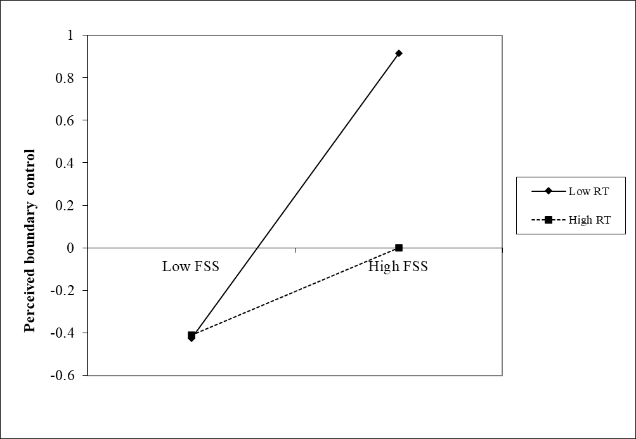
Figure A1. Moderation effect of red tape from alternative model.
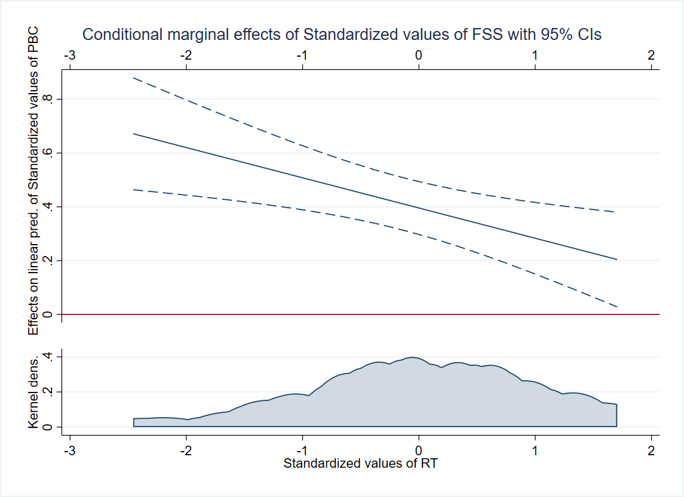
Figure A2. Marginal effects of FSS on PBC over RT from alternative model.

