Supplementary Materials for

Pepper variome reveals the history and key loci associated with fruit domestication and diversification

Yacong Cao†, Kang Zhang†, Hailong Yu†, Donghui Xu†, Shumin Chen, Hong Zhao, Zhenghai Zhang, Yinqing Yang, Xiaozhen Gu, Xinyan Liu, Haiping Wang, Yaxin Jing, Yajie Mei, Véronique Lefebvre, Weili Zhang, Yuan Jin, Dongliang An, Risheng Wang, Paul Bosland, Xixiang Li, Ilan Paran, Baoxi Zhang, Giovanni Giuliano*, Lihao Wang*, Feng Cheng*

Correspondence to: chengfeng@caas.cn, wanglihao@caas.cn, giovanni.giuliano@enea.it

This PDF file includes:

Materials and Methods
Figs. S1 to S13

Materials and Methods
Pepper sample collection
A total of 347 pepper accessions were used in this study, including the core collection of the China Gene Bank^{37, 38}, core breeding inbred lines of Institute of Vegetables and Flowers, and international typical local varieties and wild species. In total, 12 species were collected, including 309 C. annuum (cultivated species), two C. annuum var. glabriusculum (wild species), 10 C. frutescens (cultivated species), 10 C. chinense (cultivated species), five C. baccatum (cultivated species), one C. baccatum var. baccatum (wild species), two C. pubescens (cultivated species), one C. cardenasii (wild species), two C. chacoense (wild species), one C. eximium (wild species), one C. flexuosum (wild species), one C. galapagoense (wild species), one C. minutiflorum (wild species), and one C. rhomboideum (wild species). Samples originated from the Americas, Europe, Asia, and Africa and were obtained from several genebanks.

Agricultural characteristics investigation
The experimental materials were planted five times, including a greenhouse in Langfang during spring 2016; in a greenhouse in Beijing, in a plastic greenhouse in Dehong, and in the open field of Urumqi during spring 2017; and in the open field of Urumqi during spring 2018. Three replicates were planted in each experiment. In the Langfang and Beijing experiments, two to three plants were planted, and two fruits were measured in each replicate; and in Dehong and Urumqi experiments, 10 plants were planted, and 10 fruits were measured in each replicate.
The mature fruit traits measured were as follows: (1) fruit length: the distance from the pedicel attachment to the fruit apex; (2) fruit diameter: the maximum width; (3) fruit shape index - the ratio of fruit length to fruit diameter; (4) fruit orientation - if the fruit points upward, it is recorded as erect, otherwise it is recorded as pendent; (5) the content of capsaicin and dihydrocapsaicin of dried fruits without seeds and pedicels, as measured by ultra-performance liquid chromatography (UPLC).
For the measurements of capsaicin and dihydrocapsaicin, mature fruits without seeds and pedicels were dried at 55 to 60℃ for about two days, ground and processed according to an improved agricultural industry standard (NY/T 1381-2007, Determination of Capsaicin by high-performance liquid chromatography [HPLC]). For each determination, 0.2 g (accurate to 0.0001 g) of sample powder was extracted with 25 mL of methanol-tetrahydrofuran (1:1) (HPLC-grade; Sigma, USA) solution, shaken, extracted in an ultrasonic extractor for 30 min in a 60℃ water bath, and then filtered. The filter residue and filter paper were re-extracted with 25 mL methanol-tetrahydrofuran solution in an ultrasonic extractor for 10 min, filtered, and then the above operation was repeated. The three collected filtrates were combined, concentrated on a rotary evaporator (70–75℃ water bath) to about 30 mL, and then transferred to a 50 mL volumetric flask, where methanol was added to produce the final volume. After being filtered through a 0.22-μm micron organic phase filter membrane, chromatographic analysis was performed. The capsaicin content in the test solution was diluted to 0.13 mg/L–160 mg/L, and the dihydrocapsaicin content was diluted to 0.04 mg/L–160 mg/L. The filtrate was injected into a UPLC system (Waters UPLC, USA) with an ACQUITY UPLC BEH C18 1.7 μm, 2.1*100 mm column (Waters, USA) and Photo Diode Array Detector. The mixture of methanol and distilled water (70:30) represented the mobile phase. The flow rate was 0.20 mL/min. The injection volume was 2 μL, and the column temperature was 30℃. The detection wavelength was at 280 nm, and the retention times were 3.276 min for capsaicin and 4.395 min for dihydrocapsaicin. Capsaicin and dihydrocapsaicin external standards (Sigma, USA) were prepared as 200 mg/L stocks in absolute methanol. The stock solution was diluted with methanol to a series of standard working solutions of 100 mg/L, 50 mg/L, 20 mg/L, 10 mg/L, 1 mg/L, and 0.2 mg/L, and measured under the above liquid chromatography conditions. With the concentration of capsaicin and dihydrocapsaicin as the ordinate, and the corresponding peak area integral as the abscissa, the standard curves and linear regression equations were calculated. After the prepared test solution was measured, it was calibrated at multiple points and quantified by the peak area integral values. Finally, the capsaicin and dihydrocapsaicin contents were converted into mg per kg dry weight.

DNA extraction and library construction
The DNA library was prepared according to the manufacturer’s instructions (NEBNext® UltraTM DNA Library Prep Kit for Illumina®). The adaptor-ligated DNA was cleaned with the MinElute Reaction Cleanup Kit instead of Vortex AMPure XP Beads. After PCR amplification, the PCR products were assessed on 2% agarose electrophoresis. Next, quantitative analysis of the DNA library was conducted with a Qubit 2.0 (Invitrogen, USA) and an Agilent 2100 Bioanalyzer (Agilent, USA). All the samples were sequenced on the Illumina Solexa platform.

Variants calling and annotation
Trimmomatic v0.33 trimmed the Illumina fastq raw reads and removed adapters based on the manufacturer’s adapter sequences to obtain clean reads. Clean reads were mapped to the Zunla-1 2.0 genome³⁹ using BWA 0.7.17⁴⁰ with the following parameters: mem -M -A 1 -B 4 -O 6 -E 1. Samtools was used to sort the sam files and convert them into bam files. The function MarkDuplicates integrated in GATK (version 4.1.7) was used to deduplicate the bam files. Then, variants were called out using the HaplotypeCaller function of GATK with default parameters and generated the raw VCF files. Variant loci that were ungenotyped in more than 40% of the 311 C. annuum accessions, as well as those loci with a heterozygosity ratio of more than 10% and a minor allele frequency < 5% in the C. annuum population, were further filtered by an in-house Perl script. The genotype information of these remaining reliable variant loci in the 311 accessions of C. annuum and 37 accessions from other Capsicum species were then obtained for further data analysis. By doing this, we reduced the bulk and biased variants resulting from the large genetic difference between the genomes of C. annuum and the other Capsicum species.
The ANNOVAR⁴¹ was used to annotate variant function. Based on annotated data, SNPs and InDels were classified according to their position in or outside genes as being in: (1) inter-genic regions. (2) CDS (coding sequences) regions, (3) intronic regions, and (4) UTR (untranslated regions) (both 5’and 3’). Variants in CDS were subdivided into two groups: one group causing changes to the coding amino acids, including non-synonymous SNPs and non-threefold frame shift InDels, and another group with synonymous SNPs and InDels without frame-shifts. Intronic variants were divided into two groups: splice site mutations (within 2 bp of the splice site) and others.

Frequency distribution of variants
To estimate the density of the variants in the pepper genome, the number of various types of SNPs and InDels were counted in a one Mb sliding window across the 12 chromosomes of pepper, and the results were drawn in a genomic circos plot using the Circos tool⁴².
For the frequency of average variants in the gene body and the flanking regions of the gene, firstly the 5 kb regions flanking each gene were determined. When the flanking region overlapped with the gene body or flanking region of another gene, the process was stopped at the middle site in the two neighboring genes. A one kb sliding window with a 100 bp step screened the flanking regions and gene body of all pepper genes, and the number of SNPs and InDels located in the window were calculated. After that, each of these windows were further averaged across all the genes, and the upper and lower quartiles were calculated.

KASP genotype verification
Kompetitive Allele Specific PCR (KASP) verified the SNPs. The SNPs were randomly selected for the KASP assay, and primers were designed using BatchPrimer3 online⁴³ (https://probes.pw.usda.gov/batchprimer3/). The allele-specific forward primers allele 1 and allele 2 carried the FAM- and HEX-labeled tails with the targeted SNP at the 3' end. A common reverse primer was designed to amplify the 80–200 bp target region. The test operation mainly followed the #KBS-1016-017 (Laboratory of the Government Chemist, UK) instructions (www.lgcgroup.com/genomics) and was as follows: 1) DNA samples were arrayed into 384-well PCR plate. No-template controls are included on each plate; 2) to prepare the genotyping mix, 2.0 μL DNA (10–50 ng/μL), 2.0 μL 2× KASP Master mix, 0.055 μL KASP Assay mix were combined. The total reaction volume was 4μL; 3) the genotyping mix was dispensed onto the reaction plate, to which 2.0μL genotyping mix was added to each DNA sample in the reaction plate using a pipette; 4) the plate was sealed and centrifuged; 5) the thermal cycle was run in the Roche LightCycler 480 System®. The cycle included an initial denaturation step of 15 min at 94°C, followed by 10 touchdown cycles of 20 s at 94°C and 60 s at 61°C, then decreasing by −0.6°C per cycle, followed by 26 cycles of 20 s at 94°C and 60 s at 55°C, and nine additional cycles of 20 s at 94°C and 60 s at 57°C. 6) the plate was then read, and the data were analyzed. After completion of the thermal cycle, the reaction plate was read in a FRET-capable platter reader at 37℃. The LightCycler 480 Software® was used to analyze the data. The result was assessed based on the difference between the cycle threshold (Ct) values of the two alleles. The greater the difference, the greater the possibility of a pure gene (determine its allele according to the type of fluorescent substance connected by the special primers), and the smaller the difference, the more likely it was heterozygous.

Phylogenetic tree construction
In order to select neutral and reliable SNP variants to investigate the phylogenetic relationships of the resequenced pepper accessions, these genic SNPs that were annotated as synonymous variations by ANNOVAR were extracted⁴¹. It was determined that 165,864 such SNPs were in the 347 resequenced pepper accessions. Genotype data of the 165,864 SNP loci were obtained. The distance matrixes with the genotype data for all 347 pepper accessions was generated. Within the 311 C. annuum accessions the pairwise allele sharing distance (ASD) was calculated for each pair of two accessions, and the data in the distance matrix were used to construct a neighbor-joining (NJ) phylogenetic tree using PHYLIP3.69⁴⁴.

Population structure analysis
The software Admixture (version 1.3.0)⁴⁵ performed genetic structure analyses using 160,000 randomly selected SNPs from the 311 C. annuum accessions. Admixture was run with k = 2–15 clusters with the default parameters. Finally, k = 7 (seven major genetic components, Fig. 1d) that showed the smallest CV error was selected to represent the population genetic features of C. annuum.

Linkage disequilibrium
Correlation coefficients (r²) were calculated for each pair of SNP loci with a distance of 1–500 kb between them and averaged per bin of 50 bp distance, producing a histogram of r² per such distance bin (Fig. S5). From these histograms, the distance at which r² decayed to half its maximum value was determined as a linkage disequilibrium (LD) length estimate of a particular sample group.

Determination of ancestral and derived alleles
In order to estimate the frequency of genotype status—ancestral or non-ancestral (derived)—of the SNP variants and compare them in different groups of pepper, the ancestral/derived alleles for each SNP locus were determined. To obtain a reliable genotype status, the genotypes of the two wild C. annuum var. glabriusculum samples were used as the controls. Only the homozygous SNP locus shared by the two samples were retained. We then recorded the genotype of the two wild samples as the ancestral allele of the SNP locus, while the other allele in the pepper population at this SNP locus was recorded as the derived one. With this rule, the ancestral/derived alleles of 14,194,356 SNPs out of the 18,372,022 total SNPs were successfully obtained. The information of derived alleles of these SNPs was used in the data analysis.

Genome diversity and selection sweeps
Two measures were used to estimate the genomic diversity of the C. annuum population: π and ROD (reduction of diversity). The π measures the genomic diversity⁴⁶ through computing the average difference per locus on each pair of accessions. While ROD is a measure based on π, which estimates the diversity reduction of a sample group with respect to the control sample group⁴⁷. In this study, ROD detected the genomic regions under group-specific selection as compared to the parental group.
Akey’s F_{ST} calculated the pairwise genomic differentiation between two groups of samples⁴⁸, which evaluates the strength of genomic divergence between two compared groups. Values ranged from 0 (no differentiation) to 1 (complete or fixed differentiation).
XP-EHH detected signals of recent positive selection (group-specific selection signatures)⁴⁹ in the blocky fruit group of C. annuum, using the combined software of Beagle (version 5.1)⁵⁰ and SelScan (version v1.3.0)⁵¹, with default parameters. Large XP-EHH values indicate unusually long haplotypes in the derived group under selection as compared to the control group. Tajima’s D was applied to estimate genomic regions under negative selection/purifying selection, and outliers were detected with a threshold of less than -2⁵².
To obtain the strongest selection signals from the large genome of pepper (3.6 Gb), which is comparatively larger than most crop genomes sequenced, the calculated values of these population genomic measures were further averaged using a 10 Mb window with a 1 Mb increment sliding across the whole genome of pepper, except for Tajima’s D, which was calculated directly in each sliding window. The top 5% of ROD and XP-EHH were determined as outlier signals of genomic regions under selection. If two outlier windows overlapped with each other, then they were merged into one region.

Selection strength on gene units
The gene body combined with its 5 kb upstream and 5 kb downstream regions were defined as a gene unit, and 35,336 such gene units were generated using the Zunla-1 genome (version 2.0) as the reference³⁹. Measures of π and ROD⁴⁷ were then calculated using SNP variants located at each of these gene units, which were further used to estimate the gene level selection strength in the pepper population. The top 5% of ROD values, together with the top 30% of smaller π values in the control group, were determined as outliers of gene units that were under selection.

Major haplotype sharing analysis
The major haplotypes in the blocky fruit groups were first determined using a 10 Mb window with 1 Mb increment sliding across the 12 chromosomes of the pepper reference genome. In total, there were 548 such windows. In each window, the major allele frequency of each SNP in the blocky fruit pepper was calculated, and the SNP loci with a value ≥0.8 were counted and collected. If more than 80% of the SNPs in the window were counted, then these major alleles comprise the major haplotype of the blocky fruit groups in the analysed window. These major haplotypes were kept and compared to all of these resequenced C. annuum accessions. The average score of allele sharing between the major haplotype and each of the 311 accessions in the analyzed window was calculated and considered as a major haplotype sharing score (MHS). The MHS then estimated the relationship on the origin of the blocky fruit pepper-specific haplotype in the pepper population.

K_{S} analysis
In order to obtain the gene sequences for blocky fruit pepper, the consensus genome of blocky fruit pepper by replacing the Zunla-1 reference genome was generated³⁹ using the major genotype of blocky fruit pepper at each variant locus. Gene sequences of blocky fruit pepper were extracted based on the gene annotation coordinate file. After that, pairwise protein sequences between blocky fruit pepper and Zunla-1 (non-blocky fruit pepper) were aligned by MUSCLE⁵³. Protein alignments were translated into coding sequence alignments using an in-house Perl script. The K_{S} values were calculated with the coding sequence alignments using the method of Nei and Gojobori as integrated in the KaKs_calculator⁵⁴.

GWAS analysis
GEMMA⁵⁵ was applied to perform GWAS. The relatedness (kinship) matrix was first calculated by GEMMA and applied to correct the pepper population stratification. The linear mixed model (LMM) analyzed the correlation of the population, and P-values of all SNPs to each trait were generated by GEMMA. The GWAS signals of traits analysed in this study are replicable in the five phenotypic trials, and GWAS results on the averaged values of the five trials were used to make the Manhattan plotting.

Validation of associations in another pepper population
The candidate genes were then further validated in another 241 C. annuum accessions. According to the mutation types, different types of primers were developed. For SNPs related to the fruit shape index, primers spanning the SNP were designed (F: GGAGGTCAGACGTGGATCATC, R: TGATGGTTTGTTTGGTTTGAGCA) and the genotype was determined by the PCR products sequencing using the forward primer as the sequencing primer. For structural variations related to fruit orientation, primers that span the variation segment were designed (F: GTGCTGCAAGAGGAAGAAAACT, R: CAGCCCTCTTTTTCCTTGTATG), and the genotype was determined by the PCR-amplified fragment size indicated by polyacrylamide gel and agarose gel electrophoresis, respectively.

RNA-Seq and data analysis
For transcriptome sequencing, 22 accessions of various fruit types and 10 accessions with different heat levels were selected. The pericarp from accessions with various fruit types at the early stage about 5 to 7 d after pollination, and then about 15 to 20 d after pollination, the placenta of different heat levels at the middle stage of fruit development were sampled and immediately placed into liquid nitrogen for more than 30 s, then they were stored in an ultra-low temperature refrigerator at -80°C until sequencing. The RNA-Seq data were mapped to the genome of Zunla-1 (version 2.0)³⁹ using the software Hisat2 (version 2.1.0)⁵⁶ together with Samtools (version 1.9)⁵⁷ with default parameters. The mapping results were then submitted to featureCounts⁵⁸ to calculate the TPM (tags per million reads) values to estimate the level of gene expression in each sample.

BSA-Seq and data analysis
A wild pepper (C. annuum var. glabriusculum) accession Ac1979 with erect fruit was crossed with a blocky pepper accession Qiemen with pendent fruit to construct an F₂ population of ~360 plants. 30 plants exhibiting the erect and 30 exhibiting the pendent fruit phenotypes were selected from the population. DNA from the parents and the two F₂ groups was extracted, and the later were further combined into two pools for library construction. The resulting libraries were sequenced on the MGI’s DNBSEQ-T7 platform from BGI-Shenzhen company (Shenzhen, China). Clean reads were mapped to the Zunla-1 2.0 genome and the variants were called following the same method described above. Low quality (Q < 20, DP < 5) or multi-allelic variants were filtered out, and the homozygous SNPs that showed polymorphism between the two parents were obtained using an in-house Perl script. The ∆SNP-index was calculated based on a 500 kb sliding window with a 50 kb increment as described previously⁵⁹.

Quantitative RT-PCR analysis of candidate genes of pepper fruit orientation
For qRT-PCR analysis of the gene Capana12g000954, fruit pedicels at 7 d post-pollination were sampled and immediately frozen in liquid nitrogen for at least 30 s and then stored at -80℃. The RNA isolation and cDNA synthesis were performed using an SV Total RNA Isolation System kit (Promega) and the GoScriptTM Reverse Transcription System kit (Promega), respectively, according to the manufacturer’s instructions. Gene expression analysis was performed by qRT-PCR with the LightCyler®480 SYBR Green I Master on a LightCycler®480 II (Roche) real-time PCR system. The Capsicum actin (GQ339766.1) and EF1a (AY496125) were used as reference genes. The primers (F- AGTTATGCAAGCTCTGATCTGT and R- TGTTGTTTCATAGACGGGCA) were designed online (https://primer3.ut.ee/). The qRT-PCR was performed with two biological and three technical repetitions and each reaction was repeated three times. The same method was used to analyze gene silencing in the VIGS experiment.

Virus-induced gene silencing (VIGS)
VIGS was used to verify the function of the up gene Capana12g000954. A 300 bp fragment of Capana12g000954 was cloned from a pepper CDNA template using gene specific primers F-TGAGTAAGGTTACCGAATTCCAAGCTGGCCAAGAGAAGAA and R-GGAGGCCTTCTAGAGAATTCCCTCCAGGAGAAATCTGCTTA, containing an EcoRI site. The resulting product was inserted into the EcoRI site of pTRV2, to construct TRV2::up. A fragment of about 100 bp of CaPDS gene was inserted into pTRV2 to construct the control vector TRV2::CaPDS. The tobacco rattle virus (TRV)-based vectors TRV1 and TRV2::rec were tansfromed into Agrobacterium tumefaciens (strain GV3101) for infiltration. Bacteria were grown and resuspended in infiltration solution at an OD₆₀₀ of about 4.0. After standing at room temperature for 3 hours, the Agrobacterium suspensions containing the TRV1 vector and one of the TRV2 vectors (TRV1+TRV2; TRV1+TRV2::CaPDS; TRV1+TRV2::up) were mixed at a ratio 1:1 and infiltrated. 2-month old plants of the accession “Changyang chili” (pendent fruit) was used for VIGS experiments. The plant growth environment was 23±2°C, the relative humidity was 60%-80%, and the light was 16h/8h (light/dark). After infiltration, the plants were placed in the dark and cultured for 24h and then reverted to 16/8h light-dark alternate culture. Five plants were used for each of the three groups (non-infiltrated, TRV2::00, and TRV2::up experiments. Only plants infiltrated with TRV2::up plants showed fruits with erect orientation, two months after infiltration. To investigate the expression of the up gene, total RNA was isolated from pendent fruit pedicels of wild and TRV2::00 and from erect pedicels of TRV2::up plants. Gene expression analysis was performed by the qRT-PCR method described above. Four biological replicates (pedicels) and four technical replicates were performed.

Supplementary Figures

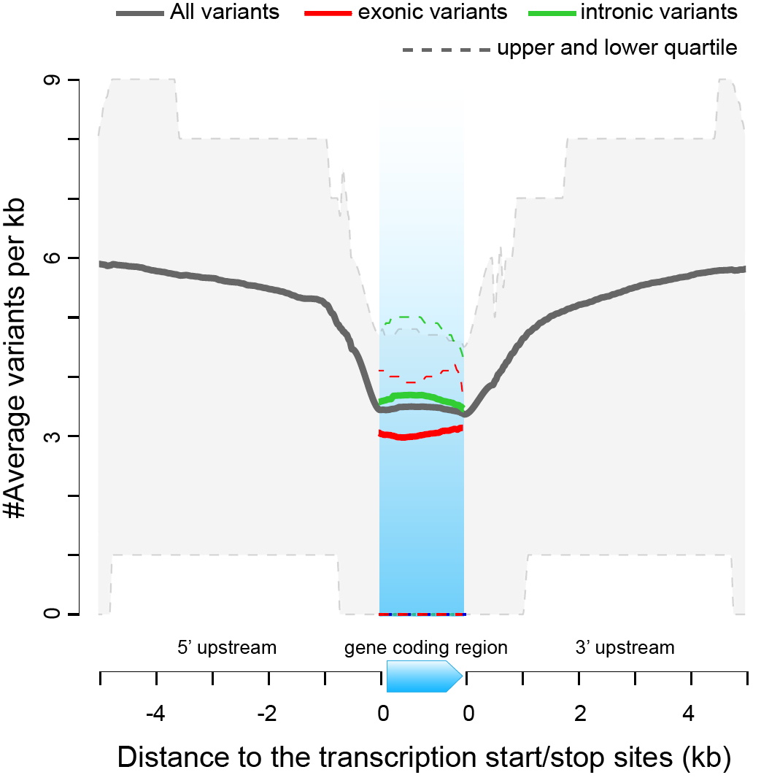

Fig. S1. Density of the variants in the gene bodies and the 5 kb gene-flanking regions in the C. annuum population.

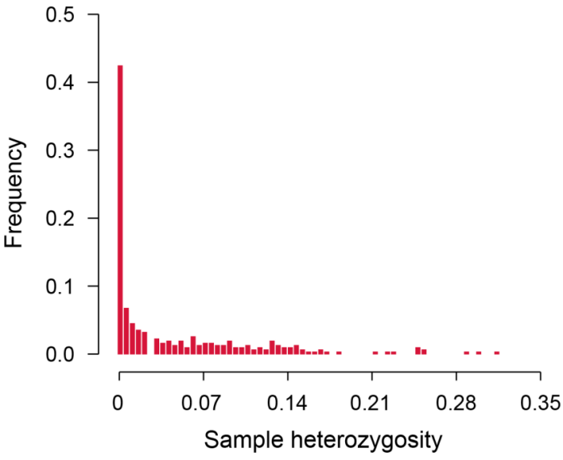

Fig. S2. Frequency distribution of the sample heterozygosity in the resequenced pepper population.

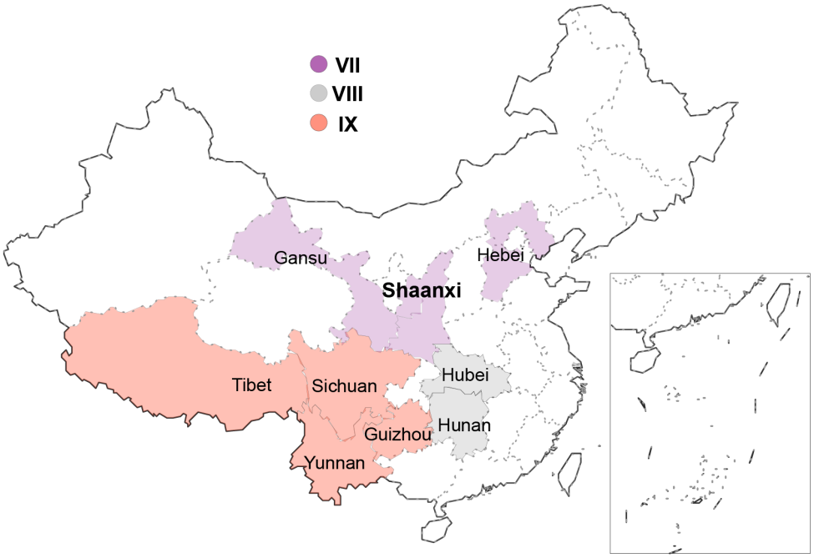

Fig. S3. Locations of China inland pepper groups Ⅶ, Ⅷ, and Ⅸ in provinces from the north, middle and southwest of China.

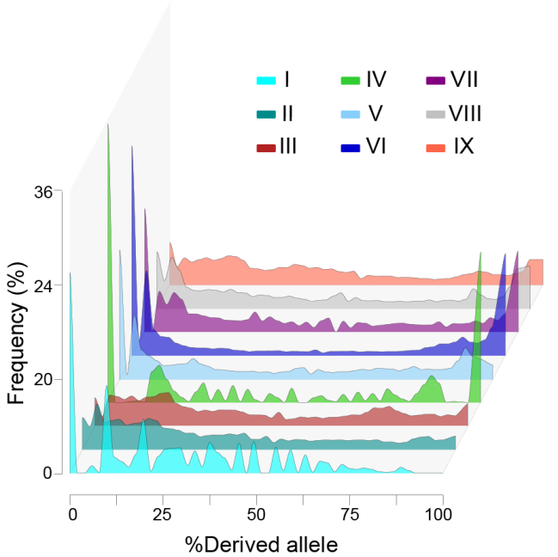

Fig. S4. Frequency distribution of derived alleles of all SNPs in the nine pepper groups.

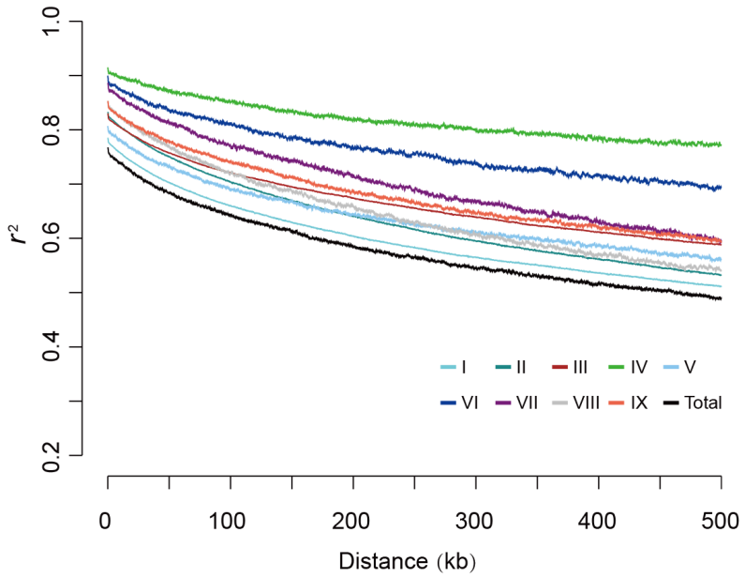

Fig. S5. Decay of genomic linkage disequilibrium (LD) in the total C. annuum population, and in the nine groups (I-Ⅸ).

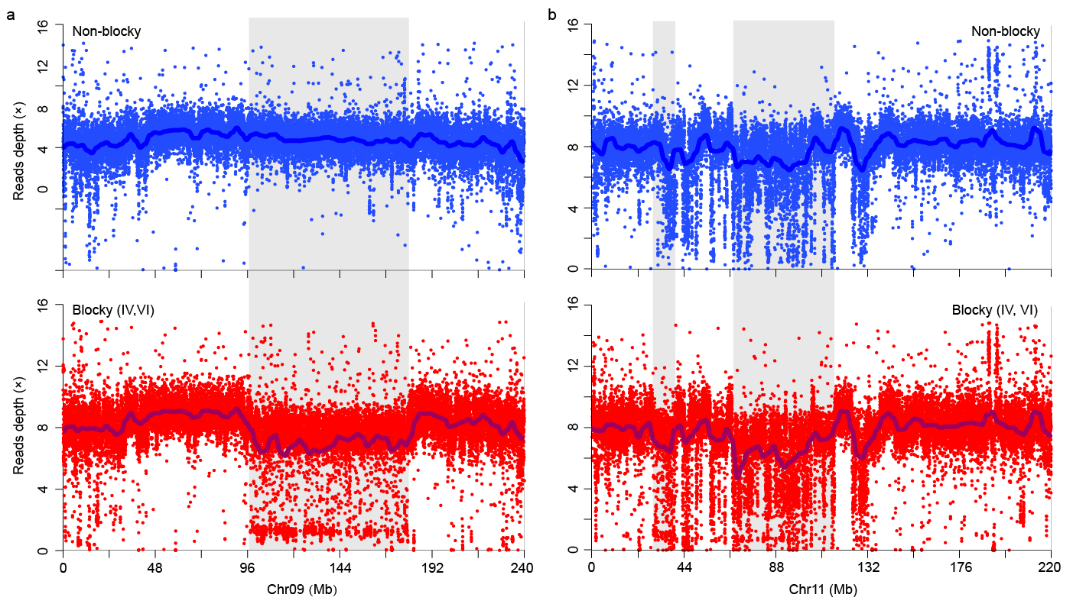

Fig. S6. The difference on depth of reads mapped to chromosomes 9 (a) and 11 (b) between the blocky and non-blocky fruit peppers. Blue and red points indicate average reads depth in 10 kb windows, dark blue lines denote average reads depth in 1 Mb window, grey rectangles indicate the genomic regions showing lower depth of reads mapped to blocky fruit peppers.

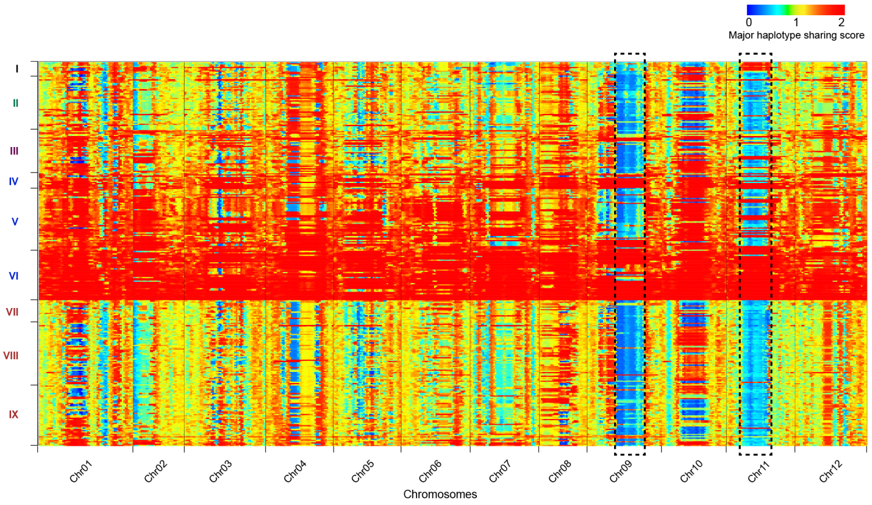

Fig. S7. Genome-wide haplotype sharing between blocky and non-blocky fruit peppers, with the major haplotype of the blocky fruit pepper as the reference. The y-axis lists samples following the same order as shown in main-text Fig. 1c-d. The heatmap colored from blue to red denotes low to high levels of major haplotype sharing score (MHS) of each sample to the major haplotype of blocky fruit pepper in a 10 Mb window across the whole genome.

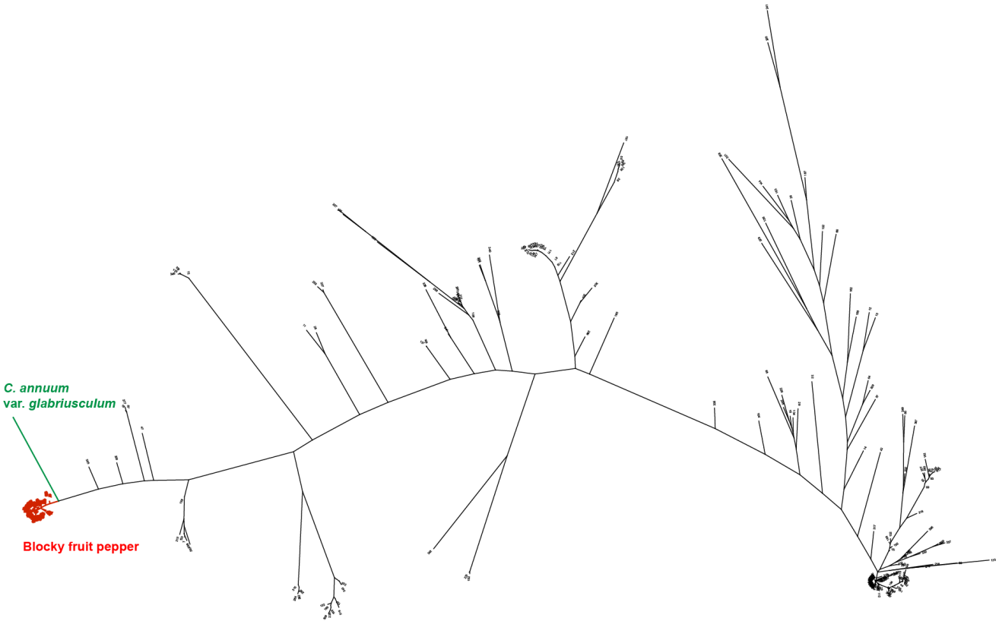

Fig. S8. Phylogenetic tree of the C. annuum population plus C. annuum var. glabriusculum whose genome has been released previously ³⁹, using genotypes of loci located at F9.

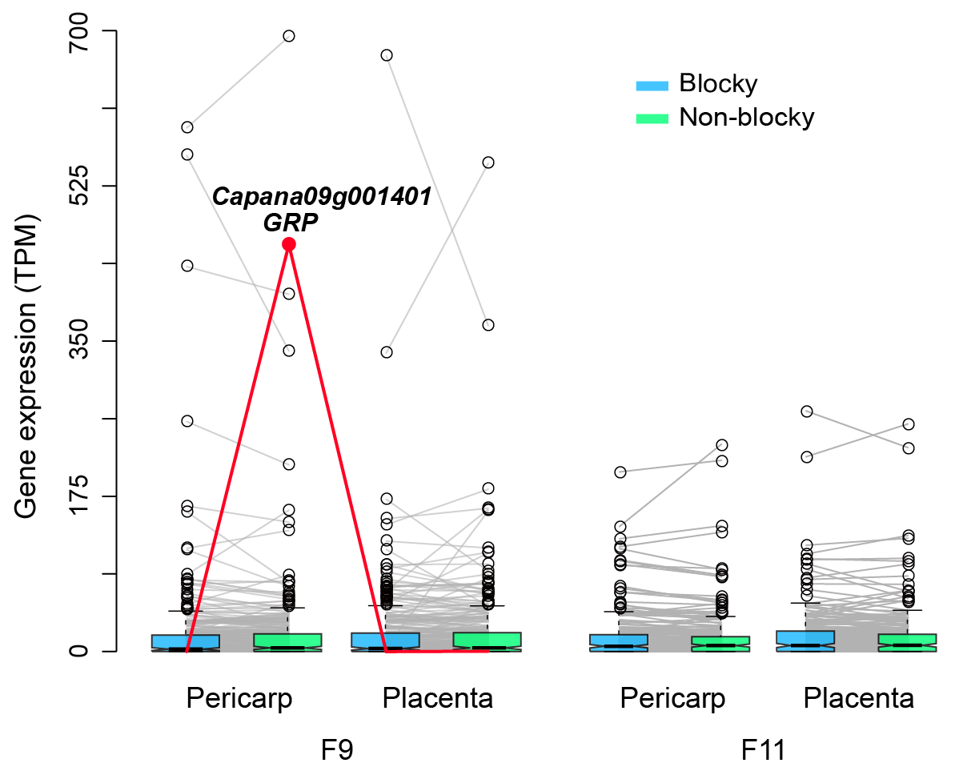

Fig. S9. Boxplot of gene expression for genes located at F9 and F11 in two pepper fruit tissues (pericarp and placenta) between blocky and non-blocky fruit peppers. The lines link the same genes in different boxplots; the red line indicates the gene Capana09g001401 that is highly and specifically expressed in the pericarp of non-blocky fruit pepper. TPM: tags per million reads.

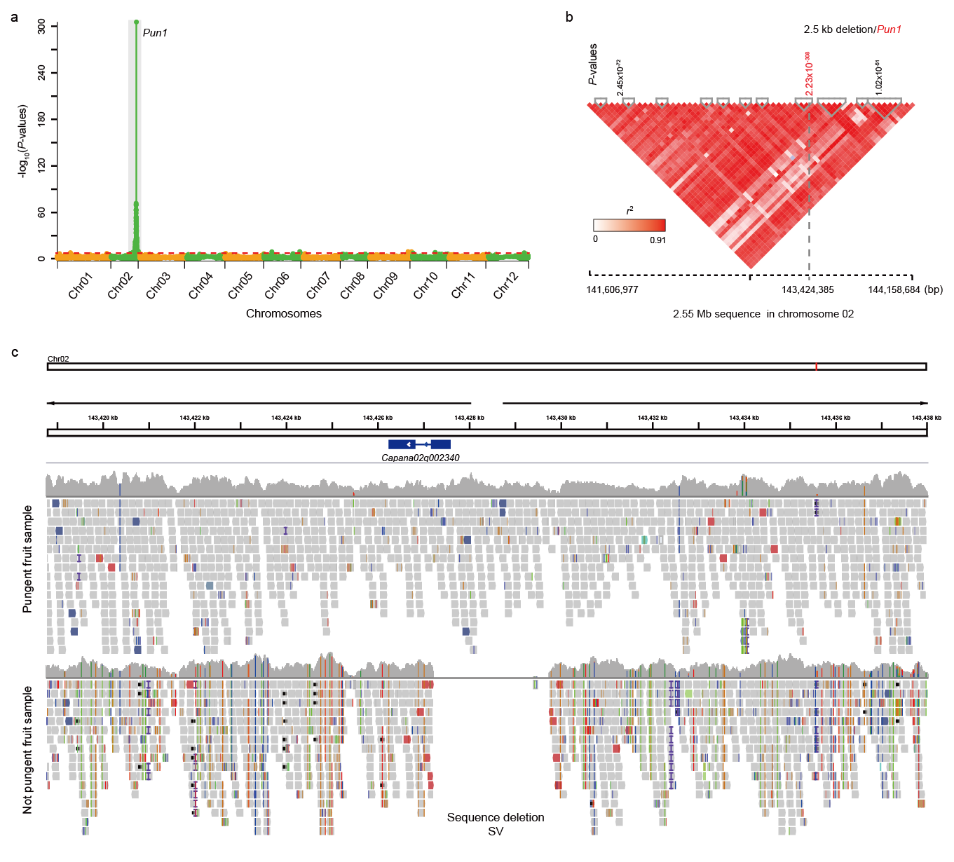
Fig. S10. Identification of the structural variation of PUN1 associating with the pepper pungency. (a) Manhattan plot of GWAS signals associated with pungency (binomial data). The region covered by significant association signals harbored the Pun1 gene. (b) Linkage disequilibrium among SNP loci with extremely significant association signals (P-value<1.00×10⁻³⁰) to the pungent trait. (c) Mapping of reads mapped onto the genomic region around gene Capana02g002340 (PUN1) between peppers with pungent (top) and non-pungent (bottom) fruits. The region that was not covered by any reads in non-pungent fruit peppers, indicating a large sequence deletion.

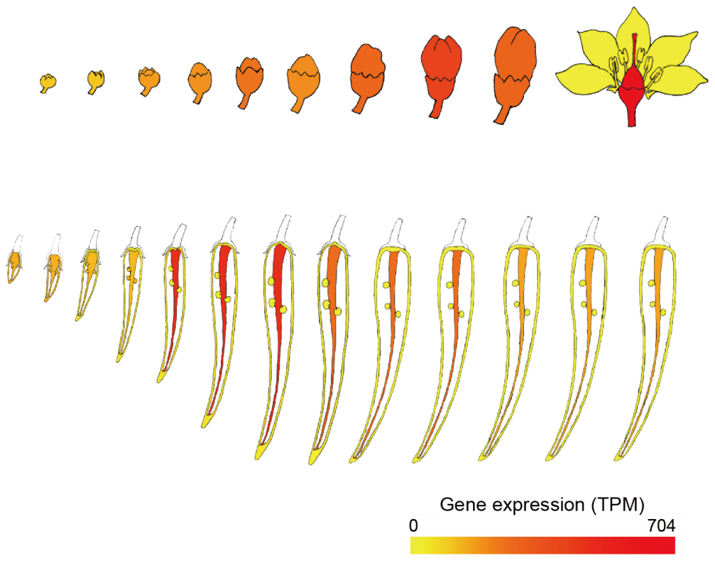

Fig. S11. Gene expression of Capana12g000954 (Up) in different developmental stages of pepper flower and fruit⁶⁰.

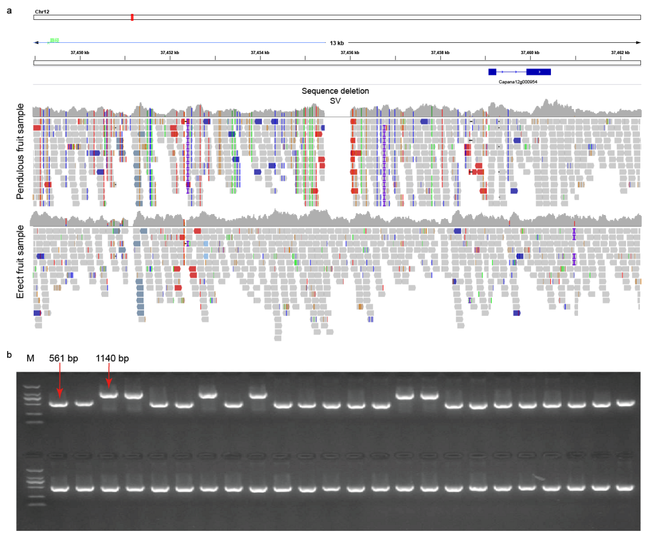

Fig. S12. The 579 bp deletion in the promoter region of Capana12g000954. (a) Visualization example of reads mapped onto the genomic region around gene Capana12g000954 (Up) between samples with pendent (top) and erect (bottom) pepper fruits. The region that was not covered by any reads in the pendent fruit pepper indicates a large sequence deletion. (b) Electropherogram of the PCR products that cover the deletion upstream of gene Capana12g000954 (Up) in different pepper samples. The 561 bp electrophoretic bands indicate samples with the 579 bp sequence deletion, while the 1,140 bp bands indicate samples without the sequence deletion. M: DNA marker DM2000.

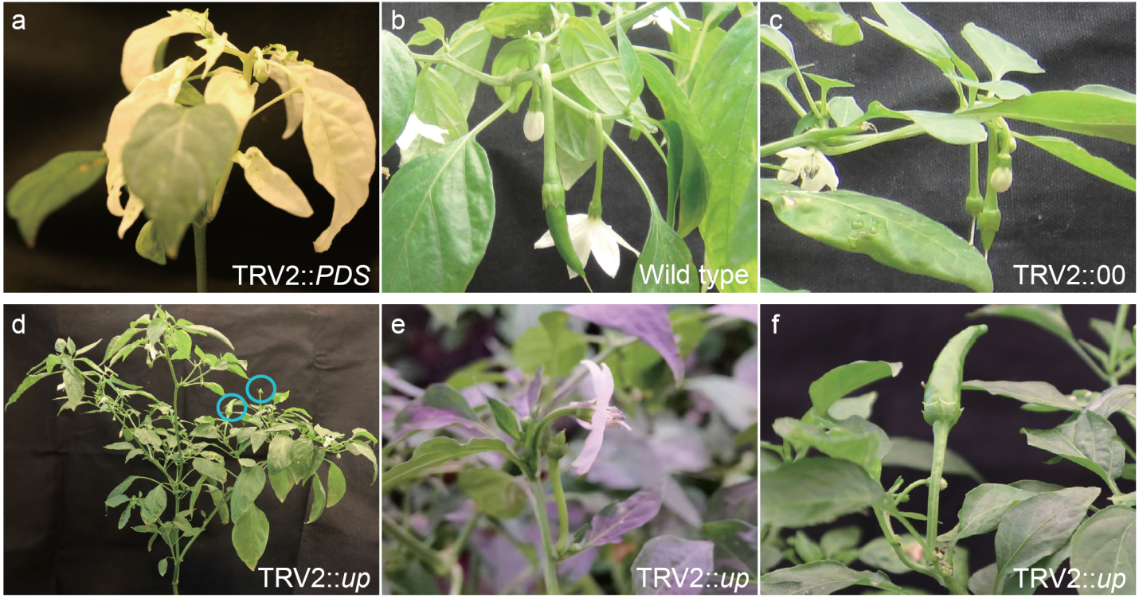
Fig. S13. The phenotypes of virus-induced gene silencing experiments on pepper accession “Changyang chili” with pendent fruit (wild type). (a) The TRV2::CaPDS pepper plant shows photobleaching; (b) Pendent fruit observed in the control plant (wild type); (c) Pendent fruit observed in plants treated with empty vector (TRV2::00); (d) Whole plant treated with TRV2::up, exhibiting with erect fruits; (e) Close-up of an erect flower and a small erect pepper fruit in a plant treated with TRV2::up; (f) Close-up of a large erect pepper fruit in a plant treated with TRV2::up.

References

37. Gu X-z, et al. Genetic diversity and population structure analysis of Capsicum germplasm accessions. Journal of Integrative Agriculture 18, 1312-1320 (2019).

38. Wang HP, Li XX, Song JP. Vegetable Genetic Resources in China. Hortic Plant J 4, 83-88 (2018).

39. Qin C, et al. Whole-genome sequencing of cultivated and wild peppers provides insights into Capsicum domestication and specialization. Proceedings of the National Academy of Sciences of the United States of America 111, 5135-5140 (2014).

40. Li H, Durbin R. Fast and accurate short read alignment with Burrows–Wheeler transform. Bioinformatics 25, 1754-1760 (2009).

41. Wang K, Li M, Hakonarson H. ANNOVAR: functional annotation of genetic variants from high-throughput sequencing data. Nucleic Acids Research 38, e164-e164 (2010).

42. Krzywinski M, et al. Circos: an information aesthetic for comparative genomics. Genome research 19, 1639-1645 (2009).

43. You FM, et al. BatchPrimer3: a high throughput web application for PCR and sequencing primer design. BMC Bioinformatics 9, 253 (2008).

44. Retief JD. Phylogenetic analysis using PHYLIP. Methods in Molecular Biology 132, 243-258 (2000).

45. Pritchard JK, Stephens M, Donnelly P. Inference of population structure using multilocus genotype data. Genetics 155, 945-959 (2000).

46. Tajima F. Evolutionary relationship of DNA sequences in finite populations. Genetics 105, 437-460 (1983).

47. Xu X, et al. Resequencing 50 accessions of cultivated and wild rice yields markers for identifying agronomically important genes. Nature Biotechnology 30, 105-111 (2011).

48. Akey JM, Zhang G, Zhang K, Jin L, Shriver MD. Interrogating a high-density SNP map for signatures of natural selection. Genome research 12, 1805-1814 (2002).

49. Sabeti PC, et al. Genome-wide detection and characterization of positive selection in human populations. Nature 449, 913-918 (2007).

50. Browning BL, Zhou Y, Browning SR. A One-Penny Imputed Genome from Next-Generation Reference Panels. The American Journal of Human Genetics 103, 338-348 (2018).

51. Szpiech ZA, Hernandez RD. selscan: an efficient multithreaded program to perform EHH-based scans for positive selection. Molecular Biology and Evolution 31, 2824-2827 (2014).

52. Tajima F. Statistical method for testing the neutral mutation hypothesis by DNA polymorphism. Genetics 123, 585-595 (1989).

53. Edgar RC. MUSCLE: a multiple sequence alignment method with reduced time and space complexity. BMC Bioinformatics 5, 113 (2004).

54. Wang D, Zhang Y, Zhang Z, Zhu J, Yu J. KaKs_Calculator 2.0: a toolkit incorporating gamma-series methods and sliding window strategies. Genomics Proteomics Bioinformatics 8, 77-80 (2010).

55. Zhou X, Stephens M. Genome-wide efficient mixed-model analysis for association studies. Nature Genetics 44, 821-824 (2012).

56. Kim D, Paggi JM, Park C, Bennett C, Salzberg SL. Graph-based genome alignment and genotyping with HISAT2 and HISAT-genotype. Nature Biotechnology 37, 907-915 (2019).

57. Li H, et al. The Sequence Alignment/Map format and SAMtools. Bioinformatics 25, 2078-2079 (2009).

58. Liao Y, Smyth GK, Shi W. featureCounts: an efficient general purpose program for assigning sequence reads to genomic features. Bioinformatics 30, 923-930 (2014).

59. Zhang X, et al. QTL-Seq and Sequence Assembly Rapidly Mapped the Gene BrMYBL2.1 for the Purple Trait in Brassica rapa. Scientific Reports 10, 2328 (2020).

60. Liu F, et al. PepperHub, an Informatics Hub for the Chili Pepper Research Community. Molecular Plant 10, 1129-1132 (2017).

