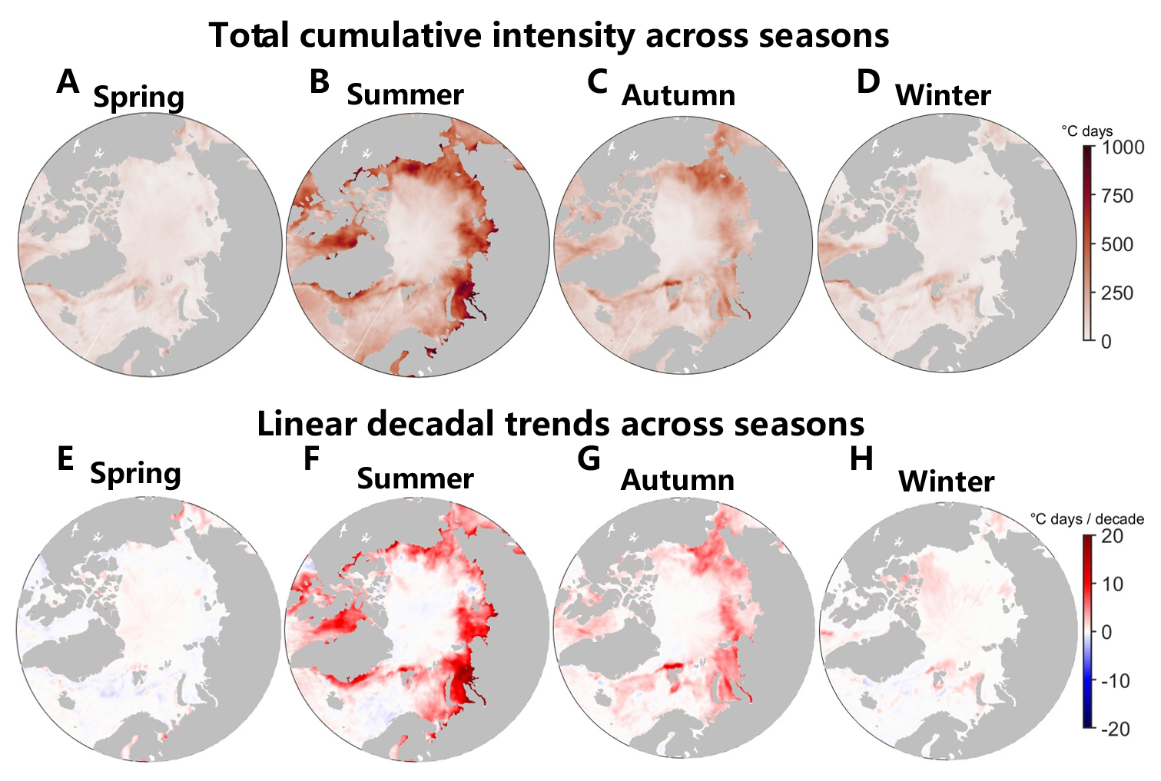
Fig. S1. Seasonal Total Cumulative Intensity (CI) and Trends Across Seasons from 1982 to 2022. (A-D) Mean CI of marine heatwaves for each season: spring (March-May), summer (June-August), autumn (September-November), and winter (December-February). (E-H) Linear decadal trends of seasonal mean CI for spring, summer, autumn, and winter.

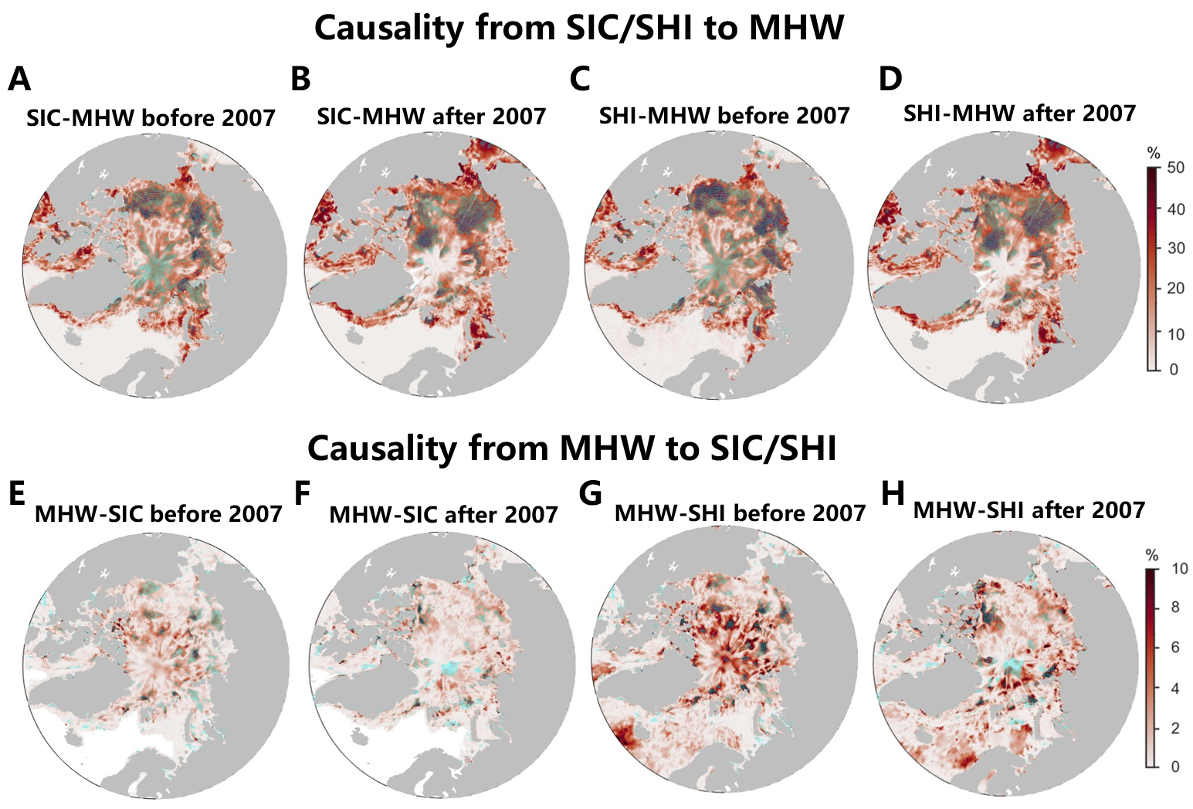
Fig. S2. Causal Relationships between Marine Heatwaves (MHWs), Sea Ice Concentration (SIC), and Solar Heat Input (SHI). (A-B) Causal relationships from SIC to MHWs before (A) and after (B) 2007. (C-D) Causal relationships from SHI to MHW before (C) and after (D) 2007. (E-H) Similar to (A-D), but showing causality from SIC/SHI to MHWs. Cyan grid points indicate regions where the causal relationships are statistically significant at the 5% confidence level.

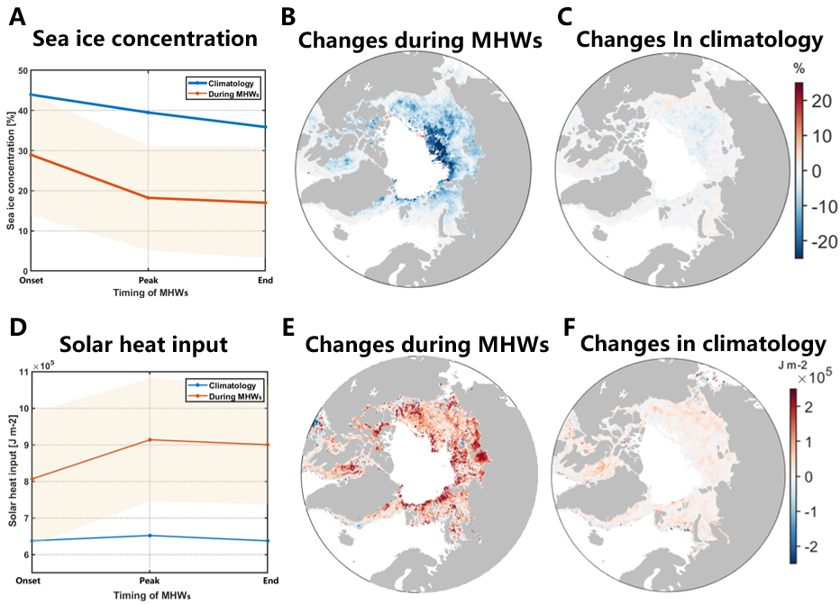
Fig. S3. Sea Ice Concentration (SIC) and Solar Heat Input (SHI) during Marine Heatwave (MHW) Events (1982 –2022). (A) SIC at the onset of MHWs, at the peak of MHWs, and at the end of MHWs, along with the 41-year climatological mean for these dates. The composite mean of all MHW events is shown, with the shaded area representing uncertainty. (B) Composite SIC difference between the peak day of MHWs and the average SIC at the onset and end of MHWs. (C) Same as (B), but using climatological dates (41-year mean). (D-F) Same as (A-C), but for SHI.

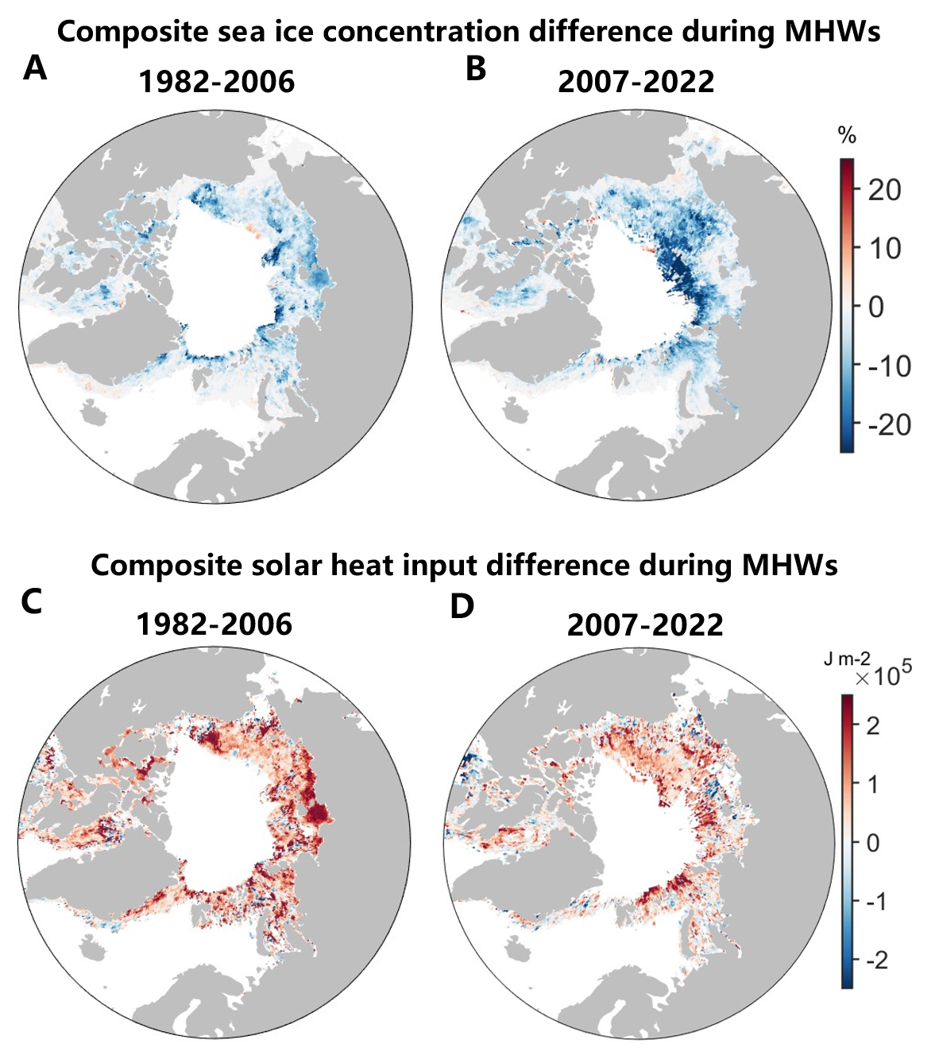
Fig. S4. Composite Differences in Sea Ice Concentration (SIC) and Solar Heat Input (SHI) During Marine Heatwaves (MHWs). (A) Composite of the SIC difference between the day of maximum intensity and the average SIC at the onset and end of MHWs from 1982 to 2006. (B) Same as (A), but for the period 2007 to 2022.

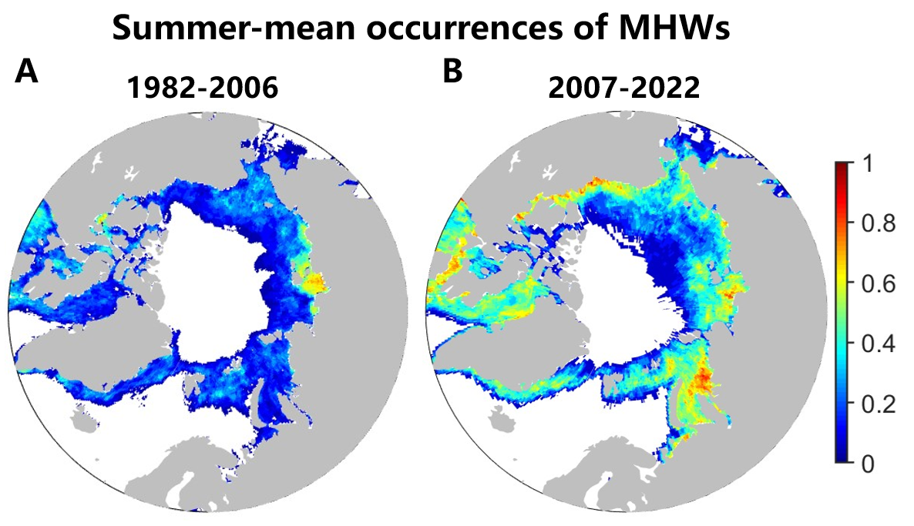
Fig. S5. Summer Mean Occurrences of Marine Heatwaves (MHWs). (A) MHW occurrences from 1982 to 2006. (B) MHW occurrences from 2007 to 2022.

