Supplementary File F - Predictive modelling results

Incident rOA

Incident Pain

Progression of rOA

Progression of Pain

Pain progression for those with lower-limb loss

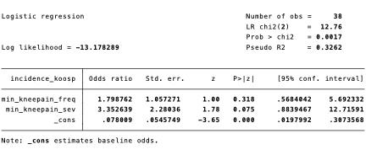

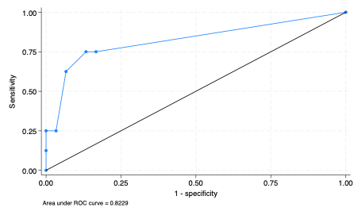
R2 | 0.3362
P | 0.0017
AUROC | 0.8229
SE | 0.0931
AIC | 32.35658
BIC | 37.26734

