Supplementary Information
Afforestation on Abandoned Croplands in China Has the Potential to Increase Carbon Sequestration by half
Tao Liuª, Le Yu^{a, b, c, *}, Ying Tu^{d}, Xin Chen^{e}, Zhenrong Du^{f}, Hui Wuª, Shijun Zhengª, Minxuan Sunª, Yixuan Li^{g}, Dailiang Peng^{h}, Chao Wuª, Yuyu Zhou^{i, j}
a Department of Earth System Science, Ministry of Education Key Laboratory for Earth System Modeling, Institute for Global Change Studies, Tsinghua University, Beijing 100084, China
b Ministry of Education Ecological Field Station for East Asian Migratory Birds, Department of Earth System Science, Tsinghua University, Beijing 100084, China
c Tsinghua University (Department of Earth System Science)- Xi’an Institute of Surveying and Mapping Joint Research Center for Next-Generation Smart Mapping, Beijing 100084, China
d Department of Global Development, Cornell University, Ithaca, NY 14853, USA
e Institute of Loess Plateau, Shanxi University, Taiyuan 030006, China
f School of Information and Communication Engineering, Dalian University of Technology, Dalian 116024, China
g Centre for Environmental Policy, Imperial College London, London SW7 2AZ, UK
h Key Laboratory of Digital Earth Science, Aerospace Information Research Institute, Chinese Academy of Sciences, Beijing 100094, China
i Department of Geography, The University of Hong Kong, Hong Kong 999077, China
j Institute for Climate and Carbon Neutrality, The University of Hong Kong, Hong Kong, China
* Correspondence author
Le Yu
Email: leyu@tsinghua.edu.cn;

SUPPLEMENTARY FIGURES
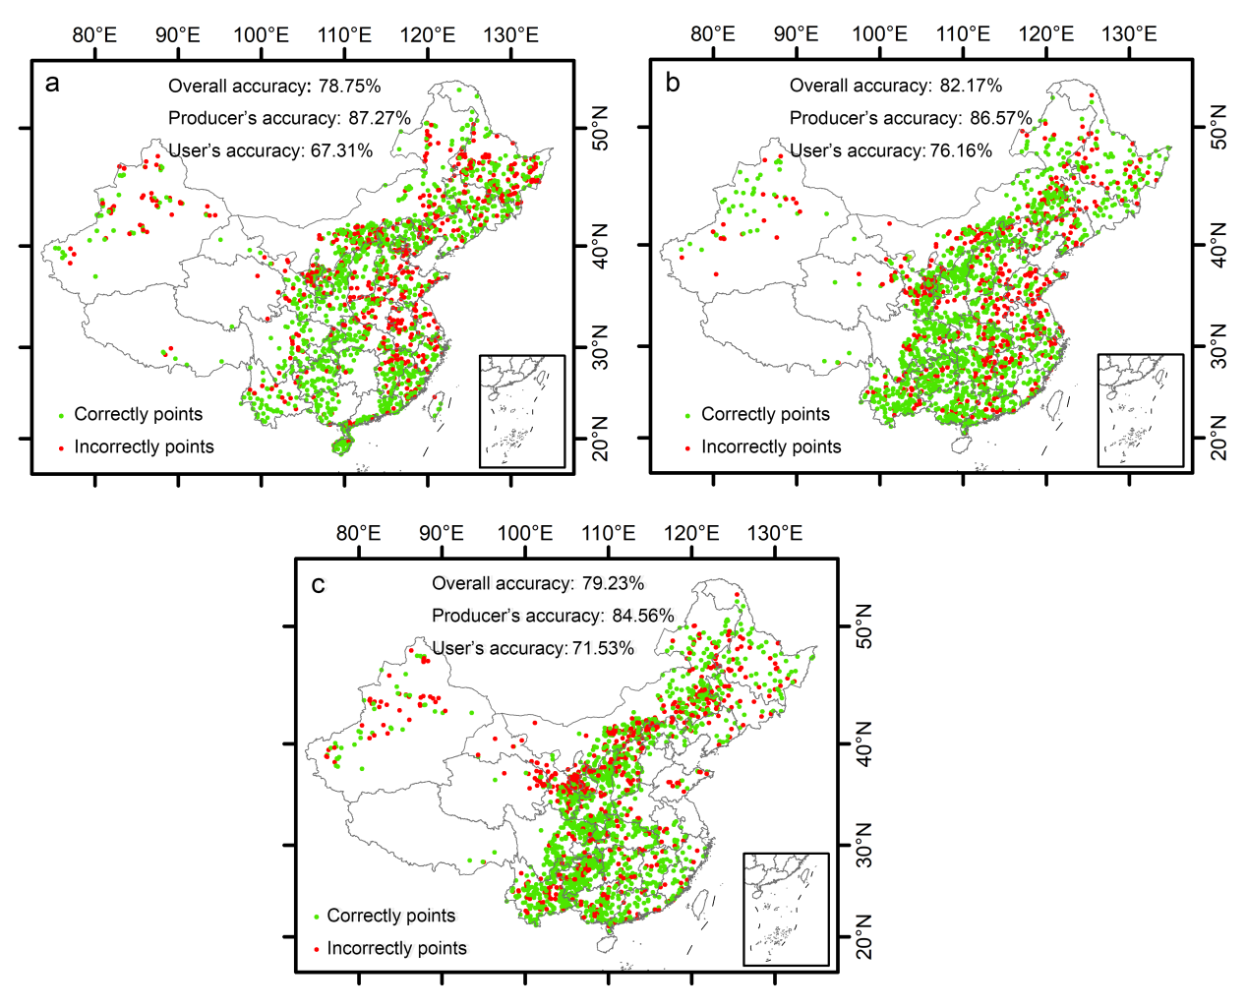
Supplementary Fig. 1. Accuracy assessment results of three sets of abandoned cropland products and their sample point distribution in China. (The accuracy results of abandoned croplands derived from the China’s Land Cover Dataset (CLCD) (a), China’s Land-Use/cover Datasets-A (CLUD-A) (b), and China’s Land Cover Dataset (CACD) (c).)
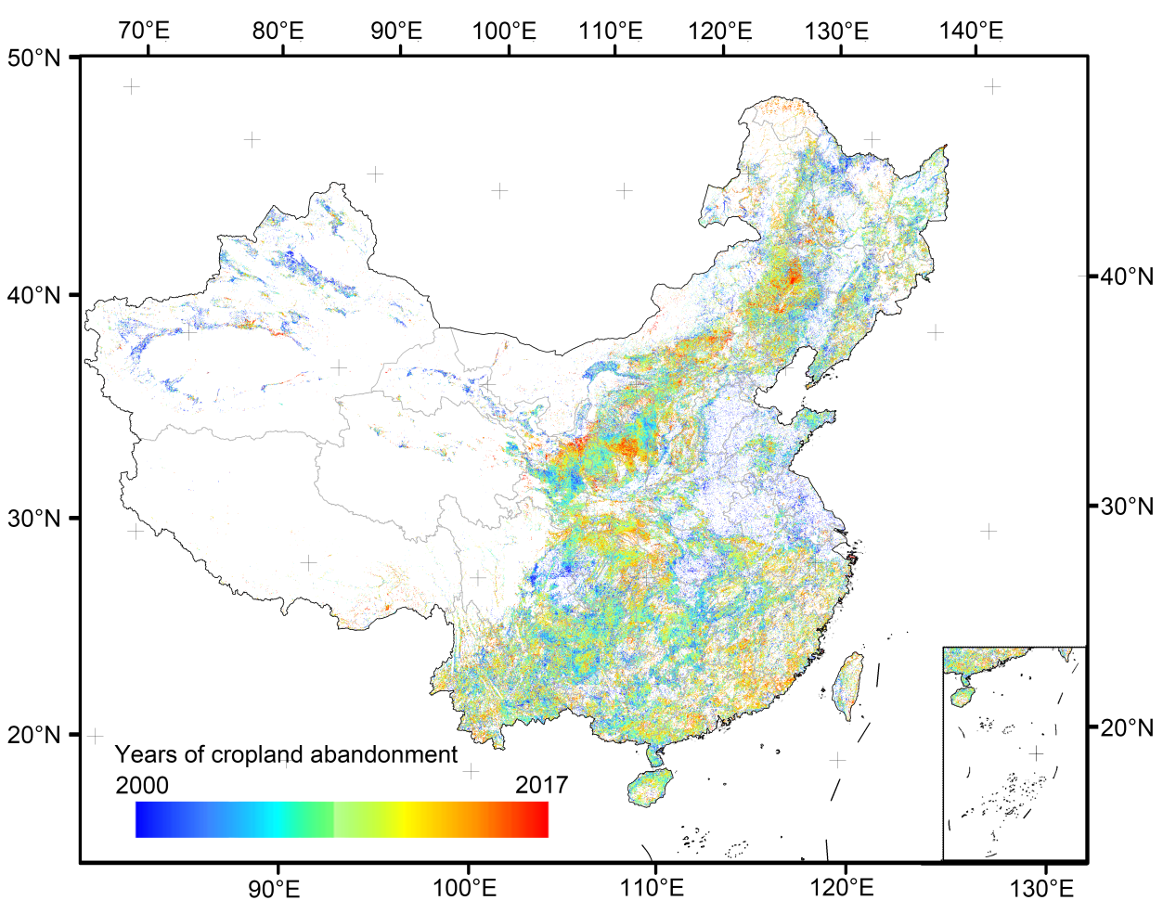
Supplementary Fig. 2. Year of cropland abandonment in China. (We aggregated the abandoned land raster map with 30m to 1km resolution. The abandonment year serve as an crucial covariate of the machine learning model.)

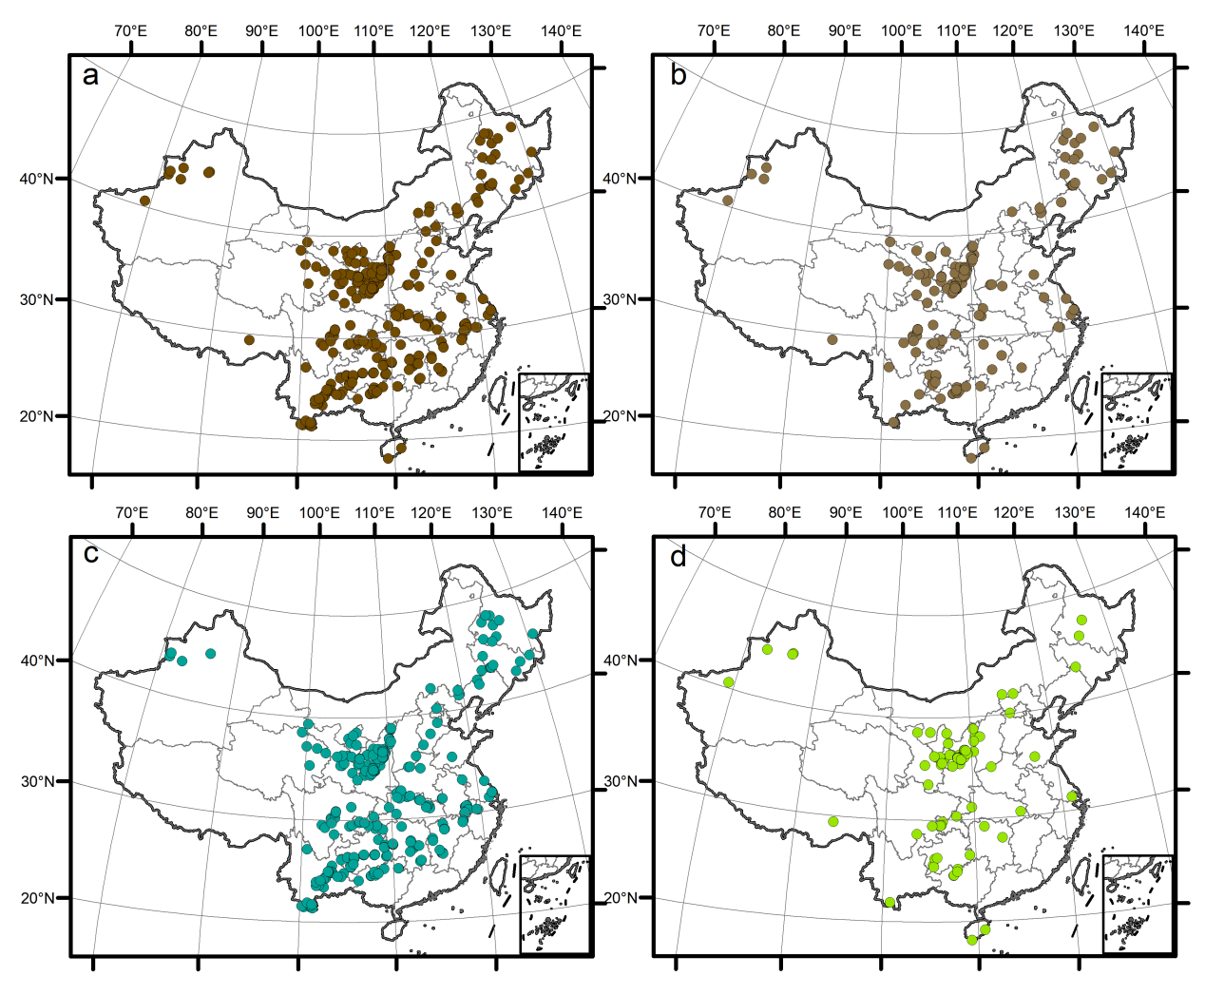
Supplementary Fig. 3. The distribution of 3502 soil organic carbon (SOC) empirical samples. (Total soil organic carbon empirical samples distribution (a); Soil organic carbon empirical samples after afforestation (b); Soil organic carbon empirical samples after cropland abandonment (c); Soil organic carbon empirical samples in long-term cultivated cropland (d).)
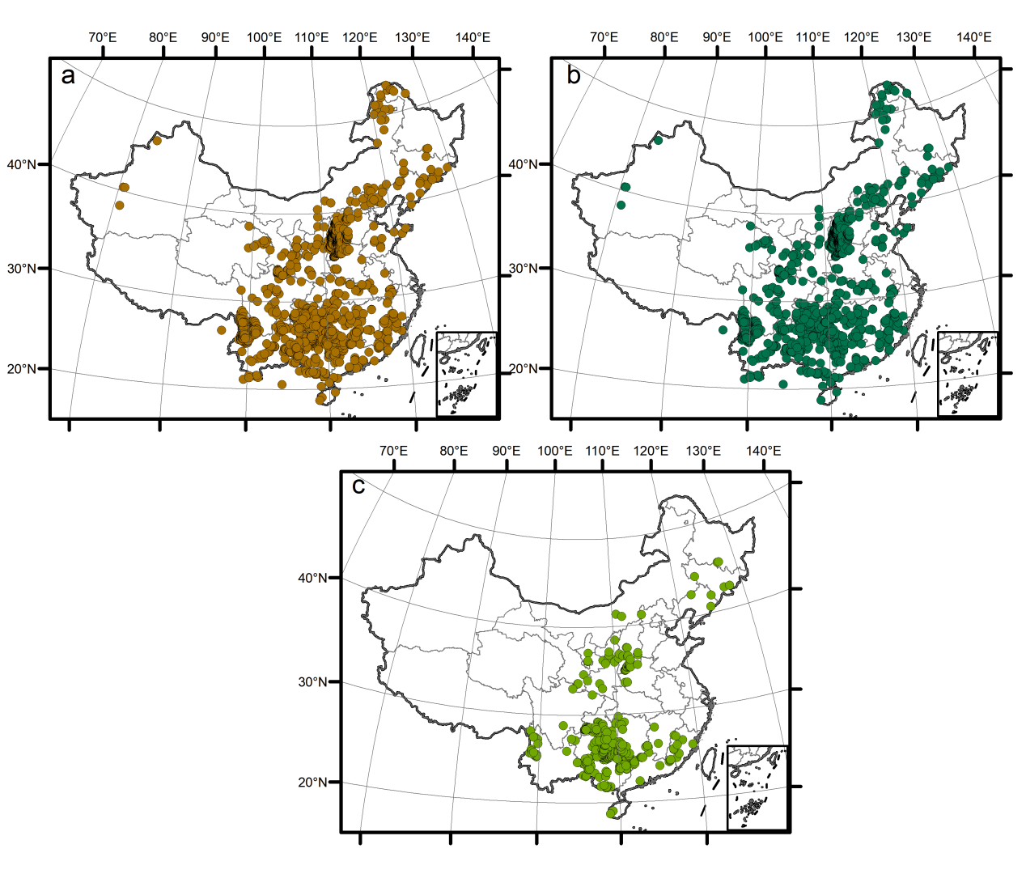
Supplementary Fig. 4. The distribution of 7316 biomass carbon empirical samples. (Total biomass carbon empirical samples distribution (a); The biomass carbon empirical samples after afforestation (b); The biomass carbon empirical samples after cropland abandonment (c).)
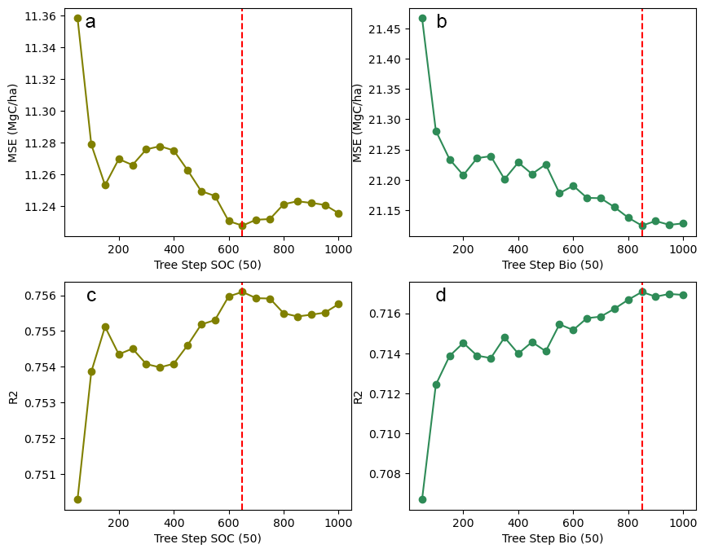
Supplementary Fig. 5. The Mean Squared Error (MSE) and R² corresponding to the number of decision trees in the random forest model.
Supplementary Fig. 6. The accuracy evaluation results for SOC and biomass carbon predicted models.

Supplementary Fig. 7. Uncertainty maps. (The uncertainty maps of soil organic carbon (SOC) under abandoned (a) and afforestation (b) scenarios, respectively; The uncertainty maps of biomass carbon under abandoned (c) and afforestation (d) scenarios).

Supplementary Tables
Supplementary Table 1. Environmental covariates used in the machine-learning model.
Covariate | Source
Elevation (m) | ¹
Slope (°) | ¹
Aspect | ¹
NHx Deposition | ²
Annual mean temperature (℃) | ³
Annual precipitation (mm) | ³
CO₂ Deposition | ⁴
Soil Water Content (%) | ⁵
Sand Content (kg / kg) | ⁵
Soil Bulk (kg/m^3) | ⁵
Soil_PH (Soil pH in H2O) | ⁵
Soil Type | ⁶
Depth to Bedrock (cm) | ⁷
Average Wind Speed (M/s) | ⁸
Relative Humidity (%) | ⁵
Restoration type (1 abandonment; 2 afforestation) | -
Stand ages (Years) | -

Supplementary Table 2. Afforestation subsidies in different geographical regions.
Regions | Subsidy (USD/ha)
Northeast China | 2721.70
North China | 2548.75
East China | 2698.24
Northwest China | 2720.40
Southwest China | 2849.00
Central South China | 2728.74
Average | 2711.14

Supplementary Tables 3. The cases study distinguishing between afforestation and abandonment in the post-agricultural period.
References | Research areas | Aims | Methods
⁹ | Agricultural and pastoral transition zone in northern China | Distinguishing between abandonment and afforestation | A change detection method based on land cover change trajectories
¹⁰ | Southwest China | Distinguishing between abandonment and afforestation | Slope of NDVI changes based on Landsat time series
¹¹ | Southern Spain | Distinguishing between abandonment and afforestation | An object-oriented classification approach combining vegetation spectral features and surface texture
¹² | Małopolska region in southern Poland | Distinguishing between abandonment and afforestation | Identification of vegetation height and structure using LiDAR data

Supplementary Tables 4. Review of the results of Chine’s land abandonment studies: methods, intensity, and abandonment rate.
References | Information |  |  | Result
 | Data input | Resolution (m) | Methods | Area | Time span | Annual abandonment rate
¹³ | CLCD | 30m | land use trajectory method | 30.8 Mha | 2000-2019 | 0.83%
¹⁴ | GlobeLand30 dataset | 500 | Conversion of cropland to barren land | 862 km² per year | 2003-2016 | 0.55%
¹⁵ | CLCD | 30 | land use trajectory method | 26.47 Mha | 1991 to 2018 | 4.59%
¹⁶ | CLCD | 30 | land use trajectory method | 39.2 Mha | 1992-2015 | 13.03 %
¹⁷ | MODIS NDVI | 250 | land use trajectory method | 8.47 Mha | 2002–2017 | 5%
¹⁸ | MODIS images | 500 | Decision tree | - | 2005–2019 | nearly 20%
References:
1. Jeffrey, J. D. & Dean, B. G. Global Multi-Resolution Terrain Elevation Data 2010. https://pubs.usgs.gov/publication/ofr20111073 (2011).
2. Lamarque, J.-F. et al. Historical (1850–2000) gridded anthropogenic and biomass burning emissions of reactive gases and aerosols: methodology and application. Atmos. Chem. Phys. 10, 7017–7039 (2010).
3. Xinliang, X. Annual spatially interpolated dataset of meteorological elements in China. (2022).
4. Cheng, W. et al. Global monthly gridded atmospheric carbon dioxide concentrations under the historical and future scenarios. Sci Data 9, 83 (2022).
5. Tomislav, H. & Surya, G. Soil water content (volumetric %) for 33kPa and 1500kPa suctions predicted at 6 standard depths (0, 10, 30, 60, 100 and 200 cm) at 250 m resolution. https://doi.org/10.5281/zenodo.2784001 (2019).
6. Shi, X. Z. et al. Cross‐Reference System for Translating Between Genetic Soil Classification of China and Soil Taxonomy. Soil Science Soc of Amer J 70, 78–83 (2006).
7. Yan, F., Shangguan, W., Zhang, J. & Hu, B. Depth-to-bedrock map of China at a spatial resolution of 100 meters. Sci Data 7, 2 (2020).
8. Zhou, J. et al. Projection of China’s future runoff based on the CMIP6 mid-high warming scenarios. Sci. China Earth Sci. 66, 528–546 (2023).
9. Du, Z., Yang, J., Ou, C. & Zhang, T. Agricultural Land Abandonment and Retirement Mapping in the Northern China Crop-Pasture Band Using Temporal Consistency Check and Trajectory-Based Change Detection Approach. IEEE Trans. Geosci. Remote Sensing 60, 1–12 (2022).
10. Hong, C., Prishchepov, A. V., Jin, X. & Zhou, Y. Mapping cropland abandonment and distinguishing from intentional afforestation with Landsat time series. International Journal of Applied Earth Observation and Geoinformation 127, 103693 (2024).
11. Ivanov, E., Manakos, I. & Benayas, J. M. R. Remote sensing evaluation of afforestation versus natural revegetation on abandoned croplands in central Spain. (2007).
12. Janus, J. & Bozek, P. Using ALS data to estimate afforestation and secondary forest succession on agricultural areas: An approach to improve the understanding of land abandonment causes. Applied Geography 97, 128–141 (2018).
13. Li, M., Cui, Y., Dong, J. & Qin, Y. Abandoned cropland compensates the decrease in net ecosystem productivity of impervious surface expansion in China. Environmental Impact Assessment Review 104, 107363 (2024).
14. Qiu, B. et al. Urban expansion or poor productivity: Explaining regional differences in cropland abandonment in China during the early 21st century. Land Degrad Dev 31, 2540–2551 (2020).
15. Wang, H. et al. Is Abandoned Cropland Continuously Growing in China? Quantitative Evidence and Enlightenment from Landsat-Derived Annual China Land Cover Dataset. Land 13, 45 (2023).
16. Zhang, M. et al. Reveal the severe spatial and temporal patterns of abandoned cropland in China over the past 30 years. Science of The Total Environment 857, 159591 (2023).
17. Zhu, X., Xiao, G., Zhang, D. & Guo, L. Mapping abandoned farmland in China using time series MODIS NDVI. Science of The Total Environment 755, 142651 (2021).
18. Li, L., Pan, Y., Zheng, R. & Liu, X. Understanding the spatiotemporal patterns of seasonal, annual, and consecutive farmland abandonment in China with time‐series MODIS images during the period 2005–2019. Land Degrad Dev 33, 1608–1625 (2022).

