Additional file 1 for
Rupture process of the 2024 Noto peninsula earthquake inferred from strong motion, teleseismic, and geodetic data
Hiroaki Kobayashi¹, Tetsushi Watanabe¹, Kazuki Koketsu²
¹ Kobori Research Complex Inc., 6-5-30 Akasaka, Minato-ku, Tokyo, Japan.
² SFC Research Institute, Keio University, 5322 Endo, Fujisawa‐shi, Kanagawa, Japan
Correspondence: kohiroak@kobori-takken.co.jp

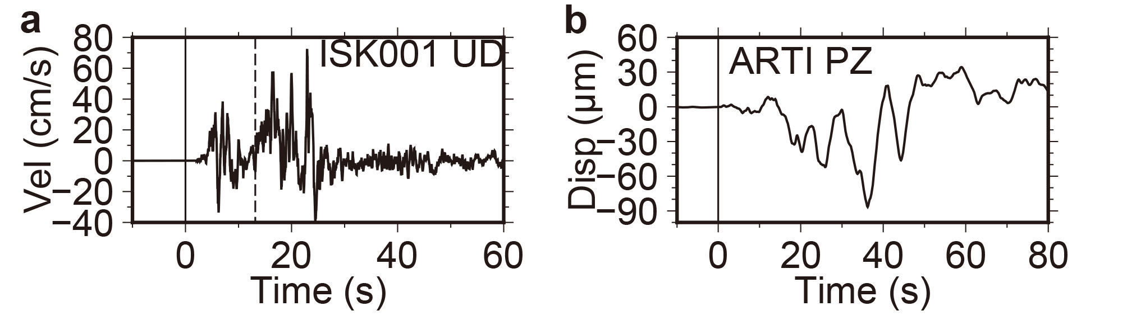
Figure S1
a Unfiltered observed velocity waveform (UD component) at the strong motion station ISK001. T = 0 s is the origin time of the M_{JMA} 5.9 earthquake. The origin time of the M_{JMA} 7.6 earthquake is indicated by the black broken line. b Unfiltered observed displacement waveform (P-wave, UD component) at the teleseismic station ARTI. T = 0 s is the picked P-arrival time of the M_{JMA} 5.9 earthquake.
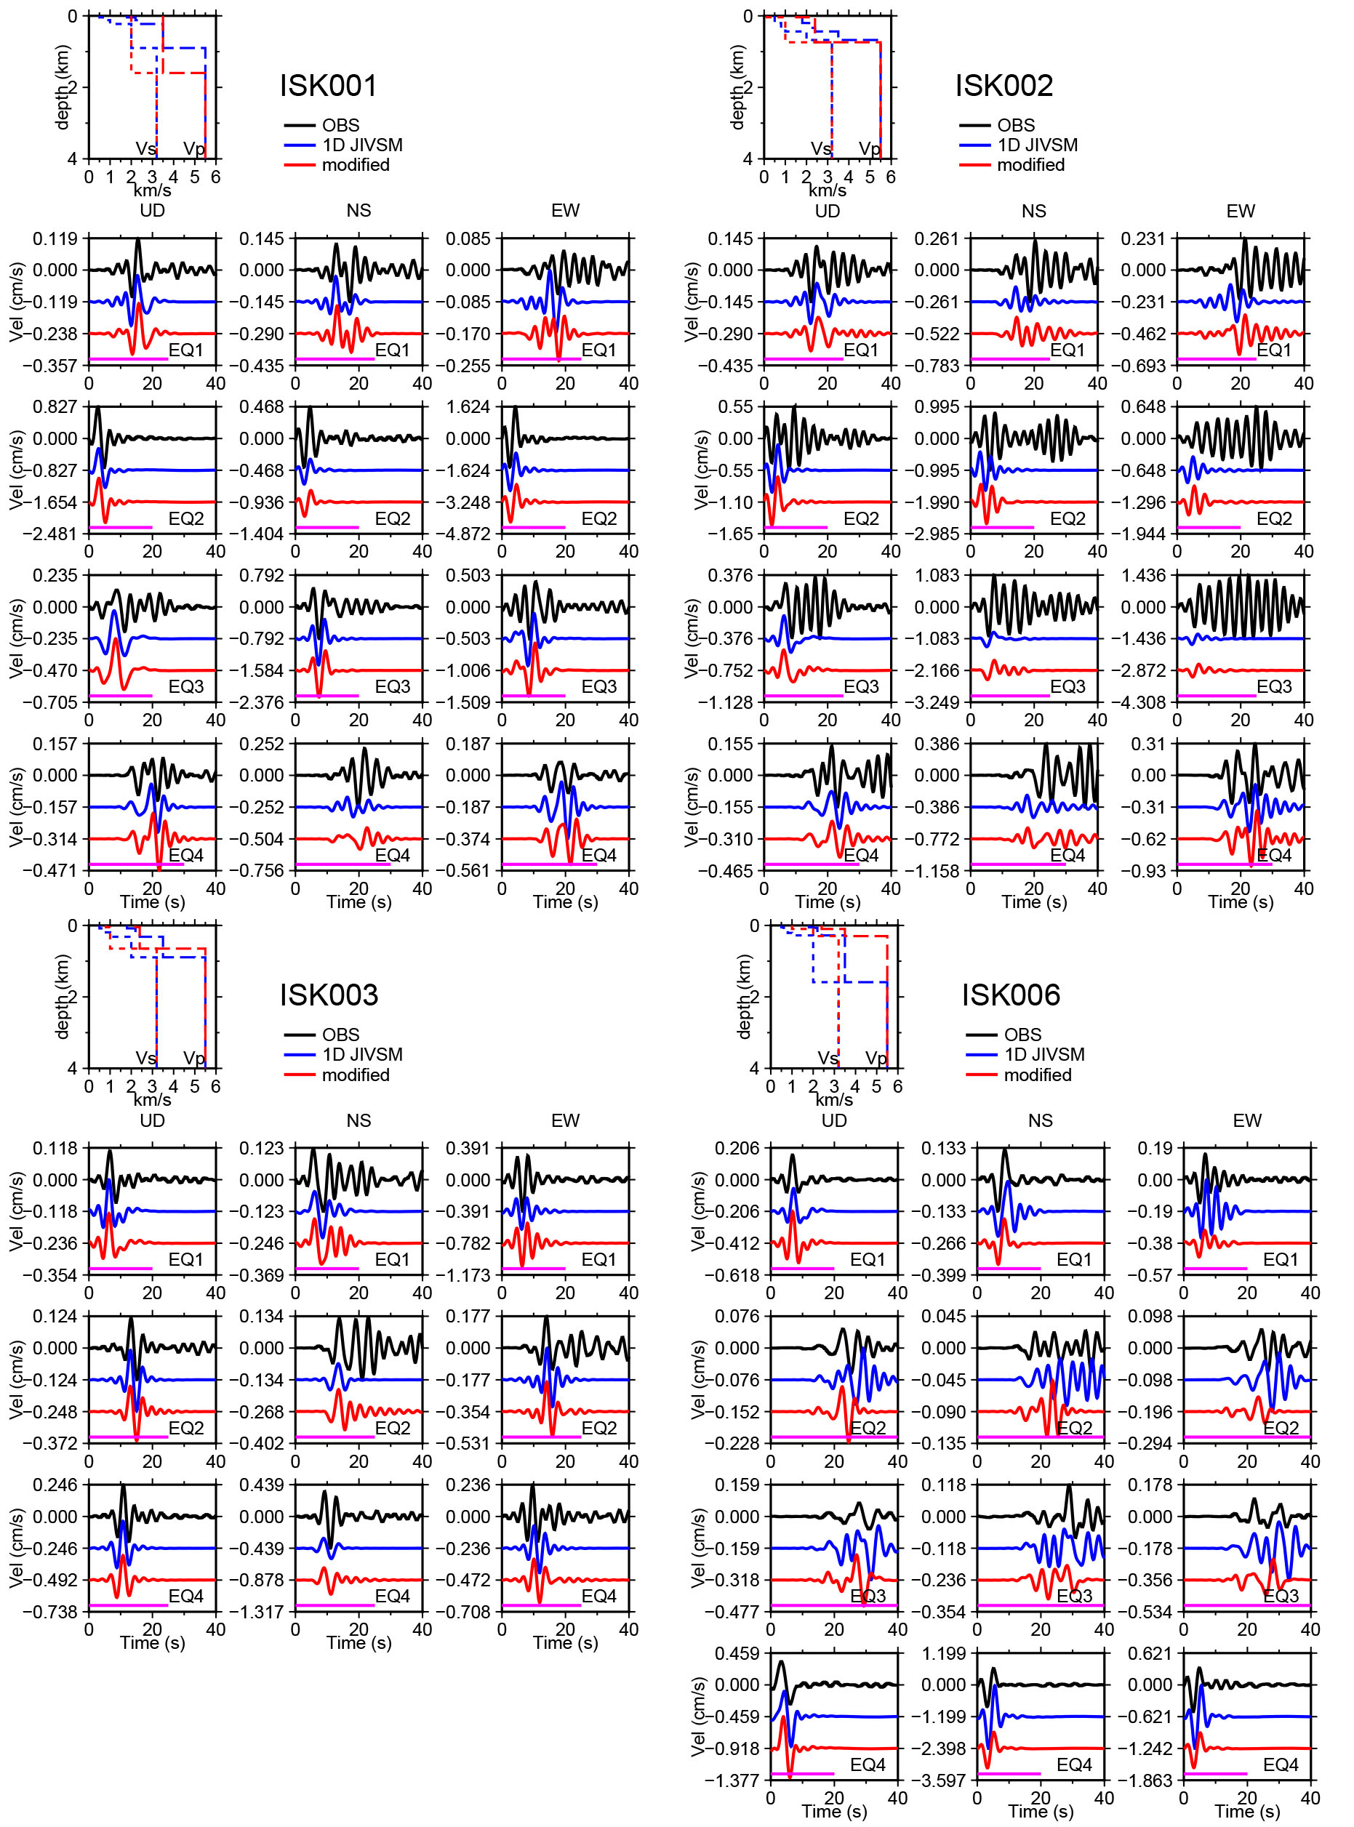
Figure S2
Velocity structure models prior to and after the adjustment and comparisons of the observed and synthetic waveforms of the medium-sized earthquakes. The blue and red dotted lines show the Vs structure of the 1D JIVSM and the modified models, respectively. The blue and red broken lines denote the Vp structure of the 1D JIVSM and the modified models, respectively. The black lines indicate the observed waveforms (0.05–0.3 Hz). The blue and red lines represent the synthetic waveforms (0.05–0.3 Hz) calculated using the 1D JIVSM and the modified models, respectively. The purple lines denote the time range used for the adjustment.
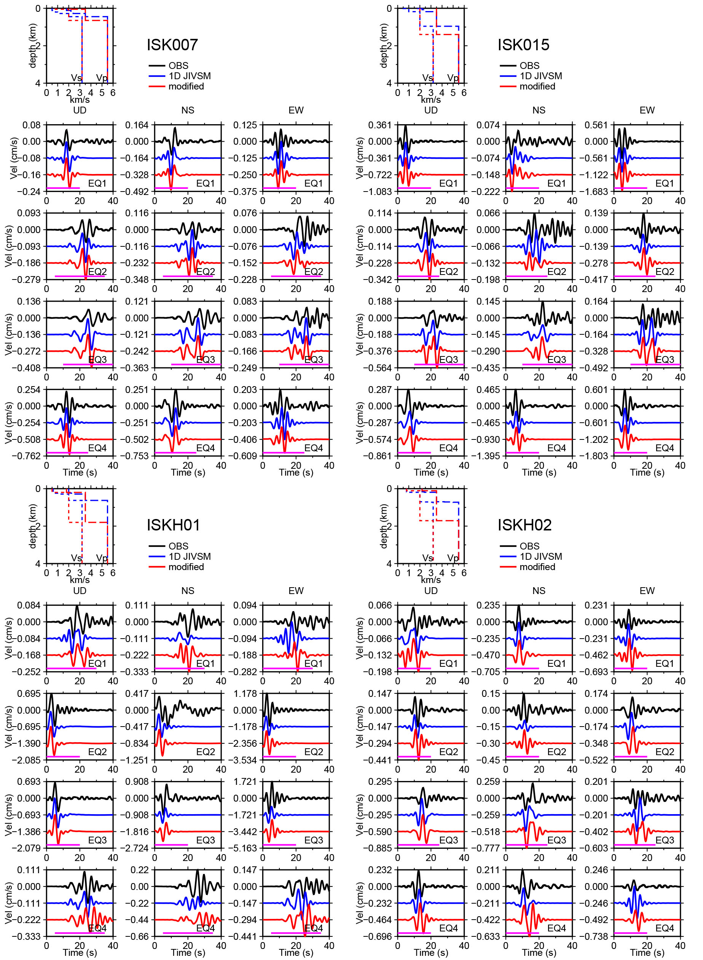
Figure S2
Continued.
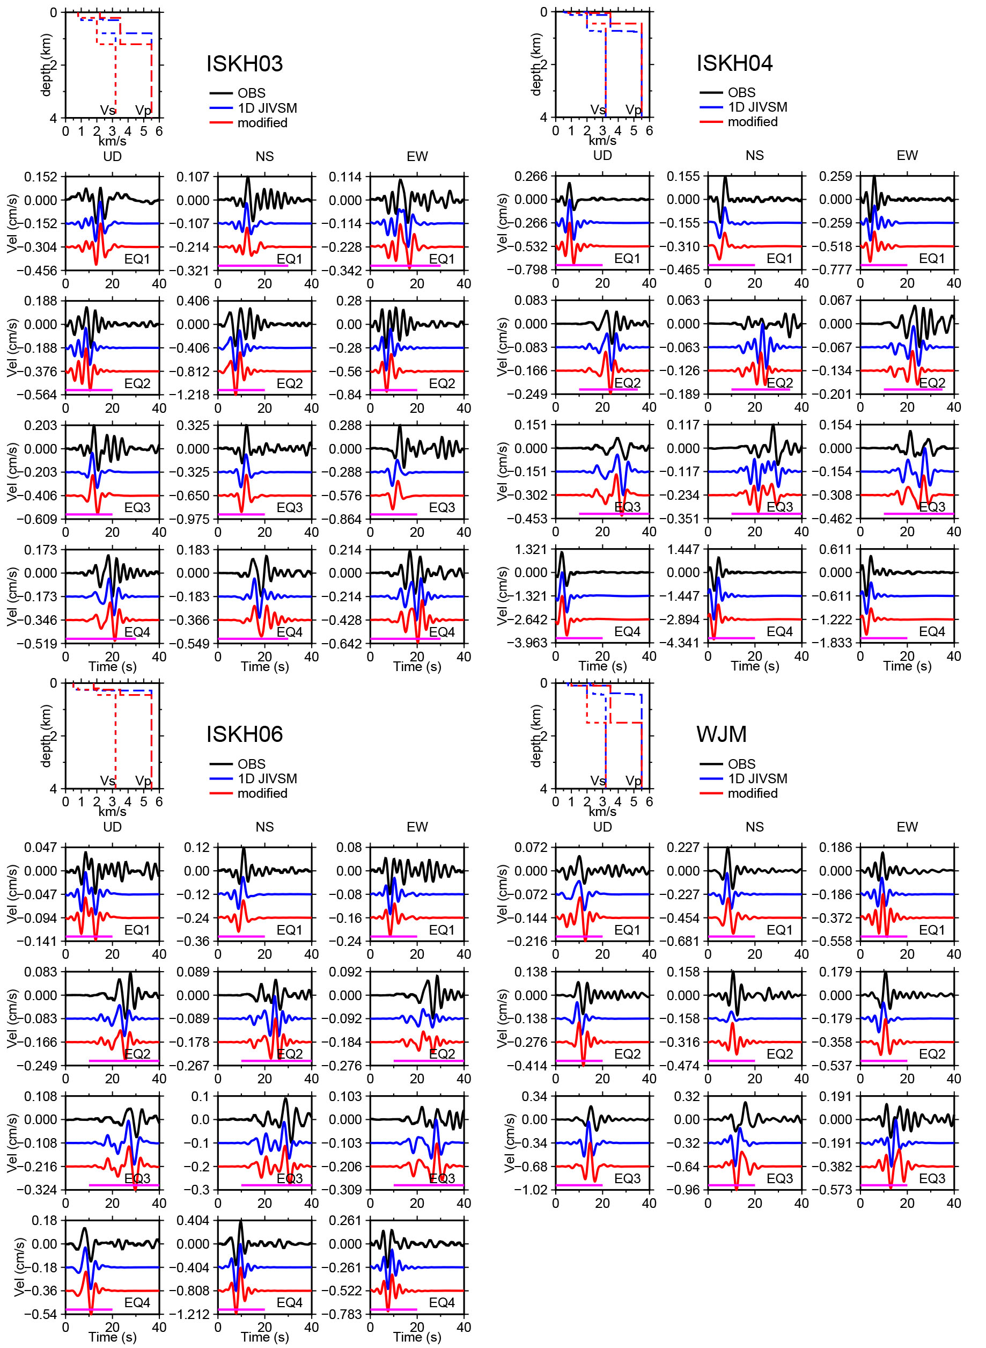
Figure S2
Continued.
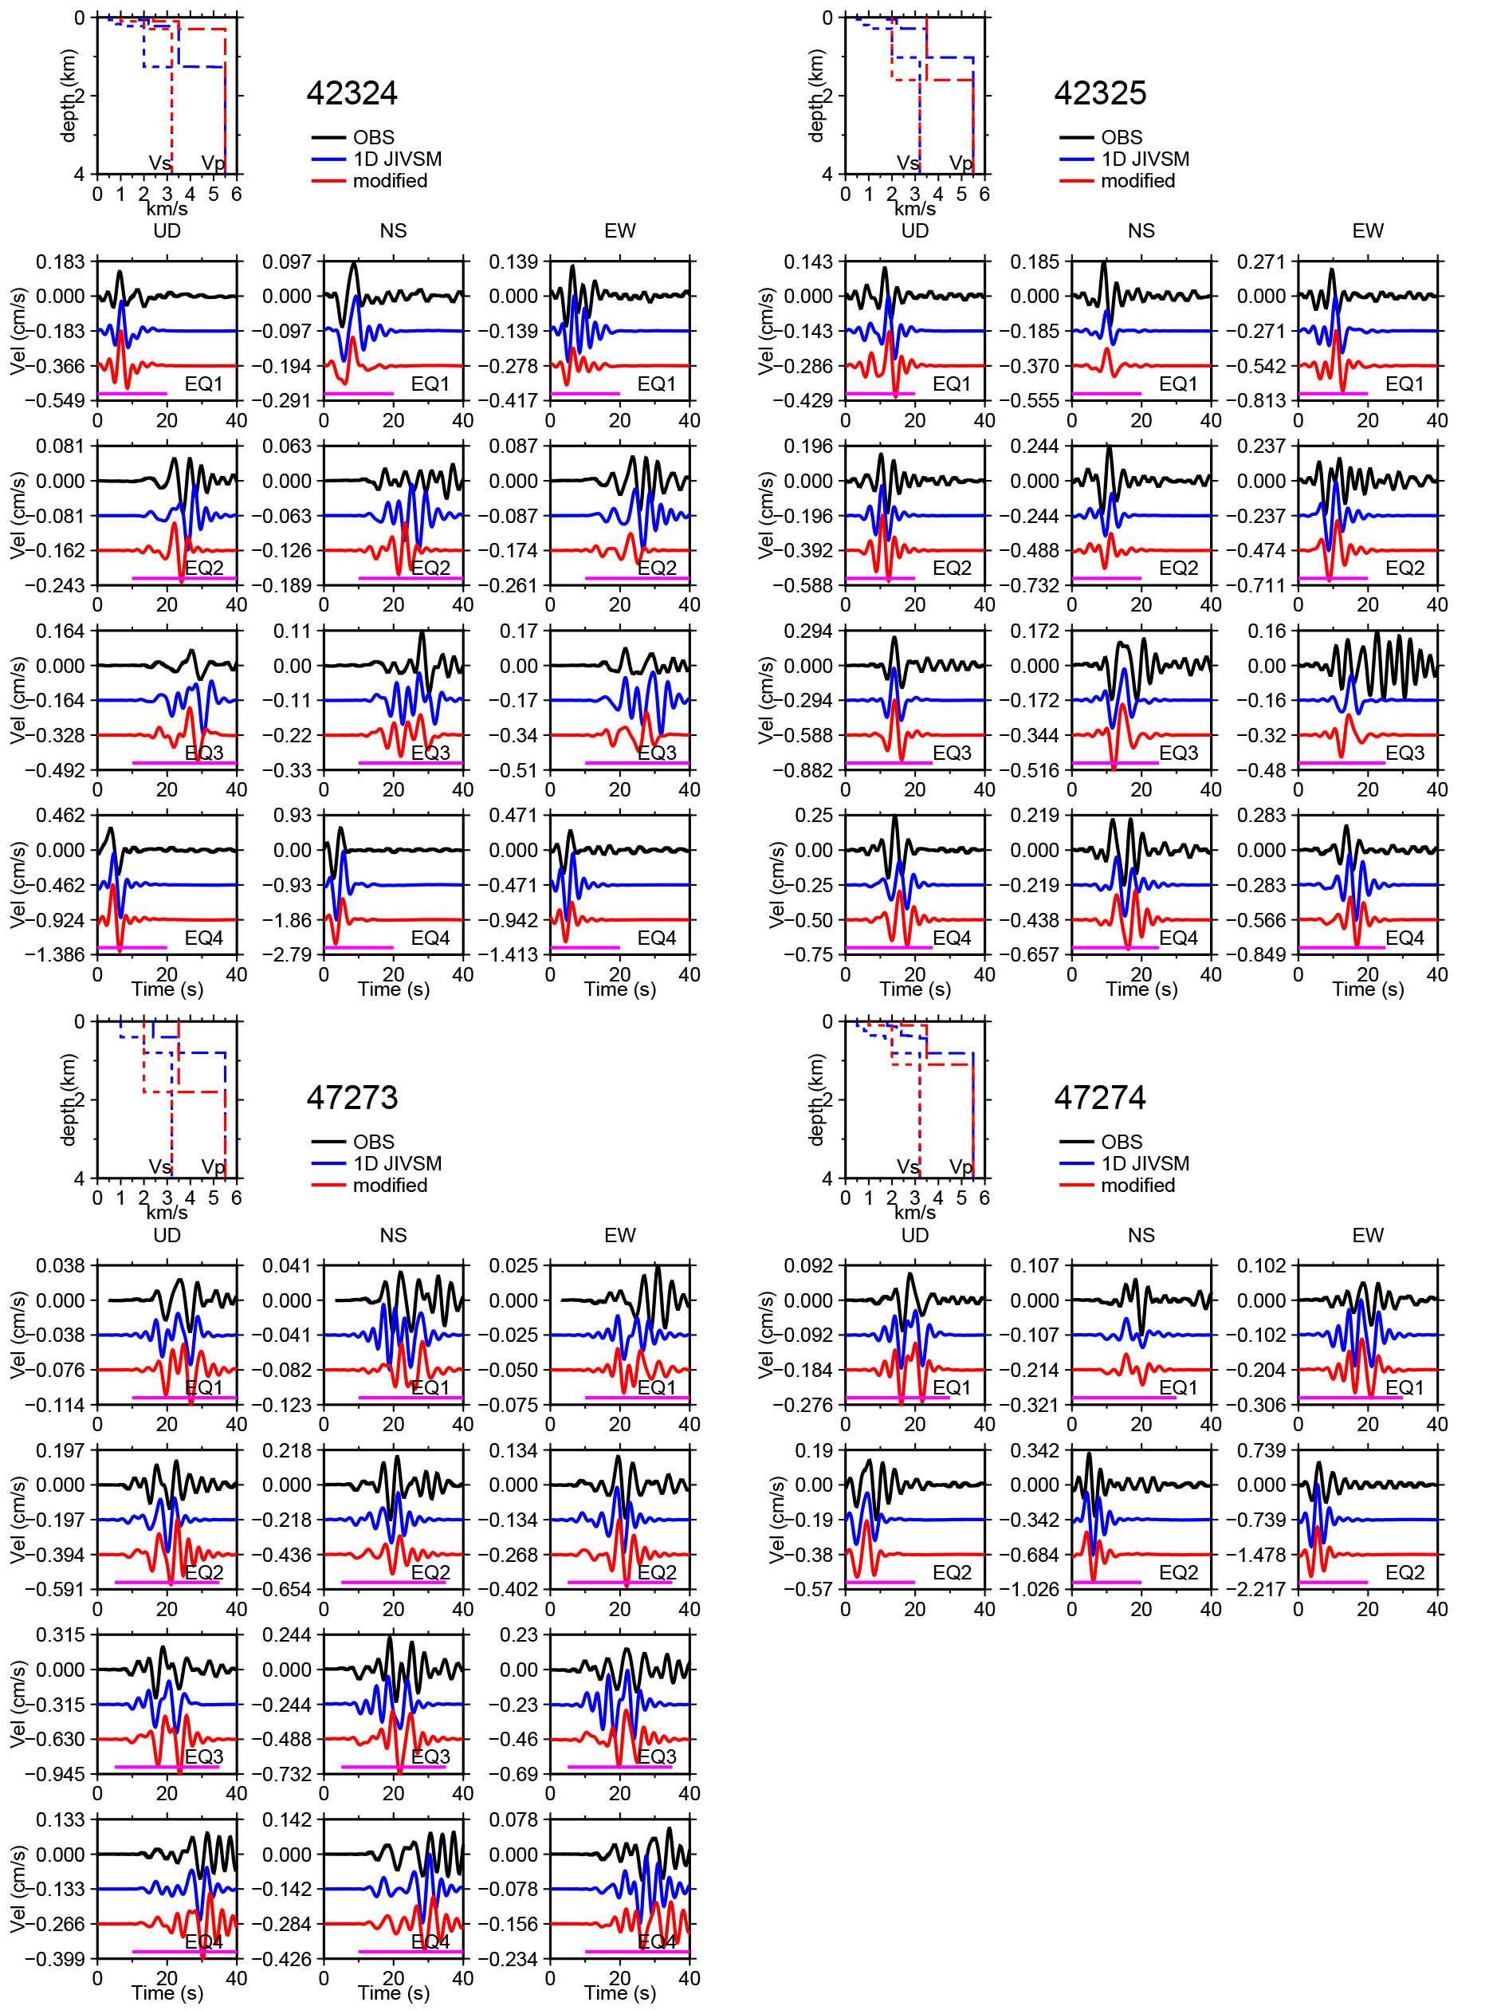
Figure S2
Continued.
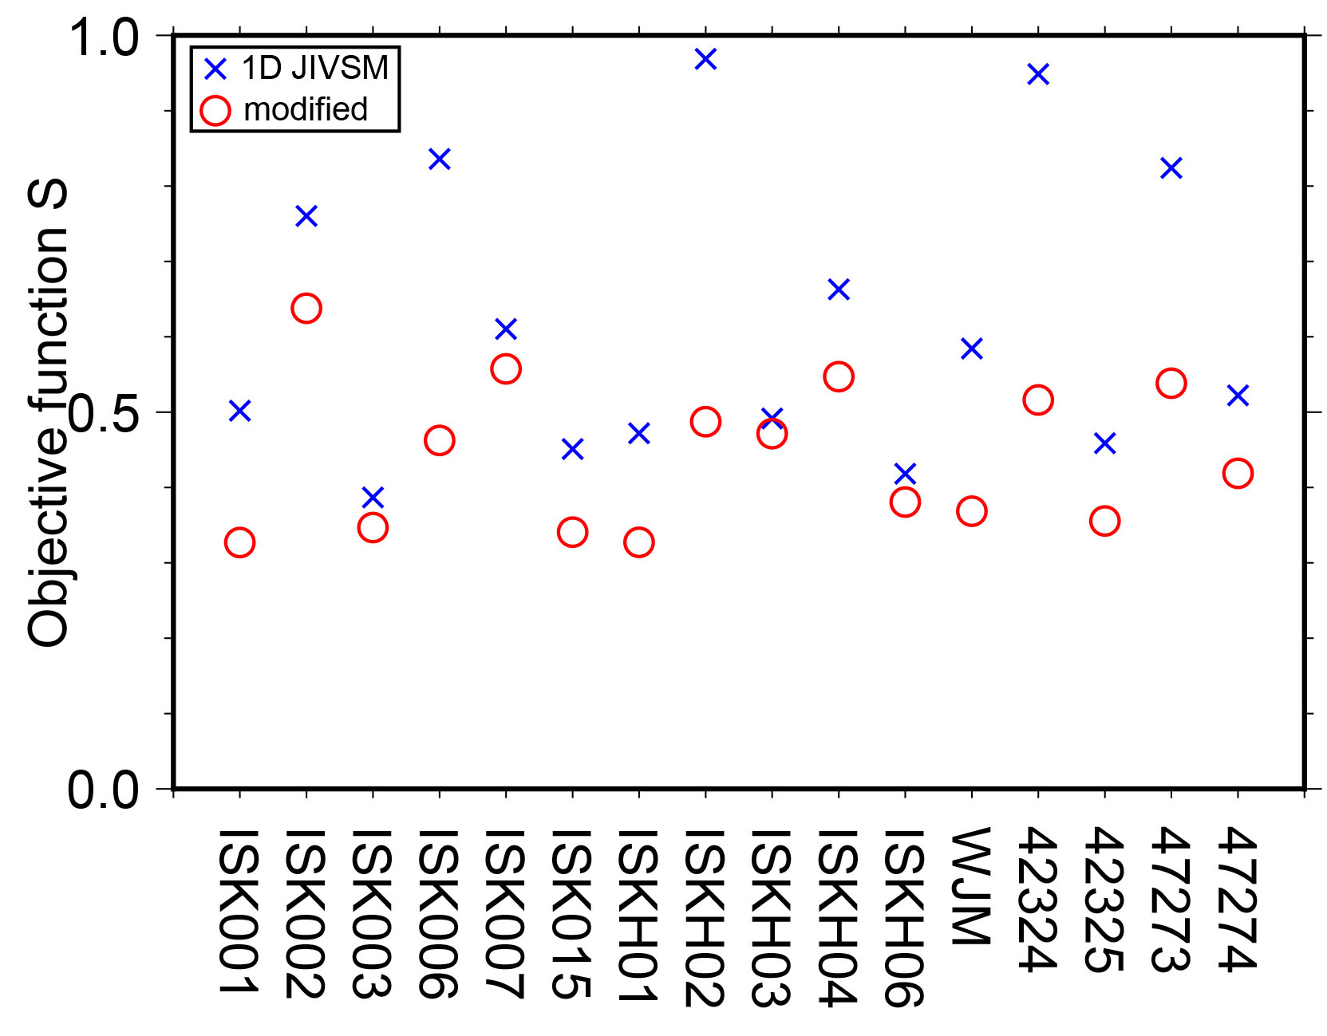
Figure S3
Values of the objective function S prior to (blue crosses) and after (red circles) the velocity structure adjustment.
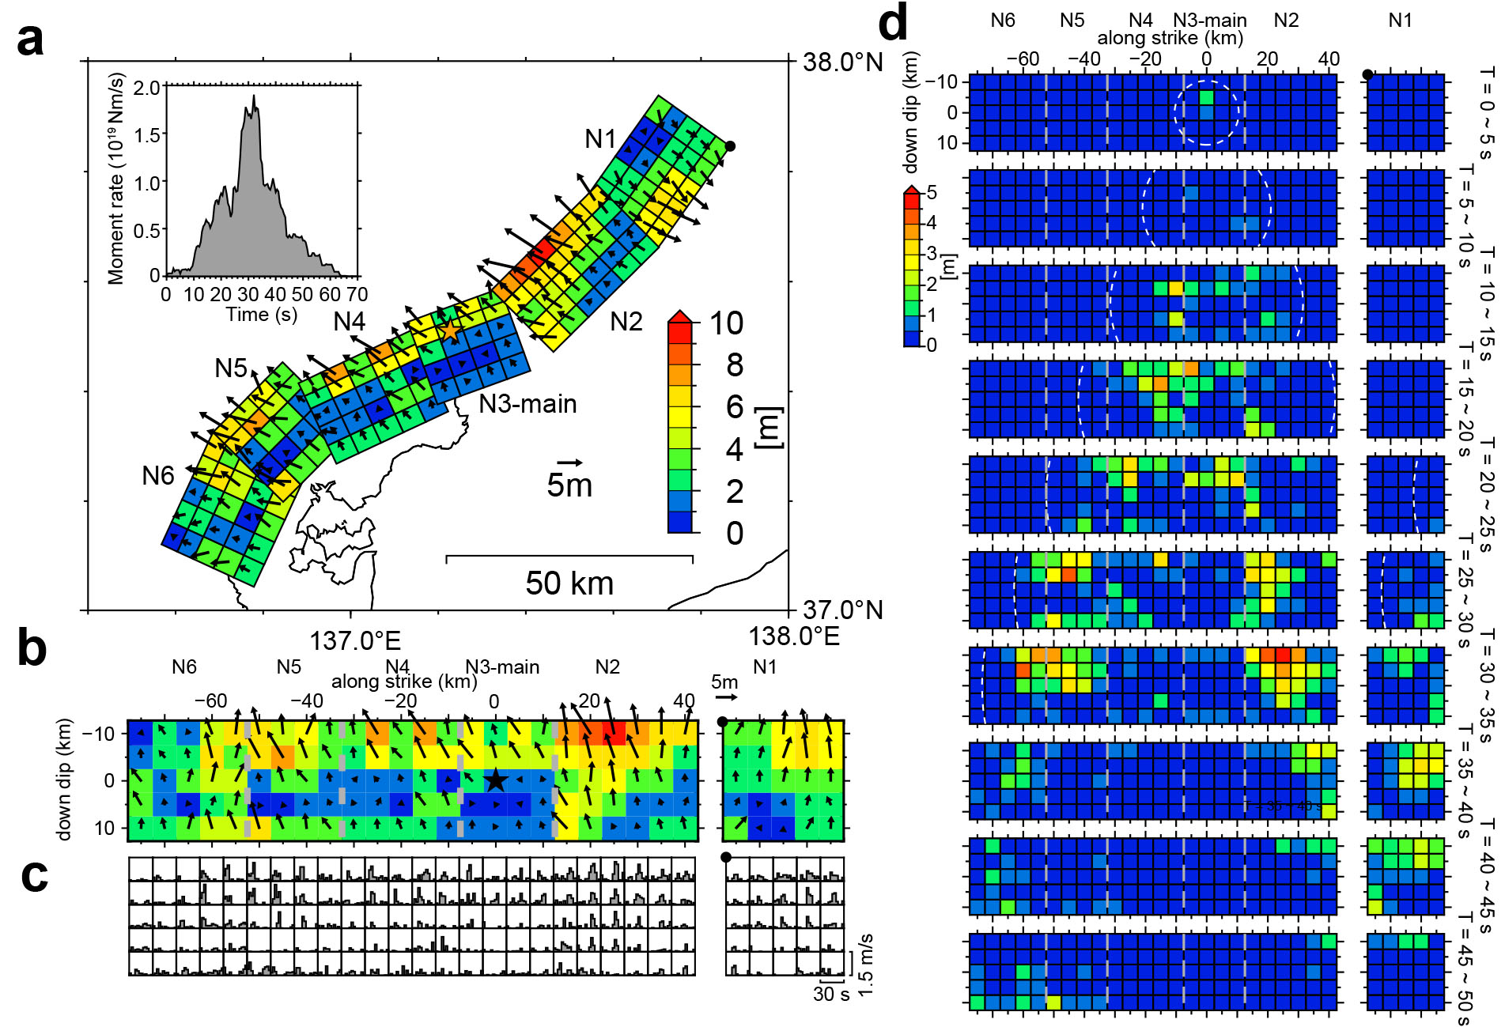
Figure S4
First preliminary source inversion result. a Map view of the slip distribution and apparent moment rate function. The orange star represents the hypocenter of the mainshock. b Fault view of the slip distribution. The black star indicates the rupture initiation point. c Slip rate function of each subfault. d Snapshots of the slip distribution. The gray broken lines indicate the segment boundaries. The white broken lines denote the rupture front at the end of the corresponding time range. The black circle indicates the corresponding locations on the fault in Panel a.
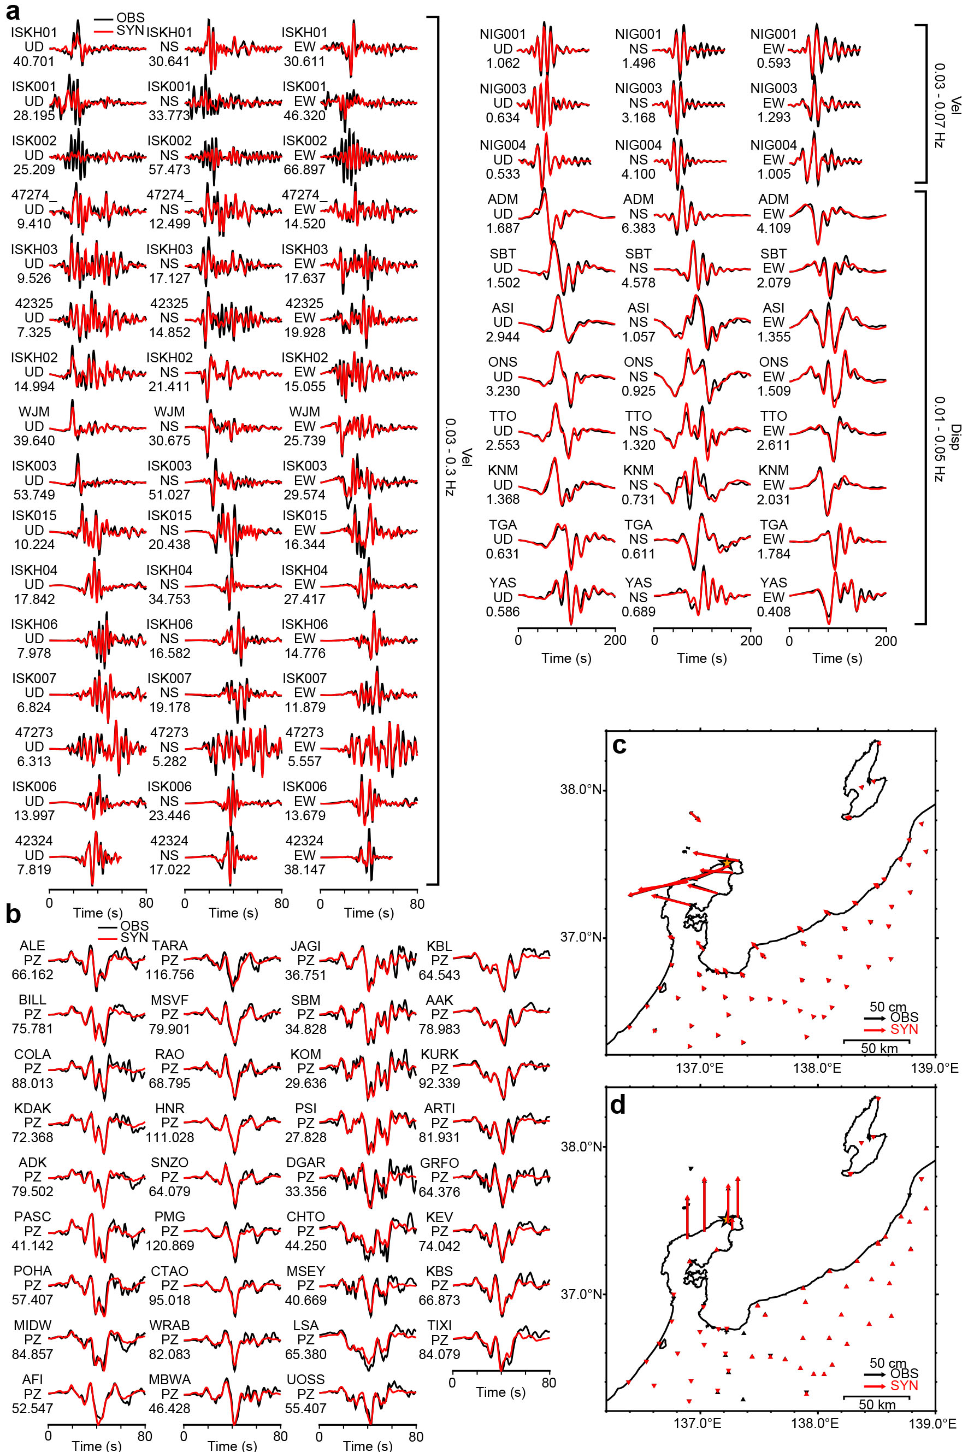
Figure S5
Comparisons of the observed (black) and synthetic (red) data of the first preliminary inversion result. a Strong motion and b Teleseismic (0.01–0.4 Hz) waveforms. The frequency ranges of the applied bandpass filters and waveform types are shown to the right of each strong motion station group. The station name, component, and maximum observed amplitude (cm/s or cm for strong motion and μm for teleseismic) are shown to the left of each waveform. c Horizontal static displacements. d Vertical static displacement.
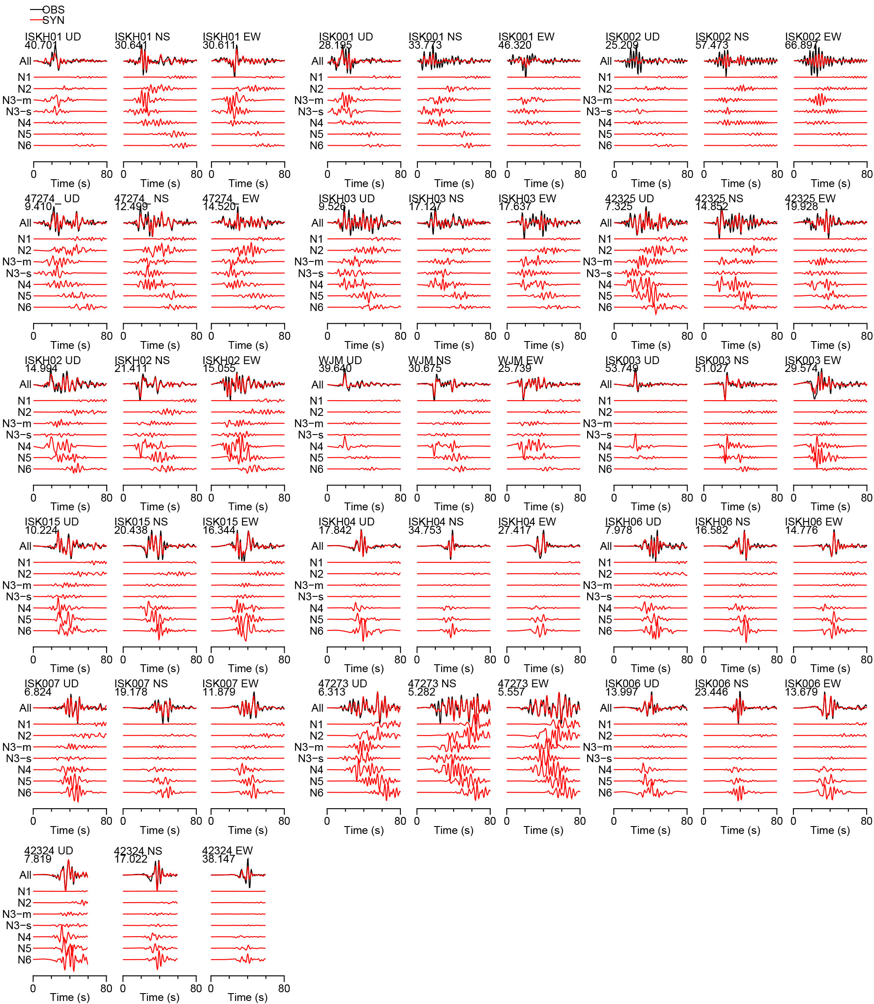
Figure S6
Comparisons of the observed (black) and synthetic (red) strong motion waveforms at the stations in the Noto Peninsula and station 47273 in the main inversion result. Synthetic waveforms for each segment are shown below the comparisons. The frequency ranges of the applied bandpass filters and waveform types are 0.03–0.3 Hz and the velocity, respectively. The station name, component, and maximum observed amplitude (cm/s) are shown above each waveform.
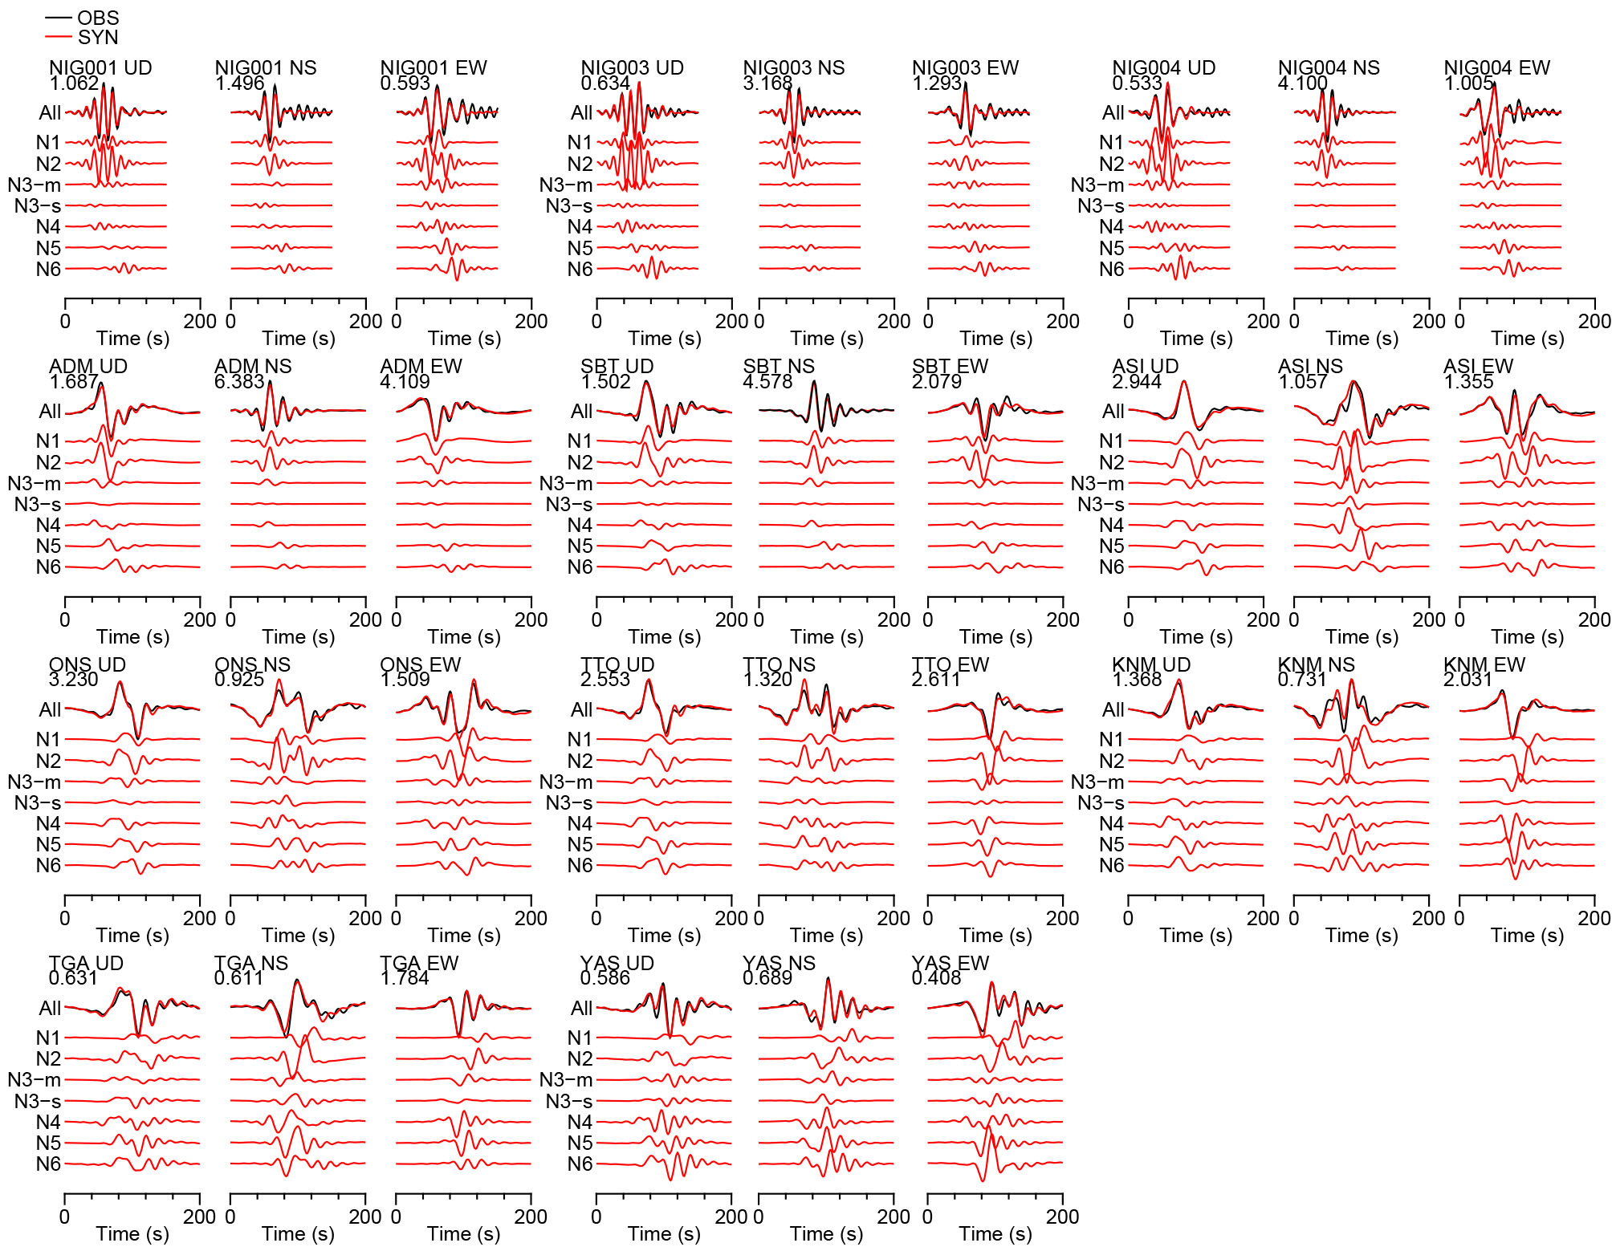
Figure S7
Comparisons of the observed (black) and synthetic (red) strong motion waveforms at the stations outside the Noto Peninsula in the main inversion result. Synthetic waveforms for each segment are shown below the comparisons. The frequency ranges of the applied bandpass filters are 0.03–0.07 Hz (NIG001 to NIG004) and 0.01–0.05 Hz (ADM to YAS). Waveform types are the velocity (NIG001 to NIG004) and displacement (ADM to YAS). The station name, component, and maximum observed amplitude (cm/s or cm) are shown above each waveform.
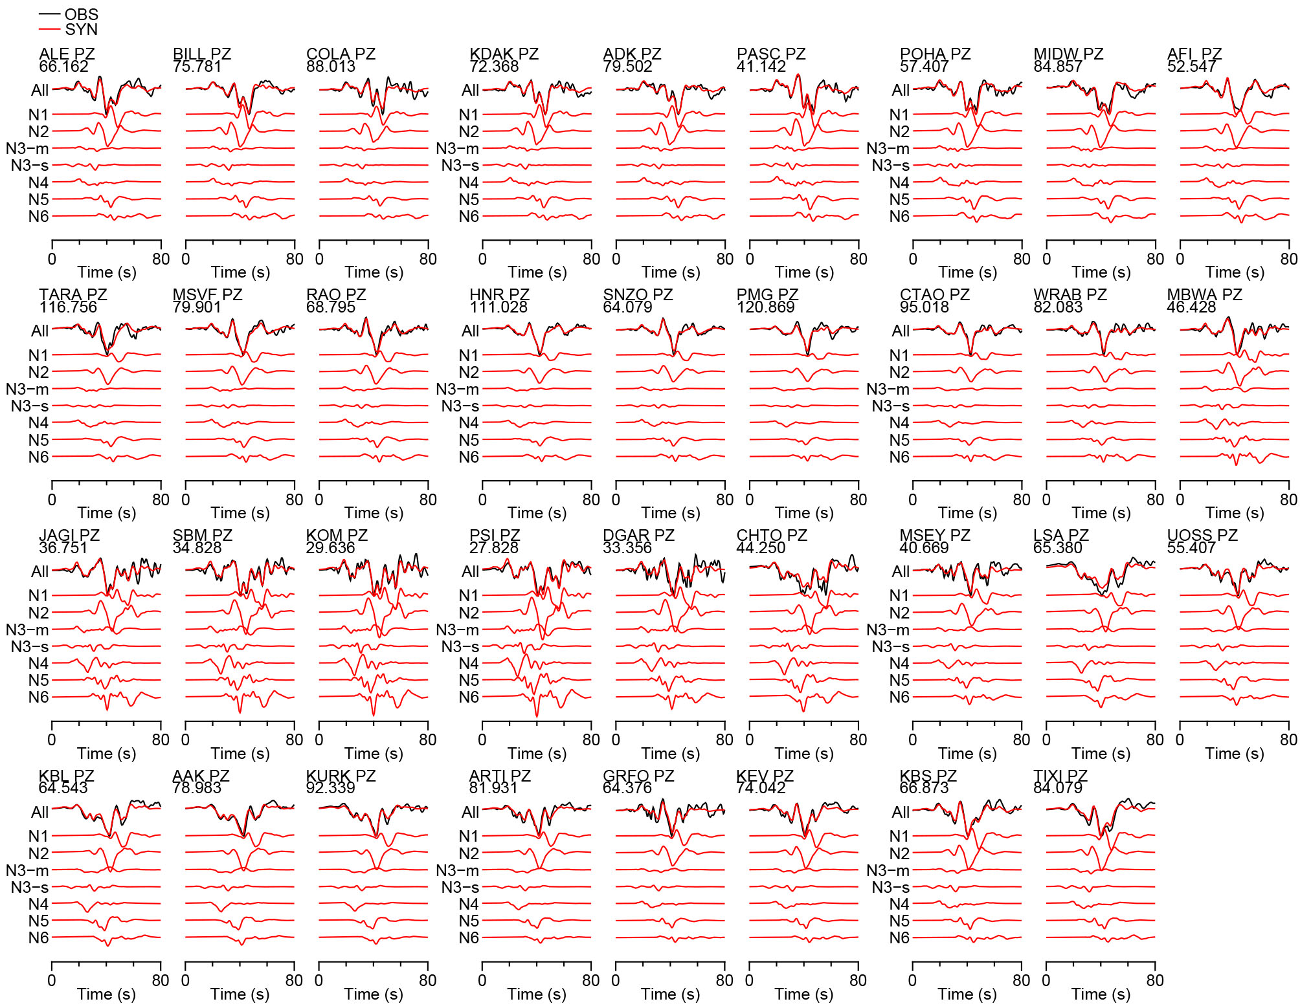
Figure S8
Comparisons of the observed (black) and synthetic (red) teleseismic displacement waveforms (0.01–0.04 Hz) in the main inversion result. Synthetic waveforms for each segment are shown below the comparisons. The station name, component, and maximum observed amplitude (μm) are shown above each waveform.
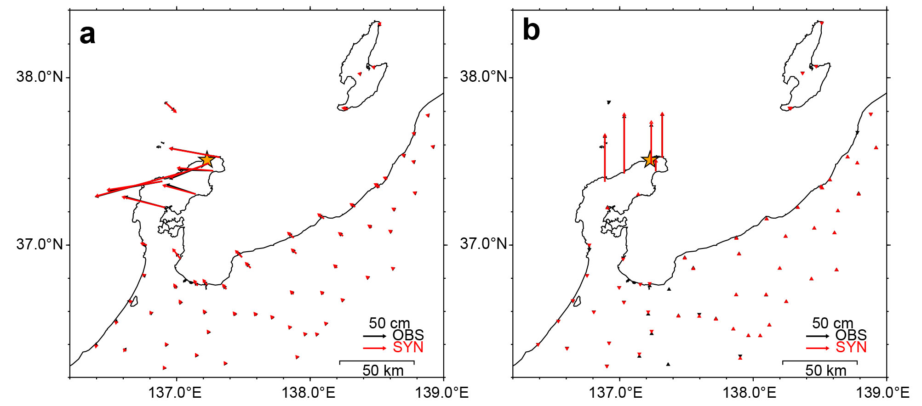
Figure S9
Comparisons of the observed (black) and synthetic (red) a horizontal static displacement and b vertical static displacement in the main inversion result.
Table S1. Datasets used in the inversion analysis.
Strong motion | Teleseismic | Geodetic (GNSS)
27 stations  81 components | 35 stations  35 UD components | 65 stations  65 horizontal and  65 vertical components

Event | Origin timeª  (UTC) | Centroid |  |  |  |  | (Strike,dip,rake)  (°) | M₀ (Nm) | Rise time^{b}  (s)
Event | Origin timeª  (UTC) | Latitude  (°) |  | Longitude  (°) |  | Depth  (km) | (Strike,dip,rake)  (°) | M₀ (Nm) | Rise time^{b}  (s)
EQ1 | 2020-03-12  19:18:46.77 | 37.2707 | 136.8358 |  | 11.0 |  | (9.7, 35.2, 91.9) | 8.65 × 10¹⁶ | 2.0
EQ2 | 2024-01-01  07:06:06.11 | 37.5105 | 137.2463 |  | 7.0 |  | (71.0, 35.2, 107.4) | 8.70 × 10¹⁶ | 2.1
EQ3 | 2024-01-01  09:08:18.42 | 37.5423 | 137.3713 |  | 10.0 |  | (22.7, 49.0, 75.6) | 2.79 × 10¹⁷ | 2.9
EQ4 | 2024-01-02  01:17:32.64 | 37.2311 | 136.7337 |  | 7.0 |  | (48.3, 53.0, 115.0) | 1.29 × 10¹⁷ | 2.5
Table S2. Source parameters of the medium-sized events.
a: values were from the JMA catalog. b: values were determined using M₀ from the F-net catalog and equation (1) in Ekström et al. (2012).

Table S3. Physical properties and search conditions of the layers.
Layer no. | Basic search range of thickness (km) | Search interval of thickness (km) | Vp  (km/s) | Vs  (km/s) | ρ  (10³ kg/m³) | Qp | Qs
0ª | 0.0-0.1 | 0.02 | 1.51 | 0.13 | 1.5 | 44 | 26
1 | 0.0–0.5 | 0.05 | 1.8 | 0.5 | 1.95 | 170 | 100
2 | 0.0–0.5 | 0.05 | 2.2 | 0.8 | 2.07 | 272 | 160
3 | 0.0–1.0 | 0.1 | 2.4 | 1.0 | 2.15 | 340 | 200
4 | 0.0–2.0 | 0.2 | 3.5 | 2.0 | 2.35 | 680 | 400
5 | -^{b} | -^{b} | 5.5 | 3.2 | 2.65 | 680 | 400
a: This layer is considered only for station ISK002. b: The thickness of this layer is determined automatically depending on that of the other layers.

Table S4. 1D near-receiver velocity structure model for the calculation of the teleseismic Green’s functions.
Thickness (km) | Vp (km/s) | Vs (km/s) | ρ (10³ kg/m³)
15.0 | 5.57 | 3.36 | 2.65
18.0 | 6.50 | 3.74 | 2.87
∞ | 8.10 | 4.68 | 3.30

