Supplementary Materials for
Stabilization and Destabilization of Multimode Solitons in Nonlinear Degenerate Multi-Pass Cavities
Junhan Huang^{1,2}, Bingbing Zhu^{1,2}, Shanyue Li^{1,2}, Kun Ding^{1,2}, and Zhensheng Tao^{1,2*}
¹ State Key Laboratory of Surface Physics, Key Laboratory of Micro and Nano Photonic Structures (MOE), and Department of Physics, Fudan University, Shanghai 200433, China.
² Shanghai Key Laboratory of Metasurfaces for Light Manipulation, Fudan University, Shanghai 200433, China.
*Corresponding author. Email: zhenshengtao@fudan.edu.cn.

S1. NLSE Simulation
Nonlinear MPCs are simulated using the equivalent lens sequence model, where cavity mirrors are replaced by focusing lenses and beams are assumed to propagate forward. The Kerr medium, chosen as fused silica with a thickness of 2d, is placed at the center of the cavity. NLSE for forward propagation with radial symmetry is given by [1]
$\frac{∂U}{∂z}=\frac{i}{2n_{0}k_{0}}T^{-1}∇_{⊥}^{2}U+iDU+i\frac{ω_{0}}{c}n_{2}T\left[\left(1-χ_{K}\right){\left|U\right|}^{2}+χ_{K}\int_{-∞}^{t}{h\left(t-t'\right){\left|U\left(t'\right)\right|}^{2}dt'}\right]U$, (S1)
where U represents the complex field amplitude, t is the retarded time $t-z/{v_{g}}$, with v_{g} being the group velocity near the carrier frequency ω₀, k₀ is the wave vector in the vacuum, $D=\frac{k^{''}}{2}{\left(i∂_{t}\right)}^{2}$ represents the dispersion term, $T=\left(1+\frac{i∂_{t}}{ω_{0}}\right)$, $χ_{K}$ is the coefficient for the Raman response and $h\left(t\right)=\frac{2}{3}\frac{τ_{1}^{2}+τ_{2}^{2}}{τ_{1}τ_{2}^{2}}e^{{-t}/{τ_{2}}}\sin\left(t/{τ_{1}}\right)$ is the Raman response function. The effect of cavity mirrors is incorporated using the transformation $U^{'}=Ue^{{-iπr^{2}}/{λF}}$ within the thin-lens approximation.
The split-step Fourier method is used to numerically solved the NLSE [2]. Due to the large variation in the beam radius during propagation in the MPCs, a non-uniform grid is applied in the radial direction to improve numerical accuracy. This is achieved through a non-uniform grid defined by the transformation $r=r_{0}\left(e^{y}-1\right)$ where y is uniformly discretized. In practice, r₀ is chosen to approximate the beam waist radius of the eigenmodes of the corresponding cavity. The numerical error at each step is carefully maintained at O(dz³), where dz is the step size in propagation.
For our simulations for the phase diagram (Fig. 2 in the main text), the cavity length is set to 2L = 79.5 cm. For solid and gas MPCs, we use fused silica and argon as the nonlinear media, respectively, both of which are commonly used in MPC compressors. The unfilled volume is assumed to be vacuum for simplicity. For d=d_{MCS}, to avoid significant temporal dispersion caused by long propagation distances in the solid medium, we artificially tuned the group-velocity dispersion (GVD) of fused silica to a near-zero value k’’≈ 0.2 fs² mm⁻¹. In practice, this can be achieved by adding negative GVD to the spherical mirror coating or by operating at laser wavelengths where the Kerr medium is near the zero GVD regime. The parameters used in our simulation are listed in Table S1.
Table S1. Parameters used in the NLSE simulation
 | fused silica | argon
n₀ | 1.4535 [3] | 1.000274 [4]
n₂ (m²/W) | 2.4⨉10⁻²⁰ [5] | 6.5⨉10⁻²³ [6]
k’’ (fs²/mm) | 18.973 [3] | 0.0162 [4]
𝜒_{K} | 0.160 [1] | 0.5 [7]
τ₁ (fs) | 13.5 [1] | 62 [7]
τ₂ (fs) | 40 [1] | 77 [7]

S2. Propagation of stable spatial discrete solitons
In Fig. S1, we plot the beam propagation dynamics for conditions A and B as shown in Fig. 2 of the main text. It is clear that for condition B, the laser pulses maintain stable spatial profiles within the nonlinear medium and on the cavity mirrors, indicating the formation of stable spatial discrete solitons. However, for condition A (degenerate cavity geometry), the spatial profile distorts as the beam propagates forward, and the temporal profile undergoes strong splitting.
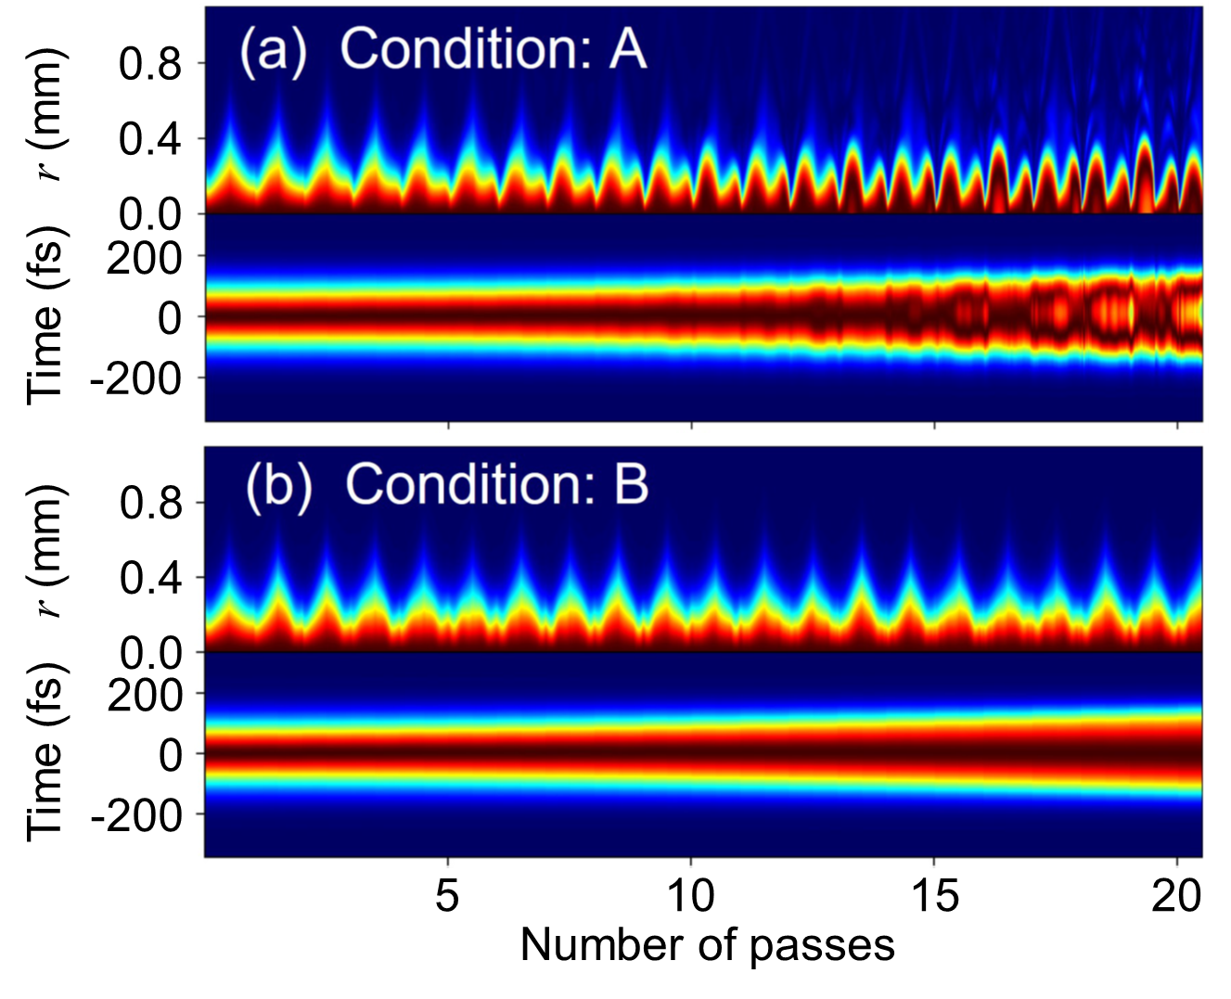
Figure S1. Beam propagation dynamics corresponding to conditions A and B.

S3. Fox-Li algorithm for the soliton solution in solid MPCs.
For a solid MPC, under thin-lens and thin-Kerr-medium approximations, the simplified NLSE has an equivalent integral form, where the propagation in free space is described by Fresnel-Kirchhoff diffraction (FKD), and the effects of the lens and the Kerr medium is represented by the phase factors $e^{i\frac{πr^{2}}{λ_{0}F}}$ and $e^{ib{\left|U\right|}^{2}}$. The FKD integral for free-space propagation with length L (half the cavity) is given by
$\hat{F}U\left(ρ\right)=-2πie^{iπρ^{2}}\int_{0}^{+∞}{U\left(ρ'\right)e^{iπ{ρ'}^{2}}J_{0}\left(2πρρ'\right)ρ'dρ'}$, (S2)
where J₀ is the zeroth-order Bessel function, and $ρ=r/{\sqrt{λ_{0}L}}$ is the reduced radial coordinate. The propagation from the k-th Kerr plate to the (k+1)-th plate is given by
$\left.\left|U_{k+1}\left(ρ\right)\right.\right\rangle =\hat{L}e^{ib{\left|U_{k}\left(ρ\right)\right|}^{2}}\left.\left|U_{k}\left(ρ\right)\right.\right\rangle$. (S3)
Here, $\hat{L}≡\hat{F}\hat{N}\hat{F}$ describes the linear part of beam propagation, where $\hat{N}≡e^{i\frac{πρ^{2}}{F/L}}$ represents the focus of the spherical mirrors, and $e^{ib{\left|U\left(ρ\right)\right|}^{2}}$ represents the nonlinear self-focusing induced by a thin Kerr plate.
This model can be solved following the Fox-Li iteration framework [8,9]. The idea here is to find the soliton solution that satisfies $\left|{U_{k+1}\left(ρ\right)}/{U_{k}\left(ρ\right)}\right|→1$ using the Fox-Li algorithm. The Fox-Li pseudocode is as follows:
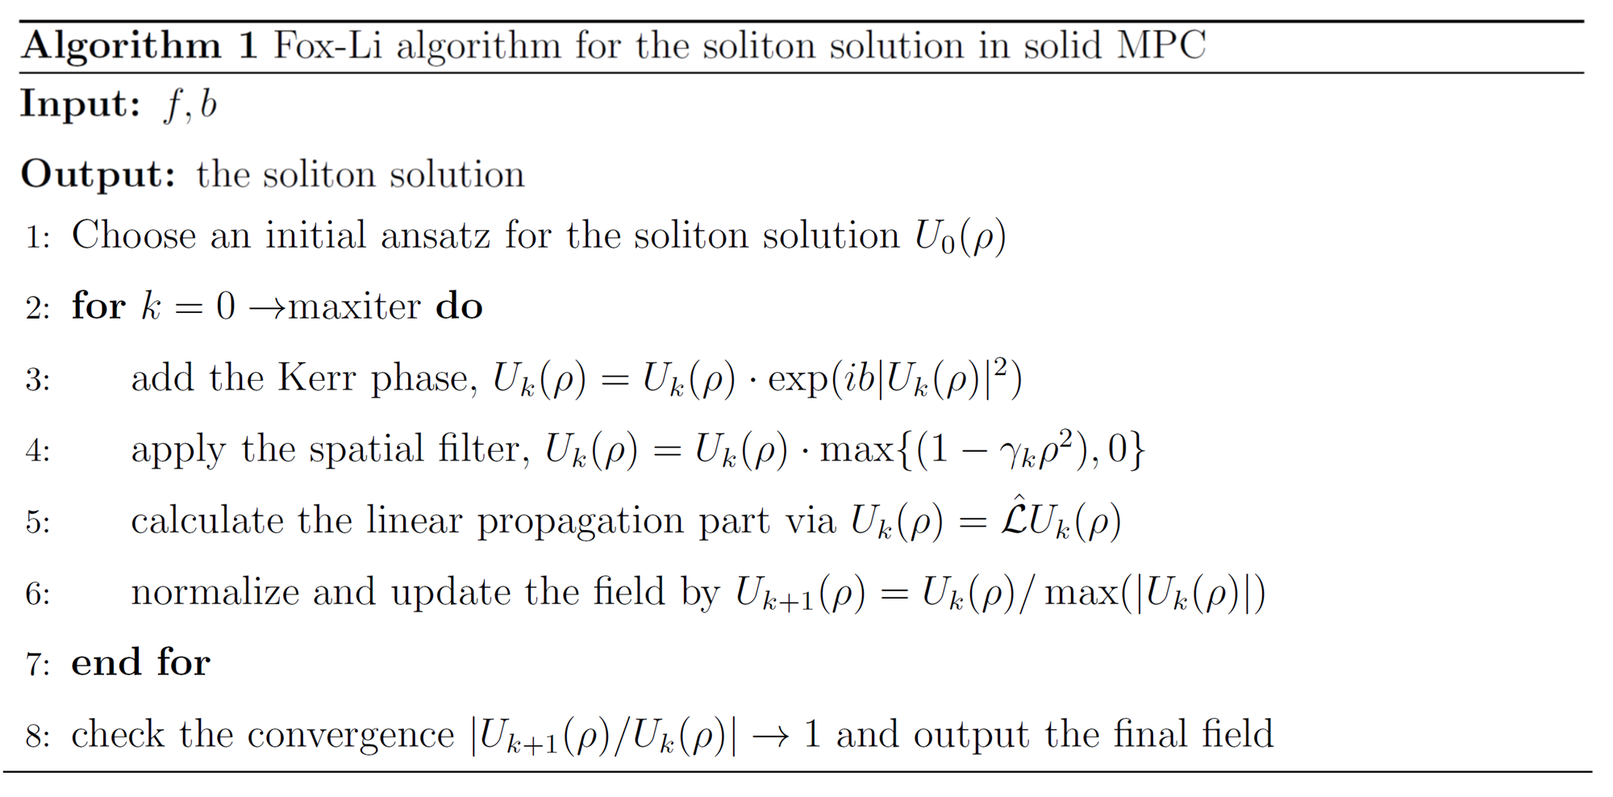
S4. Soliton stabilization analysis
To analyze the stability of the soliton solutions, we employ a linear stability analysis approach [10]. We perform the standard linearization procedure, introduce a small perturbation to the soliton solution, and use the perturbed solution as the initial condition in the simplified NLSE simulations. Specifically, we choose the perturbation to be $\left.\left|w\right.\right\rangle =\sum_{n}{a_{n}\left.\left|ψ_{n}\right.\right\rangle }$, where $\left.\left|ψ_{n}\right.\right\rangle$ is the LG_{0n} mode and an is a random coefficient in the interval [0.02, 0.04] [11].

S5. Derivation of the overlap integral and MCS length
The overlap integral has been derived from the perturbative analysis, which is given by
$Θ_{n,m}\left(d\right)=\frac{1}{2d_{eff}}\left\langle Φ_{n,m}\left(r,z\right) | S\left(z, d\right){\left|Φ_{0,0}\left(r,z\right)\right|}^{2} | Φ_{0,0}\left(r,z\right)\right\rangle$. (S4)
For the convenience of calculation, we introduce
$ϕ_{n}\left(r,z\right)=\frac{\sqrt{2/π}}{w\left(z\right)}L_{n}\left[2\frac{r^{2}}{w^{2}\left(z\right)}\right]e^{-\frac{r^{2}}{w^{2}\left(z\right)}}e^{-ik\frac{r^{2}}{2R\left(z\right)}}$, (S5)
which yields the Floquet state
$\left.\left|Φ_{n,m}\left(r,z\right)\right.\right\rangle =ϕ_{n}\left(r,z\right)e^{-i\frac{1}{2}ξ_{n}\left(z\right)+i\frac{ξ_{n}\left(L\right)}{2L}z-imΩz}$. (S6)
Substituting Eq. (S6) into Eq. (S4), we obtain
$Θ_{n,m}\left(d\right)=\frac{1}{2d_{eff}}\frac{π}{L}\int_{-d}^{d}{\left(\int_{0}^{+∞}{ϕ_{n}^{*}\left(r,z\right){\left|ϕ_{0}\left(r,z\right)\right|}^{2}ϕ_{0}\left(r,z\right)e^{i2n\left[\frac{1}{2}ξ_{0}\left(z\right)-\frac{ξ_{0}\left(L\right)}{2L}z\right]+imΩz}rdr}\right)dz}$. (S7)
The integral with respect to r can be analytically calculated as
$$\int_{0}^{+∞}{ϕ_{n}^{*}\left(r,z\right){\left|ϕ_{0}\left(r,z\right)\right|}^{2}ϕ_{0}\left(r,z\right)}rdr=\int_{0}^{+∞}{\frac{1}{{w\left(z\right)}^{4}}{\left(\frac{2}{π}\right)}^{2}L_{n}\left(2\frac{r^{2}}{{w\left(z\right)}^{2}}\right)}e^{-4\frac{r^{2}}{{w\left(z\right)}^{2}}}rdr$$
$=\frac{1}{{w\left(z\right)}^{2}}\frac{1}{π^{2}}\int_{0}^{+∞}{L_{n}\left(x\right)e^{-2x}dx}=\frac{1}{{w\left(z\right)}^{2}}\frac{1}{π^{2}}\frac{1}{2^{n+1}}$ (S8)
with the substitution of variable $2\frac{r^{2}}{{w\left(z\right)}^{2}}→x$.
The integral with respect to z can be evaluated analytically in the case when the cavity is degenerate, i.e., $ε_{n,m}=ε_{0,0}$ or equivalently $\frac{ξ_{n}\left(L\right)-ξ_{0}\left(L\right)}{2L}=\frac{2nξ_{0}\left(L\right)}{2L}=mΩ$. Thus, the overlap integral can be simplified to
$Θ_{n,m}\left(d\right)=\frac{1}{πd_{eff}L}\frac{1}{2^{n+2}}\int_{-d}^{d}{\frac{1}{{w\left(z\right)}^{2}}e^{+i2n\frac{1}{2}ξ_{0}\left(z\right)}dz}$
$=\frac{1}{2^{n+2}d_{eff}}\frac{1}{λ_{0}L}\int_{-d}^{d}{e^{+i2n\frac{1}{2}ξ_{0}\left(\frac{z/L}{{πw_{0}^{2}}/{\left(λ_{0}L\right)}}\right)}d\left(\frac{z/L}{{πw_{0}^{2}}/{\left(λ_{0}L\right)}}\right)}$
$=\frac{1}{2^{n+2}d_{eff}}\frac{1}{λ_{0}L}\frac{1}{n}\sin\left(2n\arctan\left(\frac{z/L}{{πw_{0}^{2}}/{\left(λ_{0}L\right)}}\right)\right)$
$=\frac{1}{n2^{n+2}}\frac{1}{λ_{0}L}\frac{\sin\left(2n\arctan\left(\frac{d/L}{\sqrt{2F/L-1}}\right)\right)}{\sqrt{2F/L-1}\arctan\left(\frac{d/L}{\sqrt{2F/L-1}}\right)}$. (S9)
By setting the overlap integral in Eq. (S9) equal to zero, we obtain
$4u\arctan\left(\frac{{d_{MCS}}/L}{\sqrt{{2F}/L-1}}\right)=2kπ, k=1, 2, ⋯,v$. (S10)

Reference
[1] L. Bergé, S. Skupin, R. Nuter, J. Kasparian, and J. P. Wolf, Reports Prog. Phys. 70, 1633 (2007).
[2] C. Ma and W. Lin, ArXiv:1507.05988 (2015).
[3] C. Z. Tan, J. Non. Cryst. Solids 223, 158 (1998).
[4] P. E. Ciddor, Appl. Opt. 35, 1566 (1996).
[5] D. Milam, Appl. Opt. 37, 546 (1998).
[6] E. T. J. Nibbering, G. Grillon, M. A. Franco, B. S. Prade, and A. Mysyrowicz, J. Opt. Soc. Am. B 14, 650 (1997).
[7] P. Sprangle, J. R. Peñano, and B. Hafizi, Phys. Rev. E 66, 046418 (2002).
[8] A. G. Fox and T. Li, Bell Syst. Tech. J. 40, 453 (1961).
[9] S. Zhang, Z. Fu, B. Zhu, G. Fan, Y. Chen, S. Wang, Y. Liu, A. Baltuska, C. Jin, C. Tian, and Z. Tao, Light Sci. Appl. 10, 53 (2021).
[10] P. G. Kevrekidis, The Discrete Nonlinear Schrödinger Equation (Springer Berlin, Heidelberg, 2009).
[11] B. Many Manda, R. Carretero-González, P. G. Kevrekidis, and V. Achilleos, Phys. Rev. B 109, 094308 (2024).

