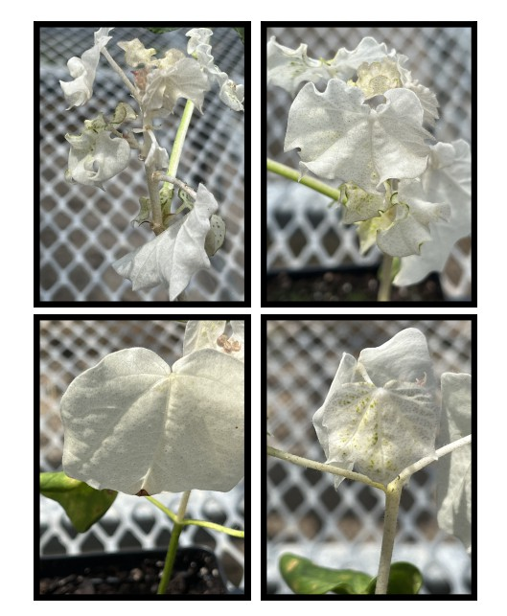
Supplementary Figure S1. Representative images of VIGS-mediated silencing of cloroplastos alternados 1(Cla1), which is involved in chloroplast development. Silencing Cla1 functions as a visual marker for the timing and efficacy of VIGS-mediated gene silencing as other GOIs (i.e. GhHydra1) do not result in an observable phenotype.
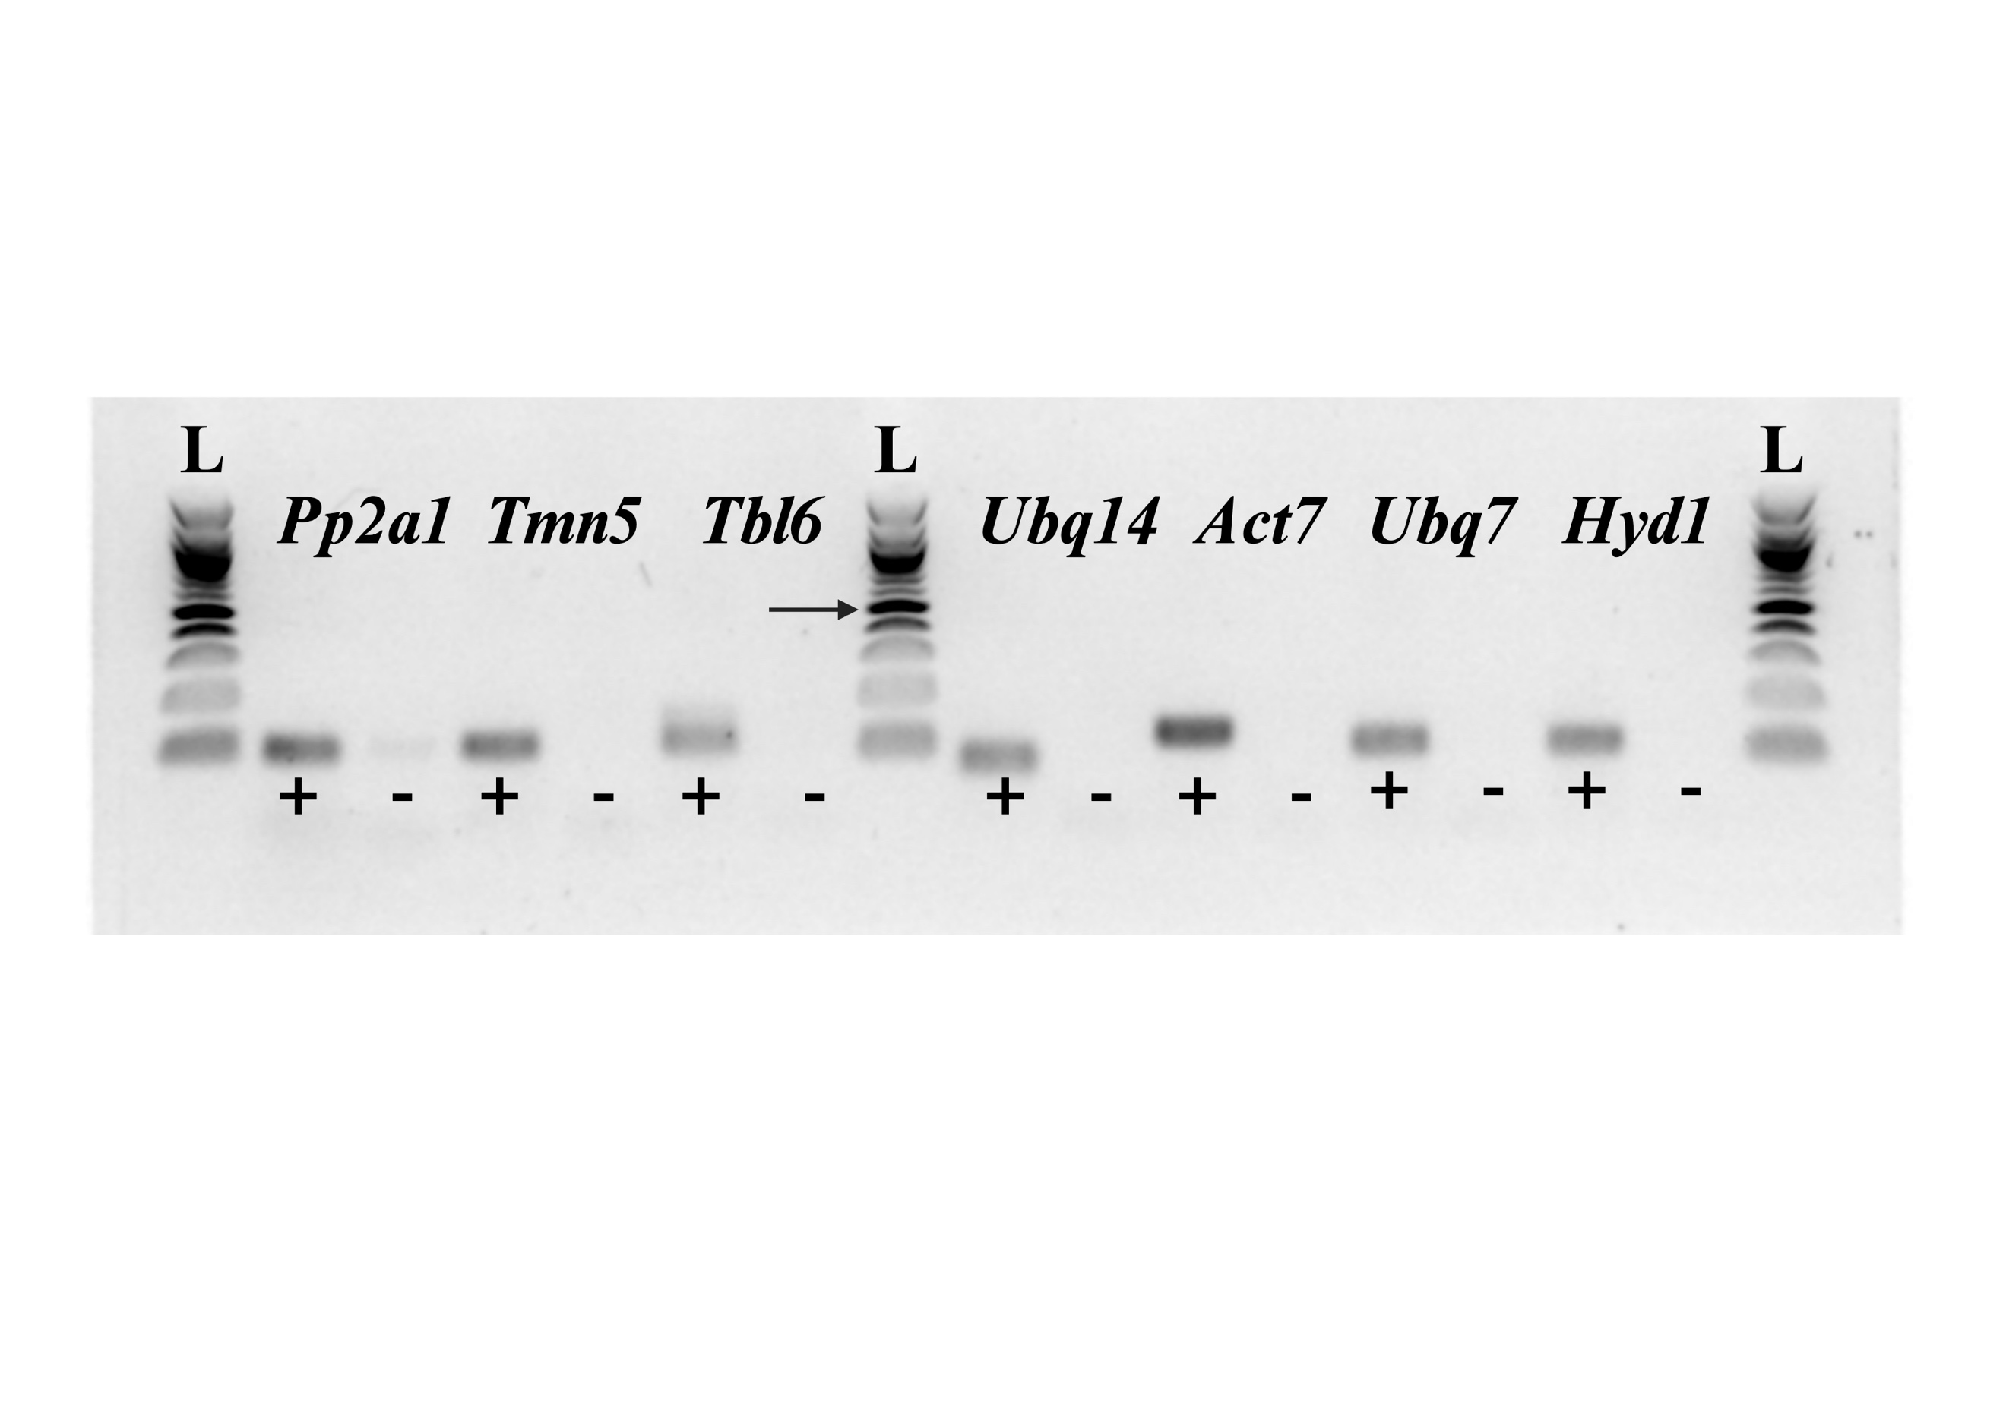
Supplementary Figure S2. Agarose (1.5%) gel electrophoresis of conventional PCR amplicons for qPCR primer sets. Only 3µL of 50µL reactions were loaded in the lanes. Remaining products were column-purified and used as template for evaluating reaction efficiencies as described in Materials and Methods subsection cDNA synthesis and RT-qPCR optimization. + positive control reaction; - no template control reaction. Black arrow indicates 500bp marker on ladder (L).

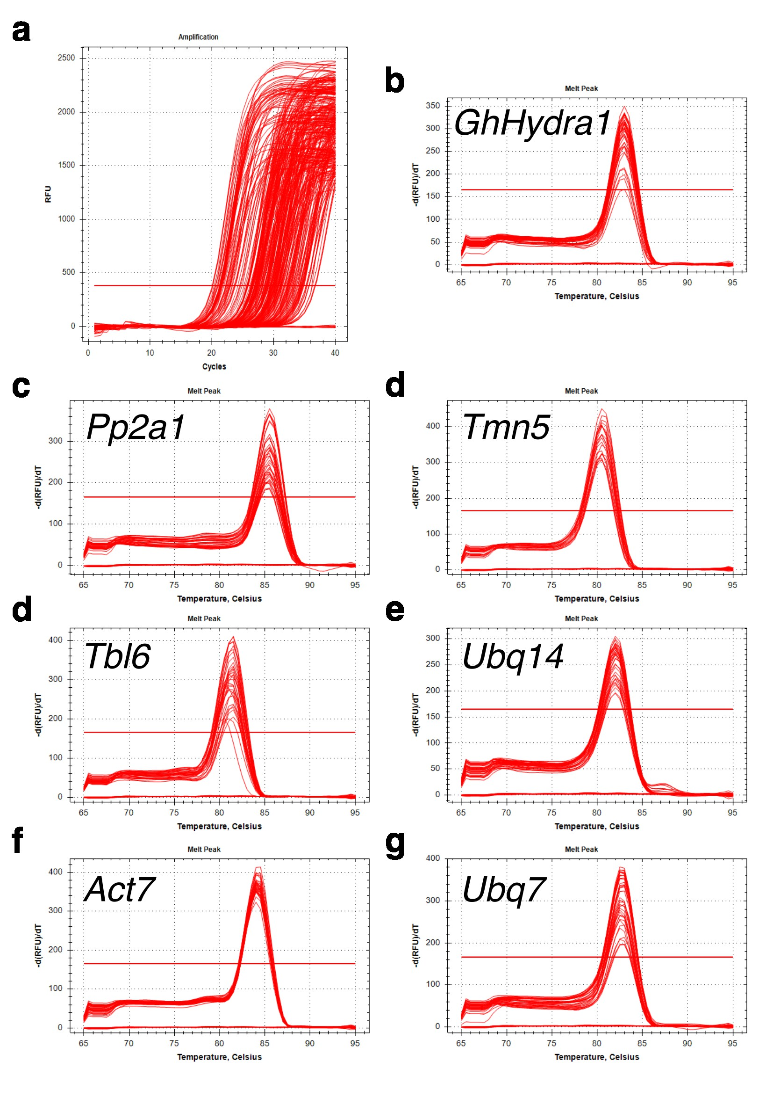
Supplementary Figure S3. Representative reverse-transcription quantitative PCR reaction amplifications and melt peaks from a 384-well plate ran in this study. Biological replicates were evenly distributed across plates. All samples were run in technical triplicates. a. Representative RFU amplification plot. b. Melt peak with a single peak for GhHydra1. c-g. Melt peaks for candidate reference genes in this study showing single peaks, indicating high amplification specificity to the template.

Supplementary Table S1. Gene accession numbers, amplicon sequences, and standard curve values for qPCR reactions in this study. Highlighted regions indicate forward and reverse primer sequences for qPCR reactions. Note: Reverse complement the reverse primer (second highlighted region) to order primers.
Gene name | Accession  number |  | Amplicon sequence | Amplicon size | Reaction efficiency (%) | Standard curve  R²
Serine/threonine protein phosphatase  2a1  (Pp2a1) | XM_041080556.1 | GATCCTTGTGGAGGAGTGGAATGTTCAGCCGGTGAAGTGTCCGGTCACCGTCTGCGGCGATATCCACGGCCAATTTCACGATCTCGTCGAACTGTTTCGC |  | 100bp | 120.3 | 0.997
Transmembrane 9 superfamily member 5-like  (Tmn5) | XM_016895405.2 | CTCACCATTCCATTACTTGTGTTGGGTGGGGTGATAGGATACCTCTTTAGGTCCGAGTTTCAGTCACCTTGTGCTACTAAAAGATACCCGAGAGAGATTCCTC |  | 103bp | 112.1 | 0.998
trichome birefringence-like 6  (Tbl6) | XM_016880182.2 | AGCAGATCCAGAGACAAGAAAGTGAAGGTGAAGTTGTAGAAGATGGTGATGGTGATGGTGAAATTGAGGATGTTGAAGAGGATACACCTGCACCTACAATGG |  | 102bp | 126.4 | 0.997
polyubiquitin 14  (Ubq14) | XM_016855771.2 | CAACGCTCCATCTTGTCCTTCGTTTGCGTGGCGGGATGCAAATCTTCGTTAAGACGCTTACGGGAAAGACGATCA |  | 75bp | 99.9 | 0.995
actin-7  (Act7) | NM_001327051.1 | GACCGCATGAGCAAGGAGATCACTGCTCTTGCTCCAAGCAGCATGAAGATTAAGGTCGTTGCGCCACCAGAGAGAAAGTACAGTGTCTGGATTGGAGGATCTATCTTGGCATCACTCAGCACCTTCCAGC |  | 130bp | 110.7 | 0.996
ubiquitin extension protein  (Ubq7) | DQ116441.1 | CCTGACCAACAACGTCTTATCTTCGCCGGCAAGCAACTCGAAGATGGCCGCACCTTAGCCGACTACAACATCCAGAAGGAATCCACTCTACACCTTGTCC |  | 100bp | 102.7 | 0.997
∆⁸-∆⁷ sterol isomerase  (GhHydra1) | GU989256.1 | TCTGCAACTGCCTGGATATGTTCCCGTCTCCCTTTCTCAGTCCACCATTCTTACCGTCTATGGTCTCTCTTCCCTGCTCGTCGTCTCCCTTGTTTGGTTCCTCTCTGGG |  | 109bp | 111.7 | 0.998

Supplementary Table S2. Descriptive statistics of cycle threshold (Ct) values for all samples in this study. Act7 was the most highly expressed reference gene whereas Tmn5 was the most lowly expressed. Tmn5 had the lowest standard deviation (SD) whereas Ubq7 had the highest SD. GhHydra1 is required for phytosterol biosynthesis and the gene of interest in this study.
Gene target | Mean Ct | Ct SD | Min Ct | Max Ct
Pp2a1 | 27.8 | 1.88 | 24.9 | 35.1
Tmn5 | 30.6 | 1.54 | 27.7 | 37.0
Tbl6 | 30.3 | 1.58 | 27.6 | 34.8
Ubq14 | 26.4 | 2.48 | 19.8 | 33.7
Act7 | 21.7 | 1.77 | 19.4 | 30.9
Ubq7 | 24.1 | 3.28 | 19.8 | 33.7
GhHydra1 | 28.1 | 1.51 | 24.8 | 32.5

