

Supplementary Materials for

Quantification and stimulation of human glymphatic dynamics:

New features of Alzheimer’s disease and effects of brain photobiomodulation

Authors: Fiza Saeed et al.

*Corresponding author. Email: hanli@uta.edu

This PDF file includes:

Inclusion and exclusion criteria for both healthy older adults and patients with Alzheimer’s disease

Fig. S1 Time series of six neurophysiological quantities in three frequency bands

Fig. S2 A data processing flow chart used to quantify Δ[HbT] (=Δ[HbO] + Δ[HHb]) and
Δ[H₂O] from raw bbNIRS data

Fig. S3 Decomposition of a Δ[HbO] time series into three frequency bands

References

- Inclusion and exclusion criteria for both healthy older adults and patients with Alzheimer’s disease
Inclusion Criteria of Healthy Adults: (1) aged 55 and older; (2) not experiencing cognitive declines; and (3) those who can travel without assistance for an IRB-approved research site on UTA campus.
Inclusion Criteria of AD Patients: (1) aged 55 years and older; (2) showing mild symptoms of dementia (early stage of dementia) – self-reported; (3) whose caregivers can provide transportation to the research site and remain with them during the hour-long process when the study subjects do not live in a long-term care facility (e.g. nursing homes, assisted living facilities, and group homes); (4) who live in a long-term care facility and have permission from the respective facility for us to visit the facility for testing.
Exclusion Criteria: (1) Brain injuries/surgeries in a year before the study; (2) those who can’t provide consent on their own.

Fig. S1 Time series of six neurophysiological quantities in three frequency bands
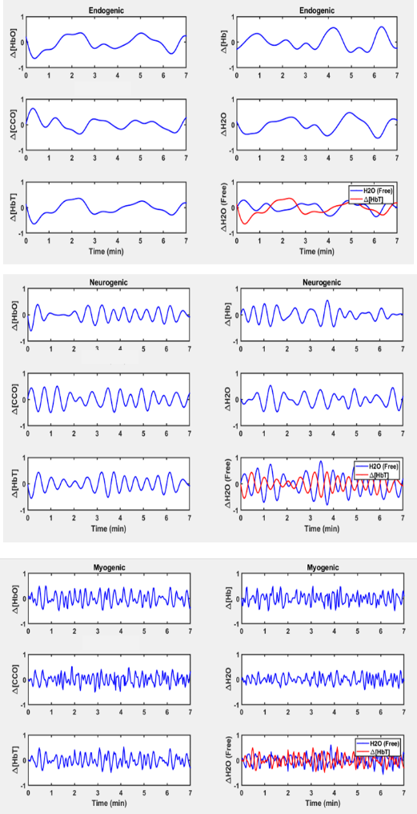
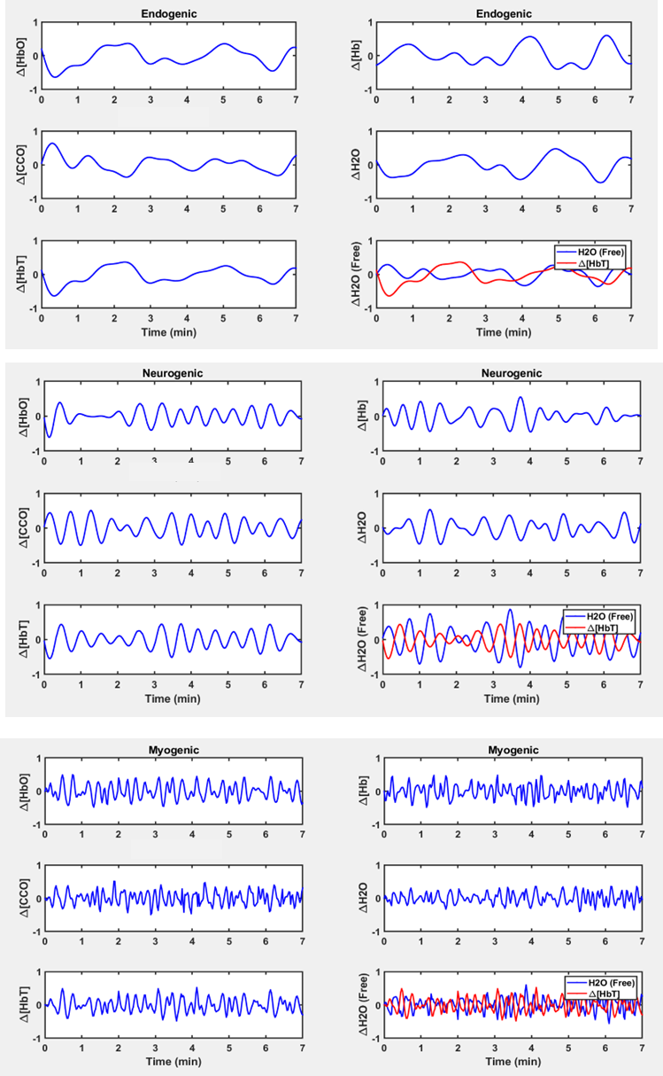
(a)
(b)
(c)

In each panel, six sub-panels are 7-min time series of concentrations of oxy-hemoglobin (Δ[HbO]), deoxy-hemoglobin(Δ[Hb]), total hemoglobin (Δ[HbT] = Δ[HbO] + Δ[Hb]), oxidized cytochrome c oxidase (Δ[oxiCCO]), water content (Δ[H₂O]), and free water content in CSF (Δ[H₂O_{free}]) in PFC of a participant. Panel (a) to (c) show the respective metrics in endogenic (0.005-0.02 Hz), neurogenic (0.02-0.04 Hz), and myogenic (0.04-0.1 Hz) frequency bands, respectively. The sub-panel on the right bottom shows temporal profiles of Δ[HbT] (red) and Δ[H₂O_{free}] (blue), exhibiting inverse oscillation pattens between them.

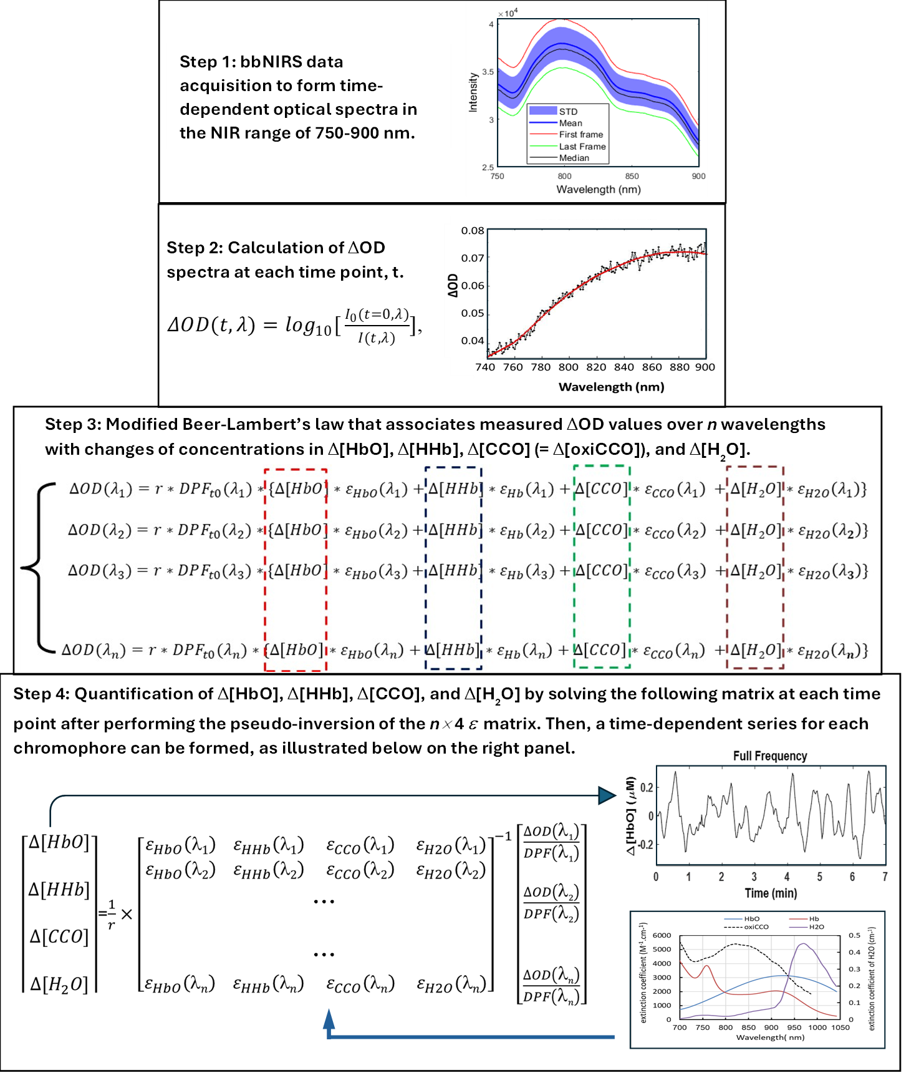
Fig. S2 A data processing flow chart used to quantify Δ[HbT] (=Δ[HbO] + Δ[HHb]) and Δ[H₂O] from raw bbNIRS data.

Note: Δ[HbO] and Δ[HHb] are changes in oxy- and deoxy-hemoglobin concentrations; Δ[HbT] is changes in total hemoglobin concentration; Δ[CCO] represents changes in oxidized cytochrome c oxidase concentration (= oxidized [CCO] - reduced [CCO]), and Δ[H₂O] is changes in water percentage.
Steps 1 and 2:
A broadband near-infrared spectroscopy (bbNIRS) system provides measurements of optical spectra at different times (t), as expressed I(t, λ). A relative optical density spectrum, ΔOD(t, λ), can be defined and calculated at each wavelength λ as (1, 2):
$ΔOD(t,λ)=\log_{10}{[}\frac{I_{0}(t=0, λ)}{I(t,λ)}]$, (1)
where I₀(t=0, λ) can be the baseline spectrum at time t=0 or an average of several initial baseline spectral readings (i.e., the first two spectra collected in each experiment), and I(t, λ) represent time-varying spectra acquired at each time point throughout the entire experiment.
Step 3:
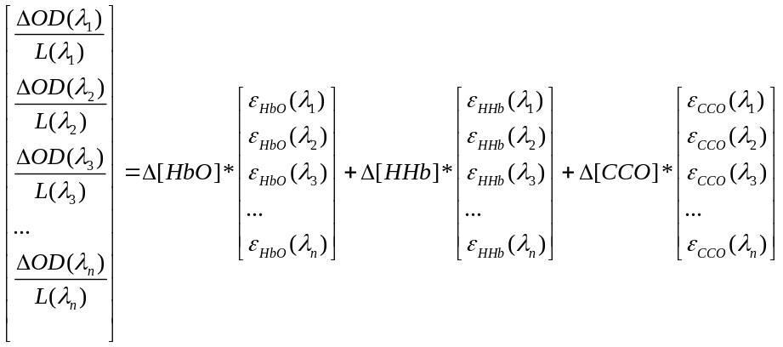

The estimations of Δ[HbO], Δ[HHb], Δ[CCO], and Δ[H₂O] from raw spectral data taken with bbNIRS throughout the experiment were based on modified Beer-Lambert’s law (3), which offers a quantitative relationship of ΔOD(λ) on Δ[HbO], Δ[HHb], Δ[CCO], and Δ[H₂O] at each wavelength, λ, at each time point, with a wavelength-dependent path-length factor, L(λ). Based on optical diffusion theory (4), ΔOD(λ)/L(λ) can be expressed as a sum of optical absorbance contributed by Δ[HbO], Δ[HHb], Δ[CCO], and Δ[H₂O] components, as given below:
(2)
where Δ[HbO], Δ[HHb], Δ[CCO], and Δ[H₂O] are relative concentration changes of HbO, HHb oxidized CCO, and H₂O, respectively; ε_{HbO}(λ), ε_{HHb}(λ) and ε_{CCO}(λ) represent the extinction coefficients at each wavelength of HbO, HHb and oxidized CCO, which can be found in ref. (1); L(λ) is a wavelength dependent factor that denotes the effective pathlength of the detected photons through tissues at each wavelength. Furthermore, according to the Modified Beer-Lambert Law (3, 5), L(λ) can be expressed as:

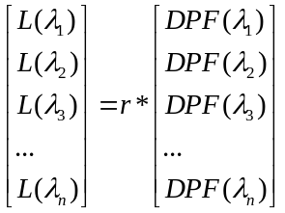,
(3)
where r is a constant that denotes the source-detector distance. In this study, we used source detector separation of 3 cm, so r=3. The wavelength dependence of L(λ) is caused by a wavelength-dependent differential pathlength factor, DPF(λ).
Step 4:
By substituting Eq. (3) into Eq. (2) for multiple wavelengths, the estimation of Δ[HbO], Δ[HHb], Δ[CCO], and Δ[H₂O] can be expressed as follows.
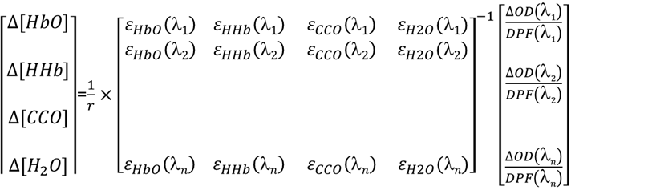
(4)
…
…

…

In order to accurately solve Δ[HbO], Δ[HHb], Δ[CCO] and Δ[H₂O] using Eq. (4), we would need to know DPF(λ) in the wavelength range of our measurements. It is known that appropriate or accurate selection/estimation of wavelength-dependent DPF is crucial for accurate estimation of chromophore concentrations (6). In this study, DPF(λ) values were assumed to be time-invariant because of given stable brain optical properties. Based on diffusion theory with the semi-infinite boundary geometry (7), DPF(λ) can be determined by
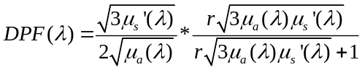
(5)
where µ_{a}(λ) and µ_{s}'(λ) are the estimated absorption and reduced scattering coefficients across the wavelength range of interest.
Values of µ_{a}(λ) and µ_{s}'(λ) were measured using a tissue oximeter (OxiplexTS, ISS) that operates in the frequency-domain. This device provides readings of µ_{a} and µ_{s}' values at 750 nm and 830 nm, as well as absolute concentrations of [HbO] and [HHb] (7). However, to obtain µ_{s}'(λ) values across the entire range of wavelengths from 780-900 nm, we used Mie theory to interpolate and extrapolate the two measured µ_{s}' values at 750 nm and 830 nm. Mie theory is typically represented by kλ^{-b}, where k and b were determined by fitting this equation to both µ_{s}' values at 750 nm and 830 nm (8). In addition, absorption coefficients in the same wavelength range (780-900 nm) were estimated based on [HbO] and [HHb] measured by the same tissue oximeter (4).
After combining the measured ΔOD(λ) values across the measurement period and empirical µa(λ) and µs'(λ) values of the human forehead (2), we were able to solve eq. (4) at each measurement time point using MATLAB, achieving temporal series of Δ[HbO], Δ[HHb] and Δ[CCO] under respective experimental conditions, as shown in Step 2 of Fig. 6 in the main paper. Specifically, our calculations covered the spectral range of 780-900 nm with a total of 121 wavelengths.

Fig. S3 Decomposition of a Δ[HbO] time series into three frequency bands

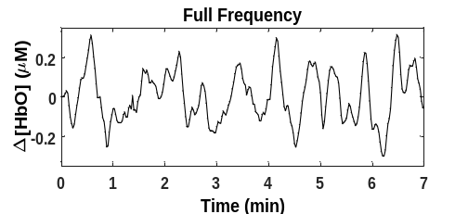
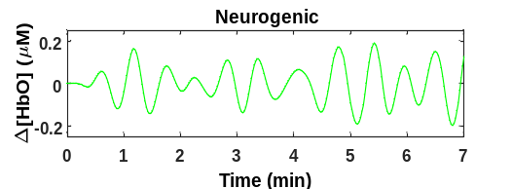
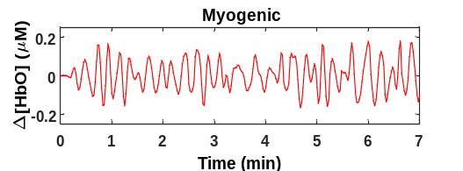
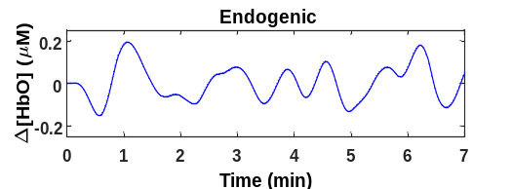
0.005-0.2 Hz original signal
Filtered E, N, and M signals

Panel (a) shows an example of a 7-min Δ[HbO] time series from one of the two-channel bbNIRS datasets of a participant. Three curves in panel (b) were obtained after applying a Butterworth band-pass filter to the trace in (a) using separate bandpass filters in endogenic (E: 0.005-0.02 Hz), neurogenic (N: 0.02-0.04 Hz), and myogenic (M: 0.04-0.2 Hz) frequency ranges. This set of figures illustrates how different infraslow oscillation components contribute to the composition of the wideband (0.005–0.2 Hz) original signal.

References:
1. C. Kolyva, I. Tachtsidis, A. Ghosh, T. Moroz, C. E. Cooper, M. Smith, C. E. Elwell, Systematic investigation of changes in oxidized cerebral cytochrome c oxidase concentration during frontal lobe activation in healthy adults. Biomed Opt Express 3, 2550-2566 (2012).
2. X. Wang, F. Tian, D. D. Reddy, S. S. Nalawade, D. W. Barrett, F. Gonzalez-Lima, H. Liu, Up-regulation of cerebral cytochrome-c-oxidase and hemodynamics by transcranial infrared laser stimulation: A broadband near-infrared spectroscopy study. J Cereb Blood Flow Metab 37, 3789-3802 (2017).
3. L. Kocsis, P. Herman, A. Eke, The modified Beer-Lambert law revisited. Phys Med Biol 51, N91-98 (2006).
4. X. Wang, F. Tian, S. S. Soni, F. Gonzalez-Lima, H. Liu, Interplay between up-regulation of cytochrome-c-oxidase and hemoglobin oxygenation induced by near-infrared laser. Sci Rep 6, 30540 (2016).
5. F. Scholkmann, S. Kleiser, A. J. Metz, R. Zimmermann, J. Mata Pavia, U. Wolf, M. Wolf, A review on continuous wave functional near-infrared spectroscopy and imaging instrumentation and methodology. NeuroImage 85 Pt 1, 6-27 (2014).
6. S. J. Matcher, M. Cope, D. T. Delpy, Use of the water absorption spectrum to quantify tissue chromophore concentration changes in near-infrared spectroscopy. Phys Med Biol 39, 177-196 (1994).
7. S. Fantini, D. Hueber, M. A. Franceschini, E. Gratton, W. Rosenfeld, P. G. Stubblefield, D. Maulik, M. R. Stankovic, Non-invasive optical monitoring of the newborn piglet brain using continuous-wave and frequency-domain spectroscopy. Phys Med Biol 44, 1543-1563 (1999).
8. S. L. Jacques, Optical properties of biological tissues: a review. Phys Med Biol 58, R37-61 (2013).

