FS1.
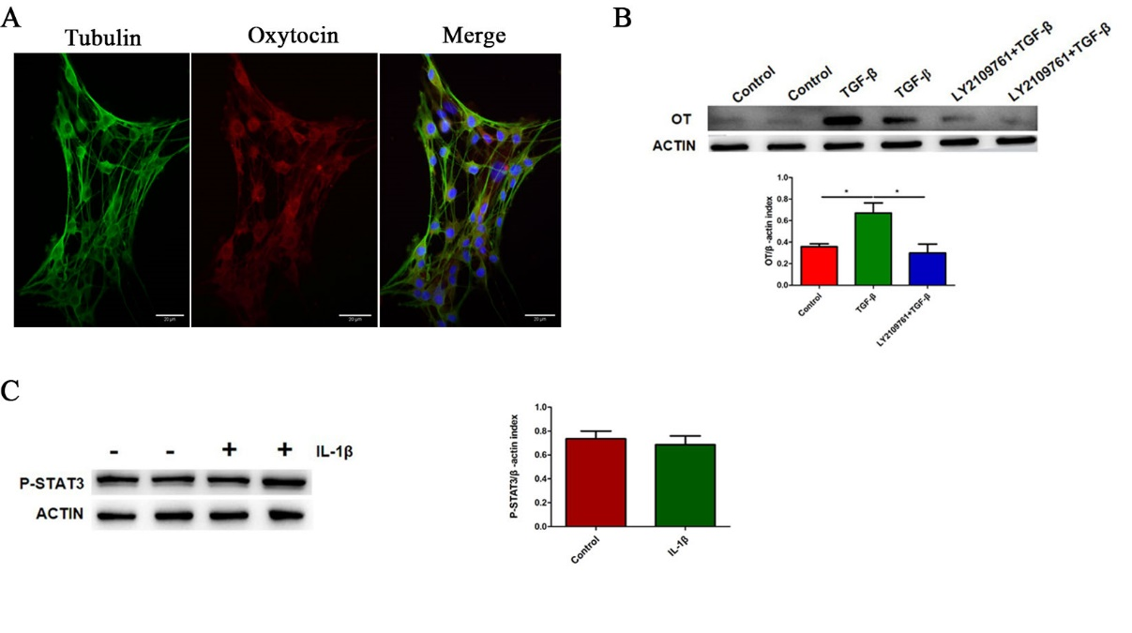
(A) Representative photographs of double immunofluorescent staining of Tubulin (green) and oxytocin (OT) (red) within randomly captured images were obtained in cultured enteric neurons. Scale bar = 20μm. (B) The effect of TGF-β receptor inhibitor (LY2109761) on OT was measured by western blots. (C) The activation of IL-1β on STAT3 signaling pathway was detected by western blot. Values represent the mean ± SEM of 4 samples and were compared by t-test or One-way ANOVA with Newman-Keuls for multiple comparisons. *p< 0.05.

FS2.
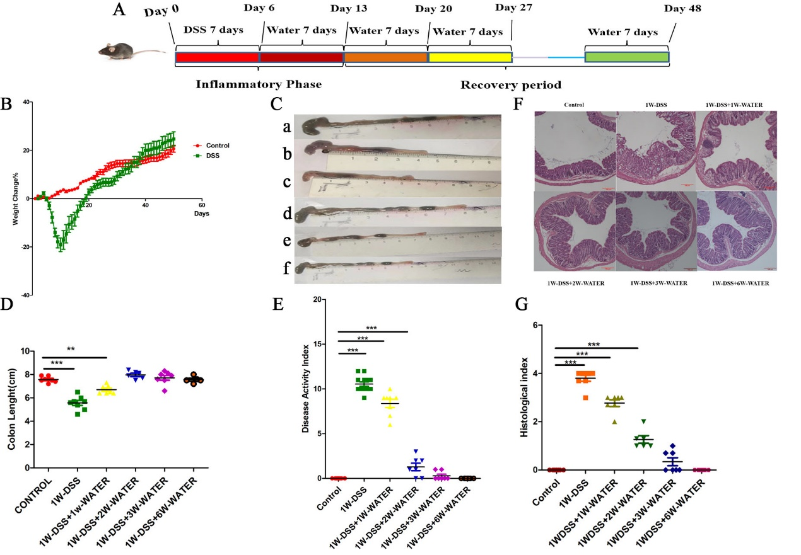
Figure S2. Dynamic changes of various parameters of DSS-induced enteritis model over time.
(A)Schematic diagram of mouse colitis model (Inflammation and recovery periods). The mice drank 2.5% DSS for 7 consecutive days, and drank water from the second week. (B) Body weight changed of WT mice in different periods of the DSS model. (C, D) The lengths of the colon from different groups were statistically compared. (E) Representative disease activity index was counted in each group based on body weight loss, stool consistence and hematochezia. (F) Representative H&E staining colonic section in each group (Scale bar: 100μm). (G) Histological assessment of the indicated group. Values represent the mean ± SEM of 7 samples and were compared by One-way ANOVA with Dunnett for multiple comparisons. *p< 0.05, **p<0.01, *** p<0.001.

FS3.
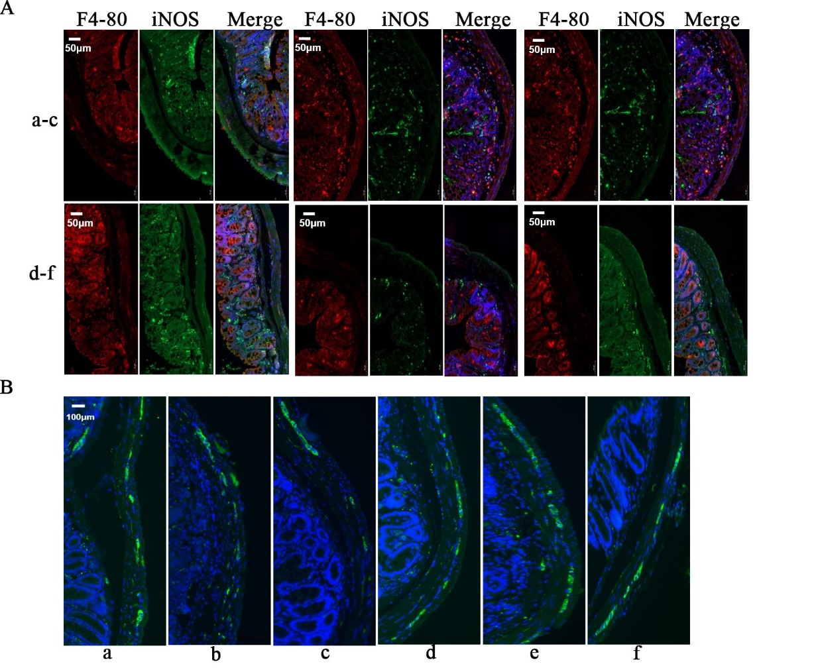
(A)Representative photographs of double immunofluorescent staining of iNOS (green) and F4-80 (red) within randomly captured images (× 20) were obtained for each section per animal. (B) Representative photographs of immunofluorescent staining of Tubulin (green) within randomly captured images (× 10) were obtained for each section per animal. (a) control (b) 1w-DSS (c) 1w-DSS +1w-water (d) 1w-DSS +2w-water (e) 1w-DSS +3w-water (f) 1w-DSS +6w-water.

FS4.
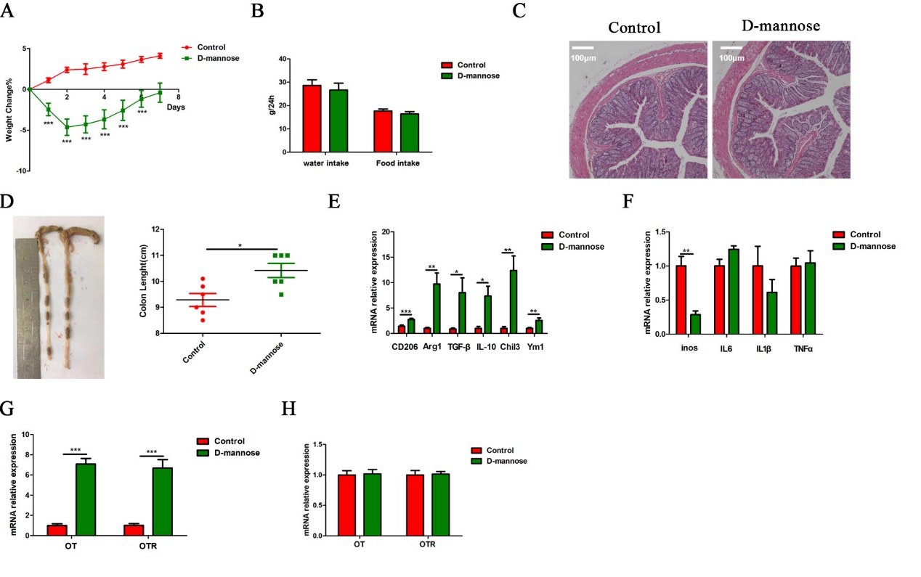
Figure S4. D-mannose promoted polarization of M2 macrophages and inhibited the polarization of M1 macrophages.
(A, B) Changes in weight and eating habits in D-mannose model. (C) Representative H&E staining colonic section in each group (Scale bar: 100μm). (D) The lengths of the colon from different groups were statistically compared. (E) The levels of CD206, Arg1, TGF-β, IL10, Chil3, YM1 mRNA of LMMP induced by D-mannose for 7 days were measured by qRT-PCR. (F) The levels of iNOS, IL-1β, IL-6, TNF-α mRNA of LMMP induced by D-mannose for 7 days were measured by qRT-PCR. (G) The levels of OT and OTR mRNA of LMMP induced by D-mannose for 7 days were measured by qRT-PCR. (H) The levels of OT and OTR mRNA by D-mannose for 24 h in enteric neurons were measured by qRT-PCR. Values represent the mean ± SEM of 6 samples and were compared by t-test for multiple comparisons. *p< 0.05, **p<0.01, *** p<0.001.

