Supplementary information
Supplemental Figures
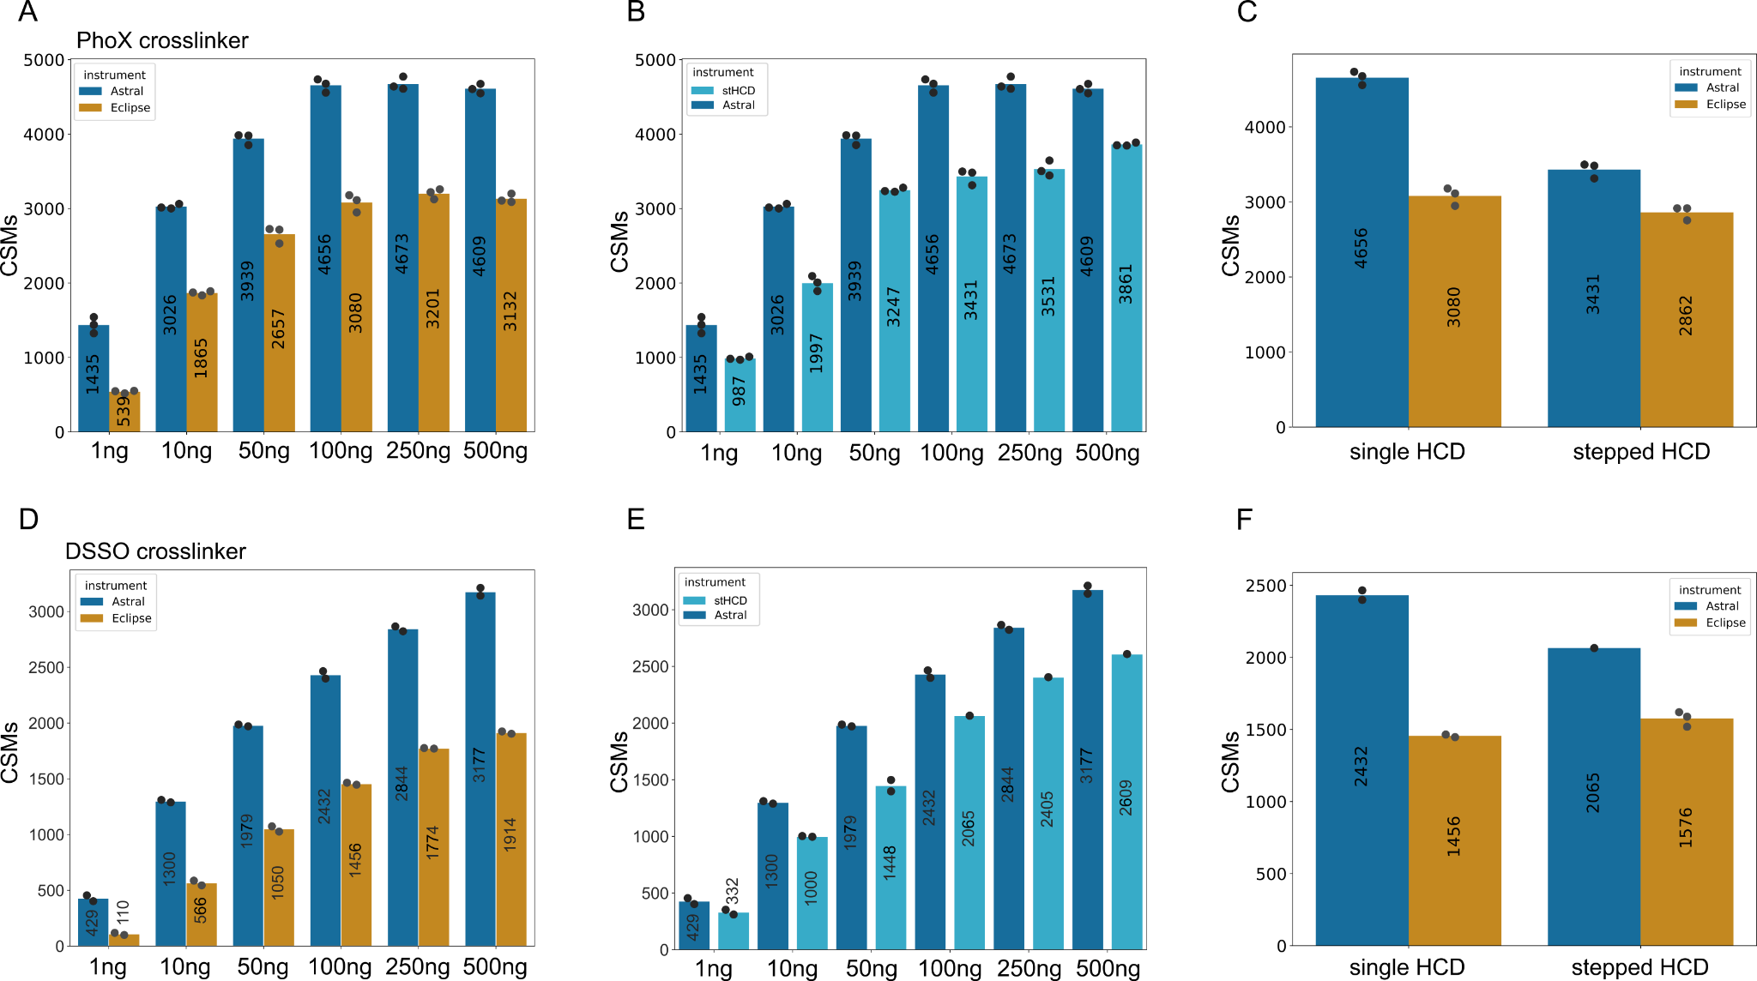
Figure S1: Comparison of Astral and Eclipse crosslink spectrum match (CSM) data with single and stepped HCD for PhoX (non-cleavable) and DSSO (cleavable) crosslinker. A: Dilution series of Cas9 crosslinked with PhoX starting from 1ng to 500 ng acquired on Eclipse and Astral in triplicates. The maximum number of CMSs is reached at 100 ng and plateauing afterwards. The Astral mass analyser (blue) outperforms the Eclipse (orange) data by more than 30%. B: Comparison between single HCD (dark blue) and stepped HCD (light blue) of the PhoX dilution series. Single HCD shows higher numbers of CSMs as stepped HCD for all injections amounts. C: Direct view on the difference between stepped and single HCD acquired on both instruments for 100 ng. The difference between single HCD and stepped HCD is dominant for Astral data (blue) but not significantly different for Eclipse data (orange). D: Dilution series of Cas9 crosslinked with DSSO starting from 1ng to 500 ng acquired on Eclipse and Astral in duplicates. The maximum number of unique crosslinks is reached with 500 ng. The Astral mass analyser (blue) outperforms the Eclipse (orange) data by more than 30% also for cleavable crosslinkers like DSSO. E: Comparison between single HCD (dark blue) and stepped HCD (light blue) of the DSSO dilution series. Single HCD shows also increased numbers of CSMs as stepped HCD for the DSSO dilution series. F: Direct view on the difference between stepped and single HCD acquired on both instruments for 100 ng. The difference between single HCD and stepped HCD is dominant for Astral data (blue) but not significantly different for Eclipse data (orange).

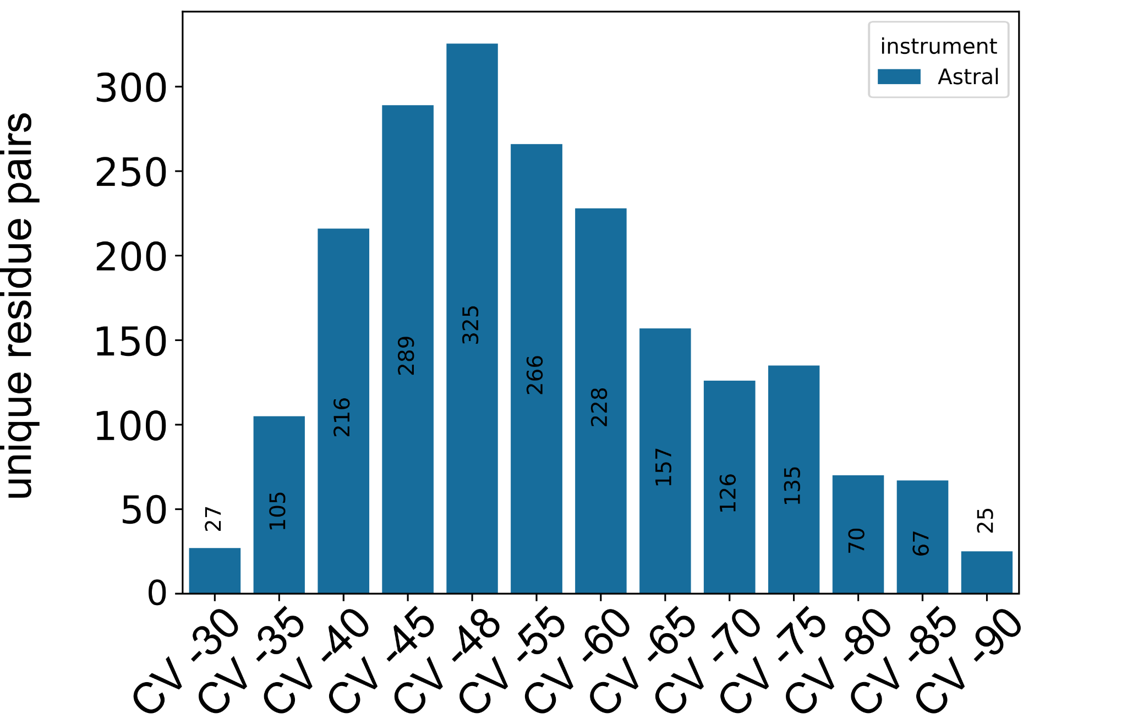
Figure S2: Compensation voltage (CV) optimization performed on Astral with Cas9 crosslinked with PhoX. CVs acquired from -30 V to -90 V separately show a gradual increase of unique residue pairs towards -48 V and a decrease in unique crosslinks towards -90 V.
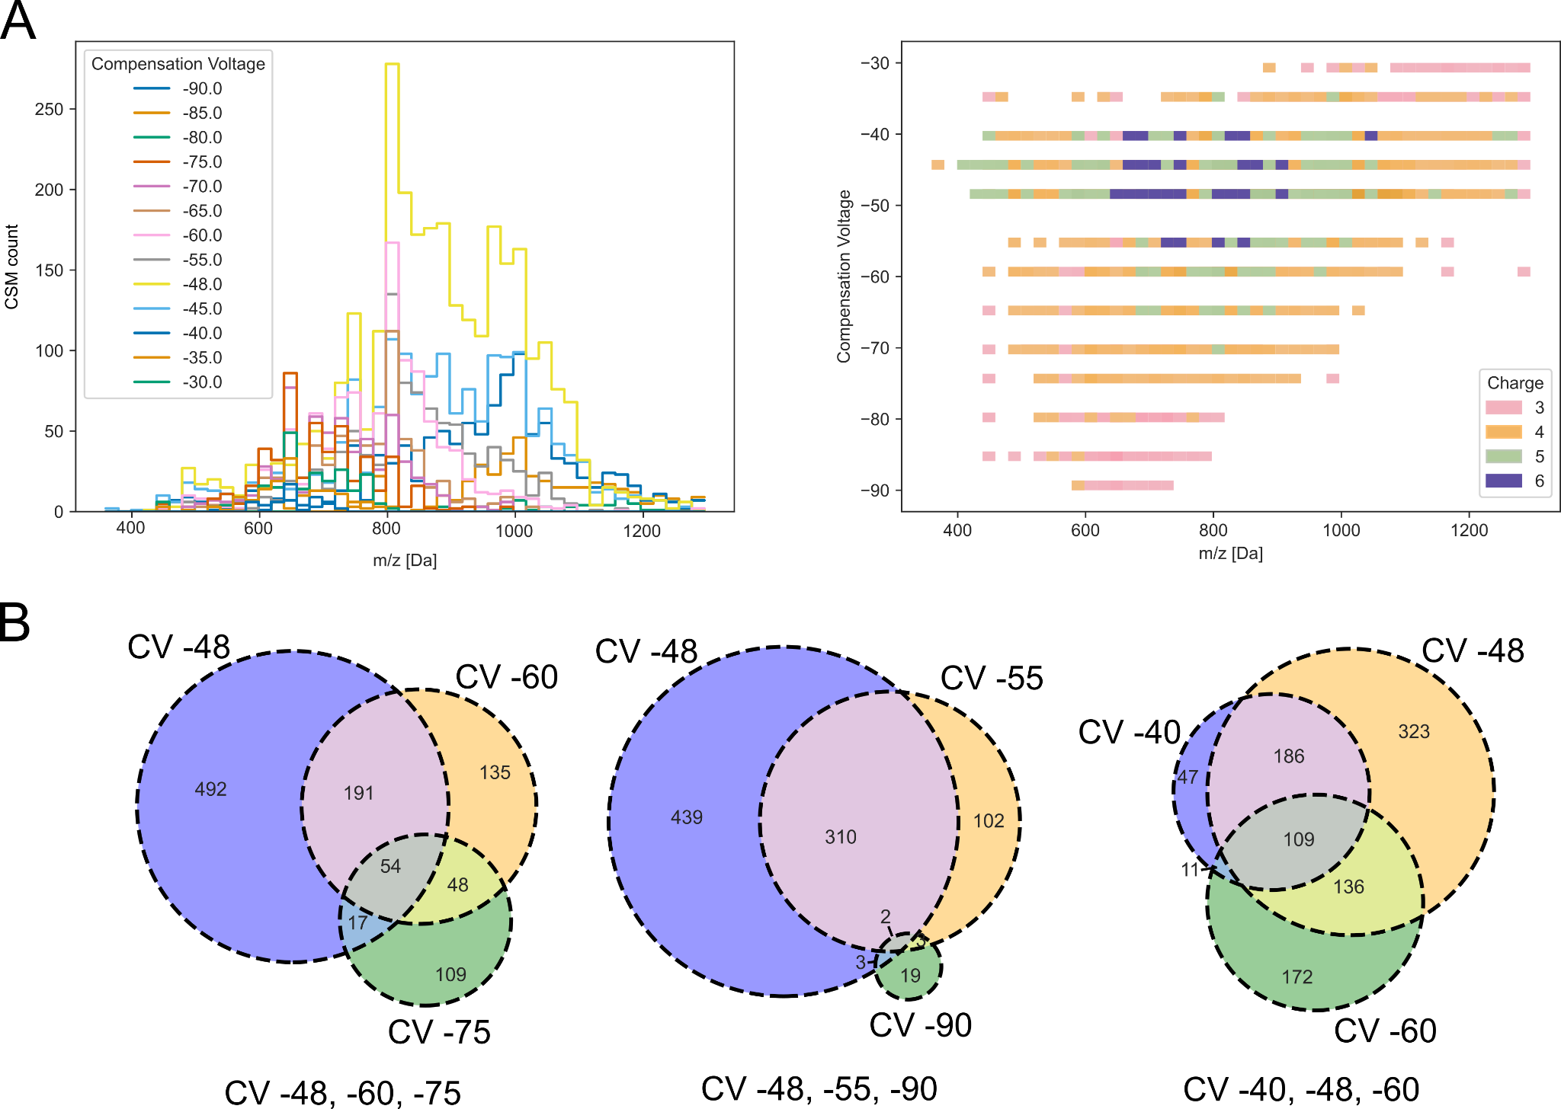
Figure S3: Detailed view on differences between single CV measurements on CSM level to determine optimal CV combinations. A left: Histogram of each CV measurement concerning their m/z values. Single CVs are coloured according to the legend in 13 different colours. -48 V (yellow) shows a broad distribution across the whole m/z range with the maximum count of CSMs, while -90 V (dark blue) shows the minimum coverage with the least CSMs count. A right: CVs across the whole mass range coloured by charge states of identified CSMs. Charge 6 could be only identified from CV -40 V to -55 V. Charge 3 and 4 show a distribution across all CV values, while Charge 5 is only present in CV -35 V to -70 V. B: Based on an upset plot of all CV measurements, the three most promising CV combinations were selected for further evaluation. CV -48 V, -60 V, -75 V were selected to achieve the highest number of crosslinks with the least overlap, CV -48 V, -55 V, -90 V were selected to have the least overall overlap and CV 40 V, -48 V, -60 V to have the highest overlap and were used as common CV values for in-house crosslinking measurements. The unique crosslinks plotted in Venn diagrams have been summed up from CSMs with 1% CSM level FDR therefore the total number of links differs from Figure S4 where the FDR was calculated directly with 1% link level FDR.

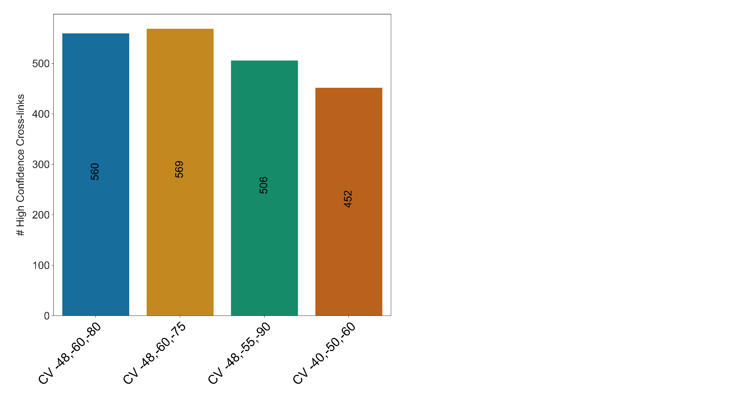
Figure S4: Results of the CV optimization and combinatory experiment on unique crosslink level with 1% link level FDR. CV -48 V, -60 V, - 75 V gave the best results as expected. CV -48 V, -55 V, -90 V resulted in 11% fewer identifications, while CV -40 V, -50 V, -60 V gave 21% fewer unique crosslinks. CV -48 V, -60 V, -80 V are used as the QC acquisition method, with no significant change to the best-performing method.

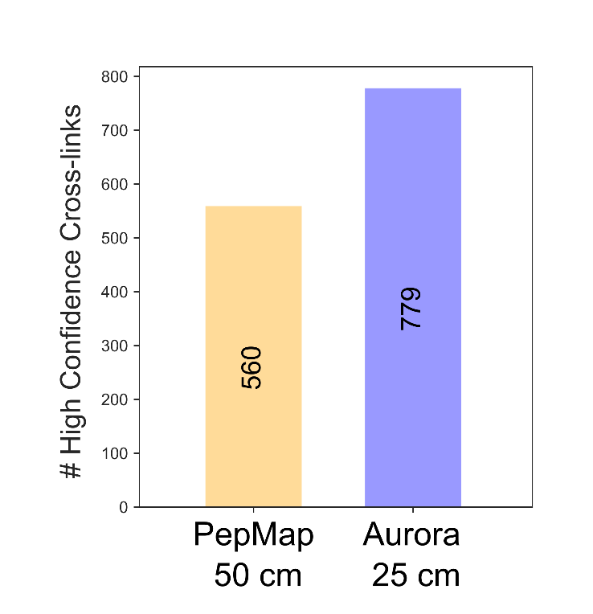
Figure S5: Column comparison of PepMap 50 cm vs. Aurora Ultimate 25 cm analytical columns. Unique crosslink numbers of both columns with Aurora outperforming PepMap by 28%.
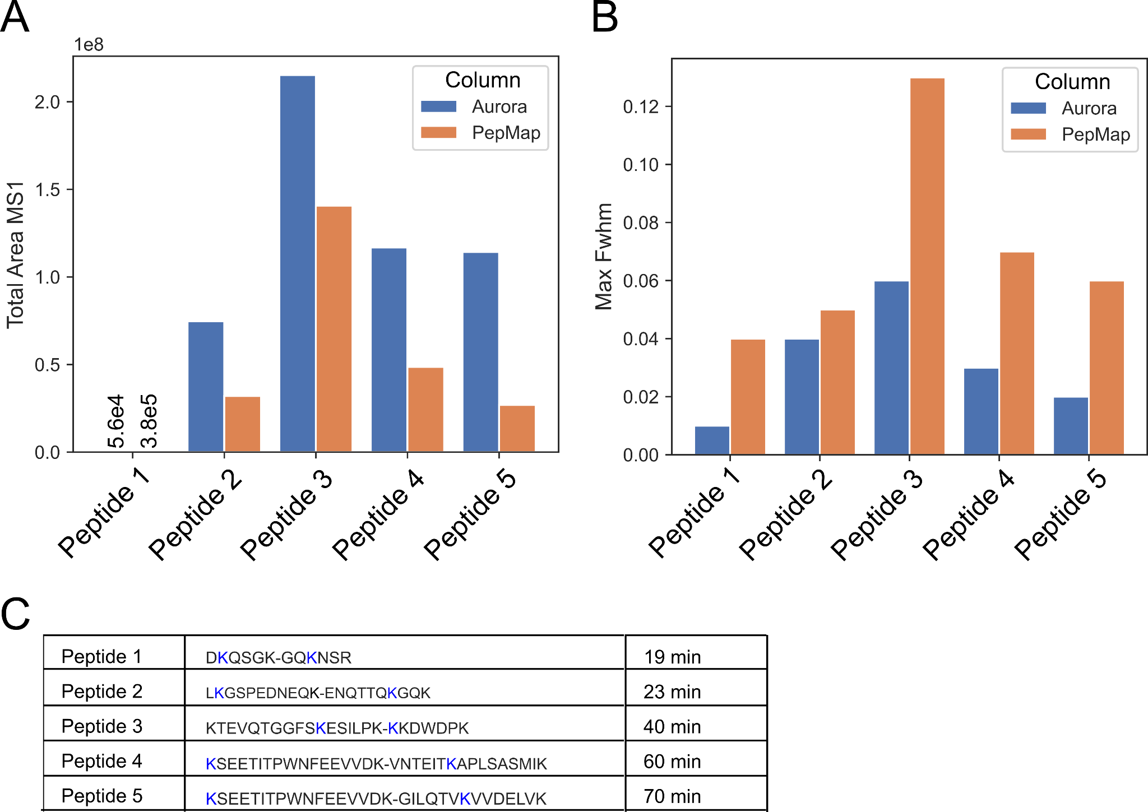
Figure S6: Column comparison of PepMap 50 cm vs. Aurora Ultimate 25 cm analytical columns using quantification of 5 crosslinked peptides across a 70 min gradient. A: Total MS1 Area of 5 selected crosslinked peptides, showing significantly higher peak areas for the Aurora column. B: Full-width half maximum times for each crosslinked peptide, showing broader peaks when using the PepMap column for crosslink samples. C: List of selected crosslinked peptides for quantitation in Skyline and their respective average retention times across the 70 min active gradient.

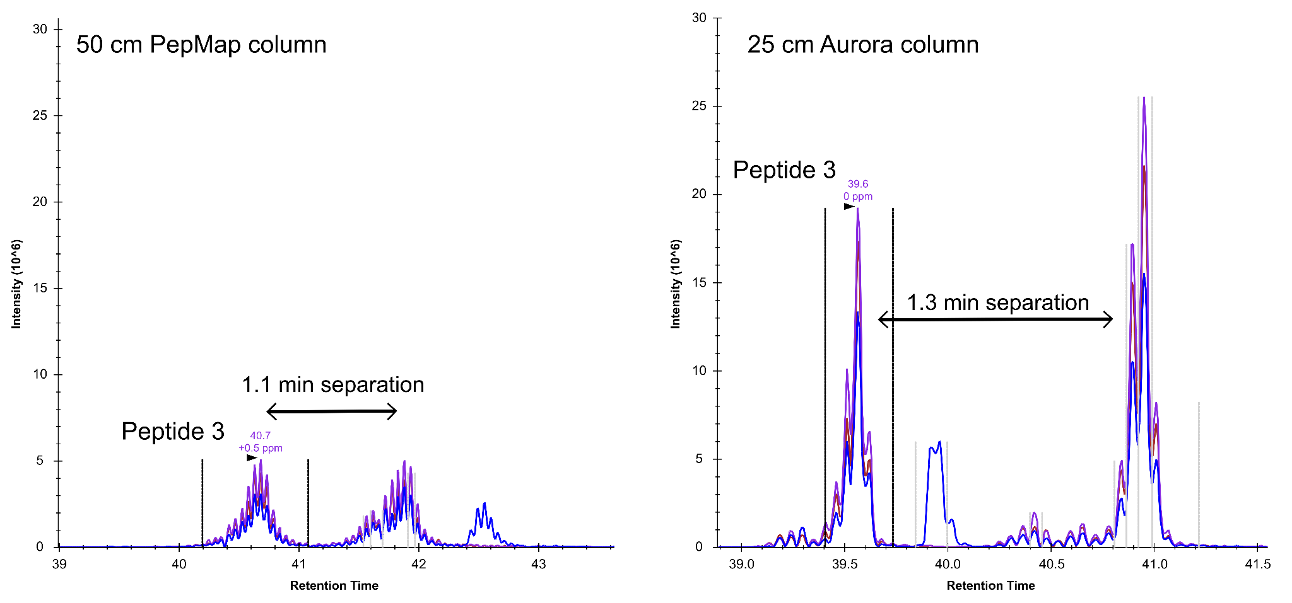
Figure S7: Chromatographic separation comparison of PepMap 50 cm vs. Aurora Ultimate 25 cm analytical columns using chromatograms of peptide 3. Elution profiles were exported from Skyline (v 21.2.0.425) after peak mapping and quantitation. PepMap chromatograms showing broadening and tailing of elution peaks of crosslinked peptide 3 and sharp well-separated peaks on the Aurora column.

Table S1: Column parameters for PepMap and Aurora analytical column used in this study.
Parameters | PepMap | Aurora
Length | 50 cm | 25 cm
Inner diameter | 75 um | 75 um
Pore size | 100 A | 120 A
Pressure limit | 1500 bar | > 1700 bar
Max. Temperature limit | 60°C | 60°C
Participle size | 2 um | 1.7 um

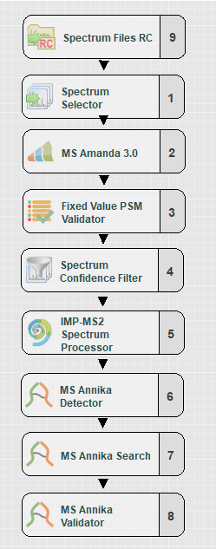
Figure S8: Exemplary search workflow using MS Annika 3.0 in Proteome Discoverer. The imported raw files are recalibrated by the Spectrum file RC node, followed by a crude selection of suitable spectra for a first search by MS Amanda for linear peptide identification. Spectra that could not map to a linear or monolink peptide are transferred to the MS Annika crosslink search and validation nodes. The cross-link spectra are adjusted and then searched with MS Annika to identify the cross-linked peptides.

Table S2: Search parameters for linear and crosslink search. Parameters not listed here were left at default settings
Parameter name | Parameter value
Linear search
MS1 tolerance | 6 ppm
MS2 tolerance | 15 ppm
Miss cleavages | 3
Fixed modification | Carbamidomethyl [57.021 Da] on C, D, E, H
Variable modification | Oxidation [15.995 Da] (M),  PhoX [209.972 Da] (K), PhoX Amidated [226.998 Da] (K), PhoX Hydrolyzed [227.982 Da] (K), PhoX Tris [331.046 Da] (K)  DSSO [158.004 Da] (K), DSSO Amidated [175.030 Da] (K), DSSO Hydrolyzed [176.014 Da] (K), DSSO Tris [279.078 Da] (K)
Crosslink search
PhoX  DSSO | PhoX [209.972 Da] (K)  DSSO [158.004 Da] (K) (additional doublet: 49.982635 Da)
MS1 tolerance | 6 ppm
MS2 tolerance | 15 ppm
Miss cleavages | 3
Fixed modification | Carbamidomethyl [57.021 Da] (C)
Variable modification | Oxidation [15.995 Da] (M)
Top N | 500
Candidate Search Method | i32SM
IMP-MS2 spectrum processor
Perform de-isotoping | False

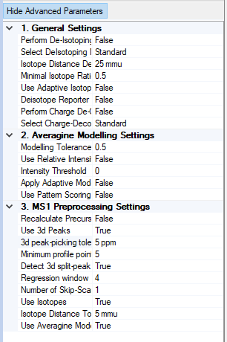
Figure S9: General settings of the IMP-MS2 Spectrum processor node. This node offers three spectrum processing steps: Deisotoping of isotopic clusters, Charge-Deconvolution and MS1-precursor recalculation. The algorithm reconstructs the elution profile of the peptide and uses the gathered data to calculate a more precise value of the precursor mass. This step was evaluated as beneficial for crosslinking data.

