Supplementary Materials to Correlation of Enthesis Calcified Fibrocartilage 3D Microstructure with Full-field Local strain and Deformation
Atousa Moayedi¹, Katerina Karali¹, Markus Boese³, Jovana Radulovic¹, Gordon Blunn²

¹ School of Mechanical and Electrical Engineering, University of Portsmouth, Portsmouth PO1 3DJ, UK
² School of Medicine, Pharmacy and Biomedical Sciences, University of Portsmouth, Portsmouth PO1 2DT, UK
³ Materials Science, Carl Zeiss Microscopy GmbH, Oberkochen 73447, Germany

Image quality comparison of FDK-type and high resolution deep learned reconstruction micro computed tomography
Micro X-ray computed tomography has emerged as a powerful non-destructive tool for measuring musculoskeletal biomechanics. However, achieving high-resolution tomographic reconstructions for large samples requires a substantial number of projections ($N_{p}$), with a minimum value of $\frac{πN}{2}$ according to the Nyquist-Shannon sampling theorem (where N is the number of pixels along the sample’s longest axis)⁵². For the murine calcaneus with a length of 1015 pixels (1.33 um pixel size), $N_{p}$ equal to 1594 is the minimum value required for a reliable reconstruction that minimizes aliasing distortion. The filtered back projection (FBP) algorithm, typically used for FDK-type reconstructions, is widely employed in micro-CT imaging due to its simplicity and computational efficiency. However, FDK-type reconstruction relies on a full set of projections, meaning that acquiring high-resolution tomograms before and after applying load can result in extremely long acquisition times (over 6 hours). This prolonged scan time can lead to tissue dehydration and reduce the accuracy of the calculated mechanical and morphometric values. Additionally, FDK reconstructions are often prone to noise and artifacts, particularly when the number of projections is limited or when scanning large samples. In contrast, Deep learning-based reconstruction (DeepRecon) has been employed to improve tomograms with insufficient $N_{p}$​ by using trained convolutional neural networks (CNNs) derived from high-resolution scans. These networks are applied between the 2D projection stacks and the final reconstructed volume⁵³. DeepRecon (DR) can significantly enhance image quality, reduce noise, and minimize artifacts compared to traditional FDK-type method. Moreover, DR offers faster throughput by achieving high-quality reconstructed volumes from a reduced $N_{p}$​ value, allowing fine structural details to be revealed without the need for a large number of projections. Figure 1 shows a comparison of micro-CT datasets acquired with different projection numbers, alongside the corresponding reconstructed tomograms enhanced using DR. The reconstruction model was trained on a high-resolution scan with 4801 projections. The histogram intensity of an HA phantom was employed to improve the contrast-to-noise ratio in the DR reconstructed tomograms. The results demonstrate improved image quality and accuracy in structural detail as projection numbers increase
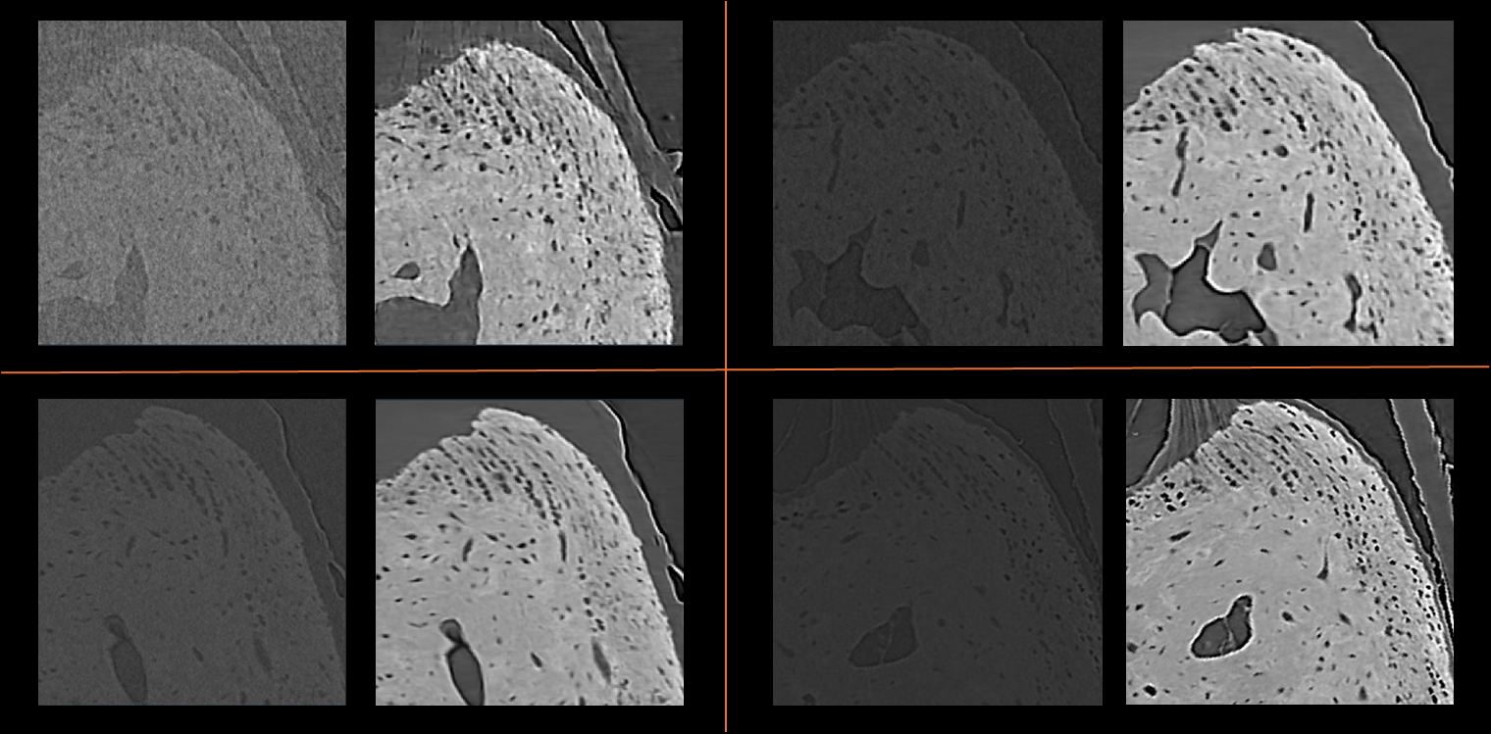
C
D
B
A
Sup. Figure 1. Comparison of micro-CT images acquired with 201 (A), 401 (B), 801 (C), and 1601 (D) projection numbers. On the left, the images are reconstructed using FDK technique, while the right images show the corresponding tomograms reconstructed with DR, which was trained using a high-resolution scan captured with 4800 projection numbers. At the same time, the CNR was enhanced through the use of a high-quality HA phantom.

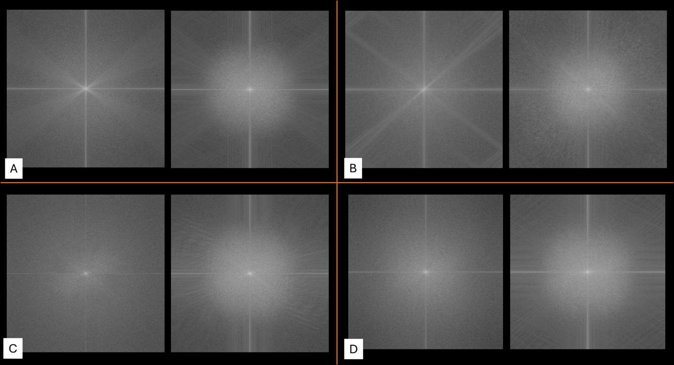
E. 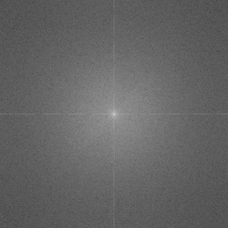
Sup. Figure 2. Fourier transform (FFT) spectra of micro-CT images showing different projection numbers. A, B, C, and D represent FFT spectra for 201, 401, 801, and 1601 projections, respectively. The left images show the spectra of the raw data, while the right images display the corresponding improved FFT after applying DR reconstruction technique (using 4801 projections dataset; (E) corresponding FFT spectra). The central peak in each image represents the low-frequency components and the surrounding diffraction patterns indicating higher frequencies. The changes in the spectra showed the improvement in resolution and frequency distribution with increasing projection numbers and DR reconstruction.

Signal to noise ratio (SNR), and Contrast to noise ratio (CNR):
To assess image quality of FDK and DR reconstructed images, the SNR and CNR were calculated based on the formula²⁵:
$SNR= \frac{µ_{bone}- µ_{air}}{\sqrt{σ_{bone}^{2}- σ_{air}^{2}}}$ $CNR= \frac{µ_{bone}- µ_{air}}{σ_{air}}$
Where, $µ_{bone}$ and $µ_{air}$ represent the mean intensities of patches corresponding to bone and background regions, respectively. $σ_{bone}$ and $σ_{air}$ denote the standard deviations of pixel intensities within the same bone and background patches. For CNR, a Small bone assembly CT phantom was utilized in this study to evaluate and calibrate imaging quality. The phantom is made with calcium inserts that simulate bone-like materials, featuring densities of 1.82 g/cm³ (1073 mg HA/cm³) and 1.56 g/cm³ (695 mg HA/cm³), which are representative of bone and mineralized tissue ranges.
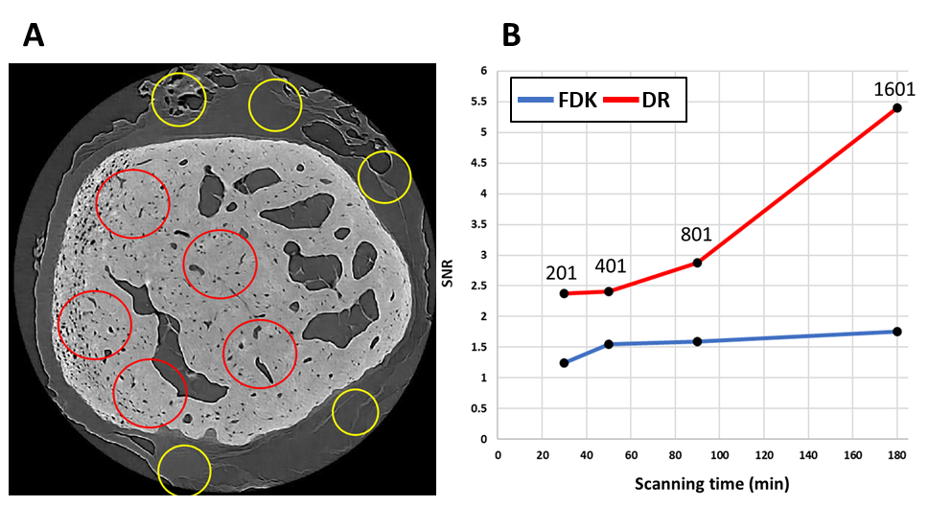
Sup. Figure 3. (A) Micro-CT image illustrating the placement of the circular patches within the quasi uniform-density of two distinct regions of the image. Five pairs of patches were randomly selected across the field of view. Regions of interest selected for SNR and CNR calculation are highlighted: red circles indicate areas of signal measurement within the bone or CFC tissues, while yellow circles mark background and soft tissues noise regions. (B) SNR comparison between original FDK and DR reconstruction methods across different projection numbers (201, 401, 801, and 1601). The DR method shows a significant increase in SNR.

DVC Correlation Value, and accuracy (MAER)
For the analysis of DVC uncertainties, two consecutive tomograms were acquired under zero-strain conditions⁵¹. The DVC strain uncertainties were evaluated using a single-step sub-volume approach, starting with a sub-volume voxel size 12 (pixel size 1.33 μm) and progressively increasing up to 52. The six components of deformation (Ɛxx, Ɛxy, Ɛxz, Ɛyy, Ɛyz, Ɛzz) were extracted and the mean absolute error (MAER) was calculated for different reconstruction methods and projection number.
By measuring the DVC correlation values for Filtered Back Projection and Deep Reconstruction methods under different projection numbers, we observed that DR consistently demonstrated higher DVC correlation values compared to FDK. The improvement was most notable at lower projection numbers (e.g., 201), where FDK displayed significantly lower correlation values. As the number of projections increased, the correlation values for both methods improved. Nevertheless, DR maintained a consistently higher value. The statistical analysis showed the significant differences between the methods, especially for smaller projection numbers. Nevertheless, differences are not significant at higher projection counts (801 and 1601). Each point represents the average of correlation value of progressively refined sub-volumes used in DVC accuracy analysis.
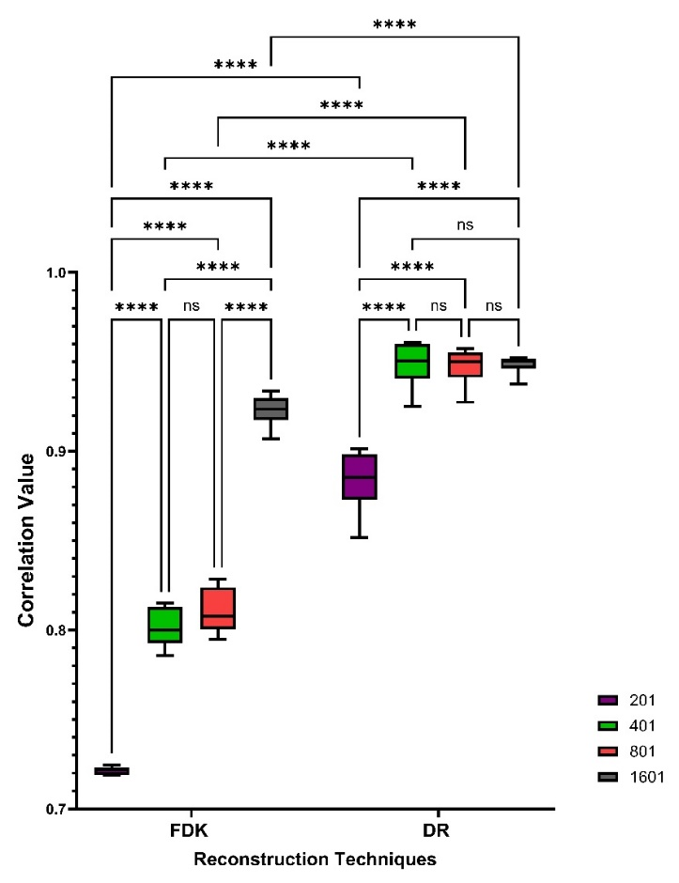
Sup. Figure 4. Comparison of DVC correlation values between FDK and DR reconstruction methods across different projection numbers (201, 401, 801, 1601). Statistical significance is denoted by **** (p < 0.0001) and ns (not significant). Two-way ANOVA with multiple comparison.
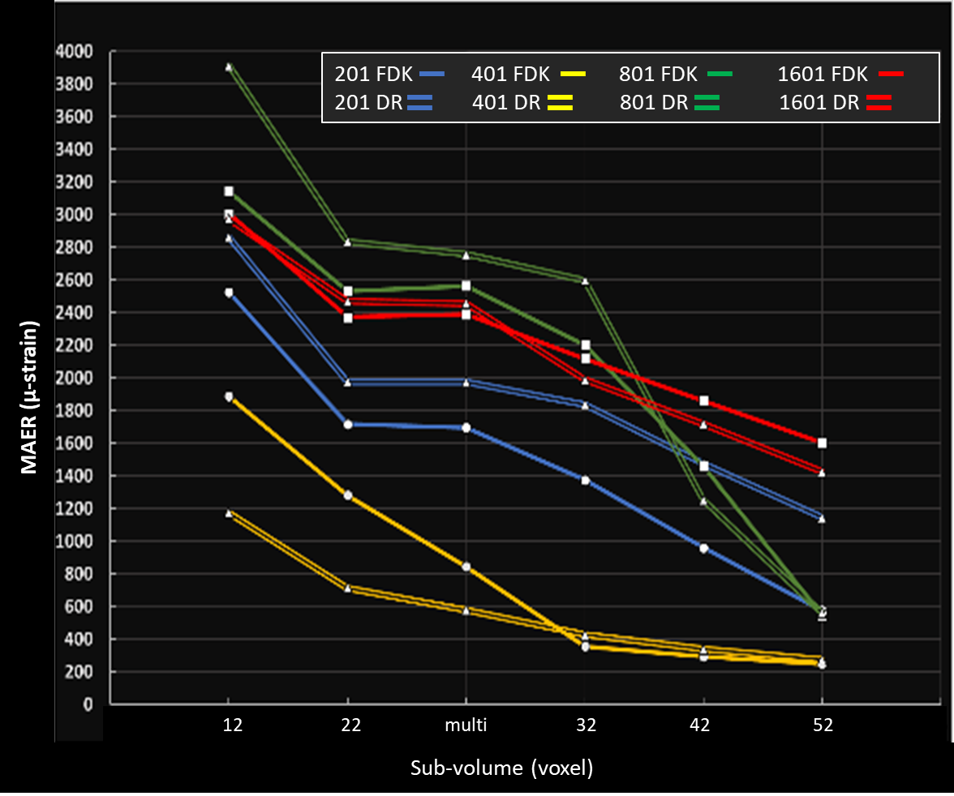
Sup. Figure 5. Strain accuracy across different sub-volume sizes (12 to 52 voxels) for FDK and DR reconstruction at projection numbers of 201, 401, 801, and 1601, representing an average of 400 micro-strain between 2 the techniques.

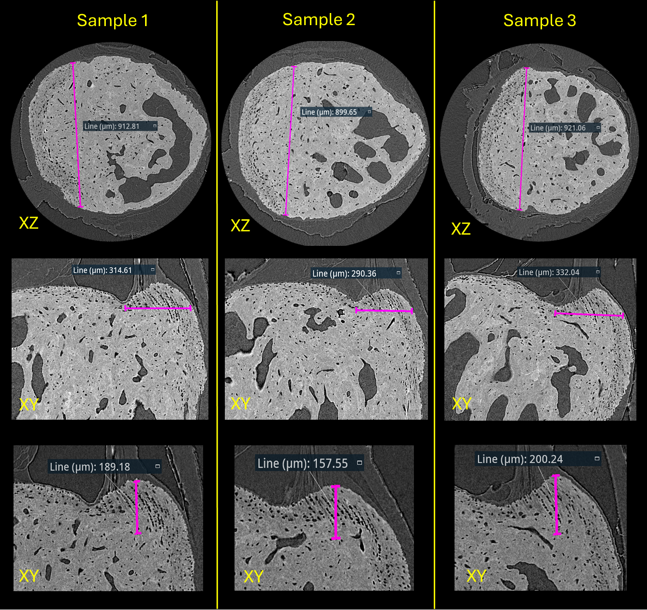
Sup. Figure 6. Microstructure measurements of Achilles insertion at calcaneus calcified CFC

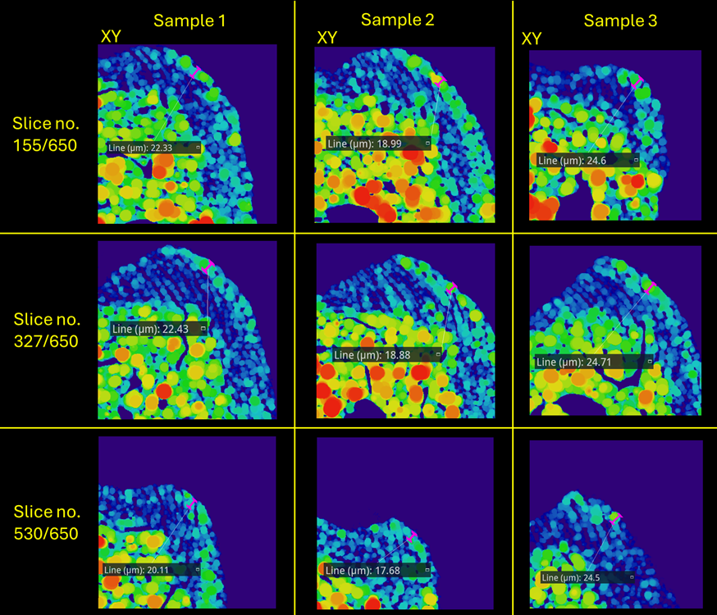
Sup. Figure 7. Microstructure measurements of Achilles insertion at calcaneus CFC

A.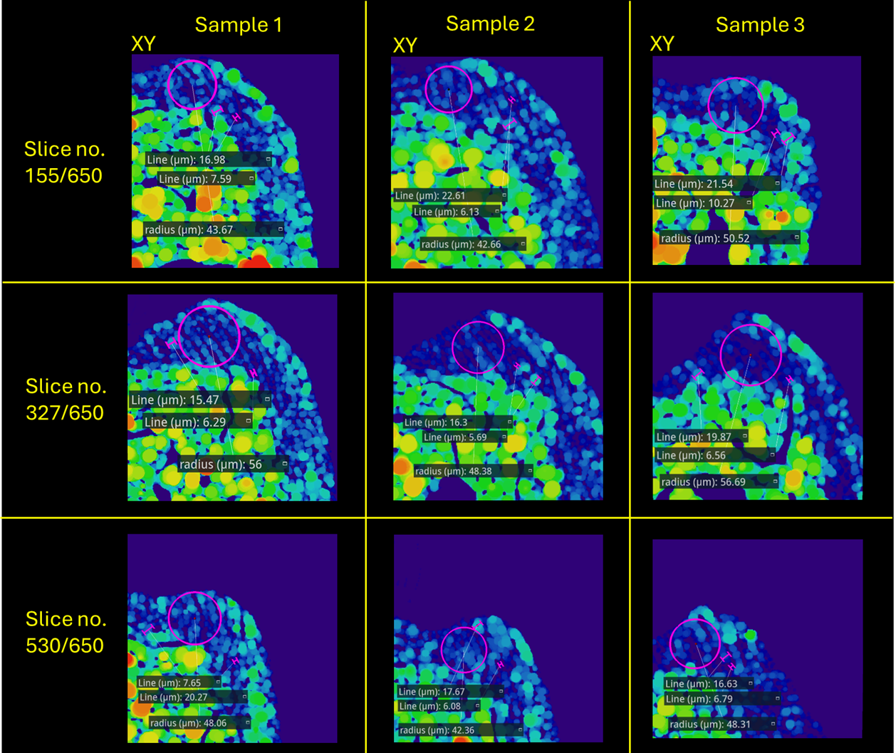
B.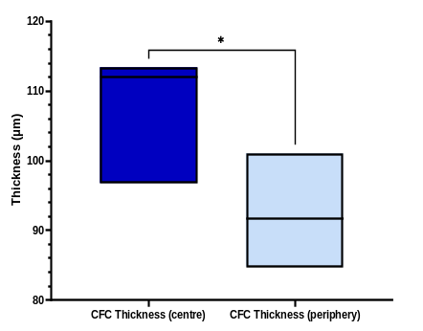
Sup. Figure 8. (A) Microstructure measurements of Achilles insertion at calcaneus CFC. (B) Box plot comparing CFC thickness between the central and peripheral regions. The central region exhibits significantly greater thickness compared to the periphery (p < 0.05, unpaired t-test).

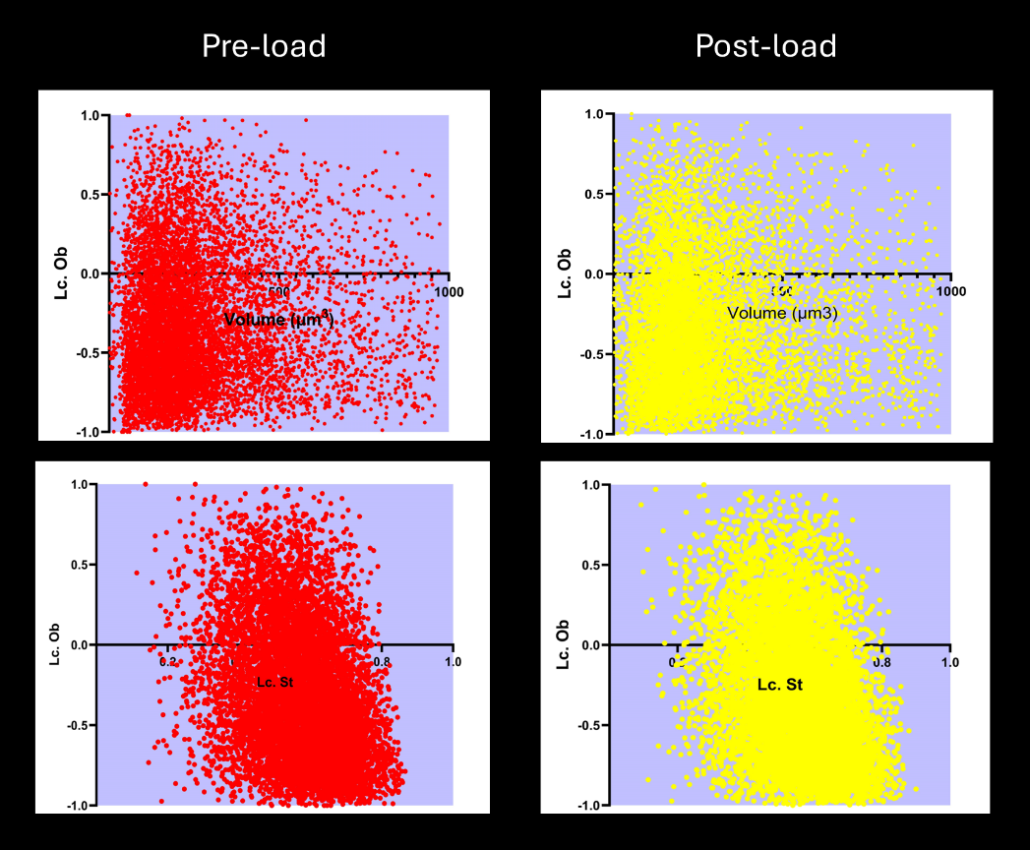
Sup. Figure 9. Scatter plots of lacunae characteristics under pre-load and post-load conditions. The top panels show the relationship between lacunae oblateness (Lc. Ob) and lacunae volume (Lc. Vol) for the pre-load (red) and post-load (yellow) conditions. Both conditions exhibit a wide distribution of lacunae (n=9000), with most lacunae being near spherical in shape (Lc. Ob close to 0), regardless of volume. The bottom panels display the relationship between lacunae oblateness (Lc. Ob) and lacunae stretch (Lc. St) for the pre-load (red) and post-load (yellow) conditions. The data indicates a similar distribution under both conditions, suggesting no significant change in the correlation between stretch and oblateness between pre-load and post-load states.

Supplementary Movies




