Supplemental Material

Assays for VAMP2 and SNAP25 determination in CSF and plasma were partially validated for several parameters as described in Andreasson et al, 2015 (doi: 10.3389/fneur.2015.00179).
Supplemental table 1: Partial analytical validation of SNAP25 Simoa assay
Parameters | Method | Acceptance criteria | Results
Measuring range | LLOQ < > upper cal point (10 CAL points) | NA | 25 - 0,02 pg/mL
Precision - repeatability | Mean intra-run CV% per sample | < 10% | CSF: 2,3% and 3,7%  Plasma: 2,3% and 4,5%
intra-run %CV | 5 independent test runs including CAL, | < 10% | CSF: 2,3% and 3,7%  Plasma: 2,3% and 4,5%
 | 2 remnant CSF (DF 120) and 2 plasma samples (DF 6), duplicates | < 10% | CSF: 2,3% and 3,7%  Plasma: 2,3% and 4,5%
Precision - reproducibility | inter-run CV% per sample | < 20% | CSF: 2,1% and 4,9%  Plasma: 5,4% and 7,9%
Inter-run %CV | 5 independent test run including CAL, | < 20% | CSF: 2,1% and 4,9%  Plasma: 5,4% and 7,9%
 | 2 remnant CSF (DF 120) and 2 Plasma samples (DF 6), duplicates | < 20% | CSF: 2,1% and 4,9%  Plasma: 5,4% and 7,9%
Accuracy | %calculated/theoretical concentrations | 90-110% | 96-105%
Accuracy | 5 independent test runs with CAL (duplicates) | 90-110% | 96-105%
Analytical LLOQ | Precision profile of extended CAL (12 datapoints) in 5 runs | Inter-run %CV > 20% | CAL based: 0,0054 pg/mL
Minimal required dilution | Dilution of 7 CSF/plasma from DF 1 up to DF 2187 and DF 20 resp. | NA | CSF: DF 9
Minimal required dilution |  | NA | Plasma: DF 6
Parallelism | Dilution of 7 CSF/plasma from DF 1 up to DF 2187 and DF 20 resp. | 80-120% (compared to MRD) | CSF: Parallel up to DF 243  plasma: parallel up to DF 16
Serum – plasma correlation | Correlation of 26 paired serum/plasma (DF 6, duplicates), Spearman rho | R² > 0.8 | R² = 0.88
Spike-recovery | (Spike control/Recovery) x 100% on 9 CSF/plasma samples  spiked with 0,5 pg/mL - 0,25 pg/mL - 0,1 pg/mL | 80-120% | CSF: High 98%, Mid 106%, Low 79%  Plasma: High 88%, Mid 94%, Low 98%
Dilution linearity | Spike of 3 CSF/plasma samples above upper CAL (40 pg/mL) with dilution into measuring range | Slope difference CAL vs spiked sample < 10% | Slope difference  4,7% CSF and 6,0% plasma
Dilution linearity |  | 85-115% Linearity | 85-115% CSF  87-125% plasma
Abbreviations: CAL= calibrator; DF= dilution factor; LLOQ= lower limit of quantification; %CV= variation coefficient; MRD= minimal required dilution

Supplemental table 2: Partial analytical validation of VAMP2 Simoa assay
Analysed parameters | Method | Acceptance criteria | Results
Measuring range | LLOQ < > upper CAL point (8 CAL points) | NA | 200-1 pg/mL
Precision - repeatability | Mean intra-run CV% per sample | < 10% | CSF: 3,0% and 6,7%  Plasma: 4,5% and 5,0%
intra-run %CV | 5 independent test runs including CAL curve and | < 10% | CSF: 3,0% and 6,7%  Plasma: 4,5% and 5,0%
 | 2 remnant CSF (DF 16) and 2 plasma samples (DF 3), duplicates | < 10% | CSF: 3,0% and 6,7%  Plasma: 4,5% and 5,0%
Precision - reproducibility | inter-run CV% per sample | < 20% | CSF: 4,5% and 8,3%  Plasma: 14% and 19%
Inter-run %CV | 5 independent test runs including CAL curve and | < 20% | CSF: 4,5% and 8,3%  Plasma: 14% and 19%
 | 2 remnant CSF (DF 16) and 2 plasma samples (DF 3), duplicates | < 20% | CSF: 4,5% and 8,3%  Plasma: 14% and 19%
Accuracy | %calculated/theoretical concentrations | 90-110% | 93-109%
Accuracy | 5 independent test runs with CAL curve (duplicates, 5 days) | 90-110% | 93-109%
Analytical LLOQ | Precision profile of CAL (8 datapoints) in 5 runs | Inter-run CV% exceeds 20% | CAL based: 2,07 pg/mL
Minimal required dilution | Dilution of 7 CSF/plasma from DF 1 up to DF 36 and DF 4,5 resp. | NA | CSF: DF 12
Minimal required dilution |  | NA | Plasma : DF 3
Parallelism | Dilution of 7 CSF/plasma from DF 1 up to DF 36 and DF 4,5 resp. | 80-120% (compared to MRD) | CSF: Parallel up to DF 24  plasma: parallel up to DF 4
Spike-recovery | (Spike control/Recovery) x 100% on 9 CSF/plasma samples  spiked with 49 pg/mL - 34 pg/mL - 18 pg/mL | 80-120% | CSF: High 113%, Mid 108%, Low 110%  Plasma: High 65%, Mid 57%, Low 52%
Dilution linearity | Spike of 4 CSF and 3plasma samples above upper CAL (1600 pg/mL) with dilution into measuring range | 85-115% Linearity | 91-134% CSF  102-121% plasma, linearity starts at 200 pg/mLuntil LLOQ
Abbreviations: CAL= calibrator; DF= dilution factor; LLOQ= lower limit of quantification; %CV= variation coefficient; MRD= minimal required dilution

The 80 paired CSF-plasma samples were run (and rerun for those with a high %CV on duplicate measurements) in four test runs for VAMP2 and four test runs for SNAP25. For VAMP-2, the average %CV of the clinical samples was 4.45% and 6.05% for CSF and plasma resp. For SNAP-25, the average %CV was 5.11% and 6.53% for CSF and plasma resp. These test runs were monitored with two run validation (RV, calibrator spiked in buffer in concentrations different from the calibrators) and two plasma QC (quality control) samples. Inter- and intra-run variability should be below 20% and a summary is shown in supplementary table 3.
Supplemental Table 3: Inter- and intra-run variability of the SNAP25 and VAMP2 runs during the study

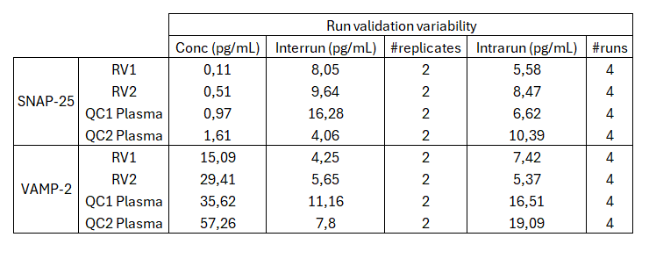

Supplemental Table 4: Receiver Operating Characteristic analysis

 |  | AUC |  | Sensitivity % |  | Specificity % |  | PLR
 | Best cut-off* | Value | 95% CI | Value | 95% CI | Value | 95% CI
AD vs OND
CSF SNAP25 | 125.3 | 0.831 | 0.744 – 0.918 | 87.3 | 78.2 - 92.9 | 71.8 | 56.2 - 83.5 | 3.09
Plasma SNAP25 | 1.6 | 0.744 | 0.589 - 0.854 | 75.9 | 65.5 - 84.1 | 74.4 | 58.9 - 85.4 | 2.96
CSF VAMP2 | 260.8 | 0.684 | 0.571 – 0.797 | 76.9 | 66.4 - 84.9 | 60.9 | 45.7 – 74.3 | 1.97
Plasma VAMP2 | 19 | 0.507 | 0.388 – 0.626 | 97.4 | 91.1 – 99.5 | 12.8 | 5.6 – 26.7 | 1.12
PD vs OND
CSF SNAP25 | 95.6 | 0.524 | 0.399 – 0.649 | 30.4 | 19.1 – 44.8 | 61.5 | 45.9 – 75.1 | 0.79
Plasma SNAP25 | 0.73 | 0.620 | 0.499 – 0.741 | 0 | 0 – 7.6 | 92.3 | 79.7 – 97.4 | 0
CSF VAMP2 | 166.7 | 0.525 | 0.400 – 0.649 | 20 | 10.9 – 33.8 | 70.7 | 55.5 – 82.4 | 0.68
Plasma VAMP2 | 33.7 | 0.511 | 0.514 – 0.763 | 51.1 | 37.2 – 64.7 | 46.2 | 31.6 – 61.4 | 0.95
Abbreviations. AD: Alzheimer’s disease. AUC: area under the curve. CI: confidence interval. OND: other neurological diseases. PD: Parkinson’s disease. PLR: positive likelihood ratio. *Best cut-off values were calculated by maximizing the Youden index. SNAP-25: synaptosomal-associated protein 25 kDa. VAMP2: vesicle-associated membrane protein 2.

Supplemental Figure 1: ROC Analysis of synaptic markers
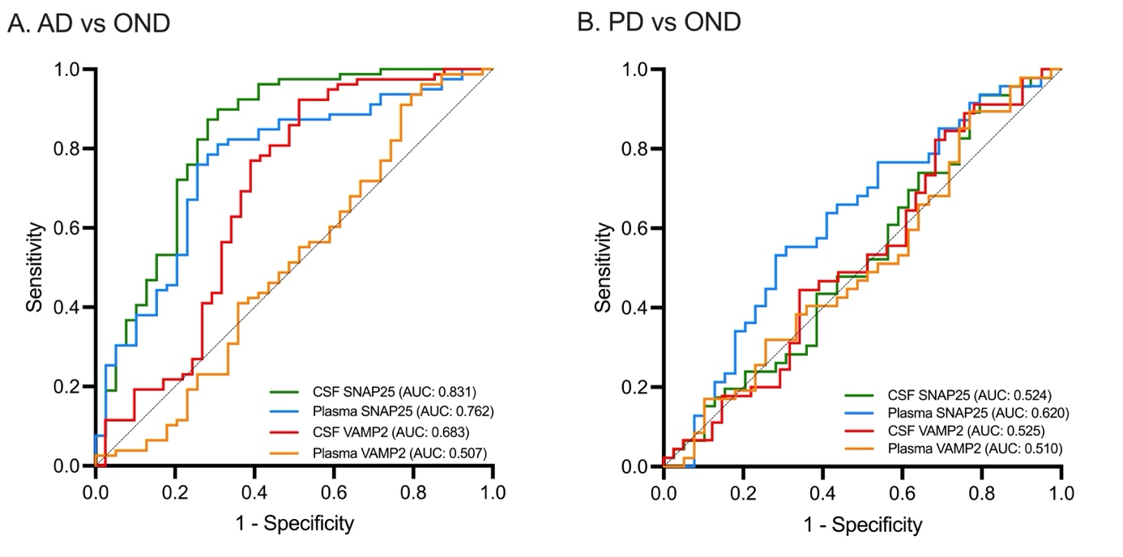
Figure legend. Panels show the results of ROC analyses in the comparisons between (A) AD and OND, and (B) PD and OND. AD: Alzheimer’s disease. OND: other neurological diseases. PD: Parkinson’s disease. ROC: receiver operating characteristic. SNAP-25: synaptosomal-associated protein 25 kDa. VAMP2: vesicle-associated membrane protein 2.

Supplemental Figure 2: Correlations between CSF and plasma SNAP25 and baseline MMSE in the study cohort.

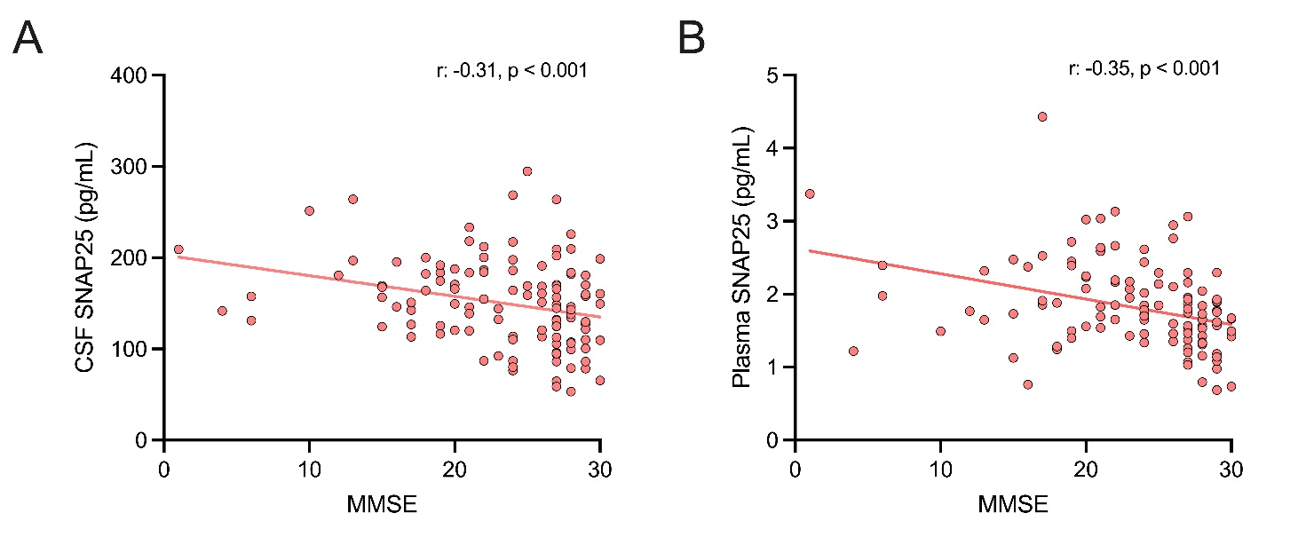
Figure legend. Panels show scatter plot of correlation between baseline MMSE and (A) CSF SNAP25 and (B) plasma SNAP25 in the study cohort. CSF: cerebrospinal fluid. MMSE: Mini Mental State Examination. SNAP-25: synaptosomal-associated protein 25 kDa.

