Graphical abstract image
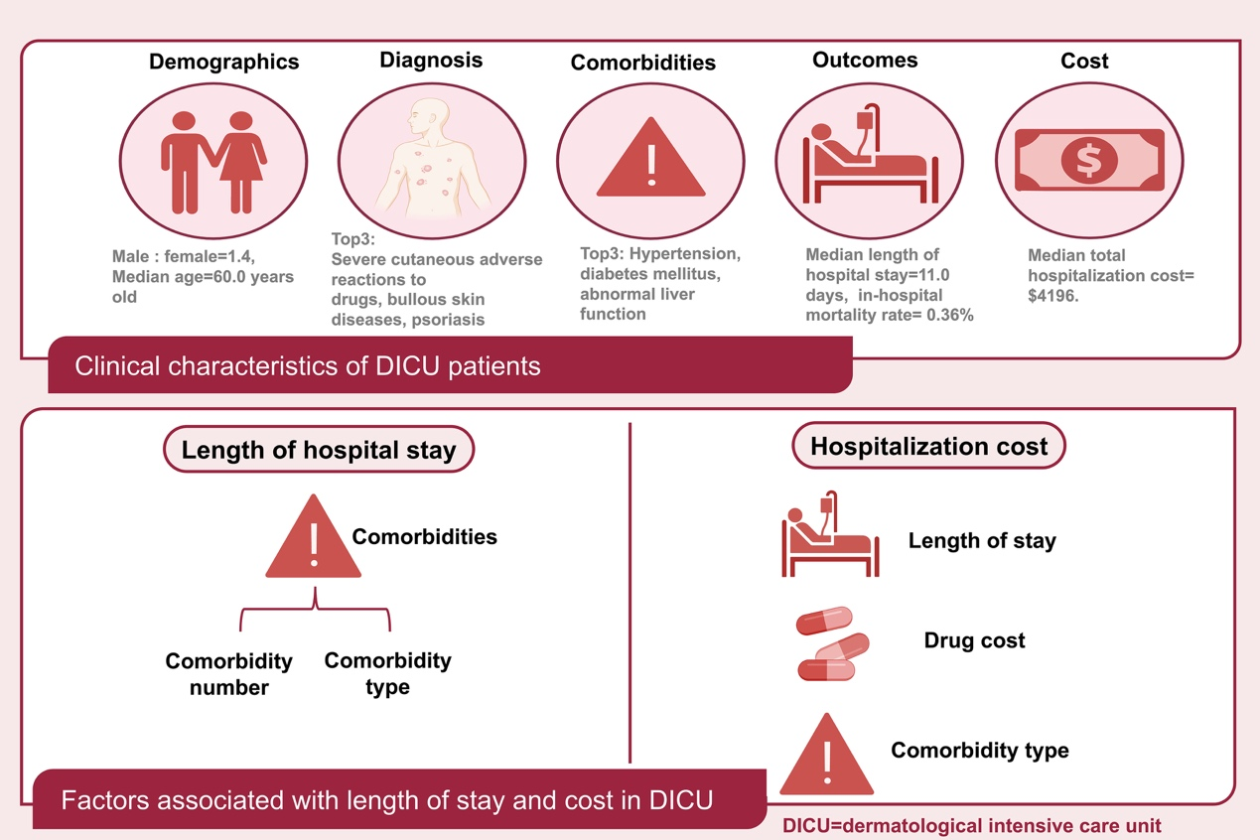
A retrospective study analyzing patients in the dermatology intensive care unit (DICU) at a single center in China from 2017 to 2023.

