
Plate 1 showing the Plantation Drive by Umashankar Mandal (Mangrove Man) and his Purbasha Eco-Helpline Society (NGO) (Source: https://www.telegraphindia.com/.../mangrove.../cid/1823882)

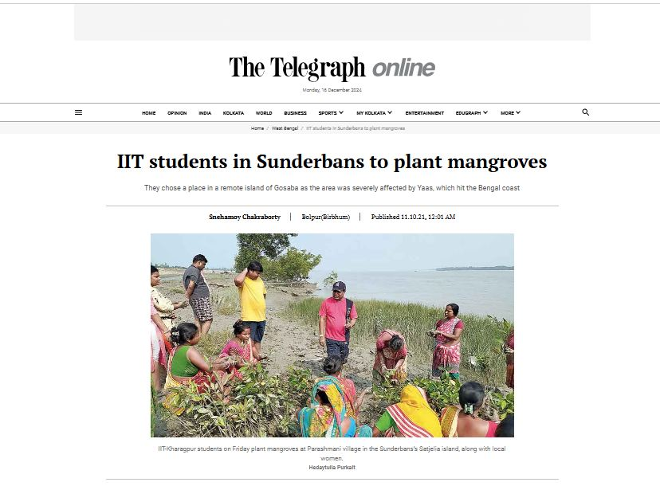
Plate 2 showing the Plantation Drive by some Research Scholars from Department of Chemical Engineering, IIT Kharagpur along with Umashankar Mandal (Mangrove Man) and his Purbasha Eco-Helpline Society (NGO) (Source: https://www.telegraphindia.com/west-bengal/iit-students-in-sunderbans-to-plant-mangroves/cid/1834166?fbclid=IwAR2ZxTUVatMj4oUiXytYA1jOg12_fXcBNapwe1aIAEHGgUzwbKn59qURDSs)

Plate 3 showing the Tiger Conservation Award is presented to Mangrove Restorer, Mr. Umashankar Mandal (Mangrove Man) for his unprecedented contribution in Mass Mangrove Plantation Programme in 2021
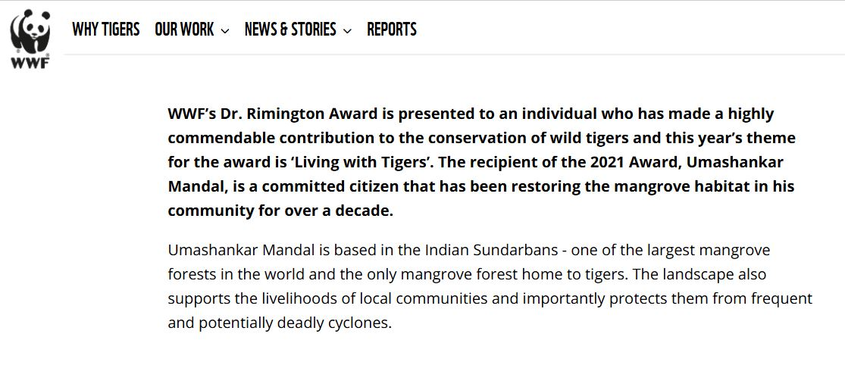
(Source:https://tigers.panda.org/news_and_stories/stories/mangrove_restorer_wins_tiger_conservation_award/?fbclid=IwAR0ZDxwMXeKxlYKbCkbz2OHB0uxWwT58yImCb_97XQ5rI6EK3wAxD5ySpHs)

