Supplementary Information
Dual-key cooperatively activated DNA regulator for controlling mitochondria-lysosome interactions and precision cancer therapy
Yang Xiao,ª Longyi Zhu,ª Songyuan Du,^{a,b} Xinyi Ge,^{a,b} Lequn Ma,ª Shengyuan Deng^{b}* and Kewei Renª*

ªSchool of Chemistry and Chemical Engineering, Nanjing University of Science and Technology, Nanjing, 210094, China.
e-mail: kwren@njust.edu.cn
^{b}School of Environmental and Biological Engineering, Nanjing University of Science and Technology, Nanjing 210094, P.R. China.
e-mail: sydeng@njust.edu.cn

Supplementary Table
Supplementary Table 1. Sequences of DNA used in this project
CD63 | CACCCCACCTCGCTCCCGTGACACTAATGCTAGTTCTA
CD63-FAM | CACCCCACCTCGCTCCCGTGACACTAATGC /I6FAMd/ TA
B1 | TAGCATTAGTGTCA
B2 | CGGGAGCGA /PC-Linker/ GGTGGGGTG
CD63APT | CACCCCACCTCGCTCCCGTGACACTAATGCTATTTTTTTTTTTTTTTTTTTTTTTTTTTTTTTTTTTTTTTTTTTTTTTTTTTTTTTTTTTT-Azide
CD63APT-FAM | CACCCCACCTCGCTCCCGTGACACTAATGC /I6FAMd/ TATTTTTTTTTTT TTTTTTTTTTTTTTTTTTTTTTTTTTTTTTTTTTTTTTTTTTTTTTTTT-Azide
B3 | TAGCATTAGTG /PC-Linker/ TCACGGGAGCG /SH-SH/ AGGTGGGGTG
R1-FAM | TCGATCACTAGTTACAGAGTCTCTACGTGC /I6FAMd/ AA-Azide
R1 | TCGATCACTAGTTACAGAGTCTCTACGTGCAA-Azide

Supplementary Figures
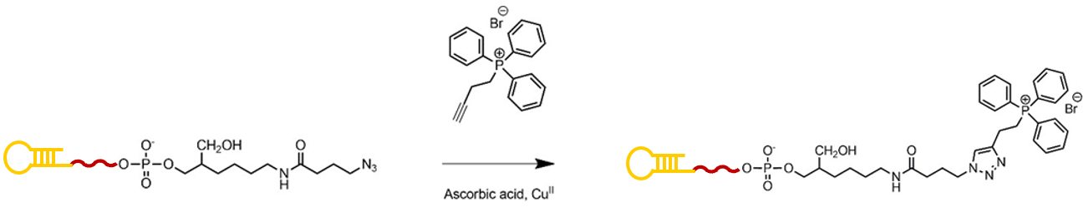
Supplementary Figure 1. Schematic synthesis of CD63APT-TPP.

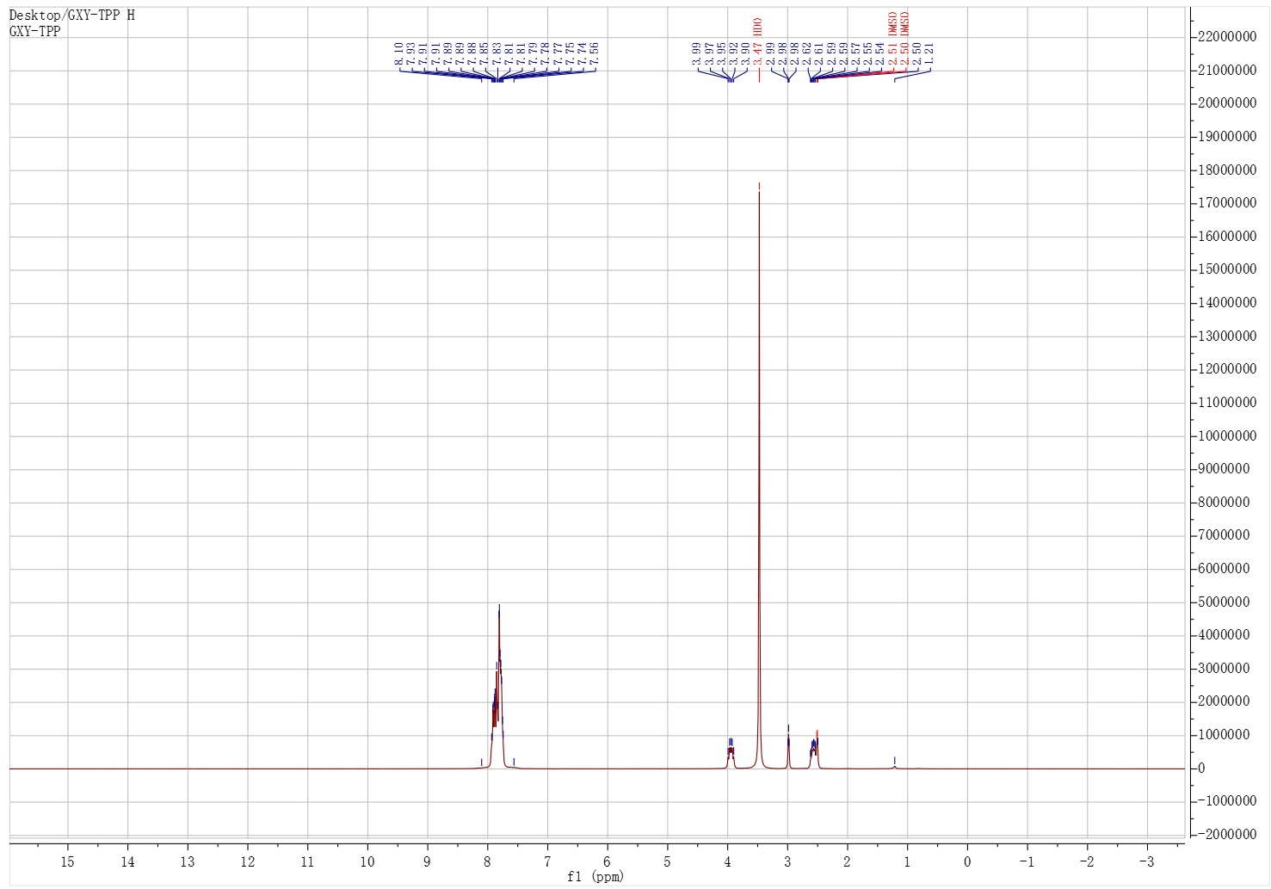
Supplementary Figure 2. ¹H-NMR spectrum of alkynyl-TPP.
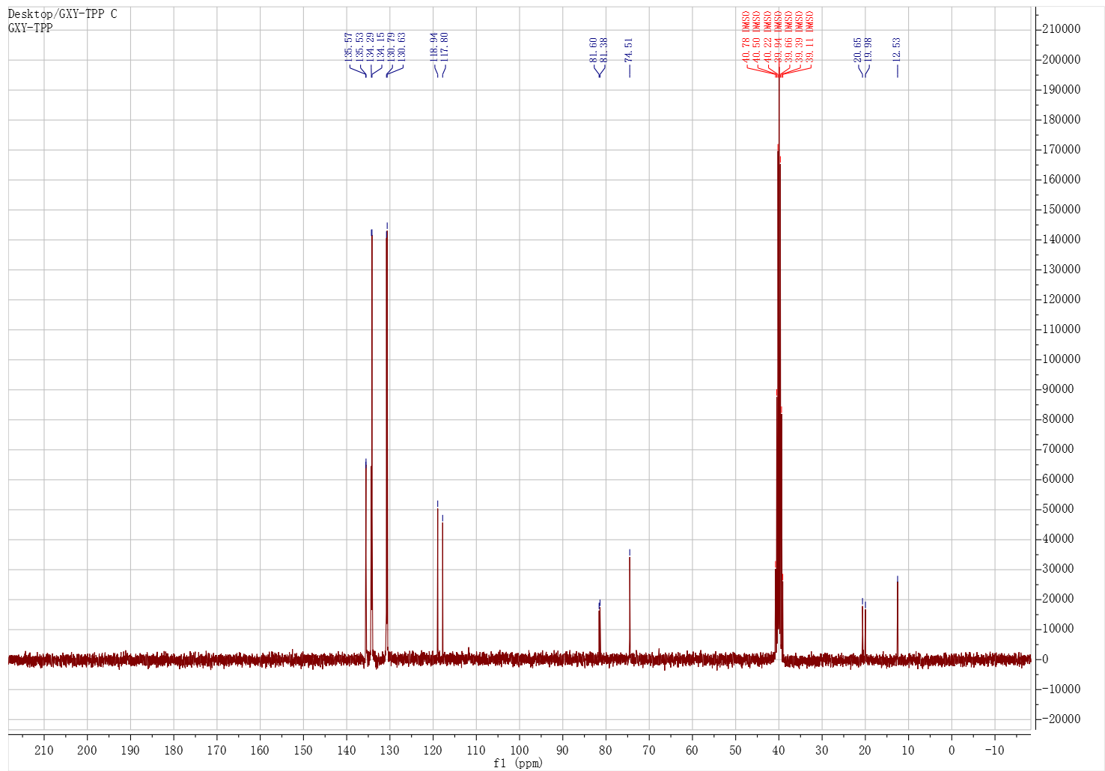
Supplementary Figure 3. ¹³C-NMR spectrum of alkynyl-TPP.

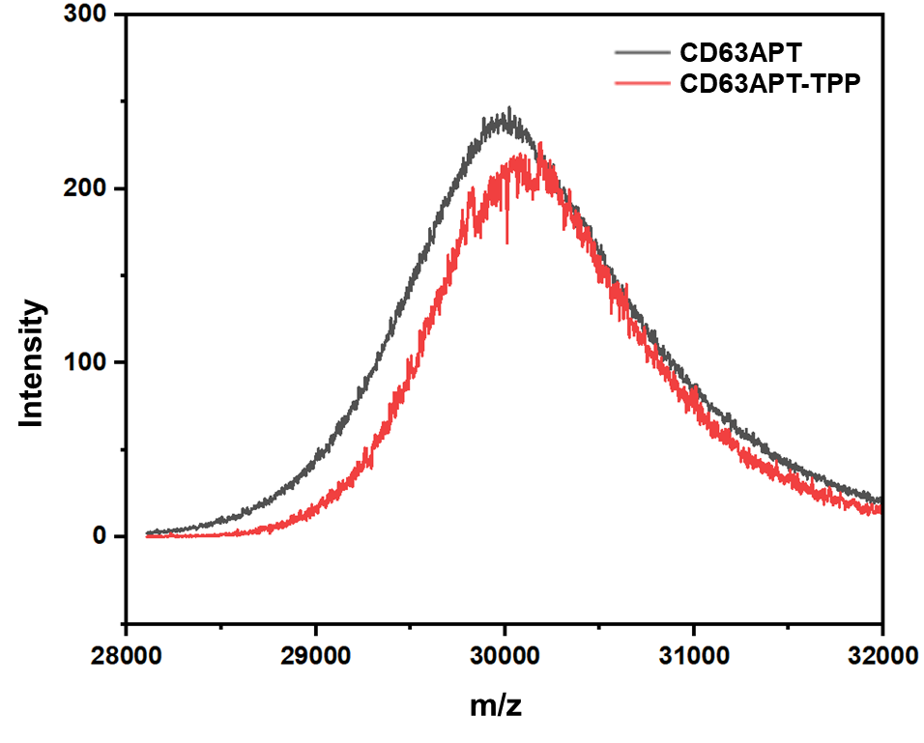
Supplementary Figure 4. MALDI-TOF MS spectra of CD63APT and CD63APT-TPP.
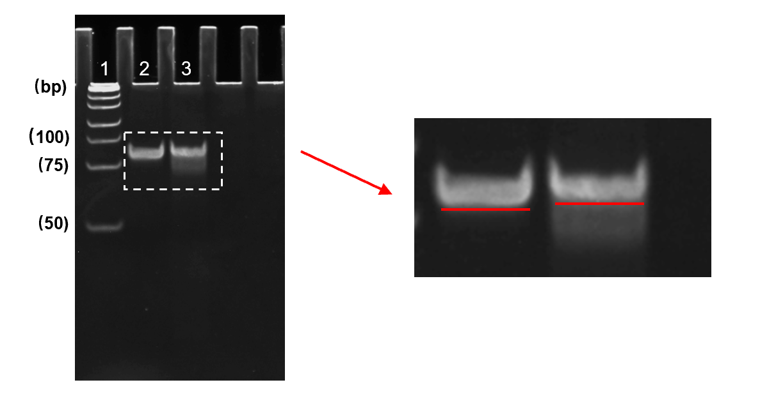
Supplementary Figure 5. Native PAGE (20 wt.%) analysis of the synthetic CD63APT-TPP. Lanes 1-3 represent from left to right: DNA ladder maker, CD63APT, and CD63APT-TPP.

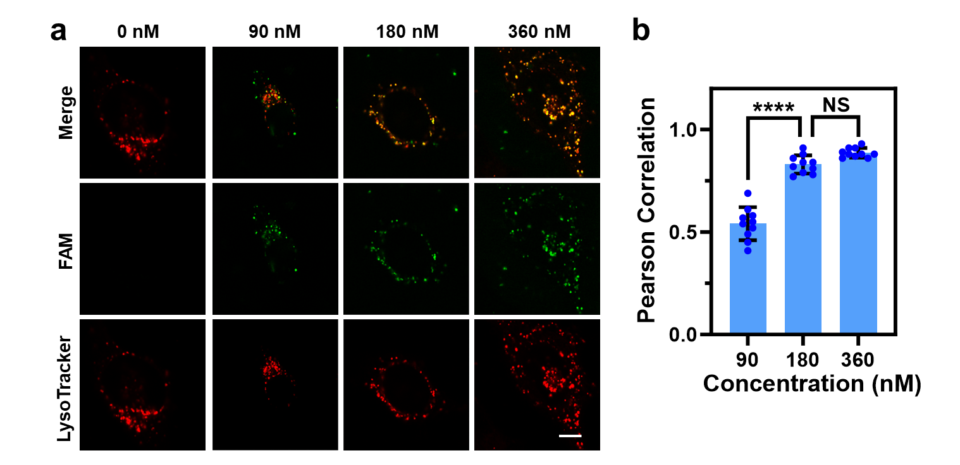
Supplementary Figure 6. Optimization of OK-MLIR concentrations. a. Confocal fluorescence images of HeLa cells incubated with different concentrations of OK-MLIR (0, 90, 180 and 360 nM). Scale bar: 10 µm. b. Pearson correlation analysis of Supplementary Figure 6a by investigating the fluorescence signals of FAM and LysoTracker. Shown are mean ± SEM from ten individual cells. ****P < 0.0001 (two-tailed Student’s t-test), NS: not significant.

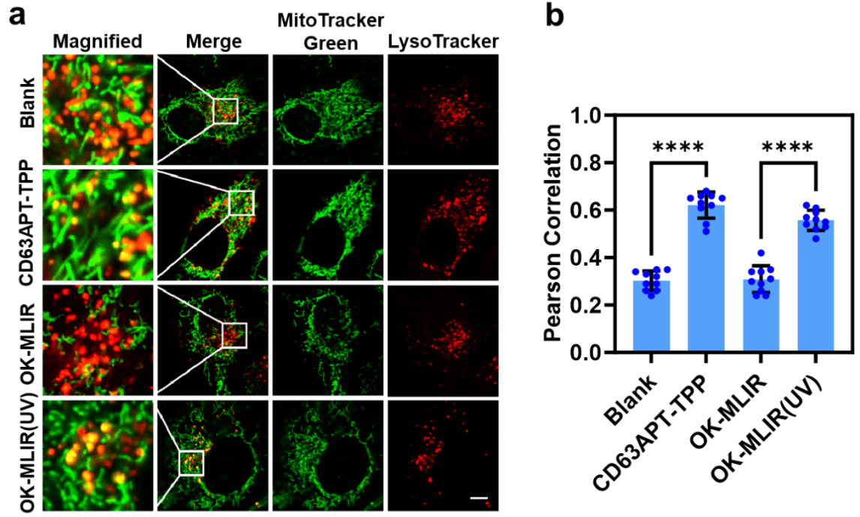
Supplementary Figure 7. Characterization of mitochondria-lysosome Interactions regulated with OK-MLIR. a. Confocal images of HeLa cells treated without (Blank), and with CD63APT-TPP and OK-MLIR (180 nM) in absence (the OK-MLIR row) and presence (OK-MLIR (UV)) of 10-min UV irradiation. Magnified, Magnify 5 times Scale bar: 10µm. b. Pearson correlation analysis of Supplementary Figure 7a by investigating the fluorescence signals of MitoTracker Green and LysoTracker. Shown are mean ± SEM from ten individual cells. ****P < 0.0001 (two-tailed Student’s t-test).

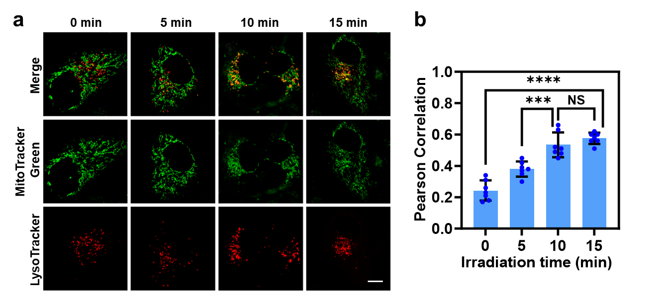
Supplementary Figure 8. Optimization of UV irradiation times. a. Confocal fluorescence images of 180 nM OK-MLIR-treated HeLa cells under different duration of UV irradiations. Scale bar: 10 µm. b. Pearson correlation analysis of Supplementary Figure 8a by investigating the fluorescence signals of MitoTracker Green and LysoTracker. Shown are mean ± SEM from ten individual cells. ****P < 0.0001, ***P < 0.001 (two-tailed Student’s t-test).

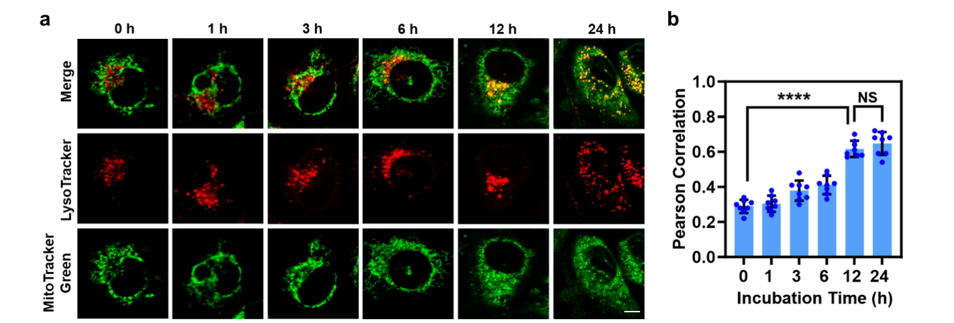
Supplementary Figure 9. Optimization of Hea cells incubation time after the treatment with OK-MLIR and light irradiation. a. Confocal fluorescence images of OK-MLIR and light irradiation treated Hela cells at different incubation time. Scale bar: 10 µm. b. Pearson correlation analysis of Supplementary Figure 9a by investigating the fluorescence signals of MitoTracker Green and LysoTracker. Shown are mean ± SEM from ten individual cells. ****P < 0.0001 (two-tailed Student’s t-test).

Supplementary Figure 10. Contact between mitochondria and lysosomes in lysosomes. Count the number of mitochondria and lysosomes in contacts for every 100 lysosomes from Fig. 2c. Shown are mean ± SEM from ten individual cells. ****P < 0.0001 (two-tailed Student’s t-test).

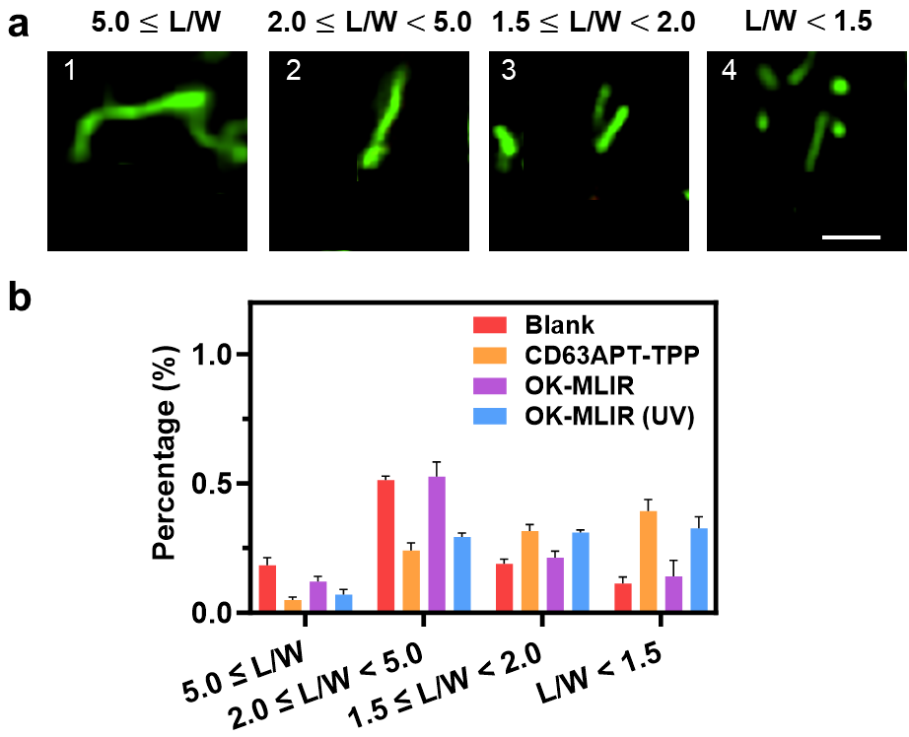
Supplementary Figure 11. The OK-MLIR system for controlled regulation of mitochondrial fission. a. Confocal images of mitochondria with different morphologies. “L” denotes length, “W” width, and “L/W” length divided by width. Scale bar: 2 µm. b. Quantitative analysis of mitochondrial morphology in HeLa cells treated without (Blank) and with CD63APT-TPP or OK-MLIR (180 nM) in absence (the OK-MLIR row) and presence (OK-MLIR (UV)) of 10-min UV irradiation. Shown are mean ± SEM from ten individual cells. ****P < 0.0001 (two-tailed Student’s t-test).

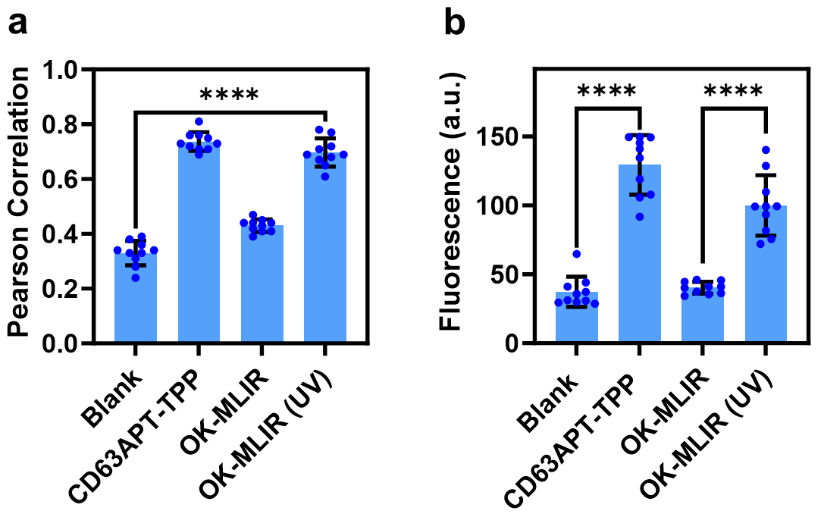
Supplementary Figure 12. Colocalization analysis and fluorescence intensity statistics. a. Quantitative colocalization analysis of purple and green parts in Fig. 2e. b. statistics of red fluorescence intensity were performed in Fig. 2e. Shown are mean ± SEM from ten individual cells. ****P < 0.0001 (two-tailed Student’s t-test).

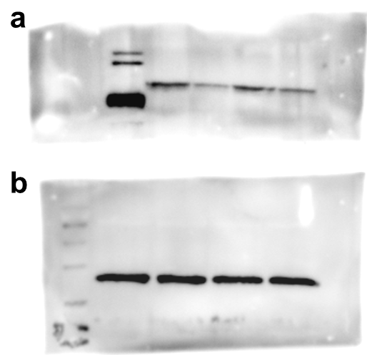
Supplementary Figure 13. The raw strips of Western blot experiment of Fig. 2h. a. TOMM20, b. GAPDH

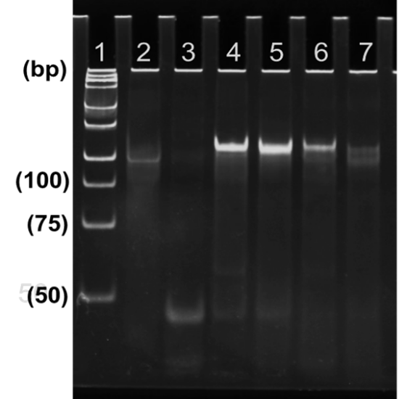
Supplementary Figure 14. Native PAGE (10 wt.%) analysis of DK-MLIR assembly and activation by dual keys. Lane 1-7 represent: DNA ladder, CD63APT-TPP, B3, CD63APT-TPP+ B3, CD63APT-TPP+ B3 with 10-min UV irradiation treatment, CD63APT-TPP+ B3 with 10 mM GSH treatment, and CD63APT-TPP + B3 with 10-min UV irradiation and 10 mM GSH treatments, respectively.

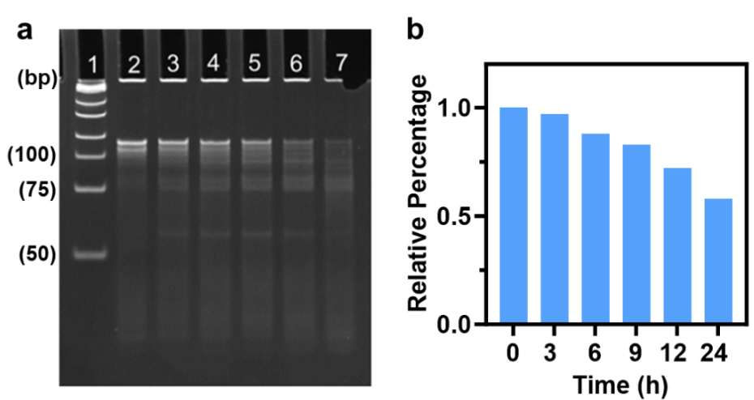
Supplementary Figure 15. Stability study of DK-MLIR. a. Native PAGE (10 wt.%) analysis of DK-MLIR in 10 % FBS over different incubation period. b. The stripe intensities extracted from corresponding Supplementary Figure 15a.

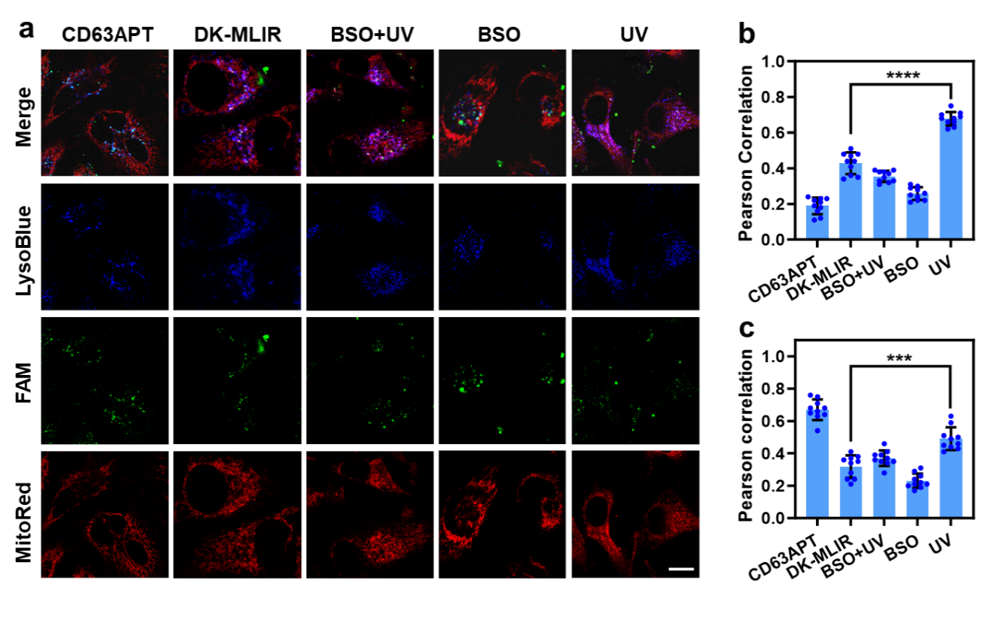
Supplementary Figure 16. Performances of the DK-MLIR system for modulating mitochondria-lysosome interactions in living cells. a. Confocal images of HeLa cells transfected without (Blank) and with 180 nM CD63APT (CD63APT), 180 nM DK-MLIR in absence (OK-MLIR) and presence of 10-min UV irradiation (UV), 100 µM BSO inhibitor (BSO), as well as UV irradiation and BSO inhibitor (BSO+UV). Scale bar: 20 µm. b. Pearson correlation analysis of Supplementary Figure 16a by investigating the fluorescence signals of MitoRed and LysoBlue. Shown are mean ± SEM from ten individual cells. ****P < 0.0001 (two-tailed Student’s t-test). c. Pearson correlation analysis of Supplementary Figure 16a by investigating the fluorescence signals of FAM and LysoBlue. Shown are mean ± SEM from ten individual cells. ****P < 0.0001 (two-tailed Student’s t-test).
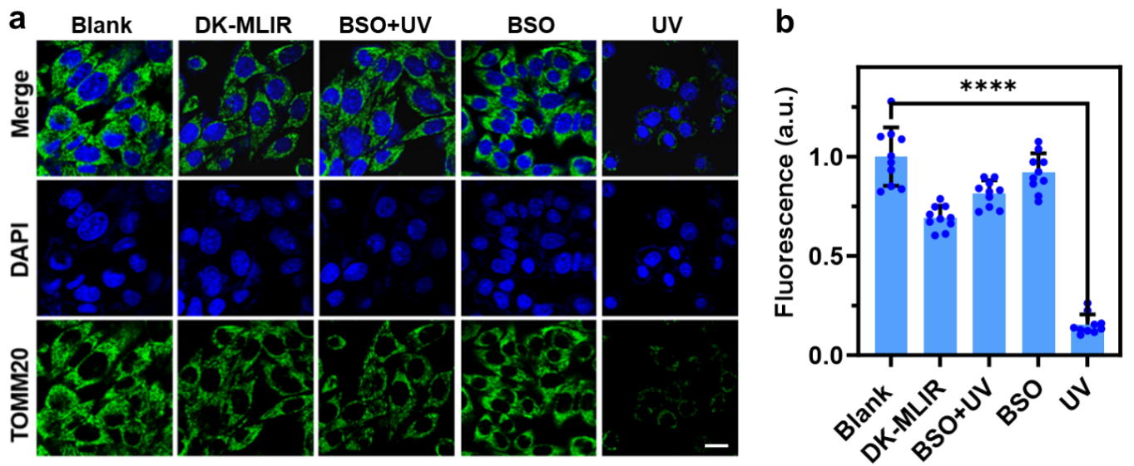
Supplementary Figure 17. Expression level of TOMM20. a. Confocal immunofluorescence staining images of HeLa cells transfected without (Blank) and with DK-MLIR (180 nM) in absence (OK-MLIR), and presence of 10-min UV irradiation (UV), BSO inhibitor (100 µM BSO), as well as UV irradiation and BSO inhibitor (BSO+UV). Scale bar: 50 µm. b. Fluorescence intensities extracted from corresponding Supplementary Figure 17a. Shown are mean ± SEM from ten individual cells. ****P < 0.0001 (two-tailed Student’s t-test).

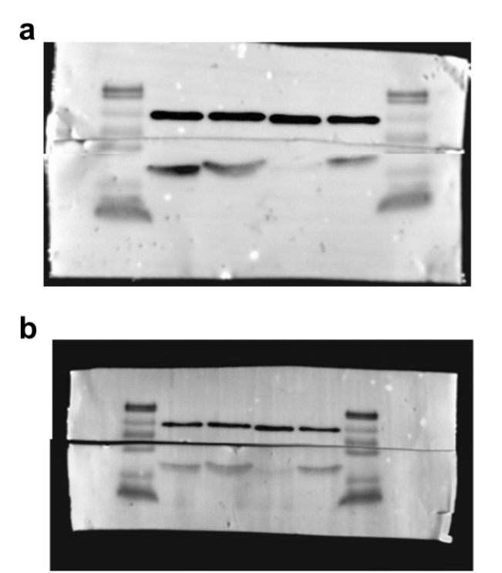
Supplementary Figure 18. Raw strips of Western blot experiment for Fig. 3f. a. TOMM20, GAPDH. b. COXIV, GAPDH.

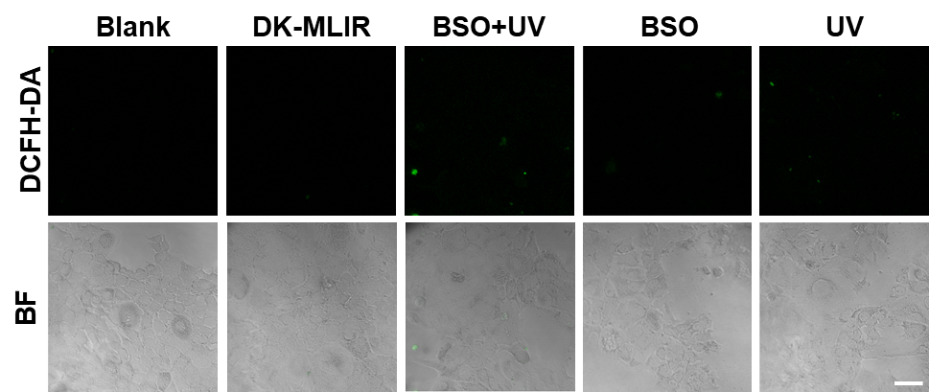
Supplementary Figure 19. Intracellular ROS measurement. Confocal images of AML-12 cells transfected without (Blank) and with DK-MLIR (180 nM) in absence (OK-MLIR), and presence of 10-min UV irradiation (UV), BSO inhibitor (100 µM BSO), as well as UV irradiation and BSO inhibitor (BSO+UV) after incubation with 10 μM DCFH-DA for 30 min. Scale bar: 60 µm.

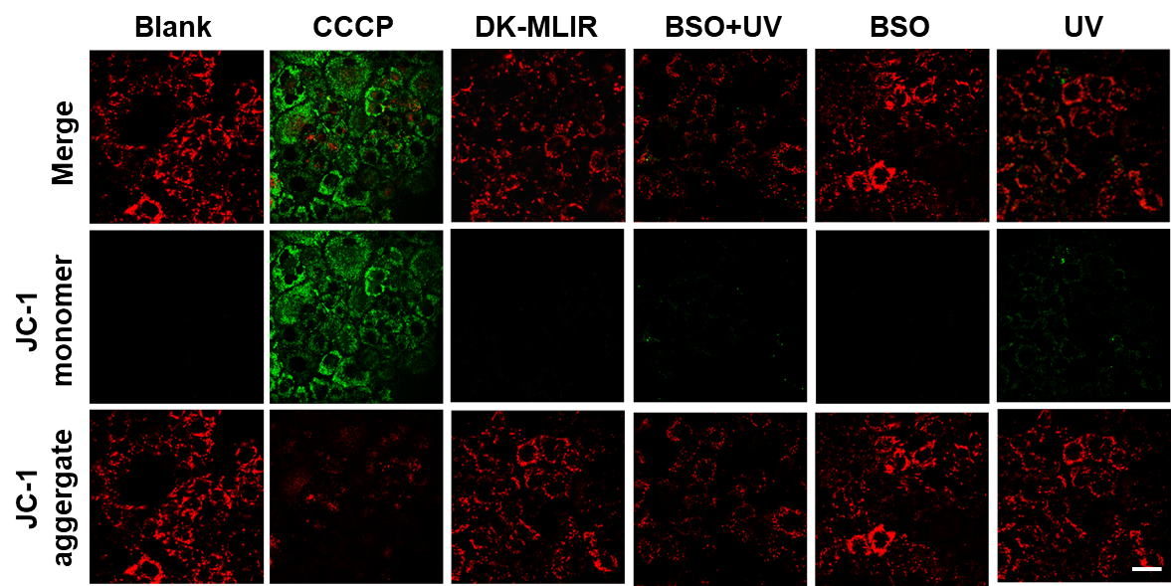
Supplementary Figure 20. Mitochondrial membrane potential measurement. Confocal images of AML-12 cells transfected without (Blank) and with DK-MLIR (180 nM) in absence (OK-MLIR), and presence of 10-min UV irradiation (UV), BSO inhibitor (100 µM BSO), as well as UV irradiation and BSO inhibitor (BSO+UV) after incubation with 1 mg/L JC-1 dye for 20 min. CCCP (10 μM) was the positive control group. Scale bar: 50µm.

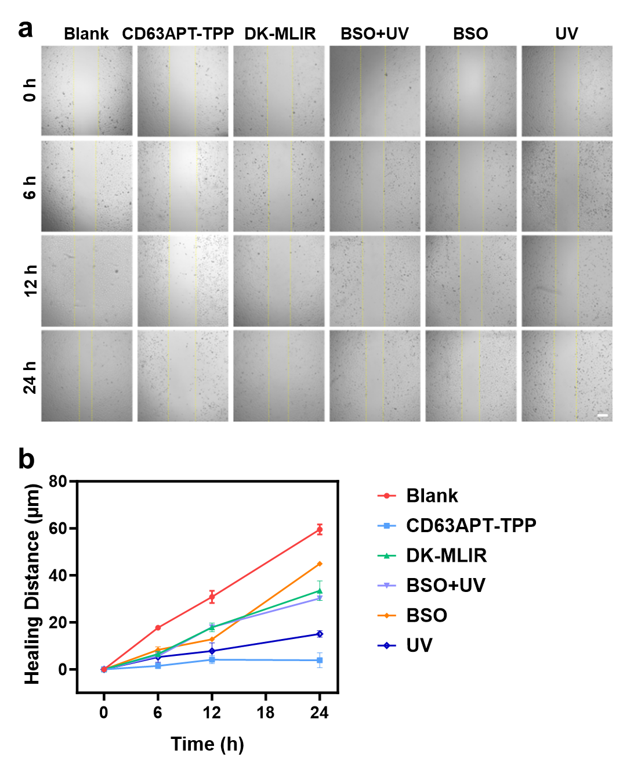
Supplementary Figure 21. Wound healing assays. a. Confocal images of HeLa cells transfected without (Blank) and with DK-MLIR (180 nM) in absence (OK-MLIR), and presence of 10-min UV irradiation (UV), BSO inhibitor (100 µM BSO), as well as UV irradiation and BSO inhibitor (BSO+UV) at different time points. The HeLa cells treated with CD63APT-TPP were used as positive control. The yellow lines indicate the wound edges. Scale bar: 200 µm. b. The distance of the wound was measured by ImageJ software in Supplementary Figure 21a. Shown are mean ± SEM from three individual experiments.

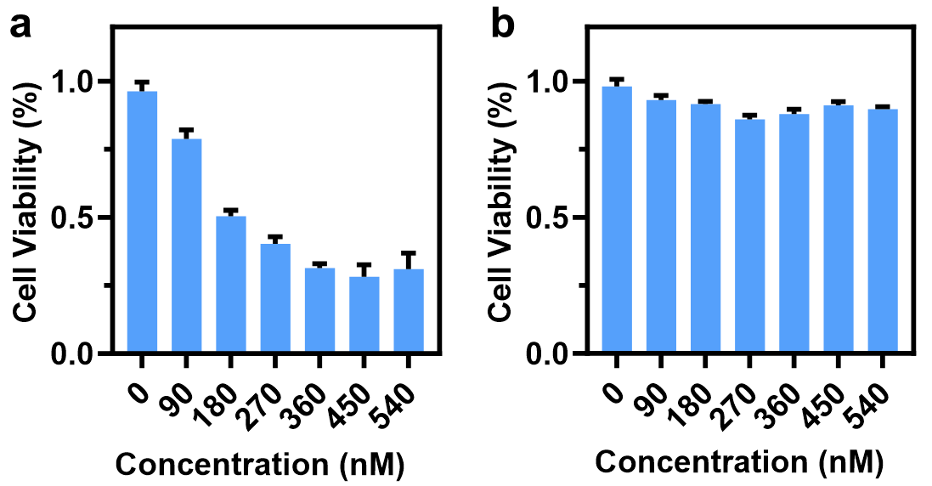
Supplementary Figure 22. Cell viability assays. a. Cytotoxicity of HeLa cells induced with different concentrations of the activated DK-MLIR. b. Cytotoxicity of Aml-12 cells induced with different concentrations of the activated DK-MLIR. Shown are mean ± SEM from three individual experiments.

